
Good Shepherd Lutheran Church
Pastor: Rev. Katie Anderson | Music Director: Rev. Lois Swanson
Pastor’s Cell: (715) 502-9433 | Office Phone: (715) 387-2731
Pastor Email: gslcwi.pastor@gmail.com | Office Email: gslcwi.office@gmail.com
Website: GoodShepherdMarshfield.org
Seventh Sunday after Pentecost
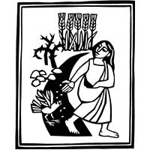
July 12, 2026 9:00 am
Welcome to Good Shepherd.
We’re so glad you’re here. Whether you’re seeking, curious, returning, or rooted in faith – you are welcome.
At Good Shepherd, we believe that Jesus Christ calls each one of us by name and leads us with love, grace, and truth. Just as a shepherd gathers all their sheep, we believe Christ embraces all people – no matter your race, ethnicity, sexual orientation, gender identity or expression, social status, or level of ability.
Here you will find a community shaped by compassion, guided by Scripture, and committed to building the Kingdom of God through justice and equity for all.
There is room in the fold for you.
Welcome home.
ANNOUNCEMENTS
GATHERING

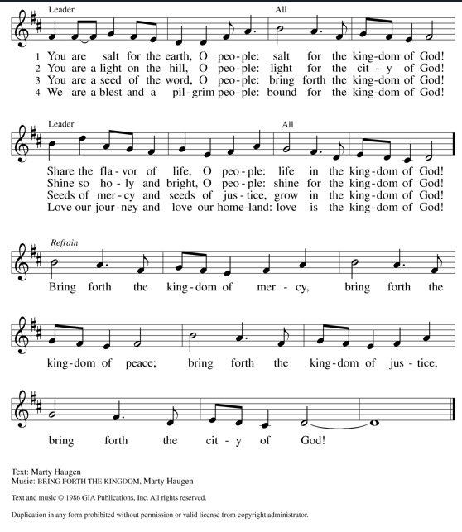
GATHERING HYMN Bring Forth the Kingdom
CONFESSION AND FORGIVENESS

Blessed be the holy Trinity,☩ one God,
whose compassion endures forever.
Amen.
Let us confess our sin to God.
Silence is kept for reflection.
Compassionate God,
we confess to you all our sins.
Our burden is heavy, and we cannot free ourselves.
In your mercy, call us back to you.
Your yoke is easy and your burden is light.
Restore us to dwell in your peace.
In Christ’s name we pray,
Amen.
Jesus says, “Come to me,
all you who are weary
and are carrying heavy burdens,
and I will give you rest.”
In the name of God,
Father, ☩ Son, and Holy Spirit,
your sins are forgiven.
Rest in God’s love.
Amen.
PRAYER OF THE DAY
Almighty God, we thank you for planting in us the seed of your word. By your Holy Spirit help us to receive it with joy, live according to it, and grow in faith and hope and love, through Jesus Christ, our Savior and Lord.
CHILDREN’S MUSIC Send Me, Jesus ELW 549
CHILDREN’S MESSAGE
SCRIPTURE READINGS
FIRST READING: Isaiah 55:10-13
¹⁰ For as the rain and the snow come down from heaven
and do not return there until they have watered the earth,
making it bring forth and sprout,
giving seed to the sower and bread to the eater,
¹¹ so shall my word be that goes out from my mouth;
it shall not return to me empty,
but it shall accomplish that which I purpose
and succeed in the thing for which I sent it.
¹² For you shall go out in joy
and be led back in peace;
the mountains and the hills before you
shall burst into song,
and all the trees of the field shall clap their hands.
¹³ Instead of the thorn shall come up the cypress;
instead of the brier shall come up the myrtle,
and it shall be to the Lord for a memorial,
for an everlasting sign that shall not be cut off.
Word of God, word of life.
Thanks be to God.
PSALM: Psalm 65:[1-8] 9-13
¹ You are to be praised, O God, in Zion;
to you shall vows be fulfilled.
² To you, the one who answers prayer,
to you all flesh shall come.
³ Our sins are stronger than we are,
but you blot out our transgressions.
⁴ Happy are they whom you choose and draw to your courts to dwell there!
They will be satisfied by the beauty of your house, by the holiness of your temple.
⁵ Awesome things will you show us in your righteousness, O God of our salvation,
O hope of all the ends of the earth and of the oceans far away.
⁶ You make firm the mountains by your power;
you are girded about with might.
⁷ You still the roaring of the seas,
the roaring of their waves, and the clamor of the peoples.
⁸ Those who dwell at the ends of the earth will tremble at your marvelous signs;
you make the dawn and the dusk to sing for joy.
⁹ You visit the earth and water it abundantly; you make it very plenteous;
the river of God is full of water.
You prepare the grain, for so you provide for the earth.
¹⁰ You drench the furrows and smooth out the ridges;
with heavy rain you soften the ground and bless its increase.
¹¹ You crown the year with your goodness,
and your paths overflow with plenty.
¹² May the fields of the wilderness be rich for grazing,
and the hills be clothed with joy.
¹³ May the meadows cover themselves with flocks, and the valleys cloak themselves with grain;
let them shout for joy and sing.
SECOND READING: Romans 8:1-11
¹ Therefore there is now no condemnation for those who are in Christ Jesus. ² For the law of the Spirit of life in Christ Jesus has set you free from the law of sin and of death. ³ For God has done what the law, weakened by the flesh, could not do: by sending his own Son in the likeness of sinful flesh and to deal with sin, he condemned sin in the flesh, ⁴ so that the just requirement of the law might be fulfilled in us, who walk not according to the flesh but according to the Spirit. ⁵ For those who live according to the flesh set their minds on the things of the flesh, but those who live according to the Spirit set their minds on the things of the Spirit. ⁶ To set the mind on the flesh is death, but to set the mind on the Spirit is life and peace. ⁷ For this reason the mind that is set on the flesh is hostile to God; it does not submit to God’s law—indeed, it cannot, ⁸ and those who are in the flesh cannot please God.
⁹ But you are not in the flesh; you are in the Spirit, since the Spirit of God dwells in you. Anyone who does not have the Spirit of Christ does not belong to him. ¹⁰ But if Christ is in you, then the body is dead because of sin, but the Spirit is life because of righteousness. ¹¹ If the Spirit of him who raised Jesus from the dead dwells in you, he who raised Christ Jesus from the dead will give life to your mortal bodies also through his Spirit that dwells in you.
Word of God, word of life.
Thanks be to God.
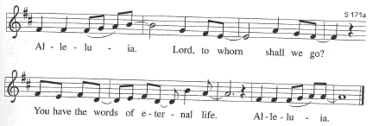
GOSPEL ACCLAMATION ELW pg. 171
GOSPEL: Matthew 13:1-9, 18-23
¹ That same day Jesus went out of the house and sat beside the sea. ² Such great crowds gathered around him that he got into a boat and sat there, while the whole crowd stood on the beach. ³ And he told them many things in parables, saying: “Listen! A sower went out to sow. ⁴ And as he sowed, some seeds fell on a path, and the birds came and ate them up. ⁵ Other seeds fell on rocky ground, where they did not have much soil, and they sprang up quickly, since they had no depth of soil. ⁶ But when the sun rose, they were scorched, and since they had no root, they withered away. ⁷ Other seeds fell among thorns, and the thorns grew up and choked them. ⁸ Other seeds fell on good soil and brought forth grain, some a hundredfold, some sixty, some thirty. ⁹ If you have ears, hear!”
¹⁸ “Hear, then, the parable of the sower. ¹⁹ When anyone hears the word of the kingdom and does not understand it, the evil one comes and snatches away what is sown in the heart; this is what was sown on the path. ²⁰ As for what was sown on rocky ground, this is the one who hears the word and immediately receives it with joy, ²¹ yet such a person has no root but endures only for a while, and when trouble or persecution arises on account of the word, that person immediately falls away. ²² As for what was sown among thorns, this is the one who hears the word, but the cares of this age and the lure of wealth choke the word, and it yields nothing. ²³ But as for what was sown on good soil, this is the one who hears the word and understands it, who indeed bears fruit and yields in one case a hundredfold, in another sixty, and in another thirty.”
The gospel of the Lord.
Praise to you, O Christ.
SERMON (blank space for thoughts, questions, and doodles)

HYMN OF THE DAY As Rain from the Clouds ELW 508

APOSTLE’S CREED

I believe in God, the Father almighty,
creator of heaven and earth.
I believe in Jesus Christ, God’s only Son, our Lord,
who was conceived by the Holy Spirit,
born of the virgin Mary,
suffered under Pontius Pilate,
was crucified, died, and was buried;
he descended to the dead.
On the third day he rose again;
he ascended into heaven,
he is seated at the right hand of the Father,
and he will come to judge the living and the dead.
I believe in the Holy Spirit,
the holy catholic church,
the communion of saints,
the forgiveness of sins,
the resurrection of the body,
and the life everlasting. Amen.
PRAYERS OF INTERCESSION
…God of grace.
Hear our prayer.
Grateful for your abundant provision and trusting in your goodness, we cast all our cares upon you, through the abundant grace of Christ Jesus.
Amen.
PEACE
The peace of Christ be with you always.
And also with you.
HOLY COMMUNION
OFFERING In addition to our normal offering, a Special Benevolence in July (collected in a special envelope) will be going to Shirley’s House of Hope.
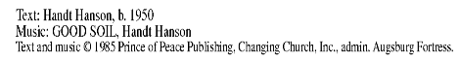
OFFERING SONG Lord Let My Heart be Good Soil ELW 512
OFFERTORY PRAYER
Loving God,
we offer at your table the gifts of our hearts.
Help us take heart in you and share freely of your love,
so that all creation can taste your abundance.
We ask this in the name of Jesus,
through the Spirit abiding with us now and forever.
Amen.
GREAT THANKSGIVING
The Lord be with you.
And also with you.
Lift up your hearts.
We lift them to the Lord.
Let us give our thanks to the Lord our God.
It is right to give our thanks and praise.
HOLY, HOLY, HOLY ELW pg. 173
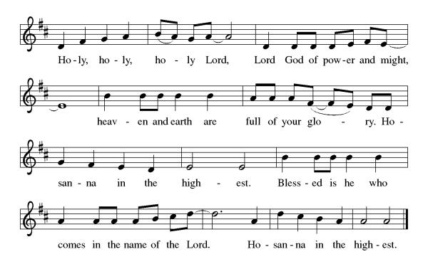
THANKSGIVING AT THE TABLE

God of our weary years, God of our silent tears,
you have brought us this far along the way.
In times of bitterness you did not abandon us,
but guided us into the path of love and light.
In every age you sent prophets
to make known your loving will for all humanity.
The cry of the poor has become your own cry;
our hunger and thirst for justice is your own desire.
In the fullness of time, you sent your chosen servant
to preach good news to the afflicted,
to break bread with the outcast and despised,
and to ransom those in bondage to prejudice and sin.
In the night in which he was betrayed,
our Lord Jesus took bread, and gave thanks;
broke it, and gave it to his disciples, saying:
Take and eat; this is my body, given for you.
Do this for the remembrance of me.
Again, after supper, he took the cup, gave thanks,
and gave it for all to drink, saying:
This cup is the new covenant in my blood,
shed for you and all people for the forgiveness of sin.
Do this for the remembrance of me.
For as often as we eat of this bread and drink from this cup we proclaim the Lord’s death until he comes.
Christ has died.
Christ is risen.
Christ will come again.
Remembering, therefore, his death and resurrection,
we await the day when Jesus shall return
to free all the earth from the bonds of slavery and death.
Come, Lord Jesus! And let the church say, Amen.
Amen.
Send your Holy Spirit, our advocate,
to fill the hearts of all who share this bread and
cup with courage and wisdom to pursue love and justice in all the world.
Come, Spirit of freedom! And let the church say, Amen.
Amen.
Join our prayers and praise with your prophets and martyrs of every age,
that, rejoicing in the hope of the resurrection,
we might live in the freedom and hope of your Son.
Through him, with him, in him, in the unity of the Holy Spirit,
all glory and honor is yours, almighty Father, now and forever.
Amen.

THE LORD’S PRAYER
Our Father, who art in heaven,
hallowed be thy name, thy kingdom come,
thy will be done, on earth as it is in heaven.
Give us this day our daily bread;
and forgive us our trespasses,
as we forgive those who trespass against us;
and lead us not into temptation, but deliver us from evil.
For thine is the kingdom,
and the power, and the glory, forever and ever. Amen.
INVITATION TO COMMUNION - Certified gluten-free crackers are in the bowl on the communion plate.
Heaven has come near.
Come, share in the feast!
HOLY COMMUNION
PRAYER AFTER COMMUNION
Compassionate God,
through the gifts of bread and wine
our hearts are filled with the abundance of your love.
Strengthen us that we, through this holy meal,
may share your love freely, as you have shared with us.
We ask this in the name of Jesus,
through the Spirit nourishing us now and forever.
Amen.
SENDING
BLESSING
Creator, Redeemer, Sustainer,
☩ one God,
bless, heal, and hold you
today and always.
Amen.
CLOSING HYMN O Holy Spirit, Enter In ELW 786
DISMISSAL
Heaven has come near. Go, share the good news!
Thanks be to God.

Coming up at GSLC
Sunday, July 12 | 9:00pm | Sunday Worship Service (Outdoor)  - Seventh Sunday after Pentecost  - Matthew 13:1-9, 18-23; The parable of the sower and the seed.
Monday, July 13 | 6:30pm | Council Meeting
Tuesday, July 14 | 7:00pm | AA Meeting
Wednesday, July 15 | 6:00pm | Pub Theology at Scotty’s: Who is My Neighbor?
Friday, July 17 | 8:00pm | Movie Night: Superman
Sunday, July 19 | 9:00am | Sunday Worship Service  - Eighth Sunday after Pentecost  - Matthew 13:24-30, 36-43; The parable of the weeds

Upcoming Worship Assistants
 | Usher | Lector | Communion | Offering Counters |  | Deep Clean
July 12 | Rob & Leslie Mader | Julie Will | Dan & Pam Mundt | Robin Beeman | Sue Schraeder | Next Deep Clean will be in September.
July  19 | Volunteer Need | Kris Tarter | Linda Schutte  Ron Rothfusz | Jon Hill | David Green | Next Deep Clean will be in September.
July 26 | Dave & Kami Weis | Leslie Mader | Jon Hill  Nancy Leonard | Nancy Leonard | Rob Mader | Next Deep Clean will be in September.
August  2 | Stuart & Chris Tipping | Katie Wernberg | Andrea Hovick  Sarah Kopitzke | Kami Weis | Bruce Tibbett | Next Deep Clean will be in September.
Pastor Katie’s Office Hours: Monday-Thursday 9am-2pm. Tuesday mornings at Uptown Coffee. Afternoons available by appointment. You are welcome to stop in any time for conversation or concerns.

Due to increasing challenges with the weather and finding volunteers for setup, we will not be having outdoor worship this summer.
There will be fellowship time after worship one Sunday a month. Please sign up on the table in the narthex.
Names on the prayer list default to 6 weeks. If you would like a name to remain on the list longer, please let Pastor Katie know.
Help Wanted
Volunteers needed to assist with music during services when Pastor Lois is absent. This would consist of pressing buttons on the keyboard for the recorded songs and playing music from the iPad. Training will be provided. Contact the church office.



Good Shepherd's Green Team would like to make you aware of another recycling opportunity in our community. See below:
Prevail Bank invites the community to a FREE E-cycling Day at our Marshfield branch. Safely dispose of obsolete electronic items, phones, and cords with a non-landfill company, that is R2v3 and NAID, AAA certified.
All data will be destroyed by First Choice at its secure facility.
What you can bring:
CRT & LCD TV / monitors
Speakers, Hard Drives, VCR / DVD Players
Printers, Laptops, Desktops
Phones, Tablets, Keyboards
Camera, Radios, Docking Stations
Cords and Cables
Not accepted are: bulbs, batteries, appliances, freon appliances, air conditioners, dehumidifiers, hazardous waste, scrap metal, and electronics from businesses.
Giving back:
Prevail Bank is a community bank that is continuously looking for ways to give back, support those pursuing dreams, and make things better in central Wisconsin.
By participating, you’re protecting yourself and the environment.
Event Details:
Location: Prevail Bank – 810 N. Central Ave., Marshfield, WI 54449
Date: Wednesday, July 22, 2026
Time: 11am - 1pm


Pub Theology is returning for the summer!
1st & 3rd Wednesday June-August
Scotty's Pizza & Chicken
6:00 pm
We are again collaborating with Wesley UMC. Topics each week include: Who is My Neighbor? (7/15), Is Ours the Only Way? (8/5), How Does it End? (8/19)
What is Pub Theology? People have been gathering in pubs and public spaces for ages talking about life, philosophy, faith, and deep questions of meaning. Increasingly, people all over are rediscovering the pub as a safe, open space where they can explore and express their own doubts and questions, learn from others, and engage people of varying religious traditions. In our increasingly fractured society, these spaces are not only welcome but needed.
Bring your questions and curiosity, and pull up a chair.

