
Good Shepherd Lutheran Church
Pastor: Rev. Katie Anderson | Music Director: Rev. Lois Swanson
Pastor’s Cell: (715) 502-9433 | Office Phone: (715) 387-2731
Pastor Email: gslcwi.pastor@gmail.com | Office Email: gslcwi.office@gmail.com
Website: GoodShepherdMarshfield.org
First Sunday of Christmas
December 28, 2025, 9:00 am

Welcome to Good Shepherd.
We’re so glad you’re here. Whether you’re seeking, curious, returning, or rooted in faith – you are welcome.
At Good Shepherd, we believe that Jesus Christ calls each one of us by name and leads us with love, grace, and truth. Just as a shepherd gathers all their sheep, we believe Christ embraces all people – no matter your race, ethnicity, sexual orientation, gender identity or expression, social status, or level of ability.
Here you will find a community shaped by compassion, guided by Scripture, and committed to building the Kingdom of God through justice and equity for all. There is room in the fold for you.
Welcome home.
ANNOUNCEMENTS
GATHERING
CALL TO WORSHIP
In worship, we hear God’s story and we ask,
“What did God do long ago?”
In worship, we hear God’s story, so we ask,
“What is God doing, here and now?”
In worship, we hear God’s story, then we ask,
“What can I do to respond to it all?”
Listen, God is speaking.
Listen, it may be time to act.
Let us worship our moving, inspiring, God with us.
Amen.

GATHERING HYMN Once in Royal David’s City ELW 269
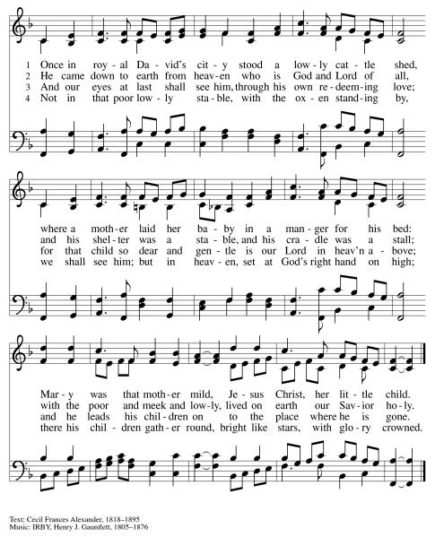
CONFESSION AND FORGIVENESS
People of God, the invitation of our faith is simple.
We are invited to do justice, to love kindness, and to walk humbly with God.
And yet, those acts have always been easier said than done.
We come to confession to speak honestly with God. We tell the truth of our lives, and in response, God offers us grace. God picks us up, shakes the dust off our weary bones, and shows us how to keep walking toward God.
We go to God in prayer, not because we have to, but because God will always meet us there.
Let us pray.
Emmanuel, God with us,
scripture tells us that you were a refugee,
but we love to forget that detail.
We love to forget every act of gun violence.
We love to forget how many people go hungry,
or how many students do not have access to good education.
We love to forget the injustices in our world that feel too big for us to face.
But you are a God who refuses to forget.
So today we pray: make it impossible for us to overlook the stories of those in need.
Make it impossible for us to sweep injustice under the rug.
Open our eyes and our hearts, so that the anger we feel at injustice
might fuel a fire for action.
With hope for a better tomorrow we pray.
Amen.
Beloved,
even when we fail to do justice,
even when we fail to love kindness,
even when we allow fear to override action, freezing us in place,
God still loves us.
So hear and believe the good news of the gospel:
On our best days and on our worst days, we belong to God.
We are invited into community. We are held in God’s grace. We are forgiven. And we are sent to serve.
Thanks be to God for a love like that.
Amen.
PRAYER OF THE DAY
There is a Latin American prayer that says:
Thank you God for the bread.
To those who have hunger, give bread.
To those who have bread, give a hunger for justice.
Thank you God for the bread.
This morning, we add a second verse to that prayer, saying:
Thank you God for the Word.
To those who seek your truth, may they hear your Word clearly.
To those who hear your Word clearly, may they speak of love fervently.
Thank you God for the Word.
Amen.
MEAL
GREAT THANKSGIVING

The Lord be with you.
And also with you.
Lift up your hearts.
We lift them to the Lord.
Let us give our thanks to the Lord our God.
It is right to give our thanks and praise.
THANKSGIVING AT THE TABLE

Holy One, the beginning and the end, the giver of life:
Blessed are you for the birth of creation.
Blessed are you in the darkness and in the light.
Blessed are you for your promise to your people.
Blessed are you in the prophets’ hopes and dreams.
Blessed are you for Mary’s openness to your will.
Blessed are you for your Son Jesus,
the Word made flesh.

In the night in which he was betrayed,
our Lord Jesus took bread, and gave thanks;
broke it, and gave it to his disciples, saying:
Take and eat; this is my body, given for you.
Do this for the remembrance of me.
Again, after supper, he took the cup, gave thanks,
and gave it for all to drink, saying:
This cup is the new covenant in my blood,
shed for you and for all people for
the forgiveness of sin.
Do this for the remembrance of me.
Let us proclaim the mystery of faith:
Christ has died.
Christ is risen.
Christ will come again.
With this bread and cup
we remember your Word dwelling among us,
full of grace and truth.
We remember our new birth in his death and resurrection.
We look with hope for his coming.
Come, Lord Jesus.

Holy God, we long for your Spirit.
Come among us.
Bless this meal.
May your Word take flesh in us.
Awaken your people.
Fill us with your light.
Bring the gift of peace on earth.
Come, Holy Spirit.
All praise and glory are yours,
Holy One of Israel,
Word of God incarnate,
Power of the Most High,
one God, now and forever.
Amen.
THE LORD’S PRAYER
Our Father, who art in heaven,
hallowed be thy name, thy kingdom come,
thy will be done, on earth as it is in heaven.
Give us this day our daily bread;
and forgive us our trespasses,
as we forgive those who trespass against us;
and lead us not into temptation, but deliver us from evil.
For thine is the kingdom,
and the power, and the glory, forever and ever. Amen.
INVITATION TO COMMUNION - Certified gluten-free crackers are in the bowl on the communion plate.
God is now in flesh appearing.
Come to the feast of joy!
HOLY COMMUNION
SCRIPTURE READING
GOSPEL: Matthew 2:1-23
¹ In the time of King Herod, after Jesus was born in Bethlehem of Judea, magi from the east came to Jerusalem, ² asking, “Where is the child who has been born king of the Jews? For we observed his star in the east and have come to pay him homage.” ³ When King Herod heard this, he was frightened, and all Jerusalem with him, ⁴ and calling together all the chief priests and scribes of the people, he inquired of them where the Messiah was to be born. ⁵ They told him, “In Bethlehem of Judea, for so it has been written by the prophet:
⁶ ‘And you, Bethlehem, in the land of Judah,
are by no means least among the rulers of Judah,
for from you shall come a ruler
who is to shepherd my people Israel.’ ”
⁷ Then Herod secretly called for the magi and learned from them the exact time when the star had appeared. ⁸ Then he sent them to Bethlehem, saying, “Go and search diligently for the child, and when you have found him, bring me word so that I may also go and pay him homage.” ⁹ When they had heard the king, they set out, and there, ahead of them, went the star that they had seen in the east, until it stopped over the place where the child was. ¹⁰ When they saw that the star had stopped, they were overwhelmed with joy. ¹¹ On entering the house, they saw the child with Mary his mother, and they knelt down and paid him homage. Then, opening their treasure chests, they offered him gifts of gold, frankincense, and myrrh. ¹² And having been warned in a dream not to return to Herod, they left for their own country by another road.
¹³ Now after they had left, an angel of the Lord appeared to Joseph in a dream and said, “Get up, take the child and his mother, and flee to Egypt, and remain there until I tell you, for Herod is about to search for the child, to destroy him.” ¹⁴ Then Joseph got up, took the child and his mother by night, and went to Egypt ¹⁵ and remained there until the death of Herod. This was to fulfill what had been spoken by the Lord through the prophet, “Out of Egypt I have called my son.”
¹⁶ When Herod saw that he had been tricked by the magi, he was infuriated, and he sent and killed all the children in and around Bethlehem who were two years old or under, according to the time that he had learned from the magi. ¹⁷ Then what had been spoken through the prophet Jeremiah was fulfilled:
¹⁸ “A voice was heard in Ramah,
wailing and loud lamentation,
Rachel weeping for her children;
she refused to be consoled, because they are no more.”
¹⁹ When Herod died, an angel of the Lord suddenly appeared in a dream to Joseph in Egypt and said, ²⁰ “Get up, take the child and his mother, and go to the land of Israel, for those who were seeking the child’s life are dead.” ²¹ Then Joseph got up, took the child and his mother, and went to the land of Israel. ²² But when he heard that Archelaus was ruling Judea in place of his father Herod, he was afraid to go there. And after being warned in a dream, he went away to the district of Galilee. ²³ There he made his home in a town called Nazareth, so that what had been spoken through the prophets might be fulfilled, “He will be called a Nazarene.”
BREAKFAST AND TABLE DISCUSSION
RESPOND WITH JUSTICE

HYMN OF THE DAY Let Streams of Living Justice ELW 710
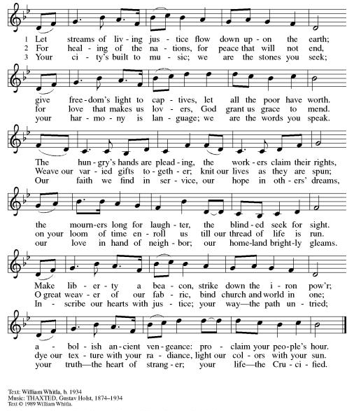
AFFIRMATION OF FAITH
We have seen the valley.
We have seen a sky without stars.
We have seen the longest night,
and still we believe.
We believe in God with us.
We believe in the hope of tomorrow.
We believe that good news is louder than fear.
We believe this good news is for all people.
So even when our knees shake,
even when our voice trembles,
even when fear is all around us,
we will hold onto that good news.

We will reach for each other.
We will look for God in our midst.
We will sing songs of joy.
We will proclaim:
Unto us, love is born.
We have seen the longest night,
and we have seen unimaginable love.
So still, we believe. Amen.
GATHER GIFTS OF JUSTICE
PRAYERS OF THE PEOPLE
Holy and loving God,
you are the one who paints the sky with stars each night.
You are the one who stirs our souls awake and invites us to dream.
You are the one who was born in a manger, and you are the one who meets us now.
So with gratitude and humility, we bring you our prayers.
Loving God, we have so much to be grateful for in this season. As we move toward the end of the year, we look back on the last 12 months with gratitude for every joyful memory.
Thank you for the winter snows and the summer sun.
Thank you for the moments of laughter and the moments of growth.
Thank you for the magic of Christmas and the joys of life in community.
At this time, we name our prayers of gratitude aloud or in the silence of our hearts.
Holy God, thank you for every beautiful and lovely thing.
However, in addition to our gratitude, God, we also look back over these last 12 months with painful
awareness that life on Earth is far from perfect.
God, we worry for those who are hungry.
We worry for those who have been told all their life that there is no room in the inn for them.
We worry for those who feel alone, and for those trapped in layers of grief.
At this time, we name our prayers of concern aloud or in the silence of our hearts.
Emmanuel, when we look back over the last 12 months, it is clear that there has been abundant beauty and abundant suffering. Where there is injustice—where there is violence and suffering, bigotry and hatred—fuel a fire in us.
Show us how to care for our immigrant neighbors, our hungry neighbors, our Republican and Democrat neighbors, our male, female, and nonbinary neighbors.
Show us how to love as you loved.
Show us how to make this next year a little more beautiful and a lot more loving than the last.
As you do, we ask that you pour out your Spirit on this offering of diapers and baby
wipes. May the individuals and families receiving these items feel your love through these small
gifts. May this act of service bind us all more closely to our neighbors. May your protection safeguard
everyone who is in harm’s way.
With hope for tomorrow and the determination to make this world a safer place for us all, we pray.
Amen.

SENDING
BENEDICTION
In a fearful world,
may you look for God’s spirit.
May you reach for each other’s hands.
May you choose courage whenever you can.
And in all things, may you remember that good news is louder than fear.
In the name of the one who calls,
the one who sends,
and the one who journeys with—
go in peace and be not afraid.
Amen.
CLOSING HYMN In the Bleak Midwinter ELW 294
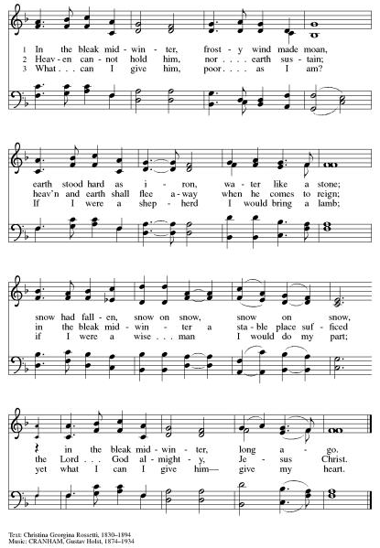
DISMISSAL
Go in peace. Keep awake.
Thanks be to God.

Upcoming Worship Assistants
 | Usher | Lector | Communion | Offering Counters |  | Deep Clean
December 28 | Charles & Mary Schlafke | Leslie Mader  Jon Hill  Jane Wagner | Andrea Hovick | Rob Mader | David Schneider | Next Deep Clean will be in March
January 4 | Dennis & Deb Janz | Shelly Schneider | Andrea Hovick  Sarah Kopitzke | Jon Hill | David Green | Next Deep Clean will be in March
January 11 | Andrea Hovick | Tammy Neumann | Dave & Sue Schraeder | Nancy Leonard | Rob Mader | Next Deep Clean will be in March
January 18 | Ed & Ruth Raatz | Nancy Tibbett | Matt & Margo Berrier | Kami Weis | Bruce Tibbett | Next Deep Clean will be in March
Coming up at GSLC
Sunday, December 28 | 9:00am | Sunday Worship Service  - First Sunday of Christmas  - Matthew 2:1-23; The slaughter of innocent children
Tuesday, December 30 | 7:00pm | AA Meeting
Thursday, January 1 | Closed | Church Office Closed for New Year’s Day
Sunday, January 4 | 9:00am | Sunday Worship Service – Sunday School  - Second Sunday of Christmas  - John 1:[1-9] 10-18; God with us; the incarnation of the Word
Pastor Katie’s Office Hours: Monday-Thursday 9am-2pm. Tuesday mornings at Uptown Coffee. Afternoons available by appointment. You are welcome to stop in any time for conversation or concerns.

Names on the prayer list default to 6 weeks. If you would like a name to remain on the list longer, please let Pastor Katie know.
There will be fellowship time after worship one Sunday a month. Please sign up on the table in the narthex.

Good Shepherd's Green Team is excited to announce our first Winter Book Club! Our first book title is "All We Can Save" with discussion on Monday January 26 and Monday February 23. The second book is "How to Give Up Plastic" with discussions on Monday March 30 and Monday April 27. All at 7 pm in the fireplace room. The Marshfield library has access to obtain up to 15 copies of each book (if they are available). Please join us on one date or all four. We are excited for winter fellowship and good discussion on important topics. The second book will coincide with Earth Day 2026 on April 22. The theme is Our Power, Our Planet, with one of the focuses on Planet versus Plastics. All are welcome! Bring a friend!
2026 offering envelopes are ready to be picked up. They are on the counter in the narthex.

Help Wanted
Volunteers needed to assist with streaming Sunday worship. Training and written instructions provided.


