
Good Shepherd Lutheran Church
Pastor: Rev. Katie Anderson | Music Director: Rev. Lois Swanson
Pastor’s Cell: (715) 245-1943 | Office Phone: (715) 387-2731
Pastor Email: gslcwi.pastor@gmail.com | Office Email: gslcwi.office@gmail.com
Website: GoodShepherdMarshfield.org
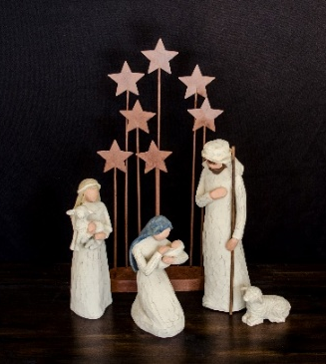
Christmas Eve
December 24, 2025, 4:00 pm / 7:00 pm
Welcome to Good Shepherd.
We’re so glad you’re here. Whether you’re seeking, curious, returning, or rooted in faith – you are welcome.
At Good Shepherd, we believe that Jesus Christ calls each one of us by name and leads us with love, grace, and truth. Just as a shepherd gathers all their sheep, we believe Christ embraces all people – no matter your race, ethnicity, sexual orientation, gender identity or expression, social status, or level of ability.
Here you will find a community shaped by compassion, guided by Scripture, and committed to building the Kingdom of God through justice and equity for all. There is room in the fold for you.
Welcome home.
ANNOUNCEMENTS
GATHERING
GATHERING SONG O Come, All Ye Faithfull ELW 283
CONFESSION AND FORGIVENESS
Blessed be the holy Trinity, ☩ one God,
Wonderful Counselor,
Mighty Savior,
Prince of Peace.
Amen.
Trusting in God’s steadfast love and faithfulness,
let us confess our sin.
Silence is kept for reflection.
Reconciling God,
we yearn for your presence to transform
our grief, pain, and despair.
We confess that we have not always prepared

room in our hearts for your love;
we have not always recognized
your presence among us;
we have not always embraced your message of peace.
We cry out, weary with the burden of violence,
oppression, and fear.
We confess our failure to make room
for those seeking refuge;
our participation in violent systems
that harm your innocent ones;
our reluctance to embody your good news.
Be born in us today
and teach us to sing the joyful song of your salvation.
Amen.
God’s grace upon grace flows over you.
☩ Christ’s presence redeems the whole creation.
Your sins are forgiven. Let the earth rejoice and be glad!
Amen.

PRAYER OF THE DAY
Almighty God, you made this holy night shine with the brightness of the true Light. Grant that here on earth we may walk in the light of Jesus’ presence and in the last day wake to the brightness of his glory; through your Son, Jesus Christ our Lord, who lives and reigns with you and the Holy Spirit, one God, now and forever.
Amen.
CHILDREN’S MUSIC Away in a Manger ELW 277
CHILDREN’S MESSAGE
SCRIPTURE READINGS
FIRST READING: Isaiah 9:2-7
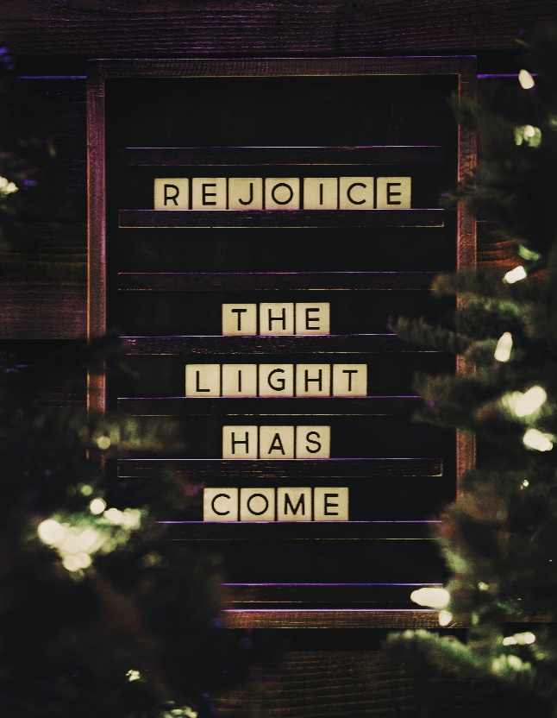
²The people who walked in darkness
have seen a great light;
those who lived in a land of deep darkness—
on them light has shined.
³You have multiplied the nation,
you have increased its joy;
they rejoice before you
as with joy at the harvest,
as people exult when dividing plunder.
⁴For the yoke of their burden,
and the bar across their shoulders,
the rod of their oppressor,
you have broken as on the day of Midian.
⁵For all the boots of the tramping warriors
and all the garments rolled in blood
shall be burned as fuel for the fire.
⁶For a child has been born for us,
a son given to us;
authority rests upon his shoulders;
and he is named
Wonderful Counselor, Mighty God,
Everlasting Father, Prince of Peace.
⁷Great will be his authority,
and there shall be endless peace
for the throne of David and his kingdom.
He will establish and uphold it
with justice and with righteousness
from this time onward and forevermore.
The zeal of the Lord of hosts will do this.
Word of God, word of life.
Thanks be to God.
PSALM: Psalm 96
¹Sing to the Lord a new song;
sing to the Lord, all the earth.
²Sing to the Lord, bless the name of the Lord;
proclaim God’s salvation from day to day.
³Declare God’s glory among the nations
and God’s wonders among all peoples.
⁴For great is the Lord and greatly to be praised,
more to be feared than all gods.
⁵As for all the gods of the nations, they are but idols;
but you, O Lord, have made the heavens.
⁶Majesty and magnificence are in your presence;
power and splendor are in your sanctuary.
⁷Ascribe to the Lord, you families of the peoples,
ascribe to the Lord honor and power.
⁸Ascribe to the Lord the honor due the holy name;
bring offerings and enter the courts | of the Lord.
⁹Worship the Lord in the beauty of holiness;
tremble before the Lord, all the earth.
¹⁰Tell it out among the nations: “The Lord is king!
The one who made the world so firm that it cannot be moved will judge the peoples with equity.”
¹¹Let the heavens rejoice, and let the earth be glad;
let the sea thunder and all that is in it; let the field be joyful and all that is therein.
¹²Then shall all the trees of the wood shout for joy at your coming, O Lord,
for you come to judge the earth.
¹³You will judge the world with righteousness
and the peoples with your truth.
SECOND READING: Titus 2:11-14
¹¹The grace of God has appeared, bringing salvation to all, ¹²training us to renounce impiety and worldly passions, and in the present age to live lives that are self-controlled, upright, and godly, ¹³while we wait for the blessed hope and the manifestation of the glory of our great God and Savior, Jesus Christ. ¹⁴He it is who gave himself for us that he might redeem us from all iniquity and purify for himself a people of his own who are zealous for good deeds.
Word of God, word of life.
Thanks be to God.
GOSPEL HYMN O Little Town of Bethlehem ELW 279
CHRISTMAS GOSPEL: Luke 2:1-14 [15-20]
¹ In those days a decree went out from Caesar Augustus that all the world should be registered. ² This was the first registration and was taken while Quirinius was governor of Syria. ³ All went to their own towns to be registered. ⁴ Joseph also went from the town of Nazareth in Galilee to Judea, to the city of David called Bethlehem, because he was descended from the house and family of David. ⁵ He went to be registered with Mary, to whom he was engaged and who was expecting a child. ⁶ While they were there, the time came for her to deliver her child. ⁷ And she gave birth to her firstborn son and wrapped him in bands of cloth and laid him in a manger, because there was no place in the guest room.
⁸ Now in that same region there were shepherds living in the fields, keeping watch over their flock by night. ⁹ Then an angel of the Lord stood before them, and the glory of the Lord shone around them, and they were terrified. ¹⁰ But the angel said to them, “Do not be afraid, for see, I am bringing you good news of great joy for all the people: ¹¹ to you is born this day in the city of David a Savior, who is the Messiah, the Lord. ¹² This will be a sign for you: you will find a child wrapped in bands of cloth and lying in a manger.” ¹³ And suddenly there was with the angel a multitude of the heavenly host, praising God and saying,
¹⁴ “Glory to God in the highest heaven,
and on earth peace among those whom he favors!”
[¹⁵ When the angels had left them and gone into heaven, the shepherds said to one another, “Let us go now to Bethlehem and see this thing that has taken place, which the Lord has made known to us.” ¹⁶ So they went with haste and found Mary and Joseph and the child lying in the manger. ¹⁷ When they saw this, they made known what had been told them about this child, ¹⁸ and all who heard it were amazed at what the shepherds told them, ¹⁹ and Mary treasured all these words and pondered them in her heart. ²⁰ The shepherds returned, glorifying and praising God for all they had heard and seen, just as it had been told them.]
The gospel of the Lord.
Praise to you, O Christ.
SERMON

NICENE CREED
We believe in one God,

the Father, the Almighty,
maker of heaven and earth,
of all that is, seen and unseen.
We believe in one Lord, Jesus Christ,
the only Son of God,
eternally begotten of the Father,
God from God, Light from Light,
true God from true God,
begotten, not made,
of one Being with the Father;
through him all things were made.
For us and for our salvation
he came down from heaven,
was incarnate of the Holy Spirit and the virgin Mary
and became truly human.
For our sake he was crucified under Pontius Pilate;
he suffered death and was buried.
On the third day he rose again
in accordance with the scriptures;
he ascended into heaven
and is seated at the right hand of the Father.
He will come again in glory to judge the living and the dead,
and his kingdom will have no end.
We believe in the Holy Spirit, the Lord, the giver of life,
who proceeds from the Father and the Son,
who with the Father and the Son is worshiped and glorified,
who has spoken through the prophets.
We believe in one holy catholic and apostolic church.
We acknowledge one baptism for the forgiveness of sins.
We look for the resurrection of the dead,
and the life of the world to come. Amen.
PRAYERS OF INTERCESSION
…Hear us, O God.
Your mercy is great.
With the joy of Christ’s birth in our hearts, we commend our prayers to you, O God, trusting in your boundless mercy and eternal love; through Jesus Christ our Savior.
Amen.
PEACE
The peace of Christ be with you always.
And also with you.
HOLY COMMUNION
OFFERING In addition to our normal offering, a Special Benevolence in December (collected in a special
envelope) will be the Hannah Center. This is being done in conjunction with the Sunday School.
OFFERING SONG Hark! The Herald Angels Sing ELW 270
OFFERTORY PRAYER
God of glory,
great are your wonders among us
and many are the blessings you bestow.
Use us and these your gifts for the needs of the world,
that all the ends of the earth may rejoice in your saving grace,
through Christ our Savior.
Amen.

GREAT THANKSGIVING
The Lord be with you.
And also with you.
Lift up your hearts.
We lift them to the Lord.
Let us give our thanks to the Lord our God.
It is right to give our thanks and praise.
COMMUNION SONG All Is Ready Now
1 Quietly into the stable where the Savior sleeping lies,
we can go, for all are welcome: shepherd, angel, poor, and wise.
What we have we bring and offer earthly gifts for Child divine,
giving that which we were given, fruits of harvest, bread and wine.
2 ‘Cross the threshold of creation, Jesus comes to dwell with us,
as he was in the beginning ever more God’s gift of love.
Now he calls us to the table, gift of love to bleed and die:
manger here becomes an altar stable Lamb is sacrificed.
3 Now enthroned as king of heaven blazing glory like the sun:  In his hands are pow’r and justice, on his lips are peace and love.  As our gifts are turned to ashes, falling down in awe we bow,  empty handed we adore him. “Come for all is ready now.” | Text & Music: 1999 Jay Beech
THANKSGIVING AT THE TABLE

Holy One, the beginning and the end, the giver of life:
Blessed are you for the birth of creation.
Blessed are you in the darkness and in the light.
Blessed are you for your promise to your people.
Blessed are you in the prophets’ hopes and dreams.
Blessed are you for Mary’s openness to your will.
Blessed are you for your Son Jesus,
the Word made flesh.
In the night in which he was betrayed,
our Lord Jesus took bread, and gave thanks;
broke it, and gave it to his disciples, saying:
Take and eat; this is my body, given for you.
Do this for the remembrance of me.
Again, after supper, he took the cup, gave thanks,
and gave it for all to drink, saying:
This cup is the new covenant in my blood,
shed for you and for all people for the forgiveness of sin.
Do this for the remembrance of me.
Let us proclaim the mystery of faith:
Christ has died.
Christ is risen.
Christ will come again.
With this bread and cup
we remember your Word dwelling among us,
full of grace and truth.
We remember our new birth in his death and resurrection.
We look with hope for his coming.
Come, Lord Jesus.
Holy God, we long for your Spirit.
Come among us.
Bless this meal.
May your Word take flesh in us.
Awaken your people.
Fill us with your light.
Bring the gift of peace on earth.
Come, Holy Spirit.
All praise and glory are yours,
Holy One of Israel,
Word of God incarnate,
Power of the Most High,
one God, now and forever.
Amen.

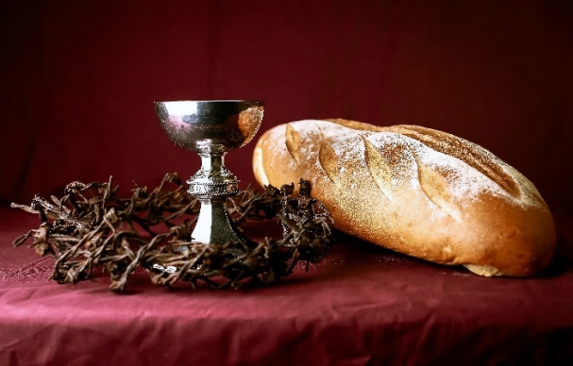
THE LORD’S PRAYER
Our Father, who art in heaven,
hallowed be thy name,
thy kingdom come,
thy will be done,
on earth as it is in heaven.
Give us this day our daily bread;
and forgive us our trespasses,
as we forgive those
who trespass against us;
and lead us not into temptation,
but deliver us from evil.
For thine is the kingdom,
and the power, and the glory,
forever and ever. Amen.
INVITATION TO COMMUNION - Certified gluten-free crackers are in the bowl on the communion plate.
God is now in flesh appearing.
Come to the feast of joy!

HOLY COMMUNION
As you return from communion, please pick up a candle from
the front pew.
We will light the candles
and sing “Silent Night” after
the Communion Prayer.
PRAYER AFTER COMMUNION
Incarnate God, you are among us at this table.
May we treasure this gift and ponder in our hearts
the mystery of your presence.
Move us to discover the wonders of your love
in the everyday moments of our lives,
through Christ born in us.
Amen.
SONG Silent Night ELW 281
1 Silent night, holy night!  All is calm, all is bright  round yon virgin mother and child.  Holy Infant, so tender and mild,  sleep in heavenly peace,  sleep in heavenly peace. | 3 Silent night, holy night!  Son of God, love's pure light  radiant beams from your holy face,  with the dawn of redeeming grace,  Jesus, Lord, at your birth,  Jesus, Lord, at your birth.
2 Silent night, holy night!  Shepherds quake at the sight;  glories stream from heaven afar,  heav'nly hosts sing, alleluia!  Christ, the Savior, is born!  Christ, the Savior, is born! | 
SENDING
BLESSING
The triune God,
glorious Mystery,
holy Incarnate One,
abiding Comforter,
☩ bless you with endless grace, peace, and joy.
Amen.
SONG Joy to the World ELW 267
DISMISSAL
Glory to God in the highest!
And peace to God’s people on earth!
Go in joy. Embody God’s redeeming grace.
Thanks be to God.

Donations of Poinsettias that
Beautify the Altar for Christmas

Margo & Matt Berrier
In Memory of Elizabeth Fuscone, Luke Dernovsek, Joe Berrier

Richard & Sarah Kopitzke
In Memory of Wayne Germain

Rob & Leslie Mader
In Memory of our Grandparents

Dan & Pam Mundt
In Memory of Christopher Mundt

Jim & Sharon Schiszik
In Honor of Corey Griepentrog
In Memory of Parents Earl and Iris Schiszik, Erwin and Maybell Kollmansberger
In Memory of Son Corey Griepentrog, Sister Kimberly Tater, Brother Dennis Kollhmansberger

Chuck & Mary Schlafke
In Memory of Family Members Lost


Dave & Shelly Schneider
In Memory of Art Feldman, Phyllis and Les Schneider
In Celebration of Roahn Schneider’s First Christmas


Dave & Sue Schraeder
In celebration of Our Family

Lois Swanson, Norlyn & Matthew Freese
In Memory of Wallace and Agnes Swanson, Jim and Maxine Freese

