
Good Shepherd Lutheran Church
Pastor: Rev. Katie Anderson | Music Director: Rev. Lois Swanson
Pastor’s Cell: (715) 502-9433 | Office Phone: (715) 387-2731
Pastor Email: gslcwi.pastor@gmail.com | Office Email: gslcwi.office@gmail.com
Website: GoodShepherdMarshfield.org
Third Sunday of Advent
December 14, 2025, 9:00 am

Welcome to Good Shepherd.
We’re so glad you’re here. Whether you’re seeking, curious, returning, or rooted in faith – you are welcome.
At Good Shepherd, we believe that Jesus Christ calls each one of us by name and leads us with love, grace, and truth. Just as a shepherd gathers all their sheep, we believe Christ embraces all people – no matter your race, ethnicity, sexual orientation, gender identity or expression, social status, or level of ability.
Here you will find a community shaped by compassion, guided by Scripture, and committed to building the Kingdom of God through justice and equity for all. There is room in the fold for you.
Welcome home.
ANNOUNCEMENTS
GATHERING
CALL TO WORSHIP
Jeremiah said, “I am only a boy.”
Moses said, “Who am I to do this work?”
Mary said, “How can this be?”
We often say, “But God, I am afraid.”
Even when we are afraid, God invites us closer.
So may we trust the Inviter.
May we heed God’s invitation.
May we summon our courage and sing God’s praise.
Let us worship our courageous, inviting, calling God. Amen!
CANDLE LIGHTING
In a world full of fear, where do you see
glimmers of joy?
We see glimmers of joy in birthday
candles and homemade cards. We see joy
in the laughter of children and the delight
of grandparents. We see joy in meals
around the table and in the singing of
Christmas songs.
Yes, even in a fearful world, joy
is all around us.
Today we light the candle of joy as a
reminder of this good news. May this
flicker of light help us remember that
even in a fearful world, joy is here. Joy is
real. We only have to look for it.
Thanks be to God for that good news!
Amen.
GATHERING HYMN Prepare the Royal Highway ELW 264

CONFESSION AND FORGIVENESS
Courageous God,
you invite us to live into our call.
You invite us to act, to serve, and to trust.
Instead of responding with a resounding “yes,”
we often hide our face.
We dig our heels in.
We look for someone else to volunteer.
Spark courage in us.
Remind us that every person is capable of making a difference.
Remind us that even when we’re scared, we are not alone.
You invite us forward.
With baby steps we hope,
we pray,
Amen.
People of God,
no matter where your path has led you in the past, today is a new day. So join me in declaring this good news:
We are known. We are forgiven! We are sent to serve.
May we step forward in faith, always moving closer to God’s call.
Amen.
KYRIE ELW pg. 184
PRAYER OF THE DAY
Holy One, the story of this season is not a new one. We’ve heard this tale before. We’ve seen the nativities, watched the plays, sung the songs, witnessed children act it out. The story of this season is not a new one, and yet we long to hear it as if it is. So spark our spirits awake. Call forth awareness, attention, and reverence in us. Allow us to hear this ancient tale with brand new ears. With hope we pray. Amen.
CHILDREN’S MUSIC We Are Waiting for Jesus ACS 905
CHILDREN’S MESSAGE
SCRIPTURE READINGS
FIRST READING: Jeremiah 1:4-10
⁴ Now the word of the Lord came to me saying,
⁵ “Before I formed you in the womb I knew you,
and before you were born I consecrated you;
I appointed you a prophet to the nations.”
⁶ Then I said, “Ah, Lord God! Truly I do not know how to speak, for I am only a boy.” ⁷ But the Lord said to me,
“Do not say, ‘I am only a boy,’
for you shall go to all to whom I send you,
and you shall speak whatever I command you.
⁸ Do not be afraid of them,
for I am with you to deliver you,
says the Lord.”
⁹ Then the Lord put out his hand and touched my mouth, and the Lord said to me,
“Now I have put my words in your mouth.
¹⁰ See, today I appoint you over nations and over kingdoms,
to pluck up and to pull down,
to destroy and to overthrow,
to build and to plant.”
Word of God, word of life.
Thanks be to God.
PSALM: Psalm 146:5-10
⁵ Happy are they who have the God of Jacob for their help,
whose hope is in the Lord their God;
⁶ who made heaven and earth, the seas, and all that is in them;
who keeps promises forever;
⁷ who gives justice to those who are oppressed, and food to those who hunger.
The Lord sets the captive free.
⁸ The Lord opens the eyes of the blind; the Lord lifts up those who are bowed down;
the Lord loves the righteous.
⁹ The Lord cares for the stranger;
the Lord sustains the orphan and widow, but frustrates the way of the wicked.
¹⁰ The Lord shall reign forever,
your God, O Zion, throughout all generations. Hallelujah!
SECOND READING: James 5:7-10
⁷ Be patient, therefore, brothers and sisters, until the coming of the Lord. The farmer waits for the precious crop from the earth, being patient with it until it receives the early and the late rains. ⁸ You also must be patient. Strengthen your hearts, for the coming of the Lord is near. ⁹ Brothers and sisters, do not grumble against one another, so that you may not be judged. See, the Judge is standing at the doors! ¹⁰ As an example of suffering and patience, brothers and sisters, take the prophets who spoke in the name of the Lord.
Word of God, word of life.
Thanks be to God.
GOSPEL ACCLAMATION ELW pg. 188
GOSPEL: Luke 1:26-39
²⁶ In the sixth month the angel Gabriel was sent by God to a town in Galilee called Nazareth, ²⁷ to a virgin engaged to a man whose name was Joseph, of the house of David. The virgin’s name was Mary. ²⁸ And he came to her and said, “Greetings, favored one! The Lord is with you.” ²⁹ But she was much perplexed by his words and pondered what sort of greeting this might be. ³⁰ The angel said to her, “Do not be afraid, Mary, for you have found favor with God. ³¹ And now, you will conceive in your womb and bear a son, and you will name him Jesus. ³² He will be great and will be called the Son of the Most High, and the Lord God will give to him the throne of his ancestor David. ³³ He will reign over the house of Jacob forever, and of his kingdom there will be no end.” ³⁴ Mary said to the angel, “How can this be, since I am a virgin?” ³⁵ The angel said to her, “The Holy Spirit will come upon you, and the power of the Most High will overshadow you; therefore the child to be born will be holy; he will be called Son of God. ³⁶ And now, your relative Elizabeth in her old age has also conceived a son, and this is the sixth month for her who was said to be barren. ³⁷ For nothing will be impossible with God.” ³⁸ Then Mary said, “Here am I, the servant of the Lord; let it be with me according to your word.” Then the angel departed from her.
³⁹ In those days Mary set out and went with haste to a Judean town in the hill country.
The gospel of the Lord.
Praise to you, O Christ.
SERMON
HYMN OF THE DAY My Soul Proclaims Your Greatness ELW 251
AFFIRMATION OF FAITH
We have seen the valley.
We have seen a sky without stars.
We have seen the longest night,
and still we believe.
We believe in God with us.
We believe in the hope of tomorrow.
We believe that good news is louder than fear.
We believe this good news is for all people.
So even when our knees shake,
even when our voice trembles,
even when fear is all around us,
we will hold onto that good news.
We will reach for each other.
We will look for God in our midst.
We will sing songs of joy.
We will proclaim:
Unto us, love is born.
We have seen the longest night,
and we have seen unimaginable love.
So still, we believe.
Amen.
PRAYERS OF INTERCESSION
…God of grace,
Hear our prayer.
Draw near to us, O God, as we commend all for whom we pray, trusting in your mercy through Jesus Christ, Emmanuel.
Amen.
PEACE
The peace of Christ be with you always.
And also with you.
HOLY COMMUNION
OFFERING In addition to our normal offering, a Special Benevolence in December (collected in a special envelope) will be going to Hannah Center.
OFFERING SONG He Came Down ELW 253

OFFERTORY PRAYER
Nourishing God,
you are water in the wilderness and streams in the desert.
Through this meal, satisfy our parched places,
that we may rejoice and be for the world signs of your kingdom come.
Amen.

GREAT THANKSGIVING
The Lord be with you.
And also with you.
Lift up your hearts.
We lift them to the Lord.
Let us give our thanks to the Lord our God.
It is right to give our thanks and praise.
HOLY, HOLY, HOLY ELW pg. 190
THANKSGIVING AT THE TABLE

Holy One, the beginning and the end, the giver of life:
Blessed are you for the birth of creation.
Blessed are you in the darkness and in the light.
Blessed are you for your promise to your people.
Blessed are you in the prophets’ hopes and dreams.
Blessed are you for Mary’s openness to your will.
Blessed are you for your Son Jesus,
the Word made flesh.
In the night in which he was betrayed,
our Lord Jesus took bread, and gave thanks;
broke it, and gave it to his disciples, saying:
Take and eat; this is my body, given for you.
Do this for the remembrance of me.
Again, after supper, he took the cup, gave thanks,
and gave it for all to drink, saying:
This cup is the new covenant in my blood,
shed for you and for all people for
the forgiveness of sin.
Do this for the remembrance of me.

Let us proclaim the mystery of faith:
Christ has died.
Christ is risen.
Christ will come again.
With this bread and cup
we remember your Word dwelling among us,
full of grace and truth.
We remember our new birth in his death and resurrection.
We look with hope for his coming.
Come, Lord Jesus.
Holy God, we long for your Spirit.
Come among us.
Bless this meal.
May your Word take flesh in us.
Awaken your people.
Fill us with your light.
Bring the gift of peace on earth.
Come, Holy Spirit.
All praise and glory are yours,
Holy One of Israel,
Word of God incarnate,
Power of the Most High,
one God, now and forever.
Amen.

THE LORD’S PRAYER
Our Father, who art in heaven,
hallowed be thy name, thy kingdom come,
thy will be done, on earth as it is in heaven.
Give us this day our daily bread;
and forgive us our trespasses,
as we forgive those who trespass against us;
and lead us not into temptation, but deliver us from evil.
For thine is the kingdom,
and the power, and the glory, forever and ever. Amen.

INVITATION TO COMMUNION - Certified gluten-free crackers are in the bowl on the communion plate.
Here is life. God is with us.
Come, receive what God has promised.
HOLY COMMUNION

PRAYER AFTER COMMUNION
Loving God,
In a world racked with fear,
you gather us together.
You set the table.
You meet us here.
You nourish our bodies
as you nourish our spirits.
You remind us that this is a joyful feast,
and that fear cannot win every time.
So with renewed courage,
with renewed hope,
with renewed conviction,
send us out into the world.
Help us to feed others as you have fed us.
With gratitude we pray,
Amen.
SENDING
BENEDICTION
In a fearful world,

may you look for God’s spirit.
May you reach for each other’s hands.
May you choose courage whenever you can.
And in all things, may you remember
that good news is louder than fear.
In the name of the one who calls,
the one who sends,
and the one who journeys with—
go in peace and
be not afraid.
Amen.
CLOSING HYMN Light Shone in Darkness ELW 307
DISMISSAL
Go in peace. Keep awake.
Thanks be to God.

Upcoming Worship Assistants
 | Usher | Lector | Communion | Offering Counters |  | Deep Clean
December 14 | Tammy Neumann | Laurel Peterson | Bruce & Nancy Tibbett | Dan Mundt | Bob Peterson | December:  Chris Tipping  Julie Will  Andrea Hovick  Deb Janz
December 21 | Bruce & Nancy Tibbett | Richard Kopitzke | Dave & Sue Schraeder | Nancy Leonard | Rob Mader
December 24 | Volunteer | Volunteer | Volunteer | ---- | ----
December 28 | Volunteer | Volunteer | Volunteer | Robin Beeman | David Schneider
Coming up at GSLC
Sunday, December 14 | 9:00am | Sunday Worship Service  - Third Sunday of Advent  - Luke 1:26-36
Tuesday, December 16 | 2:00pm | Chapel at Three Oaks
 | 7:00pm | AA Meeting
Wednesday, December 17 | 12:00pm | Bible Study (discuss Season 5 Episode 8 of “The Chosen”)
Wednesday, December 17 | 7:00pm | Mid-Week Worship  Confirmation Class
Sunday, December 21 | 9:00am | Sunday Worship Service – Sunday School  - Fourth Sunday of Advent  - Matthew 1:18-25
Pastor Katie’s Office Hours: Monday-Thursday 9am-2pm. Tuesday mornings at Uptown Coffee. Afternoons available by appointment. You are welcome to stop in any time for conversation or concerns.

There will be fellowship time after worship one Sunday a month. Please sign up on the table in the narthex.
Names on the prayer list default to 6 weeks. If you would like a name to remain on the list longer, please let Pastor Katie know.

Poinsettias have been purchased, and you may give a donation to help defray the cost to Altar Care. Forms are available on the table in the narthex. Your check & form need to be returned to the church office by December 14th. Designate your donation “Poinsettia”.



There will be a Fellowship craft project after Sunday Worship today.
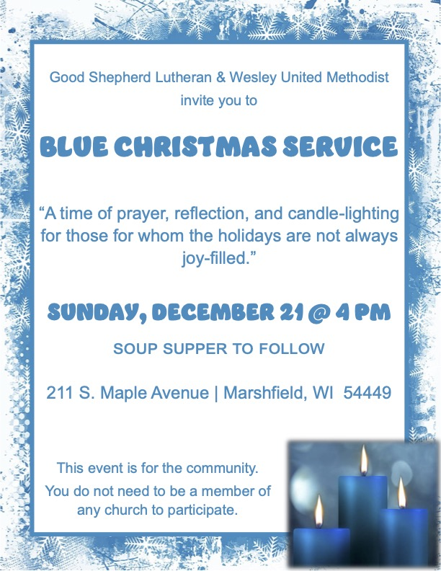
2026 offering envelopes are ready to be picked up. They are on the counter in the narthex.

Help Wanted
Volunteers needed to assist with streaming Sunday worship. Training and written instructions provided.


Bible Study is returning!
We will have an 8 week Bible study discussing Season 5 of The Chosen. Bible study begins Wednesday, October 8th at 12:00 pm. The series is available for free at The Chosen's website or in The Chosen app.

On Sunday, December 28th, we will be having a less formal, breakfast church service. If you are willing to provide any items for the meal, please sign up on the table in the narthex.

We are seeking worship volunteers for Christmas Eve (4pm and 7pm), and Sunday, December 28th. If you are available and willing to serve as usher, reader, or communion assistant at any of these services, please sign up on the table in the narthex, or contact the church office.

The movie theater has an early screening of the movie David today at 12:00, 2:30, 5:00, and 7:30. The church will cover the cost of the movie for youth confirmation age and under, and half the ticket cost for adults in the family who go with them. Simply bring your ticket stubs into church to get a reimbursement.

