
Good Shepherd Lutheran Church
Pastor: Rev. Katie Anderson | Music Director: Rev. Lois Swanson
Pastor’s Cell: (715) 502-9433 | Office Phone: (715) 387-2731
Pastor Email: gslcwi.pastor@gmail.com | Office Email: gslcwi.office@gmail.com
Website: GoodShepherdMarshfield.org
12th Sunday after Pentecost
August 31 2025, 9:00 am
Introduction to the day…
ANNOUNCEMENTS
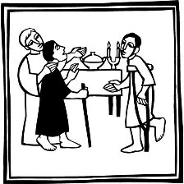
GATHERING
Invited and inviting—that is the nature of the church. By God’s grace in holy baptism we have a place at Christ’s banquet table. When, by the power of that same Spirit, humility and mutual love continue among us, the church can be more inviting still.

GATHERING HYMN All Are Welcome
All are welcome friend and stranger.  At the banquet of the Savior.  All are welcome  All are welcome here. | 2. From the ones who feel forgotten  Those who sense their place is gone  To the ones who live in hunger  Here you belong.
1. From the woman who comes crying  Leaving tears at Jesus’ feet  To the man who knows the right way  But cannot see. | 3. Go into the streets and cities.  To the farms and families  Tell about the splendid table  God’s mercy
Words & Music: Hans Peterson, Larry Olson. © 1999 Dakota Road Music, All Rights Reserved. Used by permission
Confession and Forgiveness
In the name of the Father,
and of the ☩ Son,

and of the Holy Spirit.
Amen.
Baptized into Christ, let us confess our sin.
Silence is kept for reflection.
Merciful God,
you free us to love others,
but we neglect our neighbors and follow our own way.
You lead us by the Spirit of joy and peace,
but we turn away from the abundant life you offer.
You surround us with patience, kindness, and generosity,
but we grow weary in doing what is right.
In your mercy, forgive us.
Do not give up on us.
Heal us, break our bonds, and show us the path of life.
Amen.
You belong to Christ Jesus and you are God’s children through faith.
In the cross of ☩ Christ, and through the power of the Holy Spirit, your sins are forgiven.
Clothed with Christ, you are a new creation.
Amen.

PRAYER OF THE DAY
O God, you resist those who are proud and give grace to those who are humble. Give us the humility of your Son, that we may embody the generosity of Jesus Christ, our Savior and Lord.
Amen.
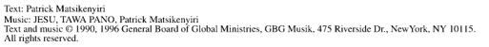
CHILDREN’S MUSIC Jesus, We are Gathered ELW 529
CHILDREN’S MESSAGE
SCRIPTURE READINGS
FIRST READING: Proverbs 25:6-7a
⁶ Do not put yourself forward in the king’s presence
or stand in the place of the great,
^{7a} for it is better to be told, “Come up here,”
than to be put lower in the presence of a noble.
Word of God, word of life.
Thanks be to God.
PSALM: Psalm 112
¹ Hallelujah! Happy are they who fear the Lord
and have great delight in God’s commandments!
² Their descendants will be mighty in the land;
the generation of the upright will be blessed.
³ Wealth and riches will be in their house,
and their righteousness will last forever.
⁴ Light shines in the darkness for the upright;
the righteous are merciful and full of compassion.
⁵ It is good for them to be generous in lending
and to manage their affairs with justice.
⁶ For they will never be shaken;
the righteous will be kept in everlasting remembrance.
⁷ They will not be afraid of any evil rumors;
their heart is steadfast, trusting in the Lord.
⁸ Their heart is established and will not shrink,
until they see their desire upon their enemies.
⁹ They have given freely to the poor, and their righteousness stands fast forever;
they will hold up their head with honor.
¹⁰ The wicked will see it and be angry; they will gnash their teeth and pine away;
the desires of the wicked will perish.

SECOND READING: Hebrews 13:1-8, 15-16
¹ Let mutual affection continue. ² Do not neglect to show hospitality to strangers, for by doing that some have entertained angels without knowing it. ³ Remember those who are in prison, as though you were in prison with them, those who are being tortured, as though you yourselves were being tortured. ⁴ Let marriage be held in honor by all, and let the marriage bed be kept undefiled, for God will judge the sexually immoral and adulterers. ⁵ Keep your lives free from the love of money, and be content with what you have, for he himself has said, “I will never leave you or forsake you.” ⁶ So we can say with confidence,
“The Lord is my helper; I will not be afraid.
What can anyone do to me?”
⁷ Remember your leaders, those who spoke the word of God to you; consider the outcome of their way of life, and imitate their faith. ⁸ Jesus Christ is the same yesterday and today and forever. ¹⁵ Through him, then, let us continually offer a sacrifice of praise to God, that is, the fruit of lips that confess his name. ¹⁶ Do not neglect to do good and to share what you have, for such sacrifices are pleasing to God.
Word of God, word of life.
Thanks be to God.
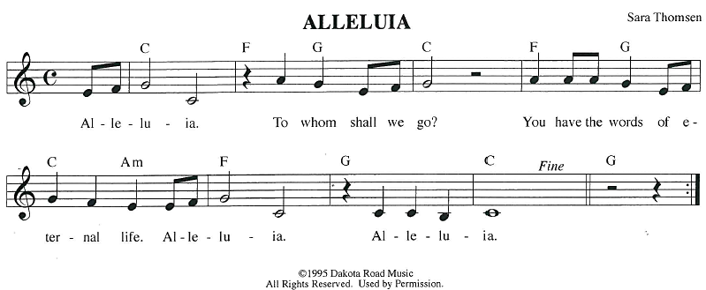
GOSPEL ACCLAMATION
GOSPEL: Luke 14:1, 7-14
¹ On one occasion when Jesus was going to the house of a leader of the Pharisees to eat a meal on the Sabbath, they were watching him closely.
⁷ When he noticed how the guests chose the places of honor, he told them a parable. ⁸ “When you are invited by someone to a wedding banquet, do not sit down at the place of honor, in case someone more distinguished than you has been invited by your host, ⁹ and the host who invited both of you may come and say to you, ‘Give this person your place,’ and then in disgrace you would start to take the lowest place. ¹⁰ But when you are invited, go and sit down at the lowest place, so that when your host comes, he may say to you, ‘Friend, move up higher’; then you will be honored in the presence of all who sit at the table with you. ¹¹ For all who exalt themselves will be humbled, and those who humble themselves will be exalted.”
¹² He said also to the one who had invited him, “When you give a luncheon or a dinner, do not invite your friends or your brothers and sisters or your relatives or rich neighbors, in case they may invite you in return, and you would be repaid. ¹³ But when you give a banquet, invite the poor, the crippled, the lame, and the blind. ¹⁴ And you will be blessed because they cannot repay you, for you will be repaid at the resurrection of the righteous.”
The gospel of the Lord.
Praise to you, O Christ.
SERMON
HYMN OF THE DAY Let Us Go Now to the Banquet ELW 523
APOSTLES’ CREED
I believe in God, the Father almighty,
creator of heaven and earth.
I believe in Jesus Christ, God's only Son, our Lord,
who was conceived by the power of the Holy Spirit, born of the Virgin Mary,
suffered under Pontius Pilate, was crucified, died, and was buried;
he descended to the dead.

On the third day he rose again;
he ascended into heaven, he is seated at the right hand of the Father,
and he will come to judge the living and the dead.
I believe in the Holy Spirit, the holy catholic Church,
the communion of saints, the forgiveness of sins,
the resurrection of the body, and the life everlasting. Amen.
PRAYERS OF INTERCESSION
…Hear us, O God
Your mercy is great
Confident in God’s presence and promise, we entrust our prayers to the one who always receives them; through Jesus Christ, our wisdom and companion.
Amen.
PEACE
The peace of Christ be with you always.
And also with you.
HOLY COMMUNION
OFFERING In addition to our normal offering, a Special Benevolence in August (collected in a special envelope) will be going to Lutheran Disaster Response’s Flood Relief.
OFFERING SONG Come to the Table ELW 481
OFFERTORY PRAYER
Creator God,
in your wisdom you bring forth all that is good and the harvest is plentiful.
Strengthen us at your table with these gifts of the earth and our labor,
that we may work for the good of all;
through Jesus Christ, our Savior.
Amen.

GREAT THANKSGIVING
The Lord be with you.
And also with you.
Lift up your hearts.
We lift them to the Lord.
Let us give our thanks to the Lord our God.
It is right to give our thanks and praise.

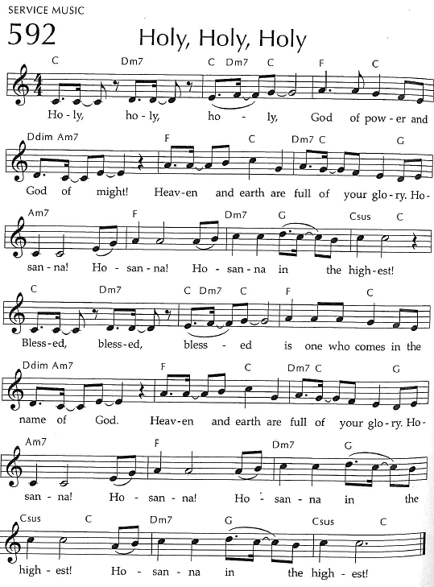
Holy, Holy, Holy

THANKSGIVING AT THE TABLE

God of our weary years, God of our silent tears,
you have brought us this far along the way.
In times of bitterness you did not abandon us,
but guided us into the path of love and light.
In every age you sent prophets
to make known your loving will for all humanity.
The cry of the poor has become your own cry;
our hunger and thirst for justice is your own desire.
In the fullness of time, you sent your chosen servant to preach good news to the afflicted,
to break bread with the outcast and despised,
and to ransom those in
bondage to prejudice and sin.
In the night in which he was betrayed,
our Lord Jesus took bread, and gave thanks;
broke it, and gave it to his disciples, saying:
Take and eat; this is my body, given for you.
Do this for the remembrance of me.
Again, after supper, he took the cup, gave thanks,
and gave it for all to drink, saying:
This cup is the new covenant in my blood,
shed for you and all people for
the forgiveness of sin.
Do this for the remembrance of me.
For as often as we eat of this bread and
drink from this cup we proclaim the
Lord’s death until he comes.
Christ has died.
Christ is risen.
Christ will come again.
Remembering, therefore,
his death and resurrection,
we await the day when Jesus shall return
to free all the earth from
the bonds of slavery and death.
Come, Lord Jesus! And let the church say, Amen. Amen.
Send your Holy Spirit, our advocate,
to fill the hearts of all who share this bread and cup
with courage and wisdom to pursue love and justice in all the world.
Come, Spirit of freedom! And let the church say, Amen.
Amen.
Join our prayers and praise with your prophets and martyrs of every age,
that, rejoicing in the hope of the resurrection,
we might live in the freedom and hope of your Son.
Through him, with him, in him,
in the unity of the Holy Spirit,
all glory and honor is yours,
almighty Father, now and forever.
Amen.
THE LORD’S PRAYER

Our Father, who art in heaven,
hallowed be thy name, thy kingdom come,
thy will be done, on earth as it is in heaven.
Give us this day our daily bread;
and forgive us our trespasses,
as we forgive those who trespass against us;
and lead us not into temptation, but deliver us from evil.
For thine is the kingdom,
and the power, and the glory, forever and ever. Amen.
INVITATION TO COMMUNION - Certified gluten-free crackers are in the bowl on the communion plate.
The kingdom of God is set before you.
Eat and rejoice.
HOLY COMMUNION
PRAYER AFTER COMMUNION
Mothering God,
you gathered us to your table and we drank deeply of your grace.
Send us out by your Spirit to love our neighbors as ourselves
and proclaim your love in Jesus’ name.
Amen.
SENDING
BLESSING
The love of God abound in you;
the grace of our Savior Jesus Christ fill your hearts;
and the life of the Spirit
☩ bless you and give you peace.
Amen.
CLOSING HYMN Sent Forth By God’s Blessing ELW 547
DISMISSAL
Go in peace. Live by the Spirit.
Thanks be to God.
Upcoming Worship Assistants
 | Usher | Lector | Communion | Offering Counters |  | Deep Clean
August 31 | Dave & Sue Schraeder | Andrea Hovick | Bruce & Nancy Tibbett | Dan Mundt | Bob Peterson | August:  Dave & Shelly Schneider  Bruce & Nancy Tibbett
September 7 | Bob & Laurel Peterson | Leslie Mader | Dan & Pam Mundt | Nancy Leonard | Rob Mader | September:  Chris Tipping  Julie Will  Andrea Hovick  Deb Janz
September 14 | Dan & Pam Mundt | Jon Hill | Bob & Laurel Peterson | Robin Beeman | David Schneider
September 21 | Stuart & Chris Tipping | Laurel Peterson | Andrea Hovick  Sarah Kopitzke | Heidi Binder | Kami Weis
Coming up at GSLC
Sunday, August 31 | 9 am | Outdoor Worship Service  - Twelfth Sunday after Pentecost  - Luke 14:1,7-14; An image of God’s reign: invite the poor, crippled to your banquet
Monday, September 1 | Closed | Church Office Closed for Labor Day
Tuesday, September 2 | 7 pm | AA Meeting
Wednesday, September 3 | 9 am-1 am | Executive Committee
Thursday, September 4 | 11am- 2pm | Purple Angels Lunch and Fellowship
Sunday, September 7 | 9 am | Sunday Worship Service  - Thirteenth Sunday after Pentecost  - Luke 15:1-10; Looking for the lost sheep, silver coin: Jesus eating with sinners
Pastor Katie’s Office Hours: Monday-Thursday 9am-2pm. Tuesday mornings at Uptown Coffee. Afternoons available by appointment. You are welcome to stop in any time for conversation or concerns.

A special congregational meeting will be held following worship on Sunday, September 21st. The purpose of this meeting is to vote on the welcome statement proposed by the Reconciling in Christ committee. This vote is the next step in this process, and a vote in favor of the welcome statement allows us to be listed as a Reconciling in Christ congregation. RIC committee members will be available during the meeting to address questions and next steps. If you have questions in the meantime, feel free to reach out to committee members: Kris Tarter, Jeff Veers, Shelly Schneider, Rick Kopitzke.
Worship moves indoors for the school year beginning next Sunday, September 7th.
Names on the prayer list now default to 6 weeks. If you would like a name to remain on the list longer, please let Pastor Katie know.
There will be fellowship time after worship one Sunday a month. Please sign up on the table in the narthex.

