
Good Shepherd Lutheran Church
Pastor: Rev. Katie Anderson | Music Director: Rev. Lois Swanson
Pastor’s Cell: (715) 502-9433 | Office Phone: (715) 387-2731
Pastor Email: gslcwi.pastor@gmail.com | Office Email: gslcwi.office@gmail.com
Website: GoodShepherdMarshfield.org
11th Sunday after Pentecost
August 24 2025, 9:00 am
Introduction to the day…
ANNOUNCEMENTS
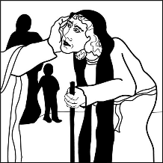
GATHERING
Remember the sabbath day. Call the sabbath a delight. This is the Lord’s day, and the Lord will do for us what the Lord does: feed us, forgive us, help and heal us. Rejoice at all the wonderful things God is doing.

GATHERING HYMN The Night You Gave Us, God Has Ended ACS 994

Confession and Forgiveness

In the name of the Father,
and of the ☩ Son,
and of the Holy Spirit.
Amen.
Baptized into Christ, let us confess our sin.
Silence is kept for reflection.
Merciful God,
you free us to love others,
but we neglect our neighbors and follow our own way.
You lead us by the Spirit of joy and peace,
but we turn away from the abundant life you offer.
You surround us with patience, kindness, and generosity,
but we grow weary in doing what is right.
In your mercy, forgive us.
Do not give up on us.
Heal us, break our bonds, and show us the path of life.
Amen.
You belong to Christ Jesus and you are God’s children through faith.
In the cross of ☩ Christ, and through the power of the Holy Spirit, your sins are forgiven.
Clothed with Christ, you are a new creation.
Amen.
PRAYER OF THE DAY
O God, mighty and immortal, you know that as fragile creatures surrounded by great dangers, we cannot by ourselves stand upright. Give us strength of mind and body, so that even when we suffer because of human sin, we may rise victorious through your Son, Jesus Christ, our Savior and Lord.
Amen.
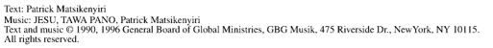
CHILDREN’S MUSIC Jesus, We are Gathered ELW 529
CHILDREN’S MESSAGE

SCRIPTURE READINGS
FIRST READING: Isaiah 58:9b-14
^{9b} If you remove the yoke from among you,
the pointing of the finger, the speaking of evil,
¹⁰ if you offer your food to the hungry
and satisfy the needs of the afflicted,
then your light shall rise in the darkness
and your gloom be like the noonday.
¹¹ The Lord will guide you continually
and satisfy your needs in parched places
and make your bones strong,
and you shall be like a watered garden,
like a spring of water
whose waters never fail.
¹² Your ancient ruins shall be rebuilt;
you shall raise up the foundations of many generations;
you shall be called the repairer of the breach,
the restorer of streets to live in.
¹³ If you refrain from trampling the Sabbath,
from pursuing your own interests on my holy day;
if you call the Sabbath a delight
and the holy day of the Lord honorable;
if you honor it, not going your own ways,
serving your own interests or pursuing your own affairs;
¹⁴ then you shall take delight in the Lord,
and I will make you ride upon the heights of the earth;
I will feed you with the heritage of your ancestor Jacob,
for the mouth of the Lord has spoken.
Word of God, word of life.
Thanks be to God.
PSALM: Psalm 103:1-8
¹ Bless the Lord, O my soul,
and all that is within me, bless God’s holy name.
² Bless the Lord, O my soul,
and forget not all God’s benefits
³ who forgives all your sins
and heals all your diseases;
⁴ who redeems your life from the grave
and crowns you with steadfast love and mercy;
⁵ who satisfies your desires with good things
so that your youth is renewed like an eagle’s.
⁶ O Lord, you provide vindication
and justice for all who are oppressed.
⁷ You made known your ways to Moses
and your works to the children of Israel.
⁸ Lord, you are full of compassion and mercy,
slow to anger and abounding in steadfast love.

SECOND READING: Hebrews 12:18-29
¹⁸ You have not come to something that can be touched, a blazing fire, and darkness, and gloom, and a tempest, ¹⁹ and the sound of a trumpet, and a voice whose words made the hearers beg that not another word be spoken to them. ²⁰ (For they could not endure the order that was given, “If even an animal touches the mountain, it shall be stoned to death.” ²¹ Indeed, so terrifying was the sight that Moses said, “I tremble with fear.”) ²² But you have come to Mount Zion and to the city of the living God, the heavenly Jerusalem, and to innumerable angels in festal gathering, ²³ and to the assembly of the firstborn who are enrolled in heaven, and to God the judge of all, and to the spirits of the righteous made perfect, ²⁴ and to Jesus, the mediator of a new covenant, and to the sprinkled blood that speaks a better word than the blood of Abel.
²⁵ See that you do not refuse the one who is speaking, for if they did not escape when they refused the one who warned them on earth, how much less will we escape if we reject the one who warns from heaven! ²⁶ At that time his voice shook the earth, but now he has promised, “Yet once more I will shake not only the earth but also the heaven.” ²⁷ This phrase, “Yet once more,” indicates the removal of what is shaken—that is, created things—so that what cannot be shaken may remain. ²⁸ Therefore, since we are receiving a kingdom that cannot be shaken, let us show gratitude, by which we may offer to God an acceptable worship with reverence and awe, ²⁹ for indeed our God is a consuming fire.
Word of God, word of life.
Thanks be to God.
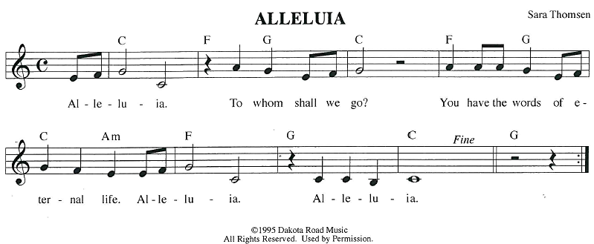
GOSPEL ACCLAMATION GOSPEL: Luke 13:10-17
¹⁰ Now [Jesus] was teaching in one of the synagogues on the Sabbath. ¹¹ And just then there appeared a woman with a spirit that had crippled her for eighteen years. She was bent over and was quite unable to stand up straight. ¹² When Jesus saw her, he called her over and said, “Woman, you are set free from your ailment.” ¹³ When he laid his hands on her, immediately she stood up straight and began praising God. ¹⁴ But the leader of the synagogue, indignant because Jesus had cured on the Sabbath, kept saying to the crowd, “There are six days on which work ought to be done; come on those days and be cured and not on the Sabbath day.” ¹⁵ But the Lord answered him and said, “You hypocrites! Does not each of you on the Sabbath untie his ox or his donkey from the manger and lead it to water? ¹⁶ And ought not this woman, a daughter of Abraham whom Satan bound for eighteen long years, be set free from this bondage on the Sabbath day?” ¹⁷ When he said this, all his opponents were put to shame, and the entire crowd was rejoicing at all the wonderful things being done by him.
The gospel of the Lord.
Praise to you, O Christ.
SERMON
HYMN OF THE DAY Healer of Our Every Ill ELW 612
APOSTLES’ CREED
I believe in God, the Father almighty,
creator of heaven and earth.
I believe in Jesus Christ, God's only Son, our Lord,
who was conceived by the power of the Holy Spirit, born of the Virgin Mary,
suffered under Pontius Pilate, was crucified, died, and was buried;
he descended to the dead.
On the third day he rose again;
he ascended into heaven, he is seated at the right hand of the Father,
and he will come to judge the living and the dead.
I believe in the Holy Spirit, the holy catholic Church,
the communion of saints, the forgiveness of sins,
the resurrection of the body, and the life everlasting. Amen.
PRAYERS OF INTERCESSION
…Hear, O God
Your mercy is great
Confident in God’s presence and promise, we entrust our prayers to the one who always receives them; through Jesus Christ, our wisdom and companion.
Amen.
PEACE
The peace of Christ be with you always.
And also with you.
HOLY COMMUNION
OFFERING In addition to our normal offering, a Special Benevolence in August (collected in a special envelope) will be going to Lutheran Disaster Response’s Flood Relief.
OFFERING SONG Oh, For a Thousand Tongues to Sing ELW 886
OFFERTORY PRAYER
Creator God,
in your wisdom you bring forth all that is good and the harvest is plentiful.
Strengthen us at your table with these gifts of the earth and our labor,
that we may work for the good of all;
through Jesus Christ, our Savior.
Amen.
GREAT THANKSGIVING
The Lord be with you.
And also with you.
Lift up your hearts.

We lift them to the Lord.
Let us give our thanks to the Lord our God.
It is right to give our thanks and praise.

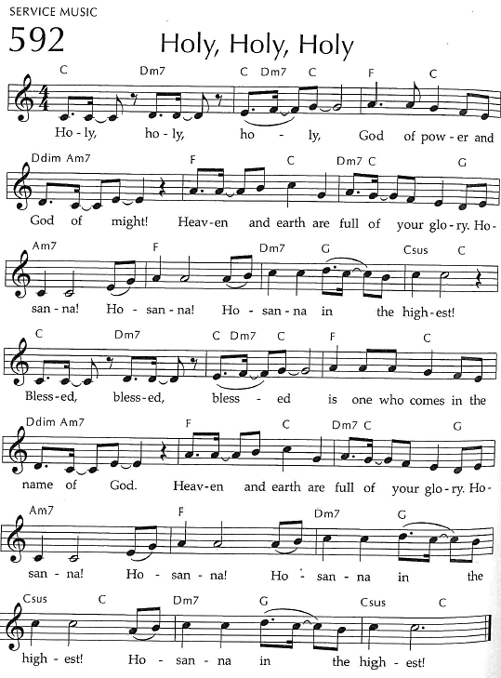
Holy, Holy, Holy

THANKSGIVING AT THE TABLE

God of our weary years, God of our silent tears,
you have brought us this far along the way.
In times of bitterness you did not abandon us,
but guided us into the path of love and light.
In every age you sent prophets
to make known your loving will for all humanity.
The cry of the poor has become your own cry;
our hunger and thirst for justice is your own desire.
In the fullness of time, you sent your chosen servant to preach good news to the afflicted,
to break bread with the outcast and despised,
and to ransom those in
bondage to prejudice and sin.

In the night in which he was betrayed,
our Lord Jesus took bread, and gave thanks;
broke it, and gave it to his disciples, saying:
Take and eat; this is my body, given for you.
Do this for the remembrance of me.
Again, after supper, he took the cup, gave thanks,
and gave it for all to drink, saying:
This cup is the new covenant in my blood,
shed for you and all people for
the forgiveness of sin.
Do this for the remembrance of me.

For as often as we eat of this bread and
drink from this cup we proclaim the
Lord’s death until he comes.
Christ has died.
Christ is risen.
Christ will come again.
Remembering, therefore,
his death and resurrection,
we await the day when Jesus shall return
to free all the earth from
the bonds of slavery and death.
Come, Lord Jesus! And let the church say, Amen. Amen.
Send your Holy Spirit, our advocate,
to fill the hearts of all who share this bread and cup
with courage and wisdom to pursue love and justice in all the world.
Come, Spirit of freedom! And let the church say, Amen.
Amen.
Join our prayers and praise with your prophets and martyrs of every age,
that, rejoicing in the hope of the resurrection,
we might live in the freedom and hope of your Son.
Through him, with him, in him,
in the unity of the Holy Spirit,
all glory and honor is yours,
almighty Father, now and forever.
Amen.
THE LORD’S PRAYER

Our Father, who art in heaven,
hallowed be thy name, thy kingdom come,
thy will be done, on earth as it is in heaven.
Give us this day our daily bread;
and forgive us our trespasses,
as we forgive those who trespass against us;
and lead us not into temptation, but deliver us from evil.
For thine is the kingdom,
and the power, and the glory, forever and ever. Amen.
INVITATION TO COMMUNION - Certified gluten-free crackers are in the bowl on the communion plate.
The kingdom of God is set before you.
Eat and rejoice.
HOLY COMMUNION
PRAYER AFTER COMMUNION
Mothering God,
you gathered us to your table and we drank deeply of your grace.
Send us out by your Spirit to love our neighbors as ourselves
and proclaim your love in Jesus’ name.
Amen.
SENDING
BLESSING
The love of God abound in you;
the grace of our Savior Jesus Christ fill your hearts;
and the life of the Spirit
☩ bless you and give you peace.
Amen.
CLOSING HYMN I Want to Walk as a Child of the Light ELW 815
DISMISSAL
Go in peace. Live by the Spirit.
Thanks be to God.
Upcoming Worship Assistants
 | Usher | Lector | Communion | Offering Counters |  | Deep Clean
August 24 | John & Jennifer Rickinger | Chris Tipping | Dave & Shelly Schneider | Pam Mundt | Margo Berrier | August:  Dave & Shelly Schneider  Bruce & Nancy Tibbett
August 31 | Dave & Sue Schraeder | Andrea Hovick | Bruce & Nancy Tibbett | Dan Mundt | Bob Peterson | August:  Dave & Shelly Schneider  Bruce & Nancy Tibbett
September 7 | Bob & Laurel Peterson | Shelly Schneider | Dan & Pam Mundt | Nancy Leonard | Rob Mader | September:  Chris Tipping  Julie Will  Andrea Hovick  Deb Janz
September 14 | Dan & Pam Mundt | Jon Hill | Bob & Laurel Peterson | Robin Beeman | David Schneider
Coming up at GSLC
Sunday, August 24 | 9:00am | Outdoor Worship Service  - Eleventh Sunday after Pentecost  - Luke 13:10-17; Jesus heals a crippled woman on the sabbath and is condemned
Tuesday, August 26 | 9:30am-11am | Children’s WI Play and Learn
 | 7:00 pm | AA Meeting
Sunday, August 31 | 9:00 am | Outdoor Worship Service  - Twelfth Sunday after Pentecost  - Luke 14:1,7-14; An image of God’s reign: invite the poor, crippled to your banquet
Pastor Katie’s Office Hours: Monday-Thursday 9am-2pm. Tuesday mornings at Uptown Coffee. Afternoons available by appointment. You are welcome to stop in any time for conversation or concerns.


A special congregational meeting will be held following worship on Sunday, September 21st. The purpose of this meeting is to vote on the welcome statement proposed by the Reconciling in Christ committee. This vote is the next step in this process, and a vote in favor of the welcome statement allows us to be listed as a Reconciling in Christ congregation. RIC committee members will be available during the meeting to address questions and next steps. If you have questions in the meantime, feel free to reach out to committee members: Kris Tarter, Jeff Veers, Shelly Schneider, Rick Kopitzke.
Pastor Katie will be out of the office for a conference August 24 to August 26.
Names on the prayer list now default to 6 weeks. If you would like a name to remain on the list longer, please let Pastor Katie know.
There will be fellowship time after worship one Sunday a month. Please sign up on the table in the narthex.
Did you know you can bring old backpacks (and more) to Staples for recycling?!

All these school supplies are accepted:
Backpacks & lunch bags, Binders & zipper binders
Crayons & colored pencils, Glue sticks & bottles (empty)
Pencils & pencil pouches, Pens, markers & highlighters
Rulers & drafting tools
10 Ways to Save Energy and Stay Cool This Summer
[1] Turn off fans in empty rooms. It ends up fans cool people, not rooms!
[2] Close window blinds and drapes when gone to block sunlight, but open windows at night to help keep cool and enjoy the extra daylight when home.
[3] Unplug appliances and electronics when not in use or put them on power strips (and use them).
[4] Raise the temperature of your air conditioner during the day to 78ºF and at night to 85ºF. Install (and program) a programmable thermostat to automatically manage temperatures when you are home and away.
[5] Replace incandescent lightbulbs with LED and CFL lighting. Most energy from inefficient lighting is heat.
[6] Use a microwave or grill to cook instead of using an oven.
[7] Take shorter, cooler showers and use bathroom exhaust fans to alleviate humidity.
[8] Run dishwasher (instead of washing by hand), and use laundry machines only when full. Allow the dishes to air-dry and remove lint from the dryer.
[9] Decrease temperature of water heater to 120ºF.
[10] Go outside! Maybe enjoy a state park!
Shared by GSLC Green Team, from cleanenergyresourceteams.org

