
Good Shepherd Lutheran Church
Pastor: Rev. Katie Anderson | Music Director: Rev. Lois Swanson
Pastor’s Cell: (715) 502-9433 | Office Phone: (715) 387-2731
Pastor Email: gslcwi.pastor@gmail.com | Office Email: gslcwi.office@gmail.com
Website: GoodShepherdMarshfield.org
10th Sunday after Pentecost
August 17 2025, 9:00 am
Introduction to the day…

ANNOUNCEMENTS
GATHERING
The word of God is a refining fire. Jesus is the great divide in human history. He invites our undivided attention and devotion. Today in worship we are surrounded by a great “cloud of witnesses.” In the word and in holy communion we are invited yet again to look to Jesus, “the pioneer and perfecter of our faith.”
GATHERING HYMN God, Who Stretched the Spangled Heavens ELW 771
Confession and Forgiveness
In the name of the Father,
and of the ☩ Son,
and of the Holy Spirit.
Amen.
Baptized into Christ, let us confess our sin.
Silence is kept for reflection.

Merciful God,
you free us to love others,

but we neglect our neighbors and follow our own way.
You lead us by the Spirit of joy and peace,
but we turn away from the abundant life you offer.
You surround us with patience, kindness, and generosity,
but we grow weary in doing what is right.
In your mercy, forgive us.
Do not give up on us.
Heal us, break our bonds, and show us the path of life.
Amen.
You belong to Christ Jesus and you are God’s children through faith.
In the cross of ☩ Christ, and through the power of the Holy Spirit, your sins are forgiven.
Clothed with Christ, you are a new creation.
Amen.
PRAYER OF THE DAY
O God, judge eternal, you love justice and hate oppression, and you call us to share your zeal for truth. Give us courage to take our stand with all victims of bloodshed and greed, and, following your servants and prophets, to look to the pioneer and perfecter of our faith, your Son, Jesus Christ, our Savior and Lord.
Amen.
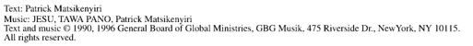
CHILDREN’S MUSIC Jesus, We are Gathered ELW 529
CHILDREN’S MESSAGE
SCRIPTURE READINGS
FIRST READING: Jeremiah 23:23-29
²³ Am I a God near by, says the Lord, and not a God far off? ²⁴ Who can hide in secret places so that I cannot see them? says the Lord. Do I not fill heaven and earth? says the Lord. ²⁵ I have heard what the prophets have said who prophesy lies in my name, saying, “I have dreamed! I have dreamed!” ²⁶ How long? Will the hearts of the prophets ever turn back—those who prophesy lies and who prophesy the deceit of their own heart? ²⁷ They plan to make my people forget my name by their dreams that they tell one another, just as their ancestors forgot my name for Baal. ²⁸ Let the prophet who has a dream tell the dream, but let the one who has my word speak my word faithfully. What has straw in common with wheat? says the Lord. ²⁹ Is not my word like fire, says the Lord, and like a hammer that breaks a rock in pieces?
Word of God, word of life.
Thanks be to God.

PSALM: Psalm 82
¹ God stands to charge the divine council assembled,
giving judgment in the midst of the gods:
² “How long will you judge unjustly,
and show favor to the wicked?
³ Save the weak and the orphan;
defend the humble and needy;
⁴ rescue the weak and the poor;
deliver them from the power of the wicked.
⁵ They do not know, neither do they understand; they wander about in darkness;
all the foundations of the earth are shaken.
⁶ Now I say to you, ‘You are gods,
and all of you children of the Most High;
⁷ nevertheless, you shall die like mortals,
and fall like any prince.’ ”
⁸ Arise, O God, and rule the earth,
for you shall take all nations for your own.
SECOND READING: Hebrews 11:29-12:2
²⁹ By faith the people passed through the Red Sea as if it were dry land, but when the Egyptians attempted to do so they were drowned. ³⁰ By faith the walls of Jericho fell after they had been encircled for seven days. ³¹ By faith Rahab the prostitute did not perish with those who were disobedient, because she had received the spies in peace.
³² And what more should I say? For time would fail me to tell of Gideon, Barak, Samson, Jephthah, of David and Samuel and the prophets, ³³ who through faith conquered kingdoms, administered justice, obtained promises, shut the mouths of lions, ³⁴ quenched the power of fire, escaped the edge of the sword, were made strong out of weakness, became mighty in war, put foreign armies to flight. ³⁵ Women received their dead by resurrection. Others were tortured, refusing to accept release, in order to obtain a better resurrection. ³⁶ Others suffered mocking and flogging and even chains and imprisonment. ³⁷ They were stoned to death; they were sawn in two; they were killed by the sword; they went about in skins of sheep and goats, destitute, persecuted, tormented ³⁸ of whom the world was not worthy. They wandered in deserts and mountains and in caves and holes in the ground.
³⁹ Yet all these, though they were commended for their faith, did not receive what was promised, ⁴⁰ since God had provided something better so that they would not, apart from us, be made perfect.
^{12:1} Therefore, since we are surrounded by so great a cloud of witnesses, let us also lay aside every weight and the sin that clings so closely, and let us run with perseverance the race that is set before us, ² looking to Jesus, the pioneer and perfecter of faith, who for the sake of the joy that was set before him endured the cross, disregarding its shame, and has taken his seat at the right hand of the throne of God.
Word of God, word of life.
Thanks be to God.
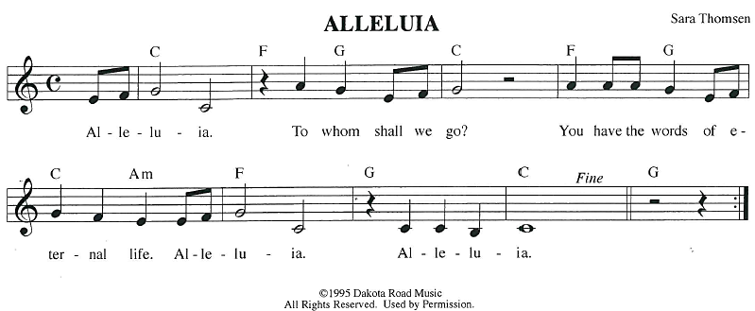
GOSPEL ACCLAMATION
GOSPEL: Luke 12:49-56
[Jesus said:] ⁴⁹ “I have come to cast fire upon the earth, and how I wish it were already ablaze! ⁵⁰ I have a baptism with which to be baptized, and what constraint I am under until it is completed! ⁵¹ Do you think that I have come to bring peace to the earth? No, I tell you, but rather division! ⁵² From now on five in one household will be divided, three against two and two against three; ⁵³ they will be divided:
father against son
and son against father,
mother against daughter
and daughter against mother,
mother-in-law against her daughter-in-law
and daughter-in-law against mother-in-law.”
⁵⁴ He also said to the crowds, “When you see a cloud rising in the west, you immediately say, ‘It is going to rain,’ and so it happens. ⁵⁵ And when you see the south wind blowing, you say, ‘There will be scorching heat,’ and it happens. ⁵⁶ You hypocrites! You know how to interpret the appearance of earth and sky, but why do you not know how to interpret the present time?”
The gospel of the Lord.
Praise to you, O Christ.
SERMON



HYMN OF THE DAY God, When Human Bonds Are Broken ELW 603
APOSTLES’ CREED
I believe in God, the Father almighty,
creator of heaven and earth.
I believe in Jesus Christ, God's only Son, our Lord,
who was conceived by the power of the Holy Spirit, born of the Virgin Mary,
suffered under Pontius Pilate, was crucified, died, and was buried;
he descended to the dead.
On the third day he rose again;
he ascended into heaven, he is seated at the right hand of the Father,
and he will come to judge the living and the dead.
I believe in the Holy Spirit, the holy catholic Church,
the communion of saints, the forgiveness of sins,
the resurrection of the body, and the life everlasting. Amen.
PRAYERS OF INTERCESSION
…Hear, O God
Your mercy is great
Confident in God’s presence and promise, we entrust our prayers to the one who always receives them; through Jesus Christ, our wisdom and companion.
Amen.
PEACE
The peace of Christ be with you always.
And also with you.

HOLY COMMUNION
OFFERING In addition to our normal offering, a Special Benevolence in August (collected in a special envelope) will be going to Lutheran Disaster Response’s Flood Relief.
OFFERING SONG Come Now, O God ACS 902
OFFERTORY PRAYER
Creator God,
in your wisdom you bring forth all that is good and the harvest is plentiful.
Strengthen us at your table with these gifts of the earth and our labor,
that we may work for the good of all;
through Jesus Christ, our Savior.
Amen.
GREAT THANKSGIVING
The Lord be with you.
And also with you.
Lift up your hearts.

We lift them to the Lord.
Let us give our thanks to the Lord our God.
It is right to give our thanks and praise.

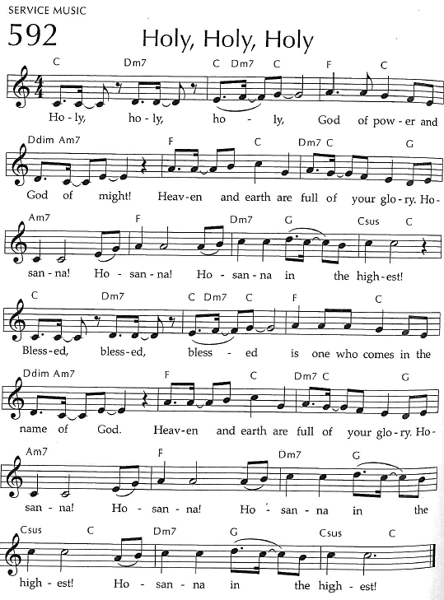
Holy, Holy, Holy

THANKSGIVING AT THE TABLE

God of our weary years, God of our silent tears,
you have brought us this far along the way.
In times of bitterness you did not abandon us,
but guided us into the path of love and light.
In every age you sent prophets
to make known your loving will for all humanity.
The cry of the poor has become your own cry;
our hunger and thirst for justice is your own desire.
In the fullness of time, you sent your chosen servant to preach good news to the afflicted,
to break bread with the outcast and despised,
and to ransom those in
bondage to prejudice and sin.

In the night in which he was betrayed,
our Lord Jesus took bread, and gave thanks;
broke it, and gave it to his disciples, saying:
Take and eat; this is my body, given for you.
Do this for the remembrance of me.
Again, after supper, he took the cup, gave thanks,
and gave it for all to drink, saying:
This cup is the new covenant in my blood,
shed for you and all people for the forgiveness of sin.
Do this for the remembrance of me.
For as often as we eat of this bread and drink from this cup
we proclaim the Lord’s death until he comes.
Christ has died.
Christ is risen.
Christ will come again.
Remembering, therefore, his death and resurrection,
we await the day when Jesus shall return
to free all the earth from the bonds of slavery and death.
Come, Lord Jesus! And let the church say, Amen. Amen.
Send your Holy Spirit, our advocate,
to fill the hearts of all who share this bread and cup
with courage and wisdom to pursue love and justice in all the world.
Come, Spirit of freedom! And let the church say, Amen.
Amen.
Join our prayers and praise with your prophets and martyrs of every age,
that, rejoicing in the hope of the resurrection,
we might live in the freedom and hope of your Son.
Through him, with him, in him, in the unity of the Holy Spirit,
all glory and honor is yours, almighty Father, now and forever.
Amen.


THE LORD’S PRAYER
Our Father, who art in heaven,
hallowed be thy name, thy kingdom come,
thy will be done, on earth as it is in heaven.
Give us this day our daily bread;
and forgive us our trespasses,
as we forgive those who trespass against us;
and lead us not into temptation, but deliver us from evil.
For thine is the kingdom,
and the power, and the glory, forever and ever. Amen.
INVITATION TO COMMUNION - Certified gluten-free crackers are in the bowl on the communion plate.
The kingdom of God is set before you.
Eat and rejoice.
HOLY COMMUNION
PRAYER AFTER COMMUNION
Mothering God,
you gathered us to your table and we drank deeply of your grace.
Send us out by your Spirit to love our neighbors as ourselves
and proclaim your love in Jesus’ name.
Amen.
SENDING
BLESSING
The love of God abound in you;
the grace of our Savior Jesus Christ fill your hearts;
and the life of the Spirit
☩ bless you and give you peace.
Amen.
CLOSING HYMN Canticle of the Turning ELW 723
DISMISSAL
Go in peace. Live by the Spirit.
Thanks be to God.
Upcoming Worship Assistants
 | Usher | Lector | Communion | Offering Counters |  | Deep Clean
August 17 | Dennis & Deb Janz | Nancy Tibbett | Bob & Laurel Peterson | Heidi Binder | Kami Weis | August:  Dave & Shelly Schneider  Bruce & Nancy Tibbett
August 24 | John & Jennifer Rickinger | Chris Tipping | Dave & Shelly Schneider | Pam Mundt | Margo Berrier | August:  Dave & Shelly Schneider  Bruce & Nancy Tibbett
August 31 | Dave & Sue Schraeder | Andrea Hovick | Bruce & Nancy Tibbett | Dan Mundt | Bob Peterson | August:  Dave & Shelly Schneider  Bruce & Nancy Tibbett
September 7 | Bob & Laurel Peterson | Shelly Schneider | Dan & Pam Mundt | Nancy Leonard | Rob Mader | September:  Chris Tipping  Julie Will  Andrea Hovick  Deb Janz

Coming up at GSLC
Sunday, August 17 | 9:00am | Outdoor Worship Service  - Tenth Sunday after Pentecost  - Luke 12:49-56; Jesus brings fire on earth and has a baptism with which to be baptized
Tuesday, August 19 | 9:30am-11am | Children’s WI Play and Learn
 | 2:00pm | Chapel at Three Oaks
 | 7:00 pm | AA Meeting
Wednesday, August 20 | 6:00pm | Pub Theology (last one for the season) at Scotty’s Pizza & Chicken  Topic: “Religion & Politics”
Sunday, August 24 | 9:00am | Outdoor Worship Service  - Eleventh Sunday after Pentecost  - Luke 13:10-17; Jesus heals a crippled woman on the sabbath and is condemned
Pastor Katie’s Office Hours: Monday-Thursday 9am-2pm. Tuesday mornings at Uptown Coffee. Afternoons available by appointment. You are welcome to stop in any time for conversation or concerns.

Pastor Katie will be out of the office for a conference August 24 to August 26.
There will be fellowship time after worship one Sunday a month. Please sign up on the table in the narthex.
Names on the prayer list now default to 6 weeks. If you would like a name to remain on the list longer, please let Pastor Katie know.

10 Ways to Save Energy and Stay Cool This Summer
[1] Turn off fans in empty rooms. It ends up fans cool people, not rooms!
[2] Close window blinds and drapes when gone to block sunlight, but open windows at night to help keep cool and enjoy the extra daylight when home.
[3] Unplug appliances and electronics when not in use or put them on power strips (and use them).
[4] Raise the temperature of your air conditioner during the day to 78ºF and at night to 85ºF. Install (and program) a programmable thermostat to automatically manage temperatures when you are home and away.
[5] Replace incandescent lightbulbs with LED and CFL lighting. Most energy from inefficient lighting is heat.
[6] Use a microwave or grill to cook instead of using an oven.
[7] Take shorter, cooler showers and use bathroom exhaust fans to alleviate humidity.
[8] Run dishwasher (instead of washing by hand), and use laundry machines only when full. Allow the dishes to air-dry and remove lint from the dryer.
[9] Decrease temperature of water heater to 120ºF.
[10] Go outside! Maybe enjoy a state park!
Shared by GSLC Green Team, from cleanenergyresourceteams.org

Did you know you can bring old backpacks (and more) to Staples for recycling?!

All these school supplies are accepted:
Backpacks & lunch bags, Binders & zipper binders
Crayons & colored pencils, Glue sticks & bottles (empty)
Pencils & pencil pouches, Pens, markers & highlighters
Rulers & drafting tools
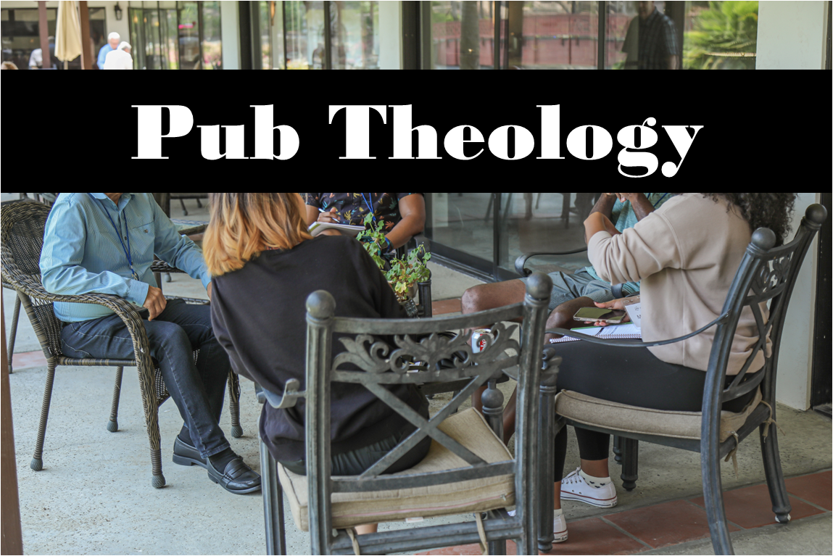
Pub Theology is returning for the summer!
1st & 3rd Wednesday June-August: Scotty’s Pizza & Chicken 6:00 pm
This year, we’re collaborating with Wesley UMC. Topics each week include: Having Hard Conversations (6/4), Attitude of Gratitude (6/18), Good Grief (7/2), What is Truth? (7/16), Faith & Science (8/6), Religion & Politics (8/20)
What is Pub Theology? People have been gathering in pubs and public spaces for ages talking about life, philosophy, faith, and deep questions of meaning. Increasingly, people all over are rediscovering the pub as a safe, open space where they can explore and express their own doubts and questions, learn from others, and engage people of varying religious traditions. In our increasingly fractured society, these spaces are not only welcome but needed.
Bring your questions and curiosity, and pull up a chair.

