
Good Shepherd Lutheran Church
Pastor: Rev. Katie Anderson | Music Director: Rev. Lois Swanson
Pastor’s Cell: (715) 502-9433 | Office Phone: (715) 387-2731
Pastor Email: gslcwi.pastor@gmail.com | Office Email: gslcwi.office@gmail.com
Website: GoodShepherdMarshfield.org
9th Sunday after Pentecost
August 10 2025, 9:00 am
Introduction to the day…
ANNOUNCEMENTS
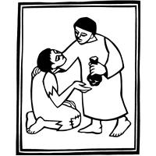
GATHERING
Jesus says, “It is your Father’s good pleasure to give you the kingdom.” It is God’s promise from the beginning—to Abraham, to the early church, and to the “little flock” of which we are a part in today’s assembly. Faith, God’s baptismal gift, trusts the promises of God. Have no fear.
GATHERING HYMN Wake, Awake, for Night is Flying ELW 436

Confession and Forgiveness
In the name of the Father,
and of the ☩ Son,
and of the Holy Spirit.
Amen.
Baptized into Christ, let us confess our sin.
Silence is kept for reflection.
Merciful God,
you free us to love others,
but we neglect our neighbors and follow our own way.
You lead us by the Spirit of joy and peace,
but we turn away from the abundant life you offer.
You surround us with patience, kindness, and generosity,
but we grow weary in doing what is right.
In your mercy, forgive us.
Do not give up on us.
Heal us, break our bonds, and show us the path of life.
Amen.
You belong to Christ Jesus and you are God’s children through faith.
In the cross of ☩ Christ, and through the power of the Holy Spirit, your sins are forgiven.
Clothed with Christ, you are a new creation.
Amen.
PRAYER OF THE DAY
Almighty God, you sent your Holy Spirit to be the life and light of your church. Open our hearts to the riches of your grace, that we may be ready to receive you wherever you appear, through Jesus Christ, our Savior and Lord.
Amen.

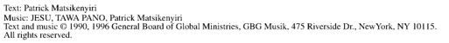
CHILDREN’S MUSIC Jesus, We are Gathered ELW 529
CHILDREN’S MESSAGE

SCRIPTURE READINGS
FIRST READING: Genesis 15:1-6
¹ After these things the word of the Lord came to Abram in a vision, “Do not be afraid, Abram, I am your shield; your reward shall be very great.” ² But Abram said, “O Lord God, what will you give me, for I continue childless, and the heir of my house is Eliezer of Damascus?” ³ And Abram said, “You have given me no offspring, so a slave born in my house is to be my heir.” ⁴ But the word of the Lord came to him, “This man shall not be your heir; no one but your very own issue shall be your heir.” ⁵ He brought him outside and said, “Look toward heaven and count the stars, if you are able to count them.” Then he said to him, “So shall your descendants be.” ⁶ And he believed the Lord, and the Lord reckoned it to him as righteousness.
Word of God, word of life.
Thanks be to God.
PSALM: Psalm 33:12-22
¹² Happy is the nation whose God is the Lord!
Happy the people chosen to be God’s heritage!
¹³ The Lord looks down from heaven,
and sees all humankind.
¹⁴ God sits firmly enthroned and
watches all who dwell on the earth.
¹⁵ God fashions all their hearts and
observes all their deeds.
¹⁶ A king is not saved by the size of the army,
nor are warriors rescued by their great strength.
¹⁷ The horse gives vain hope for victory;
despite its great strength it cannot save.
¹⁸ Truly, your eye is upon those who fear you, O Lord,
upon those who wait for your steadfast love,
¹⁹ to deliver their lives from death,
and to keep them alive in time of famine.
²⁰ Our innermost being waits for you, O Lord,
our helper and our shield.
²¹ Surely, our heart rejoices in you,
for in your holy name we put our trust.
²² Let your lovingkindness, O Lord, be upon us,
even as we place our hope in you.
SECOND READING: Hebrews 11:1-3, 8-16
¹ Now faith is the assurance of things hoped for, the conviction of things not seen. ² Indeed, by faith our ancestors received approval. ³ By faith we understand that the worlds were prepared by the word of God, so that what is seen was made from things that are not visible.
⁸ By faith Abraham obeyed when he was called to set out for a place that he was to receive as an inheritance, and he set out, not knowing where he was going. ⁹ By faith he stayed for a time in the land he had been promised, as in a foreign land, living in tents, as did Isaac and Jacob, who were heirs with him of the same promise. ¹⁰ For he looked forward to the city that has foundations, whose architect and builder is God. ¹¹ By faith, with Sarah’s involvement, he received power of procreation, even though he was too old, because he considered him faithful who had promised. ¹² Therefore from one person, and this one as good as dead, descendants were born, “as many as the stars of heaven and as the innumerable grains of sand by the seashore.”
¹³ All of these died in faith without having received the promises, but from a distance they saw and greeted them. They confessed that they were strangers and foreigners on the earth, ¹⁴ for people who speak in this way make it clear that they are seeking a homeland. ¹⁵ If they had been thinking of the land that they had left behind, they would have had opportunity to return. ¹⁶ But as it is, they desire a better homeland, that is, a heavenly one. Therefore God is not ashamed to be called their God; indeed, he has prepared a city for them.
Word of God, word of life.
Thanks be to God.
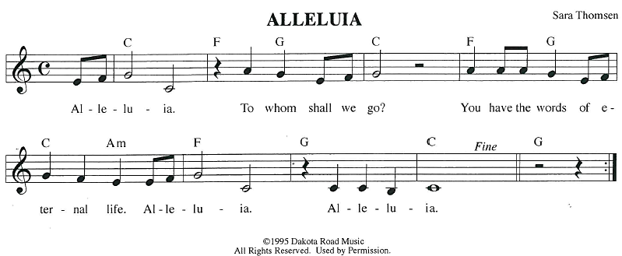
GOSPEL ACCLAMATION
GOSPEL: Luke 12:32-40
[Jesus said:] ³² “Do not be afraid, little flock, for it is your Father’s good pleasure to give you the kingdom. ³³ Sell your possessions and give alms. Make purses for yourselves that do not wear out, an unfailing treasure in heaven, where no thief comes near and no moth destroys. ³⁴ For where your treasure is, there your heart will be also.
³⁵ “Be dressed for action and have your lamps lit; ³⁶ be like those who are waiting for their master to return from the wedding banquet, so that they may open the door for him as soon as he comes and knocks. ³⁷ Blessed are those slaves whom the master finds alert when he comes; truly I tell you, he will fasten his belt and have them sit down to eat, and he will come and serve them. ³⁸ If he comes during the middle of the night or near dawn and finds them so, blessed are those slaves.
³⁹ “But know this: if the owner of the house had known at what hour the thief was coming, he would not have let his house be broken into. ⁴⁰ You also must be ready, for the Son of Man is coming at an hour you do not expect.”
The gospel of the Lord.
Praise to you, O Christ.

SERMON
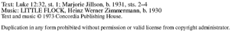
HYMN OF THE DAY Have No Fear, Little Flock ELW 764
COUNCIL INSTALLATION
These people have been elected by the congregation, or appointed by the council to positions of leadership. We give thanks for their willingness to serve. In baptism we are welcomed into the body of Christ and sent to share in the mission of God; we rejoice in their leadership in our common life and our mutual mission as a congregation.
The offices and names of those who are to be installed are read.
A reading from First Corinthians: There are varieties of gifts, but the same Spirit; and there are varieties of services, but the same Lord; and there are varieties of activities, but it is the same God who activates all of them in everyone. To each is given the manifestation of the Spirit for the common good. (1 Corinthians 12:4-7)
You have been elected and appointed to positions of leadership and trust in this congregation.
You are entrusted with seeing that the words and deeds of this household of faith bear witness to God, who gathers us into one together with the whole church.
You are to seek to involve all members of this congregation in worship, learning, witness, service, and support, so that the mission of Christ is carried out in this congregation, in the wider church, in this community, and in the whole world.
You are to be faithful in your area of serving, that the Spirit who empowers you may be glorified.
You are to be examples of faith active in love, fostering peace, harmony, and mutual understanding in this congregation.
On behalf of this congregation, I ask you:
Will you accept and faithfully carry out the duties of the offices
to which you serve?
Response: I will, and I ask God to help me.

People of God, I ask you:
Will you support these leaders,
and will you share in the mutual ministry
that Christ has given to all who are baptized?
We will, and we ask God to help us.
I now declare you installed as council members of this congregation.
Almighty God bless you, and direct your days and your deeds in peace,
that you may be faithful servants of Christ.
Amen.
APOSTLES’ CREED
I believe in God, the Father almighty,
creator of heaven and earth.
I believe in Jesus Christ, God's only Son, our Lord,
who was conceived by the power of the Holy Spirit, born of the Virgin Mary,
suffered under Pontius Pilate, was crucified, died, and was buried;
he descended to the dead.
On the third day he rose again;
he ascended into heaven, he is seated at the right hand of the Father,
and he will come to judge the living and the dead.
I believe in the Holy Spirit, the holy catholic Church,
the communion of saints, the forgiveness of sins,
the resurrection of the body, and the life everlasting. Amen.
PRAYERS OF INTERCESSION
…God of Grace.
Hear our prayer
Trusting in your lovingkindness, we place our prayer and hope in you, in the name of Jesus Christ.
Amen.
PEACE
The peace of Christ be with you always.
And also with you.
HOLY COMMUNION
OFFERING In addition to our normal offering, a Special Benevolence in August (collected in a special envelope) will be going to Lutheran Disaster Response’s Flood Relief.

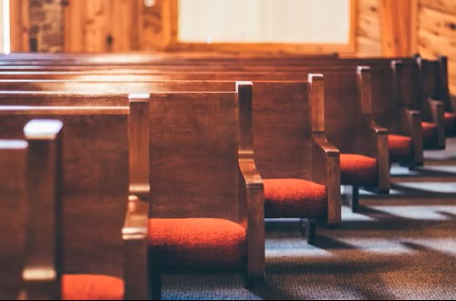
OFFERING SONG The King of Love My Shepherd Is ELW 502
OFFERTORY PRAYER
Creator God,
in your wisdom you bring forth all that is good and the harvest is plentiful.
Strengthen us at your table with these gifts of the earth and our labor,
that we may work for the good of all;
through Jesus Christ, our Savior.
Amen.
GREAT THANKSGIVING
The Lord be with you.
And also with you.
Lift up your hearts.

We lift them to the Lord.
Let us give our thanks to the Lord our God.
It is right to give our thanks and praise.

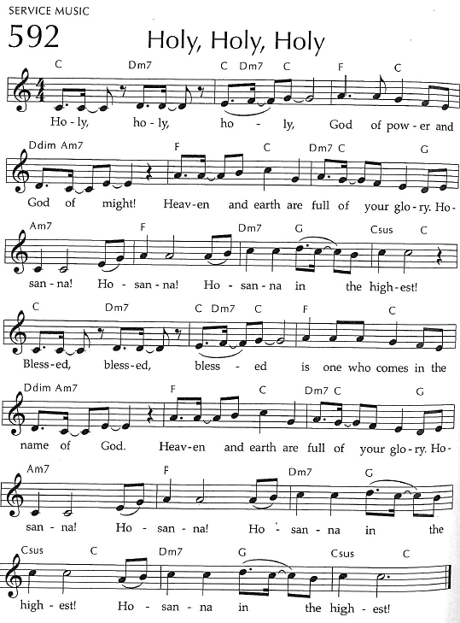
Holy, Holy, Holy

THANKSGIVING AT THE TABLE

God of our weary years, God of our silent tears,
you have brought us this far along the way.
In times of bitterness you did not abandon us,
but guided us into the path of love and light.
In every age you sent prophets
to make known your loving will for all humanity.
The cry of the poor has become your own cry;
our hunger and thirst for justice is your own desire.
In the fullness of time, you sent your chosen servant to preach good news to the afflicted,
to break bread with the outcast and despised,
and to ransom those in
bondage to prejudice and sin.

In the night in which he was betrayed,
our Lord Jesus took bread, and gave thanks;
broke it, and gave it to his disciples, saying:
Take and eat; this is my body, given for you.
Do this for the remembrance of me.
Again, after supper, he took the cup, gave thanks,
and gave it for all to drink, saying:
This cup is the new covenant in my blood,
shed for you and all people for the forgiveness of sin.
Do this for the remembrance of me.
For as often as we eat of this bread and drink from this cup
we proclaim the Lord’s death until he comes.
Christ has died.
Christ is risen.
Christ will come again.
Remembering, therefore, his death and resurrection,
we await the day when Jesus shall return
to free all the earth from the bonds of slavery and death.
Come, Lord Jesus! And let the church say, Amen. Amen.
Send your Holy Spirit, our advocate,
to fill the hearts of all who share this bread and cup
with courage and wisdom to pursue love and justice in all the world.
Come, Spirit of freedom! And let the church say, Amen.
Amen.
Join our prayers and praise with your prophets and martyrs of every age,
that, rejoicing in the hope of the resurrection,
we might live in the freedom and hope of your Son.
Through him, with him, in him, in the unity of the Holy Spirit,
all glory and honor is yours, almighty Father, now and forever.
Amen.


THE LORD’S PRAYER
Our Father, who art in heaven,
hallowed be thy name, thy kingdom come,
thy will be done, on earth as it is in heaven.
Give us this day our daily bread;
and forgive us our trespasses,
as we forgive those who trespass against us;
and lead us not into temptation, but deliver us from evil.
For thine is the kingdom,
and the power, and the glory, forever and ever. Amen.
INVITATION TO COMMUNION - Certified gluten-free crackers are in the bowl on the communion plate.
The kingdom of God is set before you.
Eat and rejoice.
HOLY COMMUNION
PRAYER AFTER COMMUNION
Mothering God,
you gathered us to your table and we drank deeply of your grace.
Send us out by your Spirit to love our neighbors as ourselves
and proclaim your love in Jesus’ name.
Amen.
SENDING
BLESSING
The love of God abound in you;
the grace of our Savior Jesus Christ fill your hearts;
and the life of the Spirit
☩ bless you and give you peace.
Amen.
CLOSING HYMN Go in Peace and Serve the Lord
DISMISSAL
Go in peace. Live by the Spirit.
Thanks be to God.

Upcoming Worship Assistants
 | Usher | Lector | Communion | Offering Counters |  | Deep Clean
August 10 | Dave & Shelly Schneider | Leslie Mader | Matt & Margo Berrier | Robin Beeman | David Schneider | August:  Dave & Shelly Schneider  Bruce & Nancy Tibbett
August 17 | Dennis & Deb Janz | Nancy Tibbett | Bob & Laurel Peterson | Heidi Binder | Kami Weis | August:  Dave & Shelly Schneider  Bruce & Nancy Tibbett
August 24 | John & Jennifer Rickinger | Julie Will | Dave & Shelly Schneider | Pam Mundt | Margo Berrier | August:  Dave & Shelly Schneider  Bruce & Nancy Tibbett
August 31 | Dave & Sue Schraeder | Chris Tipping | Bruce & Nancy Tibbett | Dan Mundt | Bob Peterson | August:  Dave & Shelly Schneider  Bruce & Nancy Tibbett
Coming up at GSLC
Sunday, August 10 | 9:00 am | Outdoor Worship Service  - Ninth Sunday after Pentecost  - Luke 12:32-40; God will give you the treasure of the kingdom; sell all that you have
Tuesday, August 12 | 9:30am-11am | Children’s WI Play and Learn
 | 6:30pm | Council Meeting
 | 7:30pm | AA Meeting
Sunday, August 17 | 9:00am | Outdoor Worship Service  - Tenth Sunday after Pentecost  - Luke 12:49-56; Jesus brings fire on earth and has a baptism with which to be baptized

10 Ways to Save Energy and Stay Cool This Summer
[1] Turn off fans in empty rooms. It ends up fans cool people, not rooms!
[2] Close window blinds and drapes when gone to block sunlight, but open windows at night to them).
[3] Unplug appliances and electronics when not in use or put them on power strips (and use help cool and enjoy the extra daylight when home.
[4] Raise the temperature of your air conditioner during the day to 78ºF and at night to 85ºF. Install (and program) a programmable thermostat to automatically manage temperatures when you are home and away.
[5] Replace incandescent lightbulbs with LED and CFL lighting. Most energy from inefficient lighting is heat.
[6] Use a microwave or grill to cook instead of using an oven.
[7] Take shorter, cooler showers and use bathroom exhaust fans to alleviate humidity.
[8] Run dishwasher (instead of washing by hand), and use laundry machines only when full. Allow the dishes to air-dry and remove lint from the dryer.
[9] Decrease temperature of water heater to 120ºF.
[10] Go outside! Maybe enjoy a state park!

Shared by GSLC Green Team, from cleanenergyresourceteams.org

Outdoor movies are back for the summer! This year, we’re partnering with Marshfield Young Professionals for Movies in the Park. Movies will be shown the 3rd Friday in June, July, and August. June and August’s movies will be at Columbia Park. All movies will begin at dusk, GSLC is the rain location for June and August.

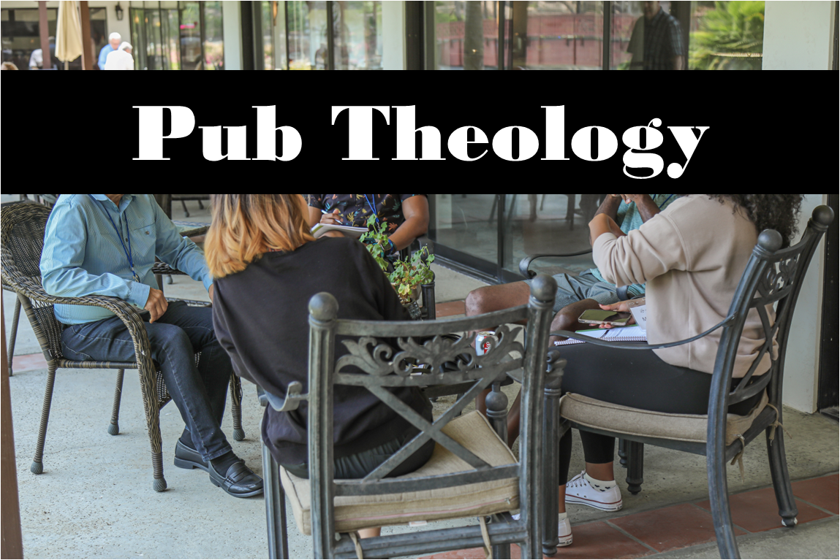
Pub Theology is returning for the summer!
1st & 3rd Wednesday June-August: Scotty’s Pizza & Chicken 6:00 pm
This year, we’re collaborating with Wesley UMC. Topics each week include: Having Hard Conversations (6/4), Attitude of Gratitude (6/18), Good Grief (7/2), What is Truth? (7/16), Faith & Science (8/6), Religion & Politics (8/20)
What is Pub Theology? People have been gathering in pubs and public spaces for ages talking about life, philosophy, faith, and deep questions of meaning. Increasingly, people all over are rediscovering the pub as a safe, open space where they can explore and express their own doubts and questions, learn from others, and engage people of varying religious traditions. In our increasingly fractured society, these spaces are not only welcome but needed.
Bring your questions and curiosity, and pull up a chair.
There will be fellowship time after worship one Sunday a month. Please sign up on the table in the narthex.
Names on the prayer list now default to 6 weeks. If you would like a name to remain on the list longer, please let Pastor Katie know.
Pastor Katie’s Office Hours: Monday-Thursday 9am-2pm. Tuesday mornings at Uptown Coffee. Afternoons available by appointment. You are welcome to stop in any time for conversation or concerns.

