
Good Shepherd Lutheran Church
Pastor: Rev. Katie Anderson | Music Director: Rev. Lois Swanson
Pastor’s Cell: (715) 502-9433 | Office Phone: (715) 387-2731
Pastor Email: gslcwi.pastor@gmail.com | Office Email: gslcwi.office@gmail.com
Website: GoodShepherdMarshfield.org
Eighth Sunday after Pentecost
August 3 2025, 9:00 am
Introduction to the day…
ANNOUNCEMENTS

GATHERING
Today’s texts offer instruction and encouragement for all who are occasionally overwhelmed by the “unhappy business” of life. Jesus urges us to take care and be on guard against all kinds of greed. We who have died with Christ in holy baptism have also been raised with him and are encouraged to elevate our thinking, seeking the “things that are above.” To that end we seek the sustenance of the Lord’s supper and the encouragement of God’s word.
GATHERING HYMN Build a Longer Table ACS 1062

Confession and Forgiveness
In the name of the Father,
and of the ☩ Son,
and of the Holy Spirit.
Amen.
Baptized into Christ, let us confess our sin.
Silence is kept for reflection.
Merciful God,
you free us to love others,
but we neglect our neighbors and follow our own way.
You lead us by the Spirit of joy and peace,
but we turn away from the abundant life you offer.
You surround us with patience, kindness, and generosity,
but we grow weary in doing what is right.
In your mercy, forgive us.
Do not give up on us.
Heal us, break our bonds, and show us the path of life.
Amen.
You belong to Christ Jesus and you are God’s children through faith.
In the cross of ☩ Christ, and through the power of the Holy Spirit, your sins are forgiven.
Clothed with Christ, you are a new creation.
Amen.
PRAYER OF THE DAY
Benevolent God, you are the source, the guide, and the goal of our lives. Teach us to love what is worth loving, to reject what is offensive to you, and to treasure what is precious in your sight, through Jesus Christ, our Savior and Lord.
Amen.
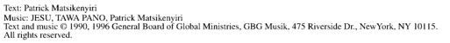
CHILDREN’S MUSIC Jesus, We are Gathered ELW 529
CHILDREN’S MESSAGE
SCRIPTURE READINGS
FIRST READING: Ecclesiastes 1:2, 12-14; 2:18-23
² Vanity of vanities, says the Teacher, vanity of vanities! All is vanity.
¹² I, the Teacher, was king over Israel in Jerusalem. ¹³ I applied my mind to seek and to search out by wisdom all that is done under heaven; it is an unhappy business that God has given to humans to be busy with. ¹⁴ I saw all the deeds that are done under the sun, and see, all is vanity and a chasing after wind. ^{2:18} I hated all my toil in which I had toiled under the sun, seeing that I must leave it to my successor, ¹⁹ and who knows whether he will be wise or foolish? Yet he will be master of all for which I toiled and used my wisdom under the sun. This also is vanity. ²⁰ So I turned and gave my heart up to despair concerning all the toil of my labors under the sun, ²¹ because sometimes one who has toiled with wisdom and knowledge and skill must leave all to be enjoyed by another who did not toil for it. This also is vanity and a great evil. ²² What do mortals get from all the toil and strain with which they toil under the sun? ²³ For all their days are full of pain, and their work is a vexation; even at night their minds do not rest. This also is vanity.
Word of God, word of life.
Thanks be to God.
PSALM: Psalm 49:1-12
¹ Hear this, all you peoples;
give ear, all you who dwell in the world,
² you of high degree and low, rich and poor together.
³ My mouth shall speak of wisdom,
and my heart shall meditate on understanding.
⁴ I will incline my ear to a proverb and set forth my riddle upon the harp.
⁵ Why should I be afraid in evil days,
when the wickedness of those at my heels surrounds me,
⁶ the wickedness of those who put their trust in their own prowess,
and boast of their great riches?
⁷ One can never redeem another,
or give to God the ransom for another’s life;
⁸ for the ransom of a life is so great that there would never be enough to pay it,
⁹ in order to live forever and ever and never see the grave.
¹⁰ For we see that the wise die also; like the dull and stupid they perish
and leave their wealth to those who come after them.
¹¹ Their graves shall be their homes forever, their dwelling places from generation to generation,
though they had named lands after themselves.
¹² Even though honored, they cannot live forever;
they are like the beasts that perish.
SECOND READING: Colossians 3:1-11
¹ So if you have been raised with Christ, seek the things that are above, where Christ is, seated at the right hand of God. ² Set your minds on the things that are above, not on the things that are on earth, ³ for you have died, and your life is hidden with Christ in God. ⁴ When Christ who is your life is revealed, then you also will be revealed with him in glory.
⁵ Put to death, therefore, whatever in you is earthly: sexual immorality, impurity, passion, evil desire, and greed (which is idolatry). ⁶ On account of these the wrath of God is coming on those who are disobedient. ⁷ These are the ways you also once followed, when you were living that life. ⁸ But now you must get rid of all such things: anger, wrath, malice, slander, and abusive language from your mouth. ⁹ Do not lie to one another, seeing that you have stripped off the old self with its practices ¹⁰ and have clothed yourselves with the new self, which is being renewed in knowledge according to the image of its creator. ¹¹ In that renewal there is no longer Greek and Jew, circumcised and uncircumcised, barbarian, Scythian, enslaved and free, but Christ is all and in all!
Word of God, word of life.
Thanks be to God.
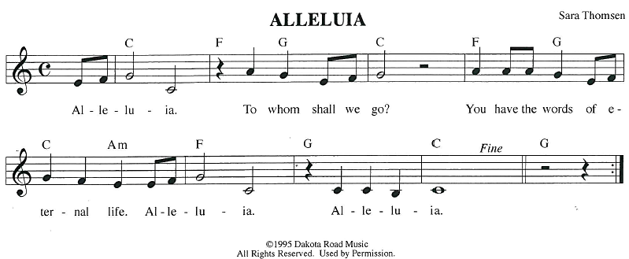
GOSPEL ACCLAMATION
GOSPEL: Luke 12:13-21
¹³ Someone in the crowd said to [Jesus,] “Teacher, tell my brother to divide the family inheritance with me.” ¹⁴ But he said to him, “Friend, who set me to be a judge or arbitrator over you?” ¹⁵ And he said to them, “Take care! Be on your guard against all kinds of greed, for one’s life does not consist in the abundance of possessions.” ¹⁶ Then he told them a parable: “The land of a rich man produced abundantly. ¹⁷ And he thought to himself, ‘What should I do, for I have no place to store my crops?’ ¹⁸ Then he said, ‘I will do this: I will pull down my barns and build larger ones, and there I will store all my grain and my goods. ¹⁹ And I will say to my soul, Soul, you have ample goods laid up for many years; relax, eat, drink, be merry.’ ²⁰ But God said to him, ‘You fool! This very night your life is being demanded of you. And the things you have prepared, whose will they be?’ ²¹ So it is with those who store up treasures for themselves but are not rich toward God.”
The gospel of the Lord.
Praise to you, O Christ.
SERMON
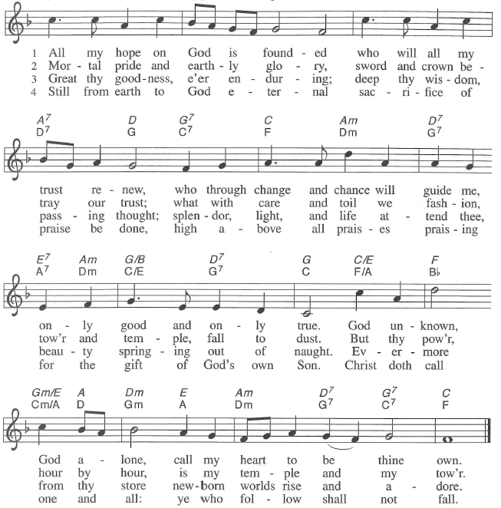
HYMN OF THE DAY All My Hope on God Is Founded ELW 757

APOSTLES’ CREED
I believe in God, the Father almighty,
creator of heaven and earth.
I believe in Jesus Christ, God's only Son, our Lord,
who was conceived by the power of the Holy Spirit, born of the Virgin Mary,
suffered under Pontius Pilate, was crucified, died, and was buried;
he descended to the dead.
On the third day he rose again;
he ascended into heaven, he is seated at the right hand of the Father,
and he will come to judge the living and the dead.
I believe in the Holy Spirit, the holy catholic Church,
the communion of saints, the forgiveness of sins,
the resurrection of the body, and the life everlasting. Amen.
PRAYERS OF INTERCESSION
…God of Grace.
Hear our prayer
Trusting in your lovingkindness, we place our prayer and hope in you, in the name of Jesus Christ.
Amen.
PEACE
The peace of Christ be with you always.
And also with you.
HOLY COMMUNION
OFFERING In addition to our normal offering, a Special Benevolence in August (collected in a special envelope) will be going to Lutheran Disaster Response’s Flood Relief.
OFFERING SONG For the Fruit of All Creation ELW 679
OFFERTORY PRAYER
Creator God,
in your wisdom you bring forth all that is good and the harvest is plentiful.

Strengthen us at your table with these gifts of the earth and our labor,
that we may work for the good of all;
through Jesus Christ, our Savior.
Amen.
GREAT THANKSGIVING
The Lord be with you.
And also with you.
Lift up your hearts.
We lift them to the Lord.
Let us give our thanks to the Lord our God.
It is right to give our thanks and praise.

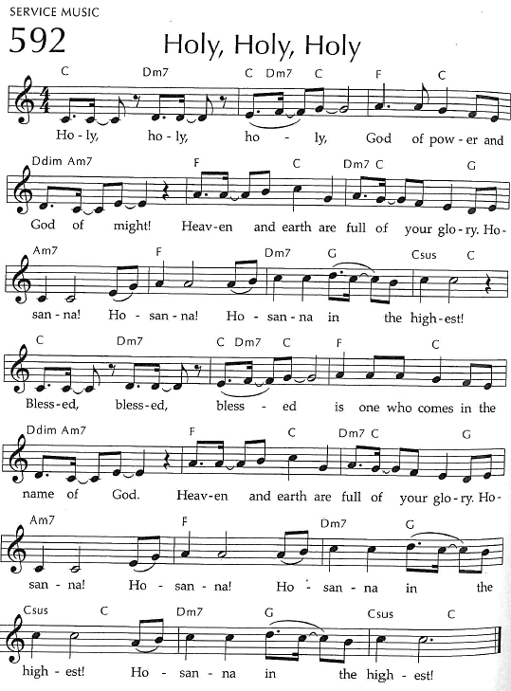
Holy, Holy, Holy

THANKSGIVING AT THE TABLE

God of our weary years, God of our silent tears,
you have brought us this far along the way.
In times of bitterness you did not abandon us,
but guided us into the path of love and light.
In every age you sent prophets
to make known your loving will for all humanity.
The cry of the poor has become your own cry;
our hunger and thirst for justice is your own desire.
In the fullness of time, you sent your chosen servant to preach good news to the afflicted,
to break bread with the outcast and despised,
and to ransom those in
bondage to prejudice and sin.
In the night in which he was betrayed,
our Lord Jesus took bread, and gave thanks;
broke it, and gave it to his disciples, saying:
Take and eat; this is my body, given for you.
Do this for the remembrance of me.
Again, after supper, he took the cup, gave thanks,
and gave it for all to drink, saying:
This cup is the new covenant in my blood,
shed for you and all people for the forgiveness of sin.
Do this for the remembrance of me.
For as often as we eat of this bread and drink from this cup
we proclaim the Lord’s death until he comes.
Christ has died.
Christ is risen.
Christ will come again.
Remembering, therefore, his death and resurrection,
we await the day when Jesus shall return
to free all the earth from the bonds of slavery and death.
Come, Lord Jesus! And let the church say, Amen. Amen.
Send your Holy Spirit, our advocate,
to fill the hearts of all who share this bread and cup
with courage and wisdom to pursue love and justice in all the world.
Come, Spirit of freedom! And let the church say, Amen.
Amen.
Join our prayers and praise with your prophets and martyrs of every age,
that, rejoicing in the hope of the resurrection,
we might live in the freedom and hope of your Son.
Through him, with him, in him, in the unity of the Holy Spirit,
all glory and honor is yours, almighty Father, now and forever.
Amen.


THE LORD’S PRAYER
Our Father, who art in heaven,
hallowed be thy name, thy kingdom come,
thy will be done, on earth as it is in heaven.
Give us this day our daily bread;
and forgive us our trespasses,
as we forgive those who trespass against us;
and lead us not into temptation, but deliver us from evil.
For thine is the kingdom,
and the power, and the glory, forever and ever. Amen.
INVITATION TO COMMUNION - Certified gluten-free crackers are in the bowl on the communion plate.
The kingdom of God is set before you.
Eat and rejoice.
HOLY COMMUNION
PRAYER AFTER COMMUNION
Mothering God,
you gathered us to your table and we drank deeply of your grace.
Send us out by your Spirit to love our neighbors as ourselves
and proclaim your love in Jesus’ name.
Amen.
SENDING
BLESSING
The love of God abound in you;
the grace of our Savior Jesus Christ fill your hearts;
and the life of the Spirit
☩ bless you and give you peace.
Amen.
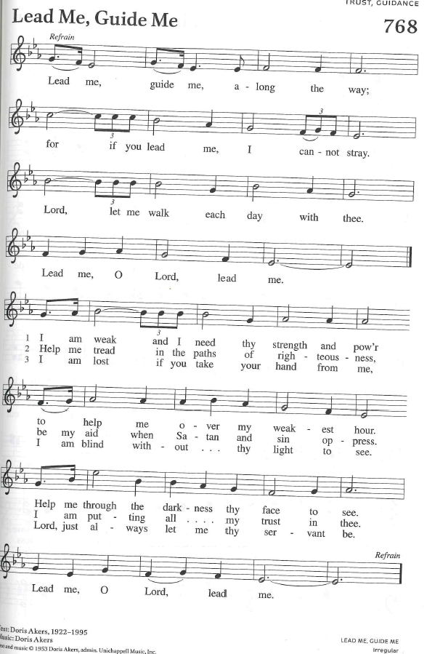
CLOSING HYMN Lead Me, Guide Me ELW 768
DISMISSAL
Go in peace. Live by the Spirit.
Thanks be to God.
Upcoming Worship Assistants
 | Usher | Lector | Communion | Offering Counters |  | Deep Clean
August 3 | Dennis & Linda Schutte | Kris Tarter | Andrea Hovick  Sarah Kopitzke | Nancy Leonard | Bob Peterson | August:  Dave & Shelly Schneider  Bruce & Nancy Tibbett
August 10 | Dave & Shelly Schneider | Leslie Mader | Matt & Margo Berrier | Robin Beeman | David Schneider | August:  Dave & Shelly Schneider  Bruce & Nancy Tibbett
August 17 | Dennis & Deb Janz | Nancy Tibbett | Bob & Laurel Peterson | Heidi Binder | Kami Weis | August:  Dave & Shelly Schneider  Bruce & Nancy Tibbett
August 24 | John & Jennifer Rickinger | Julie Will | Dave & Shelly Schneider | Pam Mundt | Margo Berrier | August:  Dave & Shelly Schneider  Bruce & Nancy Tibbett
Coming up at GSLC
Sunday, August 3 | 9:00 am | Outdoor Worship Service  - Eighth Sunday after Pentecost  - Luke 12:13-21; Jesus says: Be on guard against greed; be rich toward God, your treasure
Tuesday, August 5 | 9:30am-11am | Children’s WI Play and Learn
 | 7:00 pm | AA Meeting
Wednesday, August 6 | 9:00 am | Executive Committee
 | 6:00 pm | Pub Theology at Scotty’s Pizza & Chicken  Topic: “Faith & Science”
Thursday, August 7 | 11am-2pm | Purple Angels Lunch and Fellowship
 | 9:30am-11am | Wood Co. Birth to 3 Play Group
Sunday, August 10 | 9:00 am | Outdoor Worship Service  - Ninth Sunday after Pentecost  - Luke 12:32-40; God will give you the treasure of the kingdom; sell all that you have
Pastor Katie’s Office Hours: Monday-Thursday 9am-2pm. Tuesday mornings at Uptown Coffee. Afternoons available by appointment. You are welcome to stop in any time for conversation or concerns.
Outdoor movies are back for the summer! This year, we’re partnering with Marshfield Young Professionals for Movies in the Park. Movies will be shown the 3rd Friday in June, July, and August. June and August’s movies will be at Columbia Park. All movies will begin at dusk, GSLC is the rain location for June and August.


Pub Theology is returning for the summer!
1st & 3rd Wednesday June-August: Scotty’s Pizza & Chicken 6:00 pm
This year, we’re collaborating with Wesley UMC. Topics each week include: Having Hard Conversations (6/4), Attitude of Gratitude (6/18), Good Grief (7/2), What is Truth? (7/16), Faith & Science (8/6), Religion & Politics (8/20)
What is Pub Theology? People have been gathering in pubs and public spaces for ages talking about life, philosophy, faith, and deep questions of meaning. Increasingly, people all over are rediscovering the pub as a safe, open space where they can explore and express their own doubts and questions, learn from others, and engage people of varying religious traditions. In our increasingly fractured society, these spaces are not only welcome but needed.
Bring your questions and curiosity, and pull up a chair.
There will be fellowship time after worship one Sunday a month. Please sign up on the table in the narthex.
Names on the prayer list now default to 6 weeks. If you would like a name to remain on the list longer, please let Pastor Katie know.

