
Good Shepherd Lutheran Church
Pastor: Rev. Katie Anderson | Music Director: Rev. Lois Swanson
Pastor’s Cell: (715) 502-9433 | Office Phone: (715) 387-2731
Pastor Email: gslcwi.pastor@gmail.com | Office Email: gslcwi.office@gmail.com
Website: GoodShepherdMarshfield.org
Fourth Sunday after Pentecost
July 6, 2025, 9:00 am
Introduction to the day…
ANNOUNCEMENTS
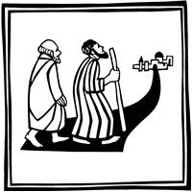
GATHERING
God is the source of our nourishment. Jesus’ invitation to “take and eat . . . take and drink” is a repeated one. In holy communion, in the word read and proclaimed, in the assembly of the people of God, the dominion of God has come near. Rejoice! Your name is written in heaven.

GATHERING HYMN As the Deer
1 As the deer pants for the water  So my soul longs after you;  You alone are my heart's desire  And I long to worship you. | 2 I want you more than gold or silver,  Only you can satisfy;  You alone are the real joy-giver  And the apple of my eye.
Refrain  You alone are my strength my shield  To you alone may my spirit yield  You alone are my heart's desire  And I long to worship you. | 3 You're my friend and you are my brother,  Even though you are a King;  I love you more than any other,  So much more than anything!
Words & Music: Martin Nystrom (1956-), alt. Words & Music © 1984 Maranatha Praise, Inc. Used by permission. CCLI LICENSE #669990
Confession and Forgiveness
In the name of the Father,
and of the ☩ Son,

and of the Holy Spirit.
Amen.
Baptized into Christ, let us confess our sin.
Silence is kept for reflection.
Merciful God,
you free us to love others,
but we neglect our neighbors and follow our own way.
You lead us by the Spirit of joy and peace,
but we turn away from the abundant life you offer.
You surround us with patience, kindness,
and generosity,
but we grow weary in doing what is right.
In your mercy, forgive us.
Do not give up on us.
Heal us, break our bonds, and show us the path of life.
Amen.
You belong to Christ Jesus and you are God’s children through faith.
In the cross of ☩ Christ,
and through the power of the Holy Spirit,
your sins are forgiven.
Clothed with Christ, you are a new creation.
Amen.
PRAYER OF THE DAY
O God, the Father of our Lord Jesus, you are the city that shelters us, the mother who comforts us. With your Spirit accompany us on our life’s journey, that we may spread your peace in all the world, through your Son, Jesus Christ, our Savior and Lord.
Amen.
CHILDREN’S MUSIC Send Me, Lord ELW 809
CHILDREN’S MESSAGE
SCRIPTURE READINGS
FIRST READING: Isaiah 66:10-14
¹⁰ Rejoice with Jerusalem, and be glad for her,
all you who love her;
rejoice with her in joy,
all you who mourn over her—
¹¹ that you may nurse and be satisfied from her consoling breast,
that you may drink deeply with delight from her glorious bosom.
¹² For thus says the Lord:
I will extend prosperity to her like a river and the wealth of the nations like an overflowing stream,
and you shall nurse and be carried on her arm and bounced on her knees.
¹³ As a mother comforts her child,
so I will comfort you;
you shall be comforted in Jerusalem.
¹⁴ You shall see, and your heart shall rejoice;
your bodies shall flourish like the grass,
and it shall be known that the power of the Lord is with his servants,
and his indignation is against his enemies
Word of God, word of life.
Thanks be to God.

PSALM: Psalm 66:1-9
¹ Be joyful in God, all you lands;
be joyful, all the earth.
² Sing the glory of God’s name;
sing the glory of God’s praise.
³ Say to God, “How awesome are your deeds!
Because of your great strength your enemies cringe before you.
⁴ All the earth bows down before you,
sings to you, sings out your name.”
⁵ Come now and see the works of God,
how awesome are God’s deeds toward all people.
⁶ God turned the sea into dry land, so that they went through the water on foot,
and there we rejoiced in God.
⁷ Ruling forever in might, God keeps watch over the nations;
let no rebels exalt themselves.
⁸ Bless our God, you peoples;
let the sound of praise be heard.
⁹ Our God has kept us among the living
and has not allowed our feet to slip.
SECOND READING: Galatians 6:[1-6] 7-16
[¹ My brothers and sisters, if anyone is detected in a transgression, you who have received the Spirit should restore such a one in a spirit of gentleness. Take care that you yourselves are not tempted. ² Bear one another’s burdens, and in this way you will fulfill the law of Christ. ³ For if those who are nothing think they are something, they deceive themselves. ⁴ All must test their own work; then that work, rather than their neighbor’s work, will become a cause for pride. ⁵ For all must carry their own loads.
⁶ Those who are taught the word must share in all good things with their teacher.]
⁷ Do not be deceived; God is not mocked, for you reap whatever you sow. ⁸ If you sow to your own flesh, you will reap corruption from the flesh, but if you sow to the Spirit, you will reap eternal life from the Spirit. ⁹ So let us not grow weary in doing what is right, for we will reap at harvest time, if we do not give up. ¹⁰ So then, whenever we have an opportunity, let us work for the good of all and especially for those of the family of faith.
¹¹ See what large letters I make when I am writing in my own hand! ¹² It is those who want to make a good showing in the flesh who try to compel you to be circumcised—only that they may not be persecuted for the cross of Christ. ¹³ Even the circumcised do not themselves obey the law, but they want you to be circumcised so that they may boast about your flesh. ¹⁴ May I never boast of anything except the cross of our Lord Jesus Christ, by which the world has been crucified to me and I to the world. ¹⁵ For neither circumcision nor uncircumcision is anything, but a new creation is everything! ¹⁶ As for those who will follow this rule—peace be upon them, and mercy, and upon the Israel of God.
Word of God, word of life.
Thanks be to God.
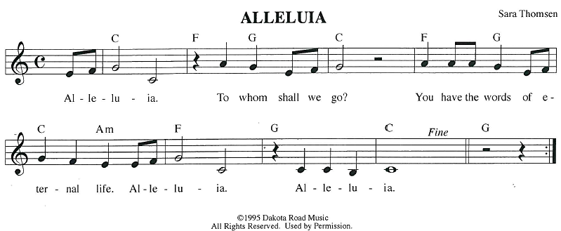
GOSPEL ACCLAMATION
GOSPEL: Luke 10:1-11, 16-20
¹ After this the Lord appointed seventy-two others and sent them on ahead of him in pairs to every town and place where he himself intended to go. ² He said to them, “The harvest is plentiful, but the laborers are few; therefore ask the Lord of the harvest to send out laborers into his harvest. ³ Go on your way; I am sending you out like lambs into the midst of wolves. ⁴ Carry no purse, no bag, no sandals, and greet no one on the road. ⁵ Whatever house you enter, first say, ‘Peace to this house!’ ⁶ And if a person of peace is there, your peace will rest on that person, but if not, it will return to you. ⁷ Remain in the same house, eating and drinking whatever they provide, for the laborer deserves to be paid. Do not move about from house to house. ⁸ Whenever you enter a town and its people welcome you, eat what is set before you; ⁹ cure the sick who are there, and say to them, ‘The kingdom of God has come near to you.’ ¹⁰ But whenever you enter a town and they do not welcome you, go out into its streets and say, ¹¹ ‘Even the dust of your town that clings to our feet, we wipe off in protest against you. Yet know this: the kingdom of God has come near.’
¹⁶ “Whoever listens to you listens to me, and whoever rejects you rejects me, and whoever rejects me rejects the one who sent me.”
¹⁷ The seventy-two returned with joy, saying, “Lord, in your name even the demons submit to us!” ¹⁸ He said to them, “I watched Satan fall from heaven like a flash of lightning. ¹⁹ Indeed, I have given you authority to tread on snakes and scorpions and over all the power of the enemy, and nothing will hurt you. ²⁰ Nevertheless, do not rejoice at this, that the spirits submit to you, but rejoice that your names are written in heaven.”
The gospel of the Lord.
Praise to you, O Christ.
SERMON

HYMN OF THE DAY Go to the World ACS 991
APOSTLES’ CREED
I believe in God, the Father almighty,
creator of heaven and earth.
I believe in Jesus Christ, God's only Son, our Lord,
who was conceived by the power of the Holy Spirit, born of the Virgin Mary,
suffered under Pontius Pilate, was crucified, died, and was buried;
he descended to the dead.
On the third day he rose again;
he ascended into heaven, he is seated at the right hand of the Father,
and he will come to judge the living and the dead.
I believe in the Holy Spirit, the holy catholic Church,
the communion of saints, the forgiveness of sins,
the resurrection of the body, and the life everlasting. Amen.
PRAYERS OF INTERCESSION
…God of Grace.
Hear our prayer
Gather all our prayers in your mercy, O God, through Jesus Christ, our Savior.
Amen.
PEACE
The peace of Christ be with you always.
And also with you.

HOLY COMMUNION
OFFERING In addition to our normal offering, a Special Benevolence in July (collected in a special
envelope) will be going to Marshfield Area Respite Care.
OFFERING SONG Here I Am Lord ELW 574
OFFERTORY PRAYER
Creator God,
in your wisdom you bring forth all that is good
and the harvest is plentiful.
Strengthen us at your table with these gifts of the earth
and our labor,
that we may work for the good of all;
through Jesus Christ, our Savior.
Amen.

GREAT THANKSGIVING
The Lord be with you.
And also with you.
Lift up your hearts.
We lift them to the Lord.
Let us give our thanks to the Lord our God.
It is right to give our thanks and praise.
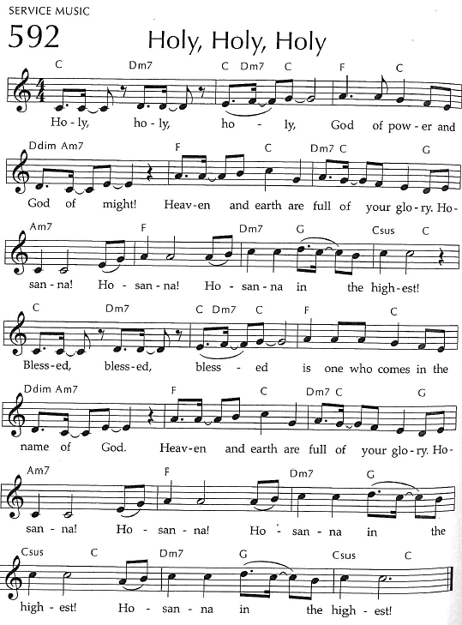
Holy, Holy, Holy

THANKSGIVING AT THE TABLE

God of our weary years, God of our silent tears,
you have brought us this far along the way.
In times of bitterness you did not abandon us,
but guided us into the path of love and light.
In every age you sent prophets
to make known your loving will for all humanity.
The cry of the poor has become your own cry;
our hunger and thirst for justice is your own desire.
In the fullness of time, you sent your chosen servant to preach good news to the afflicted,
to break bread with the outcast and despised,
and to ransom those in
bondage to prejudice and sin.
In the night in which he was betrayed,
our Lord Jesus took bread, and gave thanks;
broke it, and gave it to his disciples, saying:
Take and eat; this is my body, given for you.
Do this for the remembrance of me.

Again, after supper, he took the cup, gave thanks,
and gave it for all to drink, saying:
This cup is the new covenant in my blood,
shed for you and all people for the forgiveness of sin.
Do this for the remembrance of me.
For as often as we eat of this bread and drink from this cup
we proclaim the Lord’s death until he comes.
Christ has died.
Christ is risen.
Christ will come again.
Remembering, therefore, his death and resurrection,
we await the day when Jesus shall return
to free all the earth from the bonds of slavery and death.
Come, Lord Jesus! And let the church say, Amen. Amen.
Amen.
Send your Holy Spirit, our advocate,
to fill the hearts of all who share this bread and cup
with courage and wisdom to pursue love and justice in all the world.
Come, Spirit of freedom! And let the church say, Amen.
Amen.
Join our prayers and praise with your prophets and martyrs of every age,
that, rejoicing in the hope of the resurrection,
we might live in the freedom and hope of your Son.
Through him, with him, in him, in the unity of the Holy Spirit,
all glory and honor is yours, almighty Father, now and forever.
Amen.

THE LORD’S PRAYER
Our Father, who art in heaven,
hallowed be thy name, thy kingdom come,
thy will be done, on earth as it is in heaven.
Give us this day our daily bread;
and forgive us our trespasses,
as we forgive those who trespass against us;
and lead us not into temptation, but deliver us from evil.
For thine is the kingdom,
and the power, and the glory, forever and ever. Amen.
INVITATION TO COMMUNION - Certified gluten-free crackers are in the bowl on the communion plate.
The kingdom of God is set before you.
Eat and rejoice.
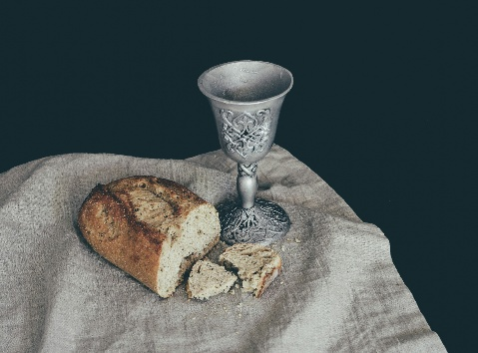
HOLY COMMUNION
PRAYER AFTER COMMUNION
Mothering God,
you gathered us to your table
and we drank deeply of your grace.
Send us out by your Spirit
to love our neighbors as ourselves
and proclaim your love in Jesus’ name.
Amen.
SENDING
BLESSING
The love of God abound in you;
the grace of our Savior Jesus Christ fill your hearts;
and the life of the Spirit
☩ bless you and give you peace.
Amen.
CLOSING HYMN Lift Every Voice and Sing ELW 841
DISMISSAL
Go in peace. Live by the Spirit.
Upcoming Worship Assistants
 | Usher | Lector | Communion | Offering Counters |  | Deep Clean
July 6 | Charles & Mary Schlafke | Rob Pankratz | Bruce & Nancy Tibbett | Robin Beeman | David Schneider | July:  John & Jane Wagner  Laurel Peterson  Leslie Mader
July 13 | Rob Pankratz | Jon Hill | Tammy Neumann  Ron Rothfusz | Heidi Binder | Kami Weis | July:  John & Jane Wagner  Laurel Peterson  Leslie Mader
July 20 | Dennis & Linda Schutte | Richard Kopitzke | Nancy Leonard Rob Pankratz | Pam Mundt | Margo Berrier | July:  John & Jane Wagner  Laurel Peterson  Leslie Mader
July 27 | Ben & Sue Lee | Tammy Neumann | Dave & Sue Schraeder | Dan Mundt | Bob Peterson | July:  John & Jane Wagner  Laurel Peterson  Leslie Mader
Thanks be to God.
There will be fellowship time after worship one Sunday a month. Please sign up on the table in the narthex.
Names on the prayer list now default to 6 weeks. If you would like a name to remain on the list longer, please let Pastor Katie know.
Pastor Katie’s Office Hours: Monday-Thursday 9am-2pm. Tuesday mornings at Uptown Coffee. Afternoons available by appointment. You are welcome to stop in any time for conversation or concerns.
Message from Good Shepherd's Green Team:
Did you know you can recycle mattresses and keep them out of the landfill?
Find a Recycling Outlet : uwgb.edu/recycling
The Wisconsin Recycling Markets Directory (WRMD) provides information about landfill diversion opportunities for various materials in Wisconsin. Search the list of entries for various materials, view information about the listing and suggest additional outlets to include in the directory. For a listing and description of the materials, see recycling category definitions. For where to recycle mattresses, click on "Other Materials" in the Material Category, then "Mattresses/Box Springs" in the Material Subcategory.
Inclusion on this list is not intended to imply endorsement by the Wisconsin Department of Natural Resources, the Environmental Management and Business Institute, and UW-Green Bay, nor is exclusion intentional.
Before You Visit: We recommend calling ahead to discuss restrictions or specifications, learn about pick-up or drop-off options, etc. You can save time if you confirm accepted materials, quantities and any associated fees before you go.

Coming up at GSLC
Sunday, July 6 | 9:00 am | Worship Service  - Fourth Sunday after Pentecost  - Luke 10:1-11, 16-20; Jesus sends out seventy disciples into the harvest
Tuesday, July 8 | 6:30 pm | Council Meeting
 | 7:00 pm | AA Meeting
Sunday, July 13 | 9:00 am | Worship Service  - Fifth Sunday after Pentecost  - Luke 10:25-37; The parable of the merciful Samaritan

Outdoor movies are back for the summer! This year, we’re partnering with Marshfield Young Professionals for Movies in the Park. Movies will be shown the 3rd Friday in June, July, and August. June and August’s movies will be at Columbia Park. We are sponsoring July’s movie, Mufasa, shown here. All movies will begin at dusk, GSLC is the rain location for June and August.


Pub Theology is returning for the summer!
1st & 3rd Wednesday June-August
Scotty’s Pizza & Chicken 6:00 pm
This year, we’re collaborating with Wesley UMC. Topics each week include: Having Hard Conversations (6/4), Attitude of Gratitude (6/18), Good Grief (7/2), What is Truth? (7/16), Faith & Science (8/6), Religion & Politics (8/20)
What is Pub Theology? People have been gathering in pubs and public spaces for ages talking about life, philosophy, faith, and deep questions of meaning. Increasingly, people all over are rediscovering the pub as a safe, open space where they can explore and express their own doubts and questions, learn from others, and engage people of varying religious traditions. In our increasingly fractured society, these spaces are not only welcome but needed.
Bring your questions and curiosity, and pull up a chair.

