
Good Shepherd Lutheran Church
Pastor: Rev. Katie Anderson | Music Director: Rev. Lois Swanson
Pastor’s Cell: (715) 502-9433 | Office Phone: (715) 387-2731
Pastor Email: gslcwi.pastor@gmail.com | Office Email: gslcwi.office@gmail.com
Website: GoodShepherdMarshfield.org
Seventh Sunday after Pentecost
July 27 2025, 9:00 am
Introduction to the day…
ANNOUNCEMENTS
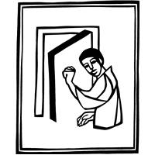
GATHERING
Persistence in prayer is encouraged by Jesus and wins the attention of God when Abraham intercedes for Sodom. The life of the baptized—to be rooted and built up in Christ Jesus—is to be nurtured with prayer. God hears and answers prayer and so strengthens God’s own. “When I called, you answered me; you increased my strength within me.”
GATHERING HYMN Sweet Hour of Prayer

Confession and Forgiveness
In the name of the Father,
and of the ☩ Son,
and of the Holy Spirit.
Amen.

Baptized into Christ, let us confess our sin.
Silence is kept for reflection.
Merciful God,
you free us to love others,
but we neglect our neighbors and follow our own way.
You lead us by the Spirit of joy and peace,
but we turn away from the abundant life you offer.
You surround us with patience, kindness,
and generosity,
but we grow weary in doing what is right.
In your mercy, forgive us.
Do not give up on us.
Heal us, break our bonds, and show us the path of life.
Amen.
You belong to Christ Jesus and you are God’s children through faith.
In the cross of ☩ Christ,
and through the power of the Holy Spirit,
your sins are forgiven.
Clothed with Christ, you are a new creation.
Amen.
PRAYER OF THE DAY
Almighty and ever-living God, you are always more ready to hear than we are to pray, and you gladly give more than we either desire or deserve. Pour upon us your abundant mercy. Forgive us those things that weigh on our conscience, and give us those good things that come only through your Son, Jesus Christ, our Savior and Lord.
Amen.
CHILDREN’S MUSIC Send Me, Lord ELW 809
CHILDREN’S MESSAGE
SCRIPTURE READINGS
FIRST READING: Genesis 18:20-32
²⁰ Then the Lord said, “How great is the outcry against Sodom and Gomorrah and how very grave their sin! ²¹ I must go down and see whether they have done altogether according to the outcry that has come to me, and if not, I will know.”
²² So the men turned from there and went toward Sodom, while Abraham remained standing before the Lord. ²³ Then Abraham came near and said, “Will you indeed sweep away the righteous with the wicked? ²⁴ Suppose there are fifty righteous within the city; will you then sweep away the place and not forgive it for the fifty righteous who are in it? ²⁵ Far be it from you to do such a thing, to slay the righteous with the wicked, so that the righteous fare as the wicked! Far be that from you! Shall not the Judge of all the earth do what is just?” ²⁶ And the Lord said, “If I find at Sodom fifty righteous in the city, I will forgive the whole place for their sake.” ²⁷ Abraham answered, “Let me take it upon myself to speak to my lord, I who am but dust and ashes. ²⁸ Suppose five of the fifty righteous are lacking? Will you destroy the whole city for lack of five?” And he said, “I will not destroy it if I find forty-five there.” ²⁹ Again he spoke to him, “Suppose forty are found there.” He answered, “For the sake of forty I will not do it.” ³⁰ Then he said, “Oh, do not let my lord be angry if I speak. Suppose thirty are found there.” He answered, “I will not do it, if I find thirty there.” ³¹ He said, “Let me take it upon myself to speak to my lord. Suppose twenty are found there.” He answered, “For the sake of twenty I will not destroy it.” ³² Then he said, “Oh, do not let my lord be angry if I speak just once more. Suppose ten are found there.” He answered, “For the sake of ten I will not destroy it.”
Word of God, word of life.
Thanks be to God.
PSALM: Psalm 138
¹ I will give thanks to you, O Lord, with my whole heart;
before the gods I will sing your praise.
² I will bow down toward your holy temple and praise your name, because of your steadfast love and faithfulness;
for you have glorified your name and your word above all things.
³ When I called, you answered me;
you increased my strength within me.
⁴ All the rulers of the earth will praise you, O Lord,
when they have heard the words of your mouth.
⁵ They will sing of the ways of the Lord,
that great is the glory of the Lord.
⁶ The Lord is high, yet cares for the lowly,
perceiving the haughty from afar.
⁷ Though I walk in the midst of trouble, you keep me safe;
you stretch forth your hand against the fury of my enemies; your right hand shall save me.
⁸ You will make good your purpose for me;
O Lord, your steadfast love endures forever; do not abandon the works of your hands.
SECOND READING: Colossians 2:6-15[16-19]
⁶ As you therefore have received Christ Jesus the Lord, continue to walk in him, ⁷ rooted and built up in him and established in the faith, just as you were taught, abounding in thanksgiving.
⁸ Watch out that no one takes you captive through philosophy and empty deceit, according to human tradition, according to the elemental principles of the world, and not according to Christ. ⁹ For in him the whole fullness of deity dwells bodily, ¹⁰ and you have come to fullness in him, who is the head of every ruler and authority. ¹¹ In him also you were circumcised with a spiritual circumcision, by the removal of the body of the flesh in the circumcision of Christ; ¹² when you were buried with him in baptism, you were also raised with him through faith in the power of God, who raised him from the dead. ¹³ And when you were dead in trespasses and the uncircumcision of your flesh, God made you alive together with him, when he forgave us all our trespasses, ¹⁴ erasing the record that stood against us with its legal demands. He set this aside, nailing it to the cross. ¹⁵ He disarmed the rulers and authorities and made a public example of them, triumphing over them in it. [
¹⁶ Therefore, do not let anyone condemn you in matters of food or drink or of observing festivals, new moons, or Sabbaths. ¹⁷ These are only a shadow of what is to come, but the body belongs to Christ. ¹⁸ Do not let anyone disqualify you, insisting on self-abasement and worship of angels, initiatory visions, puffed up without cause by a human way of thinking, ¹⁹ and not holding fast to the head, from whom the whole body, nourished and held together by its ligaments and tendons, grows with a growth that is from God.]
Word of God, word of life.
Thanks be to God.
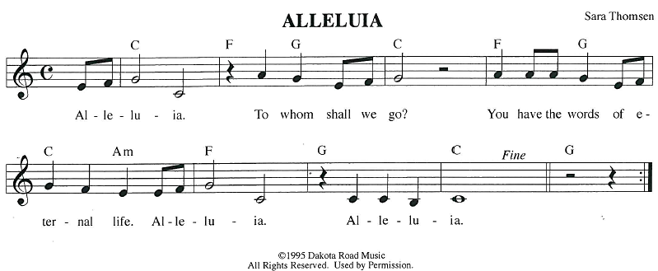
GOSPEL ACCLAMATION
GOSPEL: Luke 11:1-13
¹ [Jesus] was praying in a certain place, and after he had finished, one of his disciples said to him, “Lord, teach us to pray, as John taught his disciples.”² So he said to them, “When you pray, say:
Father, may your name be revered as holy.
May your kingdom come.
³ Give us each day our daily bread.
⁴ And forgive us our sins,
for we ourselves forgive everyone indebted to us.
And do not bring us to the time of trial.”
⁵ And he said to them, “Suppose one of you has a friend, and you go to him at midnight and say to him, ‘Friend, lend me three loaves of bread, ⁶ for a friend of mine has arrived, and I have nothing to set before him.’ ⁷ And he answers from within, ‘Do not bother me; the door has already been locked, and my children are with me in bed; I cannot get up and give you anything.’ ⁸ I tell you, even though he will not get up and give him anything out of friendship, at least because of his persistence he will get up and give him whatever he needs.
⁹ “So I say to you, Ask, and it will be given to you; search, and you will find; knock, and the door will be opened for you. ¹⁰ For everyone who asks receives, and everyone who searches finds, and for everyone who knocks, the door will be opened. ¹¹ Is there anyone among you who, if your child asked for a fish, would give a snake instead of a fish? ¹² Or if the child asked for an egg, would give a scorpion? ¹³ If you, then, who are evil, know how to give good gifts to your children, how much more will the heavenly Father give the Holy Spirit to those who ask him!”
The gospel of the Lord.
Praise to you, O Christ.
SERMON
HYMN OF THE DAY Lord, Listen to Your Children
On bended knee with needy hearts
we come and pray.
Lord, listen to your children.
With willing hearts and open arms
we come and pray.
Lord, listen to your children.
With simple words of heartfelt thanks
we come.
Believing in your promises,
we come.
On bended knee with needy hearts
we come and pray.
Lord, listen to your children,
listen to your children.
Words and Music: Handt Hanson,
APOSTLES’ CREED
I believe in God, the Father almighty,
creator of heaven and earth.
I believe in Jesus Christ, God's only Son, our Lord,
who was conceived by the power of the Holy Spirit, born of the Virgin Mary,
suffered under Pontius Pilate, was crucified, died, and was buried;
he descended to the dead.
On the third day he rose again;
he ascended into heaven, he is seated at the right hand of the Father,
and he will come to judge the living and the dead.
I believe in the Holy Spirit, the holy catholic Church,
the communion of saints, the forgiveness of sins,
the resurrection of the body, and the life everlasting. Amen.
PRAYERS OF INTERCESSION
…God of Grace.
Hear our prayer
Trusting in your lovingkindness, we place our prayer and hope in you, in the name of Jesus Christ.
Amen.
PEACE
The peace of Christ be with you always.
And also with you.
HOLY COMMUNION
OFFERING In addition to our normal offering, a Special Benevolence in July (collected in a special
envelope) will be going to Marshfield Area Respite Care.
OFFERING SONG Seek Ye First
Seek ye first the kingdom of God and its righteousness,
And all these things shall be added unto you, Allelu, alleluia.
Ask, and it shall be given unto you. Seek, and you shall find.
Knock, and the door shall be opened unto you, Allelu, alleluia.
We do not live by bread alone, But by ev’ry word.
That proceeds from the mouth of God. Allelu, alleluia.
1972 CCCM Music (Admin. by Brentwood-Benson Music Publishing, Inc.) Universal Music - Brentwood Benson Publishing (Admin. by Brentwood-Benson Music Publishing, Inc.)

OFFERTORY PRAYER
Creator God,
in your wisdom you bring forth all that is good and the harvest is plentiful.
Strengthen us at your table with these gifts of the earth and our labor,

that we may work for the good of all;
through Jesus Christ, our Savior.
Amen.
GREAT THANKSGIVING
The Lord be with you.
And also with you.
Lift up your hearts.
We lift them to the Lord.
Let us give our thanks to the Lord our God.
It is right to give our thanks and praise.
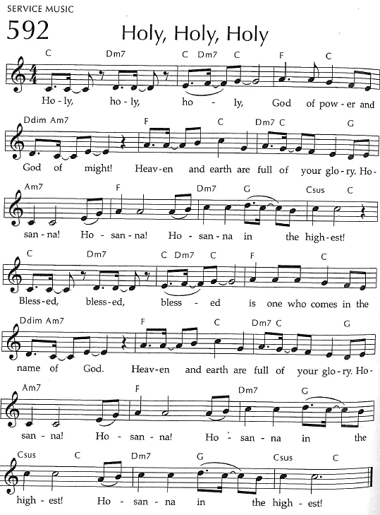
Holy, Holy, Holy

THANKSGIVING AT THE TABLE

God of our weary years, God of our silent tears,
you have brought us this far along the way.
In times of bitterness you did not abandon us,
but guided us into the path of love and light.
In every age you sent prophets
to make known your loving will for all humanity.
The cry of the poor has become your own cry;
our hunger and thirst for justice is your own desire.
In the fullness of time, you sent your chosen servant to preach good news to the afflicted,
to break bread with the outcast and despised,
and to ransom those in
bondage to prejudice and sin.
In the night in which he was betrayed,
our Lord Jesus took bread, and gave thanks;
broke it, and gave it to his disciples, saying:
Take and eat; this is my body, given for you.
Do this for the remembrance of me.
Again, after supper, he took the cup, gave thanks,
and gave it for all to drink, saying:
This cup is the new covenant in my blood,
shed for you and all people for
the forgiveness of sin.
Do this for the remembrance of me.
For as often as we eat of
this bread and drink from this cup
we proclaim the Lord’s death until he comes.
Christ has died.
Christ is risen.
Christ will come again.
Remembering, therefore, his death and resurrection,
we await the day when Jesus shall return
to free all the earth from the bonds of
slavery and death.
Come, Lord Jesus! And let the church say, Amen. Amen.
Send your Holy Spirit, our advocate,
to fill the hearts of all who share this bread and cup
with courage and wisdom to pursue love and justice in all the world.
Come, Spirit of freedom! And let the church say, Amen.
Amen.
Join our prayers and praise with
your prophets and martyrs of every age,
that, rejoicing in the hope of the resurrection,
we might live in the freedom and hope of your Son.
Through him, with him, in him, in the unity of the Holy Spirit,
all glory and honor is yours, almighty Father, now and forever.
Amen.

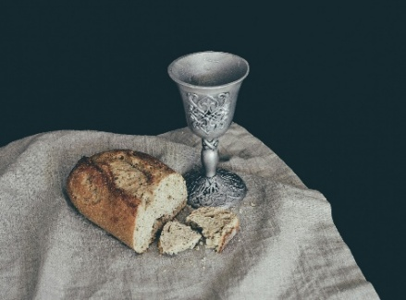
THE LORD’S PRAYER
Our Father, who art in heaven,
hallowed be thy name, thy kingdom come,
thy will be done, on earth as it is in heaven.
Give us this day our daily bread;
and forgive us our trespasses,
as we forgive those who trespass against us;
and lead us not into temptation, but deliver us from evil.
For thine is the kingdom,
and the power, and the glory, forever and ever. Amen.
INVITATION TO COMMUNION - Certified gluten-free crackers are in the bowl on the communion plate.
The kingdom of God is set before you.
Eat and rejoice.
HOLY COMMUNION
PRAYER AFTER COMMUNION
Mothering God,
you gathered us to your table and we drank deeply of your grace.
Send us out by your Spirit to love our neighbors as ourselves
and proclaim your love in Jesus’ name.
Amen.

SENDING
BLESSING
The love of God abound in you;
the grace of our Savior Jesus Christ fill your hearts;
and the life of the Spirit
☩ bless you and give you peace.
Amen.
CLOSING HYMN Your Will Be Done ELW 741
DISMISSAL
Go in peace. Live by the Spirit.
Thanks be to God.
Upcoming Worship Assistants
 | Usher | Lector | Communion | Offering Counters |  | Deep Clean
July 27 | Ben & Sue Lee | Tammy Neumann | Dave & Sue Schraeder | Dan Mundt | Rob Mader | July:  John & Jane Wagner  Laurel Peterson  Leslie Mader
August 3 | Dennis & Linda Schutte | Kris Tarter | Andrea Hovick  Sarah Kopitzke | Nancy Leonard | Bob Peterson | August:  Dave & Shelly Schneider  Bruce & Nancy Tibbett
August 10 | Dave & Shelly Schneider | Leslie Mader | Matt & Margo Berrier | Robin Beeman | David Schneider | August:  Dave & Shelly Schneider  Bruce & Nancy Tibbett
August 17 | Dennis & Deb Janz | Nancy Tibbett | Bob & Laurel Peterson | Heidi Binder | Kami Weis | August:  Dave & Shelly Schneider  Bruce & Nancy Tibbett
Outdoor movies are back for the summer! This year, we’re partnering with Marshfield Young Professionals for Movies in the Park. Movies will be shown the 3rd Friday in June, July, and August. June and August’s movies will be at Columbia Park. All movies will begin at dusk, GSLC is the rain location for June and August.

Pastor Katie’s Office Hours: Monday-Thursday 9am-2pm. Tuesday mornings at Uptown Coffee. Afternoons available by appointment. You are welcome to stop in any time for conversation or concerns.
There will be fellowship time after worship one Sunday a month. Please sign up on the table in the narthex.
Names on the prayer list now default to 6 weeks. If you would like a name to remain on the list longer, please let Pastor Katie know.
Coming up at GSLC
Sunday, July 27 | 9:00 am | Outdoor Worship Service  - Seventh Sunday after Pentecost  - Luke 11:1-13; Jesus teaches the disciples to pray
Tuesday, July 29 | 9:30 am | Children’s WI Play and Learn
 | 7:00 pm | AA Meeting
Sunday, August 3 | 9:00 am | Outdoor Worship Service  - Eighth Sunday after Pentecost  - Luke 12:13-21; Jesus says: Be on guard against greed; be rich toward God, your treasure
Pastor Katie will be out of the office to attend the ELCA’s Churchwide Assembly July 28th-August 3rd. If you need pastoral care during this time, please contact the office or council president. Office hours next week: Monday to Wednesday from 8am-12pm.

Pub Theology is returning for the summer!
1st & 3rd Wednesday June-August
Scotty’s Pizza & Chicken 6:00 pm
This year, we’re collaborating with Wesley UMC. Topics each week include: Having Hard Conversations (6/4), Attitude of Gratitude (6/18), Good Grief (7/2), What is Truth? (7/16), Faith & Science (8/6), Religion & Politics (8/20)
What is Pub Theology? People have been gathering in pubs and public spaces for ages talking about life, philosophy, faith, and deep questions of meaning. Increasingly, people all over are rediscovering the pub as a safe, open space where they can explore and express their own doubts and questions, learn from others, and engage people of varying religious traditions. In our increasingly fractured society, these spaces are not only welcome but needed.
Bring your questions and curiosity, and pull up a chair.

