
Good Shepherd Lutheran Church
Pastor: Rev. Katie Anderson | Music Director: Rev. Lois Swanson
Pastor’s Cell: (715) 502-9433 | Office Phone: (715) 387-2731
Pastor Email: gslcwi.pastor@gmail.com | Office Email: gslcwi.office@gmail.com
Website: GoodShepherdMarshfield.org
Sixth Sunday after Pentecost
July 20 2025, 9:00 am
Introduction to the day…
ANNOUNCEMENTS
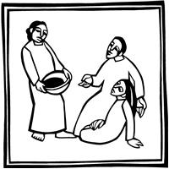
GATHERING
Perhaps the church, at its best, is “all ears.” God urges the faithful, again and again, to “listen up!”—to heed the word that gives life. So it was with Abraham and Sarah, Mary and Martha, and the early church at Colossae. So it is today as we join the assembly to hear the word of God, the word of life.
GATHERING HYMN O Living Breath of God ELW 407

Confession and Forgiveness
In the name of the Father,
and of the ☩ Son,
and of the Holy Spirit.
Amen.

Baptized into Christ, let us confess our sin.
Silence is kept for reflection.
Merciful God,
you free us to love others,
but we neglect our neighbors and follow our own way.

You lead us by the Spirit of joy and peace,
but we turn away from the abundant life you offer.
You surround us with patience, kindness,
and generosity,
but we grow weary in doing what is right.
In your mercy, forgive us.
Do not give up on us.
Heal us, break our bonds, and show us the path of life.
Amen.
You belong to Christ Jesus and you are God’s children through faith.
In the cross of ☩ Christ,
and through the power of the Holy Spirit,
your sins are forgiven.
Clothed with Christ, you are a new creation.
Amen.
PRAYER OF THE DAY
Eternal God, you draw near to us in Christ, and you make yourself our guest. Amid the cares of our lives, make us attentive to your presence, that we may treasure your word above all else, through Jesus Christ, our Savior and Lord.
Amen.
CHILDREN’S MUSIC Send Me, Lord ELW 809
CHILDREN’S MESSAGE

SCRIPTURE READINGS
FIRST READING: Genesis 18:1-10a
¹ The Lord appeared to Abraham by the oaks of Mamre, as he sat at the entrance of his tent in the heat of the day. ² He looked up and saw three men standing near him. When he saw them, he ran from the tent entrance to meet them and bowed down to the ground. ³ He said, “My lord, if I find favor with you, do not pass by your servant. ⁴ Let a little water be brought, and wash your feet, and rest yourselves under the tree. ⁵ Let me bring a little bread, that you may refresh yourselves, and after that you may pass on—since you have come to your servant.” So they said, “Do as you have said.” ⁶ And Abraham hastened into the tent to Sarah and said, “Make ready quickly three measures of choice flour, knead it, and make cakes.” ⁷ Abraham ran to the herd and took a calf, tender and good, and gave it to the servant, who hastened to prepare it. ⁸ Then he took curds and milk and the calf that he had prepared and set it before them, and he stood by them under the tree while they ate.
⁹ They said to him, “Where is your wife Sarah?” And he said, “There, in the tent.” ^{10a} Then one said, “I will surely return to you in due season, and your wife Sarah shall have a son.”
Word of God, word of life.
Thanks be to God.
PSALM: Psalm 15
¹ Lord, who may dwell in your tabernacle?
Who may abide upon your holy hill?
² Those who lead a blameless life and do what is right,
who speak the truth from their heart;
³ they do not slander with the tongue, they do no evil to their friends;
they do not cast discredit upon a neighbor.
⁴ In their sight the wicked are rejected, but they honor those who fear the Lord.
They have sworn upon their health and do not take back their word.
⁵ They do not give their money in hope of gain, nor do they take bribes against the innocent.
Those who do these things shall never be overthrown.
SECOND READING: Colossians 1:15-28
¹⁵ [Christ Jesus] is the image of the invisible God, the firstborn of all creation,¹⁶ for in him all things in heaven and on earth were created, things visible and invisible, whether thrones or dominions or rulers or powers—all things have been created through him and for him. ¹⁷ He himself is before all things, and in him all things hold together. ¹⁸ He is the head of the body, the church; he is the beginning, the firstborn from the dead, so that he might come to have first place in everything. ¹⁹ For in him all the fullness of God was pleased to dwell, ²⁰ and through him God was pleased to reconcile to himself all things, whether on earth or in heaven, by making peace through the blood of his cross.
²¹ And you who were once estranged and hostile in mind, doing evil deeds, ²² he has now reconciled in his fleshly body through death, so as to present you holy and blameless and irreproachable before him, ²³ provided that you continue securely established and steadfast in the faith, without shifting from the hope promised by the gospel that you heard, which has been proclaimed to every creature under heaven. I, Paul, became a minister of this gospel.
²⁴ I am now rejoicing in my sufferings for your sake, and in my flesh I am completing what is lacking in Christ’s afflictions for the sake of his body, that is, the church. ²⁵ I became its minister according to God’s commission that was given to me for you, to make the word of God fully known, ²⁶ the mystery that has been hidden throughout the ages and generations but has now been revealed to his saints. ²⁷ To them God chose to make known how great among the gentiles are the riches of the glory of this mystery, which is Christ in you, the hope of glory. ²⁸ It is he whom we proclaim, warning everyone and teaching everyone in all wisdom, so that we may present everyone mature in Christ.
Word of God, word of life.
Thanks be to God.
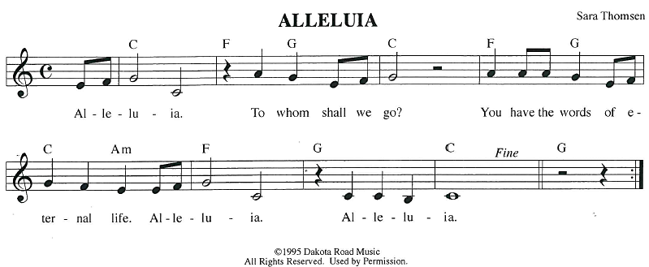
GOSPEL ACCLAMATION
GOSPEL: Luke 10:38-42
³⁸ Now as [Jesus and his disciples] went on their way, he entered a certain village where a woman named Martha welcomed him. ³⁹ She had a sister named Mary, who sat at Jesus’s feet and listened to what he was saying. ⁴⁰ But Martha was distracted by her many tasks, so she came to him and asked, “Lord, do you not care that my sister has left me to do all the work by myself? Tell her, then, to help me.” ⁴¹ But the Lord answered her, “Martha, Martha, you are worried and distracted by many things, ⁴² but few things are needed—indeed only one. Mary has chosen the better part, which will not be taken away from her.”
The gospel of the Lord.
Praise to you, O Christ.
SERMON
HYMN OF THE DAY Give Me Jesus ELW 770
APOSTLES’ CREED
I believe in God, the Father almighty,
creator of heaven and earth.
I believe in Jesus Christ, God's only Son, our Lord,
who was conceived by the power of the Holy Spirit, born of the Virgin Mary,
suffered under Pontius Pilate, was crucified, died, and was buried;
he descended to the dead.
On the third day he rose again;
he ascended into heaven, he is seated at the right hand of the Father,
and he will come to judge the living and the dead.
I believe in the Holy Spirit, the holy catholic Church,
the communion of saints, the forgiveness of sins,
the resurrection of the body, and the life everlasting. Amen.
PRAYERS OF INTERCESSION
…God of Grace.
Hear our prayer
Trusting in your lovingkindness, we place our prayer and hope in you, in the name of Jesus Christ.
Amen.
PEACE
The peace of Christ be with you always.
And also with you.
HOLY COMMUNION
OFFERING In addition to our normal offering, a Special Benevolence in July (collected in a special
envelope) will be going to Marshfield Area Respite Care.
OFFERING SONG Sanctuary
Lord, prepare me to be a sanctuary, pure and holy, tried and true.
With thanksgiving, I’ll be a living sanctuary for you.
Words: John Thompson & Randy Scruggs. Music: John Thompson & Randy Scruggs. © Whole Armor/Full Armor Music, admin. By The Kruger Organization
OFFERTORY PRAYER
Creator God,

in your wisdom you bring forth all that is good
and the harvest is plentiful.
Strengthen us at your table with these gifts of the earth
and our labor,
that we may work for the good of all;
through Jesus Christ, our Savior.
Amen.
GREAT THANKSGIVING
The Lord be with you.
And also with you.
Lift up your hearts.
We lift them to the Lord.
Let us give our thanks to the Lord our God.
It is right to give our thanks and praise.
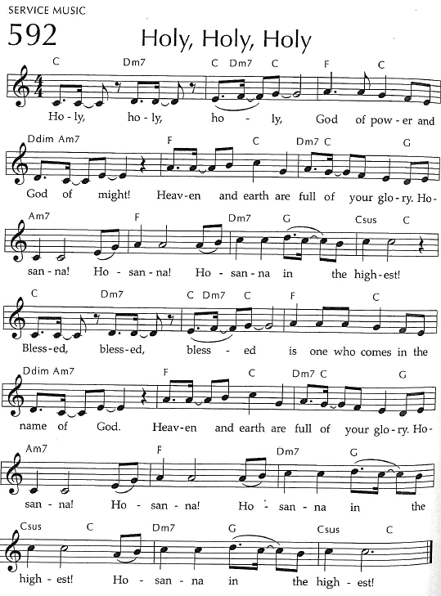
Holy, Holy, Holy
THANKSGIVING AT THE TABLE

God of our weary years, God of our silent tears,
you have brought us this far along the way.
In times of bitterness you did not abandon us,
but guided us into the path of love and light.
In every age you sent prophets
to make known your loving will for all humanity.
The cry of the poor has become your own cry;
our hunger and thirst for justice is your own desire.
In the fullness of time, you sent your chosen servant to preach good news to the afflicted,
to break bread with the outcast and despised,
and to ransom those in
bondage to prejudice and sin.

In the night in which he was betrayed,
our Lord Jesus took bread, and gave thanks;
broke it, and gave it to his disciples, saying:
Take and eat; this is my body, given for you.
Do this for the remembrance of me.
Again, after supper, he took the cup, gave thanks,
and gave it for all to drink, saying:
This cup is the new covenant in my blood,
shed for you and all people for the forgiveness of sin.
Do this for the remembrance of me.
For as often as we eat of this bread and drink from this cup
we proclaim the Lord’s death until he comes.
Christ has died.
Christ is risen.
Christ will come again.
Remembering, therefore, his death and resurrection,
we await the day when Jesus shall return
to free all the earth from the bonds of slavery and death.
Come, Lord Jesus! And let the church say, Amen. Amen.
Send your Holy Spirit, our advocate,
to fill the hearts of all who share this bread and cup
with courage and wisdom to pursue love and justice in all the world.
Come, Spirit of freedom! And let the church say, Amen.
Amen.
Join our prayers and praise with your prophets and martyrs of every age,
that, rejoicing in the hope of the resurrection,
we might live in the freedom and hope of your Son.
Through him, with him, in him, in the unity of the Holy Spirit,
all glory and honor is yours, almighty Father, now and forever.
Amen.

THE LORD’S PRAYER
Our Father, who art in heaven,
hallowed be thy name, thy kingdom come,
thy will be done, on earth as it is in heaven.
Give us this day our daily bread;
and forgive us our trespasses,
as we forgive those who trespass against us;
and lead us not into temptation, but deliver us from evil.
For thine is the kingdom,
and the power, and the glory, forever and ever. Amen.
INVITATION TO COMMUNION - Certified gluten-free crackers are in the bowl on the communion plate.
The kingdom of God is set before you.
Eat and rejoice.
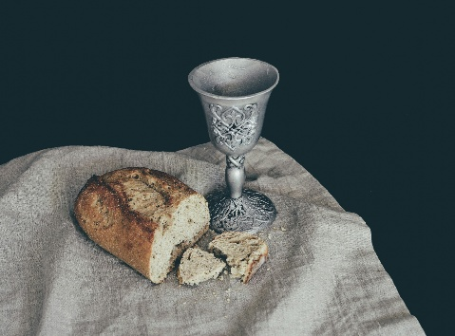
HOLY COMMUNION
PRAYER AFTER COMMUNION
Mothering God,
you gathered us to your table
and we drank deeply of your grace.
Send us out by your Spirit
to love our neighbors as ourselves
and proclaim your love in Jesus’ name.
Amen.
SENDING
BLESSING
The love of God abound in you;
the grace of our Savior Jesus Christ fill your hearts;
and the life of the Spirit
☩ bless you and give you peace.
Amen.

CLOSING HYMN Go My Children, With My Blessing ELW 543
DISMISSAL
Go in peace. Live by the Spirit.
Thanks be to God.
Upcoming Worship Assistants
 | Usher | Lector | Communion | Offering Counters |  | Deep Clean
July 20 | Lee & Sue Babcock | Richard Kopitzke | Sue Schraeder Tammy Neumann | Pam Mundt | Margo Berrier | July:  John & Jane Wagner  Laurel Peterson  Leslie Mader
July 27 | Ben & Sue Lee | Tammy Neumann | Dave & Sue Schraeder | Dan Mundt | Rob Mader | July:  John & Jane Wagner  Laurel Peterson  Leslie Mader
August 3 | Dennis & Linda Schutte | Kris Tarter | Andrea Hovick  Sarah Kopitzke | Nancy Leonard | Bob Peterson | August:  Dave & Shelly Schneider  Bruce & Nancy Tibbett
August 10 | Dave & Shelly Schneider | Leslie Mader | Matt & Margo Berrier | Robin Beeman | David Schneider | August:  Dave & Shelly Schneider  Bruce & Nancy Tibbett
Message from Good Shepherd's Green Team:
Did you know you can recycle mattresses and keep them out of the landfill?
Find a Recycling Outlet : uwgb.edu/recycling
The Wisconsin Recycling Markets Directory (WRMD) provides information about landfill diversion opportunities for various materials in Wisconsin. Search the list of entries for various materials, view information about the listing and suggest additional outlets to include in the directory. For a listing and description of the materials, see recycling category definitions. For where to recycle mattresses, click on "Other Materials" in the Material Category, then "Mattresses/Box Springs" in the Material Subcategory.
Inclusion on this list is not intended to imply endorsement by the Wisconsin Department of Natural Resources, the Environmental Management and Business Institute, and UW-Green Bay, nor is exclusion intentional.
Before You Visit: We recommend calling ahead to discuss restrictions or specifications, learn about pick-up or drop-off options, etc. You can save time if you confirm accepted materials, quantities and any associated fees before you go.

Coming up at GSLC
Sunday, July 20 | 9:00 am | Worship Service  - Sixth Sunday after Pentecost  - Luke 10:38-42; Jesus says: Martha, your sister Mary has chosen the better part
Tuesday, July 22 | 9:30 am | Children’s WI Play and Learn
 | 7:00 pm | AA Meeting
Sunday, July 27 | 9:00 am | Outdoor Worship Service  - Seventh Sunday after Pentecost  - Luke 11:1-13; Jesus teaches the disciples to pray
Outdoor movies are back for the summer! This year, we’re partnering with Marshfield Young Professionals for Movies in the Park. Movies will be shown the 3rd Friday in June, July, and August. June and August’s movies will be at Columbia Park. All movies will begin at dusk, GSLC is the rain location for June and August.

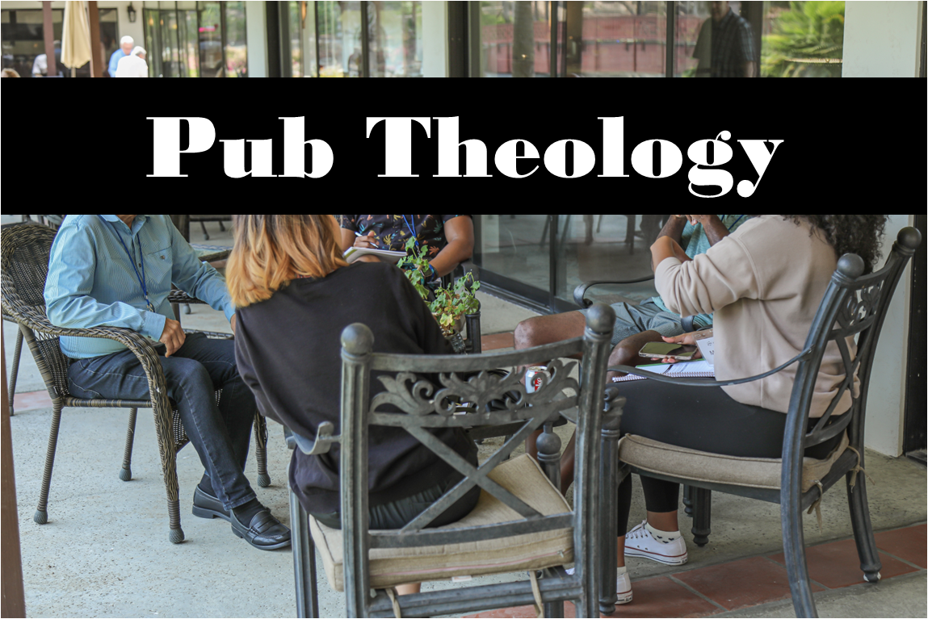
Pub Theology is returning for the summer!
1st & 3rd Wednesday June-August
Scotty’s Pizza & Chicken 6:00 pm
This year, we’re collaborating with Wesley UMC. Topics each week include: Having Hard Conversations (6/4), Attitude of Gratitude (6/18), Good Grief (7/2), What is Truth? (7/16), Faith & Science (8/6), Religion & Politics (8/20)
What is Pub Theology? People have been gathering in pubs and public spaces for ages talking about life, philosophy, faith, and deep questions of meaning. Increasingly, people all over are rediscovering the pub as a safe, open space where they can explore and express their own doubts and questions, learn from others, and engage people of varying religious traditions. In our increasingly fractured society, these spaces are not only welcome but needed.
Bring your questions and curiosity, and pull up a chair.
Names on the prayer list now default to 6 weeks. If you would like a name to remain on the list longer, please let Pastor Katie know.
Pastor Katie’s Office Hours: Monday-Thursday 9am-2pm. Tuesday mornings at Uptown Coffee. Afternoons available by appointment. You are welcome to stop in any time for conversation or concerns.
There will be fellowship time after worship one Sunday a month. Please sign up on the table in the narthex.

