
Good Shepherd Lutheran Church
Pastor: Rev. Katie Anderson | Music Director: Rev. Lois Swanson
Pastor’s Cell: (715) 502-9433 | Office Phone: (715) 387-2731
Pastor Email: gslcwi.pastor@gmail.com | Office Email: gslcwi.office@gmail.com
Website: GoodShepherdMarshfield.org
Fifth Sunday after Pentecost
July 13, 2025, 9:00 am
Introduction to the day…
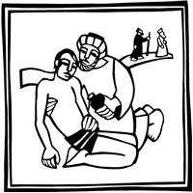
ANNOUNCEMENTS
GATHERING
To love the Lord your God with all your heart, soul, strength, and mind is to reflect God’s mercy in responding to one’s neighbor. That mercy found its most profound expression in the “gospel that has come to you”—namely the life, death, and resurrection of Jesus Christ. That gospel mercy comes to us again today: at the font, at the table, and from the pulpit. It is very near to you.
GATHERING HYMN My Life is in You, Lord
My life is in You, Lord, my strength is in You, Lord,  My hope is in You, Lord, in You, it's in You.  My life is in You, Lord, my strength is in You, Lord,  My hope is in You, Lord, in You, it's in You. | I will praise You with all of my life,  I will praise You with all of my strength.  With all of my life. With all of my strength.  All of my hope is in You.  in You, it's in You, my life!
(Daniel Gardnerc/o Integrity Music, Inc.) CCLI License No. 669990
Confession and Forgiveness
In the name of the Father,
and of the ☩ Son,

and of the Holy Spirit.
Amen.
Baptized into Christ, let us confess our sin.
Silence is kept for reflection.
Merciful God,
you free us to love others,
but we neglect our neighbors and follow our own way.
You lead us by the Spirit of joy and peace,
but we turn away from the abundant life you offer.
You surround us with patience, kindness,
and generosity,
but we grow weary in doing what is right.
In your mercy, forgive us.
Do not give up on us.
Heal us, break our bonds, and show us the path of life.
Amen.
You belong to Christ Jesus and you are God’s children through faith.
In the cross of ☩ Christ,
and through the power of the Holy Spirit,
your sins are forgiven.
Clothed with Christ, you are a new creation.
Amen.

PRAYER OF THE DAY
O Lord God, your mercy delights us, and the world longs for your loving care. Hear the cries of everyone in need, and turn our hearts to love our neighbors with the love of your Son, Jesus Christ, our Savior and Lord.
Amen.
CHILDREN’S MUSIC Send Me, Lord ELW 809
CHILDREN’S MESSAGE
SCRIPTURE READINGS
FIRST READING: Deuteronomy 30:9-14
⁹ The Lord your God will make you abundantly prosperous in all your undertakings, in the fruit of your body, in the fruit of your livestock, and in the fruit of your soil. For the Lord will again take delight in prospering you, just as he delighted in prospering your ancestors, ¹⁰ when you obey the Lord your God by observing his commandments and decrees that are written in this book of the law, because you turn to the Lord your God with all your heart and with all your soul.
¹¹ “Surely, this commandment that I am commanding you today is not too hard for you, nor is it too far away. ¹² It is not in heaven, that you should say, ‘Who will go up to heaven for us and get it for us so that we may hear it and observe it?’ ¹³ Neither is it beyond the sea, that you should say, ‘Who will cross to the other side of the sea for us and get it for us so that we may hear it and observe it?’ ¹⁴ No, the word is very near to you; it is in your mouth and in your heart for you to observe.
Word of God, word of life.
Thanks be to God.

PSALM: Psalm 25:1-10
¹ To you, O Lord,
I lift up my soul.
² My God, I put my trust in you; let me not be put to shame,
nor let my enemies triumph over me.
³ Let none who look to you be put to shame;
rather let those be put to shame who are treacherous.
⁴ Show me your ways, O Lord,
and teach me your paths.
⁵ Lead me in your truth and teach me,
for you are the God of my salvation; in you have I trusted all the day long.
⁶ Remember, O Lord, your compassion and love,
for they are from everlasting.
⁷ Remember not the sins of my youth and my transgressions;
remember me according to your steadfast love and for the sake of your goodness, O Lord.
⁸ You are gracious and upright, O Lord;
therefore you teach sinners in your way.
⁹ You lead the lowly in justice
and teach the lowly your way.
¹⁰ All your paths, O Lord, are steadfast love and faithfulness
to those who keep your covenant and your testimonies.
SECOND READING: Colossians 1:1-14
¹ Paul, an apostle of Christ Jesus by the will of God, and Timothy our brother,
² To the saints and faithful brothers and sisters in Christ in Colossae:
Grace to you and peace from God our Father.
³ In our prayers for you we always thank God, the Father of our Lord Jesus Christ, ⁴ for we have heard of your faith in Christ Jesus and of the love that you have for all the saints, ⁵ because of the hope laid up for you in heaven. You have heard of this hope before in the word of the truth, the gospel ⁶ that has come to you. Just as it is bearing fruit and growing in the whole world, so it has been bearing fruit among yourselves from the day you heard it and truly comprehended the grace of God. ⁷ This you learned from Epaphras, our beloved fellow servant. He is a faithful minister of Christ on our behalf, ⁸ and he has made known to us your love in the Spirit.
⁹ For this reason, since the day we heard it, we have not ceased praying for you and asking that you may be filled with the knowledge of God’s will in all spiritual wisdom and understanding, ¹⁰ so that you may walk worthy of the Lord, fully pleasing to him, as you bear fruit in every good work and as you grow in the knowledge of God. ¹¹ May you be made strong with all the strength that comes from his glorious power, so that you may have all endurance and patience, joyfully ¹² giving thanks to the Father, who has enabled you to share in the inheritance of the saints in the light. ¹³ He has rescued us from the power of darkness and transferred us into the kingdom of his beloved Son, ¹⁴ in whom we have redemption, the forgiveness of sins.
Word of God, word of life.
Thanks be to God.
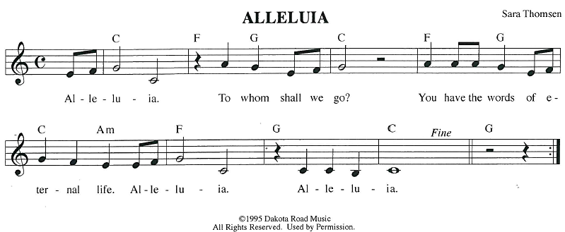
GOSPEL ACCLAMATION
GOSPEL: Luke 10:25-37
²⁵ An expert in the law stood up to test Jesus. “Teacher,” he said, “what must I do to inherit eternal life?” ²⁶ He said to him, “What is written in the law? What do you read there?” ²⁷ He answered, “You shall love the Lord your God with all your heart and with all your soul and with all your strength and with all your mind and your neighbor as yourself.” ²⁸ And he said to him, “You have given the right answer; do this, and you will live.”
²⁹ But wanting to vindicate himself, he asked Jesus, “And who is my neighbor?” ³⁰ Jesus replied, “A man was going down from Jerusalem to Jericho and fell into the hands of robbers, who stripped him, beat him, and took off, leaving him half dead. ³¹ Now by chance a priest was going down that road, and when he saw him he passed by on the other side. ³² So likewise a Levite, when he came to the place and saw him, passed by on the other side. ³³ But a Samaritan while traveling came upon him, and when he saw him he was moved with compassion. ³⁴ He went to him and bandaged his wounds, treating them with oil and wine. Then he put him on his own animal, brought him to an inn, and took care of him. ³⁵ The next day he took out two denarii, gave them to the innkeeper, and said, ‘Take care of him, and when I come back I will repay you whatever more you spend.’ ³⁶ Which of these three, do you think, was a neighbor to the man who fell into the hands of the robbers?” ³⁷ He said, “The one who showed him mercy.” Jesus said to him, “Go and do likewise.”
The gospel of the Lord.
Praise to you, O Christ.
SERMON

HYMN OF THE DAY Spirit, Open My Heart ACS 1043
APOSTLES’ CREED
I believe in God, the Father almighty,
creator of heaven and earth.
I believe in Jesus Christ, God's only Son, our Lord,
who was conceived by the power of the Holy Spirit, born of the Virgin Mary,
suffered under Pontius Pilate, was crucified, died, and was buried;
he descended to the dead.
On the third day he rose again;
he ascended into heaven, he is seated at the right hand of the Father,
and he will come to judge the living and the dead.
I believe in the Holy Spirit, the holy catholic Church,
the communion of saints, the forgiveness of sins,
the resurrection of the body, and the life everlasting. Amen.
PRAYERS OF INTERCESSION
…God of Grace.
Hear our prayer
Trusting in your lovingkindness, we place our prayer and hope in you, in the name of Jesus Christ.
Amen.
PEACE
The peace of Christ be with you always.
And also with you.
HOLY COMMUNION
OFFERING In addition to our normal offering, a Special Benevolence in July (collected in a special
envelope) will be going to Marshfield Area Respite Care.
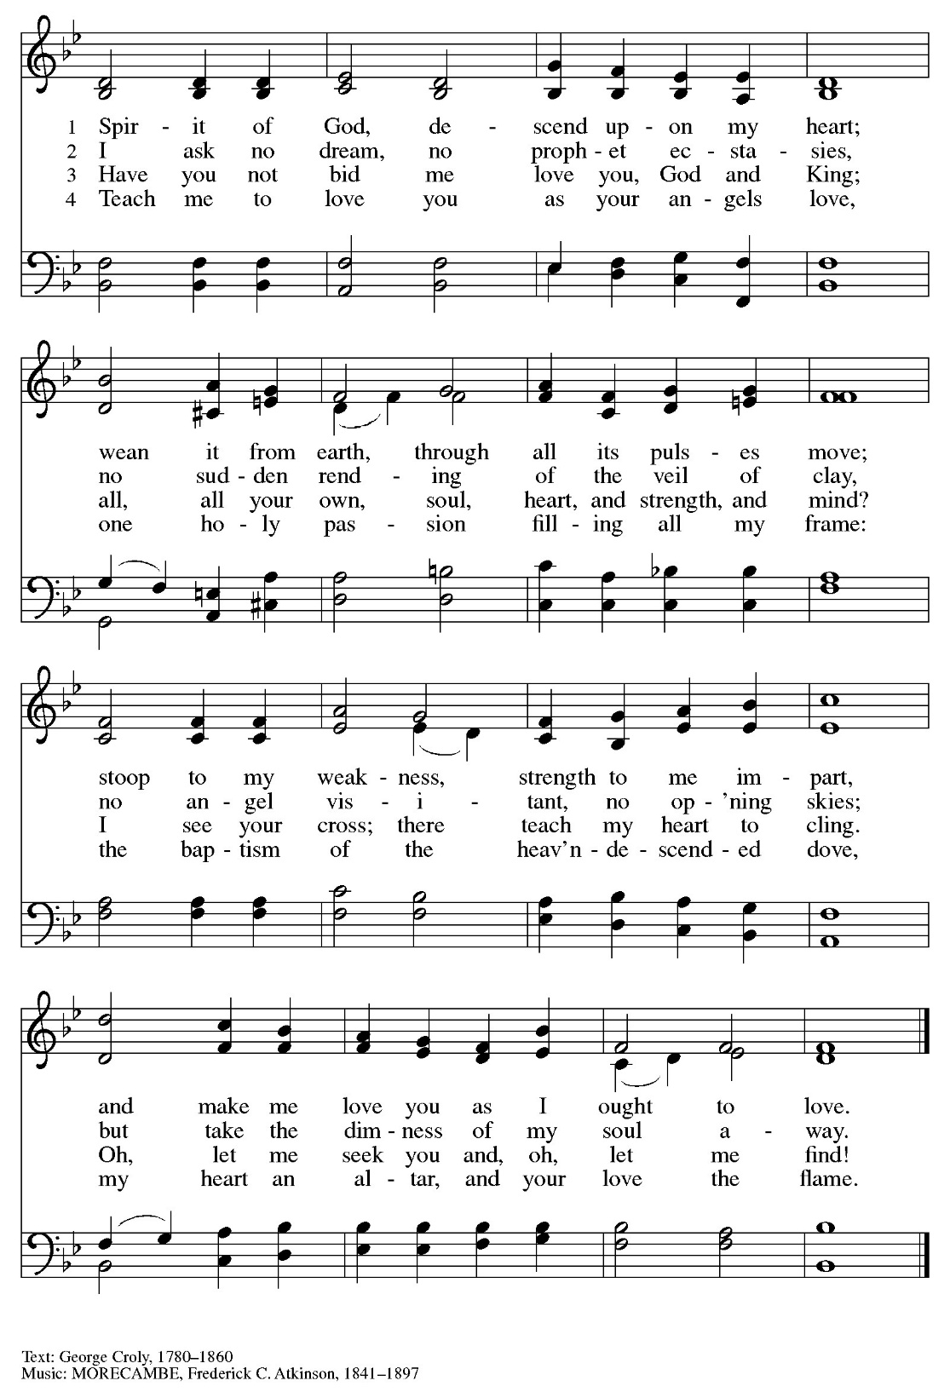
OFFERING SONG Spirit of God, Descend Upon My Heart ELW 800

OFFERTORY PRAYER
Creator God,

in your wisdom you bring forth all that is good
and the harvest is plentiful.
Strengthen us at your table with these gifts of the earth
and our labor,
that we may work for the good of all;
through Jesus Christ, our Savior.
Amen.
GREAT THANKSGIVING
The Lord be with you.
And also with you.
Lift up your hearts.
We lift them to the Lord.
Let us give our thanks to the Lord our God.
It is right to give our thanks and praise.
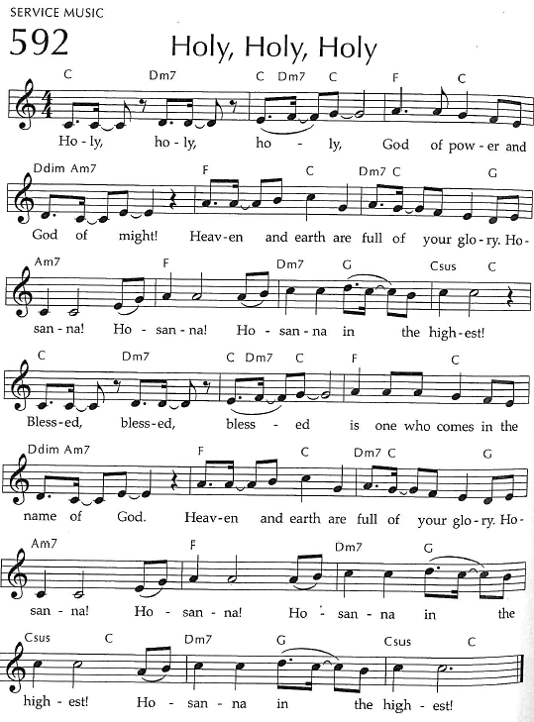
Holy, Holy, Holy

THANKSGIVING AT THE TABLE

God of our weary years, God of our silent tears,
you have brought us this far along the way.
In times of bitterness you did not abandon us,
but guided us into the path of love and light.
In every age you sent prophets
to make known your loving will for all humanity.
The cry of the poor has become your own cry;
our hunger and thirst for justice is your own desire.
In the fullness of time, you sent your chosen servant to preach good news to the afflicted,
to break bread with the outcast and despised,
and to ransom those in
bondage to prejudice and sin.
In the night in which he was betrayed,
our Lord Jesus took bread, and gave thanks;
broke it, and gave it to his disciples, saying:
Take and eat; this is my body, given for you.
Do this for the remembrance of me.
Again, after supper, he took the cup, gave thanks,
and gave it for all to drink, saying:
This cup is the new covenant in my blood,
shed for you and all people for the forgiveness of sin.
Do this for the remembrance of me.

For as often as we eat of this bread and drink from this cup
we proclaim the Lord’s death until he comes.
Christ has died.
Christ is risen.
Christ will come again.
Remembering, therefore, his death and resurrection,
we await the day when Jesus shall return
to free all the earth from the bonds of slavery and death.
Come, Lord Jesus! And let the church say, Amen. Amen.
Amen.
Send your Holy Spirit, our advocate,
to fill the hearts of all who share this bread and cup
with courage and wisdom to pursue love and justice in all the world.
Come, Spirit of freedom! And let the church say, Amen.
Amen.
Join our prayers and praise with your prophets and martyrs of every age,
that, rejoicing in the hope of the resurrection,
we might live in the freedom and hope of your Son.
Through him, with him, in him, in the unity of the Holy Spirit,
all glory and honor is yours, almighty Father, now and forever.
Amen.

THE LORD’S PRAYER
Our Father, who art in heaven,
hallowed be thy name, thy kingdom come,
thy will be done, on earth as it is in heaven.
Give us this day our daily bread;
and forgive us our trespasses,
as we forgive those who trespass against us;
and lead us not into temptation, but deliver us from evil.
For thine is the kingdom,
and the power, and the glory, forever and ever. Amen.
INVITATION TO COMMUNION - Certified gluten-free crackers are in the bowl on the communion plate.
The kingdom of God is set before you.
Eat and rejoice.
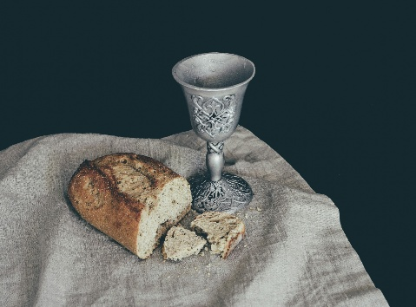
HOLY COMMUNION
PRAYER AFTER COMMUNION
Mothering God,
you gathered us to your table
and we drank deeply of your grace.
Send us out by your Spirit
to love our neighbors as ourselves
and proclaim your love in Jesus’ name.
Amen.
SENDING
BLESSING
The love of God abound in you;
the grace of our Savior Jesus Christ fill your hearts;
and the life of the Spirit
☩ bless you and give you peace.
Amen.
CLOSING HYMN Lord of All Hopefulness ELW 765
DISMISSAL
Go in peace. Live by the Spirit.
Thanks be to God
Upcoming Worship Assistants
 | Usher | Lector | Communion | Offering Counters |  | Deep Clean
July 13 | Rob Pankratz | Jon Hill | Emily Rothfusz  Ron Rothfusz | Heidi Binder | Kami Weis | July:  John & Jane Wagner  Laurel Peterson  Leslie Mader
July 20 | Dennis & Linda Schutte | Richard Kopitzke | Nancy Leonard Rob Pankratz | Pam Mundt | Margo Berrier | July:  John & Jane Wagner  Laurel Peterson  Leslie Mader
July 27 | Ben & Sue Lee | Tammy Neumann | Dave & Sue Schraeder | Dan Mundt | Bob Peterson | July:  John & Jane Wagner  Laurel Peterson  Leslie Mader
August 3 | Lee & Sue Babcock | Kris Tarter | Andrea Hovick  Sarah Kopitzke | Nancy Leonard | Rob Mader | August:  Dave & Shelly Schneider  Bruce & Nancy Tibbett
Message from Good Shepherd's Green Team:
Did you know you can recycle mattresses and keep them out of the landfill?
Find a Recycling Outlet : uwgb.edu/recycling
The Wisconsin Recycling Markets Directory (WRMD) provides information about landfill diversion opportunities for various materials in Wisconsin. Search the list of entries for various materials, view information about the listing and suggest additional outlets to include in the directory. For a listing and description of the materials, see recycling category definitions. For where to recycle mattresses, click on "Other Materials" in the Material Category, then "Mattresses/Box Springs" in the Material Subcategory.
Inclusion on this list is not intended to imply endorsement by the Wisconsin Department of Natural Resources, the Environmental Management and Business Institute, and UW-Green Bay, nor is exclusion intentional.
Before You Visit: We recommend calling ahead to discuss restrictions or specifications, learn about pick-up or drop-off options, etc. You can save time if you confirm accepted materials, quantities and any associated fees before you go.

Names on the prayer list now default to 6 weeks. If you would like a name to remain on the list longer, please let Pastor Katie know.
There will be fellowship time after worship one Sunday a month. Please sign up on the table in the narthex.
Pastor Katie’s Office Hours: Monday-Thursday 9am-2pm. Tuesday mornings at Uptown Coffee. Afternoons available by appointment. You are welcome to stop in any time for conversation or concerns.
Coming up at GSLC
Sunday, July 13 | 9:00 am | Worship Service  - Fifth Sunday after Pentecost  - Luke 10:25-37; The parable of the merciful Samaritan
Tuesday, July 15 | 7:00 pm | AA Meeting
Wednesday, July 16 | 6:00 pm | Pub Theology at Scotty’s Pizza & Chicken  Topic: “What is Truth”
Friday, July 18 | Dusk | Movie Night- Mufasa
Sunday, July 20 | 9:00 am | Worship Service  - Sixth Sunday after Pentecost  - Luke 10:38-42; Jesus says: Martha, your sister Mary has chosen the better part

Outdoor movies are back for the summer! This year, we’re partnering with Marshfield Young Professionals for Movies in the Park. Movies will be shown the 3rd Friday in June, July, and August. June and August’s movies will be at Columbia Park. We are sponsoring July’s movie, Mufasa, shown here. All movies will begin at dusk, GSLC is the rain location for June and August.


Pub Theology is returning for the summer!
1st & 3rd Wednesday June-August
Scotty’s Pizza & Chicken 6:00 pm
This year, we’re collaborating with Wesley UMC. Topics each week include: Having Hard Conversations (6/4), Attitude of Gratitude (6/18), Good Grief (7/2), What is Truth? (7/16), Faith & Science (8/6), Religion & Politics (8/20)
What is Pub Theology? People have been gathering in pubs and public spaces for ages talking about life, philosophy, faith, and deep questions of meaning. Increasingly, people all over are rediscovering the pub as a safe, open space where they can explore and express their own doubts and questions, learn from others, and engage people of varying religious traditions. In our increasingly fractured society, these spaces are not only welcome but needed.
Bring your questions and curiosity, and pull up a chair.

