
Good Shepherd Lutheran Church
Pastor: Rev. Katie Anderson | Music Director: Rev. Lois Swanson
Pastor’s Cell: (715) 502-9433 | Office Phone: (715) 387-2731
Pastor Email: gslcwi.pastor@gmail.com | Office Email: gslcwi.office@gmail.com
Website: GoodShepherdMarshfield.org
Day of Pentecost
June 8, 2025, 9:00 am
Introduction to the day…
ANNOUNCEMENTS

GATHERING
On Pentecost, we celebrate that we have been given an Advocate to accompany us. Poured out in wind and fire, water, wine, and bread, the Holy Spirit abides in and among us. We give thanks that God speaks to each of us, no matter our origins, language, or life path. Filled with the Spirit of truth, we go out from worship to proclaim the saving power of Christ’s love and the freedom of God’s grace with all the world.

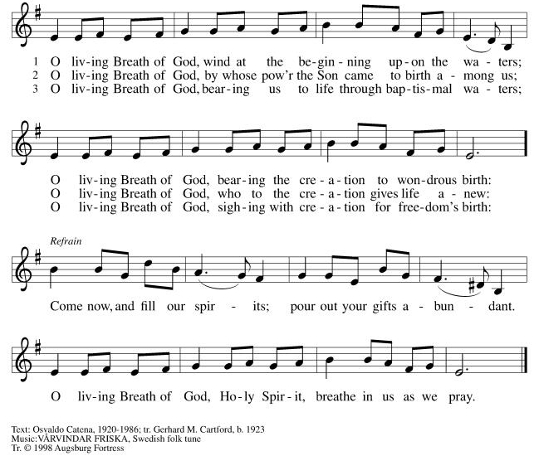
GATHERING HYMN O Living Breath of God ELW 407
Thanksgiving for Baptism
Alleluia! Christ is risen.
He is risen, indeed. Alleluia!
In the name of ☩ the One
who was, who is, and who is to come.
Amen.
Baptized into Christ’s death and resurrection,
and called to live the baptized life,
let us give thanks for the gifts of baptism.
Holy God,
we give you thanks for the waters of baptism,
waters that make a people your own,

that restore to wholeness,
and empower us to be witnesses in your name.
Baptized into you, O Living One,
make us one as you are one.
We give you thanks for the waters of baptism,
waters that strengthen believers
and give new life to beloved servants of your church;
waters that extend your boundless love
and cross barriers of our own making.
Baptized into you, O Living One,
make us one as you are one.
We give you thanks for the waters of baptism,
waters that open the hearts of believers
and give a voice in the night to those in captivity;
waters that set your people on a new path,
rejoicing in the Spirit’s power.
Baptized into you, O Living One,
make us one as you are one.
Grant us grace, love, and life, O Living One,
that our every day is shaped by these waters
that give us our very lives in you.
We ask this in the name of Jesus, the Crucified and Risen One.
Amen.
PRAYER OF THE DAY
God our creator, the resurrection of your Son offers life to all the peoples of earth. By your Holy Spirit, kindle in us the fire of your love, empowering our lives for service and our tongues for praise, through Jesus Christ, our Savior and Lord, who lives and reigns with you and the Holy Spirit, one God, now and forever.
Amen.
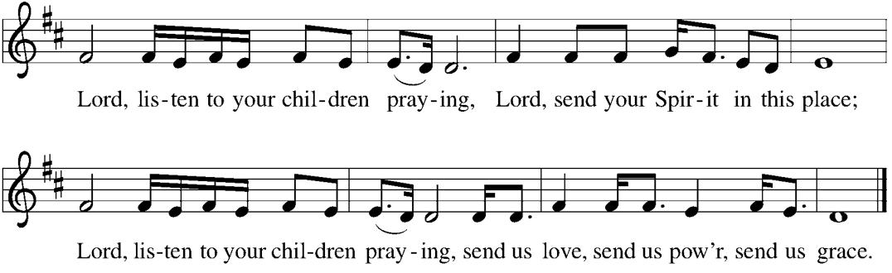
CHILDREN’S MUSIC Lord, Listen to Your Children Praying ELW 752

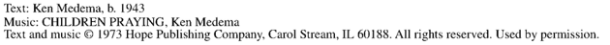
CHILDREN’S MESSAGE
SCRIPTURE READINGS
FIRST READING: Acts 2:1-21
¹ When the day of Pentecost had come, [the apostles] were all together in one place. ² And suddenly from heaven there came a sound like the rush of a violent wind, and it filled the entire house where they were sitting. ³ Divided tongues, as of fire, appeared among them, and a tongue rested on each of them. ⁴ All of them were filled with the Holy Spirit and began to speak in other languages, as the Spirit gave them ability.
⁵ Now there were devout Jews from every people under heaven living in Jerusalem. ⁶ And at this sound the crowd gathered and was bewildered, because each one heard them speaking in the native language of each. ⁷ Amazed and astonished, they asked, “Are not all these who are speaking Galileans? ⁸ And how is it that we hear, each of us, in our own native language? ⁹ Parthians, Medes, Elamites, and residents of Mesopotamia, Judea and Cappadocia, Pontus and Asia, ¹⁰ Phrygia and Pamphylia, Egypt and the parts of Libya belonging to Cyrene, and visitors from Rome, both Jews and proselytes, ¹¹ Cretans and Arabs—in our own languages we hear them speaking about God’s deeds of power.” ¹² All were amazed and perplexed, saying to one another, “What does this mean?” ¹³ But others sneered and said, “They are filled with new wine.”
¹⁴ But Peter, standing with the eleven, raised his voice and addressed them, “Fellow Jews and all who live in Jerusalem, let this be known to you, and listen to what I say. ¹⁵ Indeed, these are not drunk, as you suppose, for it is only nine o’clock in the morning. ¹⁶ No, this is what was spoken through the prophet Joel:
¹⁷ ‘In the last days it will be, God declares,
that I will pour out my Spirit upon all flesh, and your sons and your daughters shall prophesy,
and your young men shall see visions, and your old men shall dream dreams.
¹⁸ Even upon my slaves, both men and women,
in those days I will pour out my Spirit, and they shall prophesy.
¹⁹ And I will show portents in the heaven above and signs on the earth below,
blood, and fire, and smoky mist.
²⁰ The sun shall be turned to darkness and the moon to blood,
before the coming of the Lord’s great and glorious day.
²¹ Then everyone who calls on the name of the Lord shall be saved.’ ”
Word of God, word of life.
Thanks be to God.
PSALM: Psalm 104:24-34, 35b
²⁴ How manifold are your works, O Lord!
In wisdom you have made them all; the earth is full of your creatures.
²⁵ Yonder is the sea, great and wide, with its swarms too many to number,
living things both small and great.
²⁶ There go the ships to and fro,
and Leviathan, which you made for the sport of it.
²⁷ All of them look to you
to give them their food in due season.
²⁸ You give it to them; they gather it;
you open your hand, and they are filled with good things.
²⁹ When you hide your face, they are terrified;
when you take away their breath, they die and return to their dust.
³⁰ You send forth your Spirit, and they are created;
and so you renew the face of the earth.
³¹ May the glory of the Lord endure forever;
O Lord, rejoice in all your works.
³² You look at the earth and it trembles;
you touch the mountains and they smoke.
³³ I will sing to the Lord as long as I live;
I will praise my God while I have my being.
³⁴ May these words of mine please God.
I will rejoice in the Lord.
^{35b} Bless the Lord, O my soul.
Hallelujah!
SECOND READING: Romans 8:14-17
¹⁴ For all who are led by the Spirit of God are children of God. ¹⁵ For you did not receive a spirit of slavery to fall back into fear, but you received a spirit of adoption. When we cry, “Abba! Father!” ¹⁶ it is that very Spirit bearing witness with our spirit that we are children of God, ¹⁷ and if children, then heirs: heirs of God and joint heirs with Christ, if we in fact suffer with him so that we may also be glorified with him.
Word of God, word of life.
Thanks be to God.
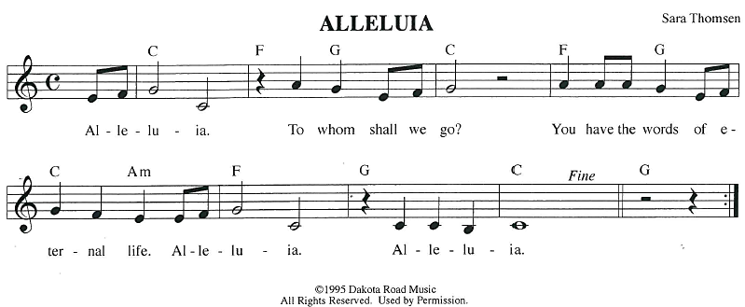
GOSPEL ACCLAMATION
GOSPEL: John 14:8-17 [25-27]
⁸ Philip said to [Jesus,] “Lord, show us the Father, and we will be satisfied.” ⁹ Jesus said to him, “Have I been with you all this time, Philip, and you still do not know me? Whoever has seen me has seen the Father. How can you say, ‘Show us the Father’? ¹⁰ Do you not believe that I am in the Father and the Father is in me? The words that I say to you I do not speak on my own, but the Father who dwells in me does his works. ¹¹ Believe me that I am in the Father and the Father is in me, but if you do not, then believe because of the works themselves. ¹² Very truly, I tell you, the one who believes in me will also do the works that I do and, in fact, will do greater works than these, because I am going to the Father. ¹³ I will do whatever you ask in my name, so that the Father may be glorified in the Son. ¹⁴ If in my name you ask me for anything, I will do it.
¹⁵ “If you love me, you will keep my commandments. ¹⁶ And I will ask the Father, and he will give you another Advocate, to be with you forever. ¹⁷ This is the Spirit of truth, whom the world cannot receive because it neither sees him nor knows him. You know him because he abides with you, and he will be in you.
²⁵ [ “I have said these things to you while I am still with you. ²⁶ But the Advocate, the Holy Spirit, whom the Father will send in my name, will teach you everything and remind you of all that I have said to you. ²⁷ Peace I leave with you; my peace I give to you. I do not give to you as the world gives. Do not let your hearts be troubled, and do not let them be afraid.”]
The gospel of the Lord.
Praise to you, O Christ.
SERMON

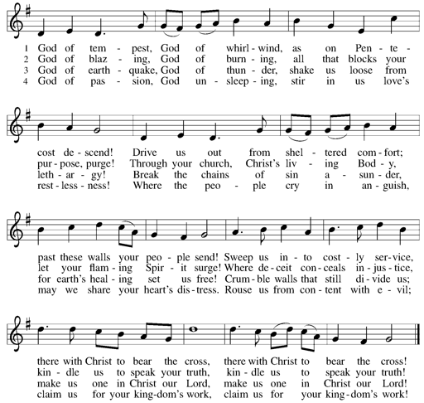
HYMN OF THE DAY God of Tempest, God of Whirlwind ELW 400
PRAYERS OF INTERCESSION
…Hear us, O God.
Your mercy is great
We commend these and all our prayers to you, O God, trusting that you are always with us; in the name of Jesus Christ, our risen Savior.
Amen.
PEACE
The peace of Christ be with you always.
And also with you.
HOLY COMMUNION
OFFERING In addition to our normal offering, a Special Benevolence in June (collected in a special
envelope) will be going to SOS.

OFFERING SONG Lord, Be Glorified ELW 744
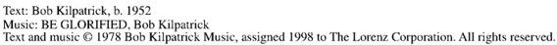
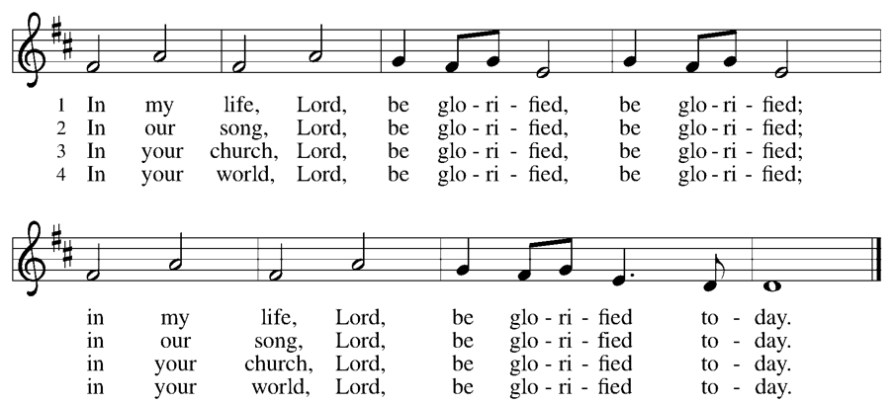
OFFERTORY PRAYER
Risen One,
you have gathered us around your table of grace along with these gifts we bring.
Come among us again, breathe your life into us,
and enliven us with this meal,
that we may live as your risen body in the world.
Amen.
GREAT THANKSGIVING
The Lord be with you.
And also with you.
Lift up your hearts.
We lift them to the Lord.

Let us give our thanks to the Lord our God.
It is right to give our thanks and praise.

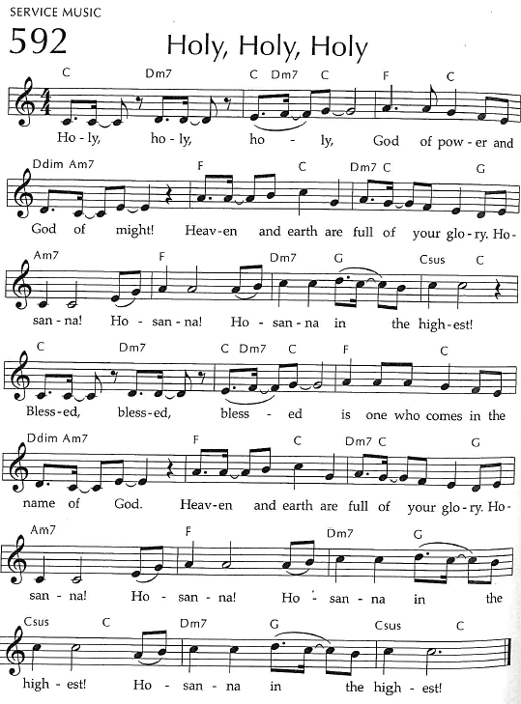
Holy, Holy, Holy
THANKSGIVING AT THE TABLE

Blessed are you, O God of the universe.
Your mercy is everlasting
and your faithfulness endures from age to age.
Praise to you for creating the heavens and
the earth.
Praise to you for saving the earth from the waters of the flood.
Praise to you for bringing the Israelites safely through the sea.
Praise to you for leading your people through the wilderness to the land of milk and honey.
Praise to you for the words and deeds of Jesus, your anointed one.
Praise to you for the death and resurrection of Christ.
Praise to you for your Spirit poured out on all nations.

In the night in which he was betrayed,
our Lord Jesus took bread, and gave thanks;
broke it, and gave it to his disciples, saying:
Take and eat; this is my body, given for you.
Do this for the remembrance of me.
Again, after supper, he took the cup, gave thanks,
and gave it for all to drink, saying:
This cup is the new covenant in my blood,
shed for you and for all people for
the forgiveness of sin. Do this for the remembrance of me.
With this bread and cup
we remember our Lord’s passover from death to life as we proclaim the mystery of faith:
Christ has died.
Christ is risen.
Christ will come again.
O God of resurrection and new life:
Pour out your Holy Spirit on us
and on these gifts of bread and wine.
Bless this feast.
Grace our table with your presence.
Come, Holy Spirit.
Reveal yourself to us in the breaking of the bread.
Raise us up as the body of Christ for the world.
Breathe new life into us.

Send us forth,
burning with justice, peace, and love.
Come, Holy Spirit.
With your holy ones of all times and places,
with the earth and all its creatures,
with sun and moon and stars,
we praise you, O God,
blessed and holy Trinity,
now and forever.
Amen.

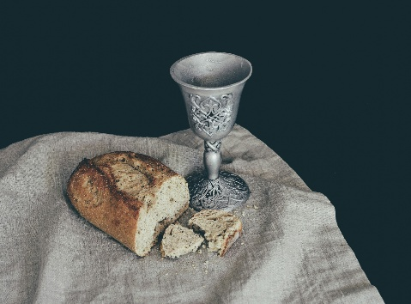
THE LORD’S PRAYER
Our Father, who art in heaven,
hallowed be thy name, thy kingdom come,
thy will be done, on earth as it is in heaven.
Give us this day our daily bread;
and forgive us our trespasses,
as we forgive those who trespass against us;
and lead us not into temptation, but deliver us from evil.
For thine is the kingdom,
and the power, and the glory, forever and ever. Amen.
INVITATION TO COMMUNION - Certified gluten-free crackers are in the bowl on the communion plate.
Come to the table of grace.
Receive the gift of new life.
HOLY COMMUNION
PRAYER AFTER COMMUNION
Living One,
in this feast you have made yourself known to us.
Send us now to tell of your wonders,
sing of your glory,
and proclaim your risen life to a wounded and weary world.
Amen.
SENDING
BLESSING
The triune God,
who was, who is,
and who is to come,
Sovereign, ☩ Savior, and Spirit,
light your way with resurrection dawn, now and always.
Amen.

CLOSING HYMN The Spirit Sends Us Forth to Serve ELW 551
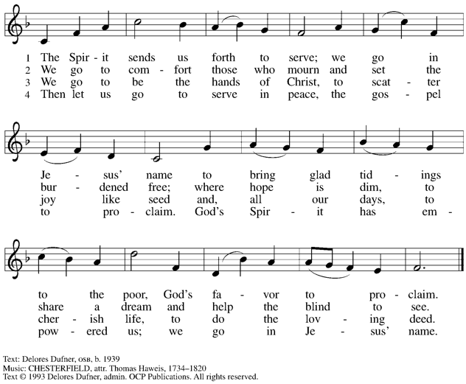
DISMISSAL
Alleluia! Christ is risen.
He is risen indeed. Alleluia!
Go in peace. In Christ you are made new. Alleluia! Alleluia!
Upcoming Worship Assistants
 | Usher | Lector | Communion | Offering Counters |  | Deep Clean
June 8 | Jon & May Hill | Nancy Tibbett | Rob Pankratz  Andrea Hovick | Heidi Binder | Kami Weis | June:  Chris Tipping  Julie Will  Andrea Hovick  Deb Janz
June 15 | Jim & Sharon Schiszik | Chris Tipping | Ron Rothfusz  Nancy Leonard | Pam Mundt | Margo Berrier | June:  Chris Tipping  Julie Will  Andrea Hovick  Deb Janz
June 22 | Ed & Ruth Raatz | Kris Tarter | Dave & Shelly Schneider | Dan Mundt | Bob Peterson | June:  Chris Tipping  Julie Will  Andrea Hovick  Deb Janz
June 29 | Ron Rothfusz | Andrea Hovick | Dan & Pam Mundt | Nancy Leonard | Rob Mader | June:  Chris Tipping  Julie Will  Andrea Hovick  Deb Janz
Thanks be to God. Alleluia! Alleluia!

Coming up at GSLC
Sunday, June 8 | 9:00 am | Worship Service  - Day of Pentecost  - John 14:8-17[25-27]; The Father will give you another Advocate, the Spirit of truth
Tuesday, June 10 | 6:30 pm | Council Meeting
 | 7:00 pm | AA Meeting
Saturday, June 14 | 11 am-6 pm | Brat Barn at Festival Foods
Sunday, June 15 | 9:00 am | Worship Service  - First Sunday after Pentecost  - John 16:12-15; The Spirit will guide you into the truth
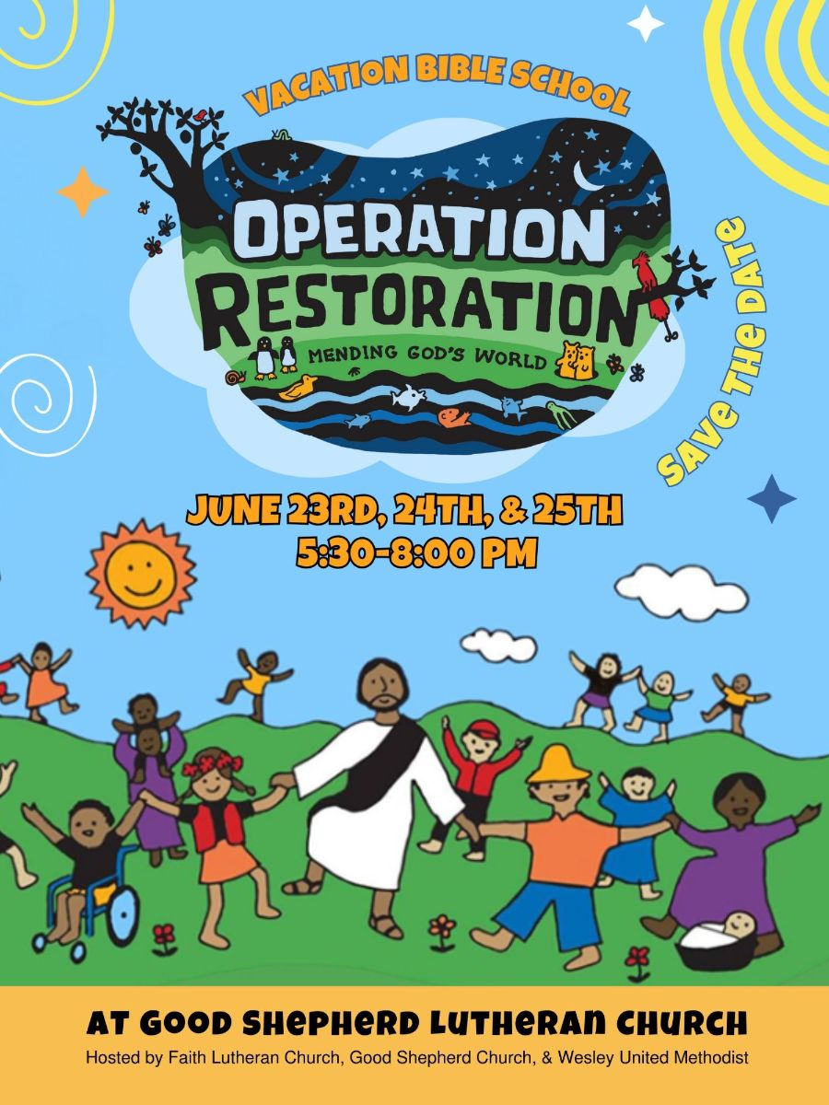
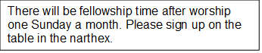
Names on the prayer list now default to 6 weeks. If you would like a name to remain on the list longer, please let Pastor Katie know.
Pastor Katie’s Office Hours: Monday-Thursday 9am-2pm. Tuesday mornings at Uptown Coffee. Afternoons available by appointment. You are welcome to stop in any time for conversation or concerns.

Pub Theology is returning for the summer!
1st & 3rd Wednesday June-August
Scotty’s Pizza & Chicken 6:00 pm
This year, we’re collaborating with Wesley UMC. Topics each week include: Having Hard Conversations (6/4), Attitude of Gratitude (6/18), Good Grief (7/2), What is Truth? (7/16), Faith & Science (8/6), Religion & Politics (8/20)
What is Pub Theology? People have been gathering in pubs and public spaces for ages talking about life, philosophy, faith, and deep questions of meaning. Increasingly, people all over are rediscovering the pub as a safe, open space where they can explore and express their own doubts and questions, learn from others, and engage people of varying religious traditions. In our increasingly fractured society, these spaces are not only welcome but needed.
Bring your questions and curiosity, and pull up a chair.
There will be fellowship time after worship one Sunday a month. Please sign up on the table in the narthex.

Our Good Shepherd Directory revision is on its way to the printer. Thank you to everyone who submitted photos and updated contact information. We are anticipating that the new directories will be printed and ready for distribution by the end of June.
Mark your calendars to join us for our Directory Distribution Celebration with refreshments and treats after church services on Sunday, June 29th. Please contact the team comprised of Jon Hill, Margo Berrier, Pam Mundt and Jane Wagner for more information.

We are signed up to work at Festival’s Brat Barn on Saturday, June 14th. We still need volunteers for shifts from 11am-6pm. Please sign up if you are available!



Outdoor movies are back for the summer! This year, we’re partnering with Marshfield Young Professionals for Movies in the Park. Movies will be shown the 3rd Friday in June, July, and August. June and August’s movies will be at Columbia Park. We are sponsoring July’s movie, Mufasa, shown here. All movies will begin at dusk, GSLC is the rain location for June and August.


