
Good Shepherd Lutheran Church
Pastor: Rev. Katie Anderson | Music Director: Rev. Lois Swanson
Pastor’s Cell: (715) 502-9433 | Office Phone: (715) 387-2731
Pastor Email: gslcwi.pastor@gmail.com | Office Email: gslcwi.office@gmail.com
Website: GoodShepherdMarshfield.org
Third Sunday after Pentecost
June 29, 2025, 9:00 am
Introduction to the day…
ANNOUNCEMENTS

GATHERING
We have no good apart from God. That makes Jesus’ call to follow him an invitation to freedom. This is freedom to revel in the Spirit’s fruit: love, joy, peace, and patience. This is freedom to not be imprisoned by anything that would keep us from the fullness of the life God has given us. This is the path of life.

GATHERING HYMN Glorious Things of You are Spoken ELW 647
Confession and Forgiveness
In the name of the Father,

and of the ☩ Son,
and of the Holy Spirit.
Amen.
Baptized into Christ, let us confess our sin.
Silence is kept for reflection.
Merciful God,
you free us to love others,
but we neglect our neighbors and follow our own way.
You lead us by the Spirit of joy and peace,
but we turn away from the abundant life you offer.
You surround us with patience, kindness,
and generosity,
but we grow weary in doing what is right.
In your mercy, forgive us.
Do not give up on us.
Heal us, break our bonds,
and show us the path of life.
Amen.
You belong to Christ Jesus
and you are God’s children through faith.
In the cross of ☩ Christ,
and through the power of the Holy Spirit,
your sins are forgiven.
Clothed with Christ, you are a new creation.
Amen.
PRAYER OF THE DAY
Sovereign God, ruler of all hearts, you call us to obey you, and you favor us with true freedom. Keep us faithful to the ways of your Son, that, leaving behind all that hinders us, we may steadfastly follow your paths, through Jesus Christ, our Savior and Lord.
Amen.
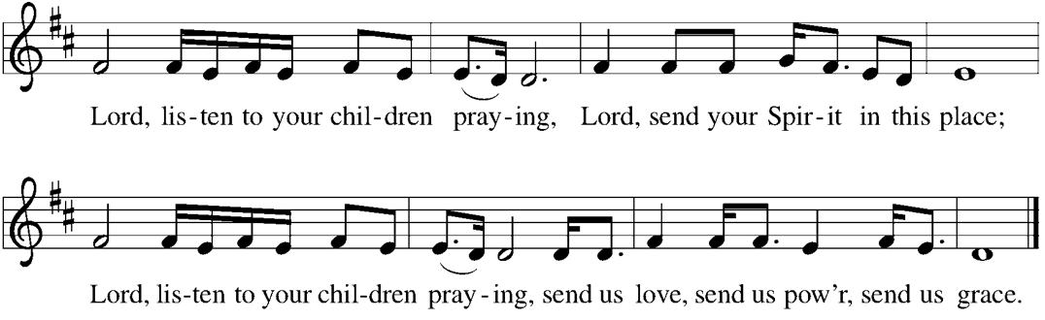
CHILDREN’S MUSIC Lord, Listen to Your Children Praying ELW 752

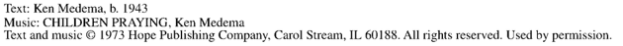

CHILDREN’S MESSAGE

SCRIPTURE READINGS
FIRST READING: 1Kings 19:15-16, 19-21
¹⁵ Then the Lord said to [Elijah], “Go, return on your way to the wilderness of Damascus; when you arrive, you shall anoint Hazael as king over Aram. ¹⁶ Also you shall anoint Jehu son of Nimshi as king over Israel, and you shall anoint Elisha son of Shaphat of Abel-meholah as prophet in your place.
¹⁹ So he set out from there and found Elisha son of Shaphat, who was plowing. There were twelve yoke of oxen ahead of him, and he was with the twelfth. Elijah passed by him and threw his mantle over him. ²⁰ He left the oxen, ran after Elijah, and said, “Let me kiss my father and my mother, and then I will follow you.” Then Elijah said to him, “Go back again, for what have I done to you?” ²¹ He returned from following him, took the yoke of oxen, and slaughtered them; using the equipment from the oxen, he boiled their flesh and gave it to the people, and they ate. Then he set out and followed Elijah and became his servant.
Word of God, word of life.
Thanks be to God.
PSALM: Psalm 16

¹ Protect me, O God, for I take refuge in you;
I have said to the Lord, “You are my Lord, my good above all other.”
² All my delight is in the godly that are in the land,
upon those who are noble among the people.
³ But those who run after other gods
shall have their troubles multiplied.
⁴ I will not pour out drink offerings to such gods,
never take their names upon my lips.
⁵ O Lord, you are my portion and my cup;
it is you who uphold my lot.
⁶ My boundaries enclose a pleasant land;
indeed, I have a rich inheritance.
⁷ I will bless the Lord who gives me counsel;
my heart teaches me night after night.
⁸ I have set the Lord always before me;
because God is at my right hand, I shall not be shaken.
⁹ My heart, therefore, is glad, and my spirit rejoices;
my body also shall rest in hope.
¹⁰ For you will not abandon me to the grave,
nor let your holy one see the pit.
¹¹ You will show me the path of life;
in your presence there is fullness of joy, and in your right hand are pleasures forevermore.
SECOND READING: Galatians 5:1, 13-25
¹ For freedom Christ has set us free. Stand firm, therefore, and do not submit again to a yoke of slavery.
¹³ For you were called to freedom, brothers and sisters, only do not use your freedom as an opportunity for self-indulgence, but through love become enslaved to one another. ¹⁴ For the whole law is summed up in a single commandment, “You shall love your neighbor as yourself.” ¹⁵ If, however, you bite and devour one another, take care that you are not consumed by one another.
¹⁶ Live by the Spirit, I say, and do not gratify the desires of the flesh. ¹⁷ For what the flesh desires is opposed to the Spirit, and what the Spirit desires is opposed to the flesh, for these are opposed to each other, to prevent you from doing what you want. ¹⁸ But if you are led by the Spirit, you are not subject to the law. ¹⁹ Now the works of the flesh are obvious: sexual immorality, impurity, debauchery, ²⁰ idolatry, sorcery, enmities, strife, jealousy, anger, quarrels, dissensions, factions, ²¹ envy, drunkenness, carousing, and things like these. I am warning you, as I warned you before: those who do such things will not inherit the kingdom of God.
²² By contrast, the fruit of the Spirit is love, joy, peace, patience, kindness, generosity, faithfulness, ²³ gentleness, and self-control. There is no law against such things. ²⁴ And those who belong to Christ have crucified the flesh with its passions and desires. ²⁵ If we live by the Spirit, let us also be guided by the Spirit.
Word of God, word of life.
Thanks be to God.
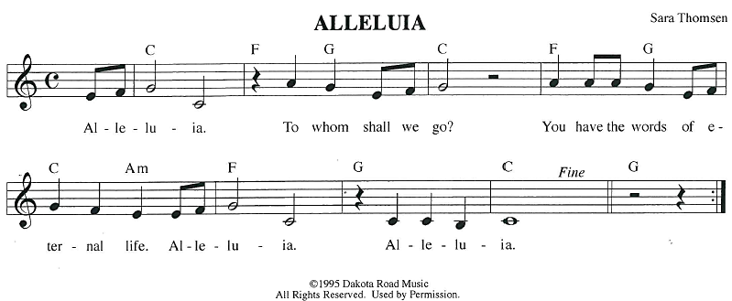
GOSPEL ACCLAMATION
GOSPEL: Luke 9:51-62
⁵¹ When the days drew near for [Jesus] to be taken up, he set his face to go to Jerusalem. ⁵² And he sent messengers ahead of him. On their way they entered a village of the Samaritans to prepare for his arrival, ⁵³ but they did not receive him because his face was set toward Jerusalem. ⁵⁴ When his disciples James and John saw this, they said, “Lord, do you want us to command fire to come down from heaven and consume them?” ⁵⁵ But he turned and rebuked them. ⁵⁶ Then they went on to another village.
⁵⁷ As they were going along the road, someone said to him, “I will follow you wherever you go.” ⁵⁸ And Jesus said to him, “Foxes have holes, and birds of the air have nests, but the Son of Man has nowhere to lay his head.” ⁵⁹ To another he said, “Follow me.” But he said, “Lord, first let me go and bury my father.” ⁶⁰ And Jesus said to him, “Let the dead bury their own dead, but as for you, go and proclaim the kingdom of God.” ⁶¹ Another said, “I will follow you, Lord, but let me first say farewell to those at my home.” ⁶² And Jesus said to him, “No one who puts a hand to the plow and looks back is fit for the kingdom of God.”
The gospel of the Lord.
Praise to you, O Christ.
SERMON Reverend Diane House

HYMN OF THE DAY Lift High the Cross ELW 660
APOSTLES’ CREED
I believe in God, the Father almighty,
creator of heaven and earth.
I believe in Jesus Christ, God's only Son, our Lord,
who was conceived by the power of the Holy Spirit, born of the Virgin Mary,
suffered under Pontius Pilate, was crucified, died, and was buried;
he descended to the dead.
On the third day he rose again;
he ascended into heaven, he is seated at the right hand of the Father,
and he will come to judge the living and the dead.
I believe in the Holy Spirit, the holy catholic Church,
the communion of saints, the forgiveness of sins,
the resurrection of the body, and the life everlasting. Amen.
PRAYERS OF INTERCESSION
…God of Grace.
Hear our prayer
Gather all our prayers in your mercy, O God, through Jesus Christ, our Savior.
Amen.
PEACE
The peace of Christ be with you always.
And also with you.
HOLY COMMUNION
OFFERING In addition to our normal offering, a Special Benevolence in June (collected in a special
envelope) will be going to SOS.
OFFERING SONG Look Who Gathers at Christ’s Table ACS 977

OFFERTORY PRAYER
Creator God,
in your wisdom you bring forth all that is good
and the harvest is plentiful.
Strengthen us at your table with these gifts of the earth
and our labor,
that we may work for the good of all;
through Jesus Christ, our Savior.
Amen.

GREAT THANKSGIVING
The Lord be with you.
And also with you.
Lift up your hearts.
We lift them to the Lord.
Let us give our thanks to the Lord our God.
It is right to give our thanks and praise.
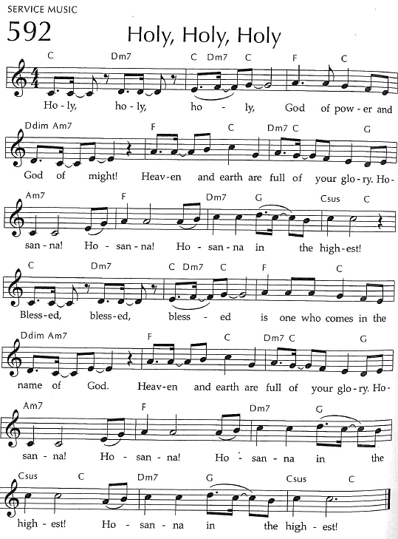
Holy, Holy, Holy

THANKSGIVING AT THE TABLE

God of our weary years, God of our silent tears,
you have brought us this far along the way.
In times of bitterness you did not abandon us,
but guided us into the path of love and light.
In every age you sent prophets
to make known your loving will for all humanity.
The cry of the poor has become your own cry;
our hunger and thirst for justice is your own desire.
In the fullness of time, you sent your chosen servant to preach good news to the afflicted,
to break bread with the outcast and despised,
and to ransom those in
bondage to prejudice and sin.

In the night in which he was betrayed,
our Lord Jesus took bread, and gave thanks;
broke it, and gave it to his disciples, saying:
Take and eat; this is my body, given for you.
Do this for the remembrance of me.
Again, after supper, he took the cup, gave thanks,
and gave it for all to drink, saying:
This cup is the new covenant in my blood,
shed for you and all people for the forgiveness of sin.
Do this for the remembrance of me.
For as often as we eat of this bread and drink from this cup
we proclaim the Lord’s death until he comes.
Christ has died.
Christ is risen.
Christ will come again.

Remembering, therefore, his death and resurrection,
we await the day when Jesus shall return
to free all the earth from the bonds of slavery and death.
Come, Lord Jesus! And let the church say, Amen.
Amen.
Send your Holy Spirit, our advocate,
to fill the hearts of all who share this bread and cup
with courage and wisdom to pursue love and justice in all the world.
Come, Spirit of freedom! And let the church say, Amen.
Amen.
Join our prayers and praise with your prophets and martyrs of every age,
that, rejoicing in the hope of the resurrection,
we might live in the freedom and hope of your Son.
Through him, with him, in him, in the unity of the Holy Spirit,
all glory and honor is yours, almighty Father, now and forever.
Amen.

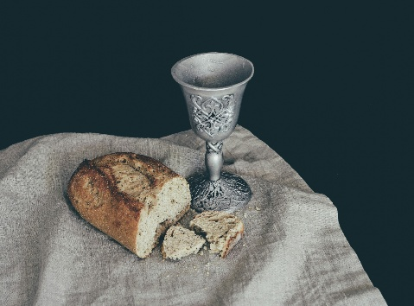
THE LORD’S PRAYER
Our Father, who art in heaven,
hallowed be thy name, thy kingdom come,
thy will be done, on earth as it is in heaven.
Give us this day our daily bread;
and forgive us our trespasses,
as we forgive those who trespass against us;
and lead us not into temptation, but deliver us from evil.
For thine is the kingdom,
and the power, and the glory, forever and ever. Amen.
INVITATION TO COMMUNION - Certified gluten-free crackers are in the bowl on the communion plate.
The kingdom of God is set before you.
Eat and rejoice.
HOLY COMMUNION
PRAYER AFTER COMMUNION
Mothering God,
you gathered us to your table
and we drank deeply of your grace.
Send us out by your Spirit
to love our neighbors as ourselves
and proclaim your love in Jesus’ name.
Amen.

SENDING
BLESSING
The love of God abound in you;
the grace of our Savior Jesus Christ fill your hearts;
and the life of the Spirit
☩ bless you and give you peace.
Amen.
CLOSING HYMN Guide My Feet ACS 987
Guide my feet while I run this race,  guide my feet while I run this race,  Guide my feet while I run this race,  for I don’t want to run this race in vain! | I’m your child while I run this race,  I’m your child while I run this race,  I’m your child while I run this race,  for I don’t want to run this race in vain!
Hold my hand while I run this race,  Hold my hand while I run this race,  Hold my hand while I run this race,  for I don’t want to run this race in vain! | Search my heart while I run this race,  Search my heart while I run this race,  Search my heart while I run this race,  for I don’t want to run this race in vain!
Stand by me while I run this race,
Stand by me while I run this race,
Stand by me while I run this race,
for I don’t want to run this race in vain!
Text & Tune: African American Spiritual; harm. By Diana Kodner, b. 1957 © GIA Publications, Inc. OneLicense.net License # A-707882
DISMISSAL
Go in peace. Live by the Spirit.
Upcoming Worship Assistants
 | Usher | Lector | Communion | Offering Counters |  | Deep Clean
June 29 | Ron Rothfusz | Chris Tipping | Dave & Shelly Schneider | Nancy Leonard | Rob Mader | June:  Chris Tipping  Julie Will  Andrea Hovick  Deb Janz
July 6 | Charles & Mary Schlafke | Rob Pankratz | Bruce & Nancy Tibbett | Robin Beeman | David Schneider | July:  John & Jane Wagner  Laurel Peterson  Leslie Mader
July 13 | Rob Pankratz | Jon Hill | Tammy Neumann  Ron Rothfusz | Heidi Binder | Kami Weis | July:  John & Jane Wagner  Laurel Peterson  Leslie Mader
July 20 | Dennis & Linda Schutte | Richard Kopitzke | Nancy Leonard Rob Pankratz | Pam Mundt | Margo Berrier | July:  John & Jane Wagner  Laurel Peterson  Leslie Mader
Thanks be to God.
Thank you to Reverend Diane House from the Synod for preaching today and joining us in worship!
Names on the prayer list now default to 6 weeks. If you would like a name to remain on the list longer, please let Pastor Katie know.
There will be fellowship time after worship one Sunday a month. Please sign up on the table in the narthex.
Pastor Katie’s Office Hours: Monday-Thursday 9am-2pm. Tuesday mornings at Uptown Coffee. Afternoons available by appointment. You are welcome to stop in any time for conversation or concerns.
Coming up at GSLC
Sunday, June 29 | 9:00 am | Worship Service  - Third Sunday after Pentecost  - Luke 9:51-62; Jesus says, Follow me and do not look back
Tuesday, July 1 | 7:00 pm | AA meeting
Wednesday, July 2 | 9:00 am | Executive Committee meeting
 | 6:00 pm | Pub Theology at Scotty’s Pizza & Chicken  Topic: “Good Grief”
Thursday, July 3 | 11am-2pm | Purple Angels Lunch and Fellowship
Sunday, July 6 | 9:00 am | Worship Service  - Fourth Sunday after Pentecost  - Luke 10:1-11, 16-20; Jesus sends out seventy disciples into the harvest

Our Good Shepherd Directory is now available! Thank you to everyone who submitted photos and updated contact information. There will be fellowship time after worship today to celebrate the new directory. If you would like to, you are welcome to make a donation to offset the cost of printing. Thank you to the directory team Jon Hill, Margo Berrier, Pam Mundt and Jane Wagner for putting the new directory together!


Pub Theology is returning for the summer!
1st & 3rd Wednesday June-August
Scotty’s Pizza & Chicken 6:00 pm
This year, we’re collaborating with Wesley UMC. Topics each week include: Having Hard Conversations (6/4), Attitude of Gratitude (6/18), Good Grief (7/2), What is Truth? (7/16), Faith & Science (8/6), Religion & Politics (8/20)
What is Pub Theology? People have been gathering in pubs and public spaces for ages talking about life, philosophy, faith, and deep questions of meaning. Increasingly, people all over are rediscovering the pub as a safe, open space where they can explore and express their own doubts and questions, learn from others, and engage people of varying religious traditions. In our increasingly fractured society, these spaces are not only welcome but needed.
Bring your questions and curiosity, and pull up a chair.

Outdoor movies are back for the summer! This year, we’re partnering with Marshfield Young Professionals for Movies in the Park. Movies will be shown the 3rd Friday in June, July, and August. June and August’s movies will be at Columbia Park. We are sponsoring July’s movie, Mufasa, shown here. All movies will begin at dusk, GSLC is the rain location for June and August.


