
Good Shepherd Lutheran Church
Pastor: Rev. Katie Anderson | Music Director: Rev. Lois Swanson
Pastor’s Cell: (715) 502-9433 | Office Phone: (715) 387-2731
Pastor Email: gslcwi.pastor@gmail.com | Office Email: gslcwi.office@gmail.com
Website: GoodShepherdMarshfield.org
Second Sunday after Pentecost
June 22, 2025, 9:00 am
Introduction to the day…
ANNOUNCEMENTS
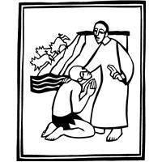
GATHERING
This Sunday’s texts paint startling pictures of the horrific nature of sin. The church’s repeated celebration of holy communion counters that tragic reality in a continued showing forth of the death of Jesus until he comes again. It is a dramatic declaration of “how much God has done for you.”

GATHERING HYMN Praise the One Who Breaks the Darkness ELW 843

Confession and Forgiveness
In the name of the Father,

and of the ☩ Son,
and of the Holy Spirit.
Amen.
Baptized into Christ, let us confess our sin.
Silence is kept for reflection.
Merciful God,
you free us to love others,
but we neglect our neighbors and follow our own way.
You lead us by the Spirit of joy and peace,
but we turn away from the abundant life you offer.
You surround us with patience, kindness,
and generosity,
but we grow weary in doing what is right.
In your mercy, forgive us.
Do not give up on us.
Heal us, break our bonds,
and show us the path of life.
Amen.
You belong to Christ Jesus
and you are God’s children through faith.
In the cross of ☩ Christ,
and through the power of the Holy Spirit,
your sins are forgiven.
Clothed with Christ, you are a new creation.
Amen.
PRAYER OF THE DAY
O Lord God, we bring before you the cries of a sorrowing world. In your mercy set us free from the chains that bind us, and defend us from everything that is evil, through Jesus Christ, our Savior and Lord.
Amen.
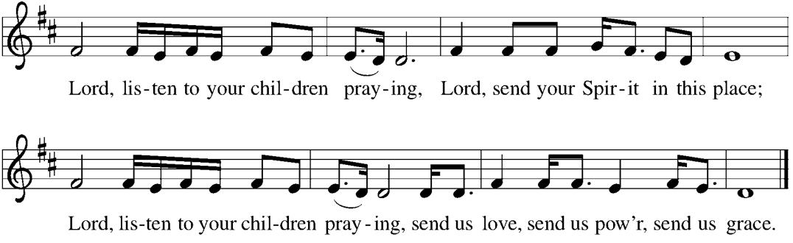
CHILDREN’S MUSIC Lord, Listen to Your Children Praying ELW 752

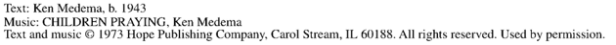

CHILDREN’S MESSAGE

SCRIPTURE READINGS
FIRST READING: Isaiah 65:1-9

¹ I was ready to be sought out by those who did not ask,
to be found by those who did not seek me.
I said, “Here I am, here I am,”
to a nation that did not call on my name.
² I held out my hands all day long to a rebellious people,
who walk in a way that is not good,
following their own devices;
³ a people who provoke me to my face continually,
sacrificing in gardens and offering incense on bricks;
⁴ who sit inside tombs and spend the night in secret places;
who eat the flesh of pigs,
with broth of abominable things in their vessels;
⁵ who say, “Keep to yourself;
do not come near me, for I am too holy for you.”
These are a smoke in my nostrils,
a fire that burns all day long.
⁶ See, it is written before me:
I will not keep silent, but I will repay;
I will indeed repay into their laps
⁷ their iniquities and their ancestors’ iniquities together,
says the Lord;
because they offered incense on the mountains and reviled me on the hills,
I will measure into their laps full payment for their actions.
⁸ Thus says the Lord:
As the wine is found in the cluster,
and they say, “Do not destroy it,
for there is a blessing in it,”
so I will do for my servants’ sake and not destroy them all.
⁹ I will bring forth descendants from Jacob
and from Judah inheritors of my mountains;
my chosen shall inherit it,
and my servants shall settle there.
Word of God, word of life.
Thanks be to God.
PSALM: Psalm 22:19-28
¹⁹ But you, O Lord, be not far away;
O my help, hasten to my aid.
²⁰ Deliver me from the sword,
my life from the power of the dog.
²¹ Save me from the lion’s mouth!
From the horns of wild bulls you have rescued me.
²² I will declare your name to my people;
in the midst of the assembly I will praise you.
²³ You who fear the Lord, give praise! All you of Jacob’s line, give glory.
Stand in awe of the Lord, all you offspring of Israel.
²⁴ For the Lord does not despise nor abhor the poor in their poverty; neither is the Lord’s face hidden from them;
but when they cry out, the Lord hears them.
²⁵ From you comes my praise in the great assembly;
I will perform my vows in the sight of those who fear the Lord.
²⁶ The poor shall eat and be satisfied,
Let those who seek the Lord give praise! May your hearts live forever!
²⁷ All the ends of the earth shall remember and turn to the Lord;
all the families of nations shall bow before God.
²⁸ For dominion belongs to the Lord,
who rules over the nations.
SECOND READING: Galatians 3:23-29
²³ Now before faith came, we were imprisoned and guarded under the law until faith would be revealed. ²⁴ Therefore the law was our disciplinarian until Christ came, so that we might be reckoned as righteous by faith. ²⁵ But now that faith has come, we are no longer subject to a disciplinarian, ²⁶ for in Christ Jesus you are all children of God through faith. ²⁷ As many of you as were baptized into Christ have clothed yourselves with Christ. ²⁸ There is no longer Jew or Greek; there is no longer slave or free; there is no longer male and female, for all of you are one in Christ Jesus. ²⁹ And if you belong to Christ, then you are Abraham’s offspring, heirs according to the promise.
Word of God, word of life.
Thanks be to God.
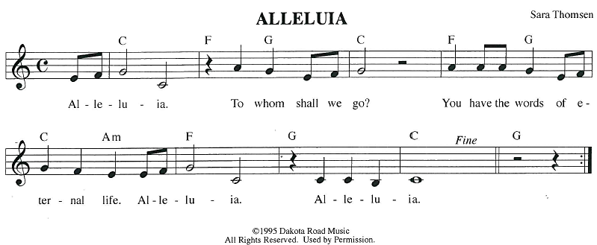
GOSPEL ACCLAMATION
GOSPEL: Luke 8:26-39
²⁶ Then [Jesus and his disciples] arrived at the region of the Gerasenes, which is opposite Galilee. ²⁷ As he stepped out on shore, a man from the city who had demons met him. For a long time he had not worn any clothes, and he did not live in a house but in the tombs. ²⁸ When he saw Jesus, he cried out and fell down before him, shouting, “What have you to do with me, Jesus, Son of the Most High God? I beg you, do not torment me,” ²⁹ for Jesus had commanded the unclean spirit to come out of the man. (For many times it had seized him; he was kept under guard and bound with chains and shackles, but he would break the bonds and be driven by the demon into the wilds.) ³⁰ Jesus then asked him, “What is your name?” He said, “Legion,” for many demons had entered him. ³¹ They begged him not to order them to go back into the abyss.
³² Now there on the hillside a large herd of swine was feeding, and the demons begged Jesus to let them enter these. So he gave them permission. ³³ Then the demons came out of the man and entered the swine, and the herd stampeded down the steep bank into the lake and was drowned.
³⁴ When the swineherds saw what had happened, they ran off and told it in the city and in the country. ³⁵ Then people came out to see what had happened, and when they came to Jesus, they found the man from whom the demons had gone sitting at the feet of Jesus, clothed and in his right mind. And they became frightened. ³⁶ Those who had seen it told them how the one who had been possessed by demons had been healed. ³⁷ Then the whole throng of people of the surrounding region of the Gerasenes asked Jesus to leave them, for they were seized with great fear. So he got into the boat and returned. ³⁸ The man from whom the demons had gone out begged that he might be with him, but Jesus sent him away, saying, ³⁹ “Return to your home, and declare how much God has done for you.” So he went away, proclaiming throughout the city how much Jesus had done for him.
The gospel of the Lord.
Praise to you, O Christ.
SERMON
HYMN OF THE DAY I Heard the Voice of Jesus Say ELW 611
APOSTLES’ CREED
I believe in God, the Father almighty,
creator of heaven and earth.
I believe in Jesus Christ, God's only Son, our Lord,
who was conceived by the power of the Holy Spirit, born of the Virgin Mary,
suffered under Pontius Pilate, was crucified, died, and was buried;
he descended to the dead.
On the third day he rose again;
he ascended into heaven, he is seated at the right hand of the Father,
and he will come to judge the living and the dead.
I believe in the Holy Spirit, the holy catholic Church,
the communion of saints, the forgiveness of sins,
the resurrection of the body, and the life everlasting. Amen.

PRAYERS OF INTERCESSION
…God of Grace.
Hear our prayer
Gather all our prayers in your mercy, O God, through Jesus Christ, our Savior.
Amen.
PEACE
The peace of Christ be with you always.
And also with you.
HOLY COMMUNION
OFFERING In addition to our normal offering, a Special Benevolence in June (collected in a special
envelope) will be going to SOS.
OFFERING SONG As the Deer
1 As the deer pants for the water  So my soul longs after you;  You alone are my heart's desire  And I long to worship you. | 2 I want you more than gold or silver,  Only you can satisfy;  You alone are the real joy-giver  And the apple of my eye.
Refrain  You alone are my strength my shield  To you alone may my spirit yield  You alone are my heart's desire  And I long to worship you. | 3 You're my friend and you are my brother,  Even though you are a King;  I love you more than any other,  So much more than anything!
Words & Music: Martin Nystrom (1956-), alt. Words & Music © 1984 Maranatha Praise, Inc. Used by permission. CCLI LICENSE #669990
OFFERTORY PRAYER
Creator God,
in your wisdom you bring forth all that is good

and the harvest is plentiful.
Strengthen us at your table with these gifts of the earth
and our labor,
that we may work for the good of all;
through Jesus Christ, our Savior.
Amen.
GREAT THANKSGIVING
The Lord be with you.
And also with you.
Lift up your hearts.
We lift them to the Lord.
Let us give our thanks to the Lord our God.
It is right to give our thanks and praise.
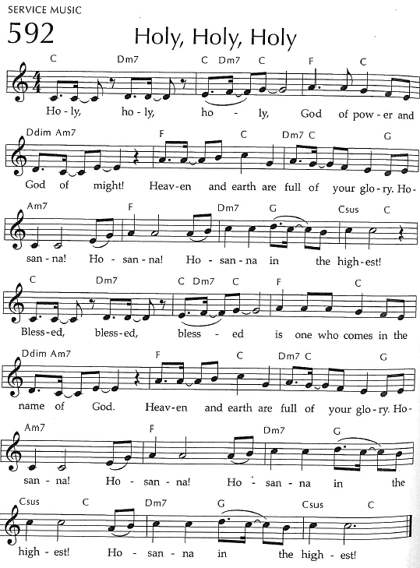
Holy, Holy, Holy

THANKSGIVING AT THE TABLE

God of our weary years, God of our silent tears,
you have brought us this far along the way.
In times of bitterness you did not abandon us,
but guided us into the path of love and light.
In every age you sent prophets
to make known your loving will for all humanity.
The cry of the poor has become your own cry;
our hunger and thirst for justice is your own desire.
In the fullness of time, you sent your chosen servant to preach good news to the afflicted,
to break bread with the outcast and despised,
and to ransom those in
bondage to prejudice and sin.
In the night in which he was betrayed,
our Lord Jesus took bread, and gave thanks;
broke it, and gave it to his disciples, saying:
Take and eat; this is my body, given for you.
Do this for the remembrance of me.
Again, after supper, he took the cup, gave thanks,
and gave it for all to drink, saying:
This cup is the new covenant in my blood,
shed for you and all people for the forgiveness of sin.
Do this for the remembrance of me.
For as often as we eat of this bread and drink from this cup
we proclaim the Lord’s death until he comes.
Christ has died.
Christ is risen.
Christ will come again.
Remembering, therefore, his death and resurrection,
we await the day when Jesus shall return
to free all the earth from the bonds of slavery and death.
Come, Lord Jesus! And let the church say, Amen.
Amen.
Send your Holy Spirit, our advocate,
to fill the hearts of all who share this bread and cup
with courage and wisdom to pursue love and justice in all the world.
Come, Spirit of freedom! And let the church say, Amen.
Amen.
Join our prayers and praise with your prophets and martyrs of every age,
that, rejoicing in the hope of the resurrection,
we might live in the freedom and hope of your Son.
Through him, with him, in him, in the unity of the Holy Spirit,
all glory and honor is yours, almighty Father, now and forever.
Amen.

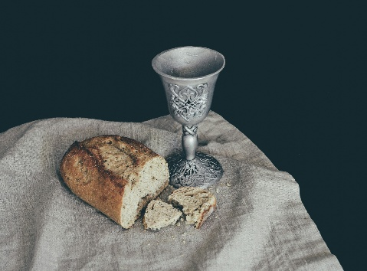
THE LORD’S PRAYER
Our Father, who art in heaven,
hallowed be thy name, thy kingdom come,
thy will be done, on earth as it is in heaven.
Give us this day our daily bread;
and forgive us our trespasses,
as we forgive those who trespass against us;
and lead us not into temptation, but deliver us from evil.
For thine is the kingdom,
and the power, and the glory, forever and ever. Amen.
INVITATION TO COMMUNION - Certified gluten-free crackers are in the bowl on the communion plate.
The kingdom of God is set before you.
Eat and rejoice.
HOLY COMMUNION
PRAYER AFTER COMMUNION
Mothering God,
you gathered us to your table
and we drank deeply of your grace.
Send us out by your Spirit
to love our neighbors as ourselves
and proclaim your love in Jesus’ name.
Amen.
SENDING
BLESSING
The love of God abound in you;
the grace of our Savior Jesus Christ fill your hearts;
and the life of the Spirit
☩ bless you and give you peace.
Amen.

CLOSING HYMN Will You Come and Follow Me ELW 798

DISMISSAL
Go in peace. Live by the Spirit.
Thanks be to God.
Upcoming Worship Assistants
 | Usher | Lector | Communion | Offering Counters |  | Deep Clean
June 22 | Ed & Ruth Raatz | Andrea Hovick | Dan & Pam Mundt | Dan Mundt | Bob Peterson | June:  Chris Tipping  Julie Will  Andrea Hovick  Deb Janz
June 29 | Ron Rothfusz | Andrea Hovick | Dave & Shelly Schneider | Nancy Leonard | Rob Mader | June:  Chris Tipping  Julie Will  Andrea Hovick  Deb Janz
July 6 | Charles & Mary Schlafke | Rob Pankratz | Bruce & Nancy Tibbett | Robin Beeman | David Schneider | July:  John & Jane Wagner  Laurel Peterson  Leslie Mader
July 13 | Rob Pankratz | Jon Hill | Tammy Neumann  Ron Rothfusz | Heidi Binder | Kami Weis | July:  John & Jane Wagner  Laurel Peterson  Leslie Mader
Names on the prayer list now default to 6 weeks. If you would like a name to remain on the list longer, please let Pastor Katie know.
There will be fellowship time after worship one Sunday a month. Please sign up on the table in the narthex.
Pastor Katie’s Office Hours: Monday-Thursday 9am-2pm. Tuesday mornings at Uptown Coffee. Afternoons available by appointment. You are welcome to stop in any time for conversation or concerns.
Coming up at GSLC
Sunday, June 22 | 9:00 am | Worship Service  - Second Sunday after Pentecost  - Luke 8:26-39; Jesus casts out demons possessing a man of the Gerasenes
Monday, June 23 | 5:30-8 pm | VBS
Tuesday, June 24 | 5:30-8 pm | VBS
 | 7:00 pm | AA Meeting
Wednesday, June 25 | 5:30-8 pm | VBS
Sunday, June 29 | 9:00 am | Worship Service  - Third Sunday after Pentecost  - Luke 9:51-62; Jesus says, Follow me and do not look back




Pub Theology is returning for the summer!
1st & 3rd Wednesday June-August
Scotty’s Pizza & Chicken 6:00 pm
This year, we’re collaborating with Wesley UMC. Topics each week include: Having Hard Conversations (6/4), Attitude of Gratitude (6/18), Good Grief (7/2), What is Truth? (7/16), Faith & Science (8/6), Religion & Politics (8/20)
What is Pub Theology? People have been gathering in pubs and public spaces for ages talking about life, philosophy, faith, and deep questions of meaning. Increasingly, people all over are rediscovering the pub as a safe, open space where they can explore and express their own doubts and questions, learn from others, and engage people of varying religious traditions. In our increasingly fractured society, these spaces are not only welcome but needed.
Bring your questions and curiosity, and pull up a chair.
Outdoor movies are back for the summer! This year, we’re partnering with Marshfield Young Professionals for Movies in the Park. Movies will be shown the 3rd Friday in June, July, and August. June and August’s movies will be at Columbia Park. We are sponsoring July’s movie, Mufasa, shown here. All movies will begin at dusk, GSLC is the rain location for June and August.


Our Good Shepherd Directory revision is on its way to the printer. Thank you to everyone who submitted photos and updated contact information. We are anticipating that the new directories will be printed and ready for distribution by the end of June.
Mark your calendars to join us for our Directory Distribution Celebration with refreshments and treats after church services on Sunday, June 29th. Please contact the team comprised of Jon Hill, Margo Berrier, Pam Mundt and Jane Wagner for more information.

