
Good Shepherd Lutheran Church
Pastor: Rev. Katie Anderson | Music Director: Rev. Lois Swanson
Pastor’s Cell: (715) 245-1943 | Office Phone: (715) 387-2731
Pastor Email: gslcwi.pastor@gmail.com | Office Email: gslcwi.office@gmail.com
Website: GoodShepherdMarshfield.org
18th Sunday after Pentecost
September 22, 2024, 9:00 am
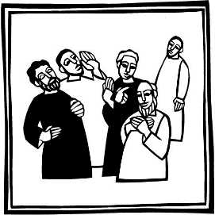
Introduction to the day…
Today we hear James warn against selfish ambition, while the disciples quarrel over which one of them is the greatest. Jesus tells them the way to be great is to serve. Then, to make it concrete, he puts in front of them a flesh-and-blood child. We are called to welcome the children God puts in front of us, to make room for them in daily interaction, and to give them a place of honor in the assembly.
ANNOUNCEMENTS
GATHERING
GATHERING HYMN Christ is Alive! Let Christians Sing ELW 389
CONFESSION AND FORGIVENESS
Blessed be the holy Trinity, ☩ one God,
who forgives all our sin,
whose mercy endures forever.
Amen.
Let us confess our sin and come to God for healing.
Silence is kept for reflection.
Gracious God,
have mercy on us.
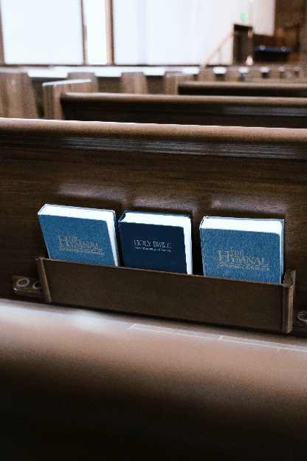
We confess that we have honored you with our lips,
but have harmed our neighbors with our tongues.
The cravings at war within us
cause conflicts and disputes.
In our desire to be first
we make distinctions among ourselves.
We place the needs of the poor and the suffering last.
In your great mercy, forgive us our sins.
Draw near to us with grace in time of need,
and turn us to follow in the way of Jesus Christ,
our Savior and Lord.
Amen.
God promises to forgive our iniquity
and to remember our sin no more.
By grace you have been saved.
In the name of ☩ Jesus Christ,
the source of eternal healing,
your sins are forgiven.
Amen.
PRAYER OF THE DAY
O God, our teacher and guide, you draw us to yourself and welcome us as beloved children. Help us to lay aside all envy and selfish ambition, that we may walk in your ways of wisdom and understanding as servants of your Son, Jesus Christ, our Savior and Lord.
Amen.
CHILDREN’S MUSIC Nothing Can Trouble ACS 1033
CHILDREN’S MESSAGE
SCRIPTURE READINGS
FIRST READING: Jeremiah 11:18-20
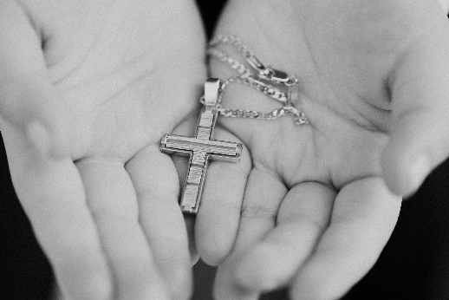
¹⁸It was the Lord who made it known to me, and I knew;
then you showed me their evil deeds.
¹⁹But I was like a gentle lamb
led to the slaughter.
And I did not know it was against me
that they devised schemes, saying,
“Let us destroy the tree with its fruit,
let us cut him off from the land of the living,
so that his name will no longer be remembered!”
²⁰But you, O Lord of hosts, who judge righteously,
who try the heart and the mind,
let me see your retribution upon them,
for to you I have committed my cause.
Word of God, word of life.
Thanks be to God.
PSALM: Psalm 54
¹Save me, O God, by your name;
in your might, defend my cause.
²Hear my prayer, O God;
give ear to the words of my mouth.
³For strangers have risen up against me, and the ruthless have sought my life,
those who have no regard for God.
⁴Behold, God is my helper;
it is the Lord who sustains my life.
⁵Render evil to those who spy on me;
in your faithfulness, destroy them.
⁶I will offer you a freewill sacrifice
and praise your name, O Lord, for it is good.
⁷For you have rescued me from every trouble,
and my eye looks down on my enemies.
SECOND READING: James 3:13-4:3, 7-8a
¹³Who is wise and understanding among you? Show by your good life that your works are done with gentleness born of wisdom. ¹⁴But if you have bitter envy and selfish ambition in your hearts, do not be boastful and false to the truth. ¹⁵Such wisdom does not come down from above, but is earthly, unspiritual, devilish. ¹⁶For where there is envy and selfish ambition, there will also be disorder and wickedness of every kind. ¹⁷But the wisdom from above is first pure, then peaceable, gentle, willing to yield, full of mercy and good fruits, without a trace of partiality or hypocrisy. ¹⁸And a harvest of righteousness is sown in peace for those who make peace.
^{4:1}Those conflicts and disputes among you, where do they come from? Do they not come from your cravings that are at war within you? ²You want something and do not have it; so you commit murder. And you covet something and cannot obtain it; so you engage in disputes and conflicts. You do not have, because you do not ask. ³You ask and do not receive, because you ask wrongly, in order to spend what you get on your pleasures. ⁷Submit yourselves therefore to God. Resist the devil, and he will flee from you. ^{8a}Draw near to God, and he will draw near to you.
Word of God, word of life.
Thanks be to God.
GOSPEL ACCLAMATION Listen to the Word That God Has Spoken ACS 974

GOSPEL: Mark 9:30-37
³⁰[Jesus and the disciples went on] and passed through Galilee. He did not want anyone to know it;³¹for he was teaching his disciples, saying to them, “The Son of Man is to be betrayed into human hands, and they will kill him, and three days after being killed, he will rise again.” ³²But they did not understand what he was saying and were afraid to ask him.
³³Then they came to Capernaum; and when he was in the house he asked them, “What were you arguing about on the way?” ³⁴But they were silent, for on the way they had argued with one another who was the greatest. ³⁵He sat down, called the twelve, and said to them, “Whoever wants to be first must be last of all and servant of all.” ³⁶Then he took a little child and put it among them; and taking it in his arms, he said to them, ³⁷“Whoever welcomes one such child in my name welcomes me, and whoever welcomes me welcomes not me but the one who sent me.”
The gospel of the Lord.
Praise to you, O Christ.
SERMON
HYMN OF THE DAY I Want to Walk as a Child of the Light ELW 815
APOSTLES’ CREED
I believe in God, the Father almighty,
creator of heaven and earth.
I believe in Jesus Christ, God's only Son, our Lord,
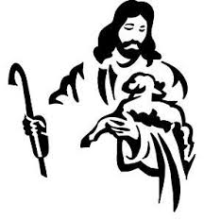
who was conceived by the power of the Holy Spirit,
born of the Virgin Mary,
suffered under Pontius Pilate,
was crucified, died, and was buried;
he descended to the dead.
On the third day he rose again;
he ascended into heaven,
he is seated at the right hand of the Father,
and he will come to judge the living and the dead.
I believe in the Holy Spirit,
the holy catholic Church,
the communion of saints,
the forgiveness of sins,
the resurrection of the body,
and the life everlasting. Amen.
PRAYERS OF INTERCESSION
…Hear us, O God,
Your mercy is great.
We entrust these and all our prayers to you, holy God, in the name of your beloved child, Jesus Christ, our Savior.
Amen.
PEACE
The peace of Christ be with you always.
And also with you.
HOLY COMMUNION
OFFERING In addition to our normal offering, a Special Benevolence in September (collected in a special envelope) will be Orenda Center.
OFFERING SONG Will You Let Me Be Young Servant ELW 659

OFFERTORY PRAYER

Blessed are you, O God,
source of every gift of your creation.
By these gifts and with our lives,
help us to serve one another and all in need,
through Jesus Christ, our Savior and Lord.
Amen.
GREAT THANKSGIVING
The Lord be with you.
And also with you.
Lift up your hearts.
We lift them to the Lord.
Let us give our thanks to the Lord our God.
It is right to give our thanks and praise.
Holy, Holy, Holy ELW 189
THANKSGIVING AT THE TABLE

God of our weary years, God of our silent tears,
you have brought us this far along the way.
In times of bitterness you did not abandon us,
but guided us into the path of love and light.
In every age you sent prophets
to make known your loving will for all humanity.
The cry of the poor has become your own cry;
our hunger and thirst for justice is your own desire.
In the fullness of time, you sent your chosen servant
to preach good news to the afflicted,
to break bread with the outcast and despised,
and to ransom those in bondage to prejudice and sin.
In the night in which he was betrayed,
our Lord Jesus took bread, and gave thanks;
broke it, and gave it to his disciples, saying:
Take and eat; this is my body, given for you.
Do this for the remembrance of me.
Again, after supper, he took the cup, gave thanks,
and gave it for all to drink, saying:
This cup is the new covenant in my blood,
shed for you and all people for the forgiveness of sin.
Do this for the remembrance of me.

For as often as we eat of this bread and drink from this cup we proclaim the Lord’s death until he comes.
Christ has died.
Christ is risen.
Christ will come again.
Remembering, therefore, his death and resurrection,
we await the day when Jesus shall return
to free all the earth from the bonds of slavery and death.
Come, Lord Jesus! And let the church say, Amen.
Amen.
Send your Holy Spirit, our advocate,
to fill the hearts of all who share this bread and cup with courage and wisdom to pursue love and justice in all the world. Come, Spirit of freedom! And let the church say, Amen.
Amen.
Join our prayers and praise with your prophets and martyrs of every age,
that, rejoicing in the hope of the resurrection,
we might live in the freedom and hope of your Son.
Through him, with him, in him, in the unity of the Holy Spirit,
all glory and honor is yours, almighty Father, now and forever.
Amen.

THE LORD’S PRAYER
Our Father, who art in heaven,
hallowed be thy name,
thy kingdom come,
thy will be done,
on earth as it is in heaven.
Give us this day our daily bread;
and forgive us our trespasses,
as we forgive those who trespass against us;
and lead us not into temptation,
but deliver us from evil.
For thine is the kingdom,
and the power, and the glory,
forever and ever. Amen.
INVITATION TO COMMUNION - Certified gluten-free crackers are in the bowl on the communion plate.
Jesus welcomes you to this table.

Come, here is your God.
HOLY COMMUNION
PRAYER AFTER COMMUNION
Holy God,
you have welcomed us to this meal
and fed us with dignity at your table.
Send us now to welcome others
and to be at peace with one another,
through Jesus Christ our Lord.
Amen.
SENDING
BLESSING
God all mighty,
God most merciful
☩ bless you, keep you,
and give you peace.
Amen.
CLOSING HYMN Lord of all Hopefulness ELW 765
DISMISSAL
Go in peace. Follow Jesus.
Thanks be to God.

Coming up at GSLC
Sunday, September 22 | 9:00 am | Worship Service  - Eighteenth Sunday after Pentecost  - Mark 9:30-37; Prediction of the passion
Tuesday, September 24 | 7:00 pm | AA Meeting
Wednesday, September 25 | 12:00 pm | Bible Study (discuss Season 4 Episode 3 of “The Chosen”)
 | 7:00 pm | Midweek Worship  Confirmation Class
Sunday, September 29 | 9:00 am | Worship Service  - Nineteenth Sunday after Pentecost  - Mark 9:38-50; Warnings to those who obstruct faith


SOS has provided their list of needs for this month, which includes:
Kidney Beans, Baked Beans, Sandwich Bags, Chicken Noodle Soup, Dish Soap, Oatmeal, Jelly, Gravy, Pudding, Broth, All Purpose Cleaner, Shampoo, Conditioner, Pancake Mix, Baking Items, Paper Towels, Dried Soup. Urgently need: Mac’n Cheese, Boxed Rice Meals, Canned Pasta Meals, Tuna, Canned Chicken, Baby wipes, Diapers size 3 and 4, Shampoo, Conditioner, Ground coffee, Tea, Pudding.
Upcoming Worship Assistants
 | Usher | Lector | Communion | Offering Counters |  | Deep Clean
September 22 | Tim & Farrah  Uphoff | Shelly Schneider | Matt & Margo  Berrier | Nancy Leonard | Breanna Butler | September:  Julie Will  Deb Janz  Chris Tipping
September 29 | Heidi Binder | Richard  Kopitzke | Tammy Neumann  Sarah Kopitzke | Robin Beeman | David Schneider
October 6 | Christopher & Trina Ignatowski | Linda Schreiber | Dan & Pam  Mundt | Hedi Binder | Kami Weis | October:  John & Jane Wagner  Laurel Peterson
October 13 | Tammy Neumann | Laurel  Peterson | Bruce & Nancy Tibbett | Pam Mundt | May Hill

Sunday School registration forms are on the table in the narthex. If your child attends Sunday School, please fill out a form and return it to the office.
The Good Shepherd T-shirts have arrived! They can be picked up in the office or after Sunday worship. Shirts are $13 each.
Bible Study is returning!
We will have an 8 week Bible study discussing Season 4 of The Chosen. Bible study begins Wednesday, September 11th at 12:00 pm. The series is available to stream for free at The Chosen’s website or in The Chosen app.
