**Good Shepherd Lutheran Church**

|  |  |
| --- | --- |
| Pastor: Rev. Katie Anderson | Music Director: Rev. Lois Swanson |
| Pastor’s Cell: (715) 245-1943 | Office Phone: (715) 387-2731 |
| Pastor Email: gslcwi.pastor@gmail.com | Office Email: gslcwi.office@gmail.com |
| Website: GoodShepherdMarshfield.org |  |

**13th Sunday after Pentecost**

**August 18, 2024, 9:00 am**

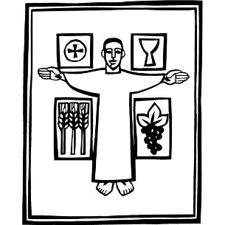***Introduction to the day…***

Wisdom prepares a feast, sets her table, and invites all to come and eat her bread and drink her wine. The first chapter of John’s gospel owes much to the biblical tradition that imagined Wisdom as existing before anything was created and having a role in the work of creation. Christ, the wisdom of God (1 Cor. 1:24), today invites us to eat his flesh and drink his blood. John’s gospel includes no account of the institution of the Lord’s supper, but here we can't help hearing Jesus’ words as an invitation to the meal of bread and wine we share.

**ANNOUNCEMENTS**

**GATHERING**

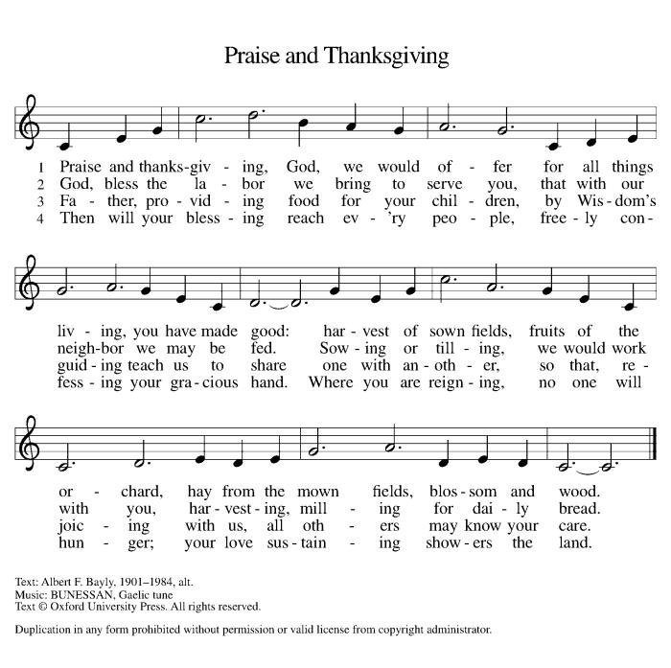**GATHERING HYMN Praise and Thanksgiving ELW 689**

**CONFESSION AND FORGIVENESS**

Blessed be the holy Trinity, ☩ one God,

the God of manna,

the God of miracles,

the God of mercy.

**Amen.**

Drawn to Christ and seeking God’s abundance,

let us confess our sin.

*Silence is kept for reflection.*

God, our provider,

**help us.**

**It is hard to believe there is enough to share.**

**We question your ways when they differ from the ways** **of the world in which we live.**

**We turn to our own understanding** **rather than trusting in you.**

**We take offense at your teachings and your ways.**

**Turn us again to you.**

**Where else can we turn?**

**Share with us the words of eternal life** **and feed us for life in the world.**

**Amen.**

Beloved people of God:

in Jesus, the manna from heaven,

you are fed and nourished. By Jesus, the worker of miracles,

there is always more than enough. Through Jesus, ☩ the bread of life,

you are shown God’s mercy:

you are forgiven and loved into abundant life.

**Amen.**

**PRAYER OF THE DAY**

**Ever-loving God, your Son gives himself as living bread for the life of the world. Fill us with such a knowledge of his presence that we may be strengthened and sustained by his risen life to serve you continually, through Jesus Christ, our Savior and Lord.**

**Amen.**

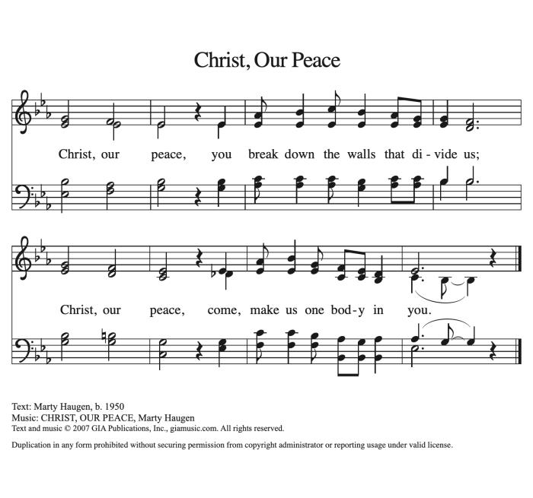**CHILDREN’S MUSIC Christ Our Peace ACS 1037**

**CHILDREN’S MESSAGE**

**SCRIPTURE READINGS**

**FIRST READING: Proverbs 9:1-6**

1Wisdom has built her house,  
 she has hewn her seven pillars.  
2She has slaughtered her animals, she has mixed her wine,  
 she has also set her table.  
3She has sent out her servant-girls, she calls  
 from the highest places in the town,  
4“You that are simple, turn in here!”  
 To those without sense she says,  
5“Come, eat of my bread  
 and drink of the wine I have mixed.  
6Lay aside immaturity, and live,  
 and walk in the way of insight.”

Word of God, word of life.

**Thanks be to God.**

**PSALM: Psalm 34:9-14**

9Fear the Lord, you saints of the Lord,  
 for those who fear the Lord lack nothing.  
10**The lions are in want and suffer hunger,**  
 **but those who seek the Lord lack nothing that is good.**  
11Come, children, and listen to me;  
 I will teach you reverence for the Lord.  
12**Who among you takes pleasure in life**  
 **and desires long life to enjoy prosperity?**  
13Keep your tongue from evil  
 and your lips from lying words.  
14**Turn from evil and do good;**  
 **seek peace and pursue it.**

**SECOND READING: Ephesians 5:15-20**

15Be careful then how you live, not as unwise people but as wise, 16making the most of the time, because the days are evil. 17So do not be foolish, but understand what the will of the Lord is. 18Do not get drunk with wine, for that is debauchery; but be filled with the Spirit, 19as you sing psalms and hymns and spiritual songs among yourselves, singing and making melody to the Lord in your hearts, 20giving thanks to God the Father at all times and for everything in the name of our Lord Jesus Christ.

Word of God, word of life.

**Thanks be to God.**

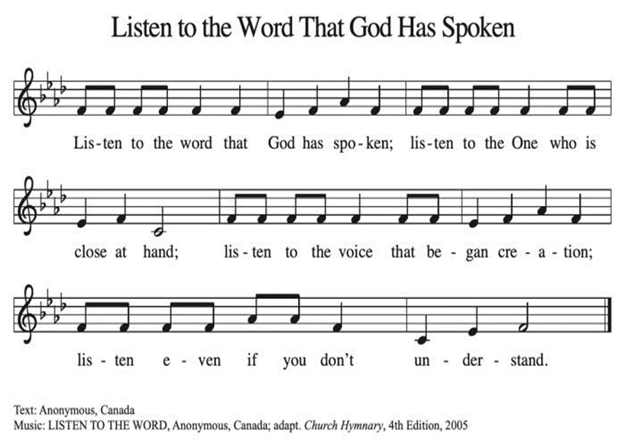**GOSPEL ACCLAMATION Listen to the Word That God Has Spoken ACS 974**

**GOSPEL: John 6:51-58**

[Jesus said,] 51“I am the living bread that came down from heaven. Whoever eats of this bread will live forever; and the bread that I will give for the life of the world is my flesh.”  
 52The Jews then disputed among themselves, saying, “How can this man give us his flesh to eat?” 53So Jesus said to them, “Very truly, I tell you, unless you eat the flesh of the Son of Man and drink his blood, you have no life in you. 54Those who eat my flesh and drink my blood have eternal life, and I will raise them up on the last day; 55for my flesh is true food and my blood is true drink. 56Those who eat my flesh and drink my blood abide in me, and I in them. 57Just as the living Father sent me, and I live because of the Father, so whoever eats me will live because of me. 58This is the bread that came down from heaven, not like that which your ancestors ate, and they died. But the one who eats this bread will live forever.”

The gospel of the Lord.

**Praise to you, O Christ.**

**SERMON**



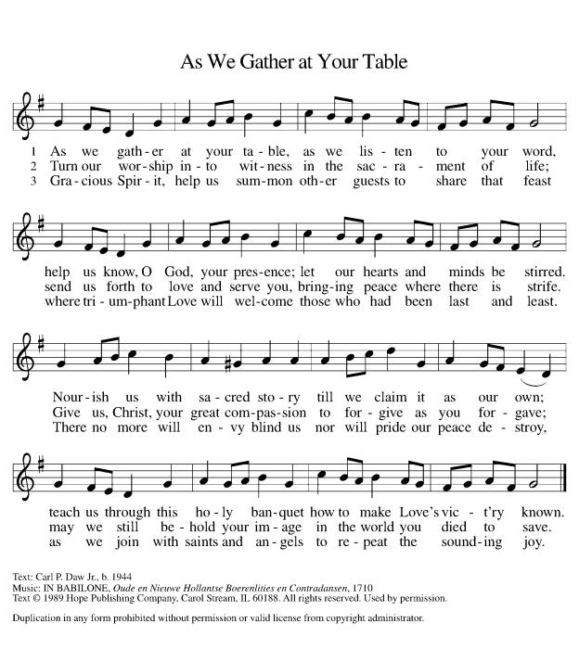**HYMN OF THE DAY As We Gather at Your Table ELW 522**

**APOSTLES’ CREED**

**I believe in God, the Father almighty,**

**creator of heaven and earth.**

**I believe in Jesus Christ, God's only Son, our Lord,**

**who was conceived by the power of the Holy Spirit,**

**born of the Virgin Mary,**

**suffered under Pontius Pilate,**

**was crucified, died, and was buried;**

**he descended to the dead.**

**On the third day he rose again;**

**he ascended into heaven,**

**he is seated at the right hand of the Father,**

**and he will come to judge the living and the dead.**

**I believe in the Holy Spirit,**

**the holy catholic Church,**

**the communion of saints,**

**the forgiveness of sins,**

**the resurrection of the body,**

**and the life everlasting. Amen.**

**PRAYERS OF INTERCESSION**

…Merciful God,

**Receive our prayer**

We lift up these prayers to you, gracious God. Receive them into your holy keeping.

**Amen.**

**PEACE**

The peace of Christ be with you always.  
**And also with you.**

**HOLY COMMUNION**

**OFFERING***In addition to our normal offering, a* ***Special Benevolence in August*** *(collected in a special envelope) will be* ***United Way's Supplies for Success Drive****.*

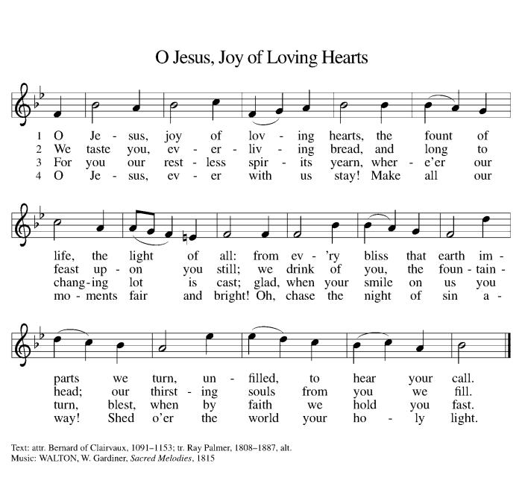*Last year the drive supplied over 700 area children with backpacks and school supplies. This year they are adding hygiene items to the event. There will also be a collection box in the entry and a poster explaining how to sponsor a child for those who are interested.*

**OFFERING SONG O Jesus, Joy of Loving Hearts ELW 658**

**OFFERTORY PRAYER**

Jesus, Bread of life,

you have set this table with your very self,

and called us to the feast of plenty.

Gather what has been sown among us,

and strengthen us in this meal.

Make us to be what we receive here,

your body for the life of the world.

**Amen.**

**GREAT THANKSGIVING**

The Lord be with you.

**And also with you.**

Lift up your hearts.

**We lift them to the Lord.**

Let us give our thanks to the Lord our God.

**It is right to give our thanks and praise.**

**Holy, Holy, Holy ELW 189**

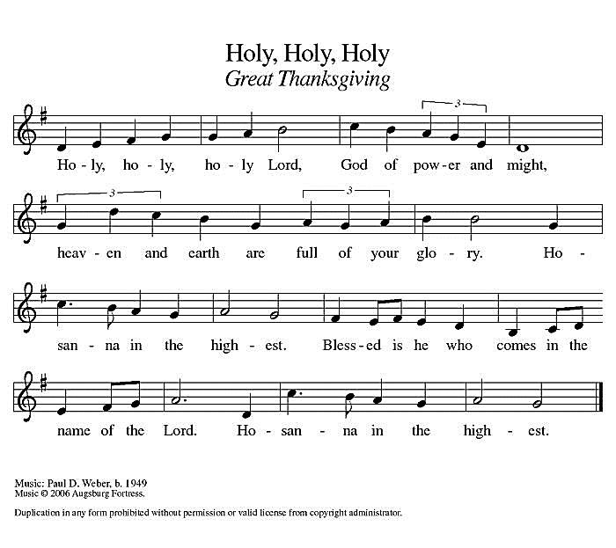

**THANKSGIVING AT THE TABLE**

God of our weary years, God of our silent tears,

you have brought us this far along the way.

In times of bitterness you did not abandon us,

but guided us into the path of love and light.

In every age you sent prophets

to make known your loving will for all humanity.

The cry of the poor has become your own cry;

our hunger and thirst for justice is your own desire.

In the fullness of time, you sent your chosen servant

to preach good news to the afflicted,

to break bread with the outcast and despised,

and to ransom those in bondage to prejudice and sin.

In the night in which he was betrayed,

our Lord Jesus took bread, and gave thanks;

broke it, and gave it to his disciples, saying:

Take and eat; this is my body, given for you.

Do this for the remembrance of me.

Again, after supper, he took the cup, gave thanks,

and gave it for all to drink, saying:

This cup is the new covenant in my blood,

shed for you and all people for the forgiveness of sin.

Do this for the remembrance of me.

For as often as we eat of this bread and drink from this cup we proclaim the Lord’s death until he comes.

**Christ has died.**

**Christ is risen.**

**Christ will come again.**

Remembering, therefore, his death and resurrection,

we await the day when Jesus shall return

to free all the earth from the bonds of slavery and death.

Come, Lord Jesus! And let the church say, Amen.

**Amen.**

Send your Holy Spirit, our advocate,

to fill the hearts of all who share this bread and cup with courage and wisdom to pursue love and justice in all the world. Come, Spirit of freedom! And let the church say, Amen.

**Amen.**

Join our prayers and praise with your prophets and martyrs of every age,

that, rejoicing in the hope of the resurrection,

we might live in the freedom and hope of your Son.

Through him, with him, in him, in the unity of the Holy Spirit,

all glory and honor is yours, almighty Father, now and forever.

**Amen.**

**THE LORD’S PRAYER**

**Our Father, who art in heaven,**

**hallowed be thy name,**

**thy kingdom come,**

**thy will be done,**

**on earth as it is in heaven.**

**Give us this day our daily bread;**

**and forgive us our trespasses,**

**as we forgive those**

**who trespass against us;**

**and lead us not into temptation,**

**but deliver us from evil.**

**For thine is the kingdom,**

**and the power, and the glory,**

**forever and ever. Amen.**

**INVITATION TO COMMUNION** *- Certified gluten-free crackers are in the bowl on the communion plate.*

Christ has set the table with more than enough for all.

Come!

**HOLY COMMUNION**

**PRAYER AFTER COMMUNION**

Jesus, Bread of life,

we have received from your table more than we could ever ask.

As you have nourished us in this meal,

now strengthen us to love the world with your own life.

In your name we pray.

**Amen.**

**SENDING**

**BLESSING**

The blessing of God,

who provides for us, feeds us, and journeys with us,

☩ be upon you now and forever.

**Amen.**

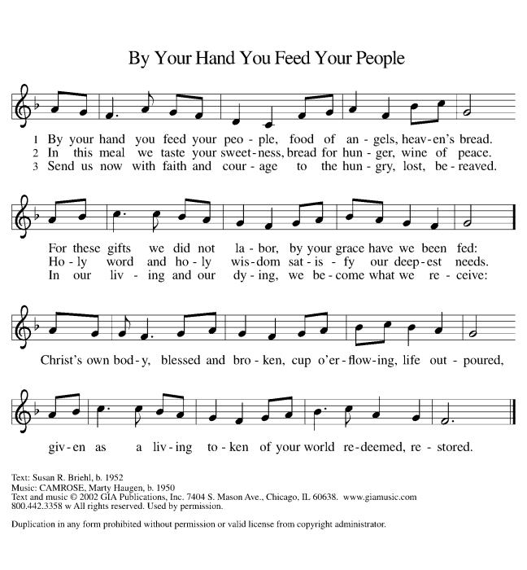**CLOSING HYMN By Your Hand Your Feed Your People ELW 469**

**DISMISSAL**

Go in peace. You are the body of Christ.

**Thanks be to God.**

|  |  |  |  |  |  |  |
| --- | --- | --- | --- | --- | --- | --- |
| ***Upcoming Worship Assistants*** | | | | | | |
|  | **Usher** | **Lector** | **Communion** | **Offering Counters** | | **Deep Clean** |
| August 18 | Dennis & Linda Schutte | Richard Kopitzke | Ron Rothfusz  Andrea Hovick | Nancy Leonard | Breanna Butler | August:  Nancy Leonard Jannalee Kolbeck-Lindquist  Heidi Binder |
| August 25 | John & Jennifer Rickinger | Andrea Hovick | John Wagner  Nancy Leonard | Robin Beeman | David Schneider |
| September 1 | Tim & Monica Jewell | Jon Hill | Dave & Shelly Schneider | Heidi Binder | Kami Weis | September:  Julie Will  Deb Janz  Chris Tipping |
| September 8 | Ron Rothfusz | Leslie Mader | Bruce & Nancy Tibbett | Pam Mundt | May Hill |

|  |  |  |
| --- | --- | --- |
| **Coming up at GSLC** | | |
| Sunday, August 18 | 9:00 am | Outdoor Worship Service   * Thirteenth Sunday after Pentecost * John 6:51-58; Christ the true food and drink |
| Tuesday, August 20 | 2:00 pm | Chapel at Three Oaks |
|  | 7:00 pm | AA Meeting |
| Sunday, August 25 | 9:00 am | Outdoor Worship Service   * Fourteenth Sunday after Pentecost * John 6:56-69; The bread of eternal life |

SOS has provided their list of needs for this month, which includes:

Kidney Beans, Baked Beans, Sandwich Bags, Chicken Noodle Soup, Dish Soap, Oatmeal, Jelly, Gravy,Pudding, Broth, All Purpose Cleaner, Shampoo, Conditioner, Pancake Mix, Baking Items, Paper Towels, Dried Soup. **Urgently need: rice mixes, pasta sauce, dried soups, and corn.**

Pastor Katie will be on vacation August 19-25. If you have any emergency pastoral needs during this time, please contact the church office.

**Pub Theology is returning for the summer!  
2nd & 4th Wednesday in July and August  
Blue Heron BrewPub 6:00 pm  
Led by Pastor Katie**  
**What is Pub Theology?** People have been gathering in pubs and public spaces for ages talking about life, philosophy, faith, and deep questions of meaning. Increasingly, people all over are rediscovering the pub as a safe, open space where they can explore and express their own doubts and questions, learn from others, and engage people of varying religious traditions. In our increasingly fractured society, these spaces are not only welcome but needed.  
***Bring your questions and curiosity and pull up a chair.***