**Good Shepherd Lutheran Church**

|  |  |
| --- | --- |
| Pastor: Rev. Katie Anderson | Music Director: Rev. Lois Swanson |
| Pastor’s Cell: (715) 245-1943 | Office Phone: (715) 387-2731 |
| Pastor Email: gslcwi.pastor@gmail.com | Office Email: gslcwi.office@gmail.com |
| Website: GoodShepherdMarshfield.org |  |

**7th Sunday after Pentecost**

**July 7, 2024, 9:00 am**

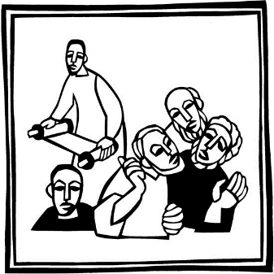***Introduction to the day…***

Jesus does great deeds of power and gives his disciples authority over demons. Yet none of this power is unilateral; it all must be received by faith. Jesus asks his disciples to go out without money or supplies, so that they will be dependent on how others receive them. When we are sent from the assembly to witness and to heal, we are asked to be vulnerable, to be dependent on the reception of others. The Spirit always operates in the “between”: between Jesus and his Abba, between Jesus and us, between you and me, between us and those to whom we are sent.

**ANNOUNCEMENTS**

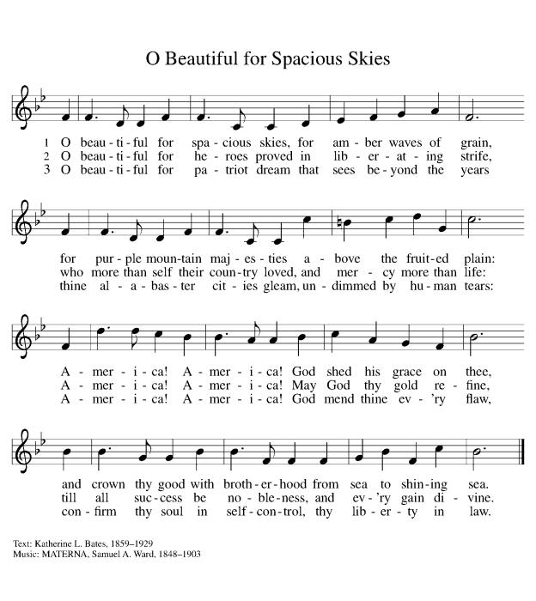**GATHERING**

**GATHERING HYMN O Beautiful for Spacious Skies ELW888**

### **CONFESSION AND FORGIVENESS**

Blessed be the holy Trinity, ☩ one God,

the God of manna,

the God of miracles,

the God of mercy.

**Amen.**

Drawn to Christ and seeking God’s abundance,

let us confess our sin.

*Silence is kept for reflection.*

God, our provider,

**help us.**

**It is hard to believe there is enough to share.**

**We question your ways when they differ from the ways** **of the world in which we live.**

**We turn to our own understanding** **rather than trusting in you.**

**We take offense at your teachings and your ways.**

**Turn us again to you.**

**Where else can we turn?**

**Share with us the words of eternal life** **and feed us for life in the world.**

**Amen.**

Beloved people of God:

in Jesus, the manna from heaven,

you are fed and nourished.

By Jesus, the worker of miracles,

there is always more than enough.

Through Jesus, ☩ the bread of life,

you are shown God’s mercy:

you are forgiven and loved into abundant life.

**Amen.**

**PRAYER OF THE DAY**

**God of the covenant, in our baptism you call us to proclaim the coming of your kingdom. Give us the courage you gave the apostles, that we may faithfully witness to your love and peace in every circumstance of life, in the name of Jesus Christ, our Savior and Lord.**

**Amen.**

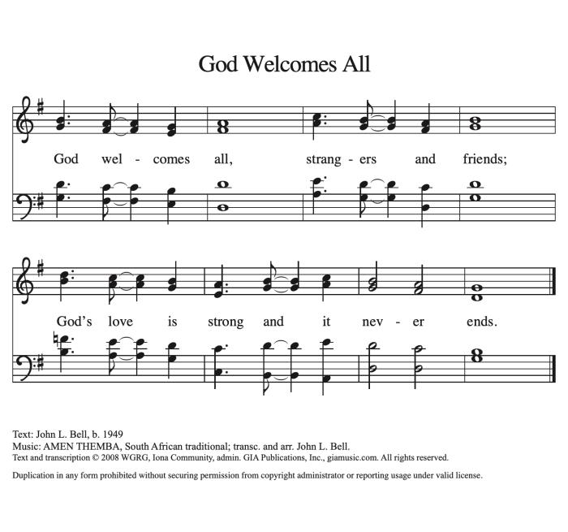**CHILDREN’S MUSIC God Welcomes All ACS 978**

**CHILDREN’S MESSAGE**

**SCRIPTURE READINGS**

**FIRST READING: Ezekiel 2:1-5**

1 [A voice] said to me: O mortal, stand up on your feet, and I will speak with you.2 And when he spoke to me, a spirit entered into me and set me on my feet; and I heard him speaking to me. 3 He said to me, Mortal, I am sending you to the people of Israel, to a nation of rebels who have rebelled against me; they and their ancestors have transgressed against me to this very day. 4 The descendants are impudent and stubborn. I am sending you to them, and you shall say to them, “Thus says the Lord God.” 5 Whether they hear or refuse to hear (for they are a rebellious house), they shall know that there has been a prophet among them.

Word of God, word of life.

**Thanks be to God.**

**PSALM: Psalm 123**

1 To you I lift up my eyes to you enthroned in the heavens.  
2 **As the eyes of servants look to the hand of their masters,**

**and the eyes of a maid to the hand of her mistress,**  
 **so our eyes look to you, O Lord our God, until you show us your mercy.**  
3 Have mercy upon us, O Lord, have mercy for we have had more than enough of contempt,  
4 **too much of the scorn of the indolent rich,**  
 **and of the derision of the proud.**

**SECOND READING: 2 Corinthians 12:2-10**

2 I know a person in Christ who fourteen years ago was caught up to the third heaven—whether in the body or out of the body I do not know; God knows. 3 And I know that such a person—whether in the body or out of the body I do not know; God knows—4 was caught up into Paradise and heard things that are not to be told, that no mortal is permitted to repeat. 5 On behalf of such a one I will boast, but on my own behalf I will not boast, except of my weaknesses. 6 But if I wish to boast, I will not be a fool, for I will be speaking the truth. But I refrain from it, so that no one may think better of me than what is seen in me or heard from me, 7 even considering the exceptional character of the revelations. Therefore, to keep me from being too elated, a thorn was given me in the flesh, a messenger of Satan to torment me, to keep me from being too elated. 8 Three times I appealed to the Lord about this, that it would leave me, 9 but he said to me, “My grace is sufficient for you, for power is made perfect in weakness.” So, I will boast all the more gladly of my weaknesses, so that the power of Christ may dwell in me. 10 Therefore I am content with weaknesses, insults, hardships, persecutions, and calamities for the sake of Christ; for whenever I am weak, then I am strong.

Word of God, word of life.

**Thanks be to God.**

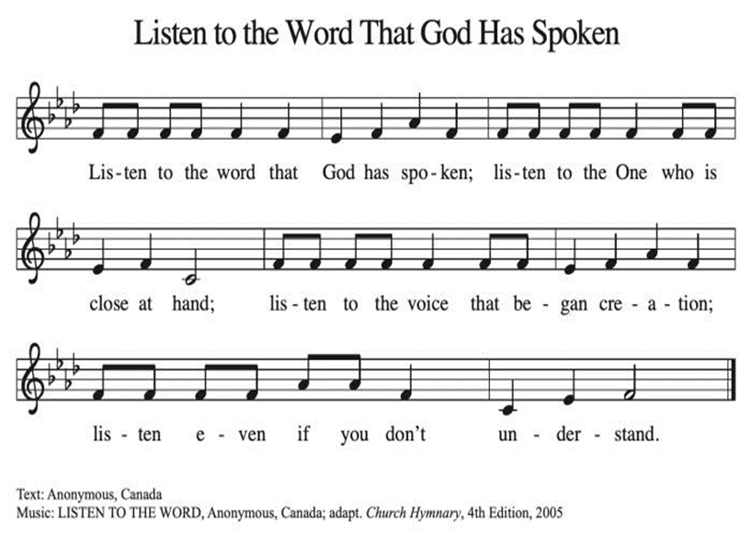**GOSPEL ACCLAMATION Listen to the Word That God Has Spoken ACS 974**

### **GOSPEL: Mark 6:1-13**

1 [Jesus] came to his hometown, and his disciples followed him.2 On the sabbath he began to teach in the synagogue, and many who heard him were astounded. They said, “Where did this man get all this? What is this wisdom that has been given to him? What deeds of power are being done by his hands! 3 Is not this the carpenter, the son of Mary and brother of James and Joses and Judas and Simon, and are not his sisters here with us?” And they took offense at him. 4 Then Jesus said to them, “Prophets are not without honor, except in their hometown, and among their own kin, and in their own house.” 5 And he could do no deed of power there, except that he laid his hands on a few sick people and cured them. 6 And he was amazed at their unbelief.  
  Then he went about among the villages teaching. 7 He called the twelve and began to send them out two by two, and gave them authority over the unclean spirits. 8 He ordered them to take nothing for their journey except a staff; no bread, no bag, no money in their belts; 9 but to wear sandals and not to put on two tunics. 10 He said to them, “Wherever you enter a house, stay there until you leave the place. 11 If any place will not welcome you and they refuse to hear you, as you leave, shake off the dust that is on your feet as a testimony against them.” 12 So they went out and proclaimed that all should repent. 13 They cast out many demons, and anointed with oil many who were sick and cured them.

The gospel of the Lord.

**Praise to you, O Christ.**

**SERMON**

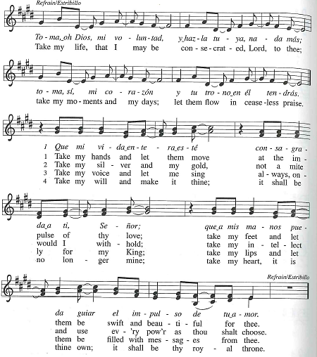**HYMN OF THE DAY Take Me Life, That I May Be ELW 583**



**APOSTLES’ CREED**

**I believe in God, the Father almighty,**

**creator of heaven and earth.**

**I believe in Jesus Christ, God's only Son, our Lord,**

**who was conceived by the power of the Holy Spirit,**

**born of the Virgin Mary,**

**suffered under Pontius Pilate,**

**was crucified, died, and was buried;**

**he descended to the dead.**

**On the third day he rose again;**

**he ascended into heaven,**

**he is seated at the right hand of the Father,**

**and he will come to judge the living and the dead.**

**I believe in the Holy Spirit,**

**the holy catholic Church,**

**the communion of saints,**

**the forgiveness of sins,**

**the resurrection of the body,**

**and the life everlasting. Amen.**

**PRAYERS OF INTERCESSION**

…In your mercy

**Hear our prayer**

Holy God, holy and merciful: into your outstretched arms we commend ourselves and all for whom we pray, trusting in the one who is the way, the truth, and the life, Jesus Christ our Savior and Lord.

**Amen.**

**PEACE**

The peace of Christ be with you always.  
**And also with you.**

**HOLY COMMUNION**

**OFFERING***In addition to our normal offering, a* ***Special Benevolence in July*** *(collected in a special envelope) will go to* ***The Best First Day Project.*** *Even though school is just ending, the best first day occurs in August. In order for our donation to be received in time to purchase needed shoes and clothing, we need to do the collection in July.*

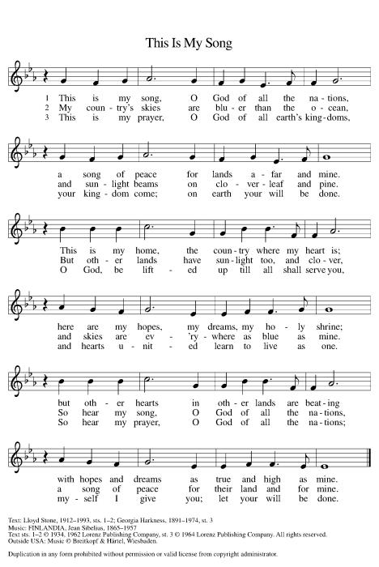**OFFERING SONG This is My Song ELW 887**

**OFFERTORY PRAYER**

Jesus, Bread of life,

you have set this table with your very self,

and called us to the feast of plenty.

Gather what has been sown among us,

and strengthen us in this meal.

Make us to be what we receive here,

your body for the life of the world.

**Amen.**

**GREAT THANKSGIVING**

The Lord be with you.

**And also with you.**

Lift up your hearts.

**We lift them to the Lord.**

Let us give our thanks to the Lord our God.

**It is right to give our thanks and praise.**

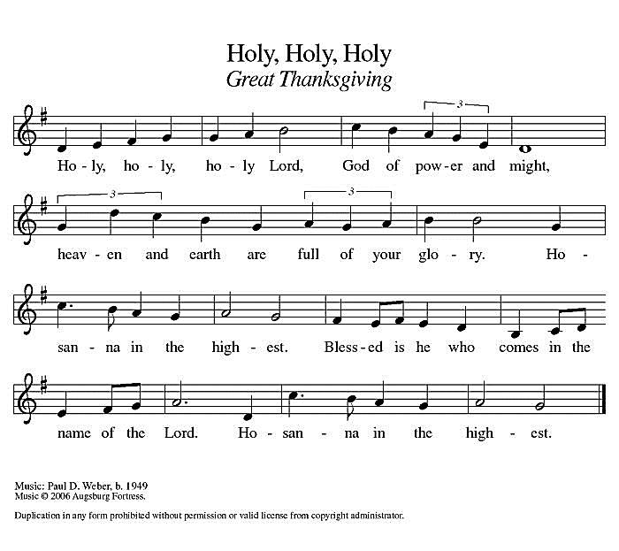**Holy, Holy, Holy ELW 189**

**THANKSGIVING AT THE TABLE**

God of our weary years, God of our silent tears,

you have brought us this far along the way.

In times of bitterness you did not abandon us,

but guided us into the path of love and light.

In every age you sent prophets

to make known your loving will for all humanity.

The cry of the poor has become your own cry;

our hunger and thirst for justice is your own desire.

In the fullness of time, you sent your chosen servant

to preach good news to the afflicted,

to break bread with the outcast and despised,

and to ransom those in bondage to prejudice and sin.

In the night in which he was betrayed,

our Lord Jesus took bread, and gave thanks;

broke it, and gave it to his disciples, saying:

Take and eat; this is my body, given for you.

Do this for the remembrance of me.

Again, after supper, he took the cup, gave thanks,

and gave it for all to drink, saying:

This cup is the new covenant in my blood,

shed for you and all people for the forgiveness of sin.

Do this for the remembrance of me.

For as often as we eat of this bread and drink from this cup

we proclaim the Lord’s death until he comes.

**Christ has died.**

**Christ is risen.**

**Christ will come again.**

Remembering, therefore, his death and resurrection,

we await the day when Jesus shall return

to free all the earth from the bonds of slavery and death.

Come, Lord Jesus! And let the church say, Amen.

**Amen.**

Send your Holy Spirit, our advocate,

to fill the hearts of all who share this bread and cup

with courage and wisdom to pursue love and justice in all the world.

Come, Spirit of freedom! And let the church say, Amen.

**Amen.**

Join our prayers and praise with your prophets and martyrs of every age,

that, rejoicing in the hope of the resurrection,

we might live in the freedom and hope of your Son.

Through him, with him, in him, in the unity of the Holy Spirit,

all glory and honor is yours, almighty Father, now and forever.

**Amen.**

**THE LORD’S PRAYER**

**Our Father, who art in heaven,**

**hallowed be thy name,**

**thy kingdom come,**

**thy will be done,**

**on earth as it is in heaven.**

**Give us this day our daily bread;**

**and forgive us our trespasses,**

**as we forgive those**

**who trespass against us;**

**and lead us not into temptation,**

**but deliver us from evil.**

**For thine is the kingdom,**

**and the power, and the glory,**

**forever and ever. Amen.**

**INVITATION TO COMMUNION** *- Certified gluten-free crackers are in the bowl on the communion plate.*

Christ has set the table with more than enough for all.

Come!

**HOLY COMMUNION**

**PRAYER AFTER COMMUNION**

Jesus, Bread of life,

we have received from your table more than we could ever ask.

As you have nourished us in this meal,

now strengthen us to love the world with your own life.

In your name we pray.

**Amen.**

**SENDING**

**BLESSING**

The blessing of God,

who provides for us, feeds us, and journeys with us,

☩ be upon you now and forever.

**Amen.**

**CLOSING HYMN Lift Every Voice and Sing ELW 841**

1. Lift every voice and sing

Till earth and heaven ring,

Ring with the harmonies of liberty;

Let our rejoicing rise

High as the listening skies,

Let it resound loud as the rolling sea.

Sing a song full of the faith that the dark past has taught us,

Sing a song full of the hope that the present has brought us.

Facing the rising sun of our new day begun,

Let us march on till victory is won.

1. Stony the road we trod,

Bitter the chastening rod,

Felt in the days when hope unborn had died;

Yet with a steady beat,

Have not our weary feet

Come to the place for which our fathers sighed?

We have come over a way that with tears has been watered,

We have come, treading our path through the blood of the slaughtered,

Out from the gloomy past,

Till now we stand at last

Where the white gleam of our bright star is cast.

1. God of our weary years,

God of our silent tears,

Thou who hast brought us thus far on the way;

Thou who hast by thy might

Led us into the light,

Keep us forever in the path, we pray.

Lest our feet stray from the places, our God, where we met thee,

Lest, our hearts drunk with the wine of the world, we forget thee;

Shadowed beneath thy hand,

May we forever stand.

True to our God,

True to our native land.

**DISMISSAL**

Go in peace. You are the body of Christ.

**Thanks be to God.**

|  |  |  |  |  |  |  |
| --- | --- | --- | --- | --- | --- | --- |
| ***Upcoming Worship Assistants*** | | | | | | |
|  | **Usher** | **Lector** | **Communion** | **Offering Counters** | | **Deep Clean** |
| July 7 | Jason & Tessa Campbell | Tammy Neumann | Matt & Margo Berrier | Dan Mundt | Jon Hill | July:  Dave & Sue Schraeder  Andrea Hovick  Linda Schutte |
| July 14 | Jon & May Hill | Linda Schrieber | Bob & Laurel Peterson | Nancy Leonard | Breanna Butler |
| July 21 |  | Laurel Peterson | Tammy Neumann  Sarah Kopitzke | Robin Beeman | Davis Schneider |
| July 28 | Chris & Robin Beeman | Nancy Tibbett | Dan & Pam Mundt | Heidi Binder | Kami Weis |

|  |  |  |
| --- | --- | --- |
| **Coming up at GSLC** | | |
| Sunday, July 7 | 9:00 am | Outdoor Worship Service   * Seventh Sunday after Pentecost * Mark 6:1-13; Sending of the Twelve to preach and heal |
| Tuesday, July 9 | 6:30 pm | Council Meeting |
|  | 7:00 pm | AA Meeting |
| Wednesday, July 10 | 6:00 pm | Pub Theology at Brew Pub |
| Sunday, July 14 | 9:00 am | Outdoor Worship Service   * Eighth Sunday after Pentecost * Mark 6:14-29; The death of John the Baptist |

SOS has provided their list of needs for this month, which includes:

Kidney Beans, Baked Beans, Sandwich Bags, Chicken Noodle Soup, Dish Soap, Oatmeal, Jelly, Gravy,Pudding, Broth, All Purpose Cleaner, Shampoo, Conditioner, Pancake Mix, Baking Items, Paper Towels, Dried Soup. **Urgently need: children’s toothbrushes and toothpaste, feminine hygiene products, and deodorant.**

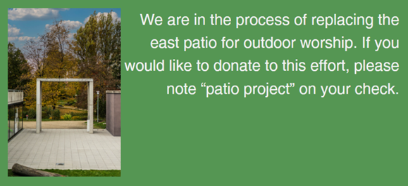  
**Pub Theology is returning for the summer!  
2nd Wednesday in June, 2nd & 4th Wednesday in July and August  
Blue Heron BrewPub 6:00 pm  
Led by Pastor Katie**  
**What is Pub Theology?** People have been gathering in pubs and public spaces for ages talking about life, philosophy, faith, and deep questions of meaning. Increasingly, people all over are rediscovering the pub as a safe, open space where they can explore and express their own doubts and questions, learn from others, and engage people of varying religious traditions. In our increasingly fractured society, these spaces are not only welcome but needed.  
***Bring your questions and curiosity, and pull up a chair.***