**Good Shepherd Lutheran Church**

|  |  |
| --- | --- |
| Pastor: Rev. Katie Anderson | Music Director: Rev. Lois Swanson |
| Pastor’s Cell: (715) 245-1943 | Office Phone: (715) 387-2731 |
| Pastor Email: gslcwi.pastor@gmail.com | Office Email: gslcwi.office@gmail.com |
| Website: GoodShepherdMarshfield.org |  |

**9th Sunday after Pentecost**

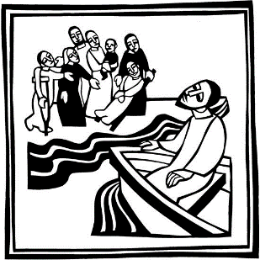**July 21, 2024, 9:00 am**

***Introduction to the day…***

Mark’s gospel makes clear how great is the press of the crowd, with its countless needs to be met, on Jesus and his disciples. Yet in today’s gospel Jesus advises his disciples to get away and rest, to take care of themselves. Sometimes we think that when others are in great need we shouldn’t think of ourselves at all; but Jesus also honors the caregivers’ need. We are sent from Christ’s table to care for others and for ourselves.

**ANNOUNCEMENTS**

**GATHERING**

**GATHERING HYMN Build a Longer Table ACS 1062**

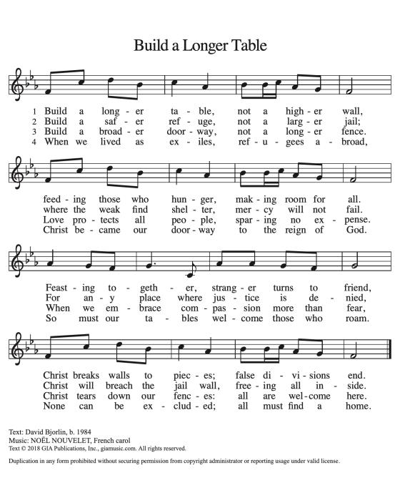

**CONFESSION AND FORGIVENESS**

Blessed be the holy Trinity, ☩ one God,

the God of manna,

the God of miracles,

the God of mercy.

**Amen.**

Drawn to Christ and seeking God’s abundance,

let us confess our sin.

*Silence is kept for reflection.*

God, our provider,

**help us.**

**It is hard to believe there is enough to share.**

**We question your ways when they differ from the ways** **of the world in which we live.**

**We turn to our own understanding** **rather than trusting in you.**

**We take offense at your teachings and your ways.**

**Turn us again to you.**

**Where else can we turn?**

**Share with us the words of eternal life** **and feed us for life in the world.**

**Amen.**

Beloved people of God:

in Jesus, the manna from heaven,

you are fed and nourished. By Jesus, the worker of miracles,

there is always more than enough. Through Jesus, ☩ the bread of life,

you are shown God’s mercy:

you are forgiven and loved into abundant life.

**Amen.**

**PRAYER OF THE DAY**

**O God, powerful and compassionate, you shepherd your people, faithfully feeding and protecting us. Heal each of us, and make us a whole people, that we may embody the justice and peace of your Son, Jesus Christ, our Savior and Lord.**

**Amen.**

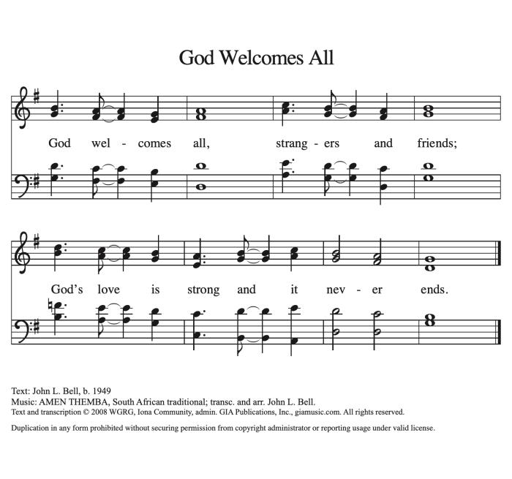**CHILDREN’S MUSIC God Welcomes All ACS 978**

**CHILDREN’S MESSAGE**

**SCRIPTURE READINGS**

**FIRST READING: Jeremiah 23:1-6**

1 Woe to the shepherds who destroy and scatter the sheep of my pasture! says the Lord. 2 Therefore thus says the Lord, the God of Israel, concerning the shepherds who shepherd my people: It is you who have scattered my flock, and have driven them away, and you have not attended to them. So I will attend to you for your evil doings, says the Lord. 3 Then I myself will gather the remnant of my flock out of all the lands where I have driven them, and I will bring them back to their fold, and they shall be fruitful and multiply. 4 I will raise up shepherds over them who will shepherd them, and they shall not fear any longer, or be dismayed, nor shall any be missing, says the Lord.  
  5 The days are surely coming, says the Lord, when I will raise up for David a righteous Branch, and he shall reign as king and deal wisely, and shall execute justice and righteousness in the land. 6 In his days Judah will be saved and Israel will live in safety. And this is the name by which he will be called: “The Lord is our righteousness.”

Word of God, word of life.

**Thanks be to God.**

**PSALM: Psalm 23**

1 The Lord is my shepherd;  
 I shall not be in want.  
2 **The Lord makes me lie down in green pastures**  
 **and leads me beside still waters.**  
3 You restore my soul, O Lord,  
 and guide me along right pathways for your name’s sake.  
4 **Though I walk through the valley of the shadow of death, I shall fear no evil;**  
 **for you are with me; your rod and your staff, they comfort me.**  
5 You prepare a table before me in the presence of my enemies;  
 you anoint my head with oil, and my cup is running over.  
6 **Surely goodness and mercy shall follow me all the days of my life,**  
 **and I will dwell in the house of the Lord forever.**

**SECOND READING: Ephesians 2:11-22**

11 Remember that at one time you Gentiles by birth, called “the uncircumcision” by those who are called “the circumcision”—a physical circumcision made in the flesh by human hands—12 remember that you were at that time without Christ, being aliens from the commonwealth of Israel, and strangers to the covenants of promise, having no hope and without God in the world. 13 But now in Christ Jesus you who once were far off have been brought near by the blood of Christ. 14 For he is our peace; in his flesh he has made both groups into one and has broken down the dividing wall, that is, the hostility between us. 15 He has abolished the law with its commandments and ordinances, that he might create in himself one new humanity in place of the two, thus making peace, 16 and might reconcile both groups to God in one body through the cross, thus putting to death that hostility through it. 17 So he came and proclaimed peace to you who were far off and peace to those who were near; 18 for through him both of us have access in one Spirit to the Father. 19 So then you are no longer strangers and aliens, but you are citizens with the saints and also members of the household of God, 20 built upon the foundation of the apostles and prophets, with Christ Jesus himself as the cornerstone. 21 In him the whole structure is joined together and grows into a holy temple in the Lord; 22 in whom you also are built together spiritually into a dwelling place for God.

Word of God, word of life.

**Thanks be to God.**

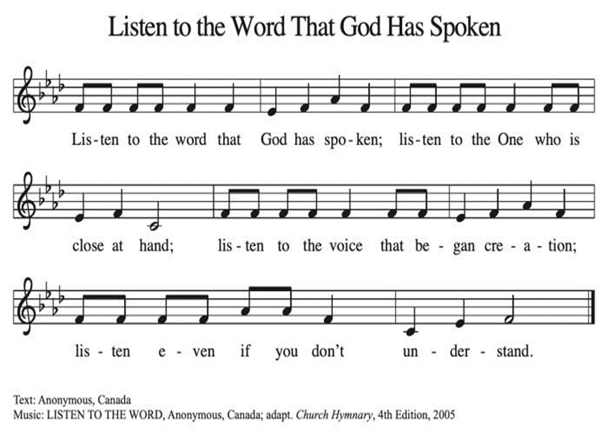**GOSPEL ACCLAMATION Listen to the Word That God Has Spoken ACS 974**

**GOSPEL: Mark 6:30-34, 53-56**

30 The apostles gathered around Jesus, and told him all that they had done and taught. 31 He said to them, “Come away to a deserted place all by yourselves and rest a while.” For many were coming and going, and they had no leisure even to eat. 32 And they went away in the boat to a deserted place by themselves. 33 Now many saw them going and recognized them, and they hurried there on foot from all the towns and arrived ahead of them. 34 As he went ashore, he saw a great crowd; and he had compassion for them, because they were like sheep without a shepherd; and he began to teach them many things.  
  53 When they had crossed over, they came to land at Gennesaret and moored the boat. 54 When they got out of the boat, people at once recognized him, 55 and rushed about that whole region and began to bring the sick on mats to wherever they heard he was. 56 And wherever he went, into villages or cities or farms, they laid the sick in the marketplaces, and begged him that they might touch even the fringe of his cloak; and all who touched it were healed.

The gospel of the Lord.

**Praise to you, O Christ.**

**SERMON**

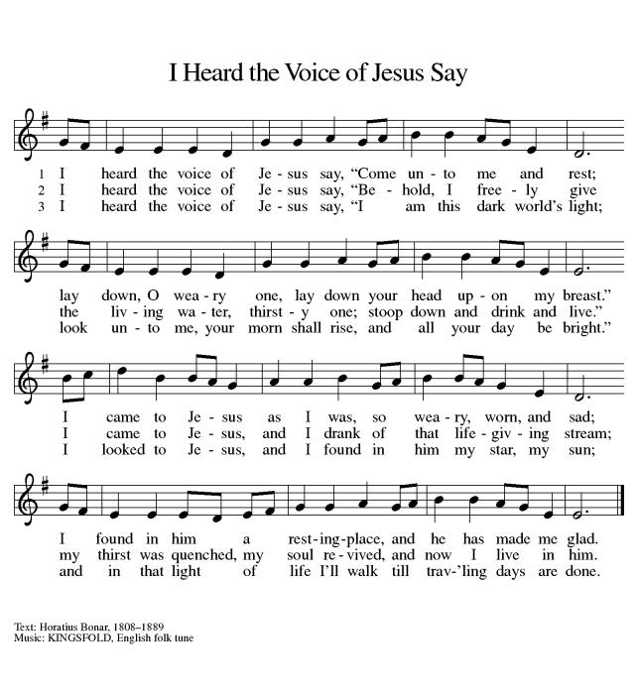**HYMN OF THE DAY I Heard the Voice of Jesus Say ELW 611**

**FABRIC BLESSING**

We give you thanks, O God, for the ways you stitch us together by your grace. Bless this fabric as a

tangible symbol of our prayers for Bishop Elect Martin Halom as he prepares to lead us in Your creative

work. You have given us all unique gifts for the work and mission of Your church. Stitch us together in

you. In Jesus’ name, **Amen.**

**APOSTLES’ CREED**

**I believe in God, the Father almighty,**

**creator of heaven and earth.**

**I believe in Jesus Christ, God's only Son, our Lord,**

**who was conceived by the power of the Holy Spirit,**

**born of the Virgin Mary,**

**suffered under Pontius Pilate,**

**was crucified, died, and was buried;**

**he descended to the dead.**

**On the third day he rose again;**

**he ascended into heaven,**

**he is seated at the right hand of the Father,**

**and he will come to judge the living and the dead.**

**I believe in the Holy Spirit,**

**the holy catholic Church,**

**the communion of saints,**

**the forgiveness of sins,**

**the resurrection of the body,**

**and the life everlasting. Amen.**

**PRAYERS OF INTERCESSION**

…In your mercy

**Hear our prayer**

Holy God, holy and merciful: into your outstretched arms we commend ourselves and all for whom we pray, trusting in the one who is the way, the truth, and the life, Jesus Christ our Savior and Lord.

**Amen.**

**PEACE**

The peace of Christ be with you always.  
**And also with you.**

**HOLY COMMUNION**

**OFFERING***In addition to our normal offering, a* ***Special Benevolence in July*** *(collected in a special envelope) will go to* ***The Best First Day Project.*** *Even though school is just ending, the best first day occurs in August. In order for our donation to be received in time to purchase needed shoes and clothing, we need to do the collection in July.*

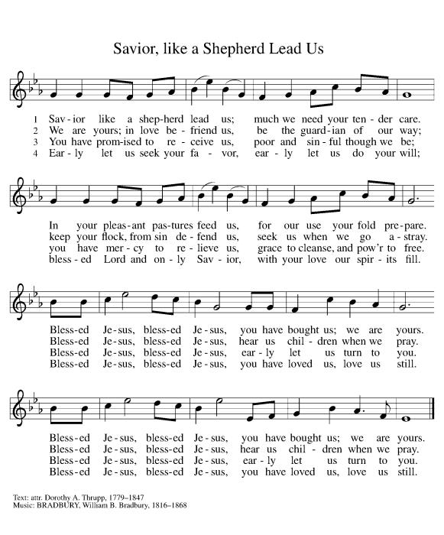**OFFERING SONG Savior, Like a Shepherd Lead Us ELW 789**

**OFFERTORY PRAYER**

Jesus, Bread of life,

you have set this table with your very self,

and called us to the feast of plenty.

Gather what has been sown among us,

and strengthen us in this meal.

Make us to be what we receive here,

your body for the life of the world.

**Amen.**

**GREAT THANKSGIVING**

The Lord be with you.

**And also with you.**

Lift up your hearts.

**We lift them to the Lord.**

Let us give our thanks to the Lord our God.

**It is right to give our thanks and praise.**

**Holy, Holy, Holy ELW 189**

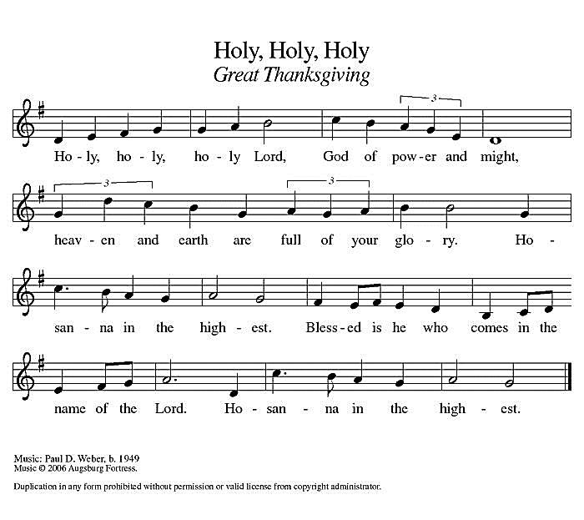

**THANKSGIVING AT THE TABLE**

God of our weary years, God of our silent tears,

you have brought us this far along the way.

In times of bitterness you did not abandon us,

but guided us into the path of love and light.

In every age you sent prophets

to make known your loving will for all humanity.

The cry of the poor has become your own cry;

our hunger and thirst for justice is your own desire.

In the fullness of time, you sent your chosen servant

to preach good news to the afflicted,

to break bread with the outcast and despised,

and to ransom those in bondage to prejudice and sin.

In the night in which he was betrayed,

our Lord Jesus took bread, and gave thanks;

broke it, and gave it to his disciples, saying:

Take and eat; this is my body, given for you.

Do this for the remembrance of me.

Again, after supper, he took the cup, gave thanks,

and gave it for all to drink, saying:

This cup is the new covenant in my blood,

shed for you and all people for the forgiveness of sin.

Do this for the remembrance of me.

For as often as we eat of this bread and drink from this cup

we proclaim the Lord’s death until he comes.

**Christ has died.**

**Christ is risen.**

**Christ will come again.**

Remembering, therefore, his death and resurrection,

we await the day when Jesus shall return

to free all the earth from the bonds of slavery and death.

Come, Lord Jesus! And let the church say, Amen.

**Amen.**

Send your Holy Spirit, our advocate,

to fill the hearts of all who share this bread and cup with courage and wisdom to pursue love and justice in all the world. Come, Spirit of freedom! And let the church say, Amen.

**Amen.**

Join our prayers and praise with your prophets and martyrs of every age,

that, rejoicing in the hope of the resurrection,

we might live in the freedom and hope of your Son.

Through him, with him, in him, in the unity of the Holy Spirit,

all glory and honor is yours, almighty Father, now and forever.

**Amen**

**THE LORD’S PRAYER**

**Our Father, who art in heaven,**

**hallowed be thy name,**

**thy kingdom come,**

**thy will be done,**

**on earth as it is in heaven.**

**Give us this day our daily bread;**

**and forgive us our trespasses,**

**as we forgive those**

**who trespass against us;**

**and lead us not into temptation,**

**but deliver us from evil.**

**For thine is the kingdom,**

**and the power, and the glory,**

**forever and ever. Amen.**

**INVITATION TO COMMUNION** *- Certified gluten-free crackers are in the bowl on the communion plate.*

Christ has set the table with more than enough for all.

Come!

**HOLY COMMUNION**

**PRAYER AFTER COMMUNION**

Jesus, Bread of life,

we have received from your table more than we could ever ask.

As you have nourished us in this meal,

now strengthen us to love the world with your own life.

In your name we pray.

**Amen.**

**SENDING**

**BLESSING**

The blessing of God,

who provides for us, feeds us, and journeys with us,

☩ be upon you now and forever.

**Amen.**

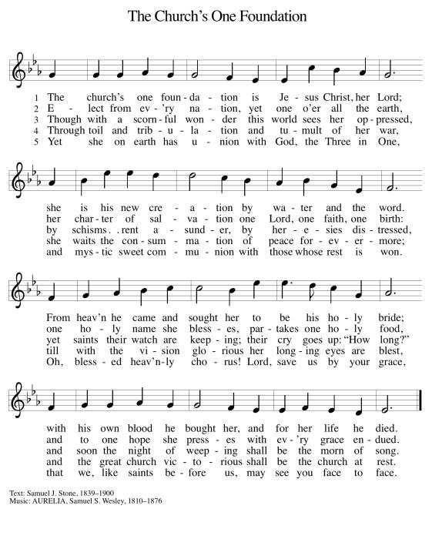**CLOSING HYMN The Church’s One Foundation ELW 654**

**DISMISSAL**

Go in peace. You are the body of Christ.

**Thanks be to God.**

|  |  |  |  |  |  |  |
| --- | --- | --- | --- | --- | --- | --- |
| ***Upcoming Worship Assistants*** | | | | | | |
|  | **Usher** | **Lector** | **Communion** | **Offering Counters** | | **Deep Clean** |
| July 21 | Chuck & Mary Schlafke | Jon Hill | Rick & Sarah Kopitzke | Robin Beeman | Davis Schneider | July:  Dave & Sue Schraeder  Andrea Hovick  Linda Schutte |
| July 28 | Chris & Robin Beeman | Nancy Tibbett | Dan & Pam Mundt | Heidi Binder | Kami Weis |
| August 4 | Lee & Sue Babcock | Julie Will | Bruce & Nancy Tibbett | Pam Mundt | May Hill | August:  Nancy Leonard Jannalee Kolbeck-Lindquist  Heidi Binder |
| August 11 | Jerry & Nonnie Arndt | Chris Tipping | Dave & Sue Schraeder | Dan Mundt | Jon Hill |

|  |  |  |
| --- | --- | --- |
| **Coming up at GSLC** | | |
| Sunday, July 21 | 9:00 am | Outdoor Worship Service   * Ninth Sunday after Pentecost * Mark 6:30-34, 53-56; Christ healing the multitudes |
| Tuesday, July 23 | 7:00 pm | AA Meeting |
| Wednesday, July 24 | 6:00 pm | Pub Theology at Brew Pub |
| Sunday, July 28 | 9:00 am | Outdoor Worship Service   * Tenth Sunday after Pentecost * John 6:1-21; Christ feeding the five thousand |

SOS has provided their list of needs for this month, which includes:

Kidney Beans, Baked Beans, Sandwich Bags, Chicken Noodle Soup, Dish Soap, Oatmeal, Jelly, Gravy,Pudding, Broth, All Purpose Cleaner, Shampoo, Conditioner, Pancake Mix, Baking Items, Paper Towels, Dried Soup. **Urgently need: rice mixes, pasta sauce, dried soups, and corn.**

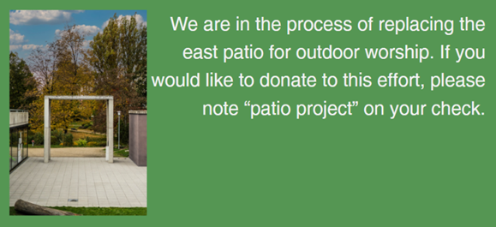  
**Pub Theology is returning for the summer!  
2nd & 4th Wednesday in July and August  
Blue Heron BrewPub 6:00 pm  
Led by Pastor Katie**  
**What is Pub Theology?** People have been gathering in pubs and public spaces for ages talking about life, philosophy, faith, and deep questions of meaning. Increasingly, people all over are rediscovering the pub as a safe, open space where they can explore and express their own doubts and questions, learn from others, and engage people of varying religious traditions. In our increasingly fractured society, these spaces are not only welcome but needed.  
***Bring your questions and curiosity, and pull up a chair.***