**Good Shepherd Lutheran Church**

|  |  |
| --- | --- |
| Pastor: Rev. Katie Anderson | Music Director: Rev. Lois Swanson |
| Pastor’s Cell: (715) 245-1943 | Office Phone: (715) 387-2731 |
| Pastor Email: gslcwi.pastor@gmail.com | Office Email: gslcwi.office@gmail.com |
| Website: GoodShepherdMarshfield.org |  |

**8th Sunday after Pentecost**

**July 14, 2024, 9:00 am**

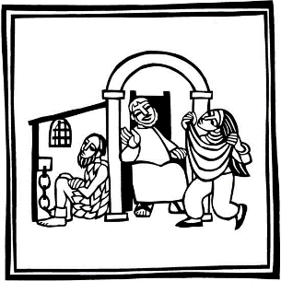***Introduction to the day…***

When Amos reports his vision of God judging Israel for its mistreatment of the poor, he becomes a threat to the power of the priests and the king. John the Baptist also speaks truth to power, and Herod has him killed. In Herod’s fear that Jesus is John returned from the dead, we may hear hope for the oppressed: all the prophets killed through the ages are alive in Jesus. We are called to witness to justice in company with them, and to proclaim God’s saving love.

**ANNOUNCEMENTS**

**GATHERING**

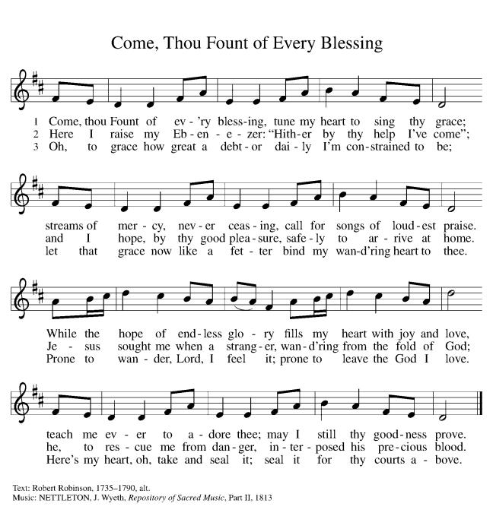**GATHERING HYMN Come thou Fount of Every Blessing ELW807**

**CONFESSION AND FORGIVENESS**

Blessed be the holy Trinity, ☩ one God,

the God of manna,

the God of miracles,

the God of mercy.

**Amen.**

Drawn to Christ and seeking God’s abundance,

let us confess our sin.

*Silence is kept for reflection.*

God, our provider,

**help us.**

**It is hard to believe there is enough to share.**

**We question your ways when they differ from the ways** **of the world in which we live.**

**We turn to our own understanding** **rather than trusting in you.**

**We take offense at your teachings and your ways.**

**Turn us again to you.**

**Where else can we turn?**

**Share with us the words of eternal life** **and feed us for life in the world.**

**Amen.**

Beloved people of God:

in Jesus, the manna from heaven,

you are fed and nourished.

By Jesus, the worker of miracles,

there is always more than enough.

Through Jesus, ☩ the bread of life,

you are shown God’s mercy:

you are forgiven and loved into abundant life.

**Amen.**

**PRAYER OF THE DAY**

**O God, from you come all holy desires, all good counsels, and all just works. Give to us, your servants, that peace which the world cannot give, that our hearts may be set to obey your commandments; and also that we, being defended from the fear of our enemies, may live in peace and quietness, through Jesus Christ, our Savior and Lord.**

**Amen.**

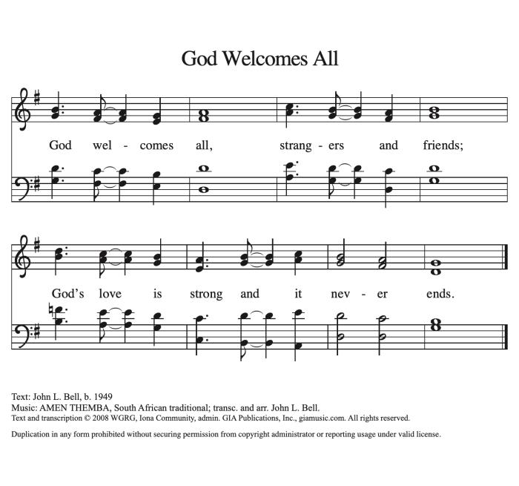**CHILDREN’S MUSIC God Welcomes All ACS 978**

**CHILDREN’S MESSAGE**

**SCRIPTURE READINGS**

**FIRST READING: Amos 7:7-15**

7 This is what [the Lord God] showed me: the Lord was standing beside a wall built with a plumb line, with a plumb line in his hand. 8 And the Lord said to me, “Amos, what do you see?” And I said, “A plumb line.” Then the Lord said,  
 “See, I am setting a plumb line in the midst of my people Israel;  
  I will never again pass them by;  
 9 the high places of Isaac shall be made desolate,  
  and the sanctuaries of Israel shall be laid waste,  
  and I will rise against the house of Jeroboam with the sword.”  
  10 Then Amaziah, the priest of Bethel, sent to King Jeroboam of Israel, saying, “Amos has conspired against you in the very center of the house of Israel; the land is not able to bear all his words. 11 For thus Amos has said,  
 ‘Jeroboam shall die by the sword,  
  and Israel must go into exile away from his land.’ ”  
12 And Amaziah said to Amos, “O seer, go, flee away to the land of Judah, earn your bread there, and prophesy there; 13 but never again prophesy at Bethel, for it is the king’s sanctuary, and it is a temple of the kingdom.”  
  14 Then Amos answered Amaziah, “I am no prophet, nor a prophet’s son; but I am a herdsman, and a dresser of sycamore trees, 15 and the Lord took me from following the flock, and the Lord said to me, ‘Go, prophesy to my people Israel.’ ”

Word of God, word of life.

**Thanks be to God.**

**PSALM: Psalm 85:8-13**

8 I will listen to what the Lord God is saying;  
 for you speak peace to your faithful people and to those who turn their hearts to you.  
9 **Truly, your salvation is very near to those who fear you,**  
 **that your glory may dwell in our land.**  
10 Steadfast love and faithfulness have met together;  
 righteousness and peace have kissed each other.  
11 **Faithfulness shall spring up from the earth,**  
 **and righteousness shall look down from heaven.**  
12 The Lord will indeed grant prosperity,  
 and our land will yield its increase.  
13 **Righteousness shall go before the Lord**  
 **and shall prepare for God a pathway.**

**SECOND READING: Ephesians 1:3-14**

3 Blessed be the God and Father of our Lord Jesus Christ, who has blessed us in Christ with every spiritual blessing in the heavenly places, 4 just as he chose us in Christ before the foundation of the world to be holy and blameless before him in love. 5 He destined us for adoption as his children through Jesus Christ, according to the good pleasure of his will, 6 to the praise of his glorious grace that he freely bestowed on us in the Beloved. 7 In him we have redemption through his blood, the forgiveness of our trespasses, according to the riches of his grace 8 that he lavished on us. With all wisdom and insight 9 he has made known to us the mystery of his will, according to his good pleasure that he set forth in Christ, 10 as a plan for the fullness of time, to gather up all things in him, things in heaven and things on earth. 11 In Christ we have also obtained an inheritance, having been destined according to the purpose of him who accomplishes all things according to his counsel and will, 12 so that we, who were the first to set our hope on Christ, might live for the praise of his glory. 13 In him you also, when you had heard the word of truth, the gospel of your salvation, and had believed in him, were marked with the seal of the promised Holy Spirit; 14 this is the pledge of our inheritance toward redemption as God’s own people, to the praise of his glory.

Word of God, word of life.

**Thanks be to God.**

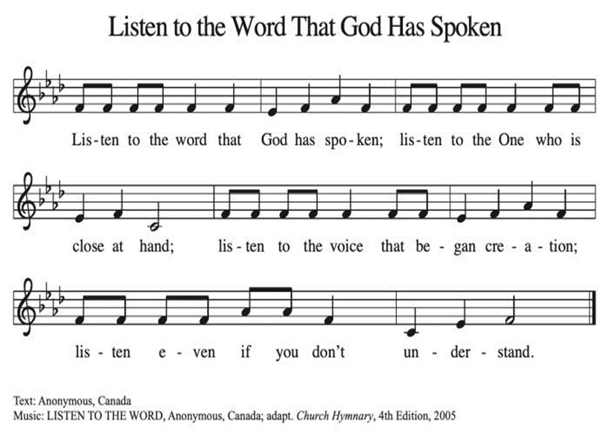**GOSPEL ACCLAMATION Listen to the Word That God Has Spoken ACS 974**

**GOSPEL: Mark 6:14-29**

14 King Herod heard of [the disciples’ preaching,] for Jesus’ name had become known. Some were saying, “John the baptizer has been raised from the dead; and for this reason these powers are at work in him.” 15 But others said, “It is Elijah.” And others said, “It is a prophet, like one of the prophets of old.” 16 But when Herod heard of it, he said, “John, whom I beheaded, has been raised.”  
  17 For Herod himself had sent men who arrested John, bound him, and put him in prison on account of Herodias, his brother Philip’s wife, because Herod had married her. 18 For John had been telling Herod, “It is not lawful for you to have your brother’s wife.” 19 And Herodias had a grudge against him, and wanted to kill him. But she could not, 20 for Herod feared John, knowing that he was a righteous and holy man, and he protected him. When he heard him, he was greatly perplexed; and yet he liked to listen to him. 21 But an opportunity came when Herod on his birthday gave a banquet for his courtiers and officers and for the leaders of Galilee. 22 When his daughter Herodias came in and danced, she pleased Herod and his guests; and the king said to the girl, “Ask me for whatever you wish, and I will give it.” 23 And he solemnly swore to her, “Whatever you ask me, I will give you, even half of my kingdom.” 24 She went out and said to her mother, “What should I ask for?” She replied, “The head of John the baptizer.” 25 Immediately she rushed back to the king and requested, “I want you to give me at once the head of John the Baptist on a platter.” 26 The king was deeply grieved; yet out of regard for his oaths and for the guests, he did not want to refuse her. 27 Immediately the king sent a soldier of the guard with orders to bring John’s head. He went and beheaded him in the prison, 28 brought his head on a platter, and gave it to the girl. Then the girl gave it to her mother. 29 When his disciples heard about it, they came and took his body, and laid it in a tomb.

The gospel of the Lord.

**Praise to you, O Christ.**

**SERMON**

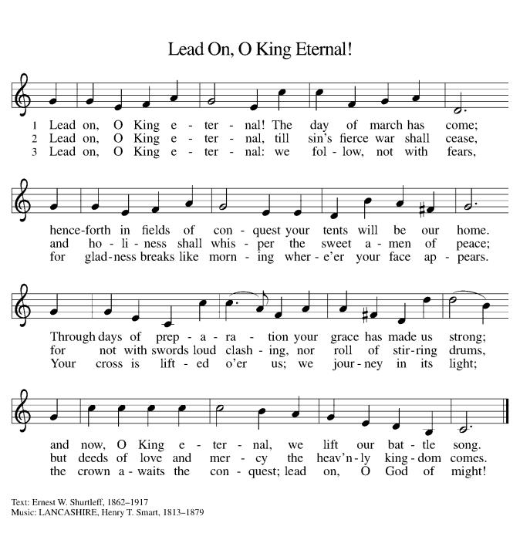**HYMN OF THE DAY Lead on, O King Eternal ELW 805**

**APOSTLES’ CREED**

**I believe in God, the Father almighty,**

**creator of heaven and earth.**

**I believe in Jesus Christ, God's only Son, our Lord,**

**who was conceived by the power of the Holy Spirit,**

**born of the Virgin Mary,**

**suffered under Pontius Pilate,**

**was crucified, died, and was buried;**

**he descended to the dead.**

**On the third day he rose again;**

**he ascended into heaven,**

**he is seated at the right hand of the Father,**

**and he will come to judge the living and the dead.**

**I believe in the Holy Spirit,**

**the holy catholic Church,**

**the communion of saints,**

**the forgiveness of sins,**

**the resurrection of the body,**

**and the life everlasting. Amen.**

**PRAYERS OF INTERCESSION**

…In your mercy

**Hear our prayer**

Holy God, holy and merciful: into your outstretched arms we commend ourselves and all for whom we pray, trusting in the one who is the way, the truth, and the life, Jesus Christ our Savior and Lord.

**Amen.**

**PEACE**

The peace of Christ be with you always.  
**And also with you.**

**HOLY COMMUNION**

**OFFERING***In addition to our normal offering, a* ***Special Benevolence in July*** *(collected in a special envelope) will go to* ***The Best First Day Project.*** *Even though school is just ending, the best first day occurs in August. In order for our donation to be received in time to purchase needed shoes and clothing, we need to do the collection in July.*

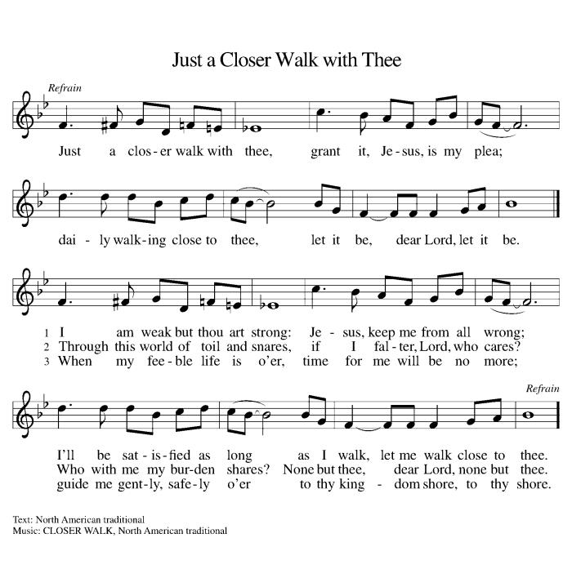**OFFERING SONG Just a Closer Walk with Thee ELW 697**

**OFFERTORY PRAYER**

Jesus, Bread of life,

you have set this table with your very self,

and called us to the feast of plenty.

Gather what has been sown among us,

and strengthen us in this meal.

Make us to be what we receive here,

your body for the life of the world.

**Amen.**

**GREAT THANKSGIVING**

The Lord be with you.

**And also with you.**

Lift up your hearts.

**We lift them to the Lord.**

Let us give our thanks to the Lord our God.

**It is right to give our thanks and praise.**

**Holy, Holy, Holy ELW 189**

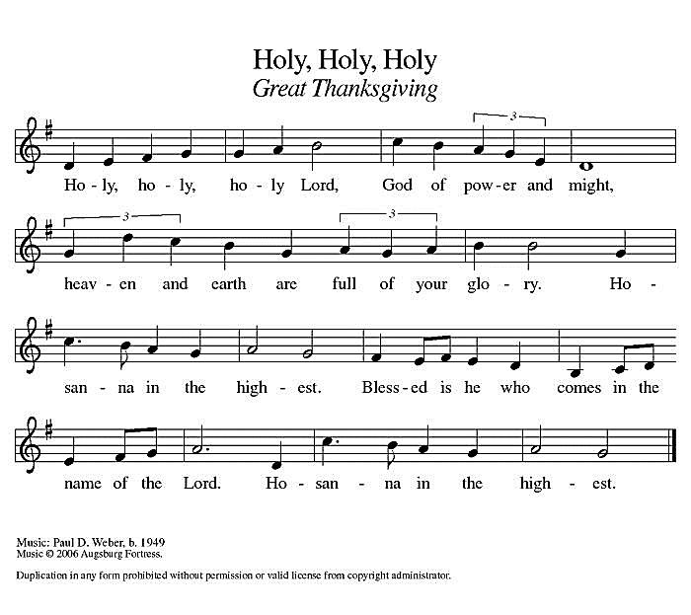

**THANKSGIVING AT THE TABLE**

God of our weary years, God of our silent tears,

you have brought us this far along the way.

In times of bitterness you did not abandon us,

but guided us into the path of love and light.

In every age you sent prophets

to make known your loving will for all humanity.

The cry of the poor has become your own cry;

our hunger and thirst for justice is your own desire.

In the fullness of time, you sent your chosen servant

to preach good news to the afflicted,

to break bread with the outcast and despised,

and to ransom those in bondage to prejudice and sin.

In the night in which he was betrayed,

our Lord Jesus took bread, and gave thanks;

broke it, and gave it to his disciples, saying:

Take and eat; this is my body, given for you.

Do this for the remembrance of me.

Again, after supper, he took the cup, gave thanks,

and gave it for all to drink, saying:

This cup is the new covenant in my blood,

shed for you and all people for the forgiveness of sin.

Do this for the remembrance of me.

For as often as we eat of this bread and drink from this cup

we proclaim the Lord’s death until he comes.

**Christ has died.**

**Christ is risen.**

**Christ will come again.**

Remembering, therefore, his death and resurrection,

we await the day when Jesus shall return

to free all the earth from the bonds of slavery and death.

Come, Lord Jesus! And let the church say, Amen.

**Amen.**

Send your Holy Spirit, our advocate,

to fill the hearts of all who share this bread and cup

with courage and wisdom to pursue love and justice in all the world.

Come, Spirit of freedom! And let the church say, Amen.

**Amen.**

Join our prayers and praise with your prophets and martyrs of every age,

that, rejoicing in the hope of the resurrection,

we might live in the freedom and hope of your Son.

Through him, with him, in him, in the unity of the Holy Spirit,

all glory and honor is yours, almighty Father, now and forever.

**Amen.**

**THE LORD’S PRAYER**

**Our Father, who art in heaven,**

**hallowed be thy name,**

**thy kingdom come,**

**thy will be done,**

**on earth as it is in heaven.**

**Give us this day our daily bread;**

**and forgive us our trespasses,**

**as we forgive those**

**who trespass against us;**

**and lead us not into temptation,**

**but deliver us from evil.**

**For thine is the kingdom,**

**and the power, and the glory,**

**forever and ever. Amen.**

**INVITATION TO COMMUNION** *- Certified gluten-free crackers are in the bowl on the communion plate.*

Christ has set the table with more than enough for all.

Come!

**HOLY COMMUNION**

**PRAYER AFTER COMMUNION**

Jesus, Bread of life,

we have received from your table more than we could ever ask.

As you have nourished us in this meal,

now strengthen us to love the world with your own life.

In your name we pray.

**Amen.**

**SENDING**

**BLESSING**

The blessing of God,

who provides for us, feeds us, and journeys with us,

☩ be upon you now and forever.

**Amen.**

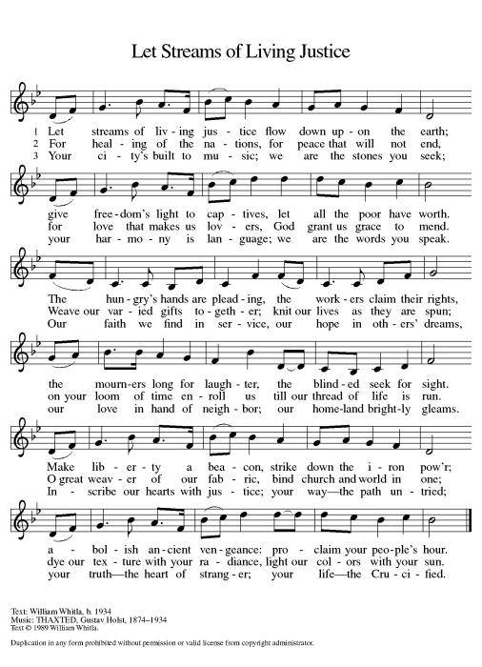**CLOSING HYMN Let Streams of Living Justice ELW 710**

**DISMISSAL**

Go in peace. You are the body of Christ.

**Thanks be to God.**

|  |  |  |  |  |  |  |
| --- | --- | --- | --- | --- | --- | --- |
| ***Upcoming Worship Assistants*** | | | | | | |
|  | **Usher** | **Lector** | **Communion** | **Offering Counters** | | **Deep Clean** |
| July 14 | Jon & May Hill | Linda Schrieber | Bob & Laurel Peterson | Nancy Leonard | Breanna Butler | July:  Dave & Sue Schraeder  Andrea Hovick  Linda Schutte |
| July 21 |  | Jon Hill | Rick & Sarah Kopitzke | Robin Beeman | Davis Schneider |
| July 28 | Chris & Robin Beeman | Nancy Tibbett | Dan & Pam Mundt | Heidi Binder | Kami Weis |
| August 4 | Lee & Sue Babcock | Julie Will | Bruce & Nancy Tibbett | Pam Mundt | May Hill |  |

**\*Could anyone help out with Usher duty on July 21st ? Please leave a note at the office if you would be able to volunteer. Thank you very much!**

|  |  |  |
| --- | --- | --- |
| **Coming up at GSLC** | | |
| Sunday, July 14 | 9:00 am | Outdoor Worship Service   * Eighth Sunday after Pentecost * Mark 6:14-29; The death of John the Baptist |
| Tuesday, July 16 | 2:00 pm | Chapel at Three Oaks |
|  | 7:00 pm | AA Meeting |
| Friday, July 19 | Dusk | Outdoor Movie Night—Top Gun: Maverick |
| Sunday, July 21 | 9:00 am | Outdoor Worship Service   * Ninth Sunday after Pentecost * Mark 6:30-34, 53-56; Christ healing the multitudes |

SOS has provided their list of needs for this month, which includes:

Kidney Beans, Baked Beans, Sandwich Bags, Chicken Noodle Soup, Dish Soap, Oatmeal, Jelly, Gravy,Pudding, Broth, All Purpose Cleaner, Shampoo, Conditioner, Pancake Mix, Baking Items, Paper Towels, Dried Soup. **Urgently need: rice mixes, pasta sauce, dried soups, and corn.**

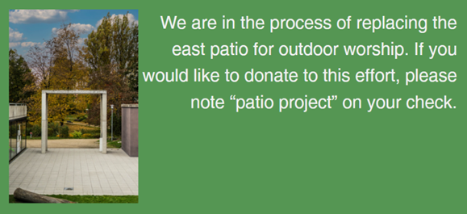  
**Pub Theology is returning for the summer!  
2nd & 4th Wednesday in July and August  
Blue Heron BrewPub 6:00 pm  
Led by Pastor Katie**  
**What is Pub Theology?** People have been gathering in pubs and public spaces for ages talking about life, philosophy, faith, and deep questions of meaning. Increasingly, people all over are rediscovering the pub as a safe, open space where they can explore and express their own doubts and questions, learn from others, and engage people of varying religious traditions. In our increasingly fractured society, these spaces are not only welcome but needed.  
***Bring your questions and curiosity, and pull up a chair.***