
Good Shepherd Lutheran Church
Pastor: Rev. Katie Anderson | Music Director: Rev. Lois Swanson
Pastor’s Cell: (715) 245-1943 | Office Phone: (715) 387-2731
Pastor Email: gslcwi.pastor@gmail.com | Office Email: gslcwi.office@gmail.com
Website: GoodShepherdMarshfield.org
Lectionary 10
3rd Sunday after Pentecost
June 9, 2024, 9:00 am
Introduction to the day…
A house divided against itself cannot stand. Jesus makes this observation in light of charges that he is possessed. He is possessed, not by a demon, but by the Holy Spirit. We who have received the Holy Spirit through baptism have been joined to Christ’s death and resurrection and knit together in the body of Christ. Those with whom we sing and pray this day are Jesus’ family. With them we go forth in peace to do the will of God.

ANNOUNCEMENTS
GATHERING
GATHERING HYMN Lord, I Lift Your Name on High ELW 857

Lord, I lift Your name on high. Lord, I love to sing Your praises.

I'm so glad You're in my life; I'm so glad You came to save us.

You came from heaven to earth to show the way.

From the earth to the cross, my debt to pay.

From the cross to the grave, from the grave to the sky;

Lord, I lift Your name on high. Repeat

CONFESSION AND FORGIVENESS
Blessed be the holy Trinity, ☩ one God,
the God of manna,
the God of miracles,
the God of mercy.
Amen.
Drawn to Christ and seeking God’s abundance,
let us confess our sin.
Silence is kept for reflection.
God, our provider,
help us.
It is hard to believe there is enough to share.
We question your ways when they differ from the ways of the world in which we live.
We turn to our own understanding rather than trusting in you.
We take offense at your teachings and your ways.
Turn us again to you.
Where else can we turn?
Share with us the words of eternal life and feed us for life in the world.
Amen.
Beloved people of God:
in Jesus, the manna from heaven,
you are fed and nourished.
By Jesus, the worker of miracles,
there is always more than enough.
Through Jesus, ☩ the bread of life,
you are shown God’s mercy:
you are forgiven and loved into abundant life.
Amen.
PRAYER OF THE DAY
All-powerful God, in Jesus Christ you turned death into life and defeat into victory. Increase our faith and trust in him, that we may triumph over all evil in the strength of the same Jesus Christ, our Savior and Lord.
Amen.
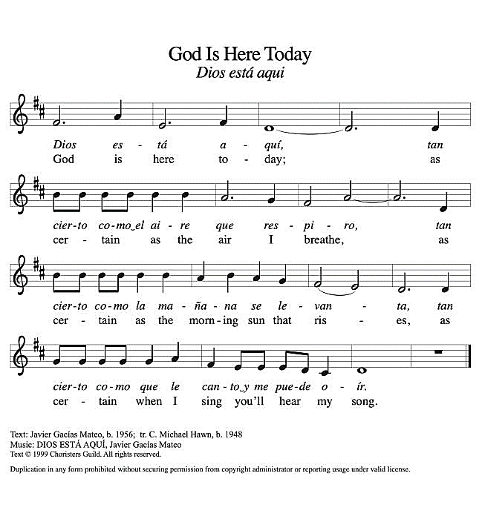
CHILDREN’S MUSIC God is Here Today ACS 993

CHILDREN’S MESSAGE
SCRIPTURE READINGS

FIRST READING: Genesis 3:8-15
⁸[Adam and Eve] heard the sound of the Lord God walking in the garden at the time of the evening breeze, and the man and his wife hid themselves from the presence of the Lord God among the trees of the garden.⁹But the Lord God called to the man, and said to him, “Where are you?” ¹⁰He said, “I heard the sound of you in the garden, and I was afraid, because I was naked; and I hid myself.” ¹¹He said, “Who told you that you were naked? Have you eaten from the tree of which I commanded you not to eat?” ¹²The man said, “The woman whom you gave to be with me, she gave me fruit from the tree, and I ate.” ¹³Then the Lord God said to the woman, “What is this that you have done?” The woman said, “The serpent tricked me, and I ate.” ¹⁴The Lord God said to the serpent,
“Because you have done this,
cursed are you among all animals and among all wild creatures;
upon your belly you shall go,
and dust you shall eat
all the days of your life.
¹⁵I will put enmity between you and the woman,
and between your offspring and hers;
he will strike your head,
and you will strike his heel.”
Word of God, word of life.
Thanks be to God.
PSALM: Psalm 130
¹Out of the depths
I cry to you, O Lord;
²O Lord, hear my voice!
Let your ears be attentive to the voice of my supplication.
³If you were to keep watch over sins,
O Lord, who could stand?
⁴Yet with you is forgiveness,
in order that you may be feared.
⁵I wait for you, O Lord; my soul waits;
in your word is my hope.
⁶My soul waits for the Lord more than those who keep watch for the morning,
more than those who keep watch for the morning.
⁷O Israel, wait for the Lord, for with the Lord there is steadfast love;
with the Lord there is plenteous redemption.
⁸For the Lord shall redeem Israel
from all their sins.
SECOND READING: 2 Corinthians 4:13-5:1
¹³Just as we have the same spirit of faith that is in accordance with scripture—“I believed, and so I spoke”—we also believe, and so we speak, ¹⁴because we know that the one who raised the Lord Jesus will raise us also with Jesus, and will bring us with you into his presence. ¹⁵Yes, everything is for your sake, so that grace, as it extends to more and more people, may increase thanksgiving, to the glory of God.
¹⁶So we do not lose heart. Even though our outer nature is wasting away, our inner nature is being renewed day by day. ¹⁷For this slight momentary affliction is preparing us for an eternal weight of glory beyond all measure, ¹⁸because we look not at what can be seen but at what cannot be seen; for what can be seen is temporary, but what cannot be seen is eternal.
^{5:1}For we know that if the earthly tent we live in is destroyed, we have a building from God, a house not made with hands, eternal in the heavens.
Word of God, word of life.
Thanks be to God.
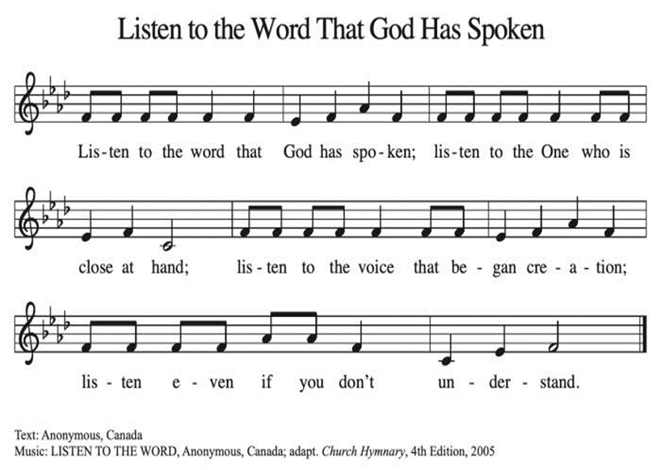
GOSPEL ACCLAMATION ACS 974

GOSPEL: Mark 3:20-35
[Jesus went home;] ²⁰and the crowd came together again, so that [Jesus and the disciples] could not even eat. ²¹When his family heard it, they went out to restrain him, for people were saying, “He has gone out of his mind.” ²²And the scribes who came down from Jerusalem said, “He has Beelzebul, and by the ruler of the demons he casts out demons.” ²³And he called them to him, and spoke to them in parables, “How can Satan cast out Satan? ²⁴If a kingdom is divided against itself, that kingdom cannot stand. ²⁵And if a house is divided against itself, that house will not be able to stand. ²⁶And if Satan has risen up against himself and is divided, he cannot stand, but his end has come. ²⁷But no one can enter a strong man’s house and plunder his property without first tying up the strong man; then indeed the house can be plundered.
²⁸“Truly I tell you, people will be forgiven for their sins and whatever blasphemies they utter; ²⁹but whoever blasphemes against the Holy Spirit can never have forgiveness, but is guilty of an eternal sin”—³⁰for they had said, “He has an unclean spirit.”
³¹Then his mother and his brothers came; and standing outside, they sent to him and called him. ³²A crowd was sitting around him; and they said to him, “Your mother and your brothers and sisters are outside, asking for you.” ³³And he replied, “Who are my mother and my brothers?” ³⁴And looking at those who sat around him, he said, “Here are my mother and my brothers! ³⁵Whoever does the will of God is my brother and sister and mother.”
The gospel of the Lord.
Praise to you, O Christ.
SERMON
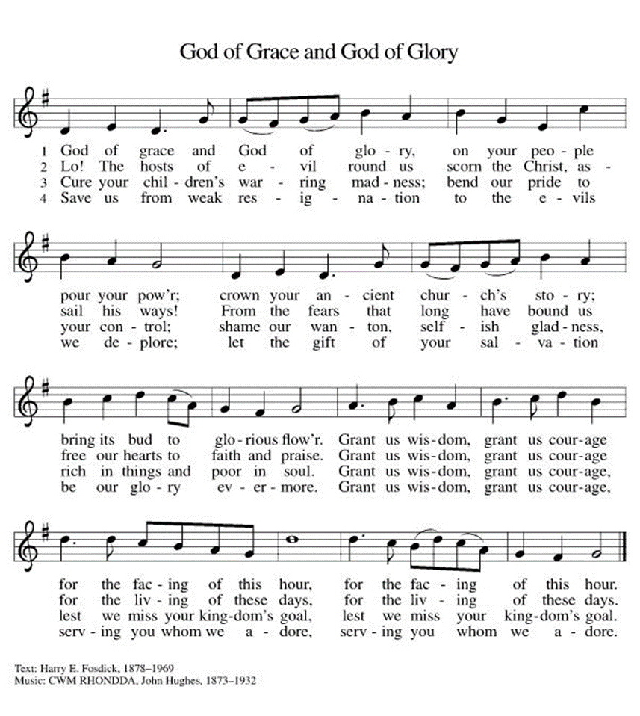
HYMN OF THE DAY God of Grace and God of Glory ELW 705

APOSTLES’ CREED
I believe in God, the Father almighty,
creator of heaven and earth.

I believe in Jesus Christ, God's only Son, our Lord,
who was conceived by the power of the Holy Spirit,
born of the Virgin Mary,
suffered under Pontius Pilate,
was crucified, died, and was buried;
he descended to the dead.
On the third day he rose again;
he ascended into heaven,
he is seated at the right hand of the Father,
and he will come to judge the living and the dead.
I believe in the Holy Spirit,
the holy catholic Church,
the communion of saints,
the forgiveness of sins,
the resurrection of the body,
and the life everlasting. Amen.
PRAYERS OF INTERCESSION
…Merciful God.
Receive our prayer
Receive our prayers, O God, and come quickly to our aid, through the power of the Spirit and the love of Jesus Christ.
Amen.
PEACE
The peace of Christ be with you always.
And also with you.
HOLY COMMUNION
OFFERING In addition to our normal offering, a Special Benevolence in June (collected in a special envelope) will go to MAPS (Marshfield Area Pet Shelter).
OFFERING SONG When Peace Like a River ELW 785
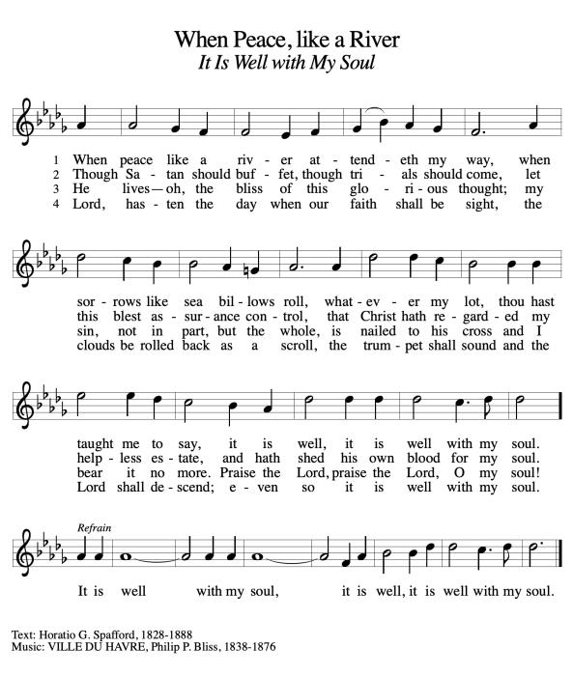

OFFERTORY PRAYER
Jesus, Bread of life,
you have set this table with your very self,

and called us to the feast of plenty.
Gather what has been sown among us,
and strengthen us in this meal.
Make us to be what we receive here,
your body for the life of the world.
Amen.
GREAT THANKSGIVING
The Lord be with you.
And also with you.
Lift up your hearts.
We lift them to the Lord.
Let us give our thanks to the Lord our God.
It is right to give our thanks and praise.
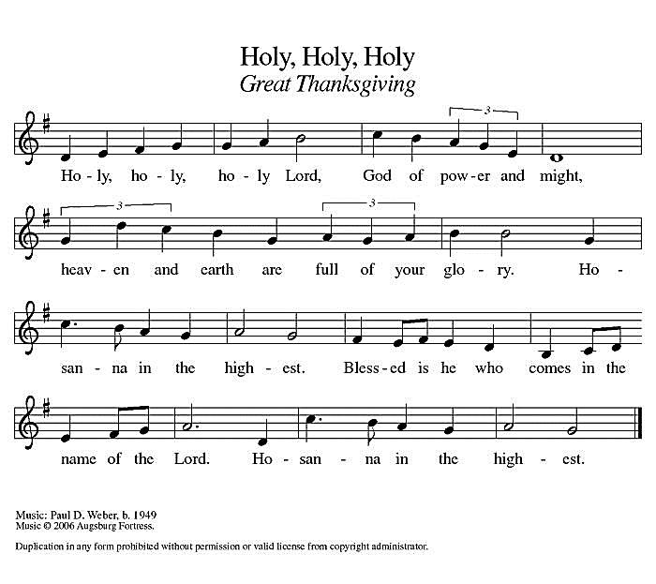
Holy, Holy, Holy ELW 189
THANKSGIVING AT THE TABLE
God of our weary years, God of our silent tears,
you have brought us this far along the way.
In times of bitterness you did not abandon us,
but guided us into the path of love and light.
In every age you sent prophets
to make known your loving will for all humanity.
The cry of the poor has become your own cry;
our hunger and thirst for justice is your own desire.
In the fullness of time, you sent your chosen servant
to preach good news to the afflicted,
to break bread with the outcast and despised,
and to ransom those in bondage to prejudice and sin.
In the night in which he was betrayed,
our Lord Jesus took bread, and gave thanks;
broke it, and gave it to his disciples, saying:
Take and eat; this is my body, given for you.
Do this for the remembrance of me.
Again, after supper, he took the cup, gave thanks,
and gave it for all to drink, saying:
This cup is the new covenant in my blood,
shed for you and all people for the forgiveness of sin.
Do this for the remembrance of me.

For as often as we eat of this bread and drink from this cup
we proclaim the Lord’s death until he comes.
Christ has died.
Christ is risen.
Christ will come again.
Remembering, therefore, his death and resurrection,
we await the day when Jesus shall return
to free all the earth from the bonds of slavery and death.
Come, Lord Jesus! And let the church say, Amen.
Amen.
Send your Holy Spirit, our advocate,
to fill the hearts of all who share this bread and cup
with courage and wisdom to pursue love and justice in all the world.
Come, Spirit of freedom! And let the church say, Amen.
Amen.
Join our prayers and praise with your prophets and martyrs of every age,
that, rejoicing in the hope of the resurrection,
we might live in the freedom and hope of your Son.
Through him, with him, in him, in the unity of the Holy Spirit,
all glory and honor is yours, almighty Father, now and forever.
Amen.
THE LORD’S PRAYER
Our Father, who art in heaven,

hallowed be thy name,
thy kingdom come,
thy will be done,
on earth as it is in heaven.
Give us this day our daily bread;
and forgive us our trespasses,
as we forgive those
who trespass against us;
and lead us not into temptation,
but deliver us from evil.
For thine is the kingdom,
and the power, and the glory,
forever and ever. Amen.
INVITATION TO COMMUNION - Certified gluten-free crackers are in the bowl on the communion plate.
Christ has set the table with more than enough for all.
Come!
HOLY COMMUNION
PRAYER AFTER COMMUNION
Jesus, Bread of life,
we have received from your table more than we could ever ask.
As you have nourished us in this meal,
now strengthen us to love the world with your own life.
In your name we pray.
Amen.

SENDING
CLOSING HYMN Go, My Children, with My Blessing ELW 543
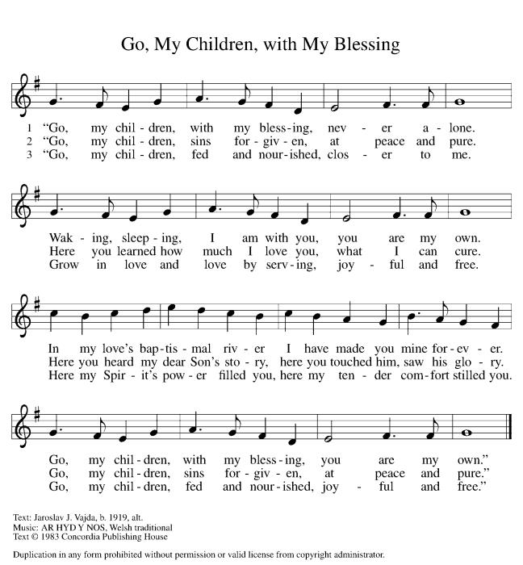

BLESSING
The blessing of God,
who provides for us, feeds us, and journeys with us,
☩ be upon you now and forever.
Amen.
DISMISSAL
Go in peace. You are the body of Christ.
Thanks be to God.

Upcoming Worship Assistants
 | Usher | Lector | Communion | Offering Counters |  | Deep Clean
June 9 | Christopher & Trina Ignatowski | Leslie Mader | Dave & Shelly Schneider | Nancy Leonard | Breanna Butler | June:  Dave & Shelly Schneider  Bruce & Nancy Tibbett
June 16 | Ben & Sue Lee | Julie Will | John Wagner  Nancy Leonard | Robin Beeman | David Schneider
June 23 | Bruce & Nancy Tibbett | Kris Tarter | Ron Rothfusz  Andrea Hovick | Heidi Binder | Kami Weis
June 30 | Julie Will | Shelly Schneider | Dave & Sue Schraeder | Pam Mundt | Jon Hill
Coming up at GSLC
Sunday, June 9 | 9:00 am | Outdoor Worship Service  - Third Sunday after Pentecost  - Mark 3:20-35; Doing the work of God as brothers and sisters of Christ
Tuesday, June 11 | 6:30 pm | Council Meeting
 | 7:00 pm | AA Meeting
Wednesday, June 12 | 6:00 pm | Pub Theology at Brew Pub
Sunday, June 16 | 9:00 am | Outdoor Worship Service  - Fourth Sunday after Pentecost  - Mark 4:26-34; The parable of the mustard seed

SOS has provided their list of needs for this month, which includes:
Kidney Beans, Baked Beans, Sandwich Bags, Chicken Noodle Soup, Dish Soap, Oatmeal, Jelly, Gravy, Pudding, Broth, All Purpose Cleaner, Shampoo, Conditioner, Pancake Mix, Baking Items, Paper Towels, Dried Soup. Urgently need: Broth, Canned Fruit, Dried Soup, Jello/Pudding, Mac N Cheese, Spaghettios

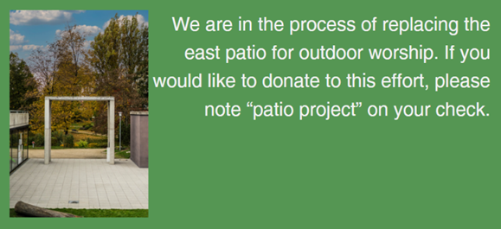



Pub Theology is returning for the summer!
2nd Wednesday in June, 2nd & 4th Wednesday in July and August
Blue Heron BrewPub 6:00 pm
Led by Pastor Katie
What is Pub Theology? People have been gathering in pubs and public spaces for ages talking about life, philosophy, faith, and deep questions of meaning. Increasingly, people all over are rediscovering the pub as a safe, open space where they can explore and express their own doubts and questions, learn from others, and engage people of varying religious traditions. In our increasingly fractured society, these spaces are not only welcome but needed.
Bring your questions and curiosity, and pull up a chair.


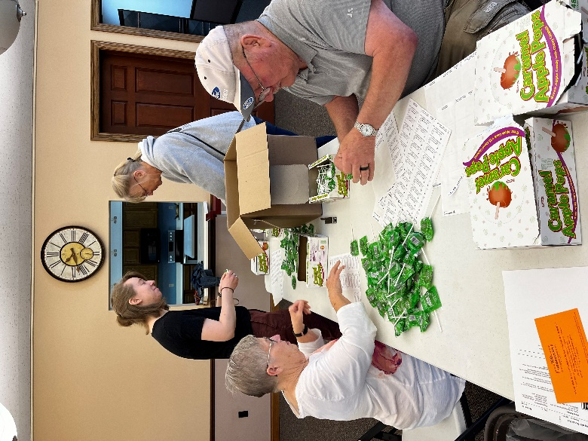
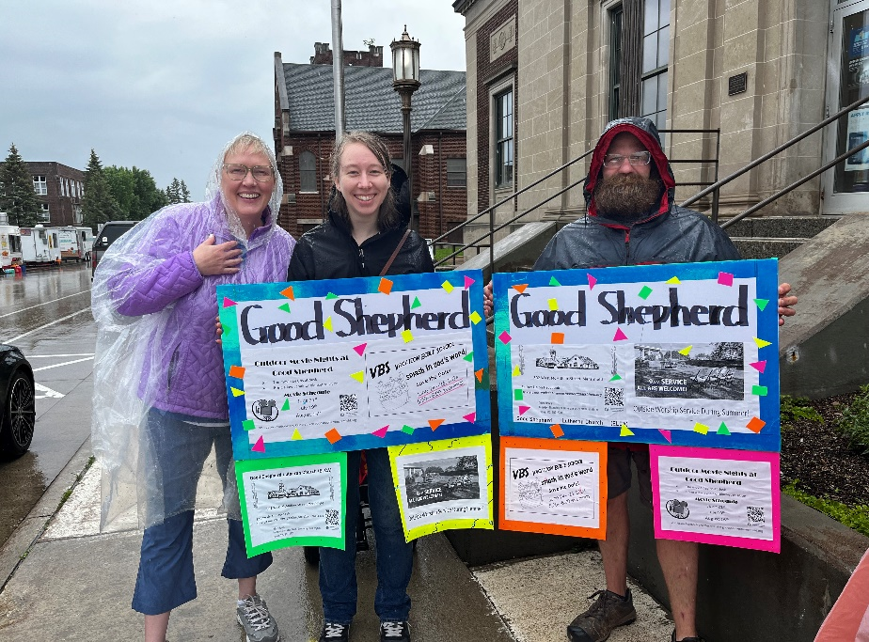
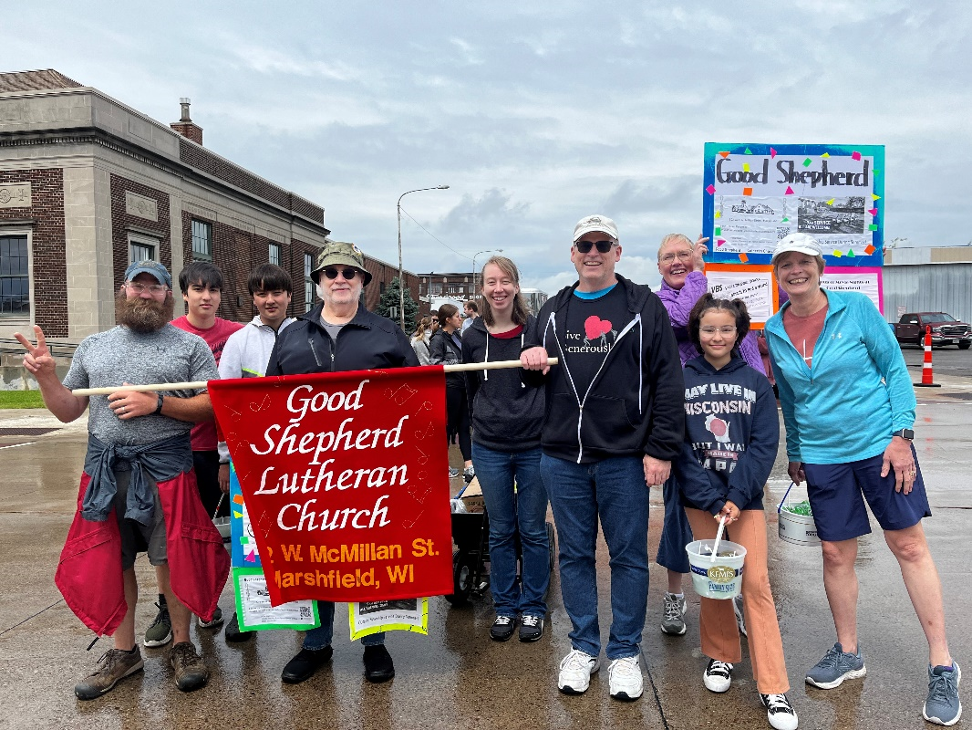
Fun walking and throwing candy in the Dairyfest parade last weekend! Looking forward to join again next year!
Dairyfest Parade!

