**Good Shepherd Lutheran Church**

|  |  |
| --- | --- |
| Pastor: Rev. Katie Anderson | Music Director: Rev. Lois Swanson |
| Pastor’s Cell: (715) 245-1943 | Office Phone: (715) 387-2731 |
| Pastor Email: gslcwi.pastor@gmail.com | Office Email: gslcwi.office@gmail.com |
| Website: GoodShepherdMarshfield.org |  |

**6th Sunday after Pentecost**

**June 30, 2024, 9:00 am**

***Introduction to the day…***

A woman finds healing by touching Jesus’ cloak, and a girl is restored to life when he takes her by the hand. In both cases a boundary is crossed: in Jesus’ time the hemorrhaging woman was considered ritually unclean, polluting others by her touch, and anyone who touched a corpse also became unclean. In Mark’s gospel Jesus breaks down barriers, from his first meal at a tax collector’s house to his last breath on the cross as the temple curtain is torn in two. We dare to touch Jesus in our “uncleanness” and to live as a community that defines no one as an outsider.

**ANNOUNCEMENTS**

**GATHERING**

**GATHERING HYMN Great Is the Lord**

|  |  |  |  |
| --- | --- | --- | --- |
| Great is the Lord, He is holy and just,  By His power we trust in His love.  Great is the Lord, He is faithful and true,  By His mercy He proves He is love.  Great is the Lord and worthy of glory.  Great is the Lord and worthy of praise.  Great is the Lord, I lift up my voice,  I lift up my voice.  Great is the Lord, great is the Lord. | Great is the Lord, He is holy and just,  By His power we trust in His love.  Great is the Lord, He is faithful and true,  By His mercy He proves He is love.  Great are you Lord and worthy of glory.  Great are you Lord and worthy of praise.  Great are you Lord, I lift up my voice,  I lift up my voice.  Great are you Lord, great are you Lord |  |  |
| Smith, Michael W. / Smith, Deborah D. EMI Christian Music Publishing Used by permission. CCLI License #669990 | |  |  |

### **CONFESSION AND FORGIVENESS**

Blessed be the holy Trinity, ☩ one God,

the God of manna,

the God of miracles,

the God of mercy.

**Amen.**

Drawn to Christ and seeking God’s abundance,

let us confess our sin.

*Silence is kept for reflection.*

God, our provider,

**help us.**

**It is hard to believe there is enough to share.**

**We question your ways when they differ from the ways** **of the world in which we live.**

**We turn to our own understanding** **rather than trusting in you.**

**We take offense at your teachings and your ways.**

**Turn us again to you.**

**Where else can we turn?**

**Share with us the words of eternal life** **and feed us for life in the world.**

**Amen.**

Beloved people of God:

in Jesus, the manna from heaven,

you are fed and nourished.

By Jesus, the worker of miracles,

there is always more than enough.

Through Jesus, ☩ the bread of life,

you are shown God’s mercy:

you are forgiven and loved into abundant life.

**Amen.**

**PRAYER OF THE DAY**

**Almighty and merciful God, we implore you to hear the prayers of your people. Be our strong defense against all harm and danger, that we may live and grow in faith and hope, through Jesus Christ, our Savior and Lord.**

**Amen.**

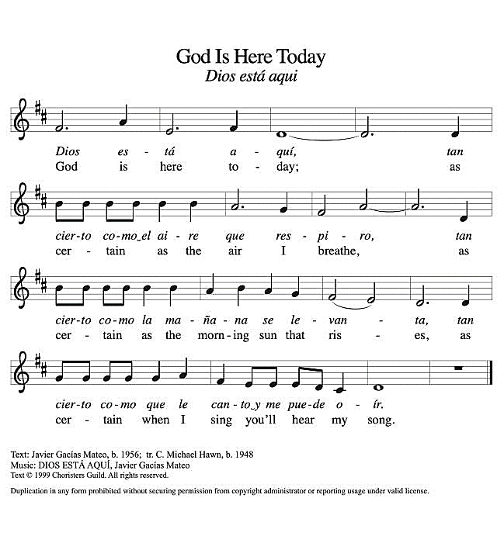**CHILDREN’S MUSIC God is Here Today ACS 993**

**CHILDREN’S MESSAGE**

**SCRIPTURE READINGS**

**FIRST READING: Lamentations 3:22-33**

22The steadfast love of the Lord never ceases,  
  his mercies never come to an end;  
 23they are new every morning;  
  great is your faithfulness.  
 24“The Lord is my portion,” says my soul,  
  “therefore I will hope in him.”  
 25The Lord is good to those who wait for him,  
  to the soul that seeks him.  
 26It is good that one should wait quietly  
  for the salvation of the Lord.  
 27It is good for one to bear  
  the yoke in youth,  
 28to sit alone in silence  
  when the Lord has imposed it,  
 29to put one’s mouth to the dust  
  (there may yet be hope),  
 30to give one’s cheek to the smiter,  
  and be filled with insults.  
 31For the Lord will not  
  reject forever.

32Although he causes grief, he will have compassion  
  according to the abundance of his steadfast love;  
 33for he does not willingly afflict  
  or grieve anyone.

Word of God, word of life.

**Thanks be to God.**

**PSALM: Psalm 30**

1I will exalt you, O Lord, because you have lifted me up  
 and have not let my enemies triumph over me.  
2**O Lord my God, I cried out to you,**  
 **and you restored me to health.**  
3You brought me up, O Lord, from the dead;  
 you restored my life as I was going down to the grave.  
4**Sing praise to the Lord, all you faithful;**  
 **give thanks in holy remembrance.**  
5God’s wrath is short; God’s favor lasts a lifetime.  
 Weeping spends the night, but joy comes in the morning.  
6**While I felt secure, I said,**  
 **“I shall never be disturbed.**  
7You, Lord, with your favor, made me as strong as the mountains.”  
 Then you hid your face, and I was filled with fear.  
8**I cried to you, O Lord;**  
 **I pleaded with my Lord, saying,**  
9“What profit is there in my blood, if I go down to the pit?  
 Will the dust praise you or declare your faithfulness?  
10**Hear, O Lord, and have mercy upon me;**  
 **O Lord, be my helper.”**  
11You have turned my wailing into dancing;  
 you have put off my sackcloth and clothed me with joy.  
12**Therefore my heart sings to you without ceasing;**  
 **O Lord my God, I will give you thanks forever.**

**SECOND READING: 2 Corinthians 8:7-15**

7Now as you excel in everything—in faith, in speech, in knowledge, in utmost eagerness, and in our love for you—so we want you to excel also in this generous undertaking.  
 8I do not say this as a command, but I am testing the genuineness of your love against the earnestness of others. 9For you know the generous act of our Lord Jesus Christ, that though he was rich, yet for your sakes he became poor, so that by his poverty you might become rich. 10And in this matter I am giving my advice: it is appropriate for you who began last year not only to do something but even to desire to do something—11now finish doing it, so that your eagerness may be matched by completing it according to your means. 12For if the eagerness is there, the gift is acceptable according to what one has—not according to what one does not have. 13I do not mean that there should be relief for others and pressure on you, but it is a question of a fair balance between 14your present abundance and their need, so that their abundance may be for your need, in order that there may be a fair balance. 15As it is written,  
 “The one who had much did not have too much,  
  and the one who had little did not have too little.”

Word of God, word of life.

**Thanks be to God.**

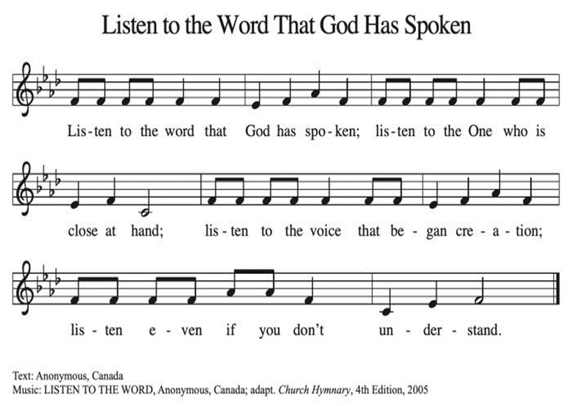**GOSPEL ACCLAMATION Listen to the Word That God Has Spoken ACS 974**

### **GOSPEL: Mark 5:21-43**

21When Jesus had crossed again in the boat to the other side, a great crowd gathered around him; and he was by the sea. 22Then one of the leaders of the synagogue named Jairus came and, when he saw him, fell at his feet 23and begged him repeatedly, “My little daughter is at the point of death. Come and lay your hands on her, so that she may be made well, and live.” 24So he went with him.  
  And a large crowd followed him and pressed in on him. 25Now there was a woman who had been suffering from hemorrhages for twelve years. 26She had endured much under many physicians, and had spent all that she had; and she was no better, but rather grew worse. 27She had heard about Jesus, and came up behind him in the crowd and touched his cloak, 28for she said, “If I but touch his clothes, I will be made well.” 29Immediately her hemorrhage stopped; and she felt in her body that she was healed of her disease. 30Immediately aware that power had gone forth from him, Jesus turned about in the crowd and said, “Who touched my clothes?” 31And his disciples said to him, “You see the crowd pressing in on you; how can you say, ‘Who touched me?’ ” 32He looked all around to see who had done it. 33But the woman, knowing what had happened to her, came in fear and trembling, fell down before him, and told him the whole truth. 34He said to her, “Daughter, your faith has made you well; go in peace, and be healed of your disease.”  
 35While he was still speaking, some people came from the leader’s house to say, “Your daughter is dead. Why trouble the teacher any further?” 36But overhearing what they said, Jesus said to the leader of the synagogue, “Do not fear, only believe.” 37He allowed no one to follow him except Peter, James, and John, the brother of James. 38When they came to the house of the leader of the synagogue, he saw a commotion, people weeping and wailing loudly. 39When he had entered, he said to them, “Why do you make a commotion and weep? The child is not dead but sleeping.” 40And they laughed at him. Then he put them all outside, and took the child’s father and mother and those who were with him, and went in where the child was. 41He took her by the hand and said to her, “Talitha cum,” which means, “Little girl, get up!” 42And immediately the girl got up and began to walk about (she was twelve years of age). At this they were overcome with amazement. 43He strictly ordered them that no one should know this, and told them to give her something to eat.

The gospel of the Lord.

**Praise to you, O Christ.**

**SERMON**

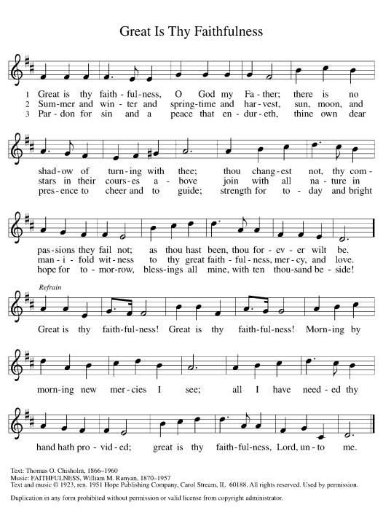**HYMN OF THE DAY Great is Thy Faithfulness ELW 733**

**APOSTLES’ CREED**

**I believe in God, the Father almighty,**

**creator of heaven and earth.**

**I believe in Jesus Christ, God's only Son, our Lord,**

**who was conceived by the power of the Holy Spirit,**

**born of the Virgin Mary,**

**suffered under Pontius Pilate,**

**was crucified, died, and was buried;**

**he descended to the dead.**

**On the third day he rose again;**

**he ascended into heaven,**

**he is seated at the right hand of the Father,**

**and he will come to judge the living and the dead.**

**I believe in the Holy Spirit,**

**the holy catholic Church,**

**the communion of saints,**

**the forgiveness of sins,**

**the resurrection of the body,**

**and the life everlasting. Amen.**

**PRAYERS OF INTERCESSION**

…In your mercy

**Hear our prayer**

Holy God, holy and merciful: into your outstretched arms we commend ourselves and all for whom we pray, trusting in the one who is the way, the truth, and the life, Jesus Christ our Savior and Lord.

**Amen.**

**PEACE**

The peace of Christ be with you always.  
**And also with you.**

**HOLY COMMUNION**

**OFFERING***In addition to our normal offering, a* ***Special Benevolence in June*** *(collected in a special envelope) will go to* ***MAPS (Marshfield Area Pet Shelter).***

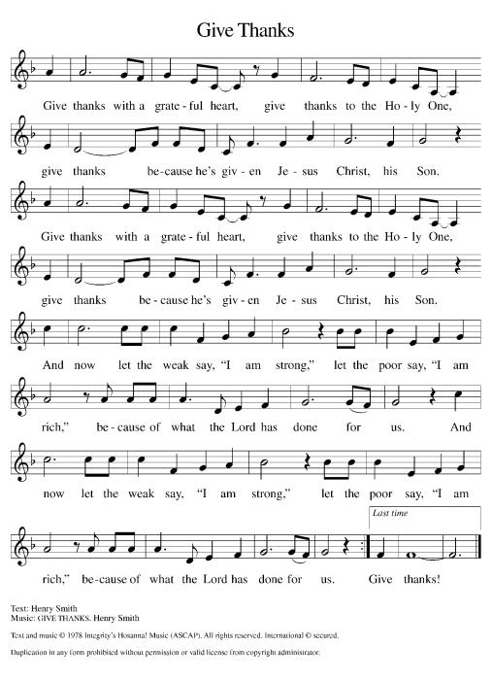**OFFERING SONG Give Thanks with a Grateful Heart**

**OFFERTORY PRAYER**

Jesus, Bread of life,

you have set this table with your very self,

and called us to the feast of plenty.

Gather what has been sown among us,

and strengthen us in this meal.

Make us to be what we receive here,

your body for the life of the world.

**Amen.**

**GREAT THANKSGIVING**

The Lord be with you.

**And also with you.**

Lift up your hearts.

**We lift them to the Lord.**

Let us give our thanks to the Lord our God.

**It is right to give our thanks and praise.**

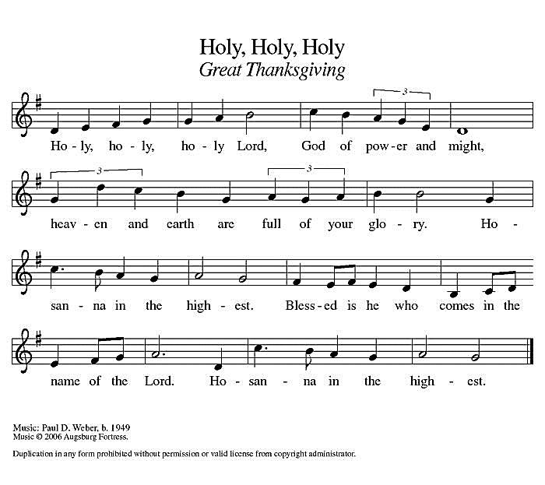**Holy, Holy, Holy ELW 189**

**THANKSGIVING AT THE TABLE**

God of our weary years, God of our silent tears,

you have brought us this far along the way.

In times of bitterness you did not abandon us,

but guided us into the path of love and light.

In every age you sent prophets

to make known your loving will for all humanity.

The cry of the poor has become your own cry;

our hunger and thirst for justice is your own desire.

In the fullness of time, you sent your chosen servant

to preach good news to the afflicted,

to break bread with the outcast and despised,

and to ransom those in bondage to prejudice and sin.

In the night in which he was betrayed,

our Lord Jesus took bread, and gave thanks;

broke it, and gave it to his disciples, saying:

Take and eat; this is my body, given for you.

Do this for the remembrance of me.

Again, after supper, he took the cup, gave thanks,

and gave it for all to drink, saying:

This cup is the new covenant in my blood,

shed for you and all people for the forgiveness of sin.

Do this for the remembrance of me.

For as often as we eat of this bread and drink from this cup

we proclaim the Lord’s death until he comes.

**Christ has died.**

**Christ is risen.**

**Christ will come again.**

Remembering, therefore, his death and resurrection,

we await the day when Jesus shall return

to free all the earth from the bonds of slavery and death.

Come, Lord Jesus! And let the church say, Amen.

**Amen.**

Send your Holy Spirit, our advocate,

to fill the hearts of all who share this bread and cup

with courage and wisdom to pursue love and justice in all the world.

Come, Spirit of freedom! And let the church say, Amen.

**Amen.**

Join our prayers and praise with your prophets and martyrs of every age,

that, rejoicing in the hope of the resurrection,

we might live in the freedom and hope of your Son.

Through him, with him, in him, in the unity of the Holy Spirit,

all glory and honor is yours, almighty Father, now and forever.

**Amen.**

**THE LORD’S PRAYER**

**Our Father, who art in heaven,**

**hallowed be thy name,**

**thy kingdom come,**

**thy will be done,**

**on earth as it is in heaven.**

**Give us this day our daily bread;**

**and forgive us our trespasses,**

**as we forgive those**

**who trespass against us;**

**and lead us not into temptation,**

**but deliver us from evil.**

**For thine is the kingdom,**

**and the power, and the glory,**

**forever and ever. Amen.**

**INVITATION TO COMMUNION** *- Certified gluten-free crackers are in the bowl on the communion plate.*

Christ has set the table with more than enough for all.

Come!

**HOLY COMMUNION**

**PRAYER AFTER COMMUNION**

Jesus, Bread of life,

we have received from your table more than we could ever ask.

As you have nourished us in this meal,

now strengthen us to love the world with your own life.

In your name we pray.

**Amen.**

**SENDING**

**BLESSING**

The blessing of God,

who provides for us, feeds us, and journeys with us,

☩ be upon you now and forever.

**Amen.**

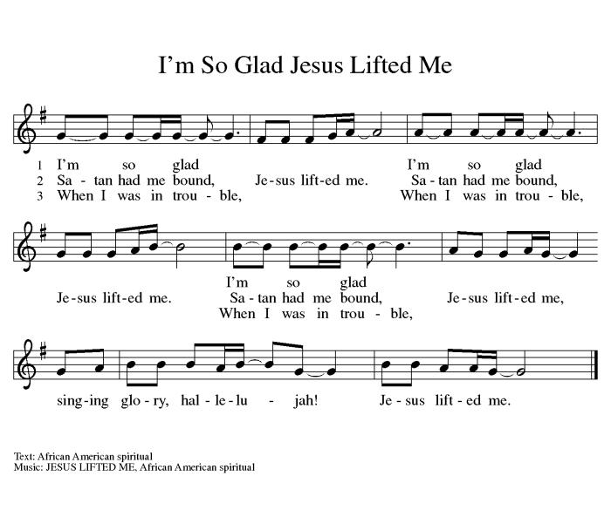**CLOSING HYMN I’m So Glad, Jesus Lifted Me ELW 860**

**DISMISSAL**

Go in peace. You are the body of Christ.

**Thanks be to God.**

|  |  |  |
| --- | --- | --- |
| **Coming up at GSLC** | | |
| Sunday, June 30 | 9:00 am | Outdoor Worship Service   * Sixth Sunday after Pentecost * Mark 5:21-43; Christ healing a woman and Jairus’ daughter |
| Tuesday, July 2 | 7:00 pm | AA Meeting |
| Wednesday, July 3 | 9:00 am | Executive Committee Meeting |
| Thursday, July 4 |  | Church Office Closed for 4th of July |
| Sunday, July 7 | 9:00 am | Outdoor Worship Service   * Seventh Sunday after Pentecost * Mark 6:1-13; Sending of the Twelve to preach and heal |

|  |  |  |  |  |  |  |
| --- | --- | --- | --- | --- | --- | --- |
| ***Upcoming Worship Assistants*** | | | | | | |
|  | **Usher** | **Lector** | **Communion** | **Offering Counters** | | **Deep Clean** |
| June 30 | Julie Will | Andrea Hovick | Dave & Sue Schraeder | Pam Mundt | May Hill |  |
| July 7 | Jason & Tessa Campbell | Tammy Neumann | Matt & Margo Berrier | Dan Mundt | Jon Hill | July:  Dave & Sue Schraeder  Andrea Hovick  Linda Schutte |
| July 14 | Jon & May Hill | Linda Schrieber | Bob & Laurel Peterson | Nancy Leonard | Breanna Butler |
| July 21 | Samantha Moore | Laurel Peterson | Tammy Neumann  Sarah Kopitzke | Robin Beeman | Davis Schneider |

SOS has provided their list of needs for this month, which includes:

Kidney Beans, Baked Beans, Sandwich Bags, Chicken Noodle Soup, Dish Soap, Oatmeal, Jelly, Gravy,Pudding, Broth, All Purpose Cleaner, Shampoo, Conditioner, Pancake Mix, Baking Items, Paper Towels, Dried Soup. **Urgently need: Broth, Canned Fruit, Dried Soup, Jello/Pudding, Mac N Cheese, Spaghettios**

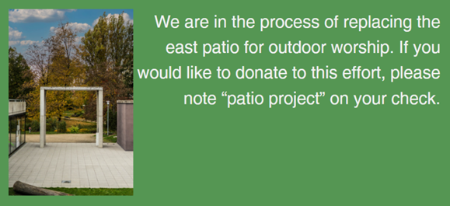  
**Pub Theology is returning for the summer!  
2nd Wednesday in June, 2nd & 4th Wednesday in July and August  
Blue Heron BrewPub 6:00 pm  
Led by Pastor Katie**  
**What is Pub Theology?** People have been gathering in pubs and public spaces for ages talking about life, philosophy, faith, and deep questions of meaning. Increasingly, people all over are rediscovering the pub as a safe, open space where they can explore and express their own doubts and questions, learn from others, and engage people of varying religious traditions. In our increasingly fractured society, these spaces are not only welcome but needed.  
***Bring your questions and curiosity, and pull up a chair.***