**Good Shepherd Lutheran Church**

|  |  |
| --- | --- |
| Pastor: Rev. Katie Anderson | Music Director: Rev. Lois Swanson |
| Pastor’s Cell: (715) 245-1943 | Office Phone: (715) 387-2731 |
| Pastor Email: gslcwi.pastor@gmail.com | Office Email: gslcwi.office@gmail.com |
| Website: GoodShepherdMarshfield.org |  |

**2nd Sunday after Pentecost**

**June 2, 2024, 9:00 am**

***Introduction to the day…***

Deuteronomy makes clear that sabbath-keeping is meant for the welfare of all. God delivered the Israelites out of slavery, so they should observe this freedom with a day of rest. No one should work seven days a week; even slaves and foreigners should be able to rest. Yet human beings can turn even the most liberating religious practice into a life-destroying rule. Jesus does not reject sabbath-keeping, but defends its original life-enhancing meaning. Our worship and our religious way of life are to lead to restoration: the hungry being fed and the sick being healed.

**ANNOUNCEMENTS**

**GATHERING**

**GATHERING HYMN Listen, God is Calling ELW 513**

### **CONFESSION AND FORGIVENESS**

Blessed be the holy Trinity, ☩ one God,

the God of manna,

the God of miracles,

the God of mercy.

**Amen.**

Drawn to Christ and seeking God’s abundance,

let us confess our sin.

*Silence is kept for reflection.*

God, our provider,

**help us.**

**It is hard to believe there is enough to share.**

**We question your ways when they differ from the ways** **of the world in which we live.**

**We turn to our own understanding** **rather than trusting in you.**

**We take offense at your teachings and your ways.**

**Turn us again to you.**

**Where else can we turn?**

**Share with us the words of eternal life** **and feed us for life in the world.**

**Amen.**

Beloved people of God:

in Jesus, the manna from heaven,

you are fed and nourished.

By Jesus, the worker of miracles,

there is always more than enough.

Through Jesus, ☩ the bread of life,

you are shown God’s mercy:

you are forgiven and loved into abundant life.

**Amen.**

**PRAYER OF THE DAY**

**Almighty and ever-living God, throughout time you free the oppressed, heal the sick, and make whole all that you have made. Look with compassion on the world wounded by sin, and by your power restore us to wholeness of life, through Jesus Christ, our Savior and Lord.**

**Amen.**

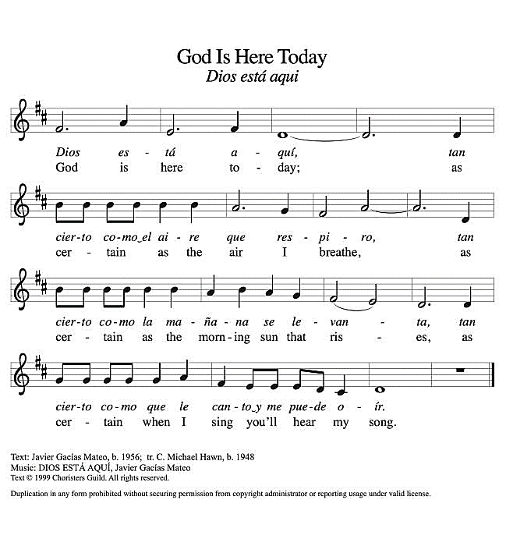**CHILDREN’S MUSIC God is Here Today ACS 993**

**CHILDREN’S MESSAGE**

**SCRIPTURE READINGS**

**FIRST READING: Deuteronomy 5:12-15**

12Observe the sabbath day and keep it holy, as the Lord your God commanded you. 13Six days you shall labor and do all your work. 14But the seventh day is a sabbath to the Lord your God; you shall not do any work—you, or your son or your daughter, or your male or female slave, or your ox or your donkey, or any of your livestock, or the resident alien in your towns, so that your male and female slave may rest as well as you. 15Remember that you were a slave in the land of Egypt, and the Lord your God brought you out from there with a mighty hand and an outstretched arm; therefore the Lord your God commanded you to keep the sabbath day.

Word of God, word of life.

**Thanks be to God.**

**PSALM: Psalm 81:1-10**

1Sing with joy to God our strength and raise a loud shout to the God of Jacob.  
 2**Raise a song and sound the timbrel,**  
  **the merry harp, and the lyre.**  
 3Blow the ram’s horn at the new moon,  
  and at the full moon, the day of our feast;  
 4**for this is a statute for Israel,**  
  **a law of the God of Jacob.**  
 5God laid it as a solemn charge upon Joseph, going out over the land of Egypt,  
  where I heard a voice I did not know:  
 6**“I eased your shoulder from the burden;**  
  **your hands were set free from the gravedigger’s basket.**  
 7You called on me in trouble, and I delivered you;  
  I answered you from the secret place of thunder and tested you at the waters of Meribah.  
 8**Hear, O my people, and I will admonish you:**  
  **O Israel, if you would but listen to me!**  
 9There shall be no strange god among you;  
  you shall not worship a foreign god.  
 10**I am the Lord your God, who brought you out of the land of Egypt.**  
  **Open your mouth wide, and I will fill it.**

**SECOND READING: 2 Corinthians 4:5-12**

5We do not proclaim ourselves; we proclaim Jesus Christ as Lord and ourselves as your slaves for Jesus’ sake. 6For it is the God who said, “Let light shine out of darkness,” who has shone in our hearts to give the light of the knowledge of the glory of God in the face of Jesus Christ.  
 7But we have this treasure in clay jars, so that it may be made clear that this extraordinary power belongs to God and does not come from us. 8We are afflicted in every way, but not crushed; perplexed, but not driven to despair; 9persecuted, but not forsaken; struck down, but not destroyed; 10always carrying in the body the death of Jesus, so that the life of Jesus may also be made visible in our bodies. 11For while we live, we are always being given up to death for Jesus’ sake, so that the life of Jesus may be made visible in our mortal flesh. 12So death is at work in us, but life in you.

Word of God, word of life.

**Thanks be to God.**

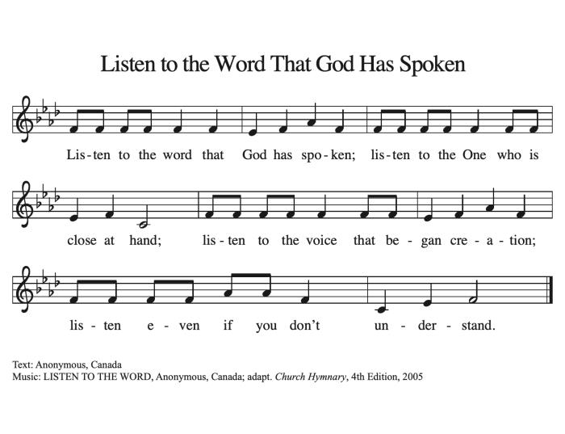**GOSPEL ACCLAMATION ACS 974**

### **GOSPEL: Mark 2:23-3:6**

23One sabbath [Jesus] was going through the grainfields; and as they made their way his disciples began to pluck heads of grain. 24The Pharisees said to him, “Look, why are they doing what is not lawful on the sabbath?” 25And he said to them, “Have you never read what David did when he and his companions were hungry and in need of food? 26He entered the house of God, when Abiathar was high priest, and ate the bread of the Presence, which it is not lawful for any but the priests to eat, and he gave some to his companions.” 27Then he said to them, “The sabbath was made for humankind, and not humankind for the sabbath; 28so the Son of Man is lord even of the sabbath.”  
 3:1Again he entered the synagogue, and a man was there who had a withered hand. 2They watched him to see whether he would cure him on the sabbath, so that they might accuse him. 3And he said to the man who had the withered hand, “Come forward.” 4Then he said to them, “Is it lawful to do good or to do harm on the sabbath, to save life or to kill?” But they were silent. 5He looked around at them with anger; he was grieved at their hardness of heart and said to the man, “Stretch out your hand.” He stretched it out, and his hand was restored. 6The Pharisees went out and immediately conspired with the Herodians against him, how to destroy him.

The gospel of the Lord.

**Praise to you, O Christ.**

**SERMON**

**HYMN OF THE DAY** **Christ, Be Our Light ELW 715**

**APOSTLES’ CREED**

**I believe in God, the Father almighty,**

**creator of heaven and earth.**

**I believe in Jesus Christ, God's only Son, our Lord,**

**who was conceived by the power of the Holy Spirit,**

**born of the Virgin Mary,**

**suffered under Pontius Pilate,**

**was crucified, died, and was buried;**

**he descended to the dead.**

**On the third day he rose again;**

**he ascended into heaven,**

**he is seated at the right hand of the Father,**

**and he will come to judge the living and the dead.**

**I believe in the Holy Spirit,**

**the holy catholic Church,**

**the communion of saints,**

**the forgiveness of sins,**

**the resurrection of the body,**

**and the life everlasting. Amen**

**PRAYERS OF INTERCESSION**

…Merciful God.

**Receive our prayer**

Receive our prayers, O God, and come quickly to our aid, through the power of the Spirit and the love of Jesus Christ.

**Amen.**

**PEACE**

The peace of Christ be with you always.  
**And also with you.**

**HOLY COMMUNION**

**OFFERING***In addition to our normal offering, a* ***Special Benevolence in June*** *(collected in a special envelope) will go to* ***MAPS (Marshfield Area Pet Shelter).***

**OFFERING SONG Thy Holy Wings ELW 613**

**OFFERTORY PRAYER**

Jesus, Bread of life,

you have set this table with your very self,

and called us to the feast of plenty.

Gather what has been sown among us,

and strengthen us in this meal.

Make us to be what we receive here,

your body for the life of the world.

**Amen.**

**GREAT THANKSGIVING**

The Lord be with you.

**And also with you.**

Lift up your hearts.

**We lift them to the Lord.**

Let us give our thanks to the Lord our God.

**It is right to give our thanks and praise.**

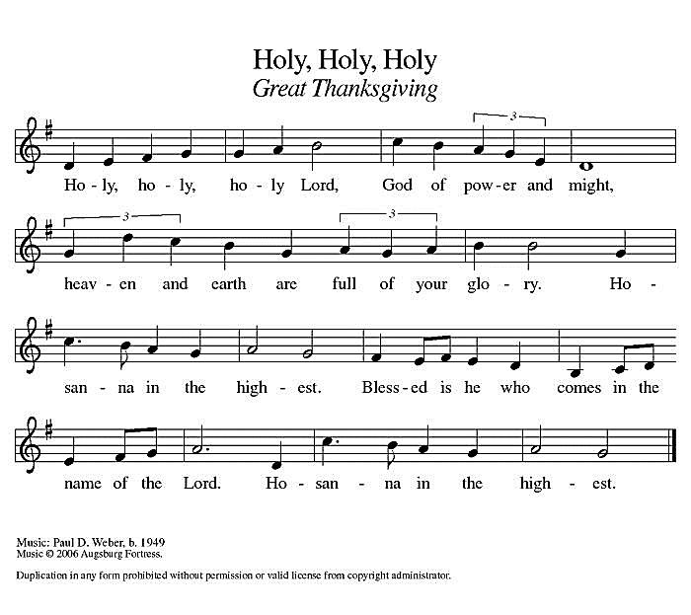**Holy, Holy, Holy ELW 189**

**THANKSGIVING AT THE TABLE**

God of our weary years, God of our silent tears,

you have brought us this far along the way.

In times of bitterness you did not abandon us,

but guided us into the path of love and light.

In every age you sent prophets

to make known your loving will for all humanity.

The cry of the poor has become your own cry;

our hunger and thirst for justice is your own desire.

In the fullness of time, you sent your chosen servant

to preach good news to the afflicted,

to break bread with the outcast and despised,

and to ransom those in bondage to prejudice and sin.

In the night in which he was betrayed,

our Lord Jesus took bread, and gave thanks;

broke it, and gave it to his disciples, saying:

Take and eat; this is my body, given for you.

Do this for the remembrance of me.

Again, after supper, he took the cup, gave thanks,

and gave it for all to drink, saying:

This cup is the new covenant in my blood,

shed for you and all people for the forgiveness of sin.

Do this for the remembrance of me.

For as often as we eat of this bread and drink from this cup

we proclaim the Lord’s death until he comes.

**Christ has died.**

**Christ is risen.**

**Christ will come again.**

Remembering, therefore, his death and resurrection,

we await the day when Jesus shall return

to free all the earth from the bonds of slavery and death.

Come, Lord Jesus! And let the church say, Amen.

**Amen.**

Send your Holy Spirit, our advocate,

to fill the hearts of all who share this bread and cup

with courage and wisdom to pursue love and justice in all the world.

Come, Spirit of freedom! And let the church say, Amen.

**Amen.**

Join our prayers and praise with your prophets and martyrs of every age,

that, rejoicing in the hope of the resurrection,

we might live in the freedom and hope of your Son.

Through him, with him, in him, in the unity of the Holy Spirit,

all glory and honor is yours, almighty Father, now and forever.

**Amen.**

**THE LORD’S PRAYER**

**Our Father, who art in heaven,**

**hallowed be thy name,**

**thy kingdom come,**

**thy will be done,**

**on earth as it is in heaven.**

**Give us this day our daily bread;**

**and forgive us our trespasses,**

**as we forgive those**

**who trespass against us;**

**and lead us not into temptation,**

**but deliver us from evil.**

**For thine is the kingdom,**

**and the power, and the glory,**

**forever and ever. Amen.**

**INVITATION TO COMMUNION** *- Certified gluten-free crackers are in the bowl on the communion plate.*

Christ has set the table with more than enough for all.

Come!

**HOLY COMMUNION**

**PRAYER AFTER COMMUNION**

Jesus, Bread of life,

we have received from your table more than we could ever ask.

As you have nourished us in this meal,

now strengthen us to love the world with your own life.

In your name we pray.

**Amen.**

**SENDING**

**CLOSING HYMN Bring Forth the Kingdom**

**BLESSING**

The blessing of God,

who provides for us, feeds us, and journeys with us,

☩ be upon you now and forever.

**Amen.**

**DISMISSAL**

Go in peace. You are the body of Christ.

|  |  |  |  |  |  |  |
| --- | --- | --- | --- | --- | --- | --- |
| ***Upcoming Worship Assistants*** | | | | | | |
|  | **Usher** | **Lector** | **Communion** | **Offering Counters** | | **Deep Clean** |
| June 2 | Dave & Kami Weis | Andrea Hovick | Bruce & Nancy Tibbett | Dan Mundt | Jon Hill | June:  Dave & Shelly Schneider  Bruce & Nancy Tibbett |
| June 9 | Christopher & Trina Ignatowski | Julie Will | Ron Rothfusz  Andrea Hovick | Nancy Leonard | Breanna Butler |
| June 16 | Ben & Sue Lee | Leslie Mader | John Wagner  Nancy Leonard | Robin Beeman | David Schneider |
| June 23 | Bruce & Nancy Tibbett | Kris Tarter | Dave & Shelly Schneider | Heidi Binder | Kami Weis |

**Thanks be to God.**

|  |  |  |
| --- | --- | --- |
| **Coming up at GSLC** | | |
| Sunday, June 2 | 9:00 am | Outdoor Worship Service   * Second Sunday after Pentecost * Mark 2:23-3:6; Doing the work of God on the sabbath |
| Tuesday, June 4 | 7:00 pm | AA Meeting |
| Wednesday, June 5 | 9:00 am | Executive Committee Meeting |
| Thursday, June 6 | 11am-2pm | Purple Angels Lunch and Fellowship |
| Sunday, June 9 | 9:00 am | Outdoor Worship Service   * Third Sunday after Pentecost * Mark 3:20-35; Doing the work of God as brothers and sisters of Christ |

SOS has provided their list of needs for this month, which includes:

Kidney Beans, Baked Beans, Sandwich Bags, Chicken Noodle Soup, Dish Soap, Oatmeal, Jelly, Gravy,Pudding, Broth, All Purpose Cleaner, Shampoo, Conditioner, Pancake Mix, Baking Items, Paper Towels, Dried Soup. **Urgently need: Broth, Canned Fruit, Dried Soup, Jello/Pudding, Mac N Cheese, Spaghettios**

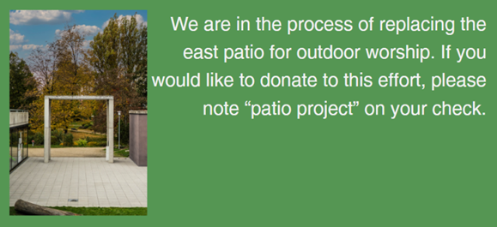

**Pub Theology is returning for the summer!  
2nd Wednesday in June, 2nd & 4th Wednesday in July and August  
Blue Heron BrewPub 6:00 pm  
Led by Pastor Katie**  
**What is Pub Theology?** People have been gathering in pubs and public spaces for ages talking about life, philosophy, faith, and deep questions of meaning. Increasingly, people all over are rediscovering the pub as a safe, open space where they can explore and express their own doubts and questions, learn from others, and engage people of varying religious traditions. In our increasingly fractured society, these spaces are not only welcome but needed.  
***Bring your questions and curiosity, and pull up a chair.***