Good Shepherd Lutheran Church
Pastor: Rev. Katie Anderson | Music Director: Rev. Lois Swanson
Pastor’s Cell: (715) 245-1943 | Office Phone: (715) 387-2731
Pastor Email: gslcwi.pastor@gmail.com | Office Email: gslcwi.office@gmail.com
Website: GoodShepherdMarshfield.org | www.facebook.com/gslcwi
Confirmation/Sixth Sunday of Easter
May 5, 2024, 9:00 am
Introduction to the day…
This Sunday’s image of the life the risen Christ shares with us is the image of friendship. We are called to serve others as Jesus came to serve; but for John’s gospel, the image of servanthood is too hierarchical, too distant, to capture the essence of life with Christ. Friendship captures the love, the joy, the deep mutuality of the relationship into which Christ invites us. The Greeks believed that true friends are willing to die for each other. This is the mutual love of Christian community commanded by Christ and enabled by the Spirit.
ANNOUNCEMENTS
GATHERING
GATHERING HYMN Awake, O Sleeper, Rise from Death ELW 452
THANKSGIVING FOR BAPTISM
Blessed be the holy Trinity,
☩ one God,
the fountain of living water,
the rock who gave us birth,
our light and our salvation.
Amen.
Joined to Christ in the waters of baptism, we are clothed with God’s mercy and forgiveness. Let us give thanks for the gift of baptism.
We give you thanks, O God, for in the beginning you created us in your image and placed us in a well-watered garden. In the desert, you promised pools of water for the parched, and you gave us water from the rock. When we did not know the way, you sent the Good Shepherd to lead us to still waters. At the cross, you washed us from Jesus’ wounded side, and on this day, you shower us again with the water of life.
We praise you for your salvation through water, for the water in this font, and for all water everywhere. Bathe us in your forgiveness, grace, and love. Satisfy all who thirst, and give us the life only you can give.
To you be given honor and praise through Jesus Christ, our living water, in the unity of the Holy Spirit, now and forever.
Amen.
PRAYER OF THE DAY
O God, you have prepared for those who love you joys beyond understanding. Pour into our hearts such love for you that, loving you above all things, we may obtain your promises, which exceed all we can desire; through Jesus Christ, your Son and our Lord, who lives and reigns with you and the Holy Spirit, one God, now and forever.
Amen.
CHILDREN’S MUSIC Don’t Be Afraid ACS 1027
CHILDREN’S MESSAGE

SCRIPTURE READINGS
FIRST READING: Acts 10:44-48
⁴⁴While Peter was still speaking, the Holy Spirit fell upon all who heard the word. ⁴⁵The circumcised believers who had come with Peter were astounded that the gift of the Holy Spirit had been poured out even on the Gentiles, ⁴⁶for they heard them speaking in tongues and extolling God. Then Peter said, ⁴⁷“Can anyone withhold the water for baptizing these people who have received the Holy Spirit just as we have?” ⁴⁸So he ordered them to be baptized in the name of Jesus Christ. Then they invited him to stay for several days.
Word of God, word of life.
Thanks be to God.
PSALM: Psalm 98
¹Sing a new song to the Lord, who has done marvelous things,
whose right hand and holy arm have | won the victory.
²O Lord, you have made known your victory,
you have revealed your righteousness in the sight of the nations.
³You remember your steadfast love and faithfulness to the house of Israel;
all the ends of the earth have seen the victory of our God.
⁴Shout with joy to the Lord, all you lands;
lift up your voice, rejoice, and sing.
⁵Sing to the Lord with the harp,
with the harp and the voice of song.
⁶With trumpets and the sound of the horn
shout with joy before the king, the Lord.
⁷Let the sea roar, and all that fills it,
the world and those who dwell therein.
⁸Let the rivers clap their hands,
and let the hills ring out with joy before the Lord, who comes to judge the earth.
⁹The Lord will judge the world with righteousness
and the peoples with equity.
SECOND READING: 1 John 5:1-6
¹Everyone who believes that Jesus is the Christ has been born of God, and everyone who loves the parent loves the child. ²By this we know that we love the children of God, when we love God and obey his commandments. ³For the love of God is this, that we obey his commandments. And his commandments are not burdensome, ⁴for whatever is born of God conquers the world. And this is the victory that conquers the world, our faith. ⁵Who is it that conquers the world but the one who believes that Jesus is the Son of God?
⁶This is the one who came by water and blood, Jesus Christ, not with the water only but with the water and the blood. And the Spirit is the one that testifies, for the Spirit is the truth.
Word of God, word of life.
Thanks be to God.
GOSPEL ACCLAMATION ACS pg. 14
GOSPEL: John 15:9-17
[Jesus said:] ⁹“As the Father has loved me, so I have loved you; abide in my love. ¹⁰If you keep my commandments, you will abide in my love, just as I have kept my Father’s commandments and abide in his love. ¹¹I have said these things to you so that my joy may be in you, and that your joy may be complete.
¹²“This is my commandment, that you love one another as I have loved you. ¹³No one has greater love than this, to lay down one’s life for one’s friends. ¹⁴You are my friends if you do what I command you. ¹⁵I do not call you servants any longer, because the servant does not know what the master is doing; but I have called you friends, because I have made known to you everything that I have heard from my Father. ¹⁶You did not choose me but I chose you. And I appointed you to go and bear fruit, fruit that will last, so that the Father will give you whatever you ask him in my name. ¹⁷I am giving you these commands so that you may love one another.”
The gospel of the Lord.
Praise to you, O Christ.
SERMON
HYMN OF THE DAY God, We Gather as your People ACS 1038
AFFIRMATION OF BAPTISM & CONFIRMATION
Confirmation Class of 2024
Sylvia Lee, Luke 1:45, And blessed is she who believed that there would be a fulfillment of what was spoken to her by the Lord.
Connor Stefanski, John 3:16, For God so loved the world that he gave his only Son, so that everyone who believes in him may not perish but may have eternal life.
Piper Weis, Psalm 16:8, I keep the LORD always before me; because he is at my right hand, I shall not be moved.
(The Confirmation youth gather at the Baptismal font)
Dear friends, we give thanks for the gift of baptism and for these confirmands, one with us in the body of Christ, who are making public affirmation of their baptism.
Let us pray.
Merciful God, we thank you for Sylvia, Connor, and Piper,
whom you have made your own by water and the Word in baptism.
You have called them to yourself,
enlightened them with the gifts of your Spirit,
and nourished them in the community of faith.
Uphold your servants in the gifts and promises of baptism,
and unite the hearts of all whom you have brought to new birth.
We ask this in the name of Christ.
Amen.
PROFESSION OF FAITH
I ask you to profess your faith in Christ Jesus, reject sin,
and confess the faith of the church.
Do you renounce the devil and all the forces that defy God?
Confirmands: I renounce them.
Do you renounce the powers of this world that rebel against God?
Confirmands: I renounce them.
Do you renounce the ways of sin that draw you from God?
Confirmands: I renounce them.
People of God, I ask you to profess together the faith we share.
Do you believe in God the Father?
I believe in God, the Father almighty,
creator of heaven and earth.
Do you believe in Jesus Christ, the Son of God?
I believe in Jesus Christ, God’s only Son, our Lord,
who was conceived by the Holy Spirit,
born of the virgin Mary,
suffered under Pontius Pilate,
was crucified, died, and was buried;
he descended to the dead.*
On the third day he rose again;
he ascended into heaven,
he is seated at the right hand of the Father,
and he will come to judge the living and the dead.

Do you believe in God the Holy Spirit?
I believe in the Holy Spirit,
the holy catholic church,
the communion of saints,
the forgiveness of sins,
the resurrection of the body,
and the life everlasting.
AFFIRMATION
You have made public profession of your faith. Do you intend to continue in the
covenant God made with you in holy baptism:
to live among God’s faithful people,
to hear the word of God and share in the Lord’s supper,
to proclaim the good news of God in Christ through word and deed,
to serve all people, following the example of Jesus,
and to strive for justice and peace in all the earth?
Confirmands: I do, and I ask God to help and guide me.
People of God, do you promise to support Sylvia, Connor, and Piper, and pray for them in their life in Christ?
We do, and we ask God to help and guide us.
Let us pray.
We give you thanks, O God, that through water and the Holy Spirit, you give us new birth, cleanse us from sin, and raise us to eternal life.
(Confirmation youth, parents and sponsors gather at the altar for the blessing)
Father in heaven, for Jesus’ sake, stir up in _____ the gift of your Holy Spirit; confirm his/her faith, guide his/her life, empower him/her in his/her serving, give him/her patience in suffering, and bring him/her to everlasting life.
Amen.
Let us rejoice with our siblings in Christ.
We rejoice with you in the life of baptism.
Together we will give thanks and praise to God
and proclaim the good news to all the world.
PRAYERS OF INTERCESSION
…God of grace.
Hear our prayer.
Into your hands, most merciful God, we commend all for whom we pray, trusting in your abiding love; through Jesus Christ, our resurrected and living Lord.
Amen.
PEACE
The peace of Christ be with you always.
And also with you.
HOLY COMMUNION
OFFERING In addition to our normal offering, a Special Benevolence in May (collected in a special envelope) will go to the Oranda Center.
OFFERING SONG I Come With Joy ELW 482
OFFERTORY PRAYER
Risen One,
you call us to believe and bear fruit.
May the gifts that we offer here be signs of your abiding love.
Form us to be your witnesses in the world,
through Jesus Christ, our true vine.
Amen.
GREAT THANKSGIVING
The Lord be with you.
And also with you.
Lift up your hearts.
We lift them to the Lord.
Let us give our thanks to the Lord our God.
It is right to give our thanks and praise.
HOLY, HOLY, HOLY ACS pg. 20
THANKSGIVING AT THE TABLE
Blessed are you, O God of the universe.
Your mercy is everlasting
and your faithfulness endures from age to age.
Praise to you for creating the heavens and the earth.
Praise to you for saving the earth from the waters of the flood.
Praise to you for bringing the Israelites safely through the sea.
Praise to you for leading your people through the wilderness
to the land of milk and honey.
Praise to you for the words and deeds of Jesus, your anointed one.
Praise to you for the death and resurrection of Christ.
Praise to you for your Spirit poured out on all nations.
In the night in which he was betrayed,
our Lord Jesus took bread, and gave thanks;
broke it, and gave it to his disciples, saying:
Take and eat; this is my body, given for you.
Do this for the remembrance of me.
Again, after supper, he took the cup, gave thanks,
and gave it for all to drink, saying:
This cup is the new covenant in my blood,
shed for you and for all people for the forgiveness of sin.
Do this for the remembrance of me.

With this bread and cup
we remember our Lord’s passover from death to life
as we proclaim the mystery of faith:
Christ has died.
Christ is risen.
Christ will come again.
O God of resurrection and new life:
Pour out your Holy Spirit on us
and on these gifts of bread and wine.
Bless this feast.
Grace our table with your presence.
Come, Holy Spirit.
Reveal yourself to us in the breaking of the bread.
Raise us up as the body of Christ for the world.
Breathe new life into us.
Send us forth,
burning with justice, peace, and love.
Come, Holy Spirit.
With your holy ones of all times and places,
with the earth and all its creatures,
with sun and moon and stars,
we praise you, O God,
blessed and holy Trinity,
now and forever.
Amen.

THE LORD’S PRAYER
Our Father, who art in heaven,
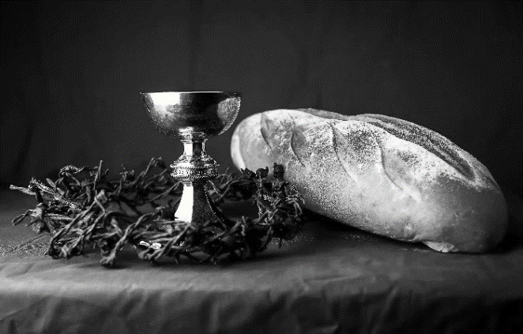
hallowed be thy name,
thy kingdom come,
thy will be done,
on earth as it is in heaven.
Give us this day our daily bread;
and forgive us our trespasses,
as we forgive those
who trespass against us;
and lead us not into temptation,
but deliver us from evil.
For thine is the kingdom,
and the power, and the glory,
forever and ever. Amen.

INVITATION TO COMMUNION - Certified gluten-free crackers are in the bowl on the communion plate.
The risen Christ is made known to us
in the breaking of the bread.
Come and eat at God’s table.
HOLY COMMUNION
PRAYER AFTER COMMUNION
Shepherding God,
you have prepared a table before us
and nourished us with your love.
Send us forth from this banquet
to proclaim your goodness
and share the abundant mercy of Jesus,
our redeemer and friend.
Amen.
SENDING
BLESSING
Alleluia! Christ is risen!
Christ is risen indeed! Alleluia!
The God of resurrection power,
the Christ of unending joy,
and the Spirit of Easter hope
☩ bless you now and always.
Amen.
CLOSING HYMN Christ is Alive! Let Christians Sing ELW 389
DISMISSAL
Alleluia! Go in peace. Rejoice and be glad.
Upcoming Worship Assistants
 | Usher | Lector | Communion | Offering Counters |  | Deep Clean
May 5  Confirmation | Dave & Shelly Schneider | Nancy Tibbett | Bob & Laurel Peterson | Nancy Leonard | Breanna Butler | May:  John & Jane Wagner  Laurel Peterson
May 12 | Dave & Sue Schraeder | Jon Hill | Matt & Margo Berrier | Robin Beeman | David Schneider
May 19 | Keith & Michelle Stuttgen | Christine Tipping | Dan & Pam Mundt | Heidi Binder | Kami Weis
May 26 | John & Jane Wagner | Richard Kopitzke | Bruce & Nancy Tibbett | Pam Mundt | May Hill
Thanks be to God. Alleluia!
Coming up at GSLC
Sunday, May 5  (Confirmation) | 9:00 am | Worship Service – Sunday School  - Sixth Sunday of Easter  - Confirmation Sunday  - John 15:9-17; Christ the friend and lover
Tuesday, May 7 | 6:30 pm | Executive Committee Meeting
 | 7:00 pm | AA Meeting
Wednesday, May 8 | 12:00 pm | Bible Study (discuss Season 3 Episode 6 of “The Chosen”)
Sunday, May 12 | 9:00 am | Worship Service  - Seventh Sunday of Easter  - John 17:6-19; Christ’s prayer for his disciples

SOS has provided their list of needs for this month, which includes:
Kidney Beans, Baked Beans, Sandwich Bags, Chicken Noodle Soup, Dish Soap, Oatmeal, Jelly, Gravy, Pudding, Broth, All Purpose Cleaner, Shampoo, Conditioner, Pancake Mix, Baking Items, Paper Towels, Dried Soup. Urgently need: Broth, Canned Fruit, Applesauce, Canned Meat, Chili/Stew, Canned Pasta Meals, Rice Mixes, Kidney Beans.

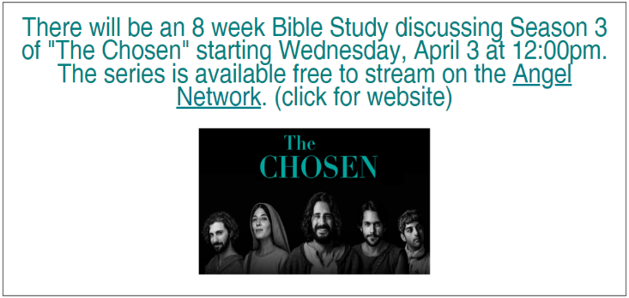
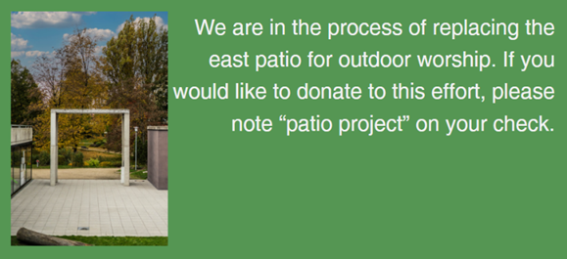
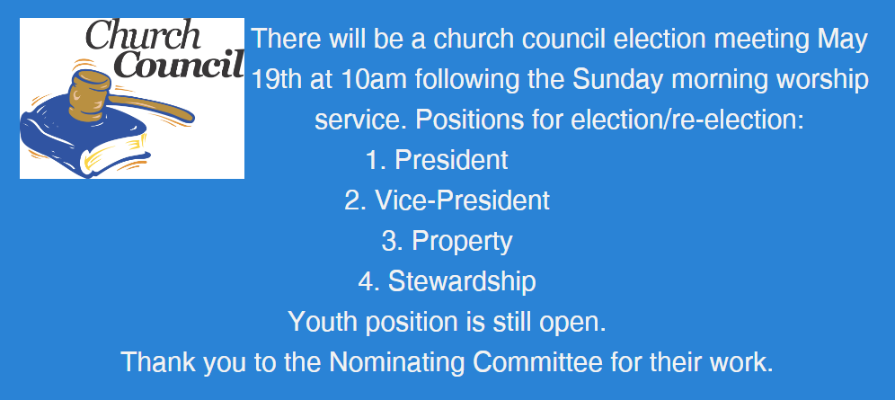
A note from the Good Shepherd Green Team. Spring time is the time many homeowners start thinking about lawn care. Challenge yourself to do some research and re-think your lawn care routine. We have been programed to feel that our lawns need to be weed free, lush and thick to be proper homeowners and good neighbors. Lawn herbicide control and even fertilizer can seep into the ground water and over time can accumulate in the environment. Early spring "weeds" like dandelions, clover and violets provide necessary early food for a variety of bees. Creating a lawn with no weeds also creates a monoculture, which over time depletes the nitrogen in the soil and therefore creates the need for fertilizing. Here are some resources to check out. The UW extension has information on having an organic or reduced-risk lawn: https://hort.extension.wisc.edu/articles/organic-and-reduced-risk-lawn-care-2/. An article about monoculture and the need for biodiversity: https://www.savingbees.org/en/2023/03/21/why-monocultures-are-not-good-for-the-environnement/ If anyone is interested in more organic lawn care, you can contact the Green Team for info about a local company.
Help the Good Shepherd Green Team celebrate Little Free Library Week May 12-18. We will have a book drive for our very own Little Free Library on Sunday May 12 and Sunday May 19. Please bring any books in good condition that you no longer have a need for, especially children's books. The box will be located in the church narthex. Download the Little Free Library app at https://littlefreelibrary.org/app/ and visit all the libraries! Have fun celebrating the week and books by playing Little Free Library BINGO. Pick up a copy near the book drive box.

Our new Facebook page (our old one got disabled by Facebook and we can’t get it back)
Visit the address below or scan QR code to check out our facebook. https://www.facebook.com/profile.php?id=61558657105180

