**Good Shepherd Lutheran Church**

|  |  |
| --- | --- |
| Pastor: Rev. Katie Anderson | Music Director: Rev. Lois Swanson |
| Pastor’s Cell: (715) 245-1943 | Office Phone: (715) 387-2731 |
| Pastor Email: gslcwi.pastor@gmail.com | Office Email: gslcwi.office@gmail.com |
| Website: GoodShepherdMarshfield.org |  |

**Day of Pentecost**

**May 19, 2024, 9:00 am**

***Introduction to the day…***

Fifty days after Easter, we celebrate the outpouring of the Holy Spirit on Pentecost. Crossing all boundaries that would separate us, the Spirit brings the wideness of God’s mercy to places we least expect it—to a crowd of strangers of different lands and tongues, to dry bones, to our weak hearts. Jesus promises his disciples that they will be accompanied by the Holy Spirit, and that this Spirit reveals the truth. We celebrate that we too have been visited with this same Spirit. Guided by the truth, we join together in worship, and then disperse to share the fullness of Christ’s love with the world.

**ANNOUNCEMENTS**

**GATHERING**

**GATHERING HYMN O Living Breath of God ELW 407**

**THANKSGIVING FOR BAPTISM**

Blessed be the holy Trinity,

☩ one God,

the fountain of living water,

the rock who gave us birth,

our light and our salvation.

**Amen.**

Joined to Christ in the waters of baptism, we are clothed with God’s mercy and forgiveness. Let us give thanks for the gift of baptism.

We give you thanks, O God, for in the beginning you created us in your image and placed us in a well-watered garden. In the desert, you promised pools of water for the parched, and you gave us water from the rock. When we did not know the way, you sent the Good Shepherd to lead us to still waters. At the cross, you washed us from Jesus’ wounded side, and on this day, you shower us again with the water of life.

We praise you for your salvation through water, for the water in this font, and for all water everywhere. Bathe us in your forgiveness, grace, and love. Satisfy all who thirst, and give us the life only you can give.

To you be given honor and praise through Jesus Christ, our living water, in the unity of the Holy Spirit, now and forever.

**Amen.**

**PRAYER OF THE DAY**

**Mighty God, you breathe life into our bones, and your Spirit brings truth to the world. Send us this Spirit, transform us by your truth, and give us language to proclaim your gospel, through Jesus Christ, our Savior and Lord, who lives and reigns with you and the Holy Spirit, one God, now and forever.**

**Amen.**

**CHILDREN’S MUSIC Don’t Be Afraid ACS 1027**

**CHILDREN’S MESSAGE**

**SCRIPTURE READINGS**

**FIRST READING: Acts 2:1-21**

1When the day of Pentecost had come, [the apostles] were all together in one place. 2And suddenly from heaven there came a sound like the rush of a violent wind, and it filled the entire house where they were sitting. 3Divided tongues, as of fire, appeared among them, and a tongue rested on each of them. 4All of them were filled with the Holy Spirit and began to speak in other languages, as the Spirit gave them ability.  
 5Now there were devout Jews from every nation under heaven living in Jerusalem. 6And at this sound the crowd gathered and was bewildered, because each one heard them speaking in the native language of each. 7Amazed and astonished, they asked, “Are not all these who are speaking Galileans? 8And how is it that we hear, each of us, in our own native language? 9Parthians, Medes, Elamites, and residents of Mesopotamia, Judea and Cappadocia, Pontus and Asia, 10Phrygia and Pamphylia, Egypt and the parts of Libya belonging to Cyrene, and visitors from Rome, both Jews and proselytes, 11Cretans and Arabs—in our own languages we hear them speaking about God’s deeds of power.” 12All were amazed and perplexed, saying to one another, “What does this mean?” 13But others sneered and said, “They are filled with new wine.”  
 14But Peter, standing with the eleven, raised his voice and addressed them, “Men of Judea and all who live in Jerusalem, let this be known to you, and listen to what I say. 15Indeed, these are not drunk, as you suppose, for it is only nine o’clock in the morning. 16No, this is what was spoken through the prophet Joel:  
 17‘In the last days it will be, God declares,  
 that I will pour out my Spirit upon all flesh,  
  and your sons and your daughters shall prophesy,  
 and your young men shall see visions,  
  and your old men shall dream dreams.  
 18Even upon my slaves, both men and women,  
  in those days I will pour out my Spirit;  
   and they shall prophesy.  
 19And I will show portents in the heaven above  
  and signs on the earth below,  
   blood, and fire, and smoky mist.  
 20The sun shall be turned to darkness  
  and the moon to blood,  
   before the coming of the Lord’s great and glorious day.  
 21Then everyone who calls on the name of the Lord shall be saved.’ ”

Word of God, word of life.

**Thanks be to God.**

**PSALM: Psalm 104:24-34,35b**

24How manifold are your works, O Lord!  
  In wisdom you have made them all; the earth is full of your creatures.  
 25**Yonder is the sea, great and wide, with its swarms too many to number,**  
  **living things both small and great.**  
 26There go the ships to and fro,  
  and Leviathan, which you made for the sport of it.  
 27**All of them look to you**  
  **to give them their food in due season.**  
 28You give it to them; they gather it;  
  you open your hand, and they are filled with good things.  
 29**When you hide your face, they are terrified;**  
  **when you take away their breath, they die and return to their dust.**  
 30You send forth your Spirit, and they are created;  
  and so you renew the face of the earth.  
 31**May the glory of the Lord endure forever;**  
  **O Lord, rejoice in all your works.**  
 32You look at the earth and it trembles;  
  you touch the mountains and they smoke.  
 33**I will sing to the Lord as long as I live;**  
  **I will praise my God while I have my being.**  
 34May these words of mine please God.  
  I will rejoice in the Lord.  
 35b**Bless the Lord, O my soul.**  
  **Hallelujah!**

**SECOND READING: Romans 8:22-27**

22We know that the whole creation has been groaning in labor pains until now; 23and not only the creation, but we ourselves, who have the first fruits of the Spirit, groan inwardly while we wait for adoption, the redemption of our bodies. 24For in hope we were saved. Now hope that is seen is not hope. For who hopes for what is seen? 25But if we hope for what we do not see, we wait for it with patience.  
 26Likewise the Spirit helps us in our weakness; for we do not know how to pray as we ought, but that very Spirit intercedes with sighs too deep for words. 27And God, who searches the heart, knows what is the mind of the Spirit, because the Spirit intercedes for the saints according to the will of God.

Word of God, word of life.

**Thanks be to God.**

**GOSPEL ACCLAMATION ACS pg. 14**

### **GOSPEL: John 15:26-27; 16:4b-15**

[Jesus said,] 26“When the Advocate comes, whom I will send to you from the Father, the Spirit of truth who comes from the Father, he will testify on my behalf. 27You also are to testify because you have been with me from the beginning.  
 16:4b“I did not say these things to you from the beginning, because I was with you. 5But now I am going to him who sent me; yet none of you asks me, ‘Where are you going?’ 6But because I have said these things to you, sorrow has filled your hearts. 7Nevertheless I tell you the truth: it is to your advantage that I go away, for if I do not go away, the Advocate will not come to you; but if I go, I will send him to you. 8And when he comes, he will prove the world wrong about sin and righteousness and judgment: 9about sin, because they do not believe in me; 10about righteousness, because I am going to the Father and you will see me no longer; 11about judgment, because the ruler of this world has been condemned.  
 12“I still have many things to say to you, but you cannot bear them now. 13When the Spirit of truth comes, he will guide you into all the truth; for he will not speak on his own, but will speak whatever he hears, and he will declare to you the things that are to come. 14He will glorify me, because he will take what is mine and declare it to you. 15All that the Father has is mine. For this reason I said that he will take what is mine and declare it to you.”

The gospel of the Lord.

**Praise to you, O Christ.**

**SERMON**

**HYMN OF THE DAY** **As the Wind Song ACS 943**

**GRADUATE RECOGNITION**

We are delighted to recognize our high school graduates today. It is our privilege to affirm these members of our congregation who have completed one phase of their lives and move with great expectations to another.

Graduates, as you celebrate your achievements and prepare to begin new endeavors, be mindful of your grounding in faith, and of your vocation to serve God in all your life’s work and accomplishments.

Let us pray.

Gracious God, you bless your servants with many achievements. We give thanks especially for the milestones these graduates have attained. As they begin new phases of their lives, may they also know your love and experience your peace in all the experiences they encounter. Bless also the parents of these students, who have raised their children and nourished them in the Christian faith. Give them strength in your continuing presence and give them many joyful reunions with their children, who may be leaving home soon to begin new and varied ventures, through Jesus Christ our Lord.

**Amen.**

Go out into the world in peace;

be of good courage;

hold to what is good;

return no one evil for evil;

strengthen the faint-hearted;

support the weak;

help the suffering;

honor all people;

love and serve our God,

rejoicing in the power of the Holy Spirit.

**Amen.**

**APOSTLES’ CREED**

**I believe in God, the Father almighty,**

**creator of heaven and earth.**

**I believe in Jesus Christ, God's only Son, our Lord,**

**who was conceived by the power of the Holy Spirit,**

**born of the Virgin Mary,**

**suffered under Pontius Pilate,**

**was crucified, died, and was buried;**

**he descended to the dead.**

**On the third day he rose again;**

**he ascended into heaven,**

**he is seated at the right hand of the Father,**

**and he will come to judge the living and the dead.**

**I believe in the Holy Spirit,**

**the holy catholic Church,**

**the communion of saints,**

**the forgiveness of sins,**

**the resurrection of the body,**

**and the life everlasting. Amen**

**PRAYERS OF INTERCESSION**

…God of grace.

**Hear our prayer.**

Into your hands, most merciful God, we commend all for whom we pray, trusting in your abiding love; through Jesus Christ, our resurrected and living Lord.

**Amen.**

**PEACE**

The peace of Christ be with you always.  
**And also with you.**

**HOLY COMMUNION**

**OFFERING***In addition to our normal offering, a* ***Special Benevolence in May*** *(collected in a special envelope) will go to* ***the Orenda Center****.*

**OFFERING SONG Spirit of Gentleness ELW 535**

**OFFERTORY PRAYER**

Risen One,

you call us to believe and bear fruit.

May the gifts that we offer here be signs of your abiding love.

Form us to be your witnesses in the world,

through Jesus Christ, our true vine.

**Amen.**

**GREAT THANKSGIVING**

The Lord be with you.

**And also with you.**

Lift up your hearts.

**We lift them to the Lord.**

Let us give our thanks to the Lord our God.

**It is right to give our thanks and praise.**

**HOLY, HOLY, HOLY ACS pg. 20**

**THANKSGIVING AT THE TABLE**

Blessed are you, O God of the universe.

Your mercy is everlasting

and your faithfulness endures from age to age.

Praise to you for creating the heavens and the earth.

Praise to you for saving the earth from the waters of the flood.

Praise to you for bringing the Israelites safely through the sea.

Praise to you for leading your people through the wilderness

to the land of milk and honey.

Praise to you for the words and deeds of Jesus, your anointed one.

Praise to you for the death and resurrection of Christ.

Praise to you for your Spirit poured out on all nations.

In the night in which he was betrayed,

our Lord Jesus took bread, and gave thanks;

broke it, and gave it to his disciples, saying:

Take and eat; this is my body, given for you.

Do this for the remembrance of me.

Again, after supper, he took the cup, gave thanks,

and gave it for all to drink, saying:

This cup is the new covenant in my blood,

shed for you and for all people for the forgiveness of sin.

Do this for the remembrance of me.

With this bread and cup

we remember our Lord’s passover from death to life

as we proclaim the mystery of faith:

**Christ has died.**

**Christ is risen.**

**Christ will come again.**

O God of resurrection and new life:

Pour out your Holy Spirit on us

and on these gifts of bread and wine.

Bless this feast.

Grace our table with your presence.

**Come, Holy Spirit.**

Reveal yourself to us in the breaking of the bread.

Raise us up as the body of Christ for the world.

Breathe new life into us.

Send us forth,

burning with justice, peace, and love.

**Come, Holy Spirit.**

With your holy ones of all times and places,

with the earth and all its creatures,

with sun and moon and stars,

we praise you, O God,

blessed and holy Trinity,

now and forever.

**Amen.**

**THE LORD’S PRAYER**

**Our Father, who art in heaven,**

**hallowed be thy name,**

**thy kingdom come,**

**thy will be done,**

**on earth as it is in heaven.**

**Give us this day our daily bread;**

**and forgive us our trespasses,**

**as we forgive those**

**who trespass against us;**

**and lead us not into temptation,**

**but deliver us from evil.**

**For thine is the kingdom,**

**and the power, and the glory,**

**forever and ever. Amen.**

**INVITATION TO COMMUNION** *- Certified gluten-free crackers are in the bowl on the communion plate.*

The risen Christ is made known to us

in the breaking of the bread.

Come and eat at God’s table.

**HOLY COMMUNION**

**PRAYER AFTER COMMUNION**

Shepherding God,

you have prepared a table before us

and nourished us with your love.

Send us forth from this banquet

to proclaim your goodness

and share the abundant mercy of Jesus,

our redeemer and friend.

**Amen.**

**SENDING**

**BLESSING**

Alleluia! Christ is risen!

**Christ is risen indeed! Alleluia!**

The God of resurrection power,

the Christ of unending joy,

and the Spirit of Easter hope

☩ bless you now and always.

**Amen.**

**CLOSING HYMN Hallelujah! We Sing Your Praises ELW 535**

**DISMISSAL**

Alleluia! Go in peace. Rejoice and be glad.

**Thanks be to God. Alleluia!**

|  |  |  |  |  |  |  |
| --- | --- | --- | --- | --- | --- | --- |
| ***Upcoming Worship Assistants*** | | | | | | |
|  | **Usher** | **Lector** | **Communion** | **Offering Counters** | | **Deep Clean** |
| May 19 | Dave & Sue Schraeder | Christine Tipping | Dan & Pam Mundt | Heidi Binder | Kami Weis | May:  John & Jane Wagner  Laurel Peterson |
| May 26 | John & Jane Wagner | Richard Kopitzke | Dave & Sue Schraeder | Pam Mundt | May Hill |
| June 2 | Dave & Kami Weis | Andrea Hovick | Bruce & Nancy Tibbett | Dan Mundt | Jon Hill | June:  Dave & Shelly Schneider  Bruce & Nancy Tibbett |
| June 9 | Christopher & Trina Ignatowski | Julie Will | Ron Rothfusz  Andrea Hovick | Nancy Leonard | Breanna Butler |

|  |  |  |
| --- | --- | --- |
| **Coming up at GSLC** | | |
| Sunday, May 19 | 9:00 am | Worship Service – Sunday School   * Day of Pentecost * Graduation Recognition * John 15:26-27, 16:4b-15; Christ sends the Spirit of truth |
|  | 10:00 am | Council Election meeting |
| Tuesday, May 21 | 2:00 pm | Chapel at Three Oaks |
|  | 7:00 pm | AA Meeting |
| Wednesday, May 22 | 12:00 pm | Bible Study (discuss Season 3 Episode 8 of “The Chosen”) |
| Sunday, May 26 | 9:00 am | Worship Service   * The Holy Trinity, First Sunday after Pentecost * John 3:1-17; Entering the reign of God through water and the Spirit |

SOS has provided their list of needs for this month, which includes:

Kidney Beans, Baked Beans, Sandwich Bags, Chicken Noodle Soup, Dish Soap, Oatmeal, Jelly, Gravy,Pudding, Broth, All Purpose Cleaner, Shampoo, Conditioner, Pancake Mix, Baking Items, Paper Towels, Dried Soup. **Urgently need: Broth, Canned Fruit, Applesauce, Canned Meat, Chili/Stew, Canned Pasta Meals, Rice Mixes, Kidney Beans.**

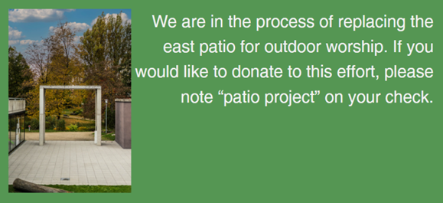

Our new Facebook page (our old one got disabled by Facebook and we can’t get it back)

Visit the address below or scan QR code to check out our facebook. https://www.facebook.com/profile.php?id=61558657105180

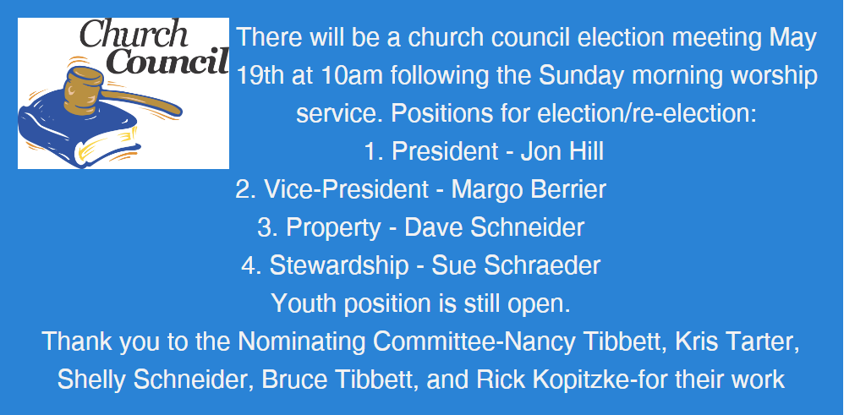

**kkkkkkkk

\A person with long red hair**