Good Shepherd Lutheran Church
Pastor: Rev. Katie Anderson | Music Director: Rev. Lois Swanson
Pastor’s Cell: (715) 245-1943 | Office Phone: (715) 387-2731
Pastor Email: gslcwi.pastor@gmail.com | Office Email: gslcwi.office@gmail.com
Website: GoodShepherdMarshfield.org | www.facebook.com/gslcwi
Fifth Sunday of Easter
April 28, 2024, 9:00 am
Introduction to the day…
This Sunday’s image of how the risen Christ shares his life with us is the image of the vine. Christ the vine and we the branches are alive in each other, in the mystery of mutual abiding described in the gospel and the first letter of John. Baptism makes us a part of Christ’s living and life-giving self and makes us alive with Christ’s life. As the vine brings food to the branches, Christ feeds us at his table. We are sent out to bear fruit for the life of the world.
ANNOUNCEMENTS

GATHERING
GATHERING HYMN Alleluia! Jesus is Risen ELW 377
THANKSGIVING FOR BAPTISM
Blessed be the holy Trinity,
☩ one God,
the fountain of living water,
the rock who gave us birth,
our light and our salvation.
Amen.
Joined to Christ in the waters of baptism, we are clothed with God’s mercy and forgiveness. Let us give thanks for the gift of baptism.
We give you thanks, O God, for in the beginning you created us in your image and placed us in a well-watered garden. In the desert, you promised pools of water for the parched, and you gave us water from the rock. When we did not know the way, you sent the Good Shepherd to lead us to still waters. At the cross, you washed us from Jesus’ wounded side, and on this day, you shower us again with the water of life.
We praise you for your salvation through water, for the water in this font, and for all water everywhere. Bathe us in your forgiveness, grace, and love. Satisfy all who thirst, and give us the life only you can give.
To you be given honor and praise through Jesus Christ, our living water, in the unity of the Holy Spirit, now and forever.
Amen.
PRAYER OF THE DAY
O God, you give us your Son as the vine apart from whom we cannot live. Nourish our life in his resurrection, that we may bear the fruit of love and know the fullness of your joy, through Jesus Christ, our Savior and Lord, who lives and reigns with you and the Holy Spirit, one God, now and forever.
Amen.
CHILDREN’S MUSIC Blessed Be God, Who Chose You ELW 215
CHILDREN’S MESSAGE

SCRIPTURE READINGS
FIRST READING: Acts 8:26-40
²⁶An angel of the Lord said to Philip, “Get up and go toward the south to the road that goes down from Jerusalem to Gaza.” (This is a wilderness road.) ²⁷So he got up and went. Now there was an Ethiopian eunuch, a court official of the Candace, queen of the Ethiopians, in charge of her entire treasury. He had come to Jerusalem to worship ²⁸and was returning home; seated in his chariot, he was reading the prophet Isaiah. ²⁹Then the Spirit said to Philip, “Go over to this chariot and join it.” ³⁰So Philip ran up to it and heard him reading the prophet Isaiah. He asked, “Do you understand what you are reading?” ³¹He replied, “How can I, unless someone guides me?” And he invited Philip to get in and sit beside him. ³²Now the passage of the scripture that he was reading was this:
“Like a sheep he was led to the slaughter,
and like a lamb silent before its shearer,
so he does not open his mouth.
³³In his humiliation justice was denied him.
Who can describe his generation?
For his life is taken away from the earth.”
³⁴The eunuch asked Philip, “About whom, may I ask you, does the prophet say this, about himself or about someone else?” ³⁵Then Philip began to speak, and starting with this scripture, he proclaimed to him the good news about Jesus. ³⁶As they were going along the road, they came to some water; and the eunuch said, “Look, here is water! What is to prevent me from being baptized?” ³⁸He commanded the chariot to stop, and both of them, Philip and the eunuch, went down into the water, and Philip baptized him. ³⁹When they came up out of the water, the Spirit of the Lord snatched Philip away; the eunuch saw him no more, and went on his way rejoicing. ⁴⁰But Philip found himself at Azotus, and as he was passing through the region, he proclaimed the good news to all the towns until he came to Caesarea.
Word of God, word of life.
Thanks be to God.
PSALM: Psalm 22:25-31
²⁵From you comes my praise in the great assembly;
I will perform my vows in the sight of those who fear the Lord.
²⁶The poor shall eat and be satisfied,
Let those who seek the Lord give praise! May your hearts live forever!
²⁷All the ends of the earth shall remember and turn to the Lord;
all the families of nations shall bow before God.
²⁸For dominion belongs to the Lord,
who rules over the nations.
²⁹Indeed, all who sleep in the earth shall bow down in worship;
all who go down to the dust, though they be dead, shall kneel before the Lord.
³⁰Their descendants shall serve the Lord,
whom they shall proclaim to generations to come.
³¹They shall proclaim God’s deliverance to a people yet unborn,
saying to them, “The Lord has acted!”
SECOND READING: 1 John 4:7-21
⁷Beloved, let us love one another, because love is from God; everyone who loves is born of God and knows God. ⁸Whoever does not love does not know God, for God is love. ⁹God’s love was revealed among us in this way: God sent his only Son into the world so that we might live through him. ¹⁰In this is love, not that we loved God but that he loved us and sent his Son to be the atoning sacrifice for our sins. ¹¹Beloved, since God loved us so much, we also ought to love one another. ¹²No one has ever seen God; if we love one another, God lives in us, and his love is perfected in us.
¹³By this we know that we abide in him and he in us, because he has given us of his Spirit. ¹⁴And we have seen and do testify that the Father has sent his Son as the Savior of the world. ¹⁵God abides in those who confess that Jesus is the Son of God, and they abide in God. ¹⁶So we have known and believe the love that God has for us.
God is love, and those who abide in love abide in God, and God abides in them. ¹⁷Love has been perfected among us in this: that we may have boldness on the day of judgment, because as he is, so are we in this world. ¹⁸There is no fear in love, but perfect love casts out fear; for fear has to do with punishment, and whoever fears has not reached perfection in love. ¹⁹We love because he first loved us. ²⁰Those who say, “I love God,” and hate their brothers or sisters, are liars; for those who do not love a brother or sister whom they have seen, cannot love God whom they have not seen. ²¹The commandment we have from him is this: those who love God must love their brothers and sisters also.
Word of God, word of life.
Thanks be to God.
GOSPEL ACCLAMATION ACS pg. 14
GOSPEL: John 15:1-8
¹“I am the true vine, and my Father is the vinegrower. ²He removes every branch in me that bears no fruit. Every branch that bears fruit he prunes to make it bear more fruit. ³You have already been cleansed by the word that I have spoken to you. ⁴Abide in me as I abide in you. Just as the branch cannot bear fruit by itself unless it abides in the vine, neither can you unless you abide in me. ⁵I am the vine, you are the branches. Those who abide in me and I in them bear much fruit, because apart from me you can do nothing. ⁶Whoever does not abide in me is thrown away like a branch and withers; such branches are gathered, thrown into the fire, and burned. ⁷If you abide in me, and my words abide in you, ask for whatever you wish, and it will be done for you. ⁸My Father is glorified by this, that you bear much fruit and become my disciples.”
The gospel of the Lord.
Praise to you, O Christ.
SERMON
HYMN OF THE DAY Blest Be the Tie That Binds ELW 656
APOSTLES’ CREED
I believe in God, the Father almighty,
creator of heaven and earth.
I believe in Jesus Christ, God's only Son, our Lord,
who was conceived by the power of the Holy Spirit,
born of the Virgin Mary,
suffered under Pontius Pilate,
was crucified, died, and was buried;
he descended to the dead.
On the third day he rose again;
he ascended into heaven,
he is seated at the right hand of the Father,
and he will come to judge the living and the dead.
I believe in the Holy Spirit,
the holy catholic Church,
the communion of saints,
the forgiveness of sins,
the resurrection of the body,
and the life everlasting. Amen
PRAYERS OF INTERCESSION
…God of grace.
Hear our prayer.
Into your hands, most merciful God, we commend all for whom we pray, trusting in your abiding love; through Jesus Christ, our resurrected and living Lord.
Amen.
PEACE
The peace of Christ be with you always.
And also with you.

HOLY COMMUNION
OFFERING In addition to our normal offering, a Special Benevolence in April (collected in a special envelope) will go to Feed My Starving Children.
OFFERING SONG We Plow the Fields and Scatter ELW 681
OFFERTORY PRAYER
Risen One,
you call us to believe and bear fruit.
May the gifts that we offer here be signs of your abiding love.
Form us to be your witnesses in the world,
through Jesus Christ, our true vine.
Amen.
GREAT THANKSGIVING
The Lord be with you.
And also with you.
Lift up your hearts.
We lift them to the Lord.
Let us give our thanks to the Lord our God.
It is right to give our thanks and praise.
HOLY, HOLY, HOLY ACS pg. 20
THANKSGIVING AT THE TABLE
Blessed are you, O God of the universe.
Your mercy is everlasting
and your faithfulness endures from age to age.
Praise to you for creating the heavens and the earth.
Praise to you for saving the earth from the waters of the flood.
Praise to you for bringing the Israelites safely through the sea.
Praise to you for leading your people through the wilderness
to the land of milk and honey.
Praise to you for the words and deeds of Jesus, your anointed one.
Praise to you for the death and resurrection of Christ.
Praise to you for your Spirit poured out on all nations.
In the night in which he was betrayed,
our Lord Jesus took bread, and gave thanks;
broke it, and gave it to his disciples, saying:
Take and eat; this is my body, given for you.
Do this for the remembrance of me.
Again, after supper, he took the cup, gave thanks,
and gave it for all to drink, saying:
This cup is the new covenant in my blood,
shed for you and for all people for the forgiveness of sin.
Do this for the remembrance of me.

With this bread and cup
we remember our Lord’s passover from death to life
as we proclaim the mystery of faith:
Christ has died.
Christ is risen.
Christ will come again.
O God of resurrection and new life:
Pour out your Holy Spirit on us
and on these gifts of bread and wine.
Bless this feast.
Grace our table with your presence.
Come, Holy Spirit.
Reveal yourself to us in the breaking of the bread.
Raise us up as the body of Christ for the world.
Breathe new life into us.
Send us forth,
burning with justice, peace, and love.
Come, Holy Spirit.
With your holy ones of all times and places,
with the earth and all its creatures,
with sun and moon and stars,
we praise you, O God,
blessed and holy Trinity,
now and forever.
Amen.

THE LORD’S PRAYER
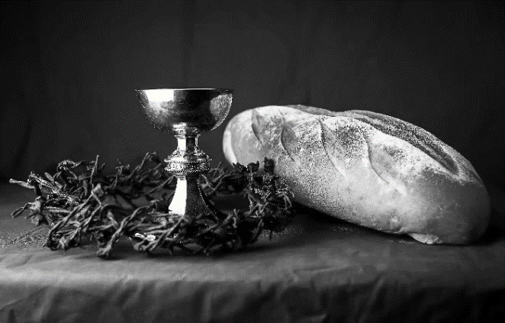
Our Father, who art in heaven,
hallowed be thy name,
thy kingdom come,
thy will be done,
on earth as it is in heaven.
Give us this day our daily bread;
and forgive us our trespasses,
as we forgive those
who trespass against us;
and lead us not into temptation,
but deliver us from evil.
For thine is the kingdom,
and the power, and the glory,
forever and ever. Amen.
INVITATION TO COMMUNION - Certified gluten-free crackers are in the bowl on the communion plate.
The risen Christ is made known to us
in the breaking of the bread.
Come and eat at God’s table.
HOLY COMMUNION
PRAYER AFTER COMMUNION
Shepherding God,
you have prepared a table before us
and nourished us with your love.
Send us forth from this banquet
to proclaim your goodness
and share the abundant mercy of Jesus,
our redeemer and friend.
Amen.
SENDING
BLESSING
Alleluia! Christ is risen!
Christ is risen indeed! Alleluia!
The God of resurrection power,
the Christ of unending joy,
and the Spirit of Easter hope
☩ bless you now and always.
Amen.
CLOSING HYMN Now All the Vault of Heaven Resound ELW 367
DISMISSAL
Alleluia! Go in peace. Rejoice and be glad.
Upcoming Worship Assistants
 | Usher | Lector | Communion | Offering Counters |  | Deep Clean
April 28 | Dennis & Deb Janz | Andrea Hovick | Sarah Kopitzke | Dan Mundt | Jon Hill
May 5  Confirmation | Dave & Shelly Schneider | Nancy Tibbett | Bob & Laurel Peterson | Nancy Leonard | Breanna Butler | May:  John & Jane Wagner  Laurel Peterson
May 12 | Dave & Sue Schraeder | Jon Hill | Matt & Margo Berrier | Robin Beeman | Davis Schneider
May 19 | Keith & Michelle Stuttgen | Christine Tipping | Dan & Pam Mundt | Heidi Binder | Kami Weis
Thanks be to God. Alleluia!

Coming up at GSLC
Sunday, April 28 | 9:00 am | Worship Service  - Fifth Sunday of Easter  - John 15:1-8; Christ the vine
Tuesday, April 30 | 7:00 pm | AA Meeting
Wednesday, May 1 | 12:00 pm | Bible Study (discuss Season 3 Episode 5 of “The Chosen”)
 | 7:00 pm | Midweek Worship  Confirmation Class
Thursday, May 2 | 11am-2pm | Purple Angels Lunch and Fellowship
Sunday, May 5 | 9:00 am | Worship Service – Sunday School  - Sixth Sunday of Easter  - Confirmation Sunday  - John 15:9-17; Christ the friend and lover
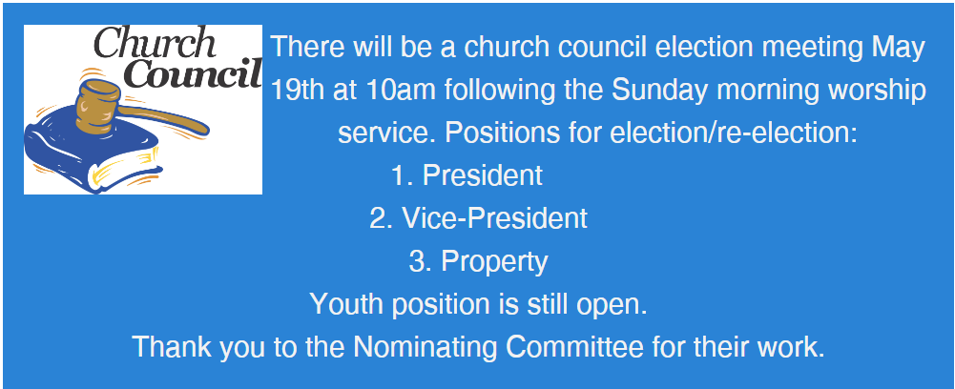
Good Shepherd's Green Team promotes No Mow May. It is an environmental campaign in Marshfield and around the United States that encourages citizens to refrain from mowing their lawns during the month of May. The aim of the campaign is to promote biodiversity and provide a habitat for pollinators such as bees, butterflies, and other insects. During the month of May, many wildflowers are in bloom, providing a vital source of nectar and pollen for pollinators. By allowing these flowers to grow and avoiding mowing the lawn, people can help to provide a much-needed refuge for these important pollinator species. Please check out the website and register your lawn at https://no-mow-may-cityofmarshfield.hub.arcgis.com/. You can also download/print a sign for your lawn.
Calling all birders! A bird watching walk is being hosted Tuesday, April 30th. Meet at church at 6pm to carpool to McMillan Marsh. The walk will run from 6:30-7:30 or 8. Be prepared for muddy patches and light drizzle. Back up rain date May 3rd. Please sign up if interested. For more information, contact Jennifer Rickinger.
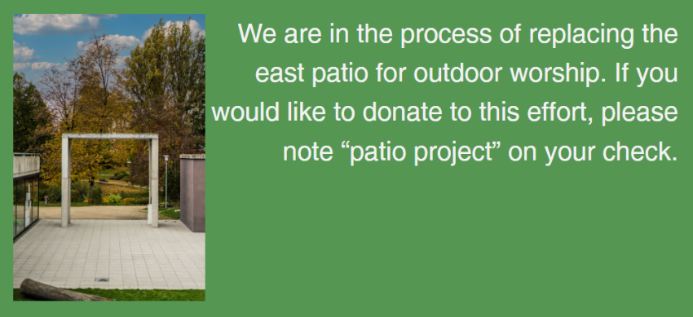
SOS has provided their list of needs for this month, which includes:
Kidney Beans, Baked Beans, Sandwich Bags, Chicken Noodle Soup, Dish Soap, Oatmeal, Jelly, Gravy, Pudding, Broth, All Purpose Cleaner, Shampoo, Conditioner, Pancake Mix, Baking Items, Paper Towels, Dried Soup. Urgently need: Broth, Canned Fruit, Applesauce, Canned Meet, Chili/Stew, Canned Pasta Meals, Rice Mixes, Kidney Beans.

