Good Shepherd Lutheran Church
Pastor: Rev. Katie Anderson | Music Director: Rev. Lois Swanson
Pastor’s Cell: (715) 245-1943 | Office Phone: (715) 387-2731
Pastor Email: gslcwi.pastor@gmail.com | Office Email: gslcwi.office@gmail.com
Website: GoodShepherdMarshfield.org | www.facebook.com/gslcwi
Fourth Sunday of Easter
April 21, 2024, 9:00 am
Introduction to the day…
The image of the good shepherd shows us how the risen Christ brings us to life. It is the relationship between the shepherd and the sheep, one of mutual knowledge and love, that gives the shepherd authority. The shepherd’s willingness to lay down his life for the sheep shows his love. First John illustrates what it means to lay down our lives for one another by the example of sharing our wealth with any sibling in need.
ANNOUNCEMENTS

GATHERING
GATHERING HYMN Christ the Lord is Risen Today; Alleluia! ELW 369
THANKSGIVING FOR BAPTISM
Blessed be the holy Trinity,
☩ one God,
the fountain of living water,
the rock who gave us birth,
our light and our salvation.
Amen.
Joined to Christ in the waters of baptism, we are clothed with God’s mercy and forgiveness. Let us give thanks for the gift of baptism.
We give you thanks, O God, for in the beginning you created us in your image and placed us in a well-watered garden. In the desert, you promised pools of water for the parched, and you gave us water from the rock. When we did not know the way, you sent the Good Shepherd to lead us to still waters. At the cross, you washed us from Jesus’ wounded side, and on this day, you shower us again with the water of life.
We praise you for your salvation through water, for the water in this font, and for all water everywhere. Bathe us in your forgiveness, grace, and love. Satisfy all who thirst, and give us the life only you can give.
To you be given honor and praise through Jesus Christ, our living water, in the unity of the Holy Spirit, now and forever.
Amen.
PRAYER OF THE DAY
O Lord Christ, good shepherd of the sheep, you seek the lost and guide us into your fold. Feed us, and we shall be satisfied; heal us, and we shall be whole. Make us one with you, for you live and reign with the Father and the Holy Spirit, one God, now and forever.
Amen.
CHILDREN’S MUSIC Blessed Be God, Who Chose You ELW 215
CHILDREN’S MESSAGE

SCRIPTURE READINGS
FIRST READING: Acts 4:5-12
⁵The next day [the] rulers, elders, and scribes assembled in Jerusalem, ⁶with Annas the high priest, Caiaphas, John, and Alexander, and all who were of the high-priestly family. ⁷When they had made the prisoners stand in their midst, they inquired, “By what power or by what name did you do this?” ⁸Then Peter, filled with the Holy Spirit, said to them, “Rulers of the people and elders, ⁹if we are questioned today because of a good deed done to someone who was sick and are asked how this man has been healed, ¹⁰let it be known to all of you, and to all the people of Israel, that this man is standing before you in good health by the name of Jesus Christ of Nazareth, whom you crucified, whom God raised from the dead. ¹¹This Jesus is
‘the stone that was rejected by you, the builders;
it has become the cornerstone.’
¹²There is salvation in no one else, for there is no other name under heaven given among mortals by which we must be saved.”
Word of God, word of life.
Thanks be to God.
PSALM: Psalm 23
¹The Lord is my shepherd;
I shall not be in want.
²The Lord makes me lie down in green pastures
and leads me beside still waters.
³You restore my soul, O Lord,
and guide me along right pathways for your name’s sake.
⁴Though I walk through the valley of the shadow of death, I shall fear no evil;
for you are with me; your rod and your staff, they comfort me.
⁵You prepare a table before me in the presence of my enemies;
you anoint my head with oil, and my cup is running over.
⁶Surely goodness and mercy shall follow me all the days of my life,
and I will dwell in the house of the Lord forever.
SECOND READING: 1 John 3:16-24
¹⁶We know love by this, that [Jesus Christ] laid down his life for us—and we ought to lay down our lives for one another. ¹⁷How does God’s love abide in anyone who has the world’s goods and sees a brother or sister in need and yet refuses help?
¹⁸Little children, let us love, not in word or speech, but in truth and action. ¹⁹And by this we will know that we are from the truth and will reassure our hearts before him ²⁰whenever our hearts condemn us; for God is greater than our hearts, and he knows everything. ²¹Beloved, if our hearts do not condemn us, we have boldness before God; ²²and we receive from him whatever we ask, because we obey his commandments and do what pleases him.
²³And this is his commandment, that we should believe in the name of his Son Jesus Christ and love one another, just as he has commanded us. ²⁴All who obey his commandments abide in him, and he abides in them. And by this we know that he abides in us, by the Spirit that he has given us.
Word of God, word of life.
Thanks be to God.
GOSPEL ACCLAMATION ACS pg. 14
GOSPEL: John 10:11-18
¹¹“I am the good shepherd. The good shepherd lays down his life for the sheep. ¹²The hired hand, who is not the shepherd and does not own the sheep, sees the wolf coming and leaves the sheep and runs away—and the wolf snatches them and scatters them. ¹³The hired hand runs away because a hired hand does not care for the sheep. ¹⁴I am the good shepherd. I know my own and my own know me, ¹⁵just as the Father knows me and I know the Father. And I lay down my life for the sheep. ¹⁶I have other sheep that do not belong to this fold. I must bring them also, and they will listen to my voice. So there will be one flock, one shepherd. ¹⁷For this reason the Father loves me, because I lay down my life in order to take it up again. ¹⁸No one takes it from me, but I lay it down of my own accord. I have power to lay it down, and I have power to take it up again. I have received this command from my Father.”
The gospel of the Lord.
Praise to you, O Christ.
SERMON
HYMN OF THE DAY The King of Love My Shepherd Is ELW 502
APOSTLES’ CREED
I believe in God, the Father almighty,
creator of heaven and earth.
I believe in Jesus Christ, God's only Son, our Lord,
who was conceived by the power of the Holy Spirit,
born of the Virgin Mary,
suffered under Pontius Pilate,
was crucified, died, and was buried;
he descended to the dead.
On the third day he rose again;
he ascended into heaven,
he is seated at the right hand of the Father,
and he will come to judge the living and the dead.
I believe in the Holy Spirit,
the holy catholic Church,
the communion of saints,
the forgiveness of sins,
the resurrection of the body,
and the life everlasting. Amen
PRAYERS OF INTERCESSION
…God of grace.
Hear our prayer.
Into your hands, most merciful God, we commend all for whom we pray, trusting in your abiding love; through Jesus Christ, our resurrected and living Lord.
Amen.
PEACE
The peace of Christ be with you always.
And also with you.
HOLY COMMUNION
OFFERING In addition to our normal offering, a Special Benevolence in April (collected in a special envelope) will go to Feed My Starving Children.
OFFERING SONG Savior, Like a Shepherd Lead Us ELW 789
OFFERTORY PRAYER
Risen One,
you call us to believe and bear fruit.
May the gifts that we offer here be signs of your abiding love.
Form us to be your witnesses in the world,
through Jesus Christ, our true vine.
Amen.
GREAT THANKSGIVING
The Lord be with you.
And also with you.
Lift up your hearts.
We lift them to the Lord.
Let us give our thanks to the Lord our God.
It is right to give our thanks and praise.
HOLY, HOLY, HOLY ACS pg. 20

THANKSGIVING AT THE TABLE
Blessed are you, O God of the universe.
Your mercy is everlasting
and your faithfulness endures from age to age.
Praise to you for creating the heavens and the earth.
Praise to you for saving the earth from the waters of the flood.
Praise to you for bringing the Israelites safely through the sea.
Praise to you for leading your people through the wilderness
to the land of milk and honey.
Praise to you for the words and deeds of Jesus, your anointed one.
Praise to you for the death and resurrection of Christ.
Praise to you for your Spirit poured out on all nations.
In the night in which he was betrayed,
our Lord Jesus took bread, and gave thanks;
broke it, and gave it to his disciples, saying:
Take and eat; this is my body, given for you.
Do this for the remembrance of me.
Again, after supper, he took the cup, gave thanks,
and gave it for all to drink, saying:
This cup is the new covenant in my blood,
shed for you and for all people for the forgiveness of sin.
Do this for the remembrance of me.

With this bread and cup
we remember our Lord’s passover from death to life
as we proclaim the mystery of faith:
Christ has died.
Christ is risen.
Christ will come again.
O God of resurrection and new life:
Pour out your Holy Spirit on us
and on these gifts of bread and wine.
Bless this feast.
Grace our table with your presence.
Come, Holy Spirit.
Reveal yourself to us in the breaking of the bread.
Raise us up as the body of Christ for the world.
Breathe new life into us.
Send us forth,
burning with justice, peace, and love.
Come, Holy Spirit.
With your holy ones of all times and places,
with the earth and all its creatures,
with sun and moon and stars,
we praise you, O God,
blessed and holy Trinity,
now and forever.
Amen.

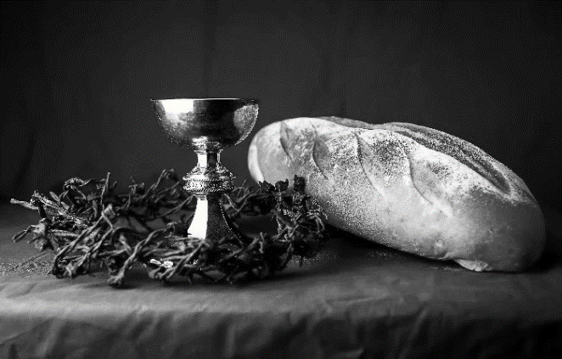
THE LORD’S PRAYER
Our Father, who art in heaven,
hallowed be thy name,
thy kingdom come,
thy will be done,
on earth as it is in heaven.
Give us this day our daily bread;
and forgive us our trespasses,
as we forgive those
who trespass against us;
and lead us not into temptation,
but deliver us from evil.
For thine is the kingdom,
and the power, and the glory,
forever and ever. Amen.
INVITATION TO COMMUNION - Certified gluten-free crackers are in the bowl on the communion plate.
The risen Christ is made known to us
in the breaking of the bread.
Come and eat at God’s table.
HOLY COMMUNION

PRAYER AFTER COMMUNION
Shepherding God,
you have prepared a table before us
and nourished us with your love.
Send us forth from this banquet
to proclaim your goodness
and share the abundant mercy of Jesus,
our redeemer and friend.
Amen.
SENDING
BLESSING
Alleluia! Christ is risen!
Christ is risen indeed! Alleluia!
The God of resurrection power,
the Christ of unending joy,
and the Spirit of Easter hope
☩ bless you now and always.
Amen.
CLOSING HYMN Built on a Rock ELW 652
DISMISSAL
Alleluia! Go in peace. Rejoice and be glad.
Thanks be to God. Alleluia!
Upcoming Worship Assistants
 | Usher | Lector | Communion | Offering Counters |  | Deep Clean
April 21 | Rob & Leslie Mader | Linda Schrieber | Christopher Stuttgen Danielle Stuttgen | Pam Mundt | May Hill | April:  Julie Will  Deb Janz  Chris Tipping
April 28 | Dennis & Deb Janz | Andrea Hovick | Sarah Kopitzke | Dan Mundt | Jon Hill
May 5  Confirmation | Dave & Shelly Schneider | Nancy Tibbett | Bob & Laurel Peterson | Nancy Leonard | Breanna Butler | May:  John & Jane Wagner  Laurel Peterson
May 12 | Dave & Sue Schraeder | Julie Will | Matt & Margo Berrier | Robin Beeman | Davis Schneider
Coming up at GSLC
Sunday, April 21 | 9:00 am | Worship Service – Sunday School  - Fourth Sunday of Easter  - John 10:11-18; Christ the shepherd
Tuesday, April 23 | 7:00 pm | AA Meeting
Wednesday, April 24 | 12:00 pm | Bible Study (discuss Season 3 Episode 4 of “The Chosen”)
 | 7:00 pm | Midweek Worship  Confirmation Class
Saturday, April 27 | 12pm-2pm | Feed My Starving Children packing at Zion Community Church
Sunday, April 28 | 9:00 am | Worship Service  - Fifth Sunday of Easter  - John 15:1-8; Christ the vine
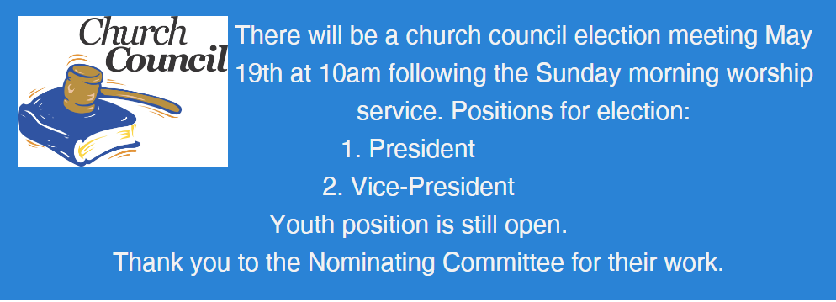
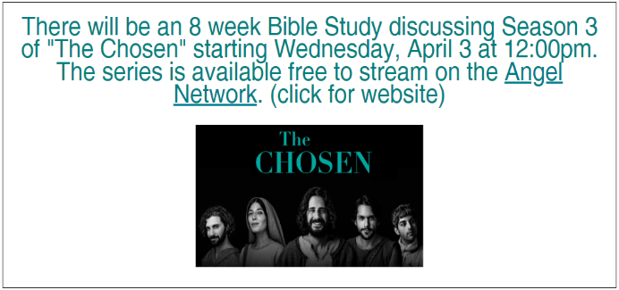
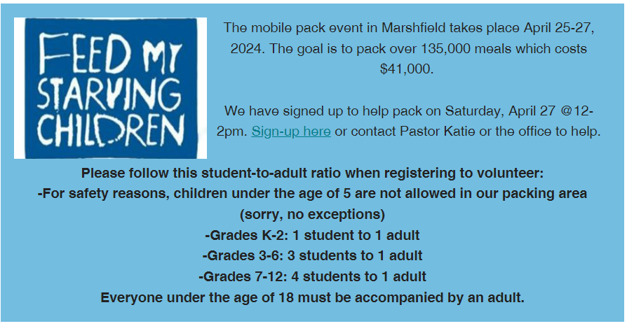
SOS has provided their list of needs for this month, which includes:
Kidney Beans, Baked Beans, Sandwich Bags, Chicken Noodle Soup, Dish Soap, Oatmeal, Jelly, Gravy, Pudding, Broth, All Purpose Cleaner, Shampoo, Conditioner, Pancake Mix, Baking Items, Paper Towels, Dried Soup. Urgently need: canned Stew, Jelly and canned meats.
Good Shepherd Green Team
Earth Day 2024, is Monday April 22. The theme is Planet versus Plastics, highlighting the fact that 380 million tons of plastic are now produced every year- while only 9% of plastic ever produced has been recycled. On behalf of Good Shepherd's Green Team, we still have a few reusable insulated shopping bags available for donation, we will have them out after Sunday's service. We also have a receptacle for battery recycling and a seasonal receptacle for broken holiday lights and extension cords. Please consider the following tips to reduce plastic:
- Bring your own bags when you shop.
- Carry a reusable water bottle and a travel mug for coffee/tea.
- Replace cling wrap with beeswax wrap.
- Switch to bamboo toothbrushes.
- Swap out your liquid soap and shampoos for bar soap/shampoo.

We are seeking two delegates to attend the Synod Assembly, June 7-8 in Eau Claire. This year is a bishop’s election, so you will help shape synod leadership for the next several years! The synod specifies we need one lay male and one lay female to attend.

