Good Shepherd Lutheran Church
Pastor: Rev. Katie Anderson | Music Director: Rev. Lois Swanson
Pastor’s Cell: (715) 245-1943 | Office Phone: (715) 387-2731
Pastor Email: gslcwi.pastor@gmail.com | Office Email: gslcwi.office@gmail.com
Website: GoodShepherdMarshfield.org | www.facebook.com/gslcwi
Third Sunday of Easter
April 14, 2024, 9:00 am
Introduction to the day…
The gospel for the third Sunday of Easter is always one in which the risen Christ shares food with the disciples, meals that are the Easter template for the meal we share each Sunday. In today’s gospel, Jesus both shares the disciples’ food and shows them the meaning of his suffering, death, and resurrection through the scriptures, the two main elements of our Sunday worship.

ANNOUNCEMENTS
GATHERING
GATHERING SONG Christ is Risen! Shout Hosanna!
1 Christ is risen! Shout hosanna!  Celebrate this day of days!  Christ is risen! Hush in wonder:  all creation is amazed.  In the desert all surrounding,  see, a spreading tree has grown.  Healing leaves of grace abounding  bring a taste of love unknown. | 3 Christ is risen! Earth and heaven  nevermore shall be the same.  Break the bread of new creation  where the world is still in pain.  ell its grim, demonic chorus:  "Christ is risen! Get you gone!"  God the first and last is with us.  Sing hosanna, ev'ryone!
2 Christ is risen! Raise your spirits
from the caverns of despair.
Walk with gladness in the morning.
See what love can do and dare.
Drink the wine of resurrection.
Not a servant, but a friend,
Jesus is our strong companion.
Joy and peace shall never end.
Text: Brian Wren, b. 1936 (c) 1986 Hope Publishing Co. All rights reserved. Duplication in any form prohibited without permission or valid license from copyright administrator Used by permission. CCLI LICENSE #669990
THANKSGIVING FOR BAPTISM
Blessed be the holy Trinity,
☩ one God,
the fountain of living water,
the rock who gave us birth,
our light and our salvation.
Amen.
Joined to Christ in the waters of baptism, we are clothed with God’s mercy and forgiveness. Let us give thanks for the gift of baptism.
We give you thanks, O God, for in the beginning you created us in your image and placed us in a well-watered garden. In the desert, you promised pools of water for the parched, and you gave us water from the rock. When we did not know the way, you sent the Good Shepherd to lead us to still waters. At the cross, you washed us from Jesus’ wounded side, and on this day, you shower us again with the water of life.
We praise you for your salvation through water, for the water in this font, and for all water everywhere. Bathe us in your forgiveness, grace, and love. Satisfy all who thirst, and give us the life only you can give.
To you be given honor and praise through Jesus Christ, our living water, in the unity of the Holy Spirit, now and forever.
Amen.

PRAYER OF THE DAY
Holy and righteous God, you are the author of life, and you adopt us to be your children. Fill us with your words of life, that we may live as witnesses to the resurrection of your Son, Jesus Christ, our Savior and Lord, who lives and reigns with you and the Holy Spirit, one God, now and forever.
Amen.
CHILDREN’S MUSIC Blessed Be God, Who Chose You ELW 215
CHILDREN’S MESSAGE
SCRIPTURE READINGS
FIRST READING: Acts 3:12-19
¹²[Peter] addressed the people, “You Israelites, why do you wonder at this, or why do you stare at us, as though by our own power or piety we had made him walk?¹³The God of Abraham, the God of Isaac, and the God of Jacob, the God of our ancestors has glorified his servant Jesus, whom you handed over and rejected in the presence of Pilate, though he had decided to release him. ¹⁴But you rejected the Holy and Righteous One and asked to have a murderer given to you, ¹⁵and you killed the Author of life, whom God raised from the dead. To this we are witnesses. ¹⁶And by faith in his name, his name itself has made this man strong, whom you see and know; and the faith that is through Jesus has given him this perfect health in the presence of all of you.
¹⁷“And now, friends, I know that you acted in ignorance, as did also your rulers. ¹⁸In this way God fulfilled what he had foretold through all the prophets, that his Messiah would suffer. ¹⁹Repent therefore, and turn to God so that your sins may be wiped out.”
PSALM: Psalm 4
¹Answer me when I call, O God, defender of my cause;
you set me free when I was in distress; have mercy on me and hear my prayer.
²“You mortals, how long will you dishonor my glory;
how long will you love illusions and seek after lies?”
³Know that the Lord does wonders for the faithful;
the Lord will hear me when I call.
⁴Tremble, then, and do not sin;
speak to your heart in silence upon your bed.
⁵Offer the appointed sacrifices,
and put your trust in the Lord.
⁶Many are saying, “Who will show us any good?”
Let the light of your face shine upon us, O Lord.
⁷You have put gladness in my heart,
more than when grain and wine abound.
⁸In peace, I will lie down and sleep;
for you alone, O Lord, make me rest secure.
SECOND READING: 1 John 3:1-7
¹See what love the Father has given us, that we should be called children of God; and that is what we are. The reason the world does not know us is that it did not know him. ²Beloved, we are God’s children now; what we will be has not yet been revealed. What we do know is this: when he is revealed, we will be like him, for we will see him as he is. ³And all who have this hope in him purify themselves, just as he is pure.
⁴Everyone who commits sin is guilty of lawlessness; sin is lawlessness. ⁵You know that he was revealed to take away sins, and in him there is no sin. ⁶No one who abides in him sins; no one who sins has either seen him or known him. ⁷Little children, let no one deceive you. Everyone who does what is right is righteous, just as he is righteous.
Word of God, word of life.
Thanks be to God.
GOSPEL ACCLAMATION ACS pg. 14

GOSPEL: Luke 24:36b-48
^{36b}Jesus himself stood among [the disciples] and said to them, “Peace be with you.” ³⁷They were startled and terrified, and thought that they were seeing a ghost. ³⁸He said to them, “Why are you frightened, and why do doubts arise in your hearts? ³⁹Look at my hands and my feet; see that it is I myself. Touch me and see; for a ghost does not have flesh and bones as you see that I have.” ⁴⁰And when he had said this, he showed them his hands and his feet. ⁴¹While in their joy they were disbelieving and still wondering, he said to them, “Have you anything here to eat?” ⁴²They gave him a piece of broiled fish, ⁴³and he took it and ate in their presence.
⁴⁴Then he said to them, “These are my words that I spoke to you while I was still with you—that everything written about me in the law of Moses, the prophets, and the psalms must be fulfilled.” ⁴⁵Then he opened their minds to understand the scriptures, ⁴⁶and he said to them, “Thus it is written, that the Messiah is to suffer and to rise from the dead on the third day, ⁴⁷and that repentance and forgiveness of sins is to be proclaimed in his name to all nations, beginning from Jerusalem. ⁴⁸You are witnesses of these things.”
The gospel of the Lord.
Praise to you, O Christ.
SERMON
HYMN OF THE DAY As We Gather At Your Table ELW 522
APOSTLES’ CREED
I believe in God, the Father almighty,
creator of heaven and earth.
I believe in Jesus Christ, God's only Son, our Lord,
who was conceived by the power of the Holy Spirit,
born of the Virgin Mary,
suffered under Pontius Pilate,
was crucified, died, and was buried;
he descended to the dead.
On the third day he rose again;
he ascended into heaven,
he is seated at the right hand of the Father,
and he will come to judge the living and the dead.
I believe in the Holy Spirit,
the holy catholic Church,
the communion of saints,
the forgiveness of sins,
the resurrection of the body,
and the life everlasting. Amen
PRAYERS OF INTERCESSION
…God of grace.
Hear our prayer.
Into your hands, most merciful God, we commend all for whom we pray, trusting in your abiding love; through Jesus Christ, our resurrected and living Lord.
Amen.
PEACE
The peace of Christ be with you always.
And also with you.
HOLY COMMUNION
OFFERING In addition to our normal offering, a Special Benevolence in April (collected in a special envelope) will go to Feed My Starving Children.
OFFERING SONG Draw Us in the Sprit’s Tether ELW 470

OFFERTORY PRAYER
Risen One,
you call us to believe and bear fruit.
May the gifts that we offer here be signs of your abiding love.
Form us to be your witnesses in the world,
through Jesus Christ, our true vine.
Amen.
GREAT THANKSGIVING
The Lord be with you.
And also with you.
Lift up your hearts.
We lift them to the Lord.
Let us give our thanks to the Lord our God.
It is right to give our thanks and praise.
HOLY, HOLY, HOLY ACS pg. 14
THANKSGIVING AT THE TABLE
Holy God, holy and mighty, holy and immortal:
you we praise and glorify, you we worship and adore.
You formed the earth from chaos;
you encircled the globe with air;
you created fire for warmth and light;
you nourish the lands with water.
You molded us in your image,
and with mercy higher than the mountains,
with grace deeper than the seas,
you blessed the Israelites and cherished them as your own.
That also we, estranged and dying,
might be adopted to live in your Spirit,
you called to us through the life and death of Jesus.
In the night in which he was betrayed,
our Lord Jesus took bread, and gave thanks;
broke it, and gave it to his disciples, saying:
Take and eat; this is my body, given for you.
Do this for the remembrance of me.
Again, after supper, he took the cup, gave thanks,
and gave it for all to drink, saying:
This cup is the new covenant in my blood,
shed for you and for all people for the forgiveness of sin.
Do this for the remembrance of me.
Together as the body of Christ,
we proclaim the Lord’s death until he comes:
Christ has died.
Christ is risen.
Christ will come again.

With this bread and cup we remember your Son,
the first-born of your new creation.
We remember his life lived for others,
and his death and resurrection, which renews the face of the earth.
We await his coming,
when, with the world made perfect through your wisdom,
all our sins and sorrows will be no more.
Amen. Come, Lord Jesus.
Holy God, holy and merciful one, holy and compassionate,
send upon us and this meal your Holy Spirit,
whose breath revives us for life,
whose fire rouses us to love.
Enfold in your arms all who share this holy food.
Nurture in us the fruits of the Spirit,
that we may be a living tree, sharing your bounty with all the world.
Amen. Come, Holy Spirit.
Holy and benevolent God,
receive our praise and petitions,
as Jesus received the cry of the needy,
and fill us with your blessing,
until, needy no longer and bound to you in love,
we feast forever in the triumph of the Lamb:
through whom all glory and honor is yours, O God, O Living One,
with the Holy Spirit, in your holy church, now and forever.
Amen.

THE LORD’S PRAYER
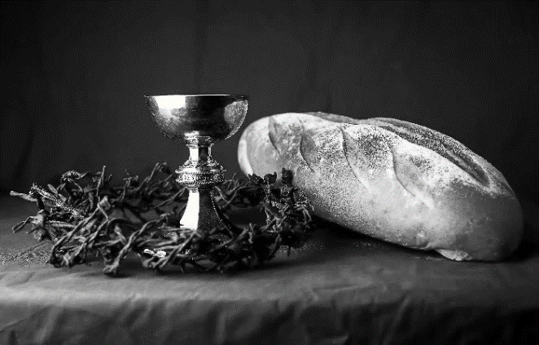
Our Father, who art in heaven,
hallowed be thy name,
thy kingdom come,
thy will be done,
on earth as it is in heaven.
Give us this day our daily bread;
and forgive us our trespasses,
as we forgive those
who trespass against us;
and lead us not into temptation,
but deliver us from evil.
For thine is the kingdom,
and the power, and the glory,
forever and ever. Amen.
INVITATION TO COMMUNION - Certified gluten-free crackers are in the bowl on the communion plate.
The risen Christ is made known to us
in the breaking of the bread.
Come and eat at God’s table.
HOLY COMMUNION
PRAYER AFTER COMMUNION
Shepherding God,
you have prepared a table before us
and nourished us with your love.
Send us forth from this banquet
to proclaim your goodness
and share the abundant mercy of Jesus,
our redeemer and friend.
Amen.
SENDING
BLESSING
Alleluia! Christ is risen!
Christ is risen indeed! Alleluia!
The God of resurrection power,
the Christ of unending joy,
and the Spirit of Easter hope
☩ bless you now and always.
Amen.
CLOSING HYMN Let Us Talents and Tongues Employ ELW 674
DISMISSAL
Alleluia! Go in peace. Rejoice and be glad.
Thanks be to God. Alleluia!
Upcoming Worship Assistants
 | Usher | Lector | Communion | Offering Counters |  | Deep Clean
April 14 | Nancy Leonard | Tammy Neumann | Dave & Shelly Schneider | Heidi Binder | Kami Weis | April:  Julie Will  Deb Janz  Chris Tipping
April 21 | Rob & Leslie Mader | Linda Schrieber | Christopher Stuttgen Danielle Stuttgen | Pam Mundt | May Hill
April 28 | Dennis & Deb Janz | Andrea Hovick | Sarah Kopitzke | Dan Mundt | Jon Hill
May 5  Confirmation | Dave & Shelly Schneider | Nancy Tibbett | Bob & Laurel Peterson | Nancy Leonard | Breanna Butler
SOS has provided their list of needs for this month, which includes:
Kidney Beans, Baked Beans, Sandwich Bags, Chicken Noodle Soup, Dish Soap, Oatmeal, Jelly, Gravy, Pudding, Broth, All Purpose Cleaner, Shampoo, Conditioner, Pancake Mix, Baking Items, Paper Towels, Dried Soup. Urgently need: canned Stew, Jelly and canned meats.
Coming up at GSLC
Sunday, April 14 | 9:00 am | Worship Service  - Third Sunday of Easter  - Luke 24:36b-48; Eating with the risen Christ
Tuesday, April 16 | 2:00 pm | Chapel at Three Oaks
 | 7:00 pm | AA Meeting
Wednesday, April 17 | 12:00 pm | Bible Study (discuss Season 3 Episode 3 of “The Chosen”)
 | 7:00 pm | Midweek Worship  Confirmation Class
Sunday, April 21 | 9:00 am | Worship Service – Sunday School  - Fourth Sunday of Easter  - John 10:11-18; Christ the shepherd
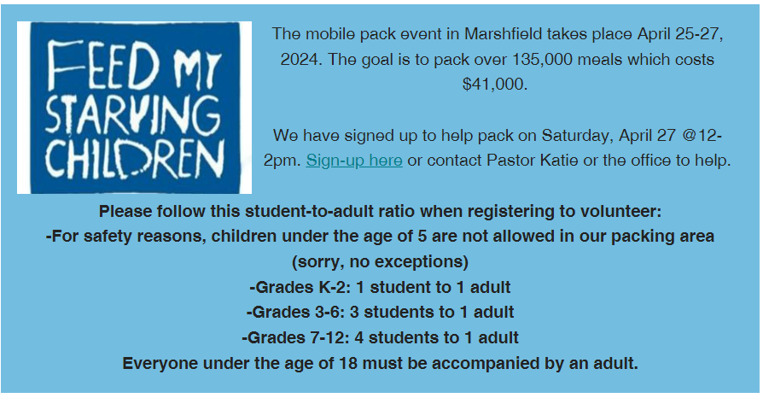

Good Shepherd Patio Replacement Project We are in the process of replacing the patio on the east side of the church in preparation for outside worship. Any donation to this project would be greatly appreciated! If you wish to donate to this effort, please note “patio project” on your check.
If there are any questions, please contact David Schneider – Property. Thank you!

We are seeking two delegates to attend the Synod Assembly, June 7-8 in Eau Claire. This year is a bishop’s election, so you will help shape synod leadership for the next several years! The synod specifies we need one lay male and one lay female to attend.

