Good Shepherd Lutheran Church
Pastor: Katie Anderson | Music Director: Lois Swanson
Pastor’s Cell: (715) 245-1943 | Office Phone: (715) 387-2731
Pastor Email: gslcwi.pastor@gmail.com | Office Email: gslcwi.office@gmail.com
Website: GoodShepherdMarshfield.org | www.facebook.com/gslcwi
Fifth Sunday in Lent
March 17, 2024, 9:00 am
Introduction to the day…
Peter is often all or nothing—either resisting Jesus or drawing closer to him in earnest. In this scripture, we see a version of Peter who is hungry to learn. His posture is humble and open—he wants to absorb Jesus’ teachings like a wet sponge. He asks a question and might expect a straightforward answer: “How many times should I forgive?” Instead, Jesus’ math is not predictable—it’s infinite. Forgiveness is abundant; grace is not earned. In your own faith, do you find comfort in theological formulas? Do you wish for straightforward answers? Can you let go of black-and-white thinking and instead embrace the infinite colors of grace?
ANNOUNCEMENTS
GATHERING
GATHERING HYMN Gather Us In ELW 532
CONFESSION AND FORGIVENESS
Holy God,
We long to be lifelong learners.
We long to approach you with curiosity and an open mind.
Instead, we often live as if we know best.
We forget that the disciples called you “Rabbi, Teacher.”
Forgive us for the times when we fail to be curious.
Forgive us for the times when we assume we know best.
Forgive us for the moments when we imagine that our learning is done and that we have all the answers.
Like Peter—who was brave enough to ask, “How many times should we forgive?”—make us brave. Spark a desire in us to learn, and may our curiosity carry our faith into deeper waters.
With hope and humility we pray.
Amen.

Beloved in Christ,
When Peter asked Jesus, “How many times should I forgive?” Jesus responded with abundance.
That abundance exists for you as well.

No matter what you have done or left undone,
no matter what lessons you have learned or are still learning,
God’s abundant grace exists for you. God’s love will never run out.

So hear and rest in this good news:
You are forgiven.
You are loved.
You are invited to serve.
Thanks be to God!
Amen.
PRAYER OF THE DAY
Teaching God, We want to learn your ways. The ways of forgiveness, grace, and love. We return to your Word week after week because we are hungry to be more like you. As we prepare to listen to your good Word, calm the noise in our minds. Center our spirits to focus on you so that we may learn and hear what we have missed in this story before. God, we want to learn your ways. Meet us here. Speak your truth. Help us listen Amen.
CHILDREN’S MUSIC Be Still and Know ACS 1083
CHILDREN’S MESSAGE
SCRIPTURE READINGS
FIRST READING: Jeremiah 31:31-34
³¹The days are surely coming, says the Lord, when I will make a new covenant with the house of Israel and the house of Judah. ³²It will not be like the covenant that I made with their ancestors when I took them by the hand to bring them out of the land of Egypt—a covenant that they broke, though I was their husband, says the Lord. ³³But this is the covenant that I will make with the house of Israel after those days, says the Lord: I will put my law within them, and I will write it on their hearts; and I will be their God, and they shall be my people. ³⁴No longer shall they teach one another, or say to each other, “Know the Lord,” for they shall all know me, from the least of them to the greatest, says the Lord; for I will forgive their iniquity, and remember their sin no more.
Word of God, word of life.
Thanks be to God.
PSALM: Psalm 119:9-16
⁹How shall the young keep their way clean?
By keeping to your word.
¹⁰With my whole heart I seek you;
let me not stray from your commandments.
¹¹I treasure your promise in my heart,
that I may not sin against you.
¹²Blessed are you, O Lord;
instruct me in your statutes.
¹³With my lips I recite
all the judgments of your mouth.
¹⁴I take greater delight in the way of your decrees
than in all manner of riches.
¹⁵I will meditate on your commandments
and give attention to your ways.
¹⁶My delight is in your statutes;
I will not forget your word.
GOSPEL ACCLAMATION ACS pg. 15
GOSPEL: Matthew 18:15-22
¹⁵If another member of the church sins against you, go and point out the fault when the two of you are alone. If the member listens to you, you have regained that one. ¹⁶But if you are not listened to, take one or two others along with you, so that every word may be confirmed by the evidence of two or three witnesses. ¹⁷If the member refuses to listen to them, tell it to the church; and if the offender refuses to listen even to the church, let such a one be to you as a Gentile and a tax collector. ¹⁸Truly I tell you, whatever you bind on earth will be bound in heaven, and whatever you loose on earth will be loosed in heaven. ¹⁹Again, truly I tell you, if two of you agree on earth about anything you ask, it will be done for you by my Father in heaven. ²⁰For where two or three are gathered in my name, I am there among them."
²¹Then Peter came and said to him, "Lord, if another member of the church sins against me, how often should I forgive? As many as seven times?" ²²Jesus said to him, "Not seven times, but, I tell you, seventy-seven times.
The gospel of the Lord.
Praise to you, O Christ.
SERMON Teach Me
HYMN OF THE DAY Forgive Our Sins As We Forgive ELW 605

AFFIRMATION OF FAITH
We believe that questions are a building block of faith.
“How many times should I forgive?”
“Jesus, where are you going?”
“What must I do to inherit eternal life?”

We believe that humble curiosity can open our eyes.
“Where does it hurt?”
“What do you need?”
“How can I help?”

We believe that God is a teacher.
“Speak, Lord, your servant is listening.”
“Here I am.”
“Send me.”

We believe that faith invites our whole being to engage,
with all our heart,
with all our mind,
with all our strength.

We believe. Help our unbelief.
In Christ’s name we pray.
Amen.
PRAYERS OF INTERCESSION
…Hear us, O God.
Your mercy is great.
Accompany us on our journey, God of grace, and receive the prayers of our hearts, through Jesus Christ, our Savior.
Amen.
PEACE
The peace of Christ be with you always.
And also with you.
HOLY COMMUNION
OFFERING In addition to our normal offering, a Special Benevolence in March (collected in a special envelope) will go to Marshfield Area Respite Care Center.
OFFERING HYMN Jesus, Keep Me Near the Cross ELW 335
OFFERTORY PRAYER
Jesus, you are the bread of life
and the host of this meal.
Bless these gifts that we have gathered
that all people may know your goodness.
Feed us not only with this holy food
but with hunger for justice and peace.
We pray this in your name.
Amen.
GREAT THANKSGIVING
The Lord be with you.
And also with you.
Lift up your hearts.
We lift them to the Lord.
Let us give our thanks to the Lord our God.
It is right to give our thanks and praise.
Holy, Holy ACS pg. 20
THANKSGIVING AT THE TABLE

Blessed are you, O God of the universe.
Your mercy is everlasting
and your faithfulness endures from age to age.
Praise to you for creating the heavens and the earth.
Praise to you for saving the earth from the waters of the flood.
Praise to you for bringing the Israelites safely through the sea.
Praise to you for leading your people through the wilderness
to the land of milk and honey.
Praise to you for the words and deeds of Jesus, your anointed one.
Praise to you for the death and resurrection of Christ.
Praise to you for your Spirit poured out on all nations.

In the night in which he was betrayed,
our Lord Jesus took bread, and gave thanks;
broke it, and gave it to his disciples, saying:
Take and eat; this is my body, given for you.
Do this for the remembrance of me.

Again, after supper, he took the cup, gave thanks,
and gave it for all to drink, saying:
This cup is the new covenant in my blood,
shed for you and for all people for the forgiveness of sin.
Do this for the remembrance of me.

With this bread and cup
we remember our Lord’s passover from death to life
as we proclaim the mystery of faith:
Christ has died.
Christ is risen.
Christ will come again.

O God of resurrection and new life:
Pour out your Holy Spirit on us
and on these gifts of bread and wine.
Bless this feast.
Grace our table with your presence.
Come, Holy Spirit.

Reveal yourself to us in the breaking of the bread.
Raise us up as the body of Christ for the world.
Breathe new life into us.
Send us forth,
burning with justice, peace, and love.
Come, Holy Spirit.

With your holy ones of all times and places,
with the earth and all its creatures,
with sun and moon and stars,
we praise you, O God,
blessed and holy Trinity,
now and forever.
Amen.
THE LORD’S PRAYER
Our Father, who art in heaven,
hallowed be thy name,
thy kingdom come,
thy will be done, on earth as it is in heaven.
Give us this day our daily bread;
and forgive us our trespasses, as we forgive those
who trespass against us;
and lead us not into temptation, but deliver us from evil.
For thine is the kingdom, and the power, and the glory,
forever and ever. Amen.
INVITATION TO COMMUNION - Certified gluten-free crackers are in the bowl on the communion plate.
Bread for the journey.
A feast for hungry hearts. Come!
HOLY COMMUNION
PRAYER AFTER COMMUNION
Generous God,
at this table we have tasted your immeasurable grace.
As grains of wheat are gathered into one bread,
now make us one loaf to feed the world;
in the name of Jesus, the Bread of life.
Amen.

SENDING
BENEDICTION
Beloved wanderer,
as you leave this place,
may you carry your curious heart on your sleeve.
May you look for God in every face.
May you find the courage to get out of the boat,
to run to the tomb,
and to speak of your faith.
And when the world falls apart,
may you hear God’s voice deep within,
saying, “Take heart, it is I, be not afraid.”
You are called.
You are blessed.
In both your ups and your downs,
you always belong to God.
Go now in peace.
Go trusting that good news.
Amen.
CLOSING HYMN Go, My Children, with My Blessing ELW 543
DISMISSAL
Go in peace. Share your bread.
Thanks be to God.
Upcoming Worship Assistants
 | Usher | Lector | Communion | Offering Counters |  | Deep Clean
March 17 | Tammy Neumann | Jon Hill | Dan & Pam Mundt | Pam Mundt | May Hill | March:  Nancy Lenard  Jannalee Kolbeck Lindquist  Heidi Binder
March 24 | Gene & Linda Schrieber | Leslie Mader | Dave & Sue Schraeder | Dan Mundt | Jon Hill
March 31  Easter | Dave & Kami Weis | Kris Tarter | Ron Rothfusz  Andrea Hovik | Nancy Leonard | Breanna Butler
April 7 | Brett & Breanna Butler | Shelly Schneider | John Wagner  Nancy Leonard | Robin Beeman | David Schneider

Sunday, March 17 | 9:00 am | Worship Service – Sunday School  - Fifth Sunday in Lent  - Matthew 18:15-22; Binding and loosing, and how often to forgive
Tuesday, March 19 | 2:00 pm | Chapel at Three Oaks
 | 7:00 pm | AA Meeting
Wednesday, March 20 | 6:00 pm | Bread & Broth
 | 7:00 pm | Midweek Worship  Confirmation Class
Sunday, March 24 | 9:00 am | Worship Service  - Palm Sunday  - John 12:12-16; Jesus’ triumphal entry into Jerusalem
SOS has provided their list of needs for this month, which includes:
Kidney Beans, Baked Beans, Sandwich Bags, Chicken Noodle Soup, Dish Soap, Oatmeal, Jelly, Gravy, Pudding, Broth, All Purpose Cleaner, Shampoo, Conditioner, Pancake Mix, Baking Items, Paper Towels, Dried Soup. Urgently need: canned Stew, Jelly and canned meats.
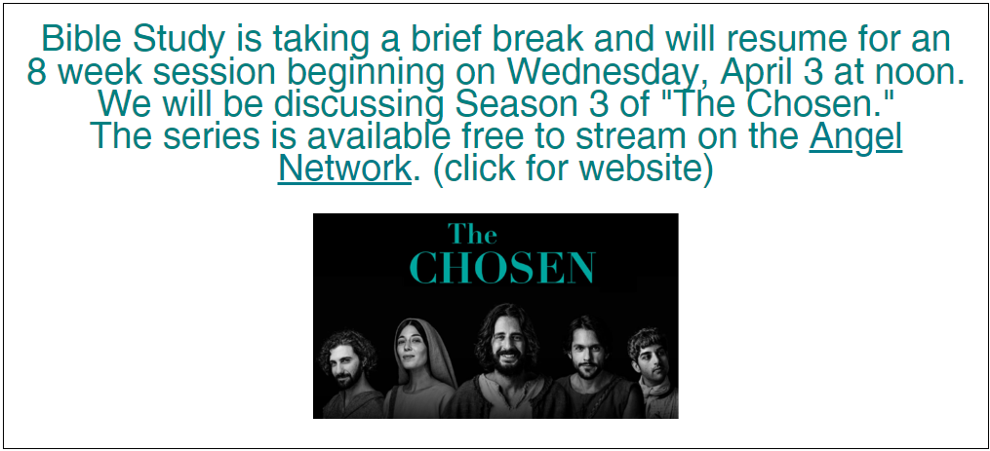
People of God, for what else do we pray?
Lent is a season to focus on prayer. No prayer is too big or too small. You are welcome to use the post-its and pens on the back table to share your prayer concerns, gratitude, celebration, and anything else on your heart.
Holy Week Schedule
Sunday, March 24
9:00 am: Palm Sunday Worship
Thursday, March 28
7:00 pm: Maundy Thursday
Friday, March 29
12:00 pm: Ecumenical Good Friday Worship at Faith Lutheran Church
7:00 pm: Joint Good Friday Worship at GSLC with Faith Lutheran
Sunday, March 31
9:00 am: Easter Sunday Worship
Easter Garden Donations
Good Shepherd altar care will soon be purchasing a variety of plants and
decorations for the Easter Garden and Outdoor Summer Services.
If you would like to make a donation, fill out the form on the table in the
narthex and place it with your check with Easter Garden in the memo line in
the offering plate or on the desk in the office.

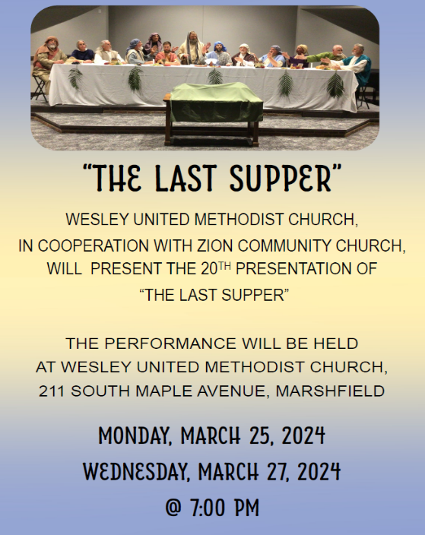
We are seeking two delegates to attend the Synod Assembly, June 7-8 in Eau Claire. This year is a bishop’s election, so you will help shape synod leadership for the next several years! The synod specifies we need one lay male and one lay female to attend.

During the season of Lent as we explore Peter’s faith journey, we consider our own faith journey as well. As we hear today’s invitation to forgiveness, consider what things are you being called to forgive, to let go of in order to move forward in your life? They may be hurts we are holding onto, past versions of ourselves, or ideas we once held to be true.

