Good Shepherd Lutheran Church
Pastor: Katie Anderson | Music Director: Lois Swanson
Pastor’s Cell: (715) 245-1943 | Office Phone: (715) 387-2731
Pastor Email: gslcwi.pastor@gmail.com | Office Email: gslcwi.office@gmail.com
Website: GoodShepherdMarshfield.org | www.facebook.com/gslcwi
Fourth Sunday in Lent
March 10, 2024, 9:00 am
Introduction to the day…
When your world unravels and your beliefs are tested, you may cling to what you know. As Jesus foretells his death and resurrection, Peter protests. Peter is fixed upon the way he thinks things should go; he resists the pain of what will come. But Jesus is fixed upon his calling and calls Peter out. For everyone, there comes a time when your faith is tested and you will have to face difficult and inconvenient truths. We may want to take the easier path, the path with less pain. We may want to cling to easy or simplistic answers. Instead, what does it look like to welcome complexity? Can you stay fixed upon your convictions while also expanding your perspective?
ANNOUNCEMENTS
GATHERING
GATHERING HYMN All Who Hunger, Gather Gladly ELW 461
CONFESSION AND FORGIVENESS
Holy God,
We often find ourselves moving through a world that does not make sense.
Like Peter, we are tempted to demand, “Forbid it, Lord!”
We want to control scenarios beyond our reach.
We want to hold your world in our hands.
Forgive us for the moments when we lead with declarations instead of curiosity.
Forgive us for arguing when we could listen.
Forgive us for fixating on one truth, when we could open ourselves up to many.
Soften our hard edges and teach us how to listen.
With hope in our hearts we pray.
Amen.

Friends, no matter how many times you have dug your heels in,
no matter how many fights you have wanted to pick with God,
no matter how many times you have disagreed, raged,
or clung to what you know instead of embracing holy change—
we worship a God of Grace.

Nothing can separate us from God’s love.
Hear and believe the good news of the gospel:
God’s love for us will always be deeper than we can imagine.
We are seen. We are loved. And we are forgiven.
Amen.
PRAYER OF THE DAY
Listening God, If we could attach ourselves to you, we would. We would bind ourselves to you, but instead, we wander. Instead of attaching ourselves to you, we find ourselves swept up in the busyness of the day. Like a seesaw of faithfulness, we move back and forth, up and down, constantly trying to find you in the midst of it all. Speak clearly to us now. Quiet the distractions long enough for us to affix ourselves to your good news. We are listening. We are hungry. We are hopeful. Amen.
CHILDREN’S MUSIC Be Still and Know ACS 1083
CHILDREN’S MESSAGE

SCRIPTURE READINGS
FIRST READING: Numbers 21:4-9
⁴From Mount Hor [the Israelites] set out by the way to the Red Sea, to go around the land of Edom; but the people became impatient on the way. ⁵The people spoke against God and against Moses, “Why have you brought us up out of Egypt to die in the wilderness? For there is no food and no water, and we detest this miserable food.” ⁶Then the Lord sent poisonous serpents among the people, and they bit the people, so that many Israelites died. ⁷The people came to Moses and said, “We have sinned by speaking against the Lord and against you; pray to the Lord to take away the serpents from us.” So Moses prayed for the people. ⁸And the Lord said to Moses, “Make a poisonous serpent, and set it on a pole; and everyone who is bitten shall look at it and live.” ⁹So Moses made a serpent of bronze, and put it upon a pole; and whenever a serpent bit someone, that person would look at the serpent of bronze and live.
Word of God, word of life.
Thanks be to God.
PSALM: Psalm 107:1-3, 17-22
¹Give thanks to the Lord, for the Lord is good,
for God’s mercy endures forever.
²Let the redeemed of the Lord proclaim
that God redeemed them from the hand of the foe,
³gathering them in from the lands;
from the east and from the west, from the north and from the south.
¹⁷Some were fools and took rebellious paths;
through their sins they were afflicted.
¹⁸They loathed all manner of food
and drew near to death’s door.
¹⁹Then in their trouble they cried to the Lord
and you delivered them from their distress.
²⁰You sent forth your word and healed them
and rescued them from the grave.
²¹Let them give thanks to you, Lord, for your steadfast love
and your wonderful works for all people.
²²Let them offer sacrifices of thanksgiving
and tell of your deeds with shouts of joy.
SECOND READING: Ephesians 2:1-10
¹You were dead through the trespasses and sins ²in which you once lived, following the course of this world, following the ruler of the power of the air, the spirit that is now at work among those who are disobedient. ³All of us once lived among them in the passions of our flesh, following the desires of flesh and senses, and we were by nature children of wrath, like everyone else. ⁴But God, who is rich in mercy, out of the great love with which he loved us ⁵even when we were dead through our trespasses, made us alive together with Christ—by grace you have been saved—⁶and raised us up with him and seated us with him in the heavenly places in Christ Jesus, ⁷so that in the ages to come he might show the immeasurable riches of his grace in kindness toward us in Christ Jesus. ⁸For by grace you have been saved through faith, and this is not your own doing; it is the gift of God—⁹not the result of works, so that no one may boast. ¹⁰For we are what he has made us, created in Christ Jesus for good works, which God prepared beforehand to be our way of life.
Word of God, word of life.
Thanks be to God.
GOSPEL ACCLAMATION ACS pg. 15
GOSPEL: Matthew 16:21-23
²¹From that time on, Jesus began to show his disciples that he must go to Jerusalem and undergo great suffering at the hands of the elders and chief priests and scribes, and be killed, and on the third day be raised. ²²And Peter took him aside and began to rebuke him, saying, "God forbid it, Lord! This must never happen to you." ²³But he turned and said to Peter, "Get behind me, Satan! You are a stumbling block to me; for you are setting your mind not on divine things but on human things."
The gospel of the Lord.
Praise to you, O Christ.
SERMON I’m Fixed Upon It
HYMN OF THE DAY Chief of Sinners Though I Be ELW 609
AFFIRMATION OF FAITH
I believe in a God of second chances,
a God who sees through my stubbornness
and holds my fear with tenderness.

I believe that this God of second chances
uses ordinary people like Peter to do good in the world.
Therefore, I believe and hope that God can use me too.

I believe that from time to time, God invites us to imagine the impossible.
I believe that from time to time, God invites us to change our minds.
This change is holy and important work, but challenging.
When fear and scarcity plague me,
or when the impossible feels out of reach,
I believe that God meets me with grace and invites me to follow.

Thanks be to God for a love like that.
Amen.
PRAYERS OF INTERCESSION
…Hear us, O God.
Your mercy is great.
Accompany us on our journey, God of grace, and receive the prayers of our hearts, through Jesus Christ, our Savior.
Amen.
PEACE
The peace of Christ be with you always.
And also with you.
HOLY COMMUNION
OFFERING In addition to our normal offering, a Special Benevolence in March (collected in a special envelope) will go to Marshfield Area Respite Care Center.
OFFERING HYMN Softly and Tenderly Jesus Is Calling ELW 608
OFFERTORY PRAYER
Jesus, you are the bread of life
and the host of this meal.
Bless these gifts that we have gathered
that all people may know your goodness.
Feed us not only with this holy food
but with hunger for justice and peace.
We pray this in your name.
Amen.
GREAT THANKSGIVING
The Lord be with you.
And also with you.
Lift up your hearts.
We lift them to the Lord.
Let us give our thanks to the Lord our God.
It is right to give our thanks and praise.
Holy, Holy ACS pg. 20

THANKSGIVING AT THE TABLE

Blessed are you, O God of the universe.
Your mercy is everlasting
and your faithfulness endures from age to age.
Praise to you for creating the heavens and the earth.
Praise to you for saving the earth from the waters of the flood.
Praise to you for bringing the Israelites safely through the sea.
Praise to you for leading your people through the wilderness
to the land of milk and honey.
Praise to you for the words and deeds of Jesus, your anointed one.
Praise to you for the death and resurrection of Christ.
Praise to you for your Spirit poured out on all nations.

In the night in which he was betrayed,
our Lord Jesus took bread, and gave thanks;
broke it, and gave it to his disciples, saying:
Take and eat; this is my body, given for you.
Do this for the remembrance of me.

Again, after supper, he took the cup, gave thanks,
and gave it for all to drink, saying:
This cup is the new covenant in my blood,
shed for you and for all people for the forgiveness of sin.
Do this for the remembrance of me.

With this bread and cup
we remember our Lord’s passover from death to life
as we proclaim the mystery of faith:
Christ has died.
Christ is risen.
Christ will come again.

O God of resurrection and new life:
Pour out your Holy Spirit on us
and on these gifts of bread and wine.
Bless this feast.
Grace our table with your presence.
Come, Holy Spirit.

Reveal yourself to us in the breaking of the bread.
Raise us up as the body of Christ for the world.
Breathe new life into us.
Send us forth,
burning with justice, peace, and love.
Come, Holy Spirit.

With your holy ones of all times and places,
with the earth and all its creatures,
with sun and moon and stars,
we praise you, O God,
blessed and holy Trinity,
now and forever.
Amen.
THE LORD’S PRAYER
Our Father, who art in heaven,
hallowed be thy name,
thy kingdom come,
thy will be done, on earth as it is in heaven.
Give us this day our daily bread;
and forgive us our trespasses, as we forgive those
who trespass against us;
and lead us not into temptation, but deliver us from evil.
For thine is the kingdom, and the power, and the glory,
forever and ever. Amen.
INVITATION TO COMMUNION - Certified gluten-free crackers are in the bowl on the communion plate.
Bread for the journey.
A feast for hungry hearts. Come!
HOLY COMMUNION
PRAYER AFTER COMMUNION
Generous God,
at this table we have tasted your immeasurable grace.
As grains of wheat are gathered into one bread,
now make us one loaf to feed the world;
in the name of Jesus, the Bread of life.
Amen.

SENDING
BENEDICTION
Beloved wanderer,
as you leave this place,
may you carry your curious heart on your sleeve.
May you look for God in every face.
May you find the courage to get out of the boat,
to run to the tomb,
and to speak of your faith.
And when the world falls apart,
may you hear God’s voice deep within,
saying, “Take heart, it is I, be not afraid.”
You are called.
You are blessed.
In both your ups and your downs,
you always belong to God.
Go now in peace.
Go trusting that good news.
Amen.
CLOSING HYMN When We Are Tested ACS 922
DISMISSAL
Go in peace. Share your bread.
Thanks be to God.
Upcoming Worship Assistants
 | Usher | Lector | Communion | Offering Counters |  | Deep Clean
March 10 | Susan Schoolman | Andrea Hovik | Bruce & Nancy Tibbett | Heidi Binder | Kami Weis | March:  Nancy Lenard  Jannalee Kolbeck Lindquist  Heidi Binder
March 17 | Tammy Neumann | Jon Hill | Dan & Pam Mundt | Pam Mundt | May Hill
March 24 | Gene & Linda Schrieber | Leslie Mader | Dave & Sue Schraeder | Dan Mundt | Jon Hill
March 31  Easter | Dave & Kami Weis | Kris Tarter | Ron Rothfusz  Andrea Hovik | Nancy Leonard | Breanna Butler

Sunday, March 10 | 9:00 am | Worship Service  - Fourth Sunday in Lent  - Matthew 16:21-23; Jesus foretells his death and resurrection
Tuesday, March 12 | 6:30 pm | Council Meeting
 | 7:00 pm | AA Meeting
Wednesday, March 13 | 12:00 pm | Bible Study (discuss Season 2 Episode 8 of “The Chosen”)
 | 6:00 pm | Bread & Broth
 | 7:00 pm | Midweek Worship  Confirmation Class
Sunday, March 17 | 9:00 am | Worship Service – Sunday School  - Fifth Sunday in Lent  - Matthew 18:15-22; Binding and loosing, and how often to forgive

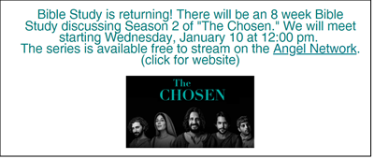
People of God, for what else do we pray?
Lent is a season to focus on prayer. No prayer is too big or too small. You are welcome to use the post-its and pens on the back table to share your prayer concerns, gratitude, celebration, and anything else on your heart.
SOS has provided their list of needs for this month, which includes:
Kidney Beans, Baked Beans, Sandwich Bags, Chicken Noodle Soup, Dish Soap, Oatmeal, Jelly, Gravy, Pudding, Broth, All Purpose Cleaner, Shampoo, Conditioner, Pancake Mix, Baking Items, Paper Towels, Dried Soup. Urgently need: Mayo and Paper Towels.
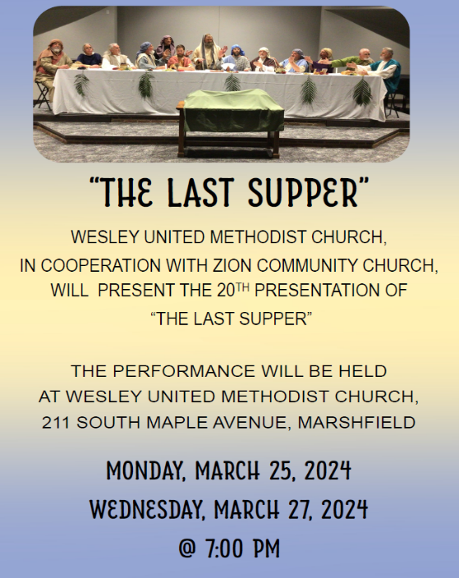
During the season of Lent as we explore Peter’s faith journey, we consider our own faith journey as well. Think of important decisions you have made in your life. What made them important? How did you decide which choice to go with? How has your faith been part of making those decisions? And what has been the result of what you decided?

