Good Shepherd Lutheran Church
Pastor: Katie Anderson | Music Director: Lois Swanson
Pastor’s Cell: (715) 245-1943 | Office Phone: (715) 387-2731
Pastor Email: gslcwi.pastor@gmail.com | Office Email: gslcwi.office@gmail.com
Website: GoodShepherdMarshfield.org | www.facebook.com/gslcwi
Third Sunday after Epiphany
January 21, 2024, 9:00am
Introduction to the day…
As we continue through the time after Epiphany, stories of the call to discipleship show us the implications of our baptismal calling to show Christ to the world. Jesus begins proclaiming the good news and calling people to repentance right after John the Baptist is arrested for preaching in a similar way. Knowing that John was later executed, we see at the very outset the cost of discipleship. Still, the two sets of brothers leave everything they have known and worked for all their lives to follow Jesus and fish for people.
GATHERING
GATHERING HYMN Light Shines in Darkness ELW 307
CONFESSION AND FORGIVENESS
Blessed be the holy Trinity, ☩ one God,
creator of darkness and light,
word of truth,
wind sweeping over the waters.
Amen.
Let us confess our sin in the presence of God and of one another.
Silence is kept for reflection.
God, our rock and refuge,
we pour out our hearts before you.
We have known you but have not always loved you.
We have wounded one another
and sinned against you.
We have not always recognized the Holy Spirit
dwelling in each of us.
Remember your covenant.
Renew your creation.
Restore us,
that we might proclaim your good news to all.
Amen.
The voice of the Lord is upon the waters.
God has spoken:
The time of grace is now.
In Jesus, the reign of God has come near.
By the authority of ☩ Jesus Christ,
your sins are forgiven.
You are God’s beloved.
Amen.

PRAYER OF THE DAY
Almighty God, by grace alone you call us and accept us in your service. Strengthen us by your Spirit, and make us worthy of your call, through Jesus Christ, our Savior and Lord.
Amen.

CHILDREN’S MUSIC In My Life, Lord, Be Glorified ELW 744 v. 1
CHILDREN’S MESSAGE

SCRIPTURE READINGS

FIRST READING: Jonah 3:1-5, 10
¹The word of the Lord came to Jonah a second time, saying, ²“Get up, go to Nineveh, that great city, and proclaim to it the message that I tell you.” ³So Jonah set out and went to Nineveh, according to the word of the Lord. Now Nineveh was an exceedingly large city, a three days’ walk across. ⁴Jonah began to go into the city, going a day’s walk. And he cried out, “Forty days more, and Nineveh shall be overthrown!” ⁵And the people of Nineveh believed God; they proclaimed a fast, and everyone, great and small, put on sackcloth.
¹⁰When God saw what they did, how they turned from their evil ways, God changed his mind about the calamity that he had said he would bring upon them; and he did not do it.
Word of God, word of life.
Thanks be to God.
PSALM: Psalm 62:5-12
⁵For God alone I wait in silence;
truly, my hope is in God.
⁶God alone is my rock and my salvation,
my stronghold, so that I shall never be shaken.
⁷In God is my deliverance and my honor;
God is my strong rock and my refuge.
⁸Put your trust in God always, O people,
pour out your hearts before the one who is our refuge.
⁹Those of high degree are but a fleeting breath; those of low estate cannot be trusted.
Placed on the scales together they weigh even less than a breath.
¹⁰Put no trust in extortion; in robbery take no empty pride;
though wealth increase, set not your heart upon it.
¹¹God has spoken once, twice have I heard it,
that power belongs to God.
¹²Steadfast love belongs to you, O Lord,
for you repay all according to their deeds.

SECOND READING: 1 Corinthians 7:29-31
²⁹Brothers and sisters, the appointed time has grown short; from now on, let even those who have wives be as though they had none, ³⁰and those who mourn as though they were not mourning, and those who rejoice as though they were not rejoicing, and those who buy as though they had no possessions, ³¹and those who deal with the world as though they had no dealings with it. For the present form of this world is passing away.
Word of God, word of life.
Thanks be to God.
GOSPEL ACCLAMATION Come and See ACS 976
GOSPEL: Mark 1:14-20
¹⁴Now after John was arrested, Jesus came to Galilee, proclaiming the good news of God, ¹⁵and saying, “The time is fulfilled, and the kingdom of God has come near; repent, and believe in the good news.”
¹⁶As Jesus passed along the Sea of Galilee, he saw Simon and his brother Andrew casting a net into the sea—for they were fishermen. ¹⁷And Jesus said to them, “Follow me and I will make you fish for people.” ¹⁸And immediately they left their nets and followed him. ¹⁹As he went a little farther, he saw James son of Zebedee and his brother John, who were in their boat mending the nets. ²⁰Immediately he called them; and they left their father Zebedee in the boat with the hired men, and followed him.
The gospel of the Lord.
Praise to you, O Christ.
SERMON
HYMN OF THE DAY I Love to Tell the Story ELW 661

APOSTLES’ CREED
I believe in God, the Father almighty,
creator of heaven and earth.
I believe in Jesus Christ, God's only Son, our Lord,
who was conceived by the power of the Holy Spirit,
born of the Virgin Mary,
suffered under Pontius Pilate,
was crucified, died, and was buried;
he descended to the dead.
On the third day he rose again;
he ascended into heaven,
he is seated at the right hand of the Father,
and he will come to judge the living and the dead.
I believe in the Holy Spirit,
the holy catholic Church,
the communion of saints,
the forgiveness of sins,
the resurrection of the body,
and the life everlasting.
Amen
PRAYERS OF INTERCESSION
…God of grace,
Receive our prayer.

Knowing the Holy Spirit intercedes for us, we offer these prayers and the silent prayers of our hearts in the name of our Savior, Jesus Christ.
Amen.
PEACE
The peace of Christ be with you always.
And also with you.
HOLY COMMUNION
OFFERING In addition to our normal offering, a Special Benevolence in January (collected in a special envelope) will go to the Marshfield Area Pet Shelter.
OFFERING HYMN I Want to Walk as a Child of the Light ELW 815
OFFERTORY PRAYER
Blessed are you, Holy One,
for all good things come from you.
In bread and cup you open heaven to us.
Meet us at this table,
that we receive what we seek
and follow your Son, Jesus,
in whose name we pray.
Amen.
GREAT THANKSGIVING
The Lord be with you.
And also with you.
Lift up your hearts.
We lift them to the Lord.
Let us give our thanks to the Lord our God.
It is right to give our thanks and praise.

HOLY, HOLY, HOLY ELW 189
THANKSGIVING AT THE TABLE

Holy One, the beginning and the end, the giver of life:
Blessed are you for the birth of creation.
Blessed are you in the darkness and in the light.
Blessed are you for your promise to your people.
Blessed are you in the prophets’ hopes and dreams.
Blessed are you for Mary’s openness to your will.
Blessed are you for your Son Jesus,
the Word made flesh.
In the night in which he was betrayed,
our Lord Jesus took bread, and gave thanks;
broke it, and gave it to his disciples, saying:
Take and eat; this is my body, given for you.
Do this for the remembrance of me.
Again, after supper, he took the cup, gave thanks,
and gave it for all to drink, saying:
This cup is the new covenant in my blood,
shed for you and for all people for the forgiveness of sin.
Do this for the remembrance of me.

Let us proclaim the mystery of faith:
Christ has died.
Christ is risen.
Christ will come again.
With this bread and cup
we remember your Word dwelling among us,
full of grace and truth.
We remember our new birth in his death and resurrection.
We look with hope for his coming.
Come, Lord Jesus.
Holy God, we long for your Spirit.
Come among us.
Bless this meal.
May your Word take flesh in us.
Awaken your people.
Fill us with your light.
Bring the gift of peace on earth.
Come, Holy Spirit.
All praise and glory are yours,
Holy One of Israel,
Word of God incarnate,
Power of the Most High,
one God, now and forever.
Amen.

THE LORD’S PRAYER
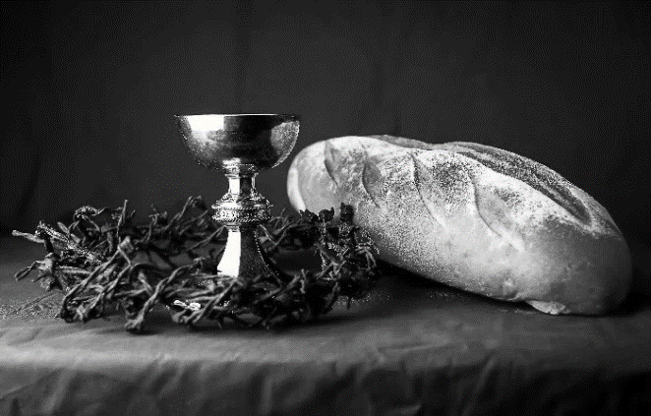
Our Father, who art in heaven,
hallowed be thy name,
thy kingdom come,
thy will be done, on earth as it is in heaven.
Give us this day our daily bread;
and forgive us our trespasses,
as we forgive those
who trespass against us;
and lead us not into temptation,
but deliver us from evil.
For thine is the kingdom,
and the power, and the glory,
forever and ever. Amen.
INVITATION TO COMMUNION - Certified gluten-free crackers are in the bowl on the communion plate.
At Jesus’ table, heaven and earth are joined as one.
Come and see.
HOLY COMMUNION
PRAYER AFTER COMMUNION
Giver of every gift,
Christ’s body is our food, and we are Christ’s body.
Raise us to life by your power
for the benefit of all and to your glory,
now and forever.
Amen.
SENDING
BLESSING
God who names you,
Christ who claims you,
and the Holy Spirit who dwells in you,
☩ bless you and remain with you always.
Amen.
CLOSING HYMN O Jesus, I Have Promised ELW 810
DISMISSAL
Go in peace. You are God’s beloved.
Thanks be to God.

Upcoming Worship Assistants
 | Usher | Lector | Communion | Offering Counters
January, 21 | Stuart & Christine Tipping | Tammy Neumann | Ron Rothfusz  Nancy Leonard | Nancy Leonard | Breanna Butler
January, 28 | Bob & Laurel Peterson | Linda Schrieber | Andrea Hovick | Robin Beeman | David Schneider
February,4 | Ed & Ruth Raatz | Laurel Peterson | Dave & Shelly Schneider | Heidi Binder | Kami Weis
Coming up at GSLC this week
Sunday, January 21 | 9:00 am | Worship Service – Sunday School  - Third Sunday after Epiphany  - Mark 1:14-20; the calling of the disciples at the sea  Budget Review (council members available)
Tuesday, January 23 | 7:00 pm | AA Meeting
Wednesday, January 24 | 12:00 pm | Bible Study (discuss Season 2 Episode 3 of “The Chosen)
 | 7:00 pm | Midweek Worship  Confirmation Class
Sunday, January 28 | 9:00 am | Worship Service  - Fourth Sunday after Epiphany  - Mark 1:21-28; the healing of one with an unclean spirit
 | 10:00 am | Annual Meeting
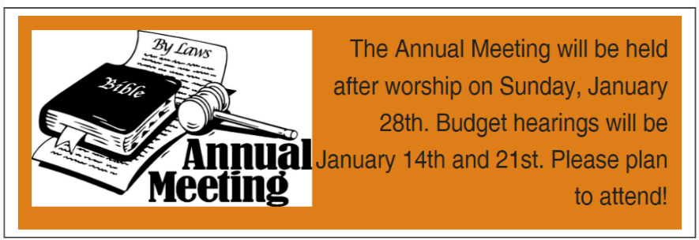
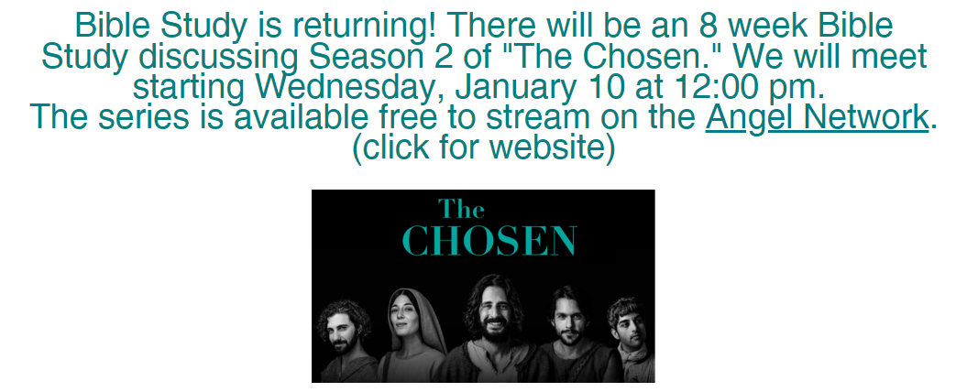

The Luther College Nordic Choir will be performing at First Presbyterian Church on Monday, January 29th at 7pm. Come for a night of excellent music! We are also seeking volunteers to host students for one night after the concert. For more info, talk to Pastor Katie.

