Good Shepherd Lutheran Church
Pastor: Katie Anderson | Music Director: Lois Swanson
Pastor’s Cell: (715) 245-1943 | Office Phone: (715) 387-2731
Pastor Email: gslcwi.pastor@gmail.com | Office Email: gslcwi.office@gmail.com
Website: GoodShepherdMarshfield.org | www.facebook.com/gslcwi
Second Sunday after Epiphany
January 14, 2024, 9:00 am
Introduction to the day…
All the baptized have a calling in God’s world. God calls not just pastors and deacons but also the youngest child, like Samuel. The story of the calling of Nathanael plays with the idea of place. Nathanael initially dismisses Jesus because he comes from Nazareth. But where we come from isn’t important; it’s where—or rather whom—we come to. Jesus refers to Jacob, who had a vision in a place he called “the house of God, and…the gate of heaven” (Gen. 28:17). Jesus says he himself is the place where Nathanael will meet God.
ANNOUNCEMENTS
GATHERING
GATHERING HYMN Light Shines in Darkness ELW 307
CONFESSION AND FORGIVENESS
Blessed be the holy Trinity, ☩ one God,
creator of darkness and light,
word of truth,
wind sweeping over the waters.
Amen.
Let us confess our sin in the presence of God and of one another.
Silence is kept for reflection.
God, our rock and refuge,
we pour out our hearts before you.
We have known you but have not always loved you.
We have wounded one another
and sinned against you.
We have not always recognized the Holy Spirit
dwelling in each of us.
Remember your covenant.
Renew your creation.
Restore us,
that we might proclaim your good news to all.
Amen.
The voice of the Lord is upon the waters.
God has spoken:
The time of grace is now.
In Jesus, the reign of God has come near.
By the authority of ☩ Jesus Christ,
your sins are forgiven.
You are God’s beloved.
Amen.
PRAYER OF THE DAY
Thanks be to you, Lord Jesus Christ, most merciful redeemer, for the countless blessings and benefits you give. May we know you more clearly, love you more dearly, and follow you more nearly, day by day praising you, with the Father and the Holy Spirit, one God, now and forever.
Amen.
CHILDREN’S MUSIC In My Life, Lord, Be Glorified ELW 744 v. 1
CHILDREN’S MESSAGE

SCRIPTURE READINGS

FIRST READING: 1 Samuel 3:1-10 [11-20]
¹Now the boy Samuel was ministering to the Lord under Eli. The word of the Lord was rare in those days; visions were not widespread.
²At that time Eli, whose eyesight had begun to grow dim so that he could not see, was lying down in his room; ³the lamp of God had not yet gone out, and Samuel was lying down in the temple of the Lord, where the ark of God was. ⁴Then the Lord called, “Samuel! Samuel!” and he said, “Here I am!” ⁵and ran to Eli, and said, “Here I am, for you called me.” But he said, “I did not call; lie down again.” So he went and lay down. ⁶The Lord called again, “Samuel!” Samuel got up and went to Eli, and said, “Here I am, for you called me.” But he said, “I did not call, my son; lie down again.” ⁷Now Samuel did not yet know the Lord, and the word of the Lord had not yet been revealed to him. ⁸The Lord called Samuel again, a third time. And he got up and went to Eli, and said, “Here I am, for you called me.” Then Eli perceived that the Lord was calling the boy. ⁹Therefore Eli said to Samuel, “Go, lie down; and if he calls you, you shall say, ‘Speak, Lord, for your servant is listening.’ ” So Samuel went and lay down in his place.
¹⁰Now the Lord came and stood there, calling as before, “Samuel! Samuel!” And Samuel said, “Speak, for your servant is listening.” [¹¹Then the Lord said to Samuel, “See, I am about to do something in Israel that will make both ears of anyone who hears of it tingle. ¹²On that day I will fulfill against Eli all that I have spoken concerning his house, from beginning to end. ¹³For I have told him that I am about to punish his house forever, for the iniquity that he knew, because his sons were blaspheming God, and he did not restrain them. ¹⁴Therefore I swear to the house of Eli that the iniquity of Eli’s house shall not be expiated by sacrifice or offering forever.”
¹⁵Samuel lay there until morning; then he opened the doors of the house of the Lord. Samuel was afraid to tell the vision to Eli. ¹⁶But Eli called Samuel and said, “Samuel, my son.” He said, “Here I am.” ¹⁷Eli said, “What was it that he told you? Do not hide it from me. May God do so to you and more also, if you hide anything from me of all that he told you.” ¹⁸So Samuel told him everything and hid nothing from him. Then he said, “It is the Lord; let him do what seems good to him.”
¹⁹As Samuel grew up, the Lord was with him and let none of his words fall to the ground. ²⁰And all Israel from Dan to Beer-sheba knew that Samuel was a trustworthy prophet of the Lord.

Word of God, word of life.
Thanks be to God.
PSALM: 139:1-6, 13-18
¹Lord, you have searched me out; O Lord, you have known me.
²You know my sitting down and my rising up;
you discern my thoughts from afar.
³You trace my journeys and my resting-places and are acquainted with all my ways.
⁴Indeed, there is not a word on my lips,
but you, O Lord, know it altogether.
⁵You encompass me, behind and before, and lay your and upon me.
⁶Such knowledge is too wonderful for me;
it is so high that I cannot attain to it.
¹³For you yourself created my inmost parts; you knit me together in my mother’s womb.
¹⁴I will thank you because I am marvelously made;
your works are wonderful, and I know it well.
¹⁵My body was not hidden from you,
while I was being made in secret and woven in the depths of the earth.
¹⁶Your eyes beheld my limbs, yet unfinished in the womb; all of them were written in your book;
my days were fashioned before they came to be.
¹⁷How deep I find your thoughts, O God!
How great is the sum of them!
¹⁸If I were to count them, they would be more in number than the sand;
to count them all, my life span would need to be like yours.

SECOND READING: 1 Corinthians 6:12-20
¹²“All things are lawful for me,” but not all things are beneficial. “All things are lawful for me,” but I will not be dominated by anything. ¹³“Food is meant for the stomach and the stomach for food,” and God will destroy both one and the other. The body is meant not for fornication but for the Lord, and the Lord for the body. ¹⁴And God raised the Lord and will also raise us by his power. ¹⁵Do you not know that your bodies are members of Christ? Should I therefore take the members of Christ and make them members of a prostitute? Never! ¹⁶Do you not know that whoever is united to a prostitute becomes one body with her? For it is said, “The two shall be one flesh.” ¹⁷But anyone united to the Lord becomes one spirit with him. ¹⁸Shun fornication! Every sin that a person commits is outside the body; but the fornicator sins against the body itself. ¹⁹Or do you not know that your body is a temple of the Holy Spirit within you, which you have from God, and that you are not your own? ²⁰For you were bought with a price; therefore glorify God in your body.
Word of God, word of life.
Thanks be to God.
GOSPEL ACCLAMATION Come and See ACS 976
GOSPEL: Matthew 1:43-51
⁴³The next day Jesus decided to go to Galilee. He found Philip and said to him, “Follow me.” ⁴⁴Now Philip was from Bethsaida, the city of Andrew and Peter. ⁴⁵Philip found Nathanael and said to him, “We have found him about whom Moses in the law and also the prophets wrote, Jesus son of Joseph from Nazareth.” ⁴⁶Nathanael said to him, “Can anything good come out of Nazareth?” Philip said to him, “Come and see.” ⁴⁷When Jesus saw Nathanael coming toward him, he said of him, “Here is truly an Israelite in whom there is no deceit!” ⁴⁸Nathanael asked him, “Where did you get to know me?” Jesus answered, “I saw you under the fig tree before Philip called you.” ⁴⁹Nathanael replied, “Rabbi, you are the Son of God! You are the King of Israel!” ⁵⁰Jesus answered, “Do you believe because I told you that I saw you under the fig tree? You will see greater things than these.” ⁵¹And he said to him, “Very truly, I tell you, you will see heaven opened and the angels of God ascending and descending upon the Son of Man.”
The gospel of the Lord.
Praise to you, O Christ.
SERMON
HYMN OF THE DAY Will You Come and Follow Me ELW 798

APOSTLES’ CREED
I believe in God, the Father almighty,
creator of heaven and earth.
I believe in Jesus Christ, God's only Son, our Lord,
who was conceived by the power of the Holy Spirit,
born of the Virgin Mary,
suffered under Pontius Pilate,
was crucified, died, and was buried;
he descended to the dead.
On the third day he rose again;
he ascended into heaven,
he is seated at the right hand of the Father,
and he will come to judge the living and the dead.
I believe in the Holy Spirit,
the holy catholic Church,
the communion of saints,
the forgiveness of sins,
the resurrection of the body,
and the life everlasting.
Amen

PRAYERS OF INTERCESSION
…God of grace,
Receive our prayer.
Knowing the Holy Spirit intercedes for us, we offer these prayers and the silent prayers of our hearts in the name of our Savior, Jesus Christ.
Amen.
PEACE
The peace of Christ be with you always.
And also with you.
HOLY COMMUNION
OFFERING In addition to our normal offering, a Special Benevolence in January(collected in a special envelope) will go to Marshfield Area Pet Shelter. Their mission is to enrich the lives of animals in need and improve the relationship between people and pets.
OFFERING HYMN Take My Life, That I May Be ELW 583
OFFERTORY PRAYER
Blessed are you, Holy One,
for all good things come from you.
In bread and cup you open heaven to us.
Meet us at this table,
that we receive what we seek
and follow your Son, Jesus,
in whose name we pray.
Amen.
GREAT THANKSGIVING
The Lord be with you.
And also with you.
Lift up your hearts.
We lift them to the Lord.
Let us give our thanks to the Lord our God.
It is right to give our thanks and praise.
HOLY, HOLY, HOLY ELW 189
THANKSGIVING AT THE TABLE

Holy One, the beginning and the end, the giver of life:
Blessed are you for the birth of creation.
Blessed are you in the darkness and in the light.
Blessed are you for your promise to your people.
Blessed are you in the prophets’ hopes and dreams.
Blessed are you for Mary’s openness to your will.
Blessed are you for your Son Jesus,
the Word made flesh.
In the night in which he was betrayed,
our Lord Jesus took bread, and gave thanks;
broke it, and gave it to his disciples, saying:
Take and eat; this is my body, given for you.
Do this for the remembrance of me.
Again, after supper, he took the cup, gave thanks,
and gave it for all to drink, saying:
This cup is the new covenant in my blood,
shed for you and for all people for the forgiveness of sin.
Do this for the remembrance of me.
Let us proclaim the mystery of faith:
Christ has died.
Christ is risen.
Christ will come again.
With this bread and cup
we remember your Word dwelling among us,
full of grace and truth.
We remember our new birth in his death and resurrection.
We look with hope for his coming.
Come, Lord Jesus.
Holy God, we long for your Spirit.
Come among us.
Bless this meal.
May your Word take flesh in us.
Awaken your people.
Fill us with your light.
Bring the gift of peace on earth.
Come, Holy Spirit.
All praise and glory are yours,
Holy One of Israel,
Word of God incarnate,
Power of the Most High,
one God, now and forever.
Amen.

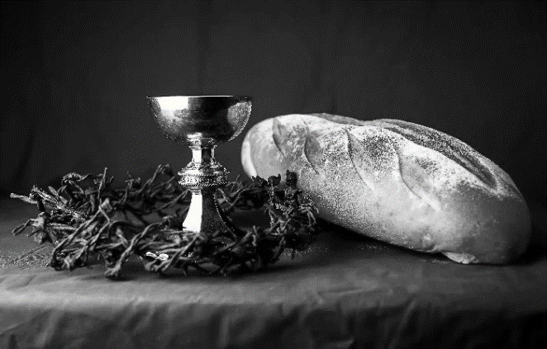
THE LORD’S PRAYER
Our Father, who art in heaven,
hallowed be thy name,
thy kingdom come,
thy will be done, on earth as it is in heaven.
Give us this day our daily bread;
and forgive us our trespasses, as we forgive those
who trespass against us;
and lead us not into temptation,
but deliver us from evil.
For thine is the kingdom, and the power, and the glory,
forever and ever. Amen.
INVITATION TO COMMUNION - Certified gluten-free crackers are in the bowl on the communion plate.
At Jesus’ table, heaven and earth are joined as one.
Come and see
HOLY COMMUNION
PRAYER AFTER COMMUNION
Giver of every gift,
Christ’s body is our food, and we are Christ’s body.
Raise us to life by your power
for the benefit of all and to your glory,
now and forever.
Amen.

SENDING
BLESSING
God who names you,
Christ who claims you,
and the Holy Spirit who dwells in you,
☩ bless you and remain with you always.
Amen.
CLOSING HYMN Here I Am, Lord ELW 673
DISMISSAL
Go in peace. You are God’s beloved.
Thanks be to God.

Upcoming Worship Assistants
 | Usher | Lector | Communion | Offering Counters
January, 14 | Matt & Margo Berrier | Shelly Schneider | Dave & Sue Schraeder | Dan Mundt | Jon Hill
January, 21 | Stuart & Christine Tipping | Tammy Neumann | Ron Rothfusz  Nancy Leonard | Nancy Leonard | Breanna Butler
January, 28 | Bob & Laurel Peterson | Linda Schrieber | Andrea Hovick  Bob Peterson | Robin Beeman | David Schneider
February, 4 | Ed & Ruth Raatz | Laurel Peterson | Dave & Shelly Schneider | Heidi Binder | Kami Weis

Sunday, January 14 | 9:00 am | Worship Service  - Second Sunday after Epiphany  - John 1:43-51; the calling of the first disciples  Budget Review (council members available)
Tuesday, January 16 | 2:00 pm | Chapel at Three Oaks
 | 7:00 pm | AA Meeting
Wednesday, January 17 | 12:00 pm | Bible Study (discuss Season 2 Episode 2 of “The Chosen)
 | 7:00 pm | Midweek Worship  Confirmation Class
Sunday, January 21 | 9:00 am | Worship Service – Sunday School  - Third Sunday after Epiphany  - Mark 1:14-20; the calling of the disciples at the sea  Budget Review (council members available)

SOS needs for January:

- Kidney Beans
- Baked Beans
- Sandwich Bags
- Chicken Noodle Soup
- Dish Soap
- Oatmeal
- Jelly
- Gravy
- Pudding
- Broth
- All Purpose Cleaner
- Shampoo
- Conditioner
- Baby Wipes
- Pancake Mix

- Mayo
- Baking Items
- Paper Towels
- Dried Soup
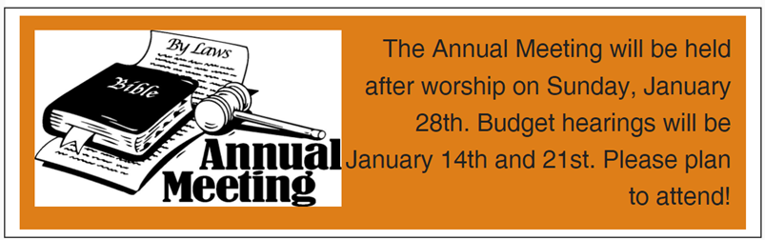

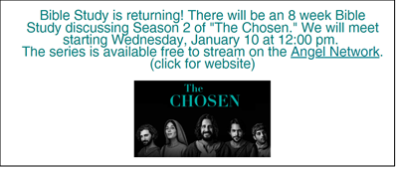

The Luther College Nordic Choir will be performing at First Presbyterian Church on Monday, January 29th at 7pm. Come for a night of excellent music! We are also seeking volunteers to host students for one night after the concert. For more info, talk to Pastor Katie.

