Good Shepherd Lutheran Church
Pastor: Katie Anderson | Music Director: Lois Swanson
Pastor’s Cell: (715) 245-1943 | Office Phone: (715) 387-2731
Pastor Email: gslcwi.pastor@gmail.com | Office Email: gslcwi.office@gmail.com
Website: GoodShepherdMarshfield.org | www.facebook.com/gslcwi
All Saints Sunday
November 5, 2023, 9:00 am
Introduction to the day…
All Saints celebrates the baptized people of God, living and dead, who are the body of Christ. As November heralds the dying of the landscape in many northern regions, the readings and liturgy call us to remember all who have died in Christ and whose baptism is complete. At the Lord’s table we gather with the faithful of every time and place, trusting that the promises of God will be fulfilled and that all tears will be wiped away in the new Jerusalem.
ANNOUNCEMENTS
GATHERING
GATHERING HYMN Shall We Gather at the River ELW 423
CONFESSION AND FORGIVENESS
Blessed be the holy Trinity, ☩ one God,
in whose image we are made,
who claims us and calls us beloved.
Amen.
Silence is kept for reflection.
Holy One,
we confess that we are not awake for you.
We are not faithful in using your gifts.
We forget the least of our siblings.
We do not see your beautiful image in one another.
We are infected by sin
that divides your beloved community.
Open our hearts to your coming,
What is All Saints Sunday?
The custom of commemorating all the saints of the church on a single day goes back at least to the third century. All Saints celebrates the baptized people of God, living and dead, who make up the body of Christ. We remember all who have died in the faith and now serve God around the heavenly throne.
open our eyes to see you in our neighbor,
open our hands to serve your creation.
Amen.
Beloved, we are God’s children,
and Jesus, our Beloved, opens the door to us.
Through ☩ Jesus you are forgiven,
by Jesus you are welcome,
in Jesus you are called to rejoice!
Let us live in the promises prepared for us
from the foundation of the world.
Amen.
PRAYER OF THE DAY
Almighty God, you have knit your people together in one communion in the mystical body of your Son, Jesus Christ our Lord. Grant us grace to follow your blessed saints in lives of faith and commitment, and to know the inexpressible joys you have prepared for those who love you, through Jesus Christ, our Savior and Lord, who lives and reigns with you and the Holy Spirit, one God, now and forever. Amen.
CHILDREN’S MUSIC We Are Marching in the Light of God ELW 866
CHILDREN’S MESSAGE

SCRIPTURE READINGS
FIRST READING: Revelation 7:9-17
⁹After this I looked, and there was a great multitude that no one could count, from every nation, from all tribes and peoples and languages, standing before the throne and before the Lamb, robed in white, with palm branches in their hands. ¹⁰They cried out in a loud voice, saying,
“Salvation belongs to our God who is seated on the throne, and to the Lamb!”
¹¹And all the angels stood around the throne and around the elders and the four living creatures, and they fell on their faces before the throne and worshiped God, ¹²singing,
“Amen! Blessing and glory and wisdom and thanksgiving and honor
and power and might be to our God forever and ever! Amen.”
¹³Then one of the elders addressed me, saying, “Who are these, robed in white, and where have they come from?” ¹⁴I said to him, “Sir, you are the one that knows.” Then he said to me, “These are they who have come out of the great ordeal; they have washed their robes and made them white in the blood of the Lamb.
¹⁵For this reason they are before the throne of God, and worship him day and night within his temple,
and the one who is seated on the throne will shelter them.
¹⁶They will hunger no more, and thirst no more; the sun will not strike them, nor any scorching heat;
¹⁷for the Lamb at the center of the throne will be their shepherd,
and he will guide them to springs of the water of life, and God will wipe away every tear from their eyes.”
Word of God, word of life.
Thanks be to God.
PSALM: Psalm 34:1-10, 22
¹I will bless the Lord at all times;
the praise of God shall ever be in my mouth.
²I will glory in the Lord;
let the lowly hear and rejoice.
³Proclaim with me the greatness of the Lord;
let us exalt God’s name together.
⁴I sought the Lord, who answered me
and delivered me from all my terrors.
⁵Look upon the Lord and be radiant,
and let not your faces be ashamed.
⁶I called in my affliction, and the Lord heard me
and saved me from all my troubles.
⁷The angel of the Lord encamps around those who fear the Lord
and delivers them.
⁸Taste and see that the Lord is good;
happy are they who take refuge in God!
⁹Fear the Lord, you saints of the Lord,
for those who fear the Lord lack nothing.
¹⁰The lions are in want and suffer hunger,
but those who seek the Lord lack nothing that is good.
²²O Lord, you redeem the life of your servants,
and those who put their trust in you will not be punished.
SECOND READING: 1 John 3:1-3
¹See what love the Father has given us, that we should be called children of God; and that is what we are. The reason the world does not know us is that it did not know him. ²Beloved, we are God’s children now; what we will be has not yet been revealed. What we do know is this: when he is revealed, we will be like him, for we will see him as he is. ³And all who have this hope in him purify themselves, just as he is pure.
Word of God, word of life.
Thanks be to God.
GOSPEL ACCLAMATION ACS 33

GOSPEL: Matthew 5:1-12
¹When Jesus saw the crowds, he went up the mountain; and after he sat down, his disciples came to him. ²Then he began to speak, and taught them, saying:
³“Blessed are the poor in spirit, for theirs is the kingdom of heaven.
⁴“Blessed are those who mourn, for they will be comforted.
⁵“Blessed are the meek, for they will inherit the earth.
⁶“Blessed are those who hunger and thirst for righteousness, for they will be filled.
⁷“Blessed are the merciful, for they will receive mercy.
⁸“Blessed are the pure in heart, for they will see God.
⁹“Blessed are the peacemakers, for they will be called children of God.
¹⁰“Blessed are those who are persecuted for righteousness’ sake, for theirs is the kingdom of heaven.
¹¹“Blessed are you when people revile you and persecute you and utter all kinds of evil against you falsely on my account. ¹²Rejoice and be glad, for your reward is great in heaven, for in the same way they persecuted the prophets who were before you.”
The gospel of the Lord.
Praise to you, O Christ.
SERMON
HYMN OF THE DAY For All the Saints ELW 422
APOSTLES’ CREED
I believe in God, the Father almighty,
creator of heaven and earth.
I believe in Jesus Christ, God's only Son, our Lord,
who was conceived by the power of the Holy Spirit,
born of the Virgin Mary,
suffered under Pontius Pilate,
was crucified, died, and was buried;
he descended to the dead.
On the third day he rose again;
he ascended into heaven,
he is seated at the right hand of the Father,
and he will come to judge the living and the dead.
I believe in the Holy Spirit,
the holy catholic Church,
the communion of saints,
the forgiveness of sins,
the resurrection of the body,
and the life everlasting.
Amen
PRAYERS OF INTERCESSION
…Hear us, O God.
Your mercy is great.
We offer our spoken prayers and those held in our hearts trusting in your mercy; through Jesus Christ our Savior and Lord.
Amen.
ALL SAINTS LITANY
… let us pray to the Lord.
Lord, have mercy.
PRAYER
Let us pray. O God, remember your church throughout the world. Make all its members grow in love for you and for one another. As you have received our sisters and brothers who have gone to their rest in the hope of the resurrection to eternal life, bring us at last with them into the light of your presence, that in union with all your saints we may give you glory forever; through your Son, Jesus Christ our Lord.
Amen.
PEACE
The peace of Christ be with you always.
And also with you.
HOLY COMMUNION
OFFERING In addition to our normal offering, a Special Benevolence in November (collected in a special envelope) will go to Mary’s Place of Central WI. Mary's Place of Central Wisconsin provides transitional housing services to those in need.
OFFERING HYMN Taste and See ELW 493
OFFERTORY PRAYER
God of all goodness,
generations have turned to you,
gathered around your table,
and shared your abundant blessings.
Number us among them
that, as we gather these gifts from your abundance,
and give thanks for your rich blessings,
we may feast upon your very self
and care for all that you have made,
through Jesus Christ, our Sovereign and Servant.
Amen.
GREAT THANKSGIVING
The Lord be with you.
And also with you.
Lift up your hearts.
We lift them to the Lord.
Let us give our thanks to the Lord our God.
It is right to give our thanks and praise.
HOLY, HOLY, HOLY (Sung) ACS 36
THANKSGIVING AT THE TABLE

Holy God, mighty Lord, gracious Father:
Endless is your mercy and eternal your reign.
You have filled all creation with light and life;
heaven and earth are full of your glory.
We praise you for the grace shown to your people in every age:
the promise to Israel,
the rescue from Egypt,
the gift of the promised land,
the words of the prophets;
and, at this end of all the ages, the gift of your Son,
who proclaimed the good news in word and deed
and was obedient to your will, even to giving his life.
In the night in which he was betrayed,
our Lord Jesus took bread, and gave thanks;
broke it, and gave it to his disciples, saying:
Take and eat; this is my body, given for you.
Do this for the remembrance of me.
Again, after supper, he took the cup, gave thanks,
and gave it for all to drink, saying:
This cup is the new covenant in my blood,
shed for you and for all people for the forgiveness of sin.
Do this for the remembrance of me.
For as often as we eat of this bread and drink from this cup,
we proclaim the Lord’s death until he comes.
Christ has died.
Christ is risen.
Christ will come again.
Therefore, O God, with this bread and cup
we remember the life our Lord offered for us.
And, believing the witness of his resurrection,
we await his coming in power
to share with us the great and promised feast.
Amen. Come, Lord Jesus.
Send now, we pray, your Holy Spirit,
that we who share in Christ’s body and blood
may live to the praise of your glory
and receive our inheritance with all your saints in light.
Amen. Come, Holy Spirit.
Join our prayers with those of your servants
of every time and every place,
and unite them with the ceaseless petitions of our great high priest
until he comes as victorious Lord of all.
Through him, with him, in him,
in the unity of the Holy Spirit,
all glory and honor is yours, almighty Father,
now and forever.
Amen.

THE LORD’S PRAYER
Our Father, who art in heaven,
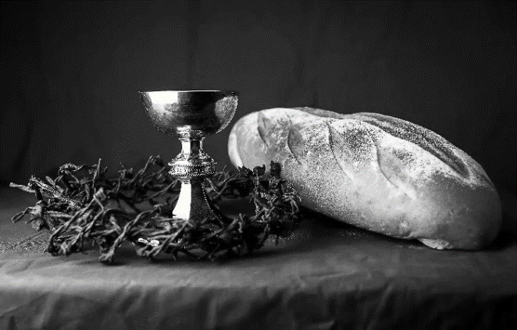
hallowed be thy name,
thy kingdom come,
thy will be done,
on earth as it is in heaven.
Give us this day our daily bread;
and forgive us our trespasses,
as we forgive those
who trespass against us;
and lead us not into temptation,
but deliver us from evil.
For thine is the kingdom,
and the power, and the glory,
forever and ever. Amen.
INVITATION TO COMMUNION - Certified gluten-free crackers are in the bowl on the communion plate.
There is a place for you at the banquet.
Come and feast at Jesus’ table.
HOLY COMMUNION
PRAYER AFTER COMMUNION
Lord Jesus,
in this simple meal you have set a banquet.
Sustain us on the journey,
strengthen us to care for the least of your beloved children,
and give us glad and generous hearts
as we meet you on the way.
Amen.
SENDING
BLESSING
May the God of all creation,
in whose image we are made,
who claims us and calls us beloved,
who strengthens us for service,
give you reason to rejoice and be glad!
The blessing of God,
Sovereign, ☩ Savior, and Spirit,
be with you today and always.
Amen.
CLOSING HYMN Oh When the Saints ACS 590
DISMISSAL
Life is short and we do not have much time to gladden the hearts of those who travel with us.
So be swift to love, make haste to be kind, and go in peace to love and serve the Lord.
Upcoming Worship Assistants
 | Usher | Lector | Communion | Offering Counters
November 5 | Richard & Sarah Kopitzke | Leslie Mader | Dave & Shelly Schneider | Dan Mundt | Jon Hill
November 12 | Ben & Sue Lee | Laurel Peterson | Dave & Sue Schraeder | Nancy Leonard | Breanna Butler
November 19 | Nancy Leonard | Tammy Neumann | Ron Rothfusz  Andrea Hovick | Robin Beeman | David Schneider
November 26 | Dan & Pam Mundt | Julie Will | Matt & Margo Barrier | Heidi Binder | Kami Weis
Thanks be to God.

Coming up at GSLC
Sunday, November 5 | 9:00 am | Worship Service – Sunday School  - All Saints Sunday  - Matthew 5:1-12; blessed are the poor in spirit
Tuesday, November 7 | 6:00 pm | Executive Committee Meeting
 | 7:00 pm | AA Meeting
Wednesday, November 8 | 12:00 pm | Bible Study (discuss Season 1 Episode 8 of “The Chosen”)
 | 7:00 pm | Midweek Worship  - Confirmation Class
Sunday, November 12 | 9:00 am | Worship Service  - 24th Sunday after Pentecost  - Matthew 25:1-13; the story of the wise and foolish bridesmaids.
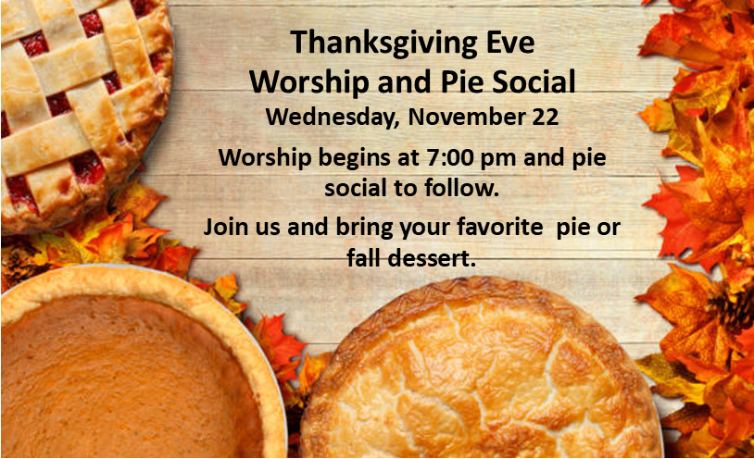
SOS shelves are low and staple needs have been requested from area churches. Good Shepherd has been asked to provide Peanut Butter, Jelly, Mayo, and Miracle Whip.

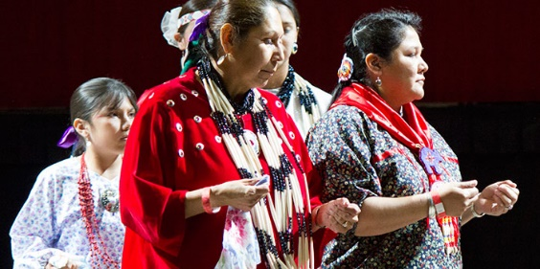
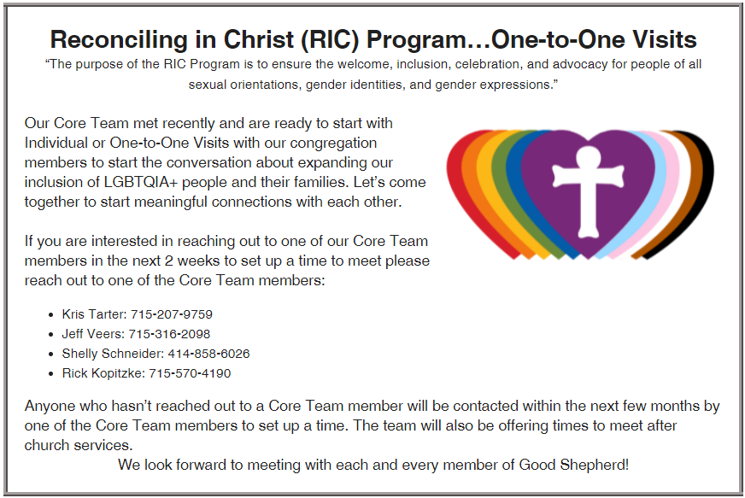
Good Shepherd is in search of an administrative assistant. We are looking for someone friendly and outgoing with good clerical skills to manage office duties. Submit a resume and/or questions to
gslcwi.president@gmail.com.
At the 2023 Synod Assembly, a resolution was passed for churches to participate in an action to honor Native American Heritage Month. The Brothertown Indian Nation, based in Wisconsin, is seeking federal recognition. As a small step we can take to promote equality for all people, a petition will be available through this month to show our support for the Brothertown Nation's efforts.

