Good Shepherd Lutheran Church
Pastor: Katie Anderson | Music Director: Lois Swanson
Pastor’s Cell: (715) 245-1943 | Office Phone: (715) 387-2731
Pastor Email: gslcwi.pastor@gmail.com | Office Email: gslcwi.office@gmail.com
Website: GoodShepherdMarshfield.org | www.facebook.com/gslcwi
24th Sunday after Pentecost
November 12, 2023, 9:00 am
Introduction to the day…
Today the prophet Amos calls for justice to roll down like waters. Paul urges us to encourage one another with the promised coming of the Lord. Jesus tells the parable of the wise and foolish bridesmaids. Surrounded by the faithful of every time and place, we celebrate Christ’s coming in our midst in the word of life and the feast of victory—the marriage feast of the lamb.
ANNOUNCEMENTS
GATHERING
GATHERING HYMN Come, We That Love the Lord ELW 623
CONFESSION AND FORGIVENESS
Blessed be the holy Trinity, ☩ one God,
in whose image we are made,
who claims us and calls us beloved.
Amen.
Silence is kept for reflection.
Holy One,
we confess that we are not awake for you.
We are not faithful in using your gifts.
We forget the least of our siblings.
We do not see your beautiful image in one another.
We are infected by sin
that divides your beloved community.
Open our hearts to your coming,
open our eyes to see you in our neighbor,
open our hands to serve your creation.
Amen.
Beloved, we are God’s children,
and Jesus, our Beloved, opens the door to us.
Through ☩ Jesus you are forgiven,
by Jesus you are welcome,
in Jesus you are called to rejoice!
Let us live in the promises prepared for us
from the foundation of the world.
Amen.
PRAYER OF THE DAY
O God of justice and love, you illumine our way through life with the words of your Son. Give us the light we need, and awaken us to the needs of others, through Jesus Christ, our Savior and Lord. Amen.
CHILDREN’S MUSIC We Are Marching in the Light of God ELW 866
CHILDREN’S MESSAGE
BAPTISM Colin Frederick Schindler
(see insert) Son of Anna and Travis Schindler

SCRIPTURE READINGS
FIRST READING: Amos 5:18-24
¹⁸Alas for you who desire the day of the Lord!
Why do you want the day of the Lord?
It is darkness, not light;
¹⁹as if someone fled from a lion,
and was met by a bear;
or went into the house and rested a hand against the wall,
and was bitten by a snake.
²⁰Is not the day of the Lord darkness, not light,
and gloom with no brightness in it?
²¹I hate, I despise your festivals,
and I take no delight in your solemn assemblies.
²²Even though you offer me your burnt offerings and grain offerings,
I will not accept them;
and the offerings of well-being of your fatted animals
I will not look upon.
²³Take away from me the noise of your songs;
I will not listen to the melody of your harps.
²⁴But let justice roll down like waters,
and righteousness like an ever-flowing stream.
Word of God, word of life.
Thanks be to God.
PSALM: Psalm 70
¹Be pleased, O God, to deliver me;
O Lord, make haste to help me.
²Let those who seek my life be put to shame and confounded;
let those who take pleasure in my misfortune draw back and be disgraced.
³Let those who say to me “Aha!” and gloat over me
turn back because of their shame.
⁴Let all who seek you rejoice and be glad in you;
let those who love your salvation say forever, “Great is the Lord!”
⁵But as for me, I am poor and needy; come to me quickly, O God.
You are my helper and my deliverer; O Lord, do not tarry.
SECOND READING: 1 Thessalonians 4:13-18
¹³We do not want you to be uninformed, brothers and sisters, about those who have died, so that you may not grieve as others do who have no hope. ¹⁴For since we believe that Jesus died and rose again, even so, through Jesus, God will bring with him those who have died. ¹⁵For this we declare to you by the word of the Lord, that we who are alive, who are left until the coming of the Lord, will by no means precede those who have died. ¹⁶For the Lord himself, with a cry of command, with the archangel’s call and with the sound of God’s trumpet, will descend from heaven, and the dead in Christ will rise first. ¹⁷Then we who are alive, who are left, will be caught up in the clouds together with them to meet the Lord in the air; and so we will be with the Lord forever. ¹⁸Therefore encourage one another with these words.
Word of God, word of life.
Thanks be to God.
GOSPEL ACCLAMATION ACS 33
GOSPEL: Matthew 25:1-13
[Jesus said to the disciples:] ¹“Then the kingdom of heaven will be like this. Ten bridesmaids took their lamps and went to meet the bridegroom. ²Five of them were foolish, and five were wise. ³When the foolish took their lamps, they took no oil with them; ⁴but the wise took flasks of oil with their lamps. ⁵As the bridegroom was delayed, all of them became drowsy and slept. ⁶But at midnight there was a shout, ‘Look! Here is the bridegroom! Come out to meet him.’ ⁷Then all those bridesmaids got up and trimmed their lamps. ⁸The foolish said to the wise, ‘Give us some of your oil, for our lamps are going out.’ ⁹But the wise replied, ‘No! there will not be enough for you and for us; you had better go to the dealers and buy some for yourselves.’ ¹⁰And while they went to buy it, the bridegroom came, and those who were ready went with him into the wedding banquet; and the door was shut. ¹¹Later the other bridesmaids came also, saying, ‘Lord, lord, open to us.’ ¹²But he replied, ‘Truly I tell you, I do not know you.’ ¹³Keep awake therefore, for you know neither the day nor the hour.”
The gospel of the Lord.
Praise to you, O Christ.
SERMON
HYMN OF THE DAY Keep Your Lamps Trimmed and Burning ACS 949
APOSTLES’ CREED
I believe in God, the Father almighty,
creator of heaven and earth.
I believe in Jesus Christ, God's only Son, our Lord,
who was conceived by the power of the Holy Spirit,
born of the Virgin Mary,
suffered under Pontius Pilate,
was crucified, died, and was buried;
he descended to the dead.
On the third day he rose again;
he ascended into heaven,
he is seated at the right hand of the Father,
and he will come to judge the living and the dead.
I believe in the Holy Spirit,
the holy catholic Church,
the communion of saints,
the forgiveness of sins,
the resurrection of the body,
and the life everlasting.
Amen
PRAYERS OF INTERCESSION
…Hear us, O God.
Your mercy is great.
We offer our spoken prayers and those held in our hearts trusting in your mercy; through Jesus Christ our Savior and Lord.
Amen.
PEACE
The peace of Christ be with you always.
And also with you.
HOLY COMMUNION
OFFERING In addition to our normal offering, a Special Benevolence in November (collected in a special envelope) will go to Mary’s Place.
OFFERING HYMN Blessed Assurance ELW 638
OFFERTORY PRAYER
God of all goodness,
generations have turned to you, gathered around your table,
and shared your abundant blessings.
Number us among them that,
as we gather these gifts from your abundance,
and give thanks for your rich blessings,
we may feast upon your very self and care for all that you have made,
through Jesus Christ, our Sovereign and Servant.
Amen.
GREAT THANKSGIVING
The Lord be with you.
And also with you.
Lift up your hearts.
We lift them to the Lord.
Let us give our thanks to the Lord our God.
It is right to give our thanks and praise.
HOLY, HOLY, HOLY (Sung) ACS 36
THANKSGIVING AT THE TABLE

Holy God, mighty Lord, gracious Father:
Endless is your mercy and eternal your reign.
You have filled all creation with light and life;
heaven and earth are full of your glory.
We praise you for the grace shown to your people in every age:
the promise to Israel,
the rescue from Egypt,
the gift of the promised land,
the words of the prophets;
and, at this end of all the ages, the gift of your Son,
who proclaimed the good news in word and deed
and was obedient to your will, even to giving his life.
In the night in which he was betrayed,
our Lord Jesus took bread, and gave thanks;
broke it, and gave it to his disciples, saying:
Take and eat; this is my body, given for you.
Do this for the remembrance of me.
Again, after supper, he took the cup, gave thanks,
and gave it for all to drink, saying:
This cup is the new covenant in my blood,
shed for you and for all people for the forgiveness of sin.
Do this for the remembrance of me.
For as often as we eat of this bread and drink from this cup,
we proclaim the Lord’s death until he comes.
Christ has died.
Christ is risen.
Christ will come again.
Therefore, O God, with this bread and cup
we remember the life our Lord offered for us.
And, believing the witness of his resurrection,
we await his coming in power
to share with us the great and promised feast.
Amen. Come, Lord Jesus.
Send now, we pray, your Holy Spirit,
that we who share in Christ’s body and blood
may live to the praise of your glory
and receive our inheritance with all your saints in light.
Amen. Come, Holy Spirit.
Join our prayers with those of your servants
of every time and every place,
and unite them with the ceaseless petitions of our great high priest
until he comes as victorious Lord of all.
Through him, with him, in him,
in the unity of the Holy Spirit,
all glory and honor is yours, almighty Father,
now and forever.
Amen.

THE LORD’S PRAYER
Our Father, who art in heaven,
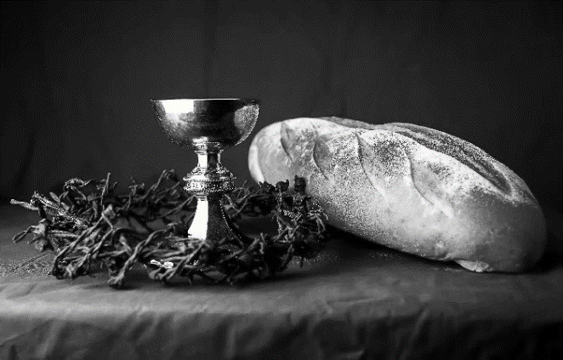
hallowed be thy name,
thy kingdom come,
thy will be done,
on earth as it is in heaven.
Give us this day our daily bread;
and forgive us our trespasses,
as we forgive those
who trespass against us;
and lead us not into temptation,
but deliver us from evil.
For thine is the kingdom,
and the power, and the glory,
forever and ever. Amen.
INVITATION TO COMMUNION - Certified gluten-free crackers are in the bowl on the communion plate.
There is a place for you at the banquet.
Come and feast at Jesus’ table.
HOLY COMMUNION
PRAYER AFTER COMMUNION
Lord Jesus,
in this simple meal you have set a banquet.
Sustain us on the journey,
strengthen us to care for the least of your beloved children,
and give us glad and generous hearts
as we meet you on the way.
Amen.
SENDING
BLESSING
May the God of all creation,
in whose image we are made,
who claims us and calls us beloved,
who strengthens us for service,
give you reason to rejoice and be glad!
The blessing of God,
Sovereign, ☩ Savior, and Spirit,
be with you today and always.
Amen.
CLOSING HYMN Let Justice Flow Like Streams ELW 717
DISMISSAL
Life is short and we do not have much time to gladden the hearts of those who travel with us.
So be swift to love, make haste to be kind, and go in peace to love and serve the Lord.
Thanks be to God.
Upcoming Worship Assistants
 | Usher | Lector | Communion | Offering Counters
November 12 | Ben & Sue Lee | Laurel Peterson | Dave & Sue Schraeder | Nancy Leonard | Breanna Butler
November 19 | Nancy Leonard | Tammy Neumann | Matt & Margo Barrier | Robin Beeman | David Schneider
November 26 | Dan & Pam Mundt | Julie Will | Ron Rothfusz  Andrea Hovick | Heidi Binder | Kami Weis
December 3 | Tammy Neumann | Andrea Hovick | Sarah Kopitzke  Tammy Neumann | Pam Mundt | May Hill
December 10 | Rob & Leslie Mader | Nancy Leonard | Bruce & Nancy Tibbett | Dan Mundt | Jon Hill
December 17 | Jeff & Carol Peterson | Shelly Schneider | John Wagner  Nancy Leonard | Nancy Leonard | Breanna Butler
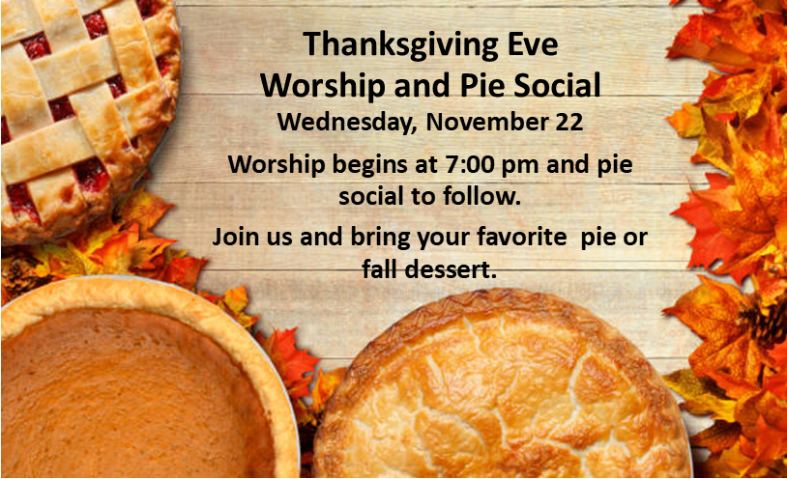
At the 2023 Synod Assembly, a resolution was passed for churches to participate in an action to honor Native American Heritage Month. The Brothertown Indian Nation, based in Wisconsin, is seeking federal recognition. As a small step we can take to promote equality for all people, a petition will be available through this month to show our support for the Brothertown Nation's efforts.
Coming up at GSLC
Sunday, November 12 | 9:00 am | Worship Service  - 24th Sunday after Pentecost  - Matthew 25:1-13; the story of the wise and foolish bridesmaids.  - Baptism of Colin Frederick Schindler, son of Anna & Travis Schindler.
Tuesday, November 14 | 6:30 pm | Council Meeting
 | 7:00 pm | AA Meeting
Wednesday, November 15 | 7:00 pm | Midweek Worship  Confirmation Class
Sunday, November 19 | 9:00 am | Worship Service – Sunday School  - 25th Sunday after Pentecost  - Matthew 25:14-30; the story of the slaves entrusted with talents.

The final Bible Study for
The Chosen: Season 1
was on November 8.
There will then be a short break
from Bible Study until January.
Good Shepherd is in search of an administrative assistant. We are looking for someone friendly and outgoing with good clerical skills to manage office duties. Submit a resume and/or questions to
gslcwi.president@gmail.com.

