Good Shepherd Lutheran Church
Pastor: Katie Anderson | Music Director: Lois Swanson
Pastor’s Cell: (715) 245-1943 | Office Phone: (715) 387-2731
Pastor Email: gslcwi.pastor@gmail.com | Office Email: gslcwi.office@gmail.com
Website: GoodShepherdMarshfield.org | www.facebook.com/gslcwi
17th Sunday after Pentecost
September 24, 2023, 9:00 am
Introduction to the day…
Matthew narrates one of Jesus’ controversial parables in which Jesus says that the reign of God is like that of a landowner who pays his workers the same wage no matter what time of day they began to work. When God changes God’s mind about punishing Nineveh for their evil ways, Jonah is angry. Yet God is gracious and merciful, abounding in steadfast love. In baptism we receive the grace of God that is freely given to all. As Martin Luther wrote, in the presence of God’s mercy we are all beggars.
ANNOUNCEMENTS
GATHERING
GATHERING HYMN Kyrie and Song of Praise ACS 31
CONFESSION AND FORGIVENESS
Blessed be God, the one who forms us,
☩ Jesus who bears the cross,
the Spirit who makes our joy complete.
Amen.
Let us bow before God in humility, confessing our sin.
Silence is kept for reflection.
Steadfast and faithful God,
you have revealed the ways of justice, yet we fail to follow you.
We are overwhelmed by the world’s violence and suffering.
We are afraid to risk what we have for the sake of others.
For the harm we have caused, known and unknown, forgive us.
For the unjust demands we place on others and your creation, forgive us.
For the ways we turn away from you and our neighbor, forgive us.
Lead us back to you and set us on the right path;
in the name of Jesus Christ, our Savior.
Amen.
Beloved in Christ,
God’s justice stretches beyond all understanding.
God’s compassion is beyond compare.
In Jesus, God is always making a new way for us.
In ☩ Christ, you are already and always forgiven.
Amen.
PRAYER OF THE DAY
Almighty and eternal God, you show perpetual lovingkindness to us your servants. Because we cannot rely on our own abilities, grant us your merciful judgment, and train us to embody the generosity of your Son, Jesus Christ, our Savior and Lord. Amen.
CHILDREN’S MUSIC Jesus We Are Gathered ELW 529
CHILDREN’S MESSAGE
SCRIPTURE READINGS
FIRST READING: Jonah 3:10--4:11
¹⁰When God saw what [the people of Ninevah] did, how they turned from their evil ways, God changed his mind about the calamity that he had said he would bring upon them; and he did not do it.
^{4:1}But this was very displeasing to Jonah, and he became angry. ²He prayed to the Lord and said, “O Lord! Is not this what I said while I was still in my own country? That is why I fled to Tarshish at the beginning; for I knew that you are a gracious God and merciful, slow to anger, and abounding in steadfast love, and ready to relent from punishing. ³And now, O Lord, please take my life from me, for it is better for me to die than to live.” ⁴And the Lord said, “Is it right for you to be angry?” ⁵Then Jonah went out of the city and sat down east of the city, and made a booth for himself there. He sat under it in the shade, waiting to see what would become of the city.
⁶The Lord God appointed a bush, and made it come up over Jonah, to give shade over his head, to save him from his discomfort; so Jonah was very happy about the bush. ⁷But when dawn came up the next day, God appointed a worm that attacked the bush, so that it withered. ⁸When the sun rose, God prepared a sultry east wind, and the sun beat down on the head of Jonah so that he was faint and asked that he might die. He said, “It is better for me to die than to live.”
⁹But God said to Jonah, “Is it right for you to be angry about the bush?” And he said, “Yes, angry enough to die.” ¹⁰Then the Lord said, “You are concerned about the bush, for which you did not labor and which you did not grow; it came into being in a night and perished in a night. ¹¹And should I not be concerned about Nineveh, that great city, in which there are more than a hundred and twenty thousand persons who do not know their right hand from their left, and also many animals?”
Word of God, word of life.
Thanks be to God.
PSALM: Psalm 145:1-8
¹I will exalt you, my God and king,
and bless your name forever and ever.
²Every day will I bless you
and praise your name forever and ever.
³Great is the Lord and greatly to be praised!
There is no end to your greatness.
⁴One generation shall praise your works to another
and shall declare your power.
⁵I will speak of the glorious splendor of your majesty
and all your marvelous works.
⁶They shall tell of the might of your wondrous acts,
and I will recount your greatness.
⁷They shall publish the remembrance of your great goodness;
they shall sing joyfully of your righteousness.
⁸The Lord is gracious and full of compassion,
slow to anger and abounding in steadfast love.
SECOND READING: Philippians 1:21-30
²¹For to me, living is Christ and dying is gain. ²²If I am to live in the flesh, that means fruitful labor for me; and I do not know which I prefer. ²³I am hard pressed between the two: my desire is to depart and be with Christ, for that is far better; ²⁴but to remain in the flesh is more necessary for you. ²⁵Since I am convinced of this, I know that I will remain and continue with all of you for your progress and joy in faith, ²⁶so that I may share abundantly in your boasting in Christ Jesus when I come to you again.
²⁷Only, live your life in a manner worthy of the gospel of Christ, so that, whether I come and see you or am absent and hear about you, I will know that you are standing firm in one spirit, striving side by side with one mind for the faith of the gospel, ²⁸and are in no way intimidated by your opponents. For them this is evidence of their destruction, but of your salvation. And this is God’s doing. ²⁹For he has graciously granted you the privilege not only of believing in Christ, but of suffering for him as well—³⁰since you are having the same struggle that you saw I had and now hear that I still have.
Word of God, word of life.
Thanks be to God.
GOSPEL ACCLAMATION ACS 33

GOSPEL: Matthew 20:1-16
[Jesus said to the disciples:] ¹“The kingdom of heaven is like a landowner who went out early in the morning to hire laborers for his vineyard. ²After agreeing with the laborers for the usual daily wage, he sent them into his vineyard. ³When he went out about nine o’clock, he saw others standing idle in the marketplace; ⁴and he said to them, ‘You also go into the vineyard, and I will pay you whatever is right.’ So they went. ⁵When he went out again about noon and about three o’clock, he did the same. ⁶And about five o’clock he went out and found others standing around; and he said to them, ‘Why are you standing here idle all day?’ ⁷They said to him, ‘Because no one has hired us.’ He said to them, ‘You also go into the vineyard.’ ⁸When evening came, the owner of the vineyard said to his manager, ‘Call the laborers and give them their pay, beginning with the last and then going to the first.’ ⁹When those hired about five o’clock came, each of them received the usual daily wage. ¹⁰Now when the first came, they thought they would receive more; but each of them also received the usual daily wage. ¹¹And when they received it, they grumbled against the landowner, ¹²saying, ‘These last worked only one hour, and you have made them equal to us who have borne the burden of the day and the scorching heat.’ ¹³But he replied to one of them, ‘Friend, I am doing you no wrong; did you not agree with me for the usual daily wage? ¹⁴Take what belongs to you and go; I choose to give to this last the same as I give to you. ¹⁵Am I not allowed to do what I choose with what belongs to me? Or are you envious because I am generous?’ ¹⁶So the last will be first, and the first will be last.”
The gospel of the Lord.
Praise to you, O Christ.
SERMON
HYMN OF THE DAY O God beyond All Praising ELW 880
APOSTLES’ CREED
I believe in God, the Father almighty,
creator of heaven and earth.
I believe in Jesus Christ, God's only Son, our Lord,
who was conceived by the power of the Holy Spirit,
born of the Virgin Mary,
suffered under Pontius Pilate,
was crucified, died, and was buried;
he descended to the dead.
On the third day he rose again;
he ascended into heaven,
he is seated at the right hand of the Father,
and he will come to judge the living and the dead.
I believe in the Holy Spirit,
the holy catholic Church,
the communion of saints,
the forgiveness of sins,
the resurrection of the body,
and the life everlasting. Amen
PRAYERS OF INTERCESSION
…Merciful God,
Receive our prayer.
Remember us according to your steadfast love as we offer these and the prayers of our heart, trusting in your compassion made known through Jesus Christ.
Amen.
PEACE
The peace of Christ be with you always.
And also with you.

HOLY COMMUNION
OFFERING In addition to our normal offering, a Special Benevolence in September (collected in a special envelope) will go to UW Stevens Point -Marshfield Campus Student Food Pantry.
OFFERING HYMN Ten Thousand Reasons ACS 1097
OFFERTORY PRAYER
God of power, God of plenty, all things belong to you.
We bring your gifts to the table, that all might be fed.
Form us into the body of your Beloved, Jesus Christ, our Savior.
Amen.
GREAT THANKSGIVING
The Lord be with you.
And also with you.
Lift up your hearts.
We lift them to the Lord.
Let us give our thanks to the Lord our God.
It is right to give our thanks and praise.
HOLY, HOLY, HOLY (Sung) ACS 36
THANKSGIVING AT THE TABLE

Holy God, mighty Lord, gracious Father:
Endless is your mercy and eternal your reign.
You have filled all creation with light and life;
heaven and earth are full of your glory.
We praise you for the grace shown to your people in every age:
the promise to Israel,
the rescue from Egypt,
the gift of the promised land,
the words of the prophets;
and, at this end of all the ages, the gift of your Son,
who proclaimed the good news in word and deed
and was obedient to your will, even to giving his life.
In the night in which he was betrayed,
our Lord Jesus took bread, and gave thanks;
broke it, and gave it to his disciples, saying:
Take and eat; this is my body, given for you.
Do this for the remembrance of me.
Again, after supper, he took the cup, gave thanks,
and gave it for all to drink, saying:
This cup is the new covenant in my blood,
shed for you and for all people for the forgiveness of sin.
Do this for the remembrance of me.
For as often as we eat of this bread and drink from this cup,
we proclaim the Lord’s death until he comes.
Christ has died.
Christ is risen.
Christ will come again.
Therefore, O God, with this bread and cup
we remember the life our Lord offered for us.
And, believing the witness of his resurrection,
we await his coming in power
to share with us the great and promised feast.
Amen. Come, Lord Jesus.
Send now, we pray, your Holy Spirit,
that we who share in Christ’s body and blood
may live to the praise of your glory
and receive our inheritance with all your saints in light.
Amen. Come, Holy Spirit.
Join our prayers with those of your servants
of every time and every place,
and unite them with the ceaseless petitions of our great high priest
until he comes as victorious Lord of all.
Through him, with him, in him,
in the unity of the Holy Spirit,
all glory and honor is yours, almighty Father,
now and forever.
Amen.

THE LORD’S PRAYER
Our Father, who art in heaven,
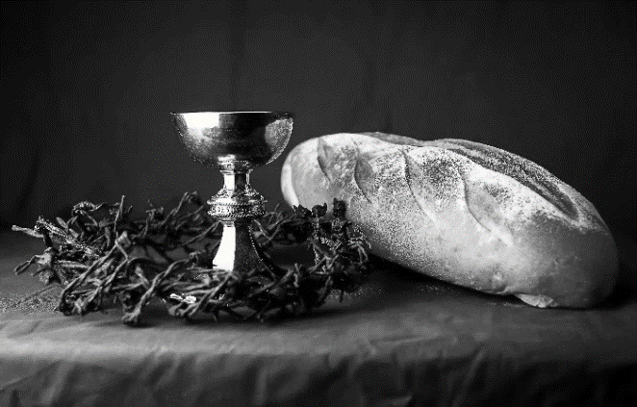
hallowed be thy name,
thy kingdom come,
thy will be done,
on earth as it is in heaven.
Give us this day our daily bread;
and forgive us our trespasses,
as we forgive those
who trespass against us;
and lead us not into temptation,
but deliver us from evil.
For thine is the kingdom,
and the power, and the glory,
forever and ever. Amen.
INVITATION TO COMMUNION - Certified gluten-free crackers are in the bowl on the communion plate.
Jesus invites you to this table.
Come, eat and live.
HOLY COMMUNION
PRAYER AFTER COMMUNION
Blessed be your name, O God, for we have feasted on your Word,
Christ Jesus, the joy and delight of our hearts.
Strengthened by this food, send us to gather the world to your banquet,
where none are left out and all are satisfied.
In Jesus’ name we pray.
Amen.
SENDING
BLESSING
The God of glory,
☩ Jesus Christ, name above all names,
and the Spirit who lives in you,
bless you now and forever.
Amen.
CLOSING HYMN The Lord Now Sends Us Forth ELW 538
DISMISSAL
Life is short and we do not have much time to gladden the hearts of those who travel with us.
So be swift to love, make haste to be kind, and go in peace to love and serve the Lord.
Upcoming Worship Assistants
 | Usher | Lector | Communion | Offering Counters
September 24 | Jason & Tessa Campbell | Linda Schrieber | Bruce & Nancy Tibbett | Pam Mundt | May Hill
October 1 | Brett & Breanna Butler | Nancy Tibbett | Matt & Margo Berrier | Dan Mundt | Jon Hill
October 8 | Chris & Robin Beeman | Richard Kopitzke | Sarah Kopitzke  Tammy Neumann | Nancy Leonard | Breanna Butler
October 15 | Heidi Binder | Andrea Hovick | John Wagner  Nancy Leonard | Robin Beeman | David Schneider
October 22 | Matt & Margo Berrier | Kris Tarter | Dan & Pam Mundt | Heidi Binder | Kami Weis
Thanks be to God.
Please sign-up in the narthex to help with food for the 40th Anniversary Brunch!
Coming up at GSLC
Sunday, September 24 | 9:00 am | Worship Service  - 17th Sunday after Pentecost  - Matthew 20:1-16; the parable of the vineyard workers
Tuesday, September 25 | 7:00 pm | AA Meeting
Wednesday, September 26 | 12:00 pm | Bible Study (discuss Season 1 Episode 2 of “The Chosen”)
 | 7:00 pm | Midweek Worship  Confirmation Class
Sunday, October 1 | 9:00 am | Worship Service – Sunday School  - 18th Sunday after Pentecost  Matthew 21:23-32; a parable of doing God’s will
 | 11:30 am | Private Baptism of Kinsley Lynn Porter
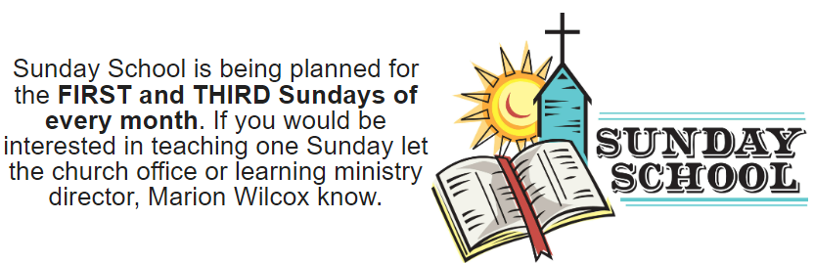
Pastor Katie will be at a conference following worship today, Sept 24-26. Contact the office for emergencies.

