Good Shepherd Lutheran Church
Pastor: Katie Anderson | Music Director: Lois Swanson
Pastor’s Cell: (715) 245-1943 | Office Phone: (715) 387-2731
Pastor Email: gslcwi.pastor@gmail.com | Office Email: gslcwi.office@gmail.com
Website: GoodShepherdMarshfield.org | www.facebook.com/gslcwi
16th Sunday after Pentecost
September 17, 2023, 9:00 am
Introduction to the day…
In today’s second reading Paul questions why we judge one another since we all stand before the judgment of God. Yet we do sin against one another, and Jesus’ challenge that we forgive seventy-seven times reveals God’s boundless mercy. When we hear the words of forgiveness in worship and sign ourselves with the cross, we are renewed in baptism to be signs of reconciliation in the world.
ANNOUNCEMENTS
GATHERING
GATHERING HYMN Kyrie and Song of Praise ACS 31
CONFESSION AND FORGIVENESS
Blessed be God, the one who forms us,
☩ Jesus who bears the cross,
the Spirit who makes our joy complete.
Amen.
Let us bow before God in humility, confessing our sin.
Silence is kept for reflection.
Steadfast and faithful God,
you have revealed the ways of justice, yet we fail to follow you.
We are overwhelmed by the world’s violence and suffering.
We are afraid to risk what we have for the sake of others.
For the harm we have caused, known and unknown, forgive us.
For the unjust demands we place on others and your creation, forgive us.
For the ways we turn away from you and our neighbor, forgive us.
Lead us back to you and set us on the right path;
in the name of Jesus Christ, our Savior.
Amen.
Beloved in Christ,
God’s justice stretches beyond all understanding.
God’s compassion is beyond compare.
In Jesus, God is always making a new way for us.
In ☩ Christ, you are already and always forgiven.
Amen.
PRAYER OF THE DAY
O Lord God, merciful judge, you are the inexhaustible fountain of forgiveness. Replace our hearts of stone with hearts that love and adore you, that we may delight in doing your will, through Jesus Christ, our Savior and Lord. Amen.
CHILDREN’S MUSIC Jesus We Are Gathered ELW 529
CHILDREN’S MESSAGE
SCRIPTURE READINGS
FIRST READING: Genesis 50:15-21
¹⁵Realizing that their father was dead, Joseph’s brothers said, “What if Joseph still bears a grudge against us and pays us back in full for all the wrong that we did to him?” ¹⁶So they approached Joseph, saying, “Your father gave this instruction before he died, ¹⁷‘Say to Joseph: I beg you, forgive the crime of your brothers and the wrong they did in harming you.’ Now therefore please forgive the crime of the servants of the God of your father.” Joseph wept when they spoke to him. ¹⁸Then his brothers also wept, fell down before him, and said, “We are here as your slaves.” ¹⁹But Joseph said to them, “Do not be afraid! Am I in the place of God? ²⁰Even though you intended to do harm to me, God intended it for good, in order to preserve a numerous people, as he is doing today. ²¹So have no fear; I myself will provide for you and your little ones.” In this way he reassured them, speaking kindly to them.
Word of God, word of life.
Thanks be to God.
PSALM: Psalm 103:1-13
¹Bless the Lord, O my soul,
and all that is within me, bless God’s holy name.
²Bless the Lord, O my soul,
and forget not all God’s benefits—
³who forgives all your sins
and heals all your diseases;
⁴who redeems your life from the grave
and crowns you with steadfast love and mercy;
⁵who satisfies your desires with good things
so that your youth is renewed like an eagle’s.
⁶O Lord, you provide vindication
and justice for all who are oppressed.
⁷You made known your ways to Moses
and your works to the children of Israel.
⁸Lord, you are full of compassion and mercy,
slow to anger and abounding in steadfast love;
⁹you will not always accuse us,
nor will you keep your anger forever.
¹⁰You have not dealt with us according to our sins,
nor repaid us according to our iniquities.
¹¹For as the heavens are high above the earth,
so great is your steadfast love for those who fear you.
¹²As far as the east is from the west,
so far have you removed our transgressions from us.
¹³As a father has compassion for his children,
so you have compassion for those who fear you, O Lord.
SECOND READING: Romans 14:1-12
¹Welcome those who are weak in faith, but not for the purpose of quarreling over opinions. ²Some believe in eating anything, while the weak eat only vegetables. ³Those who eat must not despise those who abstain, and those who abstain must not pass judgment on those who eat; for God has welcomed them. ⁴Who are you to pass judgment on servants of another? It is before their own lord that they stand or fall. And they will be upheld, for the Lord is able to make them stand.
⁵Some judge one day to be better than another, while others judge all days to be alike. Let all be fully convinced in their own minds. ⁶Those who observe the day, observe it in honor of the Lord. Also those who eat, eat in honor of the Lord, since they give thanks to God; while those who abstain, abstain in honor of the Lord and give thanks to God.
⁷We do not live to ourselves, and we do not die to ourselves. ⁸If we live, we live to the Lord, and if we die, we die to the Lord; so then, whether we live or whether we die, we are the Lord’s. ⁹For to this end Christ died and lived again, so that he might be Lord of both the dead and the living.
¹⁰Why do you pass judgment on your brother or sister? Or you, why do you despise your brother or sister? For we will all stand before the judgment seat of God. ¹¹For it is written, “As I live, says the Lord, every knee shall bow to me, and every tongue shall give praise to God.” ¹²So then, each of us will be accountable to God.
Word of God, word of life.
Thanks be to God.
GOSPEL ACCLAMATION ACS 33
GOSPEL: Matthew 18:21-35
²¹Peter came and said to [Jesus], “Lord, if another member of the church sins against me, how often should I forgive? As many as seven times?” ²²Jesus said to him, “Not seven times, but I tell you, seventy-seven times.
²³“For this reason the kingdom of heaven may be compared to a king who wished to settle accounts with his slaves. ²⁴When he began the reckoning, one who owed him ten thousand talents was brought to him; ²⁵and, as he could not pay, his lord ordered him to be sold, together with his wife and children and all his possessions, and payment to be made. ²⁶So the slave fell on his knees before him, saying, ‘Have patience with me, and I will pay you everything.’ ²⁷And out of pity for him, the lord of that slave released him and forgave him the debt. ²⁸But that same slave, as he went out, came upon one of his fellow slaves who owed him a hundred denarii; and seizing him by the throat, he said, ‘Pay what you owe.’ ²⁹Then his fellow slave fell down and pleaded with him, ‘Have patience with me, and I will pay you.’ ³⁰But he refused; then he went and threw him into prison until he would pay the debt. ³¹When his fellow slaves saw what had happened, they were greatly distressed, and they went and reported to their lord all that had taken place. ³²Then his lord summoned him and said to him, ‘You wicked slave! I forgave you all that debt because you pleaded with me. ³³Should you not have had mercy on your fellow slave, as I had mercy on you?’ ³⁴And in anger his lord handed him over to be tortured until he would pay his entire debt. ³⁵So my heavenly Father will also do to every one of you, if you do not forgive your brother or sister from your heart.”
The gospel of the Lord.
Praise to you, O Christ.
SERMON
HYMN OF THE DAY Before the Waters Nourished Earth ACS 1049
APOSTLES’ CREED
I believe in God, the Father almighty,
creator of heaven and earth.
I believe in Jesus Christ, God's only Son, our Lord,
who was conceived by the power of the Holy Spirit,
born of the Virgin Mary,
suffered under Pontius Pilate,
was crucified, died, and was buried;
he descended to the dead.
On the third day he rose again;
he ascended into heaven,
he is seated at the right hand of the Father,
and he will come to judge the living and the dead.
I believe in the Holy Spirit,
the holy catholic Church,
the communion of saints,
the forgiveness of sins,
the resurrection of the body,
and the life everlasting. Amen
PRAYERS OF INTERCESSION
…Merciful God,
Receive our prayer.
Remember us according to your steadfast love as we offer these and the prayers of our heart, trusting in your compassion made known through Jesus Christ.
Amen.
PEACE
The peace of Christ be with you always.
And also with you.
HOLY COMMUNION
OFFERING In addition to our normal offering, a Special Benevolence in September (collected in a special envelope) will go to UW Stevens Point -Marshfield Campus Student Food Pantry.
OFFERING HYMN When We Are Living ELW 639
OFFERTORY PRAYER
God of power, God of plenty, all things belong to you.
We bring your gifts to the table, that all might be fed.
Form us into the body of your Beloved, Jesus Christ, our Savior.
Amen.
GREAT THANKSGIVING
The Lord be with you.
And also with you.
Lift up your hearts.
We lift them to the Lord.
Let us give our thanks to the Lord our God.
It is right to give our thanks and praise.
HOLY, HOLY, HOLY (Sung) ACS 36
THANKSGIVING AT THE TABLE

Holy God, mighty Lord, gracious Father:
Endless is your mercy and eternal your reign.
You have filled all creation with light and life;
heaven and earth are full of your glory.
We praise you for the grace shown to your people in every age:
the promise to Israel,
the rescue from Egypt,
the gift of the promised land,
the words of the prophets;
and, at this end of all the ages, the gift of your Son,
who proclaimed the good news in word and deed
and was obedient to your will, even to giving his life.
In the night in which he was betrayed,
our Lord Jesus took bread, and gave thanks;
broke it, and gave it to his disciples, saying:
Take and eat; this is my body, given for you.
Do this for the remembrance of me.
Again, after supper, he took the cup, gave thanks,
and gave it for all to drink, saying:
This cup is the new covenant in my blood,
shed for you and for all people for the forgiveness of sin.
Do this for the remembrance of me.
For as often as we eat of this bread and drink from this cup,
we proclaim the Lord’s death until he comes.
Christ has died.
Christ is risen.
Christ will come again.
Therefore, O God, with this bread and cup
we remember the life our Lord offered for us.
And, believing the witness of his resurrection,
we await his coming in power
to share with us the great and promised feast.
Amen. Come, Lord Jesus.
Send now, we pray, your Holy Spirit,
that we who share in Christ’s body and blood
may live to the praise of your glory
and receive our inheritance with all your saints in light.
Amen. Come, Holy Spirit.
Join our prayers with those of your servants
of every time and every place,
and unite them with the ceaseless petitions of our great high priest
until he comes as victorious Lord of all.
Through him, with him, in him,
in the unity of the Holy Spirit,
all glory and honor is yours, almighty Father,
now and forever.
Amen.

THE LORD’S PRAYER
Our Father, who art in heaven,
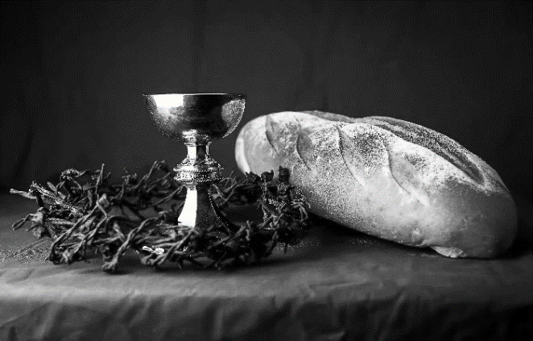
hallowed be thy name,
thy kingdom come,
thy will be done,
on earth as it is in heaven.
Give us this day our daily bread;
and forgive us our trespasses,
as we forgive those
who trespass against us;
and lead us not into temptation,
but deliver us from evil.
For thine is the kingdom,
and the power, and the glory,
forever and ever. Amen.
INVITATION TO COMMUNION - Certified gluten-free crackers are in the bowl on the communion plate.
Jesus invites you to this table.
Come, eat and live.
HOLY COMMUNION
PRAYER AFTER COMMUNION
Blessed be your name, O God, for we have feasted on your Word,
Christ Jesus, the joy and delight of our hearts.
Strengthened by this food, send us to gather the world to your banquet,
where none are left out and all are satisfied.
In Jesus’ name we pray.
Amen.
SENDING
BLESSING
The God of glory,
☩ Jesus Christ, name above all names,
and the Spirit who lives in you,
bless you now and forever.
Amen.
CLOSING HYMN My Life Is in You, Lord
My life is in You, Lord, my strength is in You, Lord,  My hope is in You, Lord, in You, it's in You.  My life is in You, Lord, my strength is in You, Lord,  My hope is in You, Lord, in You, it's in You. | I will praise You with all of my life,  I will praise You with all of my strength.  With all of my life. With all of my strength.  All of my hope is in You.  in You, it's in You, my life!
(Daniel Gardnerc/o Integrity Music, Inc.) CCLI License No. 669990
DISMISSAL
Life is short and we do not have much time to gladden the hearts of those who travel with us.
So be swift to love, make haste to be kind, and go in peace to love and serve the Lord.
Upcoming Worship Assistants
 | Usher | Lector | Communion | Offering Counters
September 17 | Lee & Sue Babcock | Andrea Hovick | Ron Rothfusz  Andrea Hovick | Heidi Binder | Kami Weis
September 24 | Jason & Tessa Campbell | Linda Schrieber | Bruce & Nancy Tibbett | Pam Mundt | May Hill
October 1 | Brett & Breanna Butler | Nancy Tibbett | Matt & Margo Barrier | Dan Mundt | Jon Hill
October 8 | Chris & Robin Beeman | Richard Kopitzke | Sarah Kopitzke  Tammy Neumann | Nancy Leonard | Breanna Butler
Thanks be to God.
Coming up at GSLC
Sunday, September 17 | 9:00 am | Worship Service – Sunday School  - 16th Sunday after Pentecost  - Matthew 18:21-35; A parable of forgiveness in the community of faith
Tuesday, September 19 | 2:00 pm | Chapel at Three Oaks
 | 7:00 pm | AA Meeting
Wednesday, September 20 | 12:00 pm | Bible Study (discuss Season 1 Episode 1 of “The Chosen”)
 | 7:00 pm | Midweek Worship  Confirmation Class
Friday, September 22 | 5:30 pm | 40th Anniversary Tree Planting Youth Event
Sunday, September 24 | 9:00 am | Worship Service  - 17th Sunday after Pentecost  - Matthew 20:1-16; the parable of the vineyard workers
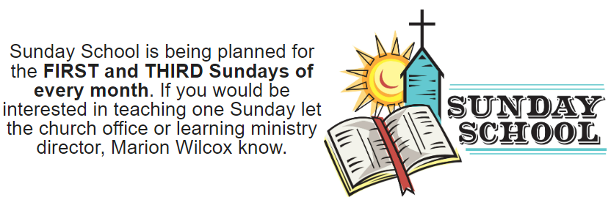

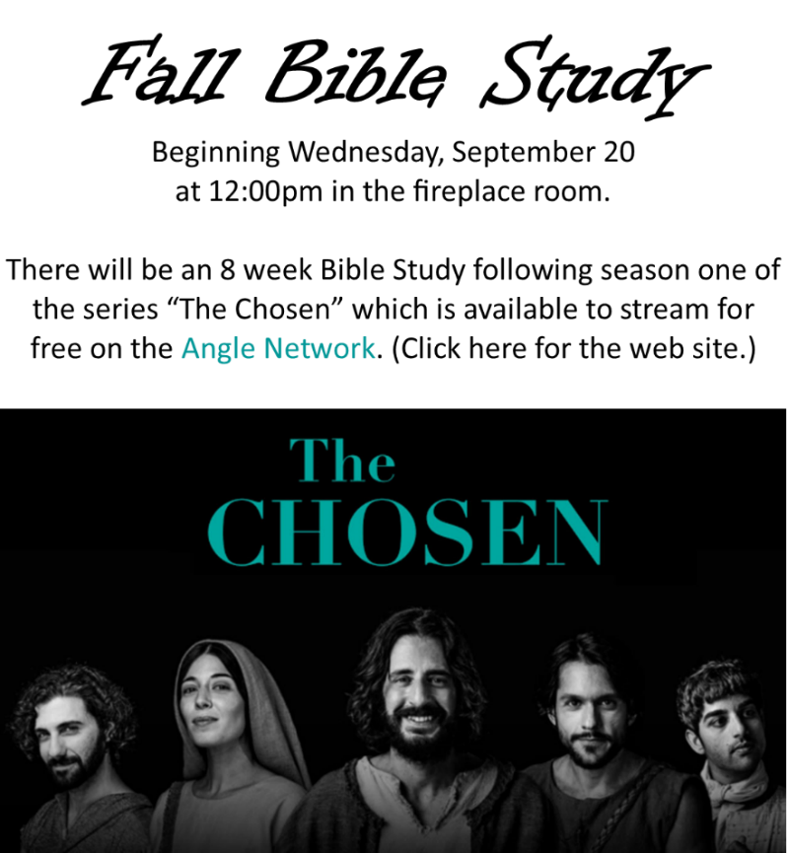
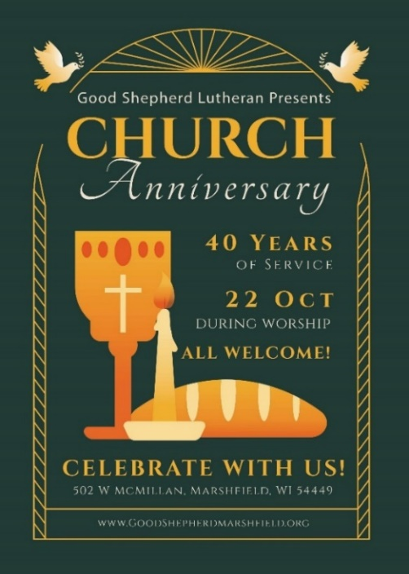
Please sign-up in the narthex to help with food for the 40th Anniversary Brunch!

