Good Shepherd Lutheran Church
Pastor: Katie Anderson | Music Director: Lois Swanson
Pastor’s Cell: (715) 245-1943 | Office Phone: (715) 387-2731
Pastor Email: gslcwi.pastor@gmail.com | Office Email: gslcwi.office@gmail.com
Website: GoodShepherdMarshfield.org | www.facebook.com/gslcwi
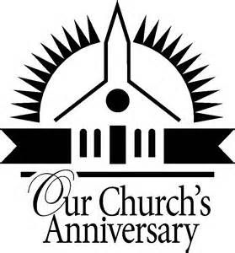
21th Sunday after Pentecost – 40th Anniversary Celebration
October 22, 2023, 9:00 am
Introduction to the day…
This is the day! This is the day that the Lord has made, that the Lord has made. Let us rejoice, let us rejoice and be glad in it and be glad in it! This is the day that the Lord has made, let us rejoice and be glad in it. This is the day! This is the day that the Lord has made!
SPECIAL MUSIC Marshfield Senior High Madrigals
ANNOUNCEMENTS
GATHERING
GATHERING HYMN Hymn of Promise
1 In the bulb there is a flower:  In the seed, an apple tree;  In cocoons, a hidden promise;  Butterflies will soon be free!  In the cold and snow of winter  There’s a spring that waits to be,  Unrevealed until its season,  Something God alone can see. | 3 In our end is our beginning;  In our time, infinity;  In our doubt there is believing;  In our life, eternity;  In our death, a resurrection;  At the last, a victory,  Unrevealed until its season,  Something God alone can see.
2 There’s a song in every silence,
Seeking word and melody;
There’s a dawn in every darkness
Bringing hope to you and me.
From the past will come the future;
What it holds, a mystery,
Unrevealed until its season,
Something God alone can see.
Words & Music: Natalie Sleeth 1986 Hope Publishing Co Used by permission. CCLI LICENSE #669990
CONFESSION AND FORGIVENESS Led by Pastor Peter Ruggles
Blessed be God,
the one who forms us,
☩ Jesus who bears the cross,
the Spirit who makes our joy complete.
Amen.
Let us bow before God in humility, confessing our sin.
Silence is kept for reflection.
Steadfast and faithful God,
you have revealed the ways of justice, yet we fail to follow you.
We are overwhelmed by the world’s violence and suffering.
We are afraid to risk what we have for the sake of others.
For the harm we have caused, known and unknown, forgive us.
For the unjust demands we place on others and your creation, forgive us.
For the ways we turn away from you and our neighbor, forgive us.
Lead us back to you and set us on the right path;
in the name of Jesus Christ, our Savior.
Amen.
Beloved in Christ,
God’s justice stretches beyond all understanding.
God’s compassion is beyond compare.
In Jesus, God is always making a new way for us.
In ☩ Christ, you are already and always forgiven.
Amen.
PRAYER OF THE DAY
Sovereign God, raise your throne in our hearts. Created by you, let us live in your image; created for you, let us act for your glory; redeemed by you, let us give you what is yours, through Jesus Christ, our Savior and Lord.
Amen.
CHILDREN’S MUSIC Children of the Heavenly Father ELW 781
CHILDREN’S MESSAGE
SCRIPTURE READINGS
FIRST READING: Isaiah 45:1-7
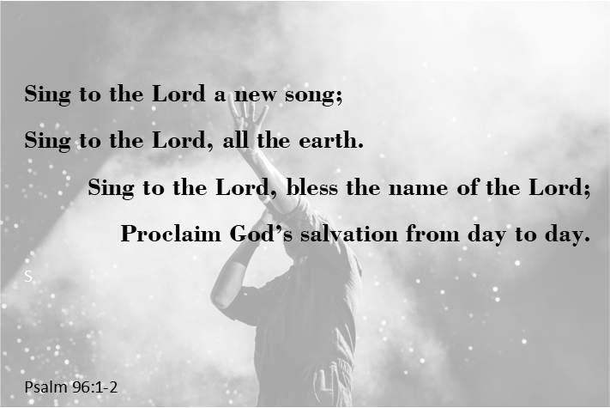
¹Thus says the Lord to his anointed, to Cyrus,
whose right hand I have grasped
to subdue nations before him
and strip kings of their robes,
to open doors before him—
and the gates shall not be closed:
²I will go before you
and level the mountains,
I will break in pieces the doors of bronze
and cut through the bars of iron,
³I will give you the treasures of darkness
and riches hidden in secret places,
so that you may know that it is I, the Lord,
the God of Israel, who call you by your name.
⁴For the sake of my servant Jacob,
and Israel my chosen,
I call you by your name,
I surname you, though you do not know me.
⁵I am the Lord, and there is no other;
besides me there is no god.
I arm you, though you do not know me,
⁶so that they may know, from the rising of the sun
and from the west, that there is no one besides me;
I am the Lord, and there is no other.
⁷I form light and create darkness,
I make weal and create woe;
I the Lord do all these things.
Word of God, word of life.
Thanks be to God.
PSALM: Psalm 96:1-13
¹Sing to the Lord a new song;
sing to the Lord, all the earth.
²Sing to the Lord, bless the name of the Lord;
proclaim God’s salvation from day to day.
³Declare God’s glory among the nations
and God’s wonders among all peoples.
⁴For great is the Lord and greatly to be praised,
more to be feared than all gods.
⁵As for all the gods of the nations, they are but idols;
but you, O Lord, have made the heavens.
⁶Majesty and magnificence are in your presence;
power and splendor are in your sanctuary.
⁷Ascribe to the Lord, you families of the peoples,
ascribe to the Lord honor and power.
⁸Ascribe to the Lord the honor due the holy name;
bring offerings and enter the courts of the Lord.
⁹Worship the Lord in the beauty of holiness;
tremble before the Lord, all the earth.
¹⁰Tell it out among the nations: “The Lord is king!
The one who made the world so firm that it cannot be moved will judge the peoples with equity.”
¹¹Let the heavens rejoice, and let the earth be glad;
let the sea thunder and all that is in it; let the field be joyful and all that is therein.
¹²Then shall all the trees of the wood shout for joy at your coming, O Lord,
for you come to judge the earth.
¹³You will judge the world with righteousness
and the peoples with your truth.
SECOND READING: 1 Thessalonians 1:1-10
¹Paul, Silvanus, and Timothy,
To the church of the Thessalonians in God the Father and the Lord Jesus Christ:
Grace to you and peace.
²We always give thanks to God for all of you and mention you in our prayers, constantly ³remembering before our God and Father your work of faith and labor of love and steadfastness of hope in our Lord Jesus Christ. ⁴For we know, brothers and sisters beloved by God, that he has chosen you, ⁵because our message of the gospel came to you not in word only, but also in power and in the Holy Spirit and with full conviction; just as you know what kind of persons we proved to be among you for your sake. ⁶And you became imitators of us and of the Lord, for in spite of persecution you received the word with joy inspired by the Holy Spirit, ⁷so that you became an example to all the believers in Macedonia and in Achaia. ⁸For the word of the Lord has sounded forth from you not only in Macedonia and Achaia, but in every place your faith in God has become known, so that we have no need to speak about it. ⁹For the people of those regions report about us what kind of welcome we had among you, and how you turned to God from idols, to serve a living and true God, ¹⁰and to wait for his Son from heaven, whom he raised from the dead—Jesus, who rescues us from the wrath that is coming.
Word of God, word of life.
Thanks be to God.
GOSPEL ACCLAMATION ACS 33
GOSPEL: Matthew 22:15-22
¹⁵Then the Pharisees went and plotted to entrap [Jesus] in what he said. ¹⁶So they sent their disciples to him, along with the Herodians, saying, “Teacher, we know that you are sincere, and teach the way of God in accordance with truth, and show deference to no one; for you do not regard people with partiality. ¹⁷Tell us, then, what you think. Is it lawful to pay taxes to the emperor, or not?” ¹⁸But Jesus, aware of their malice, said, “Why are you putting me to the test, you hypocrites? ¹⁹Show me the coin used for the tax.” And they brought him a denarius. ²⁰Then he said to them, “Whose head is this, and whose title?” ²¹They answered, “The emperor’s.” Then he said to them, “Give therefore to the emperor the things that are the emperor’s, and to God the things that are God’s.” ²²When they heard this, they were amazed; and they left him and went away.
The gospel of the Lord.
Praise to you, O Christ.
SERMON
HYMN OF THE DAY The King of Love My Shepherd Is ELW 502

APOSTLES’ CREED
I believe in God, the Father almighty,
creator of heaven and earth.
I believe in Jesus Christ, God's only Son, our Lord,
who was conceived by the power of the Holy Spirit,
born of the Virgin Mary,
suffered under Pontius Pilate,
was crucified, died, and was buried;
he descended to the dead.
On the third day he rose again;
he ascended into heaven,
he is seated at the right hand of the Father,
and he will come to judge the living and the dead.
I believe in the Holy Spirit,
the holy catholic Church,
the communion of saints,
the forgiveness of sins,
the resurrection of the body,
and the life everlasting.
Amen
PRAYERS OF INTERCESSION
…God of grace,
Hear our prayer.
Gracious God, into your hands we commend all for whom we pray, trusting in your unending love and amazing grace; through Jesus Christ, our Savior.
Amen.
PEACE
The peace of Christ be with you always.
And also with you.
HOLY COMMUNION
OFFERING In addition to our normal offering, a Special Benevolence in October (collected in a special envelope) will go to Marshfield Community Foundation "Keeping Kids Warm" coat drive.
OFFERING HYMN Savior, Like a Shepherd Lead Us ELW 789
OFFERTORY PRAYER
God of power, God of plenty, all things belong to you.
We bring your gifts to the table, that all might be fed.
Form us into the body of your Beloved, Jesus Christ, our Savior.
Amen.
GREAT THANKSGIVING
The Lord be with you.
And also with you.
Lift up your hearts.
We lift them to the Lord.
Let us give our thanks to the Lord our God.
It is right to give our thanks and praise.
HOLY, HOLY, HOLY (Sung) ACS 36

THANKSGIVING AT THE TABLE

Holy God, mighty Lord, gracious Father:
Endless is your mercy and eternal your reign.
You have filled all creation with light and life;
heaven and earth are full of your glory.
We praise you for the grace shown to your people in every age:
the promise to Israel,
the rescue from Egypt,
the gift of the promised land,
the words of the prophets;
and, at this end of all the ages, the gift of your Son,
who proclaimed the good news in word and deed
and was obedient to your will, even to giving his life.
In the night in which he was betrayed,
our Lord Jesus took bread, and gave thanks;
broke it, and gave it to his disciples, saying:
Take and eat; this is my body, given for you.
Do this for the remembrance of me.
Again, after supper, he took the cup, gave thanks,
and gave it for all to drink, saying:
This cup is the new covenant in my blood,
shed for you and for all people for the forgiveness of sin.
Do this for the remembrance of me.
For as often as we eat of this bread and drink from this cup,
we proclaim the Lord’s death until he comes.
Christ has died.
Christ is risen.
Christ will come again.
Therefore, O God, with this bread and cup
we remember the life our Lord offered for us.
And, believing the witness of his resurrection,
we await his coming in power
to share with us the great and promised feast.
Amen. Come, Lord Jesus.
Send now, we pray, your Holy Spirit,
that we who share in Christ’s body and blood
may live to the praise of your glory
and receive our inheritance with all your saints in light.
Amen. Come, Holy Spirit.
Join our prayers with those of your servants
of every time and every place,
and unite them with the ceaseless petitions of our great high priest
until he comes as victorious Lord of all.
Through him, with him, in him,
in the unity of the Holy Spirit,
all glory and honor is yours, almighty Father,
now and forever.
Amen.

THE LORD’S PRAYER
Our Father, who art in heaven,
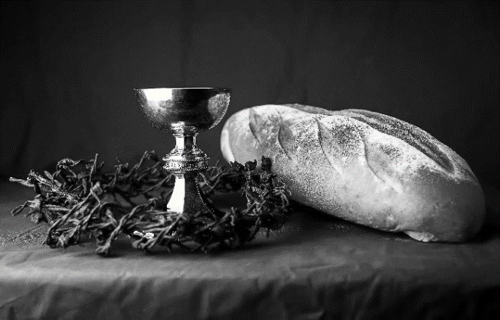
hallowed be thy name,
thy kingdom come,
thy will be done,
on earth as it is in heaven.
Give us this day our daily bread;
and forgive us our trespasses,
as we forgive those
who trespass against us;
and lead us not into temptation,
but deliver us from evil.
For thine is the kingdom,
and the power, and the glory,
forever and ever. Amen.
INVITATION TO COMMUNION - Certified gluten-free crackers are in the bowl on the communion plate.
Jesus invites you to this table.
Come, eat and live.
HOLY COMMUNION
PRAYER AFTER COMMUNION
Blessed be your name, O God, for we have feasted on your Word,
Christ Jesus, the joy and delight of our hearts.
Strengthened by this food, send us to gather the world to your banquet,
where none are left out and all are satisfied.
In Jesus’ name we pray.
Amen.

SENDING
BENEDICTION Led by Pastor Steve Carlson
In the name of the Father, (Echo)
In the name of the Son. (Echo)
In the name of the Spirit, (Echo)
The three in one! (Echo)
May the Lord bless and keep you. (Echo)
Lift His countenances upon you. (Echo)
His blessing go with you. (Echo)
And give you peace! (Echo)
Author and source unknown
BLESSING
The God of glory,
☩ Jesus Christ, name above all names,
and the Spirit who lives in you,
bless you now and forever.
Amen.
CLOSING HYMN Here I am Lord ELW 574
DISMISSAL
Life is short and we do not have much time to gladden the hearts of those who travel with us.
So be swift to love, make haste to be kind, and go in peace to love and serve the Lord.
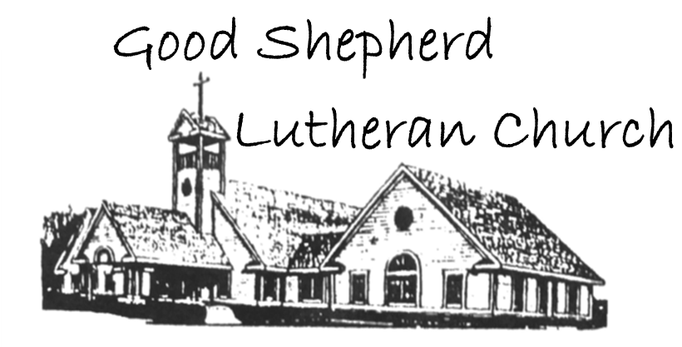
Thanks be to God.
Upcoming Worship Assistants
 | Usher | Lector | Communion | Offering Counters
October 22 | Matt & Margo Berrier | Kris Tarter | Dan & Pam Mundt | Heidi Binder | Kami Weis
October 29 | Dennis & Deb Janz | Christine Tipping | Bruce & Nancy Tibbett | Pam Mundt | May Hill
November 5 | Richard & Sarah Kopitzke | Tammy Neumann | Dave & Shelly Schneider | Dan Mundt | Jon Hill
November 12 | Ben & Sue Lee | Laurel Peterson | Dave & Sue Schraeder | Nancy Leonard | Breanna Butler

Please Join Us…
following worship for fellowship and brunch to honor Good Shepherd’s 40th Anniversary!
Coming up at GSLC
Sunday, October 22 | 9:00 am | Worship Service  - 21st Sunday after Pentecost  - Matthew 22:15-22; a teaching on giving to the emperor and to God
 | 10:00 | 40th Anniversary Brunch
Tuesday, October 24 | 7:00 pm | AA Meeting
Wednesday, October 25 | 12:00 pm | Bible Study (discuss Season 1 Episode 6 of “The Chosen”)
 | 7:00 pm | Midweek Worship  - Confirmation Class
Sunday, October 29 | 9:00 am | Worship Service  - Reformation Sunday  - John 8:31-36; Jesus says, “Continue in my word and will know the truth.”

