Good Shepherd Lutheran Church
Pastor: Katie Anderson | Music Director: Lois Swanson
Pastor’s Cell: (715) 245-1943 | Office Phone: (715) 387-2731
Pastor Email: gslcwi.pastor@gmail.com | Office Email: gslcwi.office@gmail.com
Website: GoodShepherdMarshfield.org | www.facebook.com/gslcwi
14th Sunday after Pentecost
September 3, 2023, 9:00 am
Introduction to the day…
The prophet Jeremiah speaks of the incurable wound of his suffering yet finds in God’s words the delight of his heart. When Peter doesn’t grasp Jesus’ words about suffering, Jesus tells the disciples they will find their lives in losing them. Such sacrificial love is described by Paul when he urges us to associate with the lowly and not repay evil with evil. In worship we gather as a community that we might offer ourselves for the sake of our suffering world.
ANNOUNCEMENTS
GATHERING
GATHERING HYMN Great is the Lord
Great is the Lord, He is holy and just,  By His power we trust in His love.  Great is the Lord, He is faithful and true,  By His mercy He proves He is love.  Great is the Lord and worthy of glory.  Great is the Lord and worthy of praise.  Great is the Lord, I lift up my voice,  I lift up my voice.  Great is the Lord, great is the Lord. | Great is the Lord, He is holy and just,  By His power we trust in His love.  Great is the Lord, He is faithful and true,  By His mercy He proves He is love.  Great are you Lord and worthy of glory.  Great are you Lord and worthy of praise.  Great are you Lord, I lift up my voice,  I lift up my voice.  Great are you Lord, great are you Lord
Smith, Michael W. / Smith, Deborah D. EMI Christian Music Publishing Used by permission. CCLI License #669990
CONFESSION AND FORGIVENESS
Blessed be God,
the one who forms us,
☩ Jesus who bears the cross,
the Spirit who makes our joy complete.
Amen.
Let us bow before God in humility,
confessing our sin.
Silence is kept for reflection.
Steadfast and faithful God,
you have revealed the ways of justice,
yet we fail to follow you.
We are overwhelmed
by the world’s violence and suffering.
We are afraid to risk what we have
for the sake of others.
For the harm we have caused,
known and unknown, forgive us.
For the unjust demands we place on others
and your creation, forgive us.
For the ways we turn away
from you and our neighbor, forgive us.
Lead us back to you
and set us on the right path;
in the name of Jesus Christ, our Savior.
Amen.
Beloved in Christ,
God’s justice stretches beyond all understanding.
God’s compassion is beyond compare.
In Jesus, God is always making a new way for us.
In ☩ Christ, you are already and always forgiven.
Amen.
PRAYER OF THE DAY
O God, we thank you for your Son, who chose the path of suffering for the sake of the world. Humble us by his example, point us to the path of obedience, and give us strength to follow your commands, through Jesus Christ, our Savior and Lord. Amen.
CHILDREN’S MESSAGE
SCRIPTURE READINGS
FIRST READING: Jeremiah 15:15-21
¹⁵O Lord, you know;
remember me and visit me,
and bring down retribution for me on my persecutors.
In your forbearance do not take me away;
know that on your account I suffer insult.
¹⁶Your words were found, and I ate them,
and your words became to me a joy
and the delight of my heart;
for I am called by your name,
O Lord, God of hosts.
¹⁷I did not sit in the company of merrymakers,
nor did I rejoice;
under the weight of your hand I sat alone,
for you had filled me with indignation.
¹⁸Why is my pain unceasing,
my wound incurable,
refusing to be healed?
Truly, you are to me like a deceitful brook,
like waters that fail.
¹⁹Therefore thus says the Lord:
If you turn back, I will take you back,
and you shall stand before me.
If you utter what is precious, and not what is worthless,
you shall serve as my mouth.
It is they who will turn to you,
not you who will turn to them.
²⁰And I will make you to this people
a fortified wall of bronze;
they will fight against you,
but they shall not prevail over you,
for I am with you
to save you and deliver you,
says the Lord.
²¹I will deliver you out of the hand of the wicked,
and redeem you from the grasp of the ruthless.
Word of God, word of life.
Thanks be to God.

PSALM: Psalm 26:1-8
¹Give judgment for me, O Lord, for I have lived | with integrity;
I have trusted in the Lord and | have not faltered.
²Test me, O | Lord, and try me;
examine my heart | and my mind.
³For your steadfast love is be- | fore my eyes;
I have walked faithful- | ly with you.
⁴I have not sat | with the worthless,
nor do I consort with | the deceitful. R
⁵I have hated the company of | evildoers;
I will not sit down | with the wicked.
⁶I will wash my hands in inno- | cence, O Lord,
that I may go in procession | round your altar,
⁷singing aloud a song | of thanksgiving
and recounting all your won- | derful deeds.
⁸Lord, I love the house in | which you dwell
and the place where your glo- | ry abides.
SECOND READING: Romans 12:9-21
⁹Let love be genuine; hate what is evil, hold fast to what is good; ¹⁰love one another with mutual affection; outdo one another in showing honor. ¹¹Do not lag in zeal, be ardent in spirit, serve the Lord. ¹²Rejoice in hope, be patient in suffering, persevere in prayer. ¹³Contribute to the needs of the saints; extend hospitality to strangers.
¹⁴Bless those who persecute you; bless and do not curse them. ¹⁵Rejoice with those who rejoice, weep with those who weep. ¹⁶Live in harmony with one another; do not be haughty, but associate with the lowly; do not claim to be wiser than you are. ¹⁷Do not repay anyone evil for evil, but take thought for what is noble in the sight of all. ¹⁸If it is possible, so far as it depends on you, live peaceably with all. ¹⁹Beloved, never avenge yourselves, but leave room for the wrath of God; for it is written, “Vengeance is mine, I will repay, says the Lord.” ²⁰No, “if your enemies are hungry, feed them; if they are thirsty, give them something to drink; for by doing this you will heap burning coals on their heads.” ²¹Do not be overcome by evil, but overcome evil with good.
Word of God, word of life.
Thanks be to God.
GOSPEL ACCLAMATION

GOSPEL: Matthew 16:21-28
²¹From that time on, [after Peter confessed that Jesus was the Messiah,] Jesus began to show his disciples that he must go to Jerusalem and undergo great suffering at the hands of the elders and chief priests and scribes, and be killed, and on the third day be raised. ²²And Peter took him aside and began to rebuke him, saying, “God forbid it, Lord! This must never happen to you.” ²³But he turned and said to Peter, “Get behind me, Satan! You are a stumbling block to me; for you are setting your mind not on divine things but on human things.”
²⁴Then Jesus told his disciples, “If any want to become my followers, let them deny themselves and take up their cross and follow me. ²⁵For those who want to save their life will lose it, and those who lose their life for my sake will find it. ²⁶For what will it profit them if they gain the whole world but forfeit their life? Or what will they give in return for their life?
²⁷“For the Son of Man is to come with his angels in the glory of his Father, and then he will repay everyone for what has been done. ²⁸Truly I tell you, there are some standing here who will not taste death before they see the Son of Man coming in his kingdom.”
The gospel of the Lord.
Praise to you, O Christ.
SERMON
HYMN OF THE DAY Will You Let Me Be Your Servant ELW 659
APOSTLES’ CREED
I believe in God, the Father almighty,
creator of heaven and earth.
I believe in Jesus Christ, God's only Son, our Lord,
who was conceived by the power of the Holy Spirit,
born of the Virgin Mary,
suffered under Pontius Pilate,
was crucified, died, and was buried;
he descended to the dead.
On the third day he rose again;
he ascended into heaven,
he is seated at the right hand of the Father,
and he will come to judge the living and the dead.
I believe in the Holy Spirit,
the holy catholic Church,
the communion of saints,
the forgiveness of sins,
the resurrection of the body,
and the life everlasting. Amen
PRAYERS OF INTERCESSION
…Merciful God,
Receive our prayer.
Remember us according to your steadfast love as we offer these and the prayers of our heart, trusting in your compassion made known through Jesus Christ.
Amen.
PEACE
The peace of Christ be with you always.
And also with you.
HOLY COMMUNION
OFFERING In addition to our normal offering, a Special Benevolence in September (collected in a special envelope) will go to UW Stevens Point -Marshfield Campus Student Food Pantry.
OFFERING HYMN Jesu, Jesu, Fill Us with Your Love ELW 708
OFFERTORY PRAYER
God of power, God of plenty,
all things belong to you.
We bring your gifts to the table,
that all might be fed.
Form us into the body of your Beloved,
Jesus Christ, our Savior.
Amen.
GREAT THANKSGIVING
The Lord be with you.
And also with you.
Lift up your hearts.
We lift them to the Lord.
Let us give our thanks to the Lord our God.
It is right to give our thanks and praise.
HOLY, HOLY, HOLY (Sung) ELW 189

THANKSGIVING AT THE TABLE

Holy God, mighty Lord, gracious Father:
Endless is your mercy and eternal your reign.
You have filled all creation with light and life;
heaven and earth are full of your glory.
We praise you for the grace shown to your people in every age:
the promise to Israel,
the rescue from Egypt,
the gift of the promised land,
the words of the prophets;
and, at this end of all the ages, the gift of your Son,
who proclaimed the good news in word and deed
and was obedient to your will, even to giving his life.
In the night in which he was betrayed,
our Lord Jesus took bread, and gave thanks;
broke it, and gave it to his disciples, saying:
Take and eat; this is my body, given for you.
Do this for the remembrance of me.
Again, after supper, he took the cup, gave thanks,
and gave it for all to drink, saying:
This cup is the new covenant in my blood,
shed for you and for all people for the forgiveness of sin.
Do this for the remembrance of me.
For as often as we eat of this bread and drink from this cup,
we proclaim the Lord’s death until he comes.
Christ has died.
Christ is risen.
Christ will come again.
Therefore, O God, with this bread and cup
we remember the life our Lord offered for us.
And, believing the witness of his resurrection,
we await his coming in power
to share with us the great and promised feast.
Amen. Come, Lord Jesus.
Send now, we pray, your Holy Spirit,
that we who share in Christ’s body and blood
may live to the praise of your glory
and receive our inheritance with all your saints in light.
Amen. Come, Holy Spirit.
Join our prayers with those of your servants
of every time and every place,
and unite them with the ceaseless petitions of our great high priest
until he comes as victorious Lord of all.
Through him, with him, in him,
in the unity of the Holy Spirit,
all glory and honor is yours, almighty Father,
now and forever.
Amen.

THE LORD’S PRAYER
Our Father, who art in heaven,
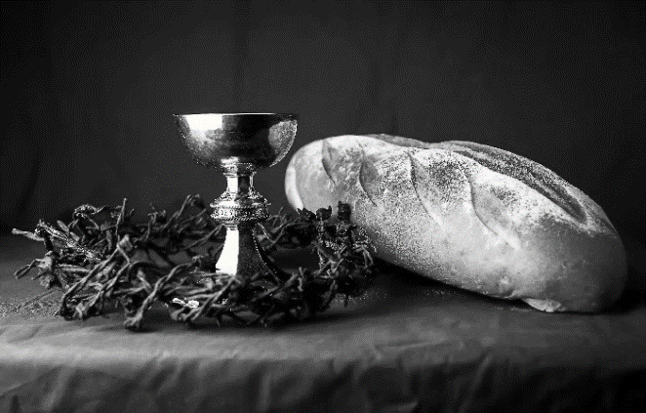
hallowed be thy name,
thy kingdom come,
thy will be done,
on earth as it is in heaven.
Give us this day our daily bread;
and forgive us our trespasses,
as we forgive those
who trespass against us;
and lead us not into temptation,
but deliver us from evil.
For thine is the kingdom,
and the power, and the glory,
forever and ever. Amen.
INVITATION TO COMMUNION - Certified gluten-free crackers are in the bowl on the communion plate.
Jesus invites you to this table.
Come, eat and live.
HOLY COMMUNION
PRAYER AFTER COMMUNION
Blessed be your name, O God,
for we have feasted on your Word,
Christ Jesus, the joy and delight of our hearts.
Strengthened by this food,
send us to gather the world to your banquet,
where none are left out and all are satisfied.
In Jesus’ name we pray.
Amen.
SENDING
BLESSING
The God of glory,
☩ Jesus Christ, name above all names,
and the Spirit who lives in you,
bless you now and forever.
Amen.
CLOSING HYMN Bind Us Together
Bind us together, Lord,  Bind us together with cords  That cannot be broken.  Bind us together, Lord,  Bind us together,  Bind us together with love. | You are the family of God.  You are the promise divine.  You are God's chosen desire.  You are the glorious new wine.
There is only one God!
There is only one King!
There is only one Body!
That is why we sing.
Gillman, Bob EMI Christian Music Publishing © 1977 Kingsway's Thankyou Music (Admin. by EMI Christian Music Publishing) CCLI License No. 669990
DISMISSAL
Life is short and we do not have much time to gladden the hearts of those who travel with us.
So be swift to love, make haste to be kind, and go in peace to love and serve the Lord.
Thanks be to God.

Upcoming Worship Assistants
 | Usher | Lector | Communion | Offering Counters
September 3 | Tim & Farrah Uphoff | Christine Tipping | Dave & Sue Schraeder | Nancy Leonard | Breanna Butler
September 10 | Greg & Terri Barth | Christine Tipping | Christopher Stuttgen  Danielle Stuttgen | Robin Beeman | David Schneider
September 17 | Lee & Sue Babcock | Andrea Hovick | Matt & Margo Barrier | Heidi Binder | Kami Weis
September 24 | Jason & Tessa Campbell | Linda Schrieber | Bruce & Nancy Tibbett | Pam Mundt | May Hill
October 1 | Brett & Breanna Butler | Nancy Tibbett | Ron Rothfusz  Andrea Hovick | Dan Mundt | Jon Hill
October 8 | Chris & Robin Beeman | Richard Kopitzke | Sarah Kopitzke  Tammy Neumann | Nancy Leonard | Breanna Butler
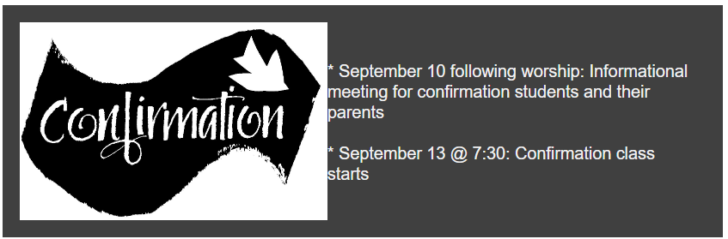
Coming up at GSLC
Sunday, September 3 | 9:00 am | Worship Service  - 14th Sunday after Pentecost  - Matthew 16:21-28; The passion prediction and rebuke to Peter
Monday, September 4 |  | Labor Day -Church Office Closed
Tuesday, September 5 | 6:00 pm | Executive Committee Meeting
 | 7:00 pm | AA Meeting
Sunday, September 10 | 9:00 am | Worship Service – Rally Sunday  - 15th Sunday after Pentecost  - Matthew 18:15-20; Reconciliation in the community of faith
 | 10:00 am | Confirmation family meeting
Tuesday, September 12 | 6:30 pm | Council Meeting
 | 7:00 pm | AA Meeting
Wednesday, September 13 | 12:00 pm | Bible Study
 | 7:00 pm | Midweek Worship  Confirmation Class
Sunday, September 17 | 9:00 am | Worship Service  - 16th Sunday after Pentecost  - Matthew 18:21-35; A parable of forgiveness in the community of faith
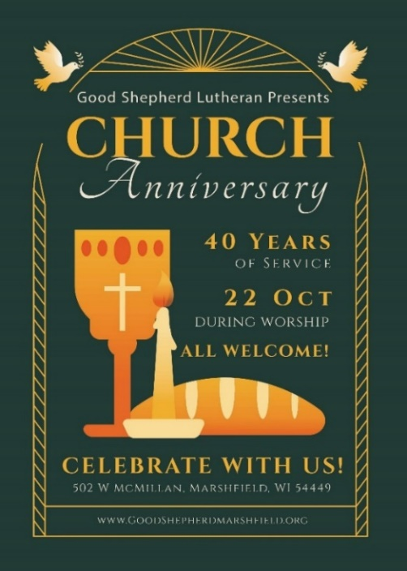
Pastor Katie's Office Hours
Monday, Wednesday, Thursday: 9:00am-2:00pm at Good Shepherd
Tuesday: 9:00am-12:00pm Uptown Coffee (located at 121 S Central Ave, Marshfield)
Other times are available by appointment.

