Good Shepherd Lutheran Church
Pastor: Katie Anderson | Music Director: Lois Swanson
Pastor’s Cell: (715) 245-1943 | Office Phone: (715) 387-2731
Pastor Email: gslcwi.pastor@gmail.com | Office Email: gslcwi.office@gmail.com
Website: GoodShepherdMarshfield.org | www.facebook.com/gslcwi
15th Sunday after Pentecost
September 10, 2023, 9:00 am
Introduction to the day…
Conflict is a part of relationships and life in a community. Jesus’ words in today's gospel are often used in situations having to do with church discipline. The prophet Ezekiel tells of warning the wicked to turn from their ways, and Paul reminds us that love is the fulfilling of the law. We gather in the name of Christ, assured that he is present among us with gifts of peace and reconciliation.
ANNOUNCEMENTS
GATHERING
GATHERING HYMN Kyrie and Song of Praise ACS 31
CONFESSION AND FORGIVENESS
Blessed be God, the one who forms us,
☩ Jesus who bears the cross,
the Spirit who makes our joy complete.
Amen.
Let us bow before God in humility, confessing our sin.
Silence is kept for reflection.
Steadfast and faithful God,
you have revealed the ways of justice, yet we fail to follow you.
We are overwhelmed by the world’s violence and suffering.
We are afraid to risk what we have for the sake of others.
For the harm we have caused, known and unknown, forgive us.
For the unjust demands we place on others and your creation, forgive us.
For the ways we turn away from you and our neighbor, forgive us.
Lead us back to you and set us on the right path;
in the name of Jesus Christ, our Savior.
Amen.
Beloved in Christ,
God’s justice stretches beyond all understanding.
God’s compassion is beyond compare.
In Jesus, God is always making a new way for us.
In ☩ Christ, you are already and always forgiven.
Amen.
PRAYER OF THE DAY
O Lord God, enliven and preserve your church with your perpetual mercy. Without your help, we mortals will fail; remove far from us everything that is harmful and lead us toward all that gives life and salvation, through Jesus Christ, our Savior and Lord. Amen.

CHILDREN’S MUSIC Jesus We Are Gathered ELW 529
CHILDREN’S MESSAGE
SCRIPTURE READINGS
FIRST READING: Ezekiel 33:7-11
⁷So you, mortal, I have made a sentinel for the house of Israel; whenever you hear a word from my mouth, you shall give them warning from me. ⁸If I say to the wicked, “O wicked ones, you shall surely die,” and you do not speak to warn the wicked to turn from their ways, the wicked shall die in their iniquity, but their blood I will require at your hand. ⁹But if you warn the wicked to turn from their ways, and they do not turn from their ways, the wicked shall die in their iniquity, but you will have saved your life.
¹⁰Now you, mortal, say to the house of Israel, Thus you have said: “Our transgressions and our sins weigh upon us, and we waste away because of them; how then can we live?” ¹¹Say to them, As I live, says the Lord God, I have no pleasure in the death of the wicked, but that the wicked turn from their ways and live; turn back, turn back from your evil ways; for why will you die, O house of Israel?
Word of God, word of life.
Thanks be to God.
PSALM: Psalm 119:33-40
³³Teach me, O Lord, the way of your statutes,
and I shall keep it to the end.
³⁴Give me understanding, and I shall keep your teaching;
I shall keep it with all my heart.
³⁵Lead me in the path of your commandments,
for that is my desire.
³⁶Incline my heart to your decrees
and not to unjust gain.
³⁷Turn my eyes from beholding falsehood;
give me life in your way.
³⁸Fulfill your promise to your servant,
which is for those who fear you.
³⁹Turn away the reproach that I dread,
because your judgments are good.
⁴⁰Behold, I long for your commandments;
by your righteousness enliven me.
SECOND READING: Romans 13:8-14
⁸Owe no one anything, except to love one another; for the one who loves another has fulfilled the law. ⁹The commandments, “You shall not commit adultery; You shall not murder; You shall not steal; You shall not covet”; and any other commandment, are summed up in this word, “Love your neighbor as yourself.” ¹⁰Love does no wrong to a neighbor; therefore, love is the fulfilling of the law.
¹¹Besides this, you know what time it is, how it is now the moment for you to wake from sleep. For salvation is nearer to us now than when we became believers; ¹²the night is far gone, the day is near. Let us then lay aside the works of darkness and put on the armor of light; ¹³let us live honorably as in the day, not in reveling and drunkenness, not in debauchery and licentiousness, not in quarreling and jealousy. ¹⁴Instead, put on the Lord Jesus Christ, and make no provision for the flesh, to gratify its desires.
Word of God, word of life.
Thanks be to God.
GOSPEL ACCLAMATION

GOSPEL: Matthew 18:15-20
[Jesus said to the disciples:] ¹⁵“If another member of the church sins against you, go and point out the fault when the two of you are alone. If the member listens to you, you have regained that one. ¹⁶But if you are not listened to, take one or two others along with you, so that every word may be confirmed by the evidence of two or three witnesses. ¹⁷If the member refuses to listen to them, tell it to the church; and if the offender refuses to listen even to the church, let such a one be to you as a Gentile and a tax collector. ¹⁸Truly I tell you, whatever you bind on earth will be bound in heaven, and whatever you loose on earth will be loosed in heaven. ¹⁹Again, truly I tell you, if two of you agree on earth about anything you ask, it will be done for you by my Father in heaven. ²⁰For where two or three are gathered in my name, I am there among them.”
The gospel of the Lord.
Praise to you, O Christ.
SERMON
HYMN OF THE DAY Drawn to the Light ELW 593
APOSTLES’ CREED
I believe in God, the Father almighty,
creator of heaven and earth.
I believe in Jesus Christ, God's only Son, our Lord,
who was conceived by the power of the Holy Spirit,
born of the Virgin Mary,
suffered under Pontius Pilate,
was crucified, died, and was buried;
he descended to the dead.
On the third day he rose again;
he ascended into heaven,
he is seated at the right hand of the Father,
and he will come to judge the living and the dead.
I believe in the Holy Spirit,
the holy catholic Church,
the communion of saints,
the forgiveness of sins,
the resurrection of the body,
and the life everlasting. Amen
PRAYERS OF INTERCESSION
…Merciful God,
Receive our prayer.
Remember us according to your steadfast love as we offer these and the prayers of our heart, trusting in your compassion made known through Jesus Christ.
Amen.
PEACE
The peace of Christ be with you always.
And also with you.
HOLY COMMUNION
OFFERING In addition to our normal offering, a Special Benevolence in September (collected in a special envelope) will go to UW Stevens Point -Marshfield Campus Student Food Pantry.
OFFERING HYMN I Come with Joy ELW 482
OFFERTORY PRAYER
God of power, God of plenty, all things belong to you.
We bring your gifts to the table, that all might be fed.
Form us into the body of your Beloved, Jesus Christ, our Savior.
Amen.
GREAT THANKSGIVING
The Lord be with you.
And also with you.
Lift up your hearts.
We lift them to the Lord.
Let us give our thanks to the Lord our God.
It is right to give our thanks and praise.
HOLY, HOLY, HOLY (Sung) ELW 189

THANKSGIVING AT THE TABLE

Holy God, mighty Lord, gracious Father:
Endless is your mercy and eternal your reign.
You have filled all creation with light and life;
heaven and earth are full of your glory.
We praise you for the grace shown to your people in every age:
the promise to Israel,
the rescue from Egypt,
the gift of the promised land,
the words of the prophets;
and, at this end of all the ages, the gift of your Son,
who proclaimed the good news in word and deed
and was obedient to your will, even to giving his life.
In the night in which he was betrayed,
our Lord Jesus took bread, and gave thanks;
broke it, and gave it to his disciples, saying:
Take and eat; this is my body, given for you.
Do this for the remembrance of me.
Again, after supper, he took the cup, gave thanks,
and gave it for all to drink, saying:
This cup is the new covenant in my blood,
shed for you and for all people for the forgiveness of sin.
Do this for the remembrance of me.
For as often as we eat of this bread and drink from this cup,
we proclaim the Lord’s death until he comes.
Christ has died.
Christ is risen.
Christ will come again.
Therefore, O God, with this bread and cup
we remember the life our Lord offered for us.
And, believing the witness of his resurrection,
we await his coming in power
to share with us the great and promised feast.
Amen. Come, Lord Jesus.
Send now, we pray, your Holy Spirit,
that we who share in Christ’s body and blood
may live to the praise of your glory
and receive our inheritance with all your saints in light.
Amen. Come, Holy Spirit.
Join our prayers with those of your servants
of every time and every place,
and unite them with the ceaseless petitions of our great high priest
until he comes as victorious Lord of all.
Through him, with him, in him,
in the unity of the Holy Spirit,
all glory and honor is yours, almighty Father,
now and forever.
Amen.

THE LORD’S PRAYER
Our Father, who art in heaven,
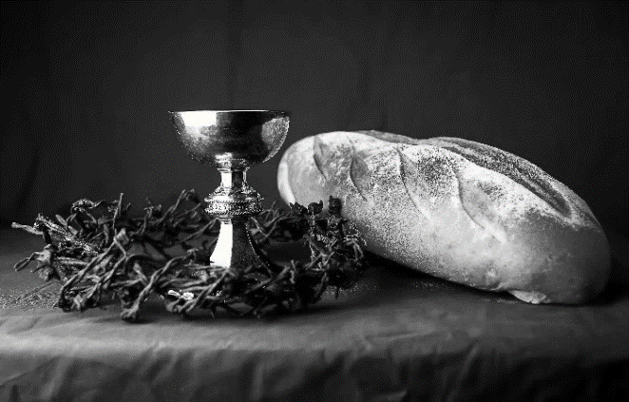
hallowed be thy name,
thy kingdom come,
thy will be done,
on earth as it is in heaven.
Give us this day our daily bread;
and forgive us our trespasses,
as we forgive those
who trespass against us;
and lead us not into temptation,
but deliver us from evil.
For thine is the kingdom,
and the power, and the glory,
forever and ever. Amen.
INVITATION TO COMMUNION - Certified gluten-free crackers are in the bowl on the communion plate.
Jesus invites you to this table.
Come, eat and live.
HOLY COMMUNION
PRAYER AFTER COMMUNION
Blessed be your name, O God,
for we have feasted on your Word,
Christ Jesus, the joy and delight of our hearts.
Strengthened by this food,
send us to gather the world to your banquet,
where none are left out and all are satisfied.
In Jesus’ name we pray.
Amen.
SENDING
BLESSING
The God of glory,
☩ Jesus Christ, name above all names,
and the Spirit who lives in you,
bless you now and forever.
Amen.
CLOSING HYMN God’s Work Our Hands ACS 1000
DISMISSAL
Life is short and we do not have much time to gladden the hearts of those who travel with us.
So be swift to love, make haste to be kind, and go in peace to love and serve the Lord.
Upcoming Worship Assistants
 | Usher | Lector | Communion | Offering Counters
September 10 | Volunteer | Christine Tipping | Christopher Stuttgen  Danielle Stuttgen | Robin Beeman | David Schneider
September 17 | Lee & Sue Babcock | Andrea Hovick | Matt & Margo Barrier | Heidi Binder | Kami Weis
September 24 | Jason & Tessa Campbell | Linda Schrieber | Bruce & Nancy Tibbett | Pam Mundt | May Hill
October 1 | Brett & Breanna Butler | Nancy Tibbett | Ron Rothfusz  Andrea Hovick | Dan Mundt | Jon Hill
October 8 | Chris & Robin Beeman | Richard Kopitzke | Sarah Kopitzke  Tammy Neumann | Nancy Leonard | Breanna Butler
Thanks be to God.

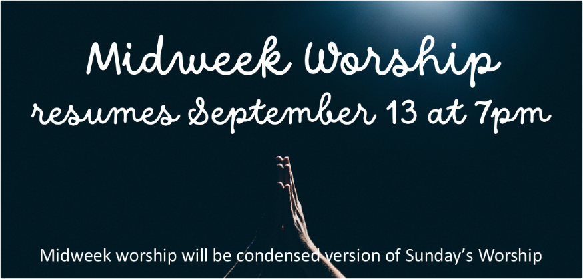
Coming up at GSLC
Sunday, September 10 | 9:00 am | Worship Service – Rally Sunday  - 15th Sunday after Pentecost  - Matthew 18:15-20; Reconciliation in the community of faith
 | 10:00 am | Confirmation family meeting
Tuesday, September 12 | 6:30 pm | Council Meeting
 | 7:00 pm | AA Meeting
Wednesday, September 13 | 12:00 pm | Bible Study
 | 7:00 pm | Midweek Worship  Confirmation Class
Sunday, September 17 | 9:00 am | Worship Service  - 16th Sunday after Pentecost  - Matthew 18:21-35; A parable of forgiveness in the community of faith

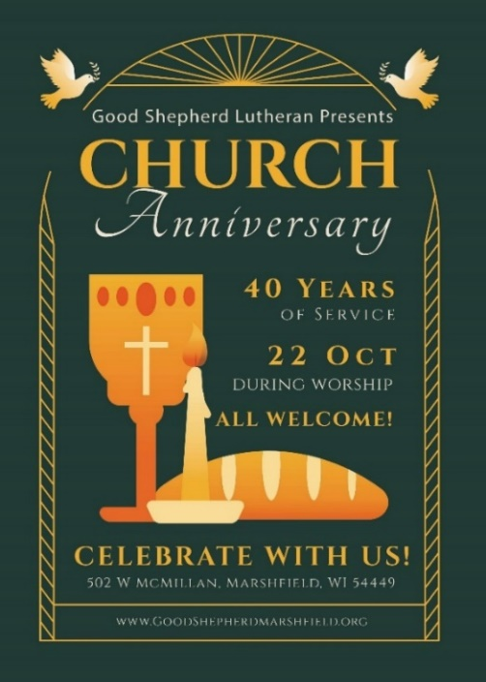
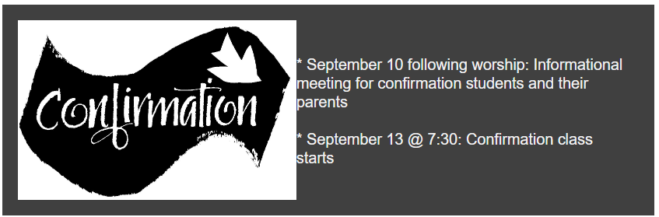
Pastor Katie's Office Hours
Monday, Wednesday, Thursday: 9:00am-2:00pm at Good Shepherd
Tuesday: 9:00am-12:00pm Uptown Coffee (located at 121 S Central Ave, Marshfield)
Other times are available by appointment.

