Good Shepherd Lutheran Church
Pastor: Katie Anderson | Music Director: Lois Swanson
Pastor’s Cell: (715) 245-1943 | Office Phone: (715) 387-2731
Pastor Email: gslcwi.pastor@gmail.com | Office Email: gslcwi.office@gmail.com
Website: GoodShepherdMarshfield.org | www.facebook.com/gslcwi
10th Sunday after Pentecost
August 6, 2023, 9:00 am
Introduction to the day…
In today’s first reading God invites all who are hungry or thirsty to receive food and drink without cost. Jesus feeds the hungry multitude and reveals the abundance of God. At the eucharistic table we remember all who are hungry or poor in our world today. As we share the bread of life, we are sent forth to give ourselves away as bread for the hungry.
ANNOUNCEMENTS
GATHERING
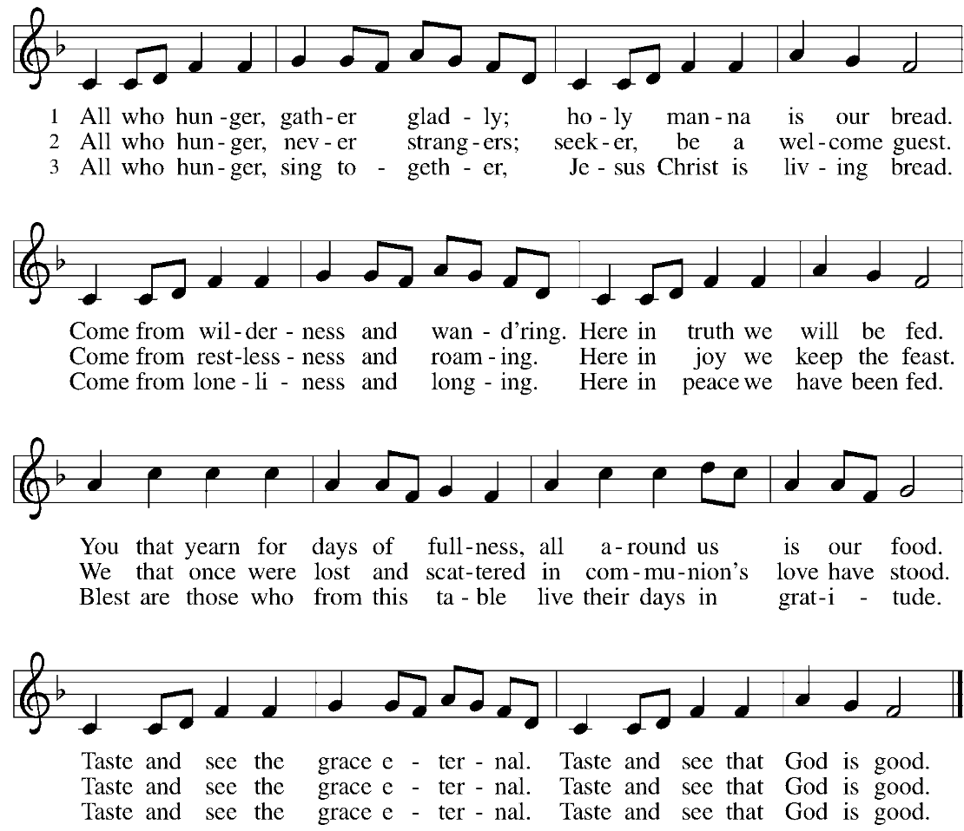
GATHERING SONG All Who Hunger, Gather Gladly ELW 461

CONFESSION AND FORGIVENESS
Blessed be the holy Trinity,☩ one God, who greets us in this and every season,
whose word never fails, whose promise is sure.
Amen.
Let us confess our sin in the presence of God and of our neighbors.
Merciful God,
we confess that we have sinned. We have hurt our community.
We have squandered your blessings. We have hoarded your bounty.
In the name of Jesus, forgive us and grant us your mercy.
Silence is kept for reflection.
Righteous God,
we confess that we have sinned. We have failed to be honest.
We have lacked the courage to speak. We have spoken falsely.
In the name of Jesus, forgive us and grant us your mercy.
Silence is kept for reflection.
God is a cup of cold water when we thirst. God offers boundless grace when we fail.
Claim the gift of God’s mercy: you are freed and forgiven in the name of ☩ Jesus Christ.
Amen.
PRAYER OF THE DAY
Glorious God, your generosity waters the world with goodness, and you cover creation with abundance. Awaken in us a hunger for the food that satisfies both body and spirit, and with this food fill all the starving world, through your Son, Jesus Christ, our Savior and Lord. Amen.
CHILDREN’S MESSAGE
SCRIPTURE READINGS
FIRST READING: Isaiah 55:1-5
¹Ho, everyone who thirsts, come to the waters;
and you that have no money, come, buy and eat!
Come, buy wine and milk without money and without price.
²Why do you spend your money for that which is not bread, and your labor for that which does not satisfy?
Listen carefully to me, and eat what is good, and delight yourselves in rich food.
³Incline your ear, and come to me; listen, so that you may live.
I will make with you an everlasting covenant, my steadfast, sure love for David.
⁴See, I made him a witness to the peoples, a leader and commander for the peoples.
⁵See, you shall call nations that you do not know, and nations that do not know you shall run to you,
because of the Lord your God, the Holy One of Israel, for he has glorified you.
Word of God, word of life.
Thanks be to God.
PSALM: Psalm 145:14-21
⁸The Lord is gracious and full of compassion,
slow to anger and abounding in steadfast love.
⁹Lord, you are good to all,
and your compassion is over all your works.
¹⁴The Lord upholds all those who fall
and lifts up those who are bowed down.
¹⁵The eyes of all wait upon you, O Lord,
and you give them their food in due season.
¹⁶You open wide your hand
and satisfy the desire of every living thing.
¹⁷You are righteous in all your ways
and loving in all your works.
¹⁸You are near to all who call upon you,
to all who call upon you faithfully.
¹⁹You fulfill the desire of those who fear you;
you hear their cry and save them.
²⁰You watch over all those who love you,
but all the wicked you shall destroy.
²¹My mouth shall speak the praise of the Lord;
let all flesh bless God’s holy name forever and ever.
SECOND READING: Romans 9:1-5
¹I am speaking the truth in Christ—I am not lying; my conscience confirms it by the Holy Spirit—²I have great sorrow and unceasing anguish in my heart. ³For I could wish that I myself were accursed and cut off from Christ for the sake of my own people, my kindred according to the flesh. ⁴They are Israelites, and to them belong the adoption, the glory, the covenants, the giving of the law, the worship, and the promises; ⁵to them belong the patriarchs, and from them, according to the flesh, comes the Messiah, who is over all, God blessed forever. Amen.
Word of God, word of life.
Thanks be to God.

GOSPEL ACCLAMATION

GOSPEL: Matthew 14:13-21
¹³Now when Jesus heard [about the beheading of John the Baptist], he withdrew from there in a boat to a deserted place by himself. But when the crowds heard it, they followed him on foot from the towns. ¹⁴When he went ashore, he saw a great crowd; and he had compassion for them and cured their sick. ¹⁵When it was evening, the disciples came to him and said, “This is a deserted place, and the hour is now late; send the crowds away so that they may go into the villages and buy food for themselves.” ¹⁶Jesus said to them, “They need not go away; you give them something to eat.” ¹⁷They replied, “We have nothing here but five loaves and two fish.” ¹⁸And he said, “Bring them here to me.” ¹⁹Then he ordered the crowds to sit down on the grass. Taking the five loaves and the two fish, he looked up to heaven, and blessed and broke the loaves, and gave them to the disciples, and the disciples gave them to the crowds. ²⁰And all ate and were filled; and they took up what was left over of the broken pieces, twelve baskets full. ²¹And those who ate were about five thousand men, besides women and children.
The gospel of the Lord.
Praise to you, O Christ.
SERMON
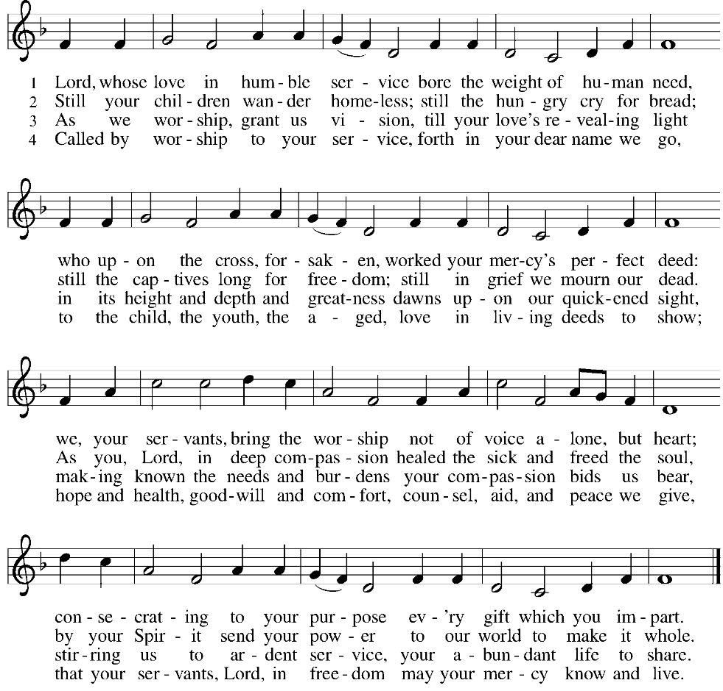
HYMN OF THE DAY Lord, Whose Love in Humble Service ELW 712

APOSTLES’ CREED
I believe in God, the Father almighty,
creator of heaven and earth.
I believe in Jesus Christ, God's only Son, our Lord,
who was conceived by the power of the Holy Spirit,
born of the Virgin Mary,
suffered under Pontius Pilate,
was crucified, died, and was buried;
he descended to the dead.
On the third day he rose again;
he ascended into heaven,
he is seated at the right hand of the Father,
and he will come to judge the living and the dead.
I believe in the Holy Spirit,
the holy catholic Church,
the communion of saints,
the forgiveness of sins,
the resurrection of the body,
and the life everlasting. Amen
PRAYERS OF INTERCESSION
…Hear us, O God,
Your mercy is great,
Into your hands, O God, we commend all for whom we pray, in the name of the one who reconciled all creation to himself, Jesus Christ our Savior.
Amen.
PEACE
The peace of Christ be with you always.
And also with you.
HOLY COMMUNION
OFFERING In addition to our normal offering, a Special Benevolence in August (collected in a special envelope) will go to Companion Day Service.
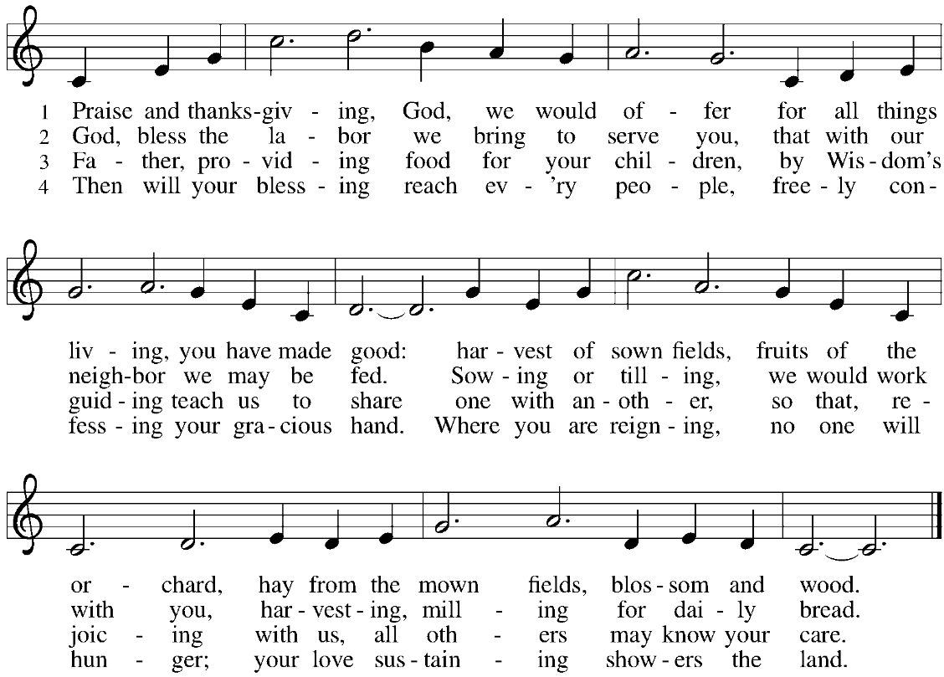
OFFERING SONG Praise and Thanksgiving ELW 689

OFFERTORY PRAYER
God of field and forest, sea and sky,
you are the giver of all good things.
Sustain us with these gifts of your creation,
and multiply your graciousness in us,
that the world may be fed with your love,
through Jesus Christ, our Savior and Lord.
Amen.
GREAT THANKSGIVING
The Lord be with you.
And also with you.
Lift up your hearts.
We lift them to the Lord.
Let us give our thanks to the Lord our God.
It is right to give our thanks and praise.
HOLY, HOLY, HOLY (Sung) ELW 189

THANKSGIVING AT THE TABLE

God of our weary years, God of our silent tears,
you have brought us this far along the way.
In times of bitterness you did not abandon us,
but guided us into the path of love and light.
In every age you sent prophets
to make known your loving will for all humanity.
The cry of the poor has become your own cry;
our hunger and thirst for justice is your own desire.
In the fullness of time, you sent your chosen servant
to preach good news to the afflicted,
to break bread with the outcast and despised,
and to ransom those in bondage to prejudice and sin.
In the night in which he was betrayed,
our Lord Jesus took bread, and gave thanks;
broke it, and gave it to his disciples, saying:
Take and eat; this is my body, given for you.
Do this for the remembrance of me.
Again, after supper, he took the cup, gave thanks,
and gave it for all to drink, saying:
This cup is the new covenant in my blood,
shed for you and all people for the forgiveness of sin.
Do this for the remembrance of me.
For as often as we eat of this bread and drink from this cup
we proclaim the Lord’s death until he comes.
Christ has died.
Christ is risen.
Christ will come again.
Remembering, therefore, his death and resurrection,
we await the day when Jesus shall return
to free all the earth from the bonds of slavery and death.
Come, Lord Jesus! And let the church say, Amen.
Amen.
Send your Holy Spirit, our advocate,
to fill the hearts of all who share this bread and cup
with courage and wisdom to pursue love and justice in all the world.
Come, Spirit of freedom! And let the church say, Amen.
Amen.
Join our prayers and praise with your prophets and martyrs of every age,
that, rejoicing in the hope of the resurrection,
we might live in the freedom and hope of your Son.
Through him, with him, in him, in the unity of the Holy Spirit,
all glory and honor is yours, almighty Father, now and forever.
Amen.

THE LORD’S PRAYER
Our Father, who art in heaven,
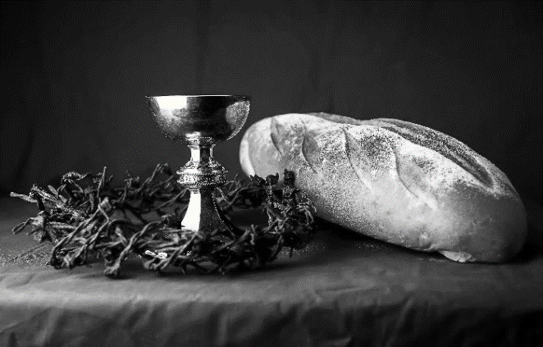
hallowed be thy name,
thy kingdom come,
thy will be done,
on earth as it is in heaven.
Give us this day our daily bread;
and forgive us our trespasses,
as we forgive those
who trespass against us;
and lead us not into temptation,
but deliver us from evil.
For thine is the kingdom,
and the power, and the glory,
forever and ever. Amen.
INVITATION TO COMMUNION - Certified gluten-free crackers are in the bowl on the communion plate.
All people are called to Christ’s table.
Come, eat what is good.
HOLY COMMUNION
PRAYER AFTER COMMUNION
We thank you, generous God, for the refreshment we have received
at your banquet table. Send us now to spread your generosity into all the world,
through the one who is our dearest treasure, Jesus Christ, our Savior and Lord.
Amen.
SENDING
BLESSING
The God who calls across the cosmos
and speaks in the smallest seed
☩ bless, keep, and sustain you
now and to the end of the age.
Amen.
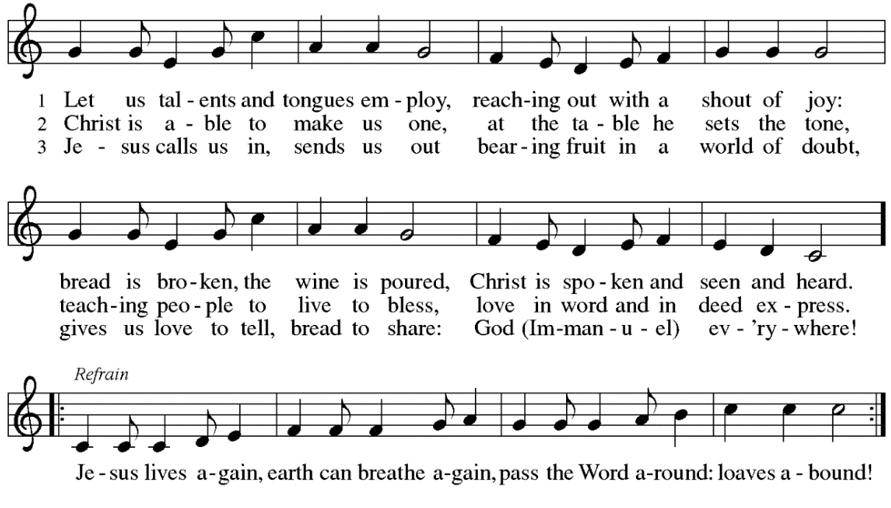
SONG Let Us Talents and Tongues Employ ELW 674

DISMISSAL
Go in peace. Share the harvest.
Thanks be to God.
Upcoming Worship Assistants
 | Usher | Lector | Communion | Offering Counters
August 6 | Julie Will | Kris Tarter | John Wagner  Nancy Leonard | Robin Beeman | David Schneider
August 13 | Andrew & Katelynn Neidner | Laurel Peterson | Dan & Pam Mundt | Heidi Binder | Kami Weis
August 20 | Samantha Bulgrin | Nancy Tibbett | Bob & Laurel Peterson | Pam Mundt | May Hill
August 27 | Jerry & Nonnie Arndt | Leslie Mader | Bruce & Nancy Tibbett | Dan Mundt | Jon Hill
September 3 | Tim & Farrah Uphoff | Christine Tipping | Dave & Sue Schraeder | Nancy Leonard | Breanna Butler
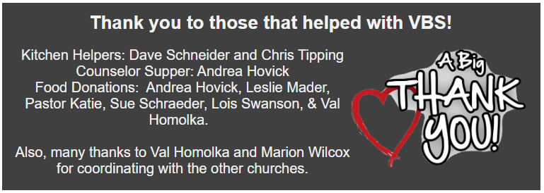
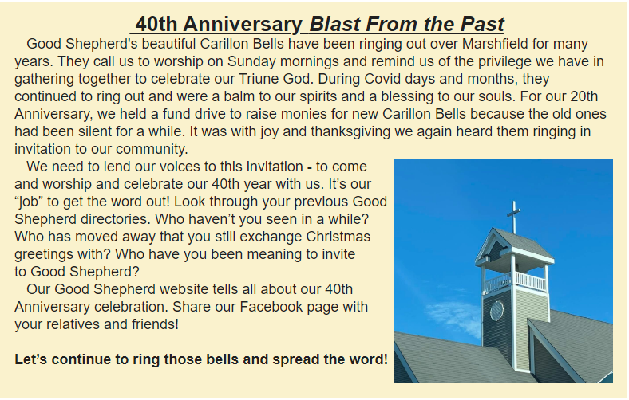
Coming up at GSLC
Sunday, August 6 | 9:00 am | Outdoor Worship Service  - 10th Sunday after Pentecost  - Matthew 14:13-21; Christ feeding five thousand.
Tuesday, August 8 | 6:30 pm | Council Meeting
 | 7:00 pm | AA Meeting
Wednesday, August 9 | 6:00 pm | Pub Theology
Sunday, August 13 | 9:00 am | Outdoor Worship Service  - 11th Sunday after Pentecost  - Matthew 14:22-33; Jesus walking on the sea.
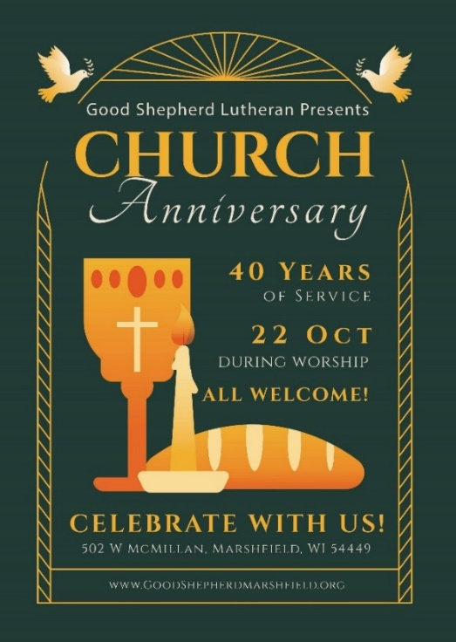

Office Summer Hours
Our office hours will vary this summer as staff are on vacation and schedules change. Please call ahead if you plan to stop by the office.

