Good Shepherd Lutheran Church
Pastor: Katie Anderson | Music Director: Lois Swanson
Pastor’s Cell: (715) 245-1943 | Office Phone: (715) 387-2731
Pastor Email: gslcwi.pastor@gmail.com | Office Email: gslcwi.office@gmail.com
Website: GoodShepherdMarshfield.org | www.facebook.com/gslcwi
13th Sunday after Pentecost
August 27, 2023, 9:00 am
Guest Pastor Gisele Berninghaus
Introduction to the day…
In Isaiah the people are advised to look to their spiritual ancestors as the rock from which they were hewn. Jesus declares that the church will be built on the rock of Peter’s bold confession of faith. God’s word of reconciliation and God’s mercy are keys to the church’s mission. Paul urges us to not be conformed to this world but to offer our bodies as a living sacrifice, using our individual gifts to build up the body of Christ. From the table we go forth to offer our spiritual worship through word and deed.
ANNOUNCEMENTS
GATHERING
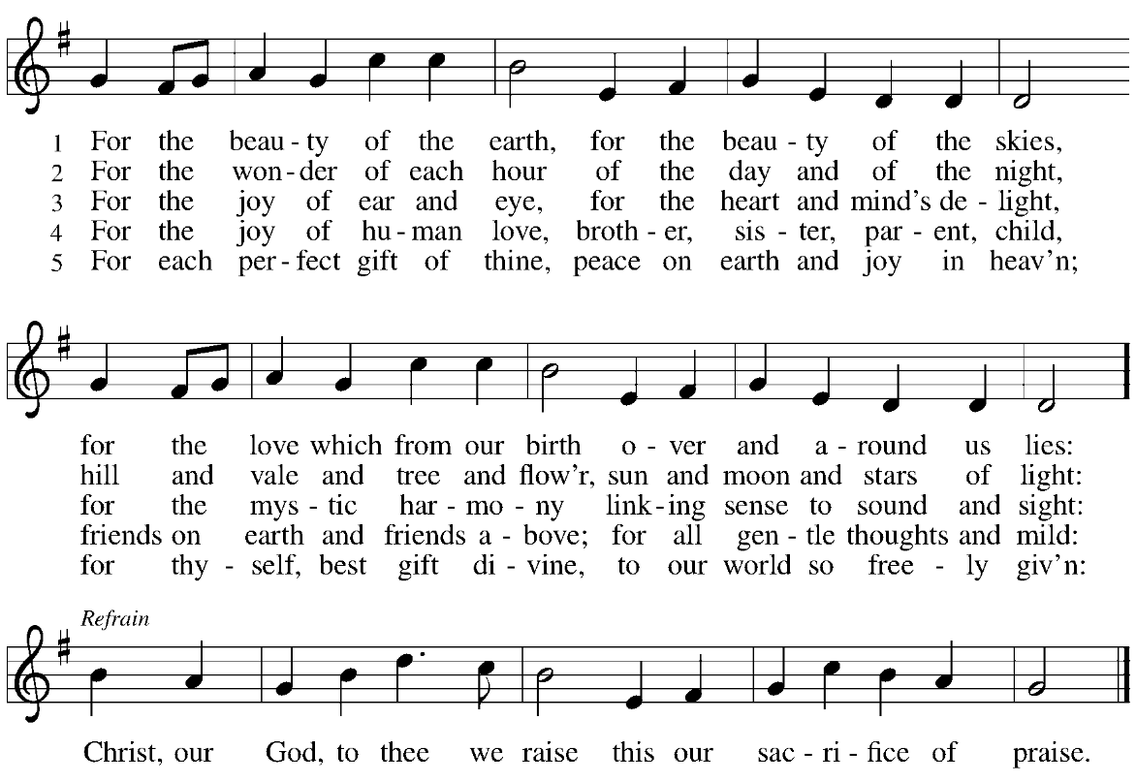
GATHERING SONG For the Beauty of the Earth ELW 879

CONFESSION AND FORGIVENESS
Blessed be the holy Trinity,☩ one God, who greets us in this and every season,
whose word never fails, whose promise is sure.
Amen.
Let us confess our sin in the presence of God and of our neighbors.
Merciful God,
we confess that we have sinned. We have hurt our community.
We have squandered your blessings. We have hoarded your bounty.
In the name of Jesus, forgive us and grant us your mercy.
Silence is kept for reflection.

Righteous God,
we confess that we have sinned. We have failed to be honest.
We have lacked the courage to speak. We have spoken falsely.
In the name of Jesus, forgive us and grant us your mercy.
Silence is kept for reflection.
God is a cup of cold water when we thirst. God offers boundless grace when we fail.
Claim the gift of God’s mercy: you are freed and forgiven in the name of ☩ Jesus Christ.
Amen.
PRAYER OF THE DAY
O God, with all your faithful followers of every age, we praise you, the rock of our life. Be our strong foundation and form us into the body of your Son, that we may gladly minister to all the world, through Jesus Christ, our Savior and Lord. Amen.
CHILDREN’S MESSAGE
SCRIPTURE READINGS
FIRST READING: Isaiah 51:1-6
¹Listen to me, you that pursue righteousness,
you that seek the Lord.
Look to the rock from which you were hewn,
and to the quarry from which you were dug.
²Look to Abraham your father
and to Sarah who bore you;
for he was but one when I called him,
but I blessed him and made him many.
³For the Lord will comfort Zion;
he will comfort all her waste places,
and will make her wilderness like Eden,
her desert like the garden of the Lord;
joy and gladness will be found in her,
thanksgiving and the voice of song.
⁴Listen to me, my people,
and give heed to me, my nation;
for a teaching will go out from me,
and my justice for a light to the peoples.
⁵I will bring near my deliverance swiftly,
my salvation has gone out
and my arms will rule the peoples;
the coastlands wait for me,
and for my arm they hope.
⁶Lift up your eyes to the heavens,
and look at the earth beneath;
for the heavens will vanish like smoke,
the earth will wear out like a garment,
and those who live on it will die like gnats;
but my salvation will be forever,
and my deliverance will never be ended.
Word of God, word of life.
Thanks be to God.

PSALM: Psalm 138
¹I will give thanks to you, O Lord, with my whole heart;
before the gods I will sing your praise.
²I will bow down toward your holy temple and praise your name, because of your steadfast love and faithfulness;
for you have glorified your name and your word above all things.
³When I called, you answered me;
you increased my strength within me.
⁴All the rulers of the earth will praise you, O Lord,
when they have heard the words of your mouth.
⁵They will sing of the ways of the Lord,
that great is the glory of the Lord.
⁶The Lord is high, yet cares for the lowly,
perceiving the haughty from afar.
⁷Though I walk in the midst of trouble, you keep me safe;
you stretch forth your hand against the fury of my enemies; your right hand shall save me.
⁸You will make good your purpose for me;
O Lord, your steadfast love endures forever; do not abandon the works of your hands.
GOSPEL ACCLAMATION

GOSPEL: Matthew 16:13-20
¹³Now when Jesus came into the district of Caesarea Philippi, he asked his disciples, “Who do people say that the Son of Man is?” ¹⁴And they said, “Some say John the Baptist, but others Elijah, and still others Jeremiah or one of the prophets.” ¹⁵He said to them, “But who do you say that I am?” ¹⁶Simon Peter answered, “You are the Messiah, the Son of the living God.” ¹⁷And Jesus answered him, “Blessed are you, Simon son of Jonah! For flesh and blood has not revealed this to you, but my Father in heaven. ¹⁸And I tell you, you are Peter, and on this rock I will build my church, and the gates of Hades will not prevail against it. ¹⁹I will give you the keys of the kingdom of heaven, and whatever you bind on earth will be bound in heaven, and whatever you loose on earth will be loosed in heaven.” ²⁰Then he sternly ordered the disciples not to tell anyone that he was the Messiah.
The gospel of the Lord.
Praise to you, O Christ.
SERMON
HYMN OF THE DAY Seek Ye First
Seek ye first the kingdom of God and its righteousness,
And all these things shall be added unto you, Allelu, alleluia.
Ask, and it shall be given unto you. Seek, and you shall find.
Knock, and the door shall be opened unto you, Allelu, alleluia.
We do not live by bread alone, But by ev’ry word.
That proceeds from the mouth of God. Allelu, alleluia.
1972 CCCM Music (Admin. by Brentwood-Benson Music Publishing, Inc.) Universal Music - Brentwood Benson Publishing (Admin. by Brentwood-Benson Music Publishing, Inc.)
APOSTLES’ CREED
I believe in God, the Father almighty,
creator of heaven and earth.
I believe in Jesus Christ, God's only Son, our Lord,
who was conceived by the power of the Holy Spirit,
born of the Virgin Mary,
suffered under Pontius Pilate,
was crucified, died, and was buried;
he descended to the dead.
On the third day he rose again;
he ascended into heaven,
he is seated at the right hand of the Father,
and he will come to judge the living and the dead.
I believe in the Holy Spirit,
the holy catholic Church,
the communion of saints,
the forgiveness of sins,
the resurrection of the body,
and the life everlasting. Amen
PRAYERS OF INTERCESSION
…Hear us, O God,
Your mercy is great,
Into your hands, O God, we commend all for whom we pray, in the name of the one who reconciled all creation to himself, Jesus Christ our Savior.
Amen.
PEACE
The peace of Christ be with you always.
And also with you.
HOLY COMMUNION
OFFERING In addition to our normal offering, a Special Benevolence in August (collected in a special envelope) will go to Companion Day Services.
OFFERING SONG We Are an Offering ELW 692
We lift our voices, We lift our hands,
We lift our lives up to You: We are an offering.
Lord use our voices, Lord use our hands,
Lord use our lives, they are Yours: We are an offering
All that we have, All that we are,
All that we hope to be, We give to You, We give to You
We lift our voices, We lift our hands,
We lift our lives up to You: We are an offering, We are an offering
OFFERTORY PRAYER
God of field and forest, sea and sky,
you are the giver of all good things.
Sustain us with these gifts of your creation,
and multiply your graciousness in us,
that the world may be fed with your love,
through Jesus Christ, our Savior and Lord.
Amen.

GREAT THANKSGIVING
The Lord be with you.
And also with you.
Lift up your hearts.
We lift them to the Lord.
Let us give our thanks to the Lord our God.
It is right to give our thanks and praise.
HOLY, HOLY, HOLY (Sung) ELW 189

THANKSGIVING AT THE TABLE

God of our weary years, God of our silent tears,
you have brought us this far along the way.
In times of bitterness you did not abandon us,
but guided us into the path of love and light.
In every age you sent prophets
to make known your loving will for all humanity.
The cry of the poor has become your own cry;
our hunger and thirst for justice is your own desire.
In the fullness of time, you sent your chosen servant
to preach good news to the afflicted,
to break bread with the outcast and despised,
and to ransom those in bondage to prejudice and sin.
In the night in which he was betrayed,
our Lord Jesus took bread, and gave thanks;
broke it, and gave it to his disciples, saying:
Take and eat; this is my body, given for you.
Do this for the remembrance of me.
Again, after supper, he took the cup, gave thanks,
and gave it for all to drink, saying:
This cup is the new covenant in my blood,
shed for you and all people for the forgiveness of sin.
Do this for the remembrance of me.
For as often as we eat of this bread and drink from this cup
we proclaim the Lord’s death until he comes.
Christ has died.
Christ is risen.
Christ will come again.
Remembering, therefore, his death and resurrection,
we await the day when Jesus shall return
to free all the earth from the bonds of slavery and death.
Come, Lord Jesus! And let the church say, Amen.
Amen.
Send your Holy Spirit, our advocate,
to fill the hearts of all who share this bread and cup
with courage and wisdom to pursue love and justice in all the world.
Come, Spirit of freedom! And let the church say, Amen.
Amen.
Join our prayers and praise with your prophets and martyrs of every age,
that, rejoicing in the hope of the resurrection,
we might live in the freedom and hope of your Son.
Through him, with him, in him, in the unity of the Holy Spirit,
all glory and honor is yours, almighty Father, now and forever.
Amen.

THE LORD’S PRAYER
Our Father, who art in heaven,
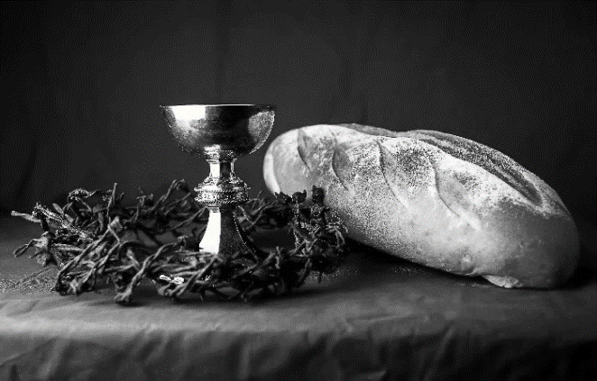
hallowed be thy name,
thy kingdom come,
thy will be done,
on earth as it is in heaven.
Give us this day our daily bread;
and forgive us our trespasses,
as we forgive those
who trespass against us;
and lead us not into temptation,
but deliver us from evil.
For thine is the kingdom,
and the power, and the glory,
forever and ever. Amen.
INVITATION TO COMMUNION - Certified gluten-free crackers are in the bowl on the communion plate.
All people are called to Christ’s table.
Come, eat what is good.
HOLY COMMUNION
PRAYER AFTER COMMUNION
We thank you, generous God, for the refreshment we have received
at your banquet table. Send us now to spread your generosity into all the world,
through the one who is our dearest treasure, Jesus Christ, our Savior and Lord.
Amen.
SENDING
BLESSING
The God who calls across the cosmos
and speaks in the smallest seed
☩ bless, keep, and sustain you
now and to the end of the age.
Amen.
SONG In Christ Alone
1 In Christ alone my hope is found  He is my light, my strength, my song  This Cornerstone, this solid ground  Firm through the fiercest drought and storm  What heights of love, what depths of peace  When fears are stilled, when strivings cease  My Comforter, my All in All  Here in the love of Christ I stand | 3 There in the ground His body lay  Light of the world by darkness slain  Then bursting forth in glorious Day  Up from the grave He rose again  And as He stands in victory  Sin's curse has lost its grip on me  For I am His and He is mine  Bought with the precious blood of Christ
2 In Christ alone, who took on flesh  Fullness of God in helpless babe  This gift of love and righteousness  Scorned by the ones He came to save  'Till on that cross as Jesus died  The wrath of God was satisfied  For every sin on Him was laid  Here in the death of Christ I live | 4 No guilt in life, no fear in death  This is the power of Christ in me  From life's first cry to final breath  Jesus commands my destiny  No power of hell, no scheme or plan  Can ever pluck me from His hand  'Till He returns or calls me home  Here in the power of Christ I'll stand
Keith Getty, Stuart Townend; CCLI #669990
DISMISSAL
Go in peace. Share the harvest.
Thanks be to God.

Upcoming Worship Assistants
 | Usher | Lector | Communion | Offering Counters
August 27 | Jerry & Nonnie Arndt | Leslie Mader | Dave & Shelly Schneider | Dan Mundt | Jon Hill
September 3 | Tim & Farrah Uphoff | Christine Tipping | Dave & Sue Schraeder | Nancy Leonard | Breanna Butler
September 10 | Greg & Terri Barth | Julie Will | Christopher Stuttgen  Danielle Stuttgen | Robin Beeman | David Schneider
September 17 | Lee & Sue Babcock | Shelly Schneider | Matt & Margo Barrier | Heidi Binder | Kami Weis
September 24 | Jason & Tessa Campbell | Linda Schrieber | Bruce & Nancy Tibbett | Pam Mundt | May Hill
October 1 | Brett & Breanna Butler | Nancy Tibbett | Ron Rothfusz  Andrea Hovick | Dan Mundt | Jon Hill
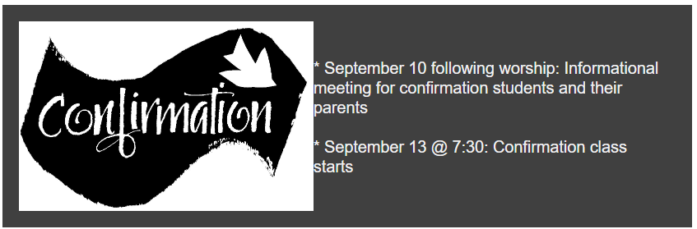
August 27 is our last outdoor worship for the summer.

Office Summer Hours
Our office hours will vary this summer as staff are on vacation and schedules change. Please call ahead if you plan to stop by the office.

Coming up at GSLC
Sunday, August 27 | 9:00 am | Outdoor Worship Service  - 13th Sunday after Pentecost  - Matthew 16:13-20; The profession of Peter’s Faith
Tuesday, August 29 | 7:00 pm | AA Meeting
Sunday, September 3 | 9:00 am | Worship Service  - 14th Sunday after Pentecost  - Matthew 16:21-28; The passion prediction and rebuke to Peter
Monday, September 4 |  | Labor Day -Church Office Closed
Tuesday, September 5 | 6:00 pm | Executive Committee Meeting
 | 7:00 pm | AA Meeting
Sunday, September 10 | 9:00 am | Worship Service – Rally Sunday  - 15th Sunday after Pentecost  - Matthew 18:15-20; Reconciliation in the community of faith
 | 10:00 am | Confirmation family meeting
