Good Shepherd Lutheran Church
Pastor: Katie Anderson | Music Director: Lois Swanson
Pastor’s Cell: (715) 245-1943 | Office Phone: (715) 387-2731
Pastor Email: gslcwi.pastor@gmail.com | Office Email: gslcwi.office@gmail.com
Website: GoodShepherdMarshfield.org | www.facebook.com/gslcwi
12th Sunday after Pentecost
August 20, 2023, 9:00 am
Introduction to the day…
In Isaiah we hear that God’s house shall be a house of prayer for all people and that God will gather the outcasts of Israel. The Canaanite woman in today’s gospel is a Gentile, an outsider, who is unflinching in her request that Jesus heal her daughter. As Jesus commends her bold faith, how might our church extend its mission to those on the margins of society? In our gathering around word and meal we receive strength to be signs of comfort, healing, and justice for those in need.
ANNOUNCEMENTS
GATHERING
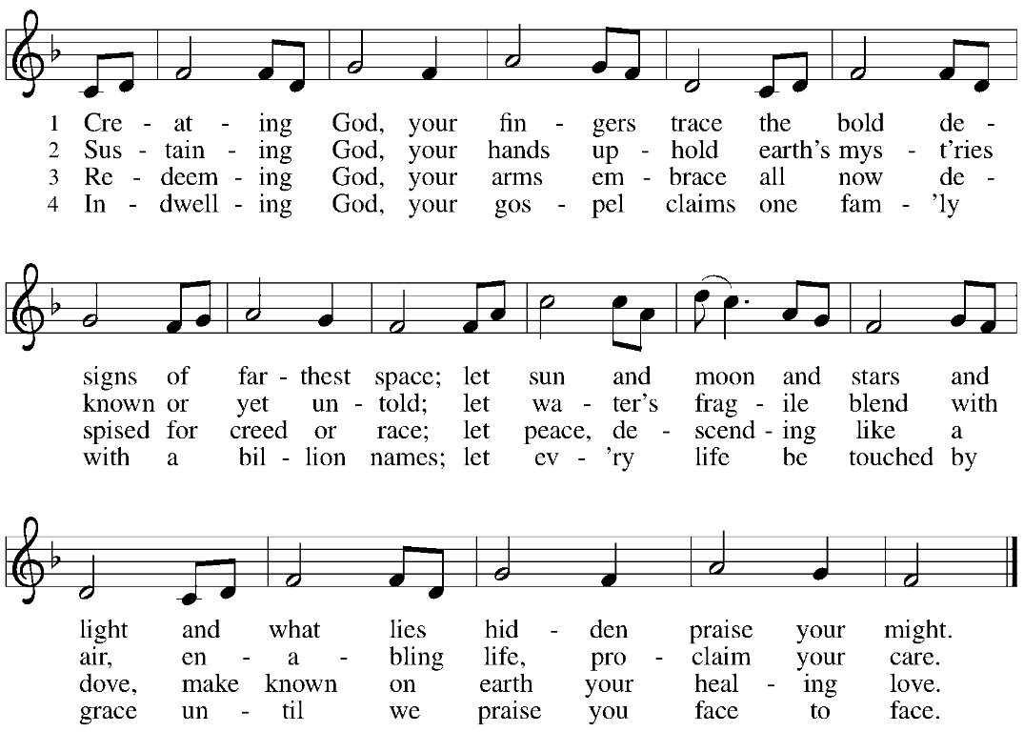
GATHERING SONG Creating God, Your Fingers Trace ELW 684

CONFESSION AND FORGIVENESS
Blessed be the holy Trinity,☩ one God, who greets us in this and every season,
whose word never fails, whose promise is sure.
Amen.
Let us confess our sin in the presence of God and of our neighbors.
Merciful God,
we confess that we have sinned. We have hurt our community.
We have squandered your blessings. We have hoarded your bounty.
In the name of Jesus, forgive us and grant us your mercy.
Silence is kept for reflection.

Righteous God,
we confess that we have sinned. We have failed to be honest.
We have lacked the courage to speak. We have spoken falsely.
In the name of Jesus, forgive us and grant us your mercy.
Silence is kept for reflection.
God is a cup of cold water when we thirst. God offers boundless grace when we fail.
Claim the gift of God’s mercy: you are freed and forgiven in the name of ☩ Jesus Christ.
Amen.
PRAYER OF THE DAY
God of all peoples, your arms reach out to embrace all those who call upon you. Teach us as disciples of your Son to love the world with compassion and constancy, that your name may be known throughout the earth, through Jesus Christ, our Savior and Lord. Amen.
CHILDREN’S MESSAGE
SCRIPTURE READINGS
FIRST READING: Isaiah 56:1, 6-8
¹Thus says the Lord:
Maintain justice, and do what is right,
for soon my salvation will come,
and my deliverance be revealed.
⁶And the foreigners who join themselves to the Lord,
to minister to him, to love the name of the Lord,
and to be his servants,
all who keep the sabbath, and do not profane it,
and hold fast my covenant—
⁷these I will bring to my holy mountain,
and make them joyful in my house of prayer;
their burnt offerings and their sacrifices
will be accepted on my altar;
for my house shall be called a house of prayer
for all peoples.
⁸Thus says the Lord God,
who gathers the outcasts of Israel,
I will gather others to them
besides those already gathered.
Word of God, word of life.
Thanks be to God.
PSALM: Psalm 67
¹May God be merciful to us and bless us;
may the light of God’s face shine upon us.
²Let your way be known upon earth,
your saving health among all nations.
³Let the peoples praise you, O God;
let all the peoples praise you.
⁴Let the nations be glad and sing for joy,
for you judge the peoples with equity and guide all the nations on earth.
⁵Let the peoples praise you, O God;
let all the peoples praise you.
⁶The earth has brought forth its increase;
God, our own God, has blessed us.
⁷May God give us blessing,
and may all the ends of the earth stand in awe.
SECOND READING: Romans 11:1-2a, 29-32
[Paul writes:] ¹I ask, then, has God rejected his people? By no means! I myself am an Israelite, a descendant of Abraham, a member of the tribe of Benjamin. ^{2a}God has not rejected his people whom he foreknew.
²⁹For the gifts and the calling of God are irrevocable. ³⁰Just as you were once disobedient to God but have now received mercy because of their disobedience, ³¹so they have now been disobedient in order that, by the mercy shown to you, they too may now receive mercy. ³²For God has imprisoned all in disobedience so that he may be merciful to all.
Word of God, word of life.
Thanks be to God.
GOSPEL ACCLAMATION

GOSPEL: Matthew 15:10-28
¹⁰[Jesus] called the crowd to him and said to them, “Listen and understand:¹¹it is not what goes into the mouth that defiles a person, but it is what comes out of the mouth that defiles.” ¹²Then the disciples approached and said to him, “Do you know that the Pharisees took offense when they heard what you said?” ¹³He answered, “Every plant that my heavenly Father has not planted will be uprooted. ¹⁴Let them alone; they are blind guides of the blind. And if one blind person guides another, both will fall into a pit.” ¹⁵But Peter said to him, “Explain this parable to us.” ¹⁶Then he said, “Are you also still without understanding? ¹⁷Do you not see that whatever goes into the mouth enters the stomach, and goes out into the sewer? ¹⁸But what comes out of the mouth proceeds from the heart, and this is what defiles. ¹⁹For out of the heart come evil intentions, murder, adultery, fornication, theft, false witness, slander. ²⁰These are what defile a person, but to eat with unwashed hands does not defile.”
²¹Jesus left that place and went away to the district of Tyre and Sidon. ²²Just then a Canaanite woman from that region came out and started shouting, “Have mercy on me, Lord, Son of David; my daughter is tormented by a demon.” ²³But he did not answer her at all. And his disciples came and urged him, saying, “Send her away, for she keeps shouting after us.” ²⁴He answered, “I was sent only to the lost sheep of the house of Israel.” ²⁵But she came and knelt before him, saying, “Lord, help me.” ²⁶He answered, “It is not fair to take the children’s food and throw it to the dogs.” ²⁷She said, “Yes, Lord, yet even the dogs eat the crumbs that fall from their masters’ table.” ²⁸Then Jesus answered her, “Woman, great is your faith! Let it be done for you as you wish.” And her daughter was healed instantly.
The gospel of the Lord.
Praise to you, O Christ.
SERMON

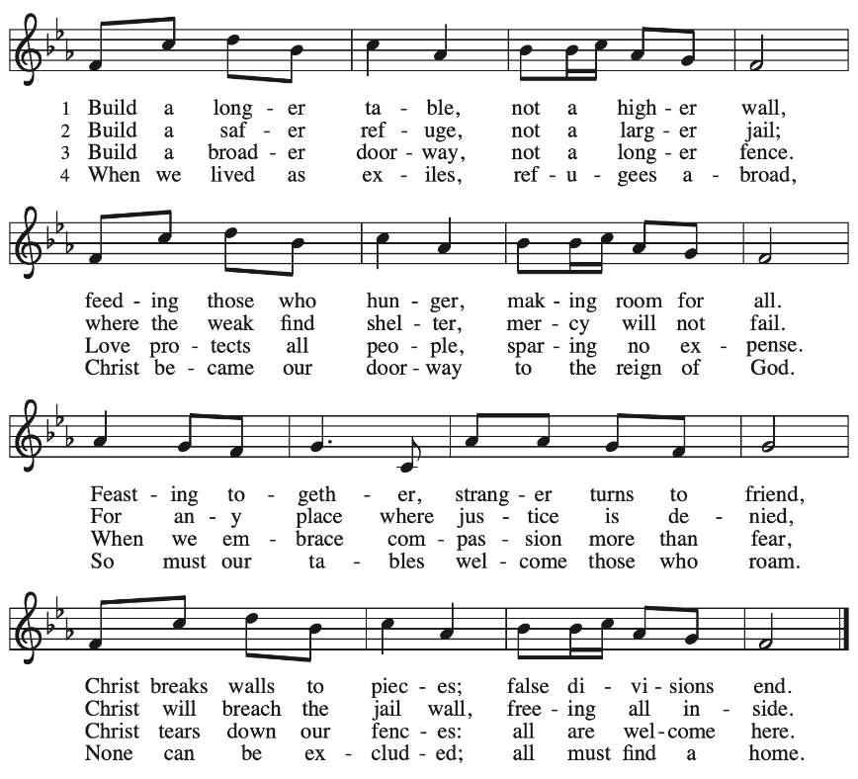
HYMN OF THE DAY Build a Longer Table ACS 1062

APOSTLES’ CREED
I believe in God, the Father almighty,
creator of heaven and earth.
I believe in Jesus Christ, God's only Son, our Lord,
who was conceived by the power of the Holy Spirit,
born of the Virgin Mary,
suffered under Pontius Pilate,
was crucified, died, and was buried;
he descended to the dead.
On the third day he rose again;
he ascended into heaven,
he is seated at the right hand of the Father,
and he will come to judge the living and the dead.
I believe in the Holy Spirit,
the holy catholic Church,
the communion of saints,
the forgiveness of sins,
the resurrection of the body,
and the life everlasting. Amen
PRAYERS OF INTERCESSION
…Hear us, O God,
Your mercy is great,
Into your hands, O God, we commend all for whom we pray, in the name of the one who reconciled all creation to himself, Jesus Christ our Savior.
Amen.
PEACE
The peace of Christ be with you always.
And also with you.
HOLY COMMUNION
OFFERING In addition to our normal offering, a Special Benevolence in August (collected in a special envelope) will go to Companion Day Services.
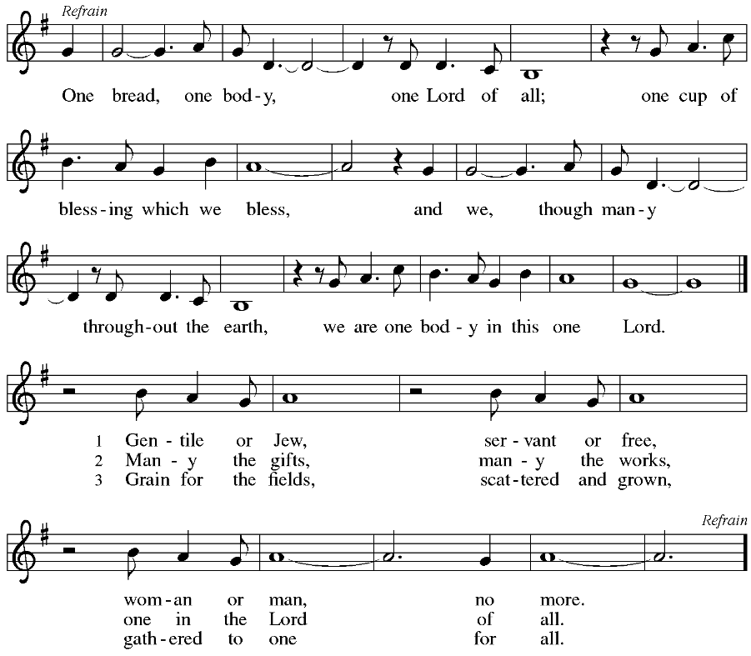
OFFERING SONG One Bread, One Body ELW 496

OFFERTORY PRAYER
God of field and forest, sea and sky,
you are the giver of all good things.
Sustain us with these gifts of your creation,
and multiply your graciousness in us,
that the world may be fed with your love,
through Jesus Christ, our Savior and Lord.
Amen.
GREAT THANKSGIVING
The Lord be with you.
And also with you.
Lift up your hearts.
We lift them to the Lord.
Let us give our thanks to the Lord our God.
It is right to give our thanks and praise.

HOLY, HOLY, HOLY (Sung) ELW 189

THANKSGIVING AT THE TABLE

God of our weary years, God of our silent tears,
you have brought us this far along the way.
In times of bitterness you did not abandon us,
but guided us into the path of love and light.
In every age you sent prophets
to make known your loving will for all humanity.
The cry of the poor has become your own cry;
our hunger and thirst for justice is your own desire.
In the fullness of time, you sent your chosen servant
to preach good news to the afflicted,
to break bread with the outcast and despised,
and to ransom those in bondage to prejudice and sin.
In the night in which he was betrayed,
our Lord Jesus took bread, and gave thanks;
broke it, and gave it to his disciples, saying:
Take and eat; this is my body, given for you.
Do this for the remembrance of me.
Again, after supper, he took the cup, gave thanks,
and gave it for all to drink, saying:
This cup is the new covenant in my blood,
shed for you and all people for the forgiveness of sin.
Do this for the remembrance of me.
For as often as we eat of this bread and drink from this cup
we proclaim the Lord’s death until he comes.
Christ has died.
Christ is risen.
Christ will come again.
Remembering, therefore, his death and resurrection,
we await the day when Jesus shall return
to free all the earth from the bonds of slavery and death.
Come, Lord Jesus! And let the church say, Amen.
Amen.
Send your Holy Spirit, our advocate,
to fill the hearts of all who share this bread and cup
with courage and wisdom to pursue love and justice in all the world.
Come, Spirit of freedom! And let the church say, Amen.
Amen.
Join our prayers and praise with your prophets and martyrs of every age,
that, rejoicing in the hope of the resurrection,
we might live in the freedom and hope of your Son.
Through him, with him, in him, in the unity of the Holy Spirit,
all glory and honor is yours, almighty Father, now and forever.
Amen.

THE LORD’S PRAYER
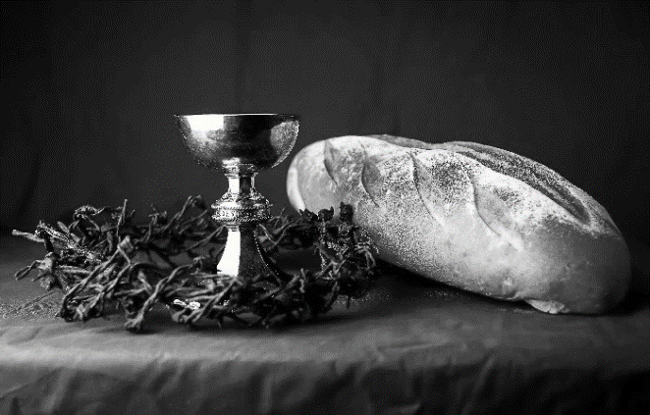
Our Father, who art in heaven,
hallowed be thy name,
thy kingdom come,
thy will be done,
on earth as it is in heaven.
Give us this day our daily bread;
and forgive us our trespasses,
as we forgive those
who trespass against us;
and lead us not into temptation,
but deliver us from evil.
For thine is the kingdom,
and the power, and the glory,
forever and ever. Amen.
INVITATION TO COMMUNION - Certified gluten-free crackers are in the bowl on the communion plate.
All people are called to Christ’s table.
Come, eat what is good.
HOLY COMMUNION
PRAYER AFTER COMMUNION
We thank you, generous God, for the refreshment we have received
at your banquet table. Send us now to spread your generosity into all the world,
through the one who is our dearest treasure, Jesus Christ, our Savior and Lord.
Amen.
SENDING
BLESSING
The God who calls across the cosmos
and speaks in the smallest seed
☩ bless, keep, and sustain you
now and to the end of the age.
Amen.
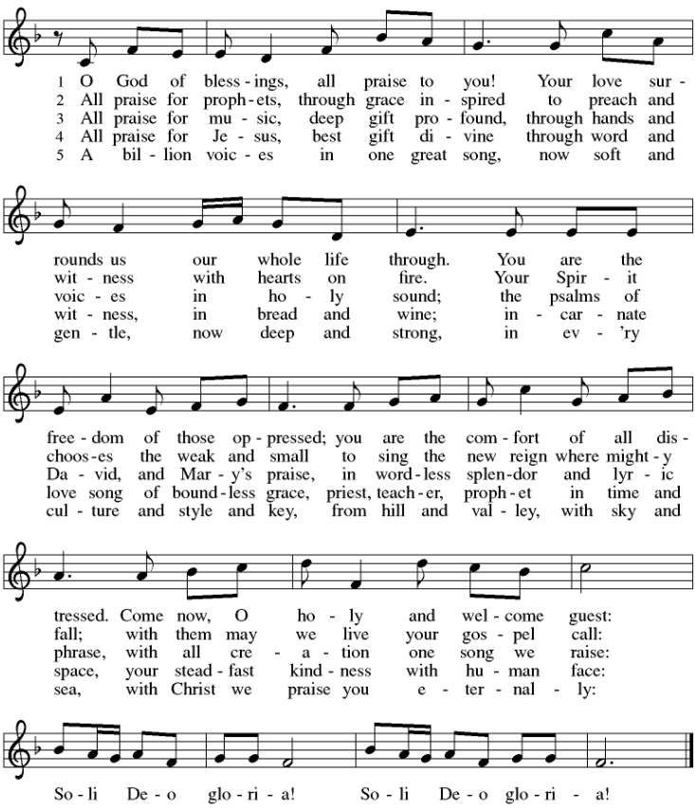
SONG Soli Deo Gloria ELW 878

DISMISSAL
Go in peace. Share the harvest.
Thanks be to God.
Coming up at GSLC
Sunday, August 20 | 9:00 am | Outdoor Worship Service  - 12th Sunday after Pentecost  - Matthew 15:10-28; the healing of the Canaanite woman’s daughter.
Tuesday, August 22 | 7:00 pm | AA Meeting
Wednesday, August 23 | 6:00 pm | Pub Theology
Sunday, August 27 | 9:00 am | Outdoor Worship Service  - 13th Sunday after Pentecost  Matthew 16:13-20; The profession of Peter’s Faith
Tuesday, August 29 | 7:00 pm | AA Meeting
Sunday, September 3 | 9:00 am | Outdoor Worship Service  - 14th Sunday after Pentecost  Matthew 16:21-28; The passion prediction and rebuke to Peter
Upcoming Worship Assistants
 | Usher | Lector | Communion | Offering Counters
August 20 | Samantha Moore | Nancy Tibbett | Bob & Laurel Peterson | Pam Mundt | May Hill
August 27 | Jerry & Nonnie Arndt | Leslie Mader | Dave & Shelly Schneider | Dan Mundt | Jon Hill
September 3 | Tim & Farrah Uphoff | Christine Tipping | Dave & Sue Schraeder | Nancy Leonard | Breanna Butler
September 10 | Greg & Terri Barth | Julie Will | Christopher Stuttgen  Danielle Stuttgen | Robin Beeman | David Schneider
September 17 | Lee & Sue Babcock | Shelly Schneider | Matt & Margo Barrier | Heidi Binder | Kami Weis
September 24 | Jason & Tessa Campbell | Linda Schrieber | Bruce & Nancy Tibbett | Pam Mundt | May Hill
Pastor Katie will be out of the office August 24-27. If you need immediate assistance, contact the office or Council President Nancy Tibbett.

Office Summer Hours
Our office hours will vary this summer as staff are on vacation and schedules change. Please call ahead if you plan to stop by the office.

