Good Shepherd Lutheran Church
Pastor: Katie Anderson | Music Director: Lois Swanson
Pastor’s Cell: (715) 245-1943 | Office Phone: (715) 387-2731
Pastor Email: gslcwi.pastor@gmail.com | Office Email: gslcwi.office@gmail.com
Website: GoodShepherdMarshfield.org | www.facebook.com/gslcwi
11th Sunday after Pentecost
August 13, 2023, 9:00 am
Introduction to the day…
Elijah finds the presence of God not in earthquake, wind, or fire, but in the sound of sheer silence. When the disciples face a great storm on the sea, they cry out with fear. Jesus says: “Take heart, it is I; do not be afraid.” Amid the storms of life, we gather to seek the calm presence of Christ that soothes our fears. In comforting words of scripture and in the refreshing bread and cup of the eucharist, God grants us peace and sends us forth to be a sign of God’s presence to others.
ANNOUNCEMENTS
GATHERING
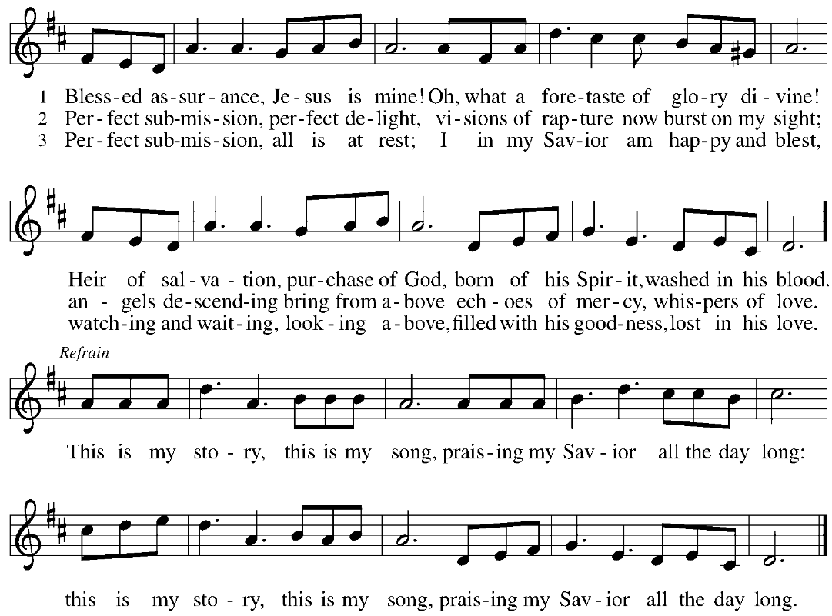
GATHERING SONG Blessed Assurance ELW 638

CONFESSION AND FORGIVENESS
Blessed be the holy Trinity,☩ one God, who greets us in this and every season,
whose word never fails, whose promise is sure.
Amen.
Let us confess our sin in the presence of God and of our neighbors.
Merciful God,
we confess that we have sinned. We have hurt our community.
We have squandered your blessings. We have hoarded your bounty.
In the name of Jesus, forgive us and grant us your mercy.
Silence is kept for reflection.
Righteous God,
we confess that we have sinned. We have failed to be honest.
We have lacked the courage to speak. We have spoken falsely.
In the name of Jesus, forgive us and grant us your mercy.
Silence is kept for reflection.
God is a cup of cold water when we thirst. God offers boundless grace when we fail.
Claim the gift of God’s mercy: you are freed and forgiven in the name of ☩ Jesus Christ.
Amen.
PRAYER OF THE DAY
O God our defender, storms rage around and within us and cause us to be afraid. Rescue your people from despair, deliver your sons and daughters from fear, and preserve us in the faith of your Son, Jesus Christ, our Savior and Lord. Amen.
CHILDREN’S MESSAGE
SCRIPTURE READINGS
FIRST READING: 1 Kings 19:9-18
⁹At [Horeb, the mount of God,][Elijah] came to a cave, and spent the night there.
Then the word of the Lord came to him, saying, “What are you doing here, Elijah?” ¹⁰He answered, “I have been very zealous for the Lord, the God of hosts; for the Israelites have forsaken your covenant, thrown down your altars, and killed your prophets with the sword. I alone am left, and they are seeking my life, to take it away.”
¹¹He said, “Go out and stand on the mountain before the Lord, for the Lord is about to pass by.” Now there was a great wind, so strong that it was splitting mountains and breaking rocks in pieces before the Lord, but the Lord was not in the wind; and after the wind an earthquake, but the Lord was not in the earthquake; ¹²and after the earthquake a fire, but the Lord was not in the fire; and after the fire a sound of sheer silence. ¹³When Elijah heard it, he wrapped his face in his mantle and went out and stood at the entrance of the cave. Then there came a voice to him that said, “What are you doing here, Elijah?” ¹⁴He answered, “I have been very zealous for the Lord, the God of hosts; for the Israelites have forsaken your covenant, thrown down your altars, and killed your prophets with the sword. I alone am left, and they are seeking my life, to take it away.” ¹⁵Then the Lord said to him, “Go, return on your way to the wilderness of Damascus; when you arrive, you shall anoint Hazael as king over Aram. ¹⁶Also you shall anoint Jehu son of Nimshi as king over Israel; and you shall anoint Elisha son of Shaphat of Abel-meholah as prophet in your place. ¹⁷Whoever escapes from the sword of Hazael, Jehu shall kill; and whoever escapes from the sword of Jehu, Elisha shall kill. ¹⁸Yet I will leave seven thousand in Israel, all the knees that have not bowed to Baal, and every mouth that has not kissed him.”
Word of God, word of life.
Thanks be to God.
PSALM: Psalm 85:8-13
⁸I will listen to what the Lord God is saying;
for you speak peace to your faithful people and to those who turn their hearts to you.
⁹Truly, your salvation is very near to those who fear you,
that your glory may dwell in our land.
¹⁰Steadfast love and faithfulness have met together;
righteousness and peace have kissed each other.
¹¹Faithfulness shall spring up from the earth,
and righteousness shall look down from heaven.
¹²The Lord will indeed grant prosperity,
and our land will yield its increase.
¹³Righteousness shall go before the Lord
and shall prepare for God a pathway.
SECOND READING: Romans 10:5-15
⁵Moses writes concerning the righteousness that comes from the law, that “the person who does these things will live by them.” ⁶But the righteousness that comes from faith says, “Do not say in your heart, ‘Who will ascend into heaven?’ ” (that is, to bring Christ down) ⁷“or ‘Who will descend into the abyss?’ ” (that is, to bring Christ up from the dead). ⁸But what does it say?
“The word is near you,
on your lips and in your heart”
(that is, the word of faith that we proclaim); ⁹because if you confess with your lips that Jesus is Lord and believe in your heart that God raised him from the dead, you will be saved. ¹⁰For one believes with the heart and so is justified, and one confesses with the mouth and so is saved. ¹¹The scripture says, “No one who believes in him will be put to shame.” ¹²For there is no distinction between Jew and Greek; the same Lord is Lord of all and is generous to all who call on him. ¹³For, “Everyone who calls on the name of the Lord shall be saved.”
¹⁴But how are they to call on one in whom they have not believed? And how are they to believe in one of whom they have never heard? And how are they to hear without someone to proclaim him? ¹⁵And how are they to proclaim him unless they are sent? As it is written, “How beautiful are the feet of those who bring good news!”
Word of God, word of life.
Thanks be to God.
GOSPEL ACCLAMATION

GOSPEL: Matthew 14:22-33
²²[Jesus] made the disciples get into the boat and go on ahead to the other side [of the Sea of Galilee], while he dismissed the crowds.²³And after he had dismissed the crowds, he went up the mountain by himself to pray. When evening came, he was there alone, ²⁴but by this time the boat, battered by the waves, was far from the land, for the wind was against them. ²⁵And early in the morning he came walking toward them on the sea. ²⁶But when the disciples saw him walking on the sea, they were terrified, saying, “It is a ghost!” And they cried out in fear. ²⁷But immediately Jesus spoke to them and said, “Take heart, it is I; do not be afraid.”
²⁸Peter answered him, “Lord, if it is you, command me to come to you on the water.” ²⁹He said, “Come.” So Peter got out of the boat, started walking on the water, and came toward Jesus. ³⁰But when he noticed the strong wind, he became frightened, and beginning to sink, he cried out, “Lord, save me!” ³¹Jesus immediately reached out his hand and caught him, saying to him, “You of little faith, why did you doubt?” ³²When they got into the boat, the wind ceased. ³³And those in the boat worshiped him, saying, “Truly you are the Son of God.”
The gospel of the Lord.
Praise to you, O Christ.
SERMON
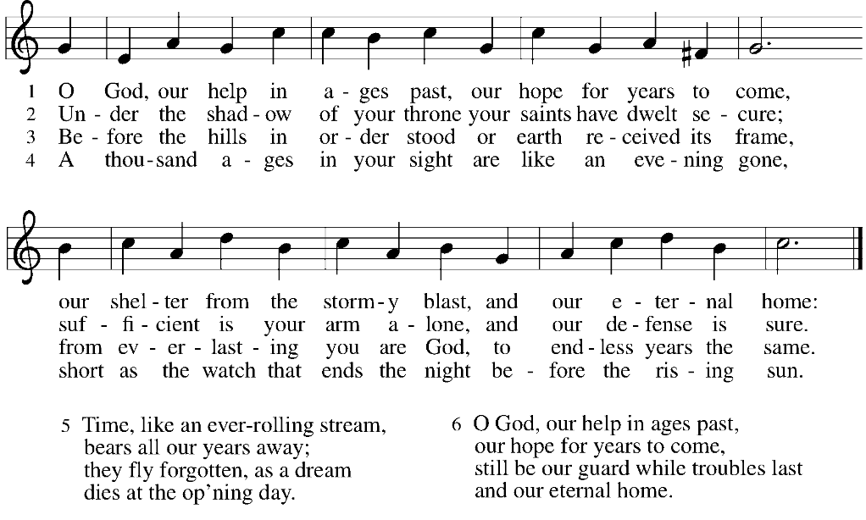
HYMN OF THE DAY O God, Our Help in Ages Past ELW 632

APOSTLES’ CREED
I believe in God, the Father almighty,
creator of heaven and earth.
I believe in Jesus Christ, God's only Son, our Lord,
who was conceived by the power of the Holy Spirit,
born of the Virgin Mary,
suffered under Pontius Pilate,
was crucified, died, and was buried;
he descended to the dead.
On the third day he rose again;
he ascended into heaven,
he is seated at the right hand of the Father,
and he will come to judge the living and the dead.
I believe in the Holy Spirit,
the holy catholic Church,
the communion of saints,
the forgiveness of sins,
the resurrection of the body,
and the life everlasting. Amen
PRAYERS OF INTERCESSION
…Hear us, O God,
Your mercy is great,
Into your hands, O God, we commend all for whom we pray, in the name of the one who reconciled all creation to himself, Jesus Christ our Savior.
Amen.
PEACE
The peace of Christ be with you always.
And also with you.
HOLY COMMUNION
OFFERING In addition to our normal offering, a Special Benevolence in August (collected in a special envelope) will go to Companion Day Services.
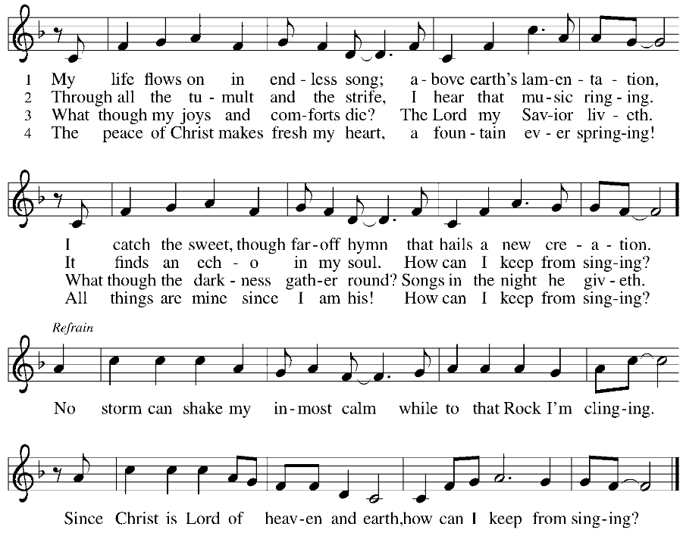
OFFERING SONG My Life Flows on in Endless Song ELW 763

OFFERTORY PRAYER
God of field and forest, sea and sky,
you are the giver of all good things.
Sustain us with these gifts of your creation,
and multiply your graciousness in us,
that the world may be fed with your love,
through Jesus Christ, our Savior and Lord.
Amen.
GREAT THANKSGIVING
The Lord be with you.
And also with you.
Lift up your hearts.
We lift them to the Lord.
Let us give our thanks to the Lord our God.
It is right to give our thanks and praise.
HOLY, HOLY, HOLY (Sung) ELW 189

THANKSGIVING AT THE TABLE

God of our weary years, God of our silent tears,
you have brought us this far along the way.
In times of bitterness you did not abandon us,
but guided us into the path of love and light.
In every age you sent prophets
to make known your loving will for all humanity.
The cry of the poor has become your own cry;
our hunger and thirst for justice is your own desire.
In the fullness of time, you sent your chosen servant
to preach good news to the afflicted,
to break bread with the outcast and despised,
and to ransom those in bondage to prejudice and sin.
In the night in which he was betrayed,
our Lord Jesus took bread, and gave thanks;
broke it, and gave it to his disciples, saying:
Take and eat; this is my body, given for you.
Do this for the remembrance of me.
Again, after supper, he took the cup, gave thanks,
and gave it for all to drink, saying:
This cup is the new covenant in my blood,
shed for you and all people for the forgiveness of sin.
Do this for the remembrance of me.
For as often as we eat of this bread and drink from this cup
we proclaim the Lord’s death until he comes.
Christ has died.
Christ is risen.
Christ will come again.
Remembering, therefore, his death and resurrection,
we await the day when Jesus shall return
to free all the earth from the bonds of slavery and death.
Come, Lord Jesus! And let the church say, Amen.
Amen.
Send your Holy Spirit, our advocate,
to fill the hearts of all who share this bread and cup
with courage and wisdom to pursue love and justice in all the world.
Come, Spirit of freedom! And let the church say, Amen.
Amen.
Join our prayers and praise with your prophets and martyrs of every age,
that, rejoicing in the hope of the resurrection,
we might live in the freedom and hope of your Son.
Through him, with him, in him, in the unity of the Holy Spirit,
all glory and honor is yours, almighty Father, now and forever.
Amen.

THE LORD’S PRAYER
Our Father, who art in heaven,
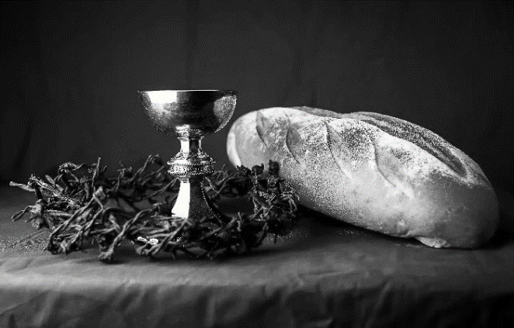
hallowed be thy name,
thy kingdom come,
thy will be done,
on earth as it is in heaven.
Give us this day our daily bread;
and forgive us our trespasses,
as we forgive those
who trespass against us;
and lead us not into temptation,
but deliver us from evil.
For thine is the kingdom,
and the power, and the glory,
forever and ever. Amen.
INVITATION TO COMMUNION - Certified gluten-free crackers are in the bowl on the communion plate.
All people are called to Christ’s table.
Come, eat what is good.
HOLY COMMUNION
PRAYER AFTER COMMUNION
We thank you, generous God, for the refreshment we have received
at your banquet table. Send us now to spread your generosity into all the world,
through the one who is our dearest treasure, Jesus Christ, our Savior and Lord.
Amen.
SENDING
BLESSING
The God who calls across the cosmos
and speaks in the smallest seed
☩ bless, keep, and sustain you
now and to the end of the age.
Amen.
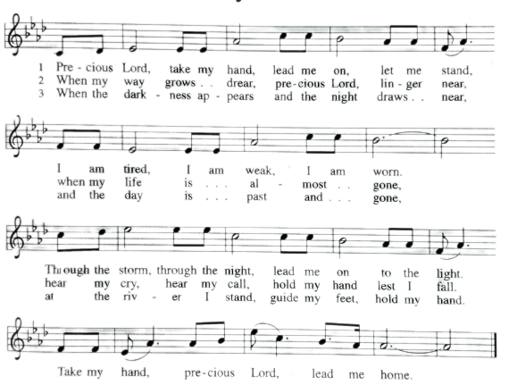
SONG Precious Lord, Take My Hand ELW 773

DISMISSAL
Go in peace. Share the harvest.
Thanks be to God.
Upcoming Worship Assistants
 | Usher | Lector | Communion | Offering Counters
August 6 | Julie Will | Kris Tarter | John Wagner  Nancy Leonard | Robin Beeman | David Schneider
August 13 | Andrew & Katelynn Neidner | Laurel Peterson | Dan & Pam Mundt | Heidi Binder | Kami Weis
August 20 | Samantha Bulgrin | Nancy Tibbett | Bob & Laurel Peterson | Pam Mundt | May Hill
August 27 | Jerry & Nonnie Arndt | Leslie Mader | Bruce & Nancy Tibbett | Dan Mundt | Jon Hill
September 3 | Tim & Farrah Uphoff | Christine Tipping | Dave & Sue Schraeder | Nancy Leonard | Breanna Butler
Coming up at GSLC
Sunday, August 13 | 9:00 am | Outdoor Worship Service  - 11th Sunday after Pentecost  - Matthew 14:22-33; Jesus walking on the sea.
Tuesday, August 15 | 2:00 pm | Chapel at Three Oaks
 | 7:00 pm | AA Meeting
Wednesday, August 16 | 6-8:00 pm | Outdoor Family Game Night at GS
Friday, August 18 | Dusk | Outdoor Movie Night
Sunday, August 20 | 9:00 am | Outdoor Worship Service  - 12th Sunday after Pentecost  Matthew 15:10-28; the healing of the Canaanite woman’s daughter.
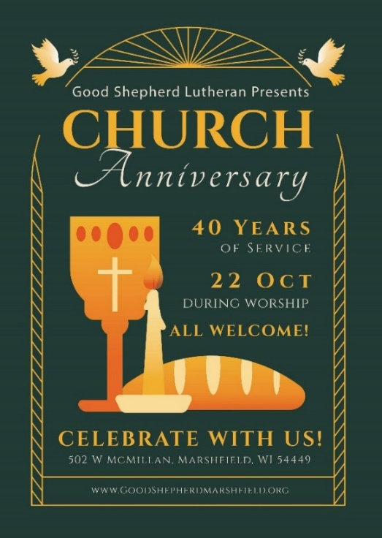

Office Summer Hours
Our office hours will vary this summer as staff are on vacation and schedules change. Please call ahead if you plan to stop by the office.

