Good Shepherd Lutheran Church
Pastor: Rev. Katie Anderson | Music Director: Rev. Lois Swanson
Pastor’s Cell: (715) 245-1943 | Office Phone: (715) 387-2731
Pastor Email: gslcwi.pastor@gmail.com | Office Email: gslcwi.office@gmail.com
Website: GoodShepherdMarshfield.org | www.facebook.com/gslcwi
6th Sunday after Pentecost
July 9, 2023, 9:00 am
Introduction to the day…
The mystery of God’s ways is sometimes hidden from the wise and intelligent. Jesus associates with those often excluded from the religious community. Like Paul, we struggle with our own selfish desires and seek God’s mercy and forgiveness. We gather to be refreshed by Christ’s invitation: “Come to me, all you that are weary.” Gathered around word, water, and meal, we find rest for our souls.
ANNOUNCEMENTS
GATHERING
GATHERING SONG Shout to the Lord ELW 821

CONFESSION AND FORGIVENESS
Blessed be the holy Trinity,☩ one God, who greets us in this and every season,
whose word never fails, whose promise is sure.
Amen.
Let us confess our sin in the presence of God and of our neighbors.
Merciful God,
we confess that we have sinned. We have hurt our community.
We have squandered your blessings. We have hoarded your bounty.
In the name of Jesus, forgive us and grant us your mercy.
Silence is kept for reflection.
Righteous God,
we confess that we have sinned. We have failed to be honest.
We have lacked the courage to speak. We have spoken falsely.
In the name of Jesus, forgive us and grant us your mercy.
Silence is kept for reflection.
God is a cup of cold water when we thirst. God offers boundless grace when we fail.
Claim the gift of God’s mercy: you are freed and forgiven in the name of ☩ Jesus Christ.
Amen.

PRAYER OF THE DAY
You are great, O God, and greatly to be praised. You have made us for yourself, and our hearts are restless until they rest in you. Grant that we may believe in you, call upon you, know you, and serve you, through your Son, Jesus Christ, our Savior and Lord. Amen.
CHILDREN’S MESSAGE
SCRIPTURE READINGS
FIRST READING: Zechariah 9:9-12
⁹Rejoice greatly, O daughter Zion!
Shout aloud, O daughter Jerusalem!
Lo, your king comes to you;
triumphant and victorious is he,
humble and riding on a donkey,
on a colt, the foal of a donkey.
¹⁰He will cut off the chariot from Ephraim
and the war-horse from Jerusalem;
and the battle bow shall be cut off,
and he shall command peace to the nations;
his dominion shall be from sea to sea,
and from the River to the ends of the earth.
¹¹As for you also, because of the blood of my covenant with you,
I will set your prisoners free from the waterless pit.
¹²Return to your stronghold, O prisoners of hope;
today I declare that I will restore to you double.
Word of God, word of life.
Thanks be to God.
PSALM: Psalm 145:8-14
⁸The Lord is gracious and full of compassion,
slow to anger and abounding in steadfast love.
⁹Lord, you are good to all,
and your compassion is over all your works.
¹⁰All your works shall praise you, O Lord,
and your faithful ones shall bless you.
¹¹They shall tell of the glory of your kingdom
and speak of your power,
¹²that all people may know of your power
and the glorious splendor of your kingdom.
¹³Your kingdom is an everlasting kingdom; your dominion endures throughout all ages.
You, Lord, are faithful in all your words, and loving in all your works.
¹⁴The Lord upholds all those who fall
and lifts up those who are bowed down.
SECOND READING: Romans 7:15-25
¹⁵I do not understand my own actions. For I do not do what I want, but I do the very thing I hate. ¹⁶Now if I do what I do not want, I agree that the law is good. ¹⁷But in fact it is no longer I that do it, but sin that dwells within me. ¹⁸For I know that nothing good dwells within me, that is, in my flesh. I can will what is right, but I cannot do it. ¹⁹For I do not do the good I want, but the evil I do not want is what I do. ²⁰Now if I do what I do not want, it is no longer I that do it, but sin that dwells within me.
²¹So I find it to be a law that when I want to do what is good, evil lies close at hand. ²²For I delight in the law of God in my inmost self, ²³but I see in my members another law at war with the law of my mind, making me captive to the law of sin that dwells in my members. ²⁴Wretched man that I am! Who will rescue me from this body of death? ^{25a}Thanks be to God through Jesus Christ our Lord!
Word of God, word of life.
Thanks be to God.
GOSPEL ACCLAMATION

GOSPEL: Matthew 11:16-19, 25-30
[Jesus spoke to the crowd saying:] ¹⁶“To what will I compare this generation? It is like children sitting in the marketplaces and calling to one another,
¹⁷‘We played the flute for you, and you did not dance;
we wailed, and you did not mourn.’
¹⁸For John came neither eating nor drinking, and they say, ‘He has a demon’; ¹⁹the Son of Man came eating and drinking, and they say, ‘Look, a glutton and a drunkard, a friend of tax collectors and sinners!’ Yet wisdom is vindicated by her deeds.”
²⁵At that time Jesus said, “I thank you, Father, Lord of heaven and earth, because you have hidden these things from the wise and the intelligent and have revealed them to infants; ²⁶yes, Father, for such was your gracious will. ²⁷All things have been handed over to me by my Father; and no one knows the Son except the Father, and no one knows the Father except the Son and anyone to whom the Son chooses to reveal him.
²⁸“Come to me, all you that are weary and are carrying heavy burdens, and I will give you rest. ²⁹Take my yoke upon you, and learn from me; for I am gentle and humble in heart, and you will find rest for your souls. ³⁰For my yoke is easy, and my burden is light.”
The gospel of the Lord.
Praise to you, O Christ.
SERMON
HYMN OF THE DAY Softly and Tenderly Jesus Is Calling ELW 608

APOSTLES’ CREED
I believe in God, the Father almighty,
creator of heaven and earth.
I believe in Jesus Christ, God's only Son, our Lord,
who was conceived by the power of the Holy Spirit,
born of the Virgin Mary,
suffered under Pontius Pilate,
was crucified, died, and was buried;
he descended to the dead.
On the third day he rose again;
he ascended into heaven,
he is seated at the right hand of the Father,
and he will come to judge the living and the dead.
I believe in the Holy Spirit,
the holy catholic Church,
the communion of saints,
the forgiveness of sins,
the resurrection of the body,
and the life everlasting. Amen
PRAYERS OF INTERCESSION
…Hear us, O God,
Your mercy is great,
Into your hands, O God, we commend all for whom we pray, in the name of the one who reconciled all creation to himself, Jesus Christ our Savior.
Amen.
PEACE
The peace of Christ be with you always.
And also with you.
HOLY COMMUNION
OFFERING In addition to our normal offering, a Special Benevolence in July (collected in a special envelope) will go to SOS Best First Day. The project will provide registered children with two outfits including shoes, socks, & underwear to begin the school year. The distribution will happen on August 10th and pre-registration is required.
OFFERING SONG Lord of All Hopefulness ELW 765

OFFERTORY PRAYER
God of field and forest, sea and sky,
you are the giver of all good things.
Sustain us with these gifts of your creation,
and multiply your graciousness in us,
that the world may be fed with your love,
through Jesus Christ, our Savior and Lord.
Amen.
GREAT THANKSGIVING
The Lord be with you.
And also with you.
Lift up your hearts.
We lift them to the Lord.
Let us give our thanks to the Lord our God.
It is right to give our thanks and praise.
HOLY, HOLY, HOLY (Sung) ELW 189

THANKSGIVING AT THE TABLE

God of our weary years, God of our silent tears,
you have brought us this far along the way.
In times of bitterness you did not abandon us,
but guided us into the path of love and light.
In every age you sent prophets
to make known your loving will for all humanity.
The cry of the poor has become your own cry;
our hunger and thirst for justice is your own desire.
In the fullness of time, you sent your chosen servant
to preach good news to the afflicted,
to break bread with the outcast and despised,
and to ransom those in bondage to prejudice and sin.
In the night in which he was betrayed,
our Lord Jesus took bread, and gave thanks;
broke it, and gave it to his disciples, saying:
Take and eat; this is my body, given for you.
Do this for the remembrance of me.
Again, after supper, he took the cup, gave thanks,
and gave it for all to drink, saying:
This cup is the new covenant in my blood,
shed for you and all people for the forgiveness of sin.
Do this for the remembrance of me.
For as often as we eat of this bread and drink from this cup
we proclaim the Lord’s death until he comes.
Christ has died.
Christ is risen.
Christ will come again.
Remembering, therefore, his death and resurrection,
we await the day when Jesus shall return
to free all the earth from the bonds of slavery and death.
Come, Lord Jesus! And let the church say, Amen.
Amen.
Send your Holy Spirit, our advocate,
to fill the hearts of all who share this bread and cup
with courage and wisdom to pursue love and justice in all the world.
Come, Spirit of freedom! And let the church say, Amen.
Amen.
Join our prayers and praise with your prophets and martyrs of every age,
that, rejoicing in the hope of the resurrection,
we might live in the freedom and hope of your Son.
Through him, with him, in him, in the unity of the Holy Spirit,
all glory and honor is yours, almighty Father, now and forever.
Amen.

THE LORD’S PRAYER
Our Father, who art in heaven,
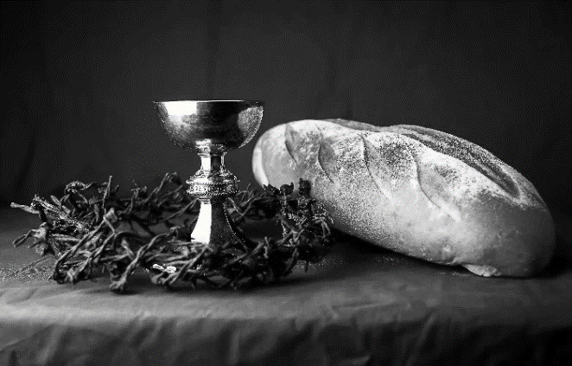
hallowed be thy name,
thy kingdom come,
thy will be done,
on earth as it is in heaven.
Give us this day our daily bread;
and forgive us our trespasses,
as we forgive those
who trespass against us;
and lead us not into temptation,
but deliver us from evil.
For thine is the kingdom,
and the power, and the glory,
forever and ever. Amen.
INVITATION TO COMMUNION - Certified gluten-free crackers are in the bowl on the communion plate.
All people are called to Christ’s table.
Come, eat what is good.
HOLY COMMUNION
PRAYER AFTER COMMUNION
We thank you, generous God, for the refreshment we have received
at your banquet table. Send us now to spread your generosity into all the world,
through the one who is our dearest treasure, Jesus Christ, our Savior and Lord.
Amen.
SENDING
BLESSING
The God who calls across the cosmos
and speaks in the smallest seed
☩ bless, keep, and sustain you
now and to the end of the age.
Amen.
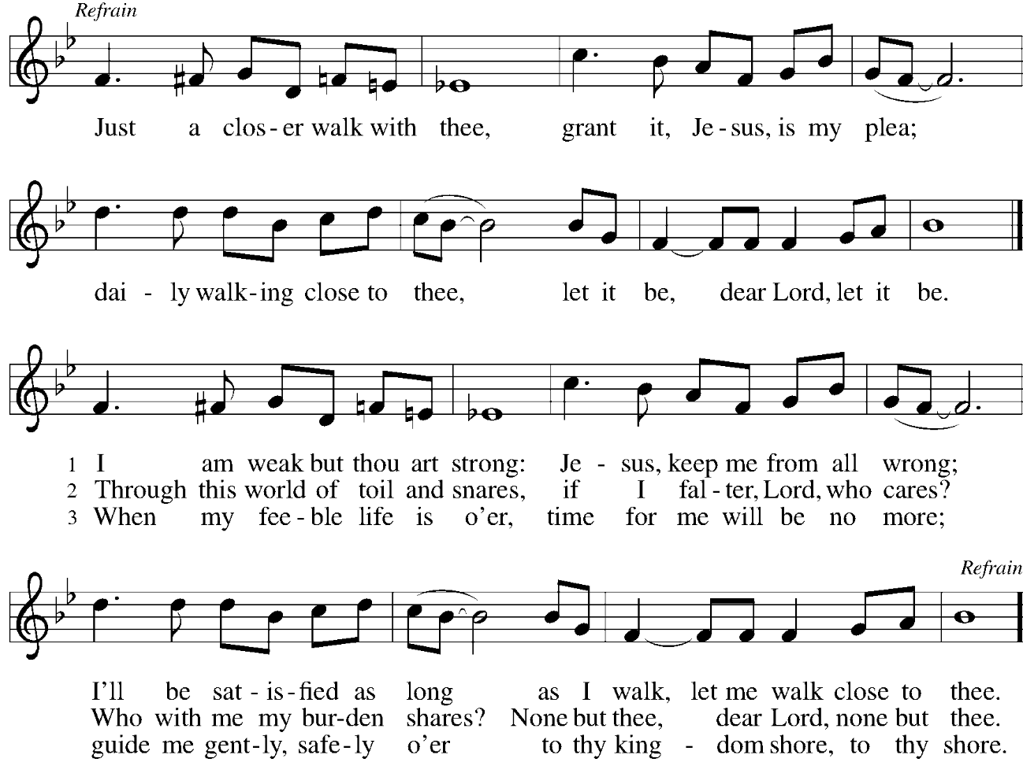
SONG Just a Closer Walk with Thee ELW 697

DISMISSAL
Go in peace. Share the harvest.
Thanks be to God.
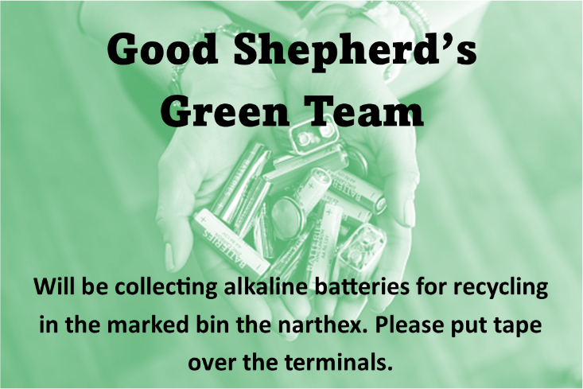
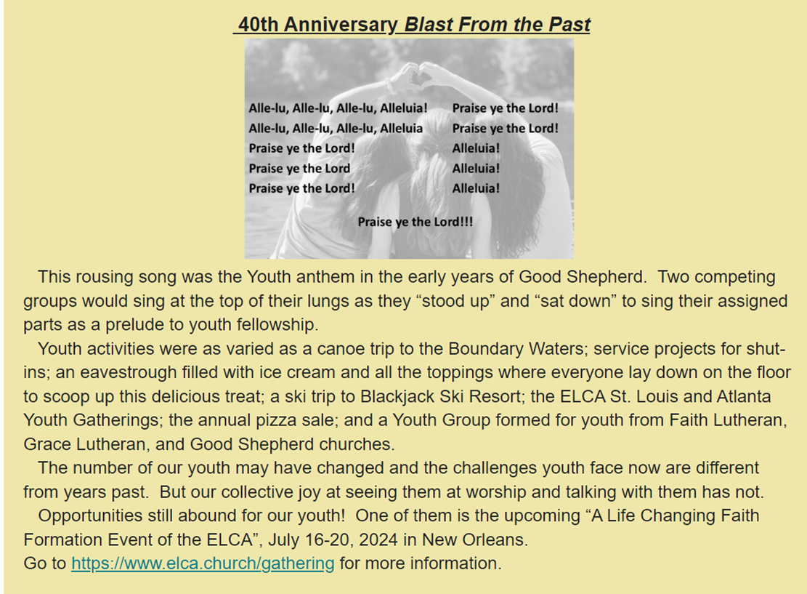

Office Summer Hours
Our office hours will vary this summer as staff are on vacation and schedules change. Please call ahead if you plan to stop by the office.

Upcoming Worship Assistants
 | Usher | Lector | Communion | Offering Counters
July 9 | Bruce & Nancy Tibbett | Leslie Mader | Matt & Margo Barrier | Heidi Binder | Kami Weis
July 16 | Stuart & Christine Tipping | Andrea Hovick | Bruce & Nancy Tibbett | Pam Mundt | May Hill
July 23 | Dave & Kami Weis | Julie Will | Ron Rothfusz  Andrea Hovick | Dan Mundt | Jon Hill
July 30 | John & Jane Wagner | Shelly Schneider | Sarah Kopitzke  Tammy Neumann | Nancy Leonard | Breanna Butler
Coming up at GSLC
Sunday, July 9 | 9:00 am | Outdoor Worship Service  - 6th Sunday after Pentecost  - Matthew 11:16-19, 25-30; The yoke of discipleship
Tuesday, July 11 | 6:30 pm | Council Meeting
 | 7:00 pm | AA Meeting
Wednesday, July 12 | 6:00 pm | Pub Theology
Sunday, July 16 | 9:00 am | Outdoor Worship Service  - 7th Sunday after Pentecost  Matthew 13:1-9, 18-23; The parable of the sower and the seed.
