Good Shepherd Lutheran Church
Pastor: Rev. Katie Anderson | Music Director: Rev. Lois Swanson
Pastor’s Cell: (715) 245-1943 | Office Phone: (715) 387-2731
Pastor Email: gslcwi.pastor@gmail.com | Office Email: gslcwi.office@gmail.com
Website: GoodShepherdMarshfield.org | www.facebook.com/gslcwi
9th Sunday after Pentecost
July 30, 2023, 9:00 am
Introduction to the day…
As Solomon prays for wisdom, we seek to more deeply know the treasures of faith. In today’s gospel Jesus offers everyday images that reveal to us the reign of God: a tree that becomes a sheltering home, yeast that penetrates and expands, a treasured pearl, a net that gains a great catch. Even as we seek the riches of God’s reign, the great surprise is that God’s grace finds us first!
ANNOUNCEMENTS
GATHERING
GATHERING SONG For the Beauty of the Earth ELW 879

CONFESSION AND FORGIVENESS
Blessed be the holy Trinity,☩ one God, who greets us in this and every season,
whose word never fails, whose promise is sure.
Amen.
Let us confess our sin in the presence of God and of our neighbors.
Merciful God,
we confess that we have sinned. We have hurt our community.
We have squandered your blessings. We have hoarded your bounty.
In the name of Jesus, forgive us and grant us your mercy.
Silence is kept for reflection.
Righteous God,
we confess that we have sinned. We have failed to be honest.
We have lacked the courage to speak. We have spoken falsely.
In the name of Jesus, forgive us and grant us your mercy.
Silence is kept for reflection.
God is a cup of cold water when we thirst. God offers boundless grace when we fail.
Claim the gift of God’s mercy: you are freed and forgiven in the name of ☩ Jesus Christ.
Amen.
PRAYER OF THE DAY
Beloved and sovereign God, through the death and resurrection of your Son you bring us into your kingdom of justice and mercy. By your Spirit, give us your wisdom, that we may treasure the life that comes from Jesus Christ, our Savior and Lord. Amen.
CHILDREN’S MESSAGE
SCRIPTURE READINGS
FIRST READING: 1 Kings 3:5-12
⁵At Gibeon the Lord appeared to Solomon in a dream by night; and God said, “Ask what I should give you.” ⁶And Solomon said, “You have shown great and steadfast love to your servant my father David, because he walked before you in faithfulness, in righteousness, and in uprightness of heart toward you; and you have kept for him this great and steadfast love, and have given him a son to sit on his throne today. ⁷And now, O Lord my God, you have made your servant king in place of my father David, although I am only a little child; I do not know how to go out or come in. ⁸And your servant is in the midst of the people whom you have chosen, a great people, so numerous they cannot be numbered or counted. ⁹Give your servant therefore an understanding mind to govern your people, able to discern between good and evil; for who can govern this your great people?”
¹⁰It pleased the Lord that Solomon had asked this. ¹¹God said to him, “Because you have asked this, and have not asked for yourself long life or riches, or for the life of your enemies, but have asked for yourself understanding to discern what is right, ¹²I now do according to your word. Indeed I give you a wise and discerning mind; no one like you has been before you and no one like you shall arise after you.”
Word of God, word of life.
Thanks be to God.
PSALM: Psalm 119:129-136
¹²⁹Your decrees are wonderful;
therefore I obey them with all my heart.
¹³⁰When your word is opened it gives light;
it gives understanding to the simple.
¹³¹I open my mouth and pant
because I long for your commandments.
¹³²Turn to me and be gracious to me,
as you always do to those who love your name.
¹³³Order my footsteps in your word;
let no iniquity have dominion over me.
¹³⁴Rescue me from those who oppress me,
and I will keep your commandments.
¹³⁵Let your face shine upon your servant
and teach me your statutes.
¹³⁶My eyes shed streams of tears,
because people do not keep your teaching.
SECOND READING: Romans 8:26-39
²⁶The Spirit helps us in our weakness; for we do not know how to pray as we ought, but that very Spirit intercedes with sighs too deep for words. ²⁷And God, who searches the heart, knows what is the mind of the Spirit, because the Spirit intercedes for the saints according to the will of God.
²⁸We know that all things work together for good for those who love God, who are called according to his purpose. ²⁹For those whom he foreknew he also predestined to be conformed to the image of his Son, in order that he might be the firstborn within a large family. ³⁰And those whom he predestined he also called; and those whom he called he also justified; and those whom he justified he also glorified.
³¹What then are we to say about these things? If God is for us, who is against us? ³²He who did not withhold his own Son, but gave him up for all of us, will he not with him also give us everything else? ³³Who will bring any charge against God’s elect? It is God who justifies. ³⁴Who is to condemn? It is Christ Jesus, who died, yes, who was raised, who is at the right hand of God, who indeed intercedes for us. ³⁵Who will separate us from the love of Christ? Will hardship, or distress, or persecution, or famine, or nakedness, or peril, or sword? ³⁶As it is written,
“For your sake we are being killed all day long;
we are accounted as sheep to be slaughtered.”
³⁷No, in all these things we are more than conquerors through him who loved us. ³⁸For I am convinced that neither death, nor life, nor angels, nor rulers, nor things present, nor things to come, nor powers, ³⁹nor height, nor depth, nor anything else in all creation, will be able to separate us from the love of God in Christ Jesus our Lord.
Word of God, word of life.
Thanks be to God.
GOSPEL ACCLAMATION

GOSPEL: Matthew 13:31-33, 44-52
³¹[Jesus] put before [the crowds] another parable: “The kingdom of heaven is like a mustard seed that someone took and sowed in his field;³²it is the smallest of all the seeds, but when it has grown it is the greatest of shrubs and becomes a tree, so that the birds of the air come and make nests in its branches.”
³³He told them another parable: “The kingdom of heaven is like yeast that a woman took and mixed in with three measures of flour until all of it was leavened.”
⁴⁴“The kingdom of heaven is like treasure hidden in a field, which someone found and hid; then in his joy he goes and sells all that he has and buys that field.
⁴⁵“Again, the kingdom of heaven is like a merchant in search of fine pearls; ⁴⁶on finding one pearl of great value, he went and sold all that he had and bought it.
⁴⁷“Again, the kingdom of heaven is like a net that was thrown into the sea and caught fish of every kind; ⁴⁸when it was full, they drew it ashore, sat down, and put the good into baskets but threw out the bad. ⁴⁹So it will be at the end of the age. The angels will come out and separate the evil from the righteous ⁵⁰and throw them into the furnace of fire, where there will be weeping and gnashing of teeth.
⁵¹“Have you understood all this?” They answered, “Yes.” ⁵²And he said to them, “Therefore every scribe who has been trained for the kingdom of heaven is like the master of a household who brings out of his treasure what is new and what is old.”
The gospel of the Lord.
Praise to you, O Christ.
SERMON

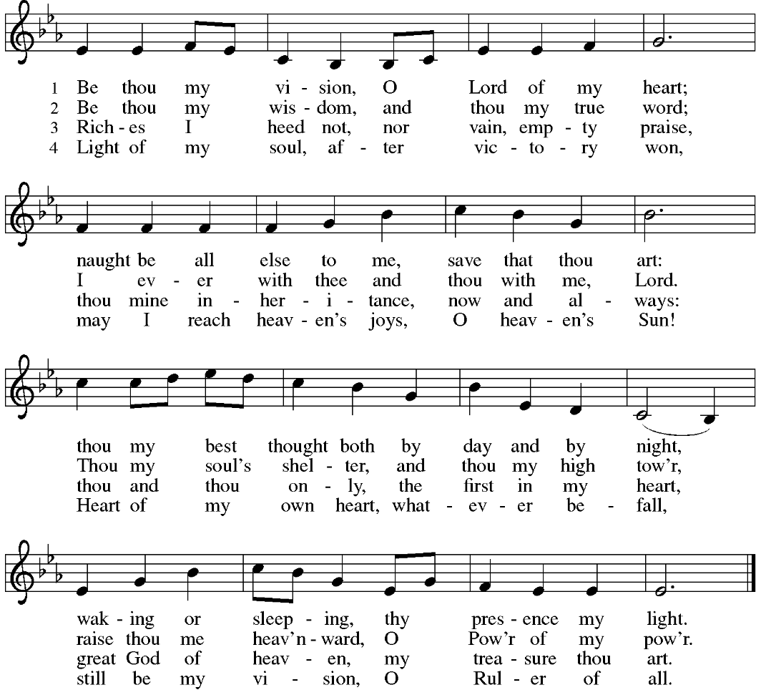
HYMN OF THE DAY Be Thou My Vision ELW 793

APOSTLES’ CREED
I believe in God, the Father almighty,
creator of heaven and earth.
I believe in Jesus Christ, God's only Son, our Lord,
who was conceived by the power of the Holy Spirit,
born of the Virgin Mary,
suffered under Pontius Pilate,
was crucified, died, and was buried;
he descended to the dead.
On the third day he rose again;
he ascended into heaven,
he is seated at the right hand of the Father,
and he will come to judge the living and the dead.
I believe in the Holy Spirit,
the holy catholic Church,
the communion of saints,
the forgiveness of sins,
the resurrection of the body,
and the life everlasting. Amen
PRAYERS OF INTERCESSION
…Hear us, O God,
Your mercy is great,
Into your hands, O God, we commend all for whom we pray, in the name of the one who reconciled all creation to himself, Jesus Christ our Savior.
Amen.
PEACE
The peace of Christ be with you always.
And also with you.
HOLY COMMUNION
OFFERING In addition to our normal offering, a Special Benevolence in July (collected in a special envelope) will go to SOS Best First Day. The project will provide registered children with two outfits including shoes, socks, & underwear to begin the school year. The distribution will happen on August 10th and pre-registration is required.
OFFERING SONG Seek Ye First
Seek ye first the kingdom of God and its righteousness,
And all these things shall be added unto you, Allelu, alleluia.
Ask, and it shall be given unto you. Seek, and you shall find.
Knock, and the door shall be opened unto you, Allelu, alleluia.
We do not live by bread alone, But by ev’ry word.
That proceeds from the mouth of God. Allelu, alleluia.
1972 CCCM Music (Admin. by Brentwood-Benson Music Publishing, Inc.) Universal Music - Brentwood Benson Publishing (Admin. by Brentwood-Benson Music Publishing, Inc.)
OFFERTORY PRAYER
God of field and forest, sea and sky,
you are the giver of all good things.
Sustain us with these gifts of your creation,
and multiply your graciousness in us,
that the world may be fed with your love,
through Jesus Christ, our Savior and Lord.
Amen.
GREAT THANKSGIVING
The Lord be with you.
And also with you.
Lift up your hearts.
We lift them to the Lord.
Let us give our thanks to the Lord our God.
It is right to give our thanks and praise.
HOLY, HOLY, HOLY (Sung) ELW 189

THANKSGIVING AT THE TABLE

God of our weary years, God of our silent tears,
you have brought us this far along the way.
In times of bitterness you did not abandon us,
but guided us into the path of love and light.
In every age you sent prophets
to make known your loving will for all humanity.
The cry of the poor has become your own cry;
our hunger and thirst for justice is your own desire.
In the fullness of time, you sent your chosen servant
to preach good news to the afflicted,
to break bread with the outcast and despised,
and to ransom those in bondage to prejudice and sin.
In the night in which he was betrayed,
our Lord Jesus took bread, and gave thanks;
broke it, and gave it to his disciples, saying:
Take and eat; this is my body, given for you.
Do this for the remembrance of me.
Again, after supper, he took the cup, gave thanks,
and gave it for all to drink, saying:
This cup is the new covenant in my blood,
shed for you and all people for the forgiveness of sin.
Do this for the remembrance of me.
For as often as we eat of this bread and drink from this cup
we proclaim the Lord’s death until he comes.
Christ has died.
Christ is risen.
Christ will come again.
Remembering, therefore, his death and resurrection,
we await the day when Jesus shall return
to free all the earth from the bonds of slavery and death.
Come, Lord Jesus! And let the church say, Amen.
Amen.
Send your Holy Spirit, our advocate,
to fill the hearts of all who share this bread and cup
with courage and wisdom to pursue love and justice in all the world.
Come, Spirit of freedom! And let the church say, Amen.
Amen.
Join our prayers and praise with your prophets and martyrs of every age,
that, rejoicing in the hope of the resurrection,
we might live in the freedom and hope of your Son.
Through him, with him, in him, in the unity of the Holy Spirit,
all glory and honor is yours, almighty Father, now and forever.
Amen.

THE LORD’S PRAYER
Our Father, who art in heaven,
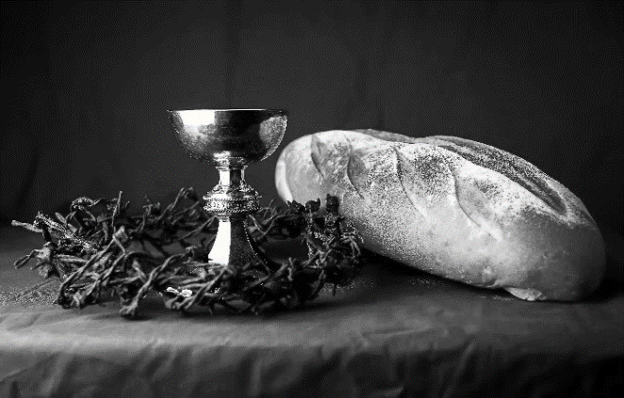
hallowed be thy name,
thy kingdom come,
thy will be done,
on earth as it is in heaven.
Give us this day our daily bread;
and forgive us our trespasses,
as we forgive those
who trespass against us;
and lead us not into temptation,
but deliver us from evil.
For thine is the kingdom,
and the power, and the glory,
forever and ever. Amen.
INVITATION TO COMMUNION - Certified gluten-free crackers are in the bowl on the communion plate.
All people are called to Christ’s table.
Come, eat what is good.
HOLY COMMUNION
PRAYER AFTER COMMUNION
We thank you, generous God, for the refreshment we have received
at your banquet table. Send us now to spread your generosity into all the world,
through the one who is our dearest treasure, Jesus Christ, our Savior and Lord.
Amen.
SENDING
BLESSING
The God who calls across the cosmos
and speaks in the smallest seed
☩ bless, keep, and sustain you
now and to the end of the age.
Amen.
SONG Sent Forth by God’s Blessing ELW 547

DISMISSAL
Go in peace. Share the harvest.
Thanks be to God.

Office Summer Hours
Our office hours will vary this summer as staff are on vacation and schedules change. Please call ahead if you plan to stop by the office.

Upcoming Worship Assistants
 | Usher | Lector | Communion | Offering Counters
July 30 | John & Jane Wagner | Shelly Schneider | Sarah Kopitzke  Tammy Neumann | Nancy Leonard | Breanna Butler
August 6 | Julie Will | Kris Tarter | John Wagner  Nancy Leonard | Robin Beeman | David Schneider
August 13 | Andrew & Katelynn Neidner | Linda Schrieber | Dan & Pam Mundt | Heidi Binder | Kami Weis
August 20 | Samantha Bulgrin | Leslie Mader | Bob & Laurel Peterson | Pam Mundt | May Hill
August 27 | Jerry & Nonnie Arndt | Nancy Tibbett | Bruce & Nancy Tibbett | Dan Mundt | Jon Hill
September 3 | Tim & Farrah Uphoff | Christine Tipping | Dave & Sue Schraeder | Nancy Leonard | Breanna Butler
Coming up at GSLC
Sunday, July 30 | 9:00 am | Outdoor Worship Service  - 9th Sunday after Pentecost  - Matthew 13:31-33, 44-42; parables of the reign of heaven.
Monday, July 31 -Thursday, August 3 | 9 am-2 pm | VBS at First Presbyterian
Tuesday, August 1 | 6:00 pm | Executive Meeting
 | 7:00 pm | AA Meeting
Sunday, August 6 | 9:00 am | Outdoor Worship Service  - 10th Sunday after Pentecost  Matthew 14:13-21; Christ feeding five thousand.

