Good Shepherd Lutheran Church
Pastor: Rev. Katie Anderson | Music Director: Rev. Lois Swanson
Pastor’s Cell: (715) 245-1943 | Office Phone: (715) 387-2731
Pastor Email: gslcwi.pastor@gmail.com | Office Email: gslcwi.office@gmail.com
Website: GoodShepherdMarshfield.org | www.facebook.com/gslcwi
8th Sunday after Pentecost
July 23, 2023, 9:00 am
Introduction to the day…
It is an age-old question: why is there evil in the world? In the parable of the wheat and the weeds Jesus suggests that both grow together until the harvest. With Paul, we long for the day that all creation will be set free from bondage and suffering. Having both weeds and wheat within us, we humbly place our hope in the promises of God, and from the Lord’s table we go forth to bear the fruit of justice and mercy.
ANNOUNCEMENTS
GATHERING
GATHERING SONG Come, Thou Fount of Every Blessing ELW 807

CONFESSION AND FORGIVENESS
Blessed be the holy Trinity,☩ one God, who greets us in this and every season,
whose word never fails, whose promise is sure.
Amen.
Let us confess our sin in the presence of God and of our neighbors.
Merciful God,
we confess that we have sinned. We have hurt our community.
We have squandered your blessings. We have hoarded your bounty.
In the name of Jesus, forgive us and grant us your mercy.
Silence is kept for reflection.
Righteous God,
we confess that we have sinned. We have failed to be honest.
We have lacked the courage to speak. We have spoken falsely.
In the name of Jesus, forgive us and grant us your mercy.
Silence is kept for reflection.
God is a cup of cold water when we thirst. God offers boundless grace when we fail.
Claim the gift of God’s mercy: you are freed and forgiven in the name of ☩ Jesus Christ.
Amen.
PRAYER OF THE DAY
Faithful God, most merciful judge, you care for your children with firmness and compassion. By your Spirit nurture us who live in your kingdom, that we may be rooted in the way of your Son, Jesus Christ, our Savior and Lord. Amen.
CHILDREN’S MESSAGE
SCRIPTURE READINGS
FIRST READING: Isaiah 44:6-8
⁶Thus says the Lord, the King of Israel,
and his Redeemer, the Lord of hosts:
I am the first and I am the last;
besides me there is no god.
⁷Who is like me? Let them proclaim it,
let them declare and set it forth before me.
Who has announced from of old the things to come?
Let them tell us what is yet to be.
⁸Do not fear, or be afraid;
have I not told you from of old and declared it?
You are my witnesses!
Is there any god besides me?
There is no other rock; I know not one.
Word of God, word of life.
Thanks be to God.
PSALM: Psalm 86:11-17
¹¹Teach me your way, O Lord, and I will walk in your truth;
give me an undivided heart to revere your name.
¹²I will thank you, O Lord my God, with all my heart,
and glorify your name forevermore.
¹³For great is your love toward me;
you have delivered me from the pit of death.
¹⁴The arrogant rise up against me, O God, and a band of violent people seeks my life;
they have not set you before their eyes.
¹⁵But you, O Lord, are gracious and full of compassion,
slow to anger, and full of kindness and truth.
¹⁶Turn to me and have mercy on me;
give your strength to your servant, and save the child of your handmaid.
¹⁷Show me a sign of your favor, so that those who hate me may see it and be put to shame;
because you, Lord, have helped me and comforted me.
SECOND READING: Romans 8:12-25
¹²So then, brothers and sisters, we are debtors, not to the flesh, to live according to the flesh—¹³for if you live according to the flesh, you will die; but if by the Spirit you put to death the deeds of the body, you will live. ¹⁴For all who are led by the Spirit of God are children of God. ¹⁵For you did not receive a spirit of slavery to fall back into fear, but you have received a spirit of adoption. When we cry, “Abba! Father!” ¹⁶it is that very Spirit bearing witness with our spirit that we are children of God, ¹⁷and if children, then heirs, heirs of God and joint heirs with Christ—if, in fact, we suffer with him so that we may also be glorified with him.
¹⁸I consider that the sufferings of this present time are not worth comparing with the glory about to be revealed to us. ¹⁹For the creation waits with eager longing for the revealing of the children of God; ²⁰for the creation was subjected to futility, not of its own will but by the will of the one who subjected it, in hope ²¹that the creation itself will be set free from its bondage to decay and will obtain the freedom of the glory of the children of God. ²²We know that the whole creation has been groaning in labor pains until now; ²³and not only the creation, but we ourselves, who have the first fruits of the Spirit, groan inwardly while we wait for adoption, the redemption of our bodies. ²⁴For in hope we were saved. Now hope that is seen is not hope. For who hopes for what is seen? ²⁵But if we hope for what we do not see, we wait for it with patience.
Word of God, word of life.
Thanks be to God.
GOSPEL ACCLAMATION

GOSPEL: Matthew 13:24-30, 36-43
²⁴[Jesus] put before [the crowds] another parable: “The kingdom of heaven may be compared to someone who sowed good seed in his field;²⁵but while everybody was asleep, an enemy came and sowed weeds among the wheat, and then went away. ²⁶So when the plants came up and bore grain, then the weeds appeared as well. ²⁷And the slaves of the householder came and said to him, ‘Master, did you not sow good seed in your field? Where, then, did these weeds come from?’ ²⁸He answered, ‘An enemy has done this.’ The slaves said to him, ‘Then do you want us to go and gather them?’ ²⁹But he replied, ‘No; for in gathering the weeds you would uproot the wheat along with them. ³⁰Let both of them grow together until the harvest; and at harvest time I will tell the reapers, Collect the weeds first and bind them in bundles to be burned, but gather the wheat into my barn.’ ”
³⁶Then he left the crowds and went into the house. And his disciples approached him, saying, “Explain to us the parable of the weeds of the field.” ³⁷He answered, “The one who sows the good seed is the Son of Man; ³⁸the field is the world, and the good seed are the children of the kingdom; the weeds are the children of the evil one, ³⁹and the enemy who sowed them is the devil; the harvest is the end of the age, and the reapers are angels. ⁴⁰Just as the weeds are collected and burned up with fire, so will it be at the end of the age. ⁴¹The Son of Man will send his angels, and they will collect out of his kingdom all causes of sin and all evildoers, ⁴²and they will throw them into the furnace of fire, where there will be weeping and gnashing of teeth. ⁴³Then the righteous will shine like the sun in the kingdom of their Father. Let anyone with ears listen!”
The gospel of the Lord.
Praise to you, O Christ.
SERMON

HYMN OF THE DAY Come, Ye Thankful People, Come ELW 693

APOSTLES’ CREED
I believe in God, the Father almighty,
creator of heaven and earth.
I believe in Jesus Christ, God's only Son, our Lord,
who was conceived by the power of the Holy Spirit,
born of the Virgin Mary,
suffered under Pontius Pilate,
was crucified, died, and was buried;
he descended to the dead.
On the third day he rose again;
he ascended into heaven,
he is seated at the right hand of the Father,
and he will come to judge the living and the dead.
I believe in the Holy Spirit,
the holy catholic Church,
the communion of saints,
the forgiveness of sins,
the resurrection of the body,
and the life everlasting. Amen
PRAYERS OF INTERCESSION
…Hear us, O God,
Your mercy is great,
Into your hands, O God, we commend all for whom we pray, in the name of the one who reconciled all creation to himself, Jesus Christ our Savior.
Amen.
PEACE
The peace of Christ be with you always.
And also with you.
HOLY COMMUNION
OFFERING In addition to our normal offering, a Special Benevolence in July (collected in a special envelope) will go to SOS Best First Day. The project will provide registered children with two outfits including shoes, socks, & underwear to begin the school year. The distribution will happen on August 10th and pre-registration is required.
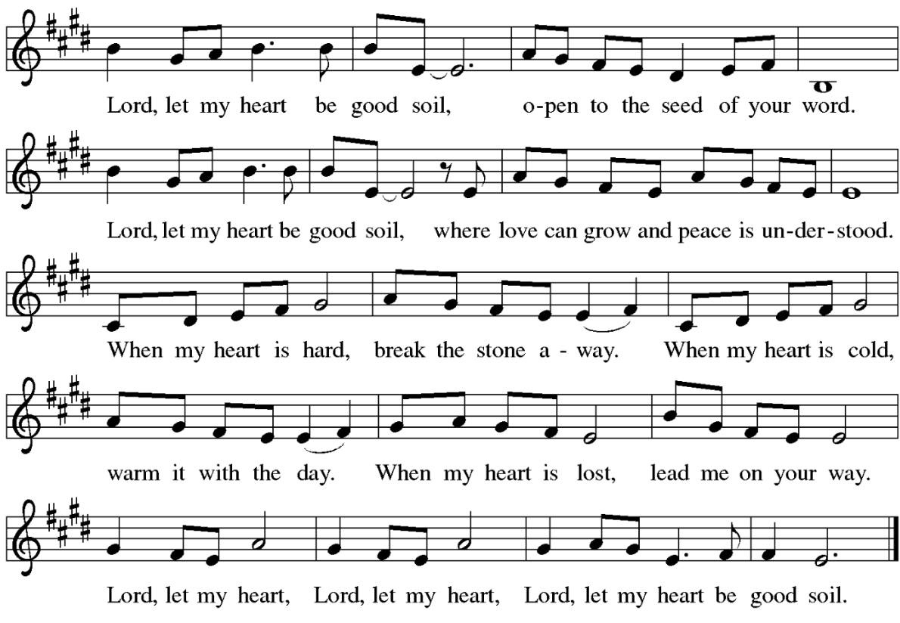
OFFERING SONG Lord, Let My Heart Be Good Soil ELW 512

OFFERTORY PRAYER
God of field and forest, sea and sky,
you are the giver of all good things.
Sustain us with these gifts of your creation,
and multiply your graciousness in us,
that the world may be fed with your love,
through Jesus Christ, our Savior and Lord.
Amen.
GREAT THANKSGIVING
The Lord be with you.
And also with you.
Lift up your hearts.
We lift them to the Lord.
Let us give our thanks to the Lord our God.
It is right to give our thanks and praise.
HOLY, HOLY, HOLY (Sung) ELW 189

THANKSGIVING AT THE TABLE

God of our weary years, God of our silent tears,
you have brought us this far along the way.
In times of bitterness you did not abandon us,
but guided us into the path of love and light.
In every age you sent prophets
to make known your loving will for all humanity.
The cry of the poor has become your own cry;
our hunger and thirst for justice is your own desire.
In the fullness of time, you sent your chosen servant
to preach good news to the afflicted,
to break bread with the outcast and despised,
and to ransom those in bondage to prejudice and sin.
In the night in which he was betrayed,
our Lord Jesus took bread, and gave thanks;
broke it, and gave it to his disciples, saying:
Take and eat; this is my body, given for you.
Do this for the remembrance of me.
Again, after supper, he took the cup, gave thanks,
and gave it for all to drink, saying:
This cup is the new covenant in my blood,
shed for you and all people for the forgiveness of sin.
Do this for the remembrance of me.
For as often as we eat of this bread and drink from this cup
we proclaim the Lord’s death until he comes.
Christ has died.
Christ is risen.
Christ will come again.
Remembering, therefore, his death and resurrection,
we await the day when Jesus shall return
to free all the earth from the bonds of slavery and death.
Come, Lord Jesus! And let the church say, Amen.
Amen.
Send your Holy Spirit, our advocate,
to fill the hearts of all who share this bread and cup
with courage and wisdom to pursue love and justice in all the world.
Come, Spirit of freedom! And let the church say, Amen.
Amen.
Join our prayers and praise with your prophets and martyrs of every age,
that, rejoicing in the hope of the resurrection,
we might live in the freedom and hope of your Son.
Through him, with him, in him, in the unity of the Holy Spirit,
all glory and honor is yours, almighty Father, now and forever.
Amen.

THE LORD’S PRAYER
Our Father, who art in heaven,
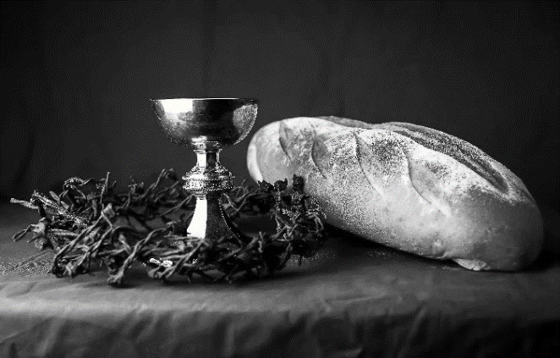
hallowed be thy name,
thy kingdom come,
thy will be done,
on earth as it is in heaven.
Give us this day our daily bread;
and forgive us our trespasses,
as we forgive those
who trespass against us;
and lead us not into temptation,
but deliver us from evil.
For thine is the kingdom,
and the power, and the glory,
forever and ever. Amen.
INVITATION TO COMMUNION - Certified gluten-free crackers are in the bowl on the communion plate.
All people are called to Christ’s table.
Come, eat what is good.
HOLY COMMUNION
PRAYER AFTER COMMUNION
We thank you, generous God, for the refreshment we have received
at your banquet table. Send us now to spread your generosity into all the world,
through the one who is our dearest treasure, Jesus Christ, our Savior and Lord.
Amen.
SENDING
BLESSING
The God who calls across the cosmos
and speaks in the smallest seed
☩ bless, keep, and sustain you
now and to the end of the age.
Amen.
SONG Great Is Thy Faithfulness ELW 733

DISMISSAL
Go in peace. Share the harvest.
VBS Helpers Needed
Junior Counselors:
We are looking for youth in grades 7-12 interested in being Junior Counselors on some or all of the VBS dates.
7/31-8/3. Camp is 9-2 but I think they would need to be there around 8:45.
Kitchen Helpers:
We are looking for someone that can help in the kitchen to provide snacks to the kids and lunch to the counselors and helpers on our “Food Day” of 8/1 from 10:15-12:45 x 2 helpers.
Thursday we are looking for one helper from 10:15-12:45 to help with snacks and lunch along with helpers from the other two churches.
Thanks be to God.

Office Summer Hours
Our office hours will vary this summer as staff are on vacation and schedules change. Please call ahead if you plan to stop by the office.
*Michelle is out of the office July 17-28.
Upcoming Worship Assistants
 | Usher | Lector | Communion | Offering Counters
July 23 | Dave & Kami Weis | Julie Will | Ron Rothfusz  Andrea Hovick | Dan Mundt | Jon Hill
July 30 | John & Jane Wagner | Shelly Schneider | Sarah Kopitzke  Tammy Neumann | Nancy Leonard | Breanna Butler
August 6 | Julie Will | Kris Tarter | John Wagner  Nancy Leonard | Robin Beeman | David Schneider
August 13 | Andrew & Katelynn Neidner | Linda Schrieber | Dan & Pam Mundt | Heidi Binder | Kami Weis
Coming up at GSLC
Sunday, July 23 | 9:00 am | Outdoor Worship Service  - 8th Sunday after Pentecost  - Matthew 13:24-30, 36-43; the parable of the weeks.
Tuesday, July 25 | 7:00 pm | AA Meeting
Wednesday, July 26 | 6:00 pm | Pub Theology
Sunday, July 30 | 9:00 am | Outdoor Worship Service  - 9th Sunday after Pentecost  Matthew 13:31-33, 44-42; parables of the reign of heaven.
SOS current needs: Dried Soup, Jelly, Pancake Mix, Cake/Brownie/Muffin Mix, Gallon Size Ziploc Bags, Kid Toothpaste, Baby Wipes.
Well Stocked: Beans—in all forms canned or dried, Corn, Peas, Canned Fruit, Cereal
There is a tote in the narthex for any donations.

