Good Shepherd Lutheran Church
Pastor: Rev. Katie Anderson | Music Director: Rev. Lois Swanson
Pastor’s Cell: (715) 245-1943 | Office Phone: (715) 387-2731
Pastor Email: gslcwi.pastor@gmail.com | Office Email: gslcwi.office@gmail.com
Website: GoodShepherdMarshfield.org | www.facebook.com/gslcwi
^{7th} Sunday after Pentecost
July 16, 2023, 9:00 am
Introduction to the day…
The mystery of God’s ways is sometimes hidden from the wise and intelligent. Jesus associates with those often excluded from the religious community. Like Paul, we struggle with our own selfish desires and seek God’s mercy and forgiveness. We gather to be refreshed by Christ’s invitation: “Come to me, all you that are weary.” Gathered around word, water, and meal, we find rest for our souls.
ANNOUNCEMENTS
GATHERING
GATHERING SONG Lord, I Lift Your Name on High

Lord, I lift Your name on high. Lord, I love to sing Your praises.

I'm so glad You're in my life; I'm so glad You came to save us.

You came from heaven to earth to show the way.

From the earth to the cross, my debt to pay.

From the cross to the grave, from the grave to the sky;

Lord, I lift Your name on high. Repeat
CONFESSION AND FORGIVENESS
Blessed be the holy Trinity,☩ one God, who greets us in this and every season,
whose word never fails, whose promise is sure.
Amen.
Let us confess our sin in the presence of God and of our neighbors.
Merciful God,
we confess that we have sinned. We have hurt our community.
We have squandered your blessings. We have hoarded your bounty.
In the name of Jesus, forgive us and grant us your mercy.
Silence is kept for reflection.
Righteous God,
we confess that we have sinned. We have failed to be honest.
We have lacked the courage to speak. We have spoken falsely.
In the name of Jesus, forgive us and grant us your mercy.
Silence is kept for reflection.
God is a cup of cold water when we thirst. God offers boundless grace when we fail.
Claim the gift of God’s mercy: you are freed and forgiven in the name of ☩ Jesus Christ.
Amen.
PRAYER OF THE DAY
Almighty God, we thank you for planting in us the seed of your word. By your Holy Spirit help us to receive it with joy, live according to it, and grow in faith and hope and love, through Jesus Christ, our Savior and Lord. Amen.
CHILDREN’S MESSAGE
SCRIPTURE READINGS
FIRST READING: Isaiah 55:10-13
¹⁰For as the rain and the snow come down from heaven,
and do not return there until they have watered the earth,
making it bring forth and sprout,
giving seed to the sower and bread to the eater,
¹¹so shall my word be that goes out from my mouth;
it shall not return to me empty,
but it shall accomplish that which I purpose,
and succeed in the thing for which I sent it.
¹²For you shall go out in joy,
and be led back in peace;
the mountains and the hills before you
shall burst into song,
and all the trees of the field shall clap their hands.
¹³Instead of the thorn shall come up the cypress;
instead of the brier shall come up the myrtle;
and it shall be to the Lord for a memorial,
for an everlasting sign that shall not be cut off.
Word of God, word of life.
Thanks be to God.
PSALM: Psalm 65:1-13
¹You are to be praised, O God, in Zion;
to you shall vows be fulfilled.
²To you, the one who answers prayer,
to you all flesh shall come.
³Our sins are stronger than we are,
but you blot out our transgressions.
⁴Happy are they whom you choose and draw to your courts to dwell there!
They will be satisfied by the beauty of your house, by the holiness of your temple.
⁵Awesome things will you show us in your righteousness, O God of our salvation,
O hope of all the ends of the earth and of the oceans far away.
⁶You make firm the mountains by your power;
you are girded about with might.
⁷You still the roaring of the seas,
the roaring of their waves, and the clamor of the peoples.
⁸Those who dwell at the ends of the earth will tremble at your marvelous signs;
you make the dawn and the dusk to sing for joy.
⁹You visit the earth and water it abundantly; you make it very plenteous; the river of God is full of water.
You prepare the grain, for so you provide for the earth.
¹⁰You drench the furrows and smooth out the ridges;
with heavy rain you soften the ground and bless its increase.
¹¹You crown the year with your goodness,
and your paths overflow with plenty.
¹²May the fields of the wilderness be rich for grazing,
and the hills be clothed with joy.
¹³May the meadows cover themselves with flocks, and the valleys cloak themselves with grain;
let them shout for joy and sing.
SECOND READING: Romans 8:1-11
¹There is therefore now no condemnation for those who are in Christ Jesus. ²For the law of the Spirit of life in Christ Jesus has set you free from the law of sin and of death. ³For God has done what the law, weakened by the flesh, could not do: by sending his own Son in the likeness of sinful flesh, and to deal with sin, he condemned sin in the flesh, ⁴so that the just requirement of the law might be fulfilled in us, who walk not according to the flesh but according to the Spirit. ⁵For those who live according to the flesh set their minds on the things of the flesh, but those who live according to the Spirit set their minds on the things of the Spirit. ⁶To set the mind on the flesh is death, but to set the mind on the Spirit is life and peace. ⁷For this reason the mind that is set on the flesh is hostile to God; it does not submit to God’s law—indeed it cannot, ⁸and those who are in the flesh cannot please God.
⁹But you are not in the flesh; you are in the Spirit, since the Spirit of God dwells in you. Anyone who does not have the Spirit of Christ does not belong to him. ¹⁰But if Christ is in you, though the body is dead because of sin, the Spirit is life because of righteousness. ¹¹If the Spirit of him who raised Jesus from the dead dwells in you, he who raised Christ from the dead will give life to your mortal bodies also through his Spirit that dwells in you.
Word of God, word of life.
Thanks be to God.
GOSPEL ACCLAMATION

GOSPEL: Matthew 13:1-9, 18-23
¹That same day Jesus went out of the house and sat beside the sea. ²Such great crowds gathered around him that he got into a boat and sat there, while the whole crowd stood on the beach. ³And he told them many things in parables, saying: “Listen! A sower went out to sow. ⁴And as he sowed, some seeds fell on the path, and the birds came and ate them up. ⁵Other seeds fell on rocky ground, where they did not have much soil, and they sprang up quickly, since they had no depth of soil. ⁶But when the sun rose, they were scorched; and since they had no root, they withered away. ⁷Other seeds fell among thorns, and the thorns grew up and choked them. ⁸Other seeds fell on good soil and brought forth grain, some a hundredfold, some sixty, some thirty. ⁹Let anyone with ears listen!”
¹⁸“Hear then the parable of the sower. ¹⁹When anyone hears the word of the kingdom and does not understand it, the evil one comes and snatches away what is sown in the heart; this is what was sown on the path. ²⁰As for what was sown on rocky ground, this is the one who hears the word and immediately receives it with joy; ²¹yet such a person has no root, but endures only for a while, and when trouble or persecution arises on account of the word, that person immediately falls away. ²²As for what was sown among thorns, this is the one who hears the word, but the cares of the world and the lure of wealth choke the word, and it yields nothing. ²³But as for what was sown on good soil, this is the one who hears the word and understands it, who indeed bears fruit and yields, in one case a hundredfold, in another sixty, and in another thirty.”
The gospel of the Lord.
Praise to you, O Christ.
SERMON
HYMN OF THE DAY Thy Word
Thy word is a lamp unto my feet
and a light unto my path.
Thy word is a lamp unto my feet
and a light unto my path.
When I feel afraid, think I’ve lost my way,
Still you’re there right beside me,
And nothing will I fear as long as you are near.
Please be near me to the end.
I will not forget your love for me, and yet
my heart forever is wandering
Jesus, be my guide and hold me to your side,
and I will love you to the end.
Amy Grant, Michael W. Smith; CCLI #669990

APOSTLES’ CREED
I believe in God, the Father almighty,
creator of heaven and earth.
I believe in Jesus Christ, God's only Son, our Lord,
who was conceived by the power of the Holy Spirit,
born of the Virgin Mary,
suffered under Pontius Pilate,
was crucified, died, and was buried;
he descended to the dead.
On the third day he rose again;
he ascended into heaven,
he is seated at the right hand of the Father,
and he will come to judge the living and the dead.
I believe in the Holy Spirit,
the holy catholic Church,
the communion of saints,
the forgiveness of sins,
the resurrection of the body,
and the life everlasting. Amen
PRAYERS OF INTERCESSION
…Hear us, O God,
Your mercy is great,
Into your hands, O God, we commend all for whom we pray, in the name of the one who reconciled all creation to himself, Jesus Christ our Savior.
Amen.
PEACE
The peace of Christ be with you always.
And also with you.
HOLY COMMUNION
OFFERING In addition to our normal offering, a Special Benevolence in July (collected in a special envelope) will go to SOS Best First Day.
OFFERING SONG For the Fruit of All Creation ELW 679

OFFERTORY PRAYER
God of field and forest, sea and sky,
you are the giver of all good things.
Sustain us with these gifts of your creation,
and multiply your graciousness in us,
that the world may be fed with your love,
through Jesus Christ, our Savior and Lord.
Amen.
GREAT THANKSGIVING
The Lord be with you.
And also with you.
Lift up your hearts.
We lift them to the Lord.
Let us give our thanks to the Lord our God.
It is right to give our thanks and praise.

HOLY, HOLY, HOLY (Sung) ELW 189

THANKSGIVING AT THE TABLE

God of our weary years, God of our silent tears,
you have brought us this far along the way.
In times of bitterness you did not abandon us,
but guided us into the path of love and light.
In every age you sent prophets
to make known your loving will for all humanity.
The cry of the poor has become your own cry;
our hunger and thirst for justice is your own desire.
In the fullness of time, you sent your chosen servant
to preach good news to the afflicted,
to break bread with the outcast and despised,
and to ransom those in bondage to prejudice and sin.
In the night in which he was betrayed,
our Lord Jesus took bread, and gave thanks;
broke it, and gave it to his disciples, saying:
Take and eat; this is my body, given for you.
Do this for the remembrance of me.
Again, after supper, he took the cup, gave thanks,
and gave it for all to drink, saying:
This cup is the new covenant in my blood,
shed for you and all people for the forgiveness of sin.
Do this for the remembrance of me.
For as often as we eat of this bread and drink from this cup
we proclaim the Lord’s death until he comes.
Christ has died.
Christ is risen.
Christ will come again.
Remembering, therefore, his death and resurrection,
we await the day when Jesus shall return
to free all the earth from the bonds of slavery and death.
Come, Lord Jesus! And let the church say, Amen.
Amen.
Send your Holy Spirit, our advocate,
to fill the hearts of all who share this bread and cup
with courage and wisdom to pursue love and justice in all the world.
Come, Spirit of freedom! And let the church say, Amen.
Amen.
Join our prayers and praise with your prophets and martyrs of every age,
that, rejoicing in the hope of the resurrection,
we might live in the freedom and hope of your Son.
Through him, with him, in him, in the unity of the Holy Spirit,
all glory and honor is yours, almighty Father, now and forever.
Amen.

THE LORD’S PRAYER
Our Father, who art in heaven,
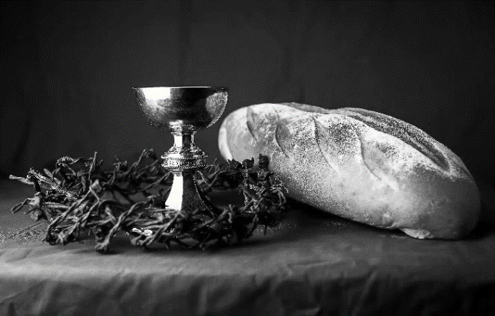
hallowed be thy name,
thy kingdom come,
thy will be done,
on earth as it is in heaven.
Give us this day our daily bread;
and forgive us our trespasses,
as we forgive those
who trespass against us;
and lead us not into temptation,
but deliver us from evil.
For thine is the kingdom,
and the power, and the glory,
forever and ever. Amen.
INVITATION TO COMMUNION - Certified gluten-free crackers are in the bowl on the communion plate.
All people are called to Christ’s table.
Come, eat what is good.
HOLY COMMUNION
PRAYER AFTER COMMUNION
We thank you, generous God,
for the refreshment we have received
at your banquet table.
Send us now to spread your generosity into all the world,
through the one who is our dearest treasure,
Jesus Christ, our Savior and Lord.
Amen.
SENDING
BLESSING
The God who calls across the cosmos
and speaks in the smallest seed
☩ bless, keep, and sustain you
now and to the end of the age.
Amen.
SONG Sent Forth by God’s Blessing

DISMISSAL
Go in peace. Share the harvest.
Thanks be to God.
Upcoming Worship Assistants
 | Usher | Lector | Communion | Offering Counters
July 9 | Bruce & Nancy Tibbett | Leslie Mader | Matt & Margo Barrier | Heidi Binder | Kami Weis
July 16 | Stuart & Christine Tipping | Andrea Hovick | Bruce & Nancy Tibbett | Pam Mundt | May Hill
July 23 | Dave & Kami Weis | Julie Will | Ron Rothfusz  Andrea Hovick | Dan Mundt | Jon Hill
July 30 | John & Jane Wagner | Shelly Schneider | Sarah Kopitzke  Tammy Neumann | Nancy Leonard | Breanna Butler
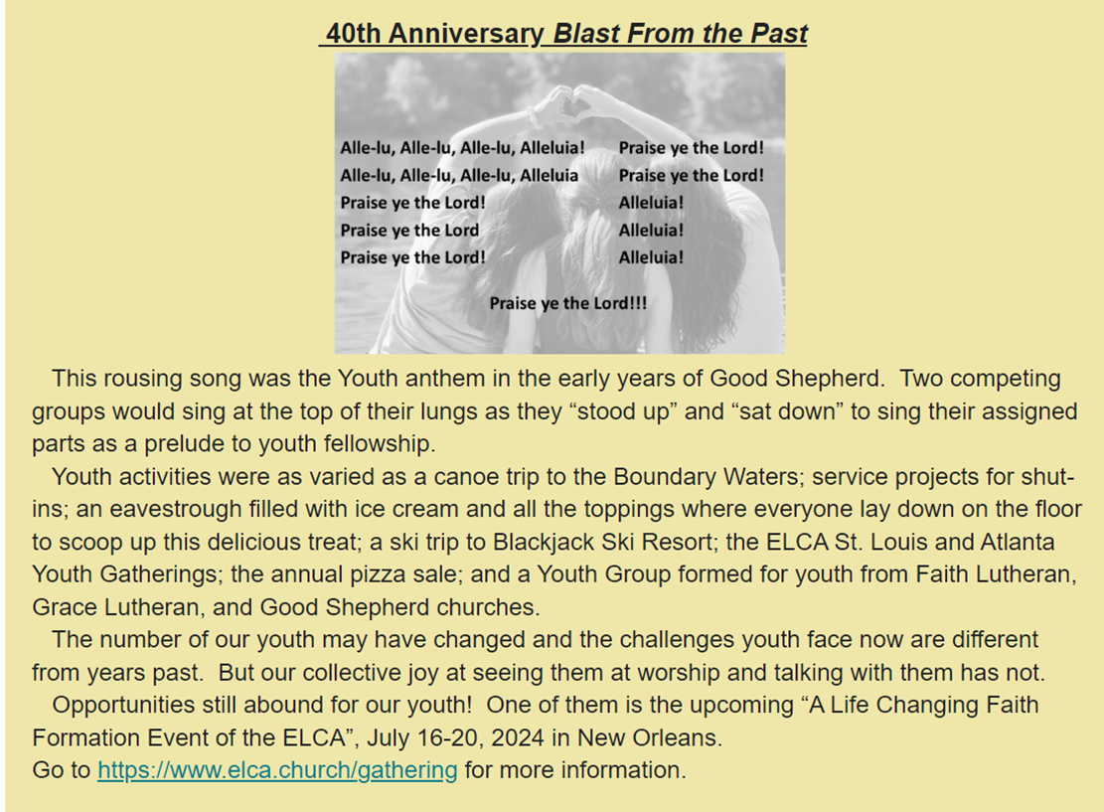
SOS current needs: Dried Soup, Jelly, Pancake Mix, Cake/Brownie/Muffin Mix, Gallon Size Ziploc Bags, Kid Toothpaste, Baby Wipes.

Well Stocked: Beans—in all forms canned or dried, Corn, Peas, Canned Fruit, Cereal

There is a tote in the narthex for any donations.

Office Summer Hours
Our office hours will vary this summer as staff are on vacation and schedules change. Please call ahead if you plan to stop by the office.

*Michelle is out of the office July 17-28.
VBS Helpers Needed
Junior Counselors:
We are looking for youth in grades 7-12 interested in being Junior Counselors on some or all of the VBS dates.
7/31-8/3. Camp is 9-2 but I think they would need to be there around 8:45.
Kitchen Helpers:
We are looking for someone that can help in the kitchen to provide snacks to the kids and lunch to the counselors and helpers on our “Food Day” of 8/1 from 10:15-12:45 x 2 helpers.
Thursday we are looking for one helper from 10:15-12:45 to help with snacks and lunch along with helpers from the other two churches.
Coming up at GSLC
Sunday, July 16 | 9:00 am | Outdoor Worship Service  - 7th Sunday after Pentecost  - Matthew 13:1-9, 18-23; The parable of the sower and the seed.
Tuesday, July 18 | 2:00 pm | Chapel at Three Oaks
 | 7:00 pm | AA Meeting
Friday, July 21 | Dusk | Outdoor Movie Night
Sunday, July 23 | 9:00 am | Outdoor Worship Service  - 8th Sunday after Pentecost  - Matthew 13:24-30, 36-43; the parable of the weeks.
