Good Shepherd Lutheran Church
Pastor: Rev. Katie Anderson | Music Director: Rev. Lois Swanson
Pastor’s Cell: (715) 245-1943 | Office Phone: (715) 387-2731
Pastor Email: gslcwi.pastor@gmail.com | Office Email: gslcwi.office@gmail.com
Website: GoodShepherdMarshfield.org | www.facebook.com/gslcwi
1st Sunday after Pentecost
June 4, 2023, 9:00 am
Introduction to the day…
Though the word trinity is not found in the scriptures, today’s second reading includes the apostolic greeting that begins the liturgy: The grace of our Lord Jesus Christ, the love of God, and the communion of the Holy Spirit be with you all. In the gospel Jesus sends his disciples forth to baptize in the name of the Father, and the Son, and the Holy Spirit. More than a doctrine, the Trinity expresses the heart of our faith: we have experienced the God of creation made known in Jesus Christ and with us always through the Holy Spirit. We celebrate the mystery of the Holy Trinity in word and sacrament, as we profess the creed, and as we are sent into the world to bear witness to our faith.
ANNOUNCEMENTS
GATHERING
GATHERING SONG Holy, Holy, Holy, Lord God Almighty ELW 413

CONFESSION AND FORGIVENESS
Blessed be the holy Trinity,☩ one God, who greets us in this and every season,
whose word never fails, whose promise is sure.
Amen.
Let us confess our sin in the presence of God and of our neighbors.
Merciful God,
we confess that we have sinned. We have hurt our community.
We have squandered your blessings. We have hoarded your bounty.
In the name of Jesus, forgive us and grant us your mercy.
Silence is kept for reflection.
Righteous God,
we confess that we have sinned. We have failed to be honest.
We have lacked the courage to speak. We have spoken falsely.
In the name of Jesus, forgive us and grant us your mercy.
Silence is kept for reflection.
God is a cup of cold water when we thirst. God offers boundless grace when we fail.
Claim the gift of God’s mercy: you are freed and forgiven in the name of ☩ Jesus Christ.
Amen.
PRAYER OF THE DAY
Almighty Creator and ever-living God: we worship your glory, eternal Three-in-One, and we praise your power, majestic One-in-Three. Keep us steadfast in this faith, defend us in all adversity, and bring us at last into your presence, where you live in endless joy and love, Father, Son, and Holy Spirit, one God, now and forever. Amen.
CHILDREN’S MESSAGE
SCRIPTURE READINGS
FIRST READING: Genesis 1:1-2:4a
¹In the beginning when God created the heavens and the earth, ²the earth was a formless void and darkness covered the face of the deep, while a wind from God swept over the face of the waters. ³Then God said, “Let there be light”; and there was light. ⁴And God saw that the light was good; and God separated the light from the darkness. ⁵God called the light Day, and the darkness he called Night. And there was evening and there was morning, the first day.
⁶And God said, “Let there be a dome in the midst of the waters, and let it separate the waters from the waters.” ⁷So God made the dome and separated the waters that were under the dome from the waters that were above the dome. And it was so. ⁸God called the dome Sky. And there was evening and there was morning, the second day.
⁹And God said, “Let the waters under the sky be gathered together into one place, and let the dry land appear.” And it was so. ¹⁰God called the dry land Earth, and the waters that were gathered together he called Seas. And God saw that it was good. ¹¹Then God said, “Let the earth put forth vegetation: plants yielding seed, and fruit trees of every kind on earth that bear fruit with the seed in it.” And it was so. ¹²The earth brought forth vegetation: plants yielding seed of every kind, and trees of every kind bearing fruit with the seed in it. And God saw that it was good. ¹³And there was evening and there was morning, the third day.
¹⁴And God said, “Let there be lights in the dome of the sky to separate the day from the night; and let them be for signs and for seasons and for days and years, ¹⁵and let them be lights in the dome of the sky to give light upon the earth.” And it was so. ¹⁶God made the two great lights—the greater light to rule the day and the lesser light to rule the night—and the stars. ¹⁷God set them in the dome of the sky to give light upon the earth, ¹⁸to rule over the day and over the night, and to separate the light from the darkness. And God saw that it was good. ¹⁹And there was evening and there was morning, the fourth day.
²⁰And God said, “Let the waters bring forth swarms of living creatures, and let birds fly above the earth across the dome of the sky.” ²¹So God created the great sea monsters and every living creature that moves, of every kind, with which the waters swarm, and every winged bird of every kind. And God saw that it was good. ²²God blessed them, saying, “Be fruitful and multiply and fill the waters in the seas, and let birds multiply on the earth.” ²³And there was evening and there was morning, the fifth day.
²⁴And God said, “Let the earth bring forth living creatures of every kind: cattle and creeping things and wild animals of the earth of every kind.” And it was so. ²⁵God made the wild animals of the earth of every kind, and the cattle of every kind, and everything that creeps upon the ground of every kind. And God saw that it was good.
²⁶Then God said, “Let us make humankind in our image, according to our likeness; and let them have dominion over the fish of the sea, and over the birds of the air, and over the cattle, and over all the wild animals of the earth, and over every creeping thing that creeps upon the earth.”
²⁷So God created humankind in his image,
in the image of God he created them;
male and female he created them.
²⁸God blessed them, and God said to them, “Be fruitful and multiply, and fill the earth and subdue it; and have dominion over the fish of the sea and over the birds of the air and over every living thing that moves upon the earth.” ²⁹God said, “See, I have given you every plant yielding seed that is upon the face of all the earth, and every tree with seed in its fruit; you shall have them for food. ³⁰And to every beast of the earth, and to every bird of the air, and to everything that creeps on the earth, everything that has the breath of life, I have given every green plant for food.” And it was so. ³¹God saw everything that he had made, and indeed, it was very good. And there was evening and there was morning, the sixth day.
^{2:1}Thus the heavens and the earth were finished, and all their multitude. ²And on the seventh day God finished the work that he had done, and he rested on the seventh day from all the work that he had done. ³So God blessed the seventh day and hallowed it, because on it God rested from all the work that he had done in creation.
^{4a}These are the generations of the heavens and the earth when they were created.
Word of God, word of life.
Thanks be to God.
PSALM: Psalm 8
¹O Lord our Lord, how majestic is your name in all the earth!—
²you whose glory is chanted above the heavens out of the mouths of infants and children;
you have set up a fortress against your enemies, to silence the foe and avenger.
³When I consider your heavens, the work of your fingers,
the moon and the stars you have set in their courses,
⁴what are mere mortals that you should be mindful of them,
human beings that you should care for them?
⁵Yet you have made them little less than divine;
with glory and honor you crown them.
⁶You have made them rule over the works of your hands;
you have put all things under their feet:
⁷all flocks and cattle, even the wild beasts of the field,
⁸the birds of the air, the fish of the sea,
and whatever passes along the paths of the sea.
⁹O Lord our Lord,
how majestic is your name in all the earth!
SECOND READING: 2 Corinthians 13:11-13
[Paul writes:] ¹¹Finally, brothers and sisters, farewell. Put things in order, listen to my appeal, agree with one another, live in peace; and the God of love and peace will be with you. ¹²Greet one another with a holy kiss. All the saints greet you.
¹³The grace of the Lord Jesus Christ, the love of God, and the communion of the Holy Spirit be with all of you.
Word of God, word of life.
Thanks be to God.
GOSPEL ACCLAMATION ELW 172

GOSPEL: Matthew 28:16-20
¹⁶Now the eleven disciples went to Galilee, to the mountain to which Jesus had directed them. ¹⁷When they saw him, they worshiped him; but some doubted. ¹⁸And Jesus came and said to them, “All authority in heaven and on earth has been given to me. ¹⁹Go therefore and make disciples of all nations, baptizing them in the name of the Father and of the Son and of the Holy Spirit, ²⁰and teaching them to obey everything that I have commanded you. And remember, I am with you always, to the end of the age.”
The gospel of the Lord.
Praise to you, O Christ.
SERMON

HYMN OF THE DAY Come Join the Dance of Trinity ELW 412

APOSTLES’ CREED
I believe in God, the Father almighty,
creator of heaven and earth.
I believe in Jesus Christ, God's only Son, our Lord,
who was conceived by the power of the Holy Spirit,
born of the Virgin Mary,
suffered under Pontius Pilate,
was crucified, died, and was buried;
he descended to the dead.
On the third day he rose again;
he ascended into heaven,
he is seated at the right hand of the Father,
and he will come to judge the living and the dead.
I believe in the Holy Spirit,
the holy catholic Church,
the communion of saints,
the forgiveness of sins,
the resurrection of the body,
and the life everlasting. Amen
PRAYERS OF INTERCESSION
…God, in your mercy,
Hear our prayer.
Receive our prayers and answer us, O God, in the name of Jesus Christ.
Amen.
PEACE
The peace of Christ be with you always.
And also with you.
HOLY COMMUNION
OFFERING In addition to our normal offering, a Special Benevolence in June (collected in a special envelope) will go to Feed My Starving Children.
OFFERING SONG Creating God, Your Fingers Trace ELW 684

OFFERTORY PRAYER
God of field and forest, sea and sky,
you are the giver of all good things.
Sustain us with these gifts of your creation,
and multiply your graciousness in us,
that the world may be fed with your love,
through Jesus Christ, our Savior and Lord.
Amen.
GREAT THANKSGIVING
The Lord be with you.
And also with you.
Lift up your hearts.
We lift them to the Lord.
Let us give our thanks to the Lord our God.
It is right to give our thanks and praise.
HOLY, HOLY, HOLY (Sung) ELW 189

THANKSGIVING AT THE TABLE

God of our weary years, God of our silent tears,
you have brought us this far along the way.
In times of bitterness you did not abandon us,
but guided us into the path of love and light.
In every age you sent prophets
to make known your loving will for all humanity.
The cry of the poor has become your own cry;
our hunger and thirst for justice is your own desire.
In the fullness of time, you sent your chosen servant
to preach good news to the afflicted,
to break bread with the outcast and despised,
and to ransom those in bondage to prejudice and sin.
In the night in which he was betrayed,
our Lord Jesus took bread, and gave thanks;
broke it, and gave it to his disciples, saying:
Take and eat; this is my body, given for you.
Do this for the remembrance of me.
Again, after supper, he took the cup, gave thanks,
and gave it for all to drink, saying:
This cup is the new covenant in my blood,
shed for you and all people for the forgiveness of sin.
Do this for the remembrance of me.
For as often as we eat of this bread and drink from this cup
we proclaim the Lord’s death until he comes.
Christ has died.
Christ is risen.
Christ will come again.
Remembering, therefore, his death and resurrection,
we await the day when Jesus shall return
to free all the earth from the bonds of slavery and death.
Come, Lord Jesus! And let the church say, Amen.
Amen.
Send your Holy Spirit, our advocate,
to fill the hearts of all who share this bread and cup
with courage and wisdom to pursue love and justice in all the world.
Come, Spirit of freedom! And let the church say, Amen.
Amen.
Join our prayers and praise with your prophets and martyrs of every age,
that, rejoicing in the hope of the resurrection,
we might live in the freedom and hope of your Son.
Through him, with him, in him, in the unity of the Holy Spirit,
all glory and honor is yours, almighty Father, now and forever.
Amen.

THE LORD’S PRAYER
Our Father, who art in heaven,
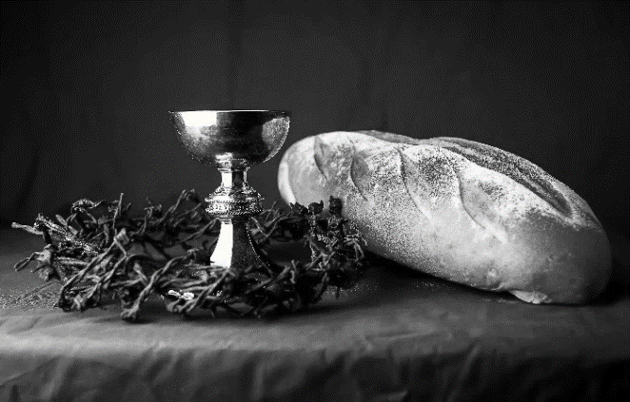
hallowed be thy name,
thy kingdom come,
thy will be done,
on earth as it is in heaven.
Give us this day our daily bread;
and forgive us our trespasses,
as we forgive those
who trespass against us;
and lead us not into temptation,
but deliver us from evil.
For thine is the kingdom,
and the power, and the glory,
forever and ever. Amen.
INVITATION TO COMMUNION - Certified gluten-free crackers are in the bowl on the communion plate.
All people are called to Christ’s table.
Come, eat what is good.
HOLY COMMUNION
PRAYER AFTER COMMUNION
We thank you, generous God, for the refreshment we have received
at your banquet table. Send us now to spread your generosity into all the world,
through the one who is our dearest treasure, Jesus Christ, our Savior and Lord.
Amen.
SENDING
BLESSING
The God who calls across the cosmos
and speaks in the smallest seed
☩ bless, keep, and sustain you
now and to the end of the age.
Amen.
SONG Go Now With God
1 Filled with the Holly Spirit  Go now with God, go now with God  Into the world as a servant  Go now with God, go now with God. | 3 Waters of mercy have found us  Go now with God, go now with God  Grace on the journey surrounds us  Go now with God, go now with God. Refrain
Refrain
Go now, go now, go now with God
Go now, go now, go now with God.
2 Offering a hand to a stranger  Go now with God, go now with God  Trusting in the risen savior Go now with  God, go now with God. Refrain | 4 Crossing every boundary, every nation  Go now with God, go now with God  Dancing in the gift of liberation  Go now with God, go now with God. Refrain
By Hans Peterson and Larry Olson; 2006 Dakota Road Music
DISMISSAL
Go in peace. Share the harvest.
Thanks be to God.
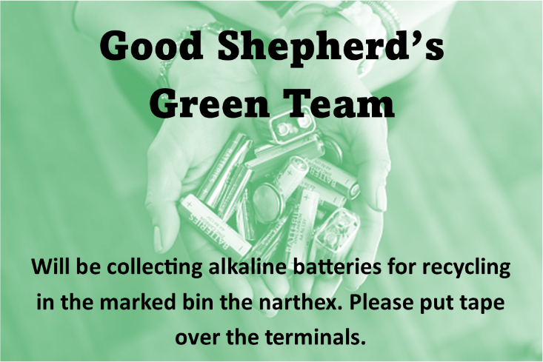

Office Summer Hours
Our office hours will vary this summer as staff are on vacation and schedules change. Please call ahead if you plan to stop by the office.

Upcoming Worship Assistants
 | Usher | Lector | Communion | Offering Counters
June 4 | Dennis & Linda Schutte | Julie Will | Dan & Pam Mundt | Heidi Binder | Kami Weis
June 11 | Dave & Shelly Schneider | Shelly Schneider | Bob & Laurel Peterson | Pam Mundt | May Hill
June 18 | Keith & Michelle Stuttgen | Kris Tarter | Dave & Shelly Schneider | Dan Mundt | Jon Hill
June 25 | Kris Tarter | Laurel Peterson | Bruce & Nancy Tibbett | Nancy Leonard | Breanna Butler
Coming up at GSLC
Sunday, June 4 | 9:00 am | Outdoor Worship Service  - 1st Sunday after Pentecost  - Matthew 28:16-20; Living in the community of the Trinity
 | 10:00 am | GSLC Council Election Meeting
Tuesday, June 6 | 6:00 pm | Executive Committee Meeting
 | 7:00 pm | AA Meeting
Sunday, June 11 | 9:00 am | Outdoor Worship Service  - 2nd Sunday after Pentecost  - Matthew 9:9-13, 18-26; Christ heals a woman and raises a synagogue leader’s daughter
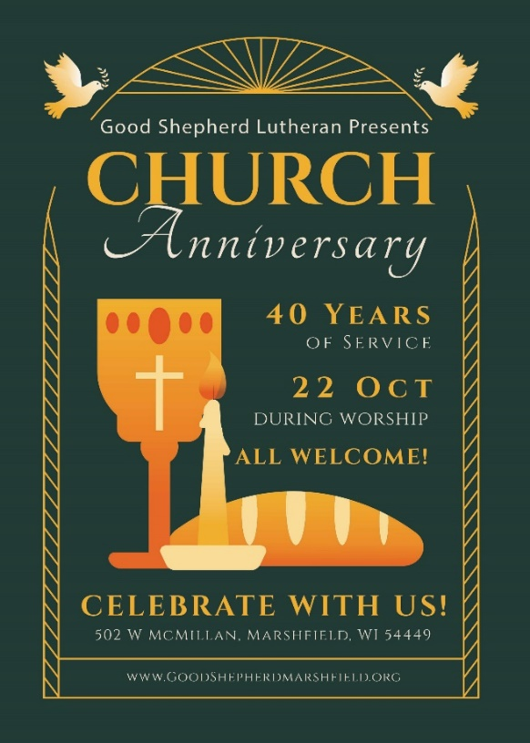

The next GSLC Council Meeting is Tuesday, June 13 at 6:30 pm.

