Good Shepherd Lutheran Church
Pastor: Rev. Katie Anderson | Music Director: Rev. Lois Swanson
Pastor’s Cell: (715) 245-1943 | Office Phone: (715) 387-2731
Pastor Email: gslcwi.pastor@gmail.com | Office Email: gslcwi.office@gmail.com
Website: GoodShepherdMarshfield.org | www.facebook.com/gslcwi
4th Sunday after Pentecost
June 25, 2023, 9:00 am
Introduction to the day…
God does not promise that the path of the disciple will be easy. Jeremiah feels the pain of rejection from those who do not want to hear what he has to say. Jesus declares that his words may bring stark division. Even so, we need not be afraid for God accounts for each hair on our heads. Though we may experience rejection, frustration, division, and death, God’s grace and love make us a new creation each day. Marked with the cross and filled with holy food, we are sent from worship to witness to Christ in the world.
ANNOUNCEMENTS
GATHERING
GATHERING SONG Be Thou My Vision ELW 793

CONFESSION AND FORGIVENESS
Blessed be the holy Trinity,☩ one God, who greets us in this and every season,
whose word never fails, whose promise is sure.
Amen.
Let us confess our sin in the presence of God and of our neighbors.
Merciful God,
we confess that we have sinned. We have hurt our community.
We have squandered your blessings. We have hoarded your bounty.
In the name of Jesus, forgive us and grant us your mercy.
Silence is kept for reflection.
Righteous God,
we confess that we have sinned. We have failed to be honest.
We have lacked the courage to speak. We have spoken falsely.
In the name of Jesus, forgive us and grant us your mercy.
Silence is kept for reflection.
God is a cup of cold water when we thirst. God offers boundless grace when we fail.
Claim the gift of God’s mercy: you are freed and forgiven in the name of ☩ Jesus Christ.
Amen.
PRAYER OF THE DAY
Teach us, good Lord God, to serve you as you deserve, to give and not to count the cost, to fight and not to heed the wounds, to toil and not to seek for rest, to labor and not to ask for reward, except that of knowing that we do your will, through Jesus Christ, our Savior and Lord. Amen.
CHILDREN’S MESSAGE
SCRIPTURE READINGS
FIRST READING: Jeremiah 20:7-13
⁷O Lord, you have enticed me, and I was enticed;
you have overpowered me, and you have prevailed.
I have become a laughingstock all day long; everyone mocks me.
⁸For whenever I speak, I must cry out, I must shout, “Violence and destruction!”
For the word of the Lord has become for me a reproach and derision all day long.
⁹If I say, “I will not mention him, or speak any more in his name,”
then within me, there is something like a burning fire shut up in my bones;
I am weary with holding it in, and I cannot.
¹⁰For I hear many whispering: “Terror is all around!
Denounce him! Let us denounce him!” All my close friends are watching for me to stumble.
“Perhaps he can be enticed, and we can prevail against him, and take our revenge on him.”
¹¹But the Lord is with me like a dread warrior; therefore my persecutors will stumble, and they will not prevail.
They will be greatly shamed, for they will not succeed. Their eternal dishonor will never be forgotten.
¹²O Lord of hosts, you test the righteous, you see the heart and the mind;
let me see your retribution upon them, for to you I have committed my cause.
¹³Sing to the Lord; praise the Lord!
For he has delivered the life of the needy from the hands of evildoers.
Word of God, word of life.
Thanks be to God.
PSALM: Psalm 69:7-18
⁷Surely, for your sake, I have suffered reproach,
and shame has covered my face.
⁸I have become a stranger to my own kindred,
an alien to my mother’s children.
⁹Zeal for your house has eaten me up;
the scorn of those who scorn you has fallen upon me.
¹⁰I humbled myself with fasting,
but that was turned to my reproach.
¹¹I put on sackcloth also,
and became a byword among them.
¹²Those who sit at the gate murmur against me,
and the drunkards make songs about me.
¹³But as for me, this is my prayer to you, at the time you have set, O Lord:
“In your great mercy, O God, answer me with your unfailing help.
¹⁴Save me from the mire; do not let me sink;
let me be rescued from those who hate me and out of the deep waters.
¹⁵Let not the torrent of waters wash over me, neither let the deep swallow me up;
do not let the pit shut its mouth upon me.
¹⁶Answer me, O Lord, for your love is kind;
in your great compassion, turn to me.
¹⁷Hide not your face from your servant;
be swift and answer me, for I am in distress.
¹⁸Draw near to me and redeem me;
because of my enemies deliver me.
SECOND READING: Romans 6:1b-11
^{1b}Should we continue in sin in order that grace may abound? ²By no means! How can we who died to sin go on living in it? ³Do you not know that all of us who have been baptized into Christ Jesus were baptized into his death? ⁴Therefore we have been buried with him by baptism into death, so that, just as Christ was raised from the dead by the glory of the Father, so we too might walk in newness of life.
⁵For if we have been united with him in a death like his, we will certainly be united with him in a resurrection like his. ⁶We know that our old self was crucified with him so that the body of sin might be destroyed, and we might no longer be enslaved to sin. ⁷For whoever has died is freed from sin. ⁸But if we have died with Christ, we believe that we will also live with him. ⁹We know that Christ, being raised from the dead, will never die again; death no longer has dominion over him. ¹⁰The death he died, he died to sin, once for all; but the life he lives, he lives to God. ¹¹So you also must consider yourselves dead to sin and alive to God in Christ Jesus.
Word of God, word of life.
Thanks be to God.
GOSPEL ACCLAMATION

GOSPEL: Matthew 10:24-39
²⁴“A disciple is not above the teacher, nor a slave above the master; ²⁵it is enough for the disciple to be like the teacher, and the slave like the master. If they have called the master of the house Beelzebul, how much more will they malign those of his household!
²⁶“So have no fear of them; for nothing is covered up that will not be uncovered, and nothing secret that will not become known. ²⁷What I say to you in the dark, tell in the light; and what you hear whispered, proclaim from the housetops. ²⁸Do not fear those who kill the body but cannot kill the soul; rather fear him who can destroy both soul and body in hell. ²⁹Are not two sparrows sold for a penny? Yet not one of them will fall to the ground apart from your Father. ³⁰And even the hairs of your head are all counted. ³¹So do not be afraid; you are of more value than many sparrows.
³²“Everyone therefore who acknowledges me before others, I also will acknowledge before my Father in heaven; ³³but whoever denies me before others, I also will deny before my Father in heaven.
³⁴“Do not think that I have come to bring peace to the earth; I have not come to bring peace, but a sword.
³⁵For I have come to set a man against his father,
and a daughter against her mother,
and a daughter-in-law against her mother-in-law;
³⁶and one’s foes will be members of one’s own household.
³⁷Whoever loves father or mother more than me is not worthy of me; and whoever loves son or daughter more than me is not worthy of me; ³⁸and whoever does not take up the cross and follow me is not worthy of me. ³⁹Those who find their life will lose it, and those who lose their life for my sake will find it.”
The gospel of the Lord.
Praise to you, O Christ.
SERMON

HYMN OF THE DAY Will You Come and Follow Me ELW 798

APOSTLES’ CREED
I believe in God, the Father almighty,
creator of heaven and earth.
I believe in Jesus Christ, God's only Son, our Lord,
who was conceived by the power of the Holy Spirit,
born of the Virgin Mary,
suffered under Pontius Pilate,
was crucified, died, and was buried;
he descended to the dead.
On the third day he rose again;
he ascended into heaven,
he is seated at the right hand of the Father,
and he will come to judge the living and the dead.
I believe in the Holy Spirit,
the holy catholic Church,
the communion of saints,
the forgiveness of sins,
the resurrection of the body,
and the life everlasting. Amen
PRAYERS OF INTERCESSION
…God, in your mercy,
Hear our prayer.
Receive our prayers and answer us, O God, in the name of Jesus Christ.
Amen.
PEACE
The peace of Christ be with you always.
And also with you.
HOLY COMMUNION
OFFERING In addition to our normal offering, a Special Benevolence in June (collected in a special envelope) will go to Feed My Starving Children.
OFFERING SONG Children of the Heavenly Father ELW 781

OFFERTORY PRAYER
God of field and forest, sea and sky,
you are the giver of all good things.
Sustain us with these gifts of your creation,
and multiply your graciousness in us,
that the world may be fed with your love,
through Jesus Christ, our Savior and Lord.
Amen.
GREAT THANKSGIVING
The Lord be with you.
And also with you.
Lift up your hearts.
We lift them to the Lord.
Let us give our thanks to the Lord our God.
It is right to give our thanks and praise.
HOLY, HOLY, HOLY (Sung) ELW 189

THANKSGIVING AT THE TABLE

God of our weary years, God of our silent tears,
you have brought us this far along the way.
In times of bitterness, you did not abandon us
but guided us into the path of love and light.
In every age, you sent prophets
to make known your loving will for all humanity.
The cry of the poor has become your own cry;
our hunger and thirst for justice is your own desire.
In the fullness of time, you sent your chosen servant
to preach good news to the afflicted,
to break bread with the outcast and despised,
and to ransom those in bondage to prejudice and sin.
In the night in which he was betrayed,
our Lord Jesus took bread, and gave thanks;
broke it, and gave it to his disciples, saying:
Take and eat; this is my body, given for you.
Do this for the remembrance of me.
Again, after supper, he took the cup, gave thanks,
and gave it for all to drink, saying:
This cup is the new covenant in my blood,
shed for you and all people for the forgiveness of sin.
Do this for the remembrance of me.
For as often as we eat of this bread and drink from this cup
we proclaim the Lord’s death until he comes.
Christ has died.
Christ is risen.
Christ will come again.
Remembering, therefore, his death and resurrection,
we await the day when Jesus shall return
to free all the earth from the bonds of slavery and death.
Come, Lord Jesus! And let the church say, Amen.
Amen.
Send your Holy Spirit, our advocate,
to fill the hearts of all who share this bread and cup
with courage and wisdom to pursue love and justice in all the world.
Come, Spirit of freedom! And let the church say, Amen.
Amen.
Join our prayers and praise with your prophets and martyrs of every age,
that, rejoicing in the hope of the resurrection,
we might live in the freedom and hope of your Son.
Through him, with him, in him, in the unity of the Holy Spirit,
all glory and honor is yours, almighty Father, now and forever.
Amen.

THE LORD’S PRAYER
Our Father, who art in heaven,
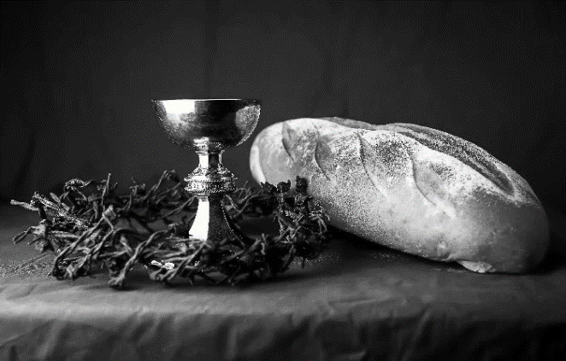
hallowed be thy name,
thy kingdom come,
thy will be done,
on earth as it is in heaven.
Give us this day our daily bread;
and forgive us our trespasses,
as we forgive those
who trespass against us;
and lead us not into temptation,
but deliver us from evil.
For thine is the kingdom,
and the power, and the glory,
forever and ever. Amen.
INVITATION TO COMMUNION - Certified gluten-free crackers are in the bowl on the communion plate.
All people are called to Christ’s table.
Come, eat what is good.
HOLY COMMUNION
PRAYER AFTER COMMUNION
We thank you, generous God, for the refreshment we have received
at your banquet table. Send us now to spread your generosity into all the world,
through the one who is our dearest treasure, Jesus Christ, our Savior and Lord.
Amen.
SENDING
BLESSING
The God who calls across the cosmos
and speaks in the smallest seed
☩ bless, keep, and sustain you
now and to the end of the age.
Amen.
SONG Lord Jesus, You Shall Be My Song ELW 808

DISMISSAL
Go in peace. Share the harvest.
Thanks be to God.
Upcoming Worship Assistants
 | Usher | Lector | Communion | Offering Counters
June 25 | Bruce & Nancy Tibbett | Laurel Peterson | Dave & Sue Schraeder | Nancy Leonard | Breanna Butler
July 2 | Chad & Audra Strasser | Nancy Leonard | John Wagner | Robin Beeman | David Schneider
July 9 | Rob & Leslie Mader | Leslie Mader | Matt & Margo Barrier | Heidi Binder | Kami Weis
July 16 | Stuart & Christine Tipping | Andrea Hovick | Bruce & Nancy Tibbett | Pam Mundt | May Hill
July 23 | Dave & Kami Weis | Julie Will | Ron Rothfusz  Andrea Hovick | Dan Mundt | Jon Hill
July 30 | John & Jane Wagner | Shelly Schneider | Sarah Kopitzke  Tammy Neumann | Nancy Leonard | Breanna Butler
Coming up at GSLC
Sunday, June 25 | 9:00 am | Worship Service  - 4th Sunday after Pentecost  - Matthew 10:24-39; The cost of discipleship.
Tuesday, June 27 | 7:00 pm | AA Meeting
Wednesday, June 28 | 6:00 pm | Pub Theology
Thursday, June 29 | 6:30 pm | VBS Planning Meeting
Friday, June 29 | All Day | Brat Barn at Festival Foods.
Sunday, July 2 | 9:00 am | Outdoor Worship Service  - 5th Sunday after Pentecost  Matthew 10:40-42; Welcome Christ in those he sends
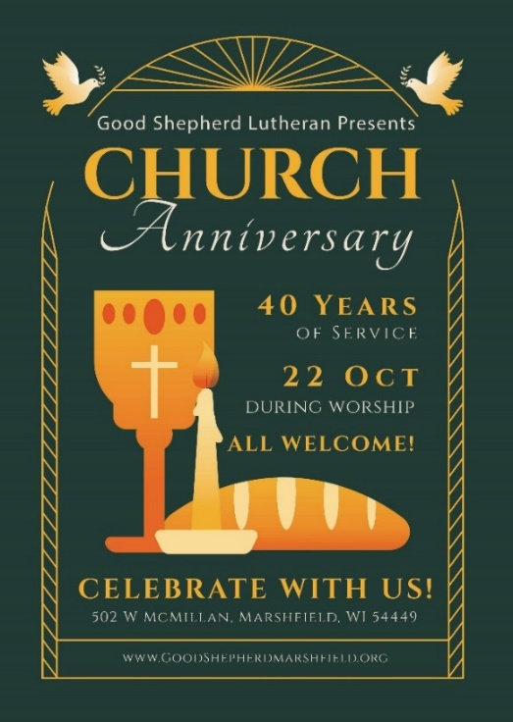

Office Summer Hours
Our office hours will vary this summer as staff are on vacation and schedules change. Please call ahead if you plan to stop by the office.

